# Chapter 5: Testing

After completion of the software development, it is deployed in the testing environment. The testing team starts the testing of the entire system. All their functionality are tested and documented whether they pass the test or not. The team may find bugs and defects which are later communicated with the developer. The developer then fixes the bugs and are re-send for testing. The cycle continues and after completion of the testing phase, the software is ready to deploy. For this project I have selected unit testing and black box testing.

## 5.1 Unit testing

It is a type of testing where individual units of software are tested. Here is some unit test of the major function of the project. Visual studio has its own integrated unit testing framework. So, the unit testing tool of visual studio is used for this unit testing.

Features to be unit tested:

* Initial register
* Login
* Forgot pin
* Change pin
* Add category
* Add liquor
* Add loyal customer
* Restock liquor
* Update liquor
* Delete liquor

**Initial register Unit test:**

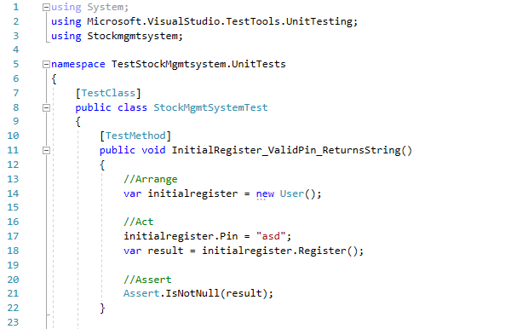

Result in database: 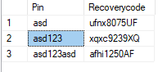

**Login Unit test:**

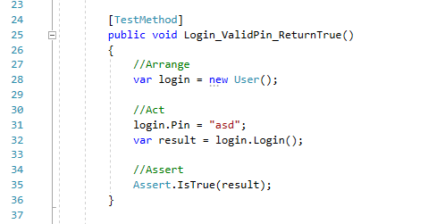

**Forgot Pin Unit test:**

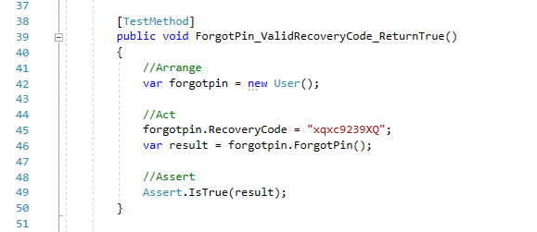

**Change Pin Unit test:**

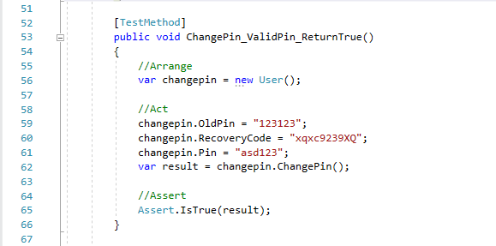

Result in database: 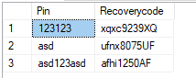 

**Add Category Unit test:**

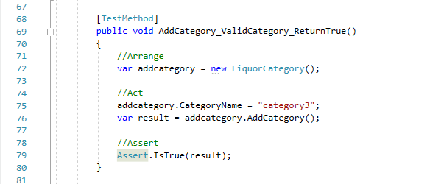

Result in database: 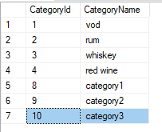

**Add Liquor Unit test:**

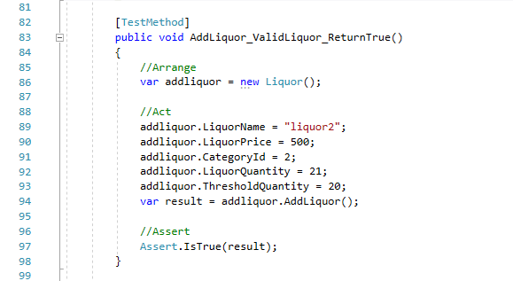

Result in database:

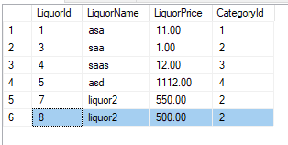 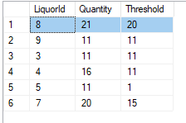

**Add Loyal Customer Unit test:**

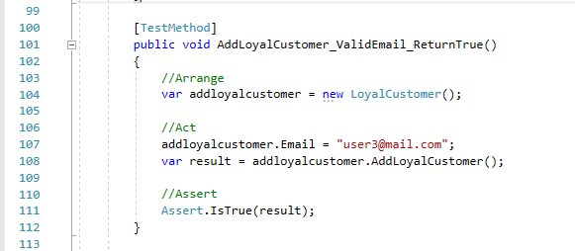

Result in database: 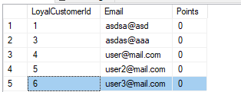

**Restock Liquor Unit test:**

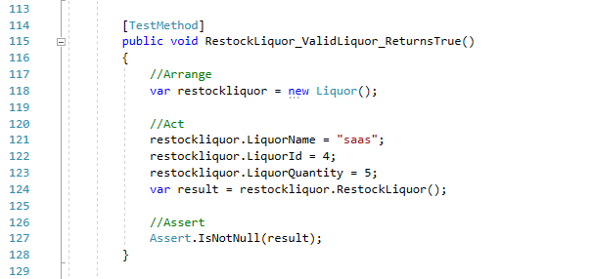

Result in database:

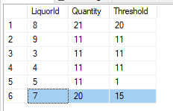 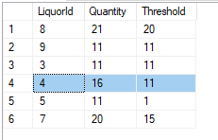

**Update Liquor Unit test:**

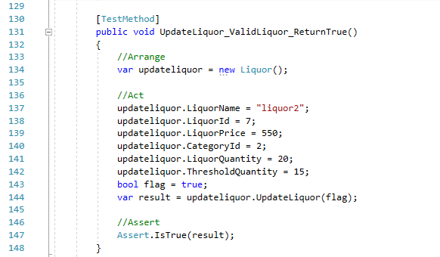

Result in database:

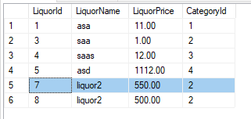 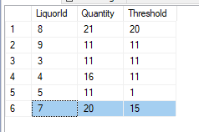

**Delete Liquor Unit test:**

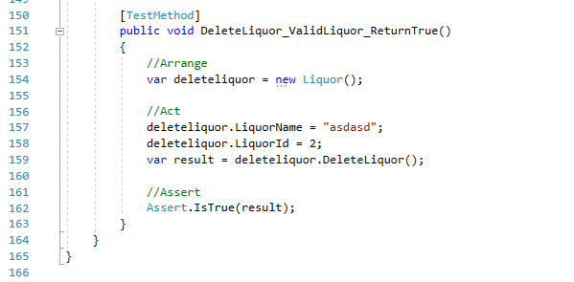

Result in database: 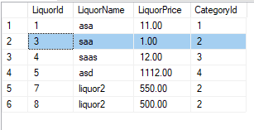

Whole unit test result:

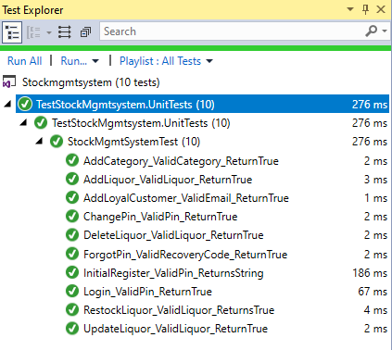

The selected data used for testing are according to the data present in the database. The test result might vary according to the data in the database. To perform the test some data are manually entered through application for manipulation through the test.

## 5.2 Black box testing

It is a type of testing technique in which functionality of application are testing without checking the source code. Test can be both functional and non-functional.

**Test plan**

**Introduction:**

The test plan is created to test the features of the application. Different features and validation are tested such as login, register, adding category and liquor and their manipulation.

**Scope:**

The scope of this test plan is to check whether the application and its features work as intended. The UI events work as intended and do not go to break codes during runtime.

**Test items:**

Liquor Stock Management System

**Feature to be tested:**

* Initial Registration
* Login
* Forgot Pin
* Change Pin
* Adding Category
* Adding Liquor
* Restocking Liquor
* Creating Bill
* Search function of Liquor
* Category filter function of Liquor

**Item pass/fail criteria:**

Whenever the actual outcome is the same as the expected outcome, the test items will be declared pass else it will be declared fail.

**Test log:**

|  |  |  |  |  |  |  |  |
| --- | --- | --- | --- | --- | --- | --- | --- |
| **Project Title:** Liquor Stock Management System | | | | | | | |
| **Test Case ID:** T01 | | | | **Designed By:** Ajar Maharjan | | | |
| **Test Title:** To Initial register | | | | **Date of Design:** June 22th, 2019 | | | |
| **Test Description:** Testing registration of user. | | | | **Executed By:** Ajar Maharjan | | | |
| **Date of Execution:** June 29th, 2019 | | | |
| **Pre-Condition:** User should not be registered. | | | | | | | |
|  | | | | | | | |
| **Step S.N.** | **Test Steps** | **Test Data** | **Expected Result** | | **Actual Result** | **Status** | **Remarks** |
| 1 | Open application |  | User should get recovery code and redirected to login window | | User got recovery code copied in clipboard and redirected to login window | Pass | Completed |
| 2 | Enter Pin and valid re-enter pin | aaa111 |
| 3 | Click on Register |  |

Screenshot of test:

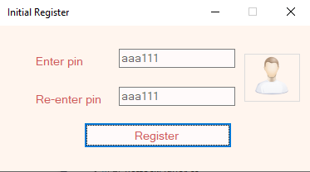 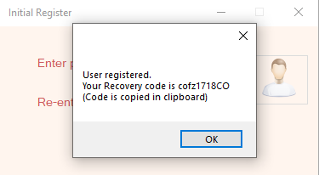

|  |  |  |  |  |  |  |  |
| --- | --- | --- | --- | --- | --- | --- | --- |
| **Project Title:** Liquor Stock Management System | | | | | | | |
| **Test Case ID:** T02 | | | | **Designed By:** Ajar Maharjan | | | |
| **Test Title:** To verify user login | | | | **Date of Design:** June 22th, 2019 | | | |
| **Test Description:** Testing the login of a user | | | | **Executed By:** Ajar Maharjan | | | |
| **Date of Execution:** June 29th, 2019 | | | |
| **Pre-Condition:** User must register. | | | | | | | |
|  | | | | | | | |
| **Step S.N.** | **Test Steps** | **Test Data** | **Expected Result** | | **Actual Result** | **Status** | **Remarks** |
| 1 | Open application |  | User should be redirected to home window | | User was redirected to home window | Pass | Completed |
| 2 | Enter Pin | aaa111 |
| 3 | Click on Login |  |

Screenshot of test:

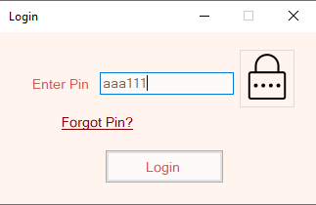 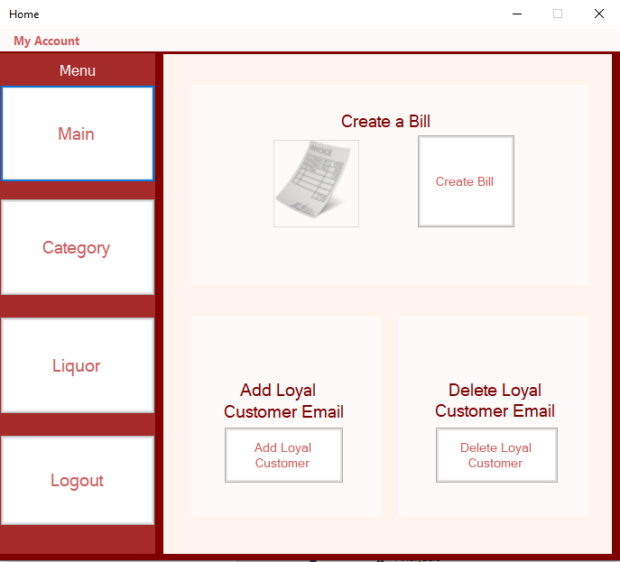

|  |  |  |  |  |  |  |  |
| --- | --- | --- | --- | --- | --- | --- | --- |
| **Project Title:** Liquor Stock Management System | | | | | | | |
| **Test Case ID:** T03 | | | | **Designed By:** Ajar Maharjan | | | |
| **Test Title:** Forgot pin | | | | **Date of Design:** June 22th, 2019 | | | |
| **Test Description:** Testing to retrieve pin using recovery code. | | | | **Executed By:** Ajar Maharjan | | | |
| **Date of Execution:** June 29th, 2019 | | | |
| **Pre-Condition:** User must enter valid data | | | | | | | |
|  | | | | | | | |
| **Step S.N.** | **Test Steps** | **Test Data** | **Expected Result** | | **Actual Result** | **Status** | **Remarks** |
| 1 | Open application and click on Forgot Pin? |  | User must get login pin | | User got message box with login pin | Pass | Completed |
| 2 | Enter recovery code | cofz1718CO |
| 3 | Click Recover Pin |  |

Screenshot of test:

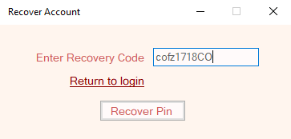 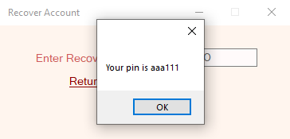

|  |  |  |  |  |  |  |  |
| --- | --- | --- | --- | --- | --- | --- | --- |
| **Project Title:** Liquor Stock Management System | | | | | | | |
| **Test Case ID:** T04 | | | | **Designed By:** Ajar Maharjan | | | |
| **Test Title:** To Change pin | | | | **Date of Design:** June 22th, 2019 | | | |
| **Test Description:** Testing the display of all products | | | | **Executed By:** Ajar Maharjan | | | |
| **Date of Execution:** June 29th, 2019 | | | |
| **Pre-Condition:** User must enter valid data | | | | | | | |
|  | | | | | | | |
| **Step S.N.** | **Test Steps** | **Test Data** | **Expected Result** | | **Actual Result** | **Status** | **Remarks** |
| 1 | Open menu strip and click on Change Pin |  | Pin should be changed | | Pin was changed | Pass | Completed |
| 2 | Enter Old Pin | aaa111 |
| 3 | Enter New Pin | a1a1 |
| 4 | Enter Recovery Code | cofz1718CO |
| 5 | Click on Save |  |

Screenshot of test:

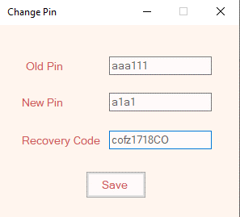 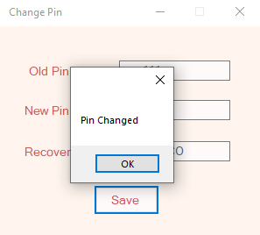

|  |  |  |  |  |  |  |  |
| --- | --- | --- | --- | --- | --- | --- | --- |
| **Project Title:** Liquor Stock Management System | | | | | | | |
| **Test Case ID:** T05 | | | | **Designed By:** Ajar Maharjan | | | |
| **Test Title:** Adding new liquor category | | | | **Date of Design:** June 22th, 2019 | | | |
| **Test Description:** Testing to add liquor category | | | | **Executed By:** Ajar Maharjan | | | |
| **Date of Execution:** June 29th, 2019 | | | |
| **Pre-Condition:** User must enter valid data | | | | | | | |
|  | | | | | | | |
| **Step S.N.** | **Test Steps** | **Test Data** | **Expected Result** | | **Actual Result** | **Status** | **Remarks** |
| 1 | Open Add Category from Category tab |  | New category should be added | | New category was added | Pass | Completed |
| 2 | Enter Category | Tequila |
| 3 | Click on Add |  |

Screenshot of test:

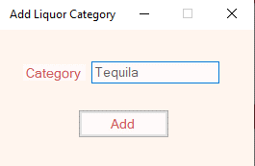 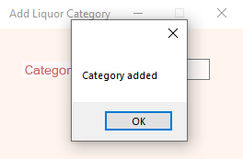

|  |  |  |  |  |  |  |  |
| --- | --- | --- | --- | --- | --- | --- | --- |
| **Project Title:** Liquor Stock Management System | | | | | | | |
| **Test Case ID:** T06 | | | | **Designed By:** Ajar Maharjan | | | |
| **Test Title:** Adding new liquor | | | | **Date of Design:** June 22th, 2019 | | | |
| **Test Description:** Testing to add liquor | | | | **Executed By:** Ajar Maharjan | | | |
| **Date of Execution:** June 29th, 2019 | | | |
| **Pre-Condition:** User must enter valid data | | | | | | | |
|  | | | | | | | |
| **Step S.N.** | **Test Steps** | **Test Data** | **Expected Result** | | **Actual Result** | **Status** | **Remarks** |
| 1 | Open Add Liquor from Liquor tab |  | New liquor should be added | | New Liquor was added | Pass | Completed |
| 2 | Enter Liquor Name | kraken |
| 3 | Select Category | rum |
| 4 | Enter Price | 500 |
| 5 | Enter Quantity | 20 |
| 6 | Enter Threshold Quantity | 5 |
| 7 | Click on Add |  |

Screenshot of test:

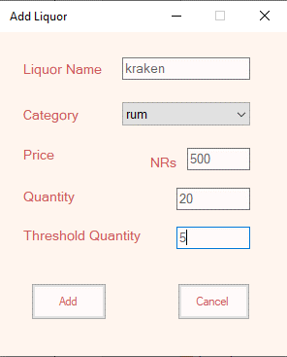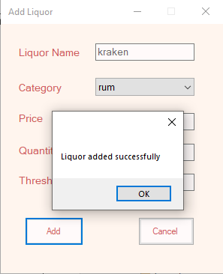

|  |  |  |  |  |  |  |  |
| --- | --- | --- | --- | --- | --- | --- | --- |
| **Project Title:** Liquor Stock Management System | | | | | | | |
| **Test Case ID:** T07 | | | | **Designed By:** Ajar Maharjan | | | |
| **Test Title:** Restocking liquor quantity | | | | **Date of Design:** June 22th, 2019 | | | |
| **Test Description:** Testing to restock liquor quantity | | | | **Executed By:** Ajar Maharjan | | | |
| **Date of Execution:** June 29th, 2019 | | | |
| **Pre-Condition:** User must enter valid data | | | | | | | |
|  | | | | | | | |
| **Step S.N.** | **Test Steps** | **Test Data** | **Expected Result** | | **Actual Result** | **Status** | **Remarks** |
| 1 | Open Restock Liquor from Liquor tab |  | Liquor quantity should be restocked | | Liquor quantity was restocked | Pass | Completed |
| 2 | Select Liquor | kraken |
| 3 | Enter New Liquor stock quantity | 10 |
| 4 | Click on Restock |  |

Screenshot of test:

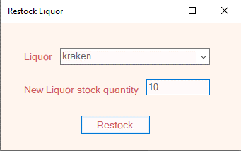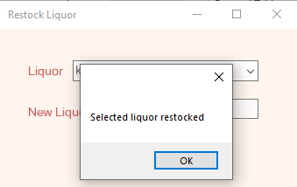

|  |  |  |  |  |  |  |  |
| --- | --- | --- | --- | --- | --- | --- | --- |
| **Project Title:** Liquor Stock Management System | | | | | | | |
| **Test Case ID:** T08 | | | | **Designed By:** Ajar Maharjan | | | |
| **Test Title:** Creating a bill | | | | **Date of Design:** June 22th, 2019 | | | |
| **Test Description:** Testing to create bill | | | | **Executed By:** Ajar Maharjan | | | |
| **Date of Execution:** June 29th, 2019 | | | |
| **Pre-Condition:** User must enter valid data | | | | | | | |
|  | | | | | | | |
| **Step S.N.** | **Test Steps** | **Test Data** | **Expected Result** | | **Actual Result** | **Status** | **Remarks** |
| 1 | Open Create Bill from Main tab |  | Bill should be created | | Bill was created | Pass | Completed |
| 2 | Select Liquor | kraken |
| 3 | Enter Quantity | 2 |
| 4 | Enter Cash | 1000 |
| 5 | Click on Create |  |

Screenshot of test:

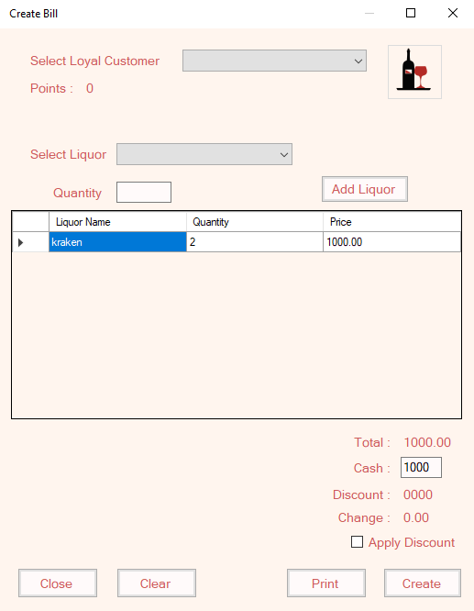 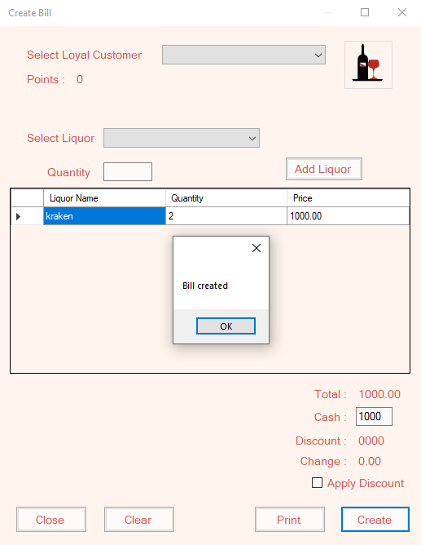

**List of all Liquors for next test**

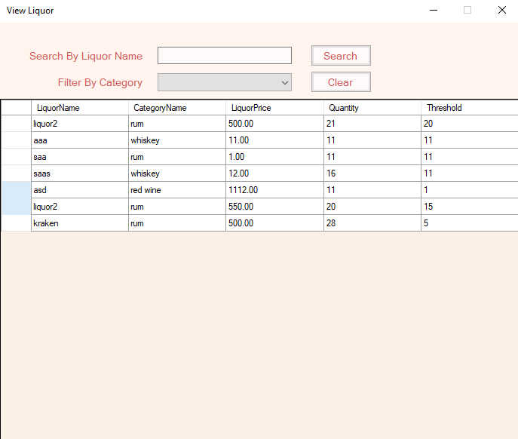

|  |  |  |  |  |  |  |  |
| --- | --- | --- | --- | --- | --- | --- | --- |
| **Project Title:** Liquor Stock Management System | | | | | | | |
| **Test Case ID:** T09 | | | | **Designed By:** Ajar Maharjan | | | |
| **Test Title:** Searching liquor | | | | **Date of Design:** June 22th, 2019 | | | |
| **Test Description:** Testing to search liquor by its name | | | | **Executed By:** Ajar Maharjan | | | |
| **Date of Execution:** June 29th, 2019 | | | |
| **Pre-Condition:** User must enter valid data | | | | | | | |
|  | | | | | | | |
| **Step S.N.** | **Test Steps** | **Test Data** | **Expected Result** | | **Actual Result** | **Status** | **Remarks** |
| 1 | Open View Liquor from Liquor tab |  | Display kraken liquor and its information | | kraken liquor and its information was displayed | Pass | Completed |
| 2 | Enter Liquor Name | kraken |
| 3 | Click on Search |  |

Screenshot of test:

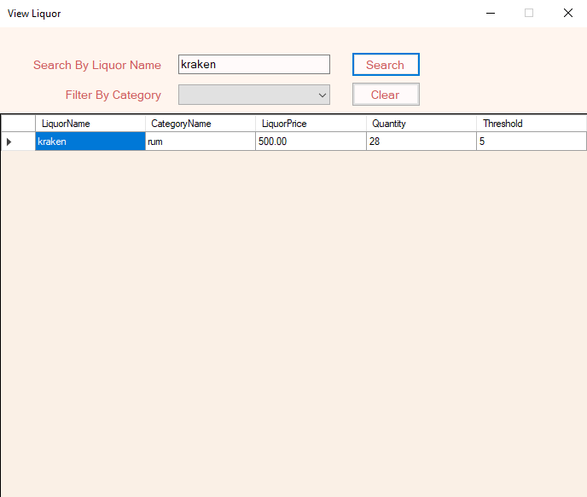

|  |  |  |  |  |  |  |  |
| --- | --- | --- | --- | --- | --- | --- | --- |
| **Project Title:** Liquor Stock Management System | | | | | | | |
| **Test Case ID:** T10 | | | | **Designed By:** Ajar Maharjan | | | |
| **Test Title:** Filtering liquor through category | | | | **Date of Design:** June 22th, 2019 | | | |
| **Test Description:** Testing to filter liquor through category | | | | **Executed By:** Ajar Maharjan | | | |
| **Date of Execution:** June 29th, 2019 | | | |
| **Pre-Condition:** User must enter valid data | | | | | | | |
|  | | | | | | | |
| **Step S.N.** | **Test Steps** | **Test Data** | **Expected Result** | | **Actual Result** | **Status** | **Remarks** |
| 1 | Open View Liquor from Liquor tab |  | Display list of all liquor having rum category | | List of liquor having rum category was displayed | Pass | Completed |
| 2 | Select Liquor Category | rum |

Screenshot of test:

