Hello, I’m Jarlin Almanzar. I am a junior majoring in Computer Science. I started to explore data when I took a probability and statistics class in high school, where I learned about many different things relating to data. As a computer science major, I decided to further explore this interesting by taking Data 101. For this assignment I chose one of my favorite activities which is video-gaming. This is also backed up by the recent media focus on violence in video games.

As such I will be looking at which genres in the video game industry drive sales and how many of them have been made. This dataset has 16,719 entries of games that have been tracked from as early as 1980 and up to 2017. It has many categories from Platform, release year, publisher, genre, and country of sale. I will use the global sales vs the North American Sales in certain genres such as action and shooters. The data is trustable and extremely accurate.

In general, we can see that the most bought games are action and sport games. From this list we see that North America has some outliers in the shooter genre, while Europe has an outlier in action games.

My question is to show that action, shooter, and video games in general don’t cause violence by checking the sales from North America vs Europe. After running the permutation test 20000 times we get to about 0 or a very small number. Which means that there is no difference in sales in these game genres and as such, blaming video-games for shootings and increase in violence is wrong. There’s another variable that we can’t tell from the data-set about increase of volume and school shootings. Such as availability of guns, and society standards. However, from this data alone games are not the cause of increase of violence and shootings and as such media are only using it to blame it on something.

Data url: https://www.kaggle.com/rush4ratio/video-game-sales-with-ratings/data

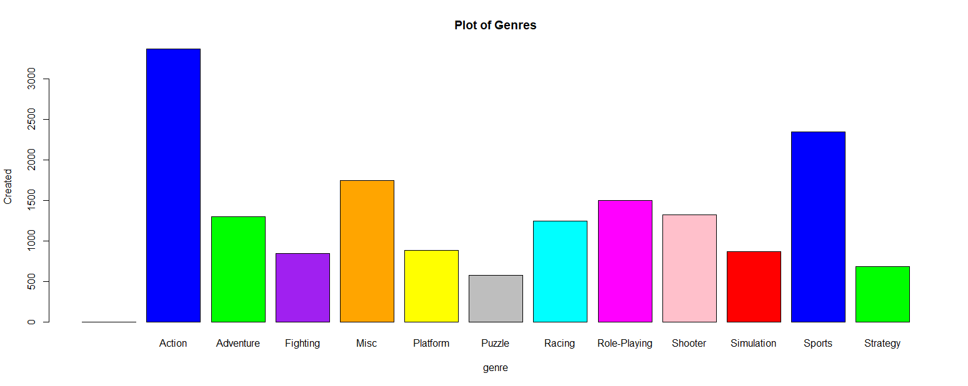

R-Code:

> plot(Video_Games_Sales_as_at_22_Dec_2016$Genre, col=c("red","blue","green", "purple","orange", "yellow", "grey", "cyan", "magenta", "pink"), xlab='genre', ylab='Created', main='Plot of Genres')

Permutation test:

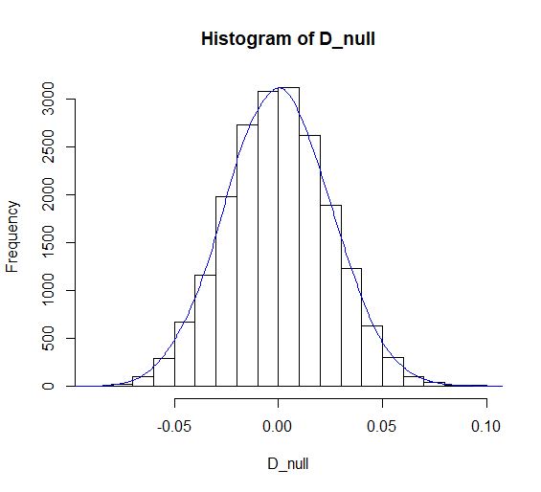

R-code:

> PermutationTestSecond::Permutation(Video_Games_Sales_as_at_22_Dec_2016, "Nation", "Global_Sales",20000, "North America", "Europe")

[1] 0

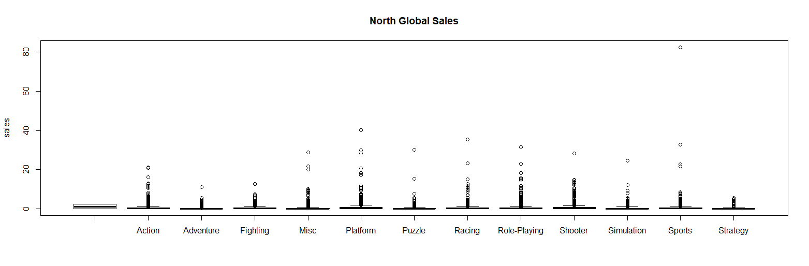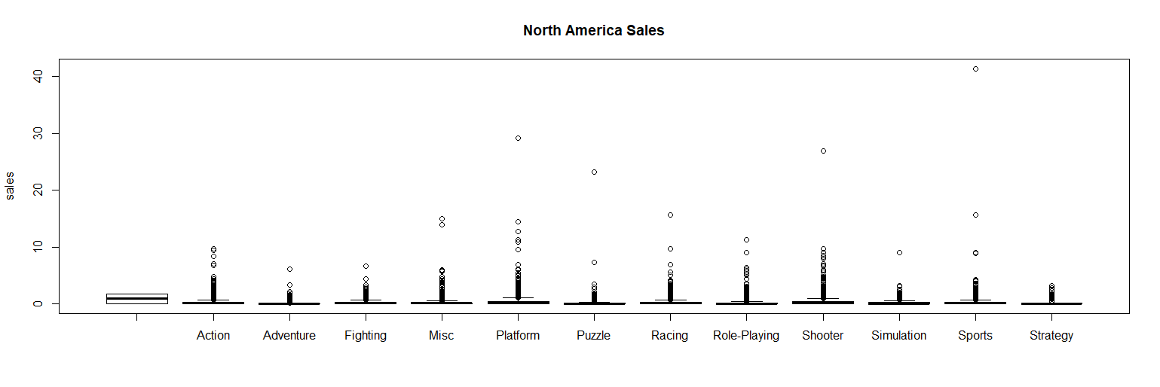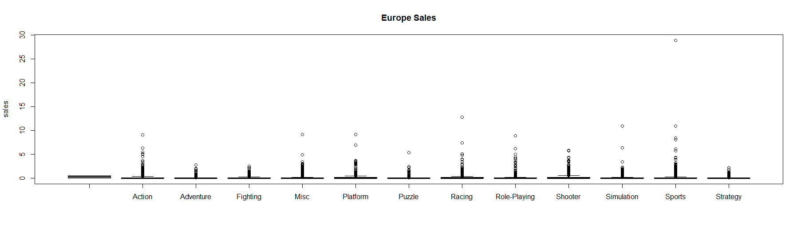

R-code:

> plot(Video_Games_Sales_as_at_22_Dec_2016$Genre->'Action', Video_Games_Sales_as_at_22_Dec_2016$NA_Sales, main="North America Sales", Xlab='Genre', ylab='sales')

> plot(Video_Games_Sales_as_at_22_Dec_2016$Genre->'Action', Video_Games_Sales_as_at_22_Dec_2016$Global_Sales, main="North Global Sales", Xlab='Genre', ylab='sales')

plot(Video_Games_Sales_as_at_22_Dec_2016$Genre->'Action', Video_Games_Sales_as_at_22_Dec_2016$EU_Sales, main="Europe Sales", Xlab='Genre', ylab='sales')