**Task**

* Extend the existing Code with the described algorithm
* Targets:
  + Tests don’t fail any more
  + Clean Code

**Explanation/Background**

The algorithm for validating locomotive numbers should work as follows:

The check digit is calculated from the first seven digits. For this purpose, the sum of digits of the number sequence is formed, which is obtained by multiplying the seven digits alternately by 2 and 1 (first digit with 2, second with 1, third again with 2, etc.); the difference of this checksum to the next multiple of ten is the check digit. When entering the calculator, the check digit is used to carry out a plausibility check, which detects for example numerical falls.

**Examples**

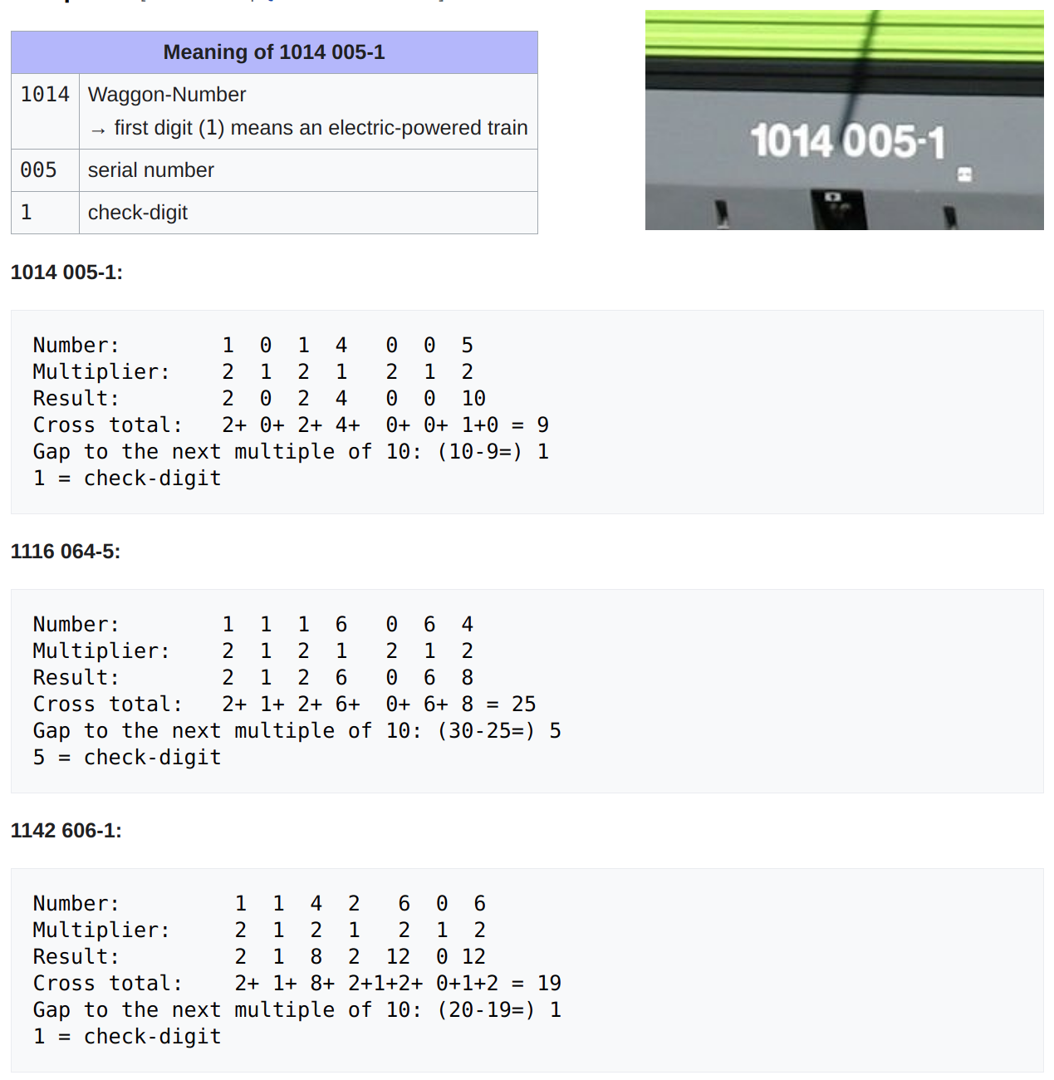  
© [Source: https://de.wikipedia.org/wiki/Reihenschema_der_%C3%96BB](https://de.wikipedia.org/wiki/Reihenschema_der_%C3%96BB)  Wikimedia Foundation