A
Summer Internship
Report on

CANVAS BOARD USING OPENCV
Submitted for partial fulfilment of the requirements for the award of the degree of

BACHELOR OF ENGINEERING
IN
INFORMATION TECHNOLOGY
By

N HRUSHIKESH (2451-23-737-030)
D JAYANTH (2451-23-737-059)
V VIKRAM – (2451-23-737-022)
Under the guidance
Dr CH Samson
Google

(Duration: April 2025 to June 2025)


MATURI VENKATA SUBBA RAO (M.V.S.R) ENGINEERING COLLEGE
(An Autonomous Institution)
Department of Information Technology
(Affiliated to Osmania University & Recognized by AICTE)
Nadergul, Saroor Nagar Mandal, Hyderabad – 501510)
AY: 2025-26



CERTIFICATE

This is to certify that the summer internship report entitled “CANVAS BOARD Using OpenCv Using Machine Learning Techniques ” is a bonafide work carried out by Mr.N.Hrushikesh(2451-23-737-030),Mr.D.Jayanth(2451-23-737-059),Mr.V.Vikram(2451-23-737-016) in partial fulfilment of the requirements for the award of degree of Bachelor of Engineering in Information Technology from Maturi Venkata Subba Rao (M.V.S.R.) Engineering College of Autonomous Institution, affiliated to Osmania University Hyderabad, during the Academic Year 2025-26. at GOOGLE, Hyderabad.

Summer Internship Co-ordinator HOD
Dr.CH.Samson Dr. K. Venugopal Rao Professor Dean – Academics,Professor Department of IT Head , Department of IT MVSREC

External Examiner

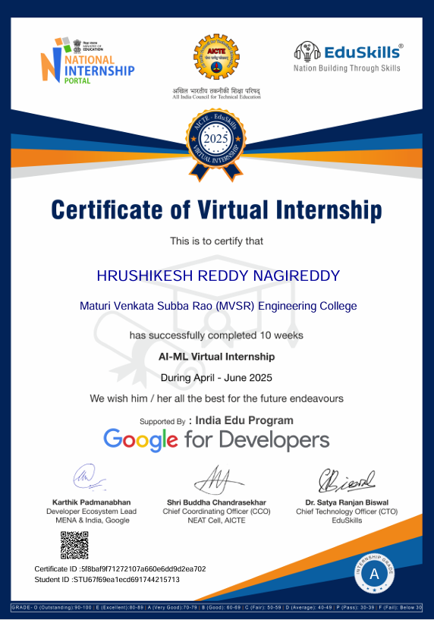
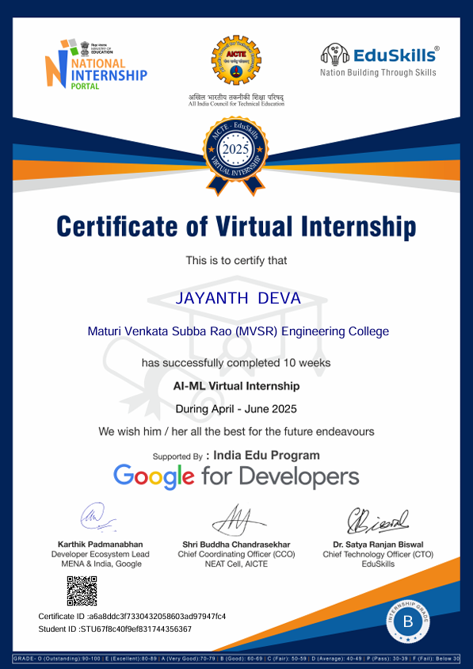
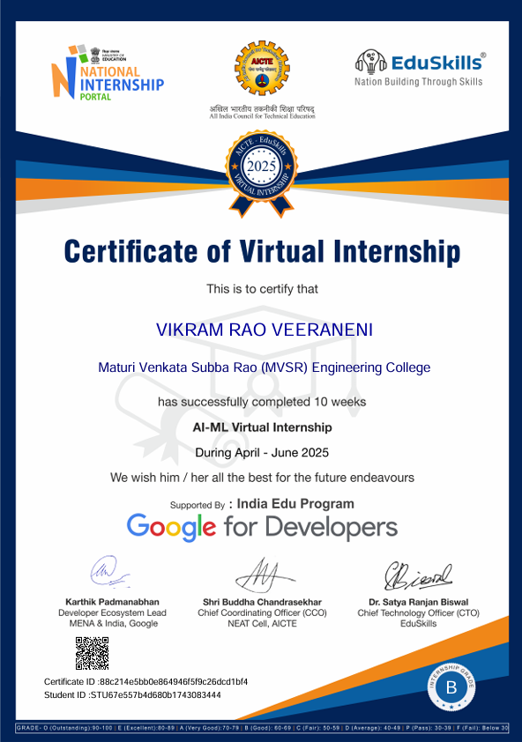

DECLARATION

This is to certify that the work reported in the present Summer Internship entitled “Canvas Board Using OpenCv” is a record of bona fide work done by us in the Department of Information Technology, Maturi Venkata Subba Rao (M.V.S.R.) Engineering College, an Autonomous Institution, affiliated to Osmania University. The reports are based on the project work done entirely by us and not copied from any other source. The results embodied in this project report have not been submitted to any other University or Institute for the award of any degree or diploma to the best of our knowledge and belief.

N Hrushikesh – (2451-23-737-030)
D Jayanth – (2451-23-737-059)
V Vikram– (2451-23-737-016)

ACKNOWLEDGEMENT

We would like to express our sincere gratitude to Dr CH Samson for giving me the opportunity and to do an internship within the organization and giving valuable suggestions and interest throughout the course of this work.
We would like to express our sincere gratitude and indebtedness to our Summer Internship Co-ordinator Dr.Ch. Samson, Professor and AHOD, for their valued recommendations and attention throughout the course of this project.
We are also thankful to our Principal Dr. Marthi Kameswara Rao, Professor and Dr. K. Venugopala Rao, Professor and Head - Department of Information Technology, Dean Academics, Maturi Venkata Subba Rao Engineering College, for providing excellent infrastructure for completing this project successfully as a part of our B.E. (IT). Finally, we would like to take this opportunity to thank our family for their support through the work. We sincerely acknowledge and thank all those who gave directly or indirectly their support in completion of this work.

N Hrushikesh– (2451-23-737-030)
D Jayanth– (2451-23-737-059)
V Vikram– (2451-23-737-016)

VISION & MISSION,
PROGR AM EDUCATIONAL OUTCOMES

Vision of the Department:
To impart technical education producing competent and socially responsible engineering professionals in the field of Information Technology.

Mission of the Department:
M1. To make teaching learning process effective and stimulating.
M2. To provide adequate fundamental knowledge of sciences and Information Technology with positive attitude.
M3. To create an environment that enhances skills and technologies required for industry. M4. To encourage creativity and innovation for solving real world problems. M5. To cultivate professional ethics in students and inculcate a sense of responsibility towards society
Program Educational Objectives:
After 3 to 4 years of graduation, graduates of the Information Technology program will:
I. Apply knowledge of mathematics and Information Technology to analyse, design and implement solutions for real world problems in core or in multidisciplinary areas.
II. Communicate effectively, work in a team, practice professional ethics and apply knowledge of computing technologies for societal development.
III. Engage in Professional development or postgraduate education to be a life-long learner.

PROGRAM OUTCOMES & PROGRAM SPECIFIC OUTCOMES

PROGRAM OUTCOMES (POs)

Engineering Graduates will be able to:

- Engineering knowledge: Apply the knowledge of mathematics, science,
engineering fundamentals, and an engineering specialization to the solution
of complex engineering problems.
2. Problem analysis: Identify, formulate, review research literature, and analyse complex engineering problems reaching substantiated conclusions using first principles of mathematics, natural sciences, and engineering sciences.
3. Design/development of solutions: Design solutions for complex engineering problems and design system components or processes that meet the specified needs with appropriate consideration for the public health and safety, and the cultural, societal, and environmental considerations.
4. Conduct investigations of complex problems: Use research-based
knowledge and research methods including design of experiments, analysis and interpretation of data, and synthesis of the information to provide valid conclusions.
5. Modern tool usage: Create, select, and apply appropriate techniques, resources, and modern engineering and IT tools including prediction and modelling to complex engineering activities with an understanding of the limitations.
6. The engineer and society: Apply reasoning informed by the contextual knowledge to assess societal, health, safety, legal and cultural issues and the consequent responsibilities relevant to the professional engineering practice.
7. Environment and sustainability: Understand the impact of the professional engineering solutions in societal and environmental contexts, and demonstrate the knowledge of, and need for sustainable development.
8. Ethics: Apply ethical principles and commit to professional ethics and responsibilities and norms of the engineering practice.
9. Individual and team work: Function effectively as an individual, and as a member or leader in diverse teams, and in multidisciplinary settings.

PROGRAM SPECIFIC OUTCOMES (PSOs):

PSO1: Hardware design: An ability to analyze, design, simulates and implements computer hardware / software and use basic analog /digital circuits, VLSI design for various computing and communication system applications.

PSO2: Software design: An ability to analyze a problem, design algorithm, identify and define the computing requirements appropriate to its solution and implement the same.

COURSE OBJECTIVES & COURSE OUTCOMES

COURSE OBJECTIVES
• To give an experience to the students in solving real life practical problems with all its constraints.
• To give an opportunity to integrate different aspects of learning with reference to real life problems.
• To enhance the confidence of the students while communicating with industry engineers and give an opportunity for useful interaction with them and familiarize with the work culture and ethics of the industry.

COURSE OUTCOMES

After completion of the course student will be able to:
CO1 - Formulate a problem to map the requirements of real-world scenario
CO2 - Design/develop a small and suitable product in hardware or software
CO3 – Exhibit the skills to use contemporary technologies used by the industry
CO4 - Evaluate the solution against pre-existing alternatives with reference to pre
specified criteria
CO5 - Demonstrate an understanding of work culture and ethics of the industry

WEEKLY OVERVIEW OF INTERNSHIP ACTIVITIES

Week | DATA RANGE | SUMMARY OF ACTIVITIES / MODULES COMPLETED
Week 1 | 07/04/25 –  12/04/25 | Understanding project objectives, system requirements, YOLO  basics, study of existing mobile detection systems, and preparation  of initial system architecture.
Week 2 | 14/04/25 –  19/04/25 | Environment setup, Python and OpenCV configuration, webcam  integration, YOLOv8 model study, and real-time object detection  testing.
Week 3 | 21/04/25 –  26/04/25 | Dataset analysis, false positive study, confidence tuning, heuristic  filtering to avoid calculator detection, and accuracy improvement.
Week 4 | 28/04/25 –  03/05/25 | Designing secure evidence storage, implementing image encryption  and decryption using cryptography, and validating secure workflow.
Week 5 | 05/05/25 –  10/05/25 | Dashboard UI design using HTML, CSS, and JavaScript, auto-  refresh logic implementation, and PyQt dashboard integration.
Week 6 | 12/05/25 –  17/05/25 | Adding alert notifications, timestamp-based evidence naming, log  management, stability testing, and code optimization.
Week 7 | 19/05/25 –  24/05/25 | Automated PDF evidence report generation, security review,  performance optimization, and internal feature validation.
Week 8 | 26/05/25 –  31/05/25 | Simulated exam hall testing, detection robustness improvement,  low-light handling, stress testing, and parameter tuning
Week 9 | 02/06/25 –  07/06/25 | Planning college-wide deployment, strict exam mode design, self-  learning classifier concept, and scalability analysis.
Week 10 | 9/06/25 –  14/06/25 | Final documentation, architecture diagrams, system demonstration,  project submission, and internship conclusion.

ABSTRACT

This project presents a virtual canvas board developed using OpenCV to enable digital drawing through gestures or a tracked colored object. The Canvas Board using OpenCV is an interactive virtual drawing application that allows users to draw on a digital canvas using hand gestures or a colored marker captured through a webcam. The system utilizes computer vision techniques such as color detection, contour extraction, and gesture recognition to track the movement of the user’s hand or pointer in real time. By identifying the position of the drawing tool, the application generates smooth strokes on a virtual canvas, enabling tasks such as writing, sketching, and erasing without requiring any physical touch-based device.The project demonstrates the integration of video processing, object tracking, and real-time graphics rendering using OpenCV and Python

TABLE OF CONTENTS

CONTENTS PAGE NO
Certificate II Certificate (Organization) iii-v Declaration vi Acknowledgement vii Vision & Mission, PEOs viii POs and PSOs ix-x
Course Objectives & Outcomes xi Weekly Overview Of Internship Activities xii Abstract xiii Table of Contents xiv List of Figures xv List of Tables xvi List of Abbreviations xvii Chapters
1. Introduction 1 - 2
1.1 Problem statement
1.2 Existing system
1.3 Proposed system
1.4 Scope
2. System Requirement Specifications 3
2.1 Software Requirements
2.2 Hardware Requirements
2.3 System Architecture / Block Diagram
3 Test & Results 4 - 5
4.1 Test cases
4.2 Results
4. Conclusion & Future Enhancements 6
References 7 Appendix 8-11 A: source/pseudo code

LIST OF FIGURES

Figure No. | Figure Name | Page No.
1 | System Architecture | 3
2 | Analysing the hand for drawing | 4
3 | Choosing an colour for drawing | 5
4 | Choosing an different colour from RGB | 5

xi

xvi

LIST OF ABBREVIATIONS

CV | Computer Vision
CV2 | Open Computer Vision Library
GPU | Graphics Processing Unit
OpenCV | Open Source Computer Vision Library

xvii

1. INTRODUCTION

Advancements in computer vision and human–computer interaction have enabled new ways of interacting with digital environments beyond traditional input devices like keyboards, mice, and touchscreens. One such innovative approach is the development of virtual drawing systems that allow users to interact with a digital canvas using simple gestures or objects captured through a camera. The Canvas Board using OpenCV is a real-time virtual drawing application that enables users to write, sketch, and draw without physically touching a device. Instead, the user’s hand or a colored marker serves as the drawing tool, and the webcam acts as the tracking sensor. his project utilizes OpenCV, a widely used open-source computer vision library, to process video frames, detect the position of the drawing tool, and convert motion into drawing strokes on a virtual canvas.

1.1PROBLEM STATEMENT
There is a need for a low-cost, touchless digital drawing system that allows users to draw and interact without relying on physical devices like whiteboards or touchscreens to develop a real-time virtual canvas using OpenCV that can accurately detect and track hand or marker movements and convert them into smooth drawing strokes.
1.2 EXISTING SYSTEM
Some projects like Air Canvas use a webcam + computer vision to allow drawing in mid-air using a coloured marker tip tracked via frame-by-frame detection (e.g. HSV color detection + contour tracking).Traditional digital white-board apps / tools like Microsoft Whiteboard (or similar) simulate drawing/drafting using input devices like stylus, mouse, or touchscreen; these are widely used but require dedicated hardware (touch devices or tablets) / physical contact

1.3 PROPOSED SYSTEM
The proposed system is a virtual canvas board developed using OpenCV that allows users to draw, write, and interact with a digital canvas using hand gestures or colored markers instead of traditional input devices like a mouse or keyboard. This system leverages computer vision techniques to detect motion, track objects, and render drawings in real time.
PROPOSED SYSTEM ADVANTAGES
• Provides a touch-free and interactive drawing experience..
• Allows easy clearing and modification of drawings and Environment-friendly by reducing paper usage.
• Improves human–computer interaction using computer vision techniques and Easy to use and user-friendly interface.
1.4 Scope
The canvas board in OpenCV provides a flexible and efficient platform for creating and manipulating digital images programmatically. It acts as a virtual drawing surface where various graphical operations such as drawing lines, shapes, text, and images can be performed. The scope of using a canvas board with OpenCV extends across multiple domains including image processing, computer vision, and interactive application development.

2. SYSTEM REQUIREMT SPECIFICATIONS

SOFTWARE REQUIREMENTS
• Operating System : Windows 10/11
• IDE / Editor
• Visual Studio code (VS code)
• Opencv library
• Python 3.7 or above and modules
HARDWARE REQUIREMENTS

• Ram: 4GB Ram
• Camera/Web cam
• Processor: Intel core i3
2.3 SYSTEM ARCHITECTURE/BLOCK DIAGRAM

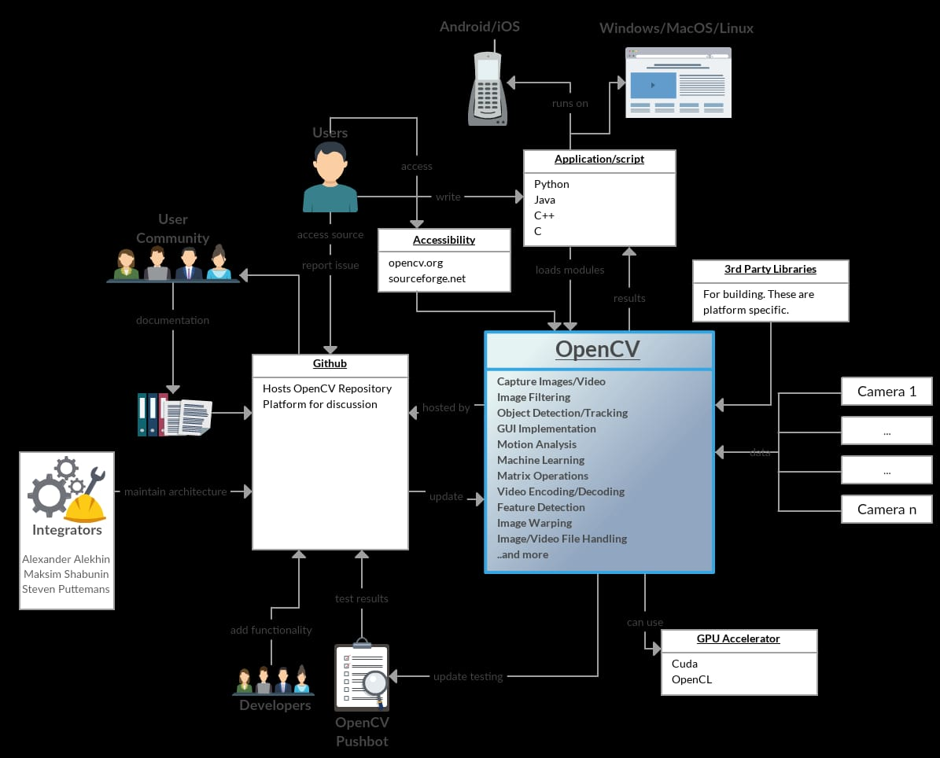
Figure: 1 System Architecture

3. DESIGN & IMPLEMENTATION

The canvas board is implemented using Python and OpenCV to allow touch-free drawing through real-time webcam input.Live video frames are captured and processed to detect hand or fingertip movements accurately.The tracked fingertip coordinates are mapped onto a virtual canvas to perform smooth drawing operations.Gesture-based controls enable functionalities such as drawing, erasing, and clearing the canvas.This system provides an interactive and cost-effective application of computer vision in human.

4. TESTS AND RESULTS

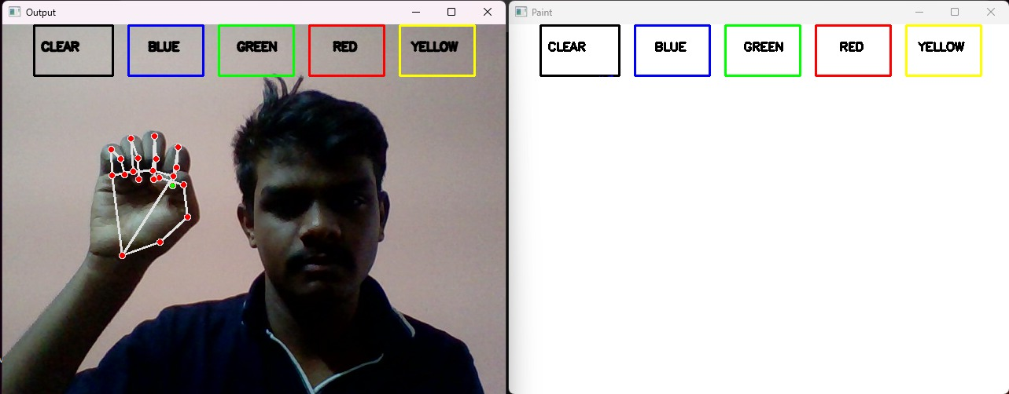

Figure 2: Analysing the hand for drawing

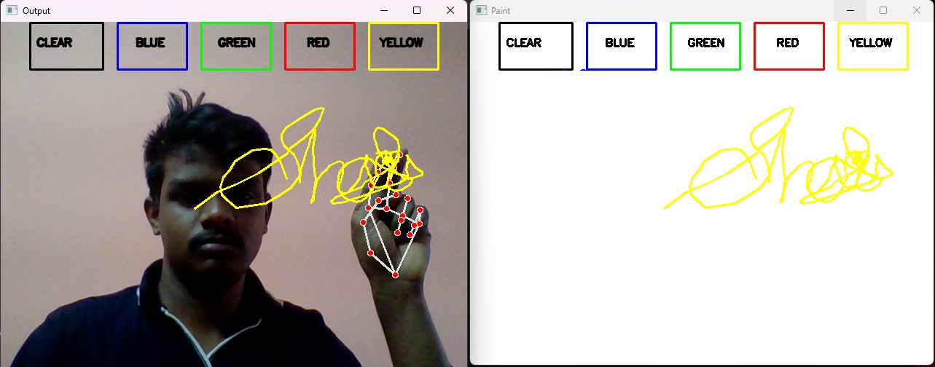

Figure 3: Choosing a colour for drawing

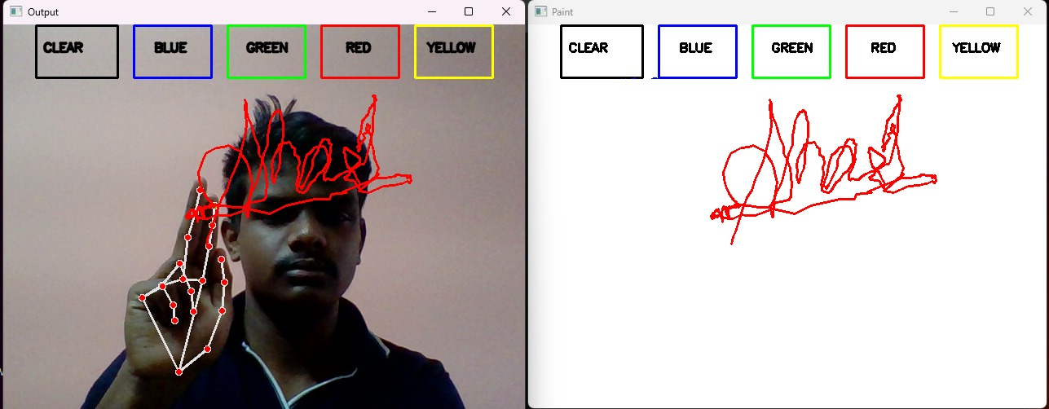

Figure 4: Choosing an different colour from RGB

CONCLUSION AND FUTURE ENHANCEMENT

In the future, the canvas board can be enhanced by incorporating mouse-based drawing for real-time interaction. Additional features such as color and brush selection, undo and clear options, and saving the canvas as an image file can be implemented. Further improvements may include integration with live video streams and AI-based techniques such as gesture recognition or object detection to make the canvas more intelligent and user-friendly.

REFERENCES

1. Bradski, G., & Kaehler, A.
Learning OpenCV: Computer Vision with the OpenCV Library.
O’Reilly Media, 2008.
2. Pulli, K., et al.
Hands-On OpenCV for Computer Vision Applications.
Packt Publishing, 2016.
3. Géron, A.
Hands-On Machine Learning with Scikit-Learn, Keras & TensorFlow.
O’Reilly Media, 2019.
4. Rautaray, S. S., & Agrawal, A.
“Vision-Based Hand Gesture Recognition for Human–Computer Interaction: A Survey.”
Artificial Intelligence Review, Springer.
5. Kadam, S., et al.
“Virtual Drawing Board Using Hand Gesture Recognition.”
International Journal of Engineering Research and Technology (IJERT), 2022
6.OpenCV Official Documentation
https://docs.opencv.org
7. Virtual Painter Using Hand Detection
https://github.com/mohamedamine99/Virtual-Painter-Using-OpenCV-and-Hand-Detection

APPENDIX

SOURCE CODE
Canvas Board:

import numpy as np
import cv2
from collections import deque
from google.colab.patches import cv2_imshow # Added for Colab display

def setValues(x):
print("")

bpoints = [deque(maxlen = 1024)]
gpoints = [deque(maxlen = 1024)]
rpoints = [deque(maxlen = 1024)]
ypoints = [deque(maxlen = 1024)]

blue_index = 0
green_index = 0
red_index = 0
yellow_index = 0

kernel = np.ones((5, 5), np.uint8)

colors = [(255, 0, 0), (0, 255, 0),
(0, 0, 255), (0, 255, 255)]
colorIndex = 0

paintWindow = np.zeros((471, 636, 3)) + 255

video_path = 'your_video.mp4' # Replace with the path to your uploaded video file
cap = cv2.VideoCapture(video_path)

if not cap.isOpened():
print(f"Error: Could not open video file {video_path}")
frame = np.zeros((471, 636, 3), dtype=np.uint8) + 255
ret = False

else:
ret, frame = cap.read() # Read the first frame if video is opened successfully

while ret: # Loop as long as frames are successfully read

frame = cv2.flip(frame, 1)
hsv = cv2.cvtColor(frame, cv2.COLOR_BGR2HSV)

u_hue = 153 # Previously from cv2.getTrackbarPos("Upper Hue", "Color detectors")
u_saturation = 255 # Previously from cv2.getTrackbarPos("Upper Saturation", "Color detectors")
u_value = 255 # Previously from cv2.getTrackbarPos("Upper Value", "Color detectors")
l_hue = 64 # Previously from cv2.getTrackbarPos("Lower Hue", "Color detectors")
l_saturation = 72 # Previously from cv2.getTrackbarPos("Lower Saturation", "Color detectors")
l_value = 49 # Previously from cv2.getTrackbarPos("Lower Value", "Color detectors")

Upper_hsv = np.array([u_hue, u_saturation, u_value])
Lower_hsv = np.array([l_hue, l_saturation, l_value])

frame = cv2.rectangle(frame, (40, 1), (140, 65),
(122, 122, 122), -1)
frame = cv2.rectangle(frame, (160, 1), (255, 65),
colors[0], -1)
frame = cv2.rectangle(frame, (275, 1), (370, 65),
colors[1], -1)
frame = cv2.rectangle(frame, (390, 1), (485, 65),
colors[2], -1)
frame = cv2.rectangle(frame, (505, 1), (600, 65),
colors[3], -1)

cv2.putText(frame, "CLEAR ALL", (49, 33),
cv2.FONT_HERSHEY_SIMPLEX, 0.5,
(255, 255, 255), 2, cv2.LINE_AA)

cv2.putText(frame, "BLUE", (185, 33),
cv2.FONT_HERSHEY_SIMPLEX, 0.5,
(255, 255, 255), 2, cv2.LINE_AA)

cv2.putText(frame, "GREEN", (298, 33),
cv2.FONT_HERSHEY_SIMPLEX, 0.5,
(255, 255, 255), 2, cv2.LINE_AA)

cv2.putText(frame, "RED", (420, 33),
cv2.FONT_HERSHEY_SIMPLEX, 0.5,
(255, 255, 255), 2, cv2.LINE_AA)

cv2.putText(frame, "YELLOW", (520, 33),
cv2.FONT_HERSHEY_SIMPLEX, 0.5,
(150, 150, 150), 2, cv2.LINE_AA)

Mask = cv2.inRange(hsv, Lower_hsv, Upper_hsv)
Mask = cv2.erode(Mask, kernel, iterations = 1)
Mask = cv2.morphologyEx(Mask, cv2.MORPH_OPEN, kernel)
Mask = cv2.dilate(Mask, kernel, iterations = 1)

cnts, _ = cv2.findContours(Mask.copy(), cv2.RETR_EXTERNAL,
cv2.CHAIN_APPROX_SIMPLE)
center = None

# Ifthe contours are formed
if len(cnts) > 0:

cnt = sorted(cnts, key = cv2.contourArea, reverse = True)[0]

((x, y), radius) = cv2.minEnclosingCircle(cnt)

cv2.circle(frame, (int(x), int(y)), int(radius), (0, 255, 255), 2)

M = cv2.moments(cnt)
center = (int(M['m10'] / M['m00']), int(M['m01'] / M['m00']))

if center[1] <= 65:

if 40 <= center[0] <= 140:
bpoints = [deque(maxlen = 512)]
gpoints = [deque(maxlen = 512)]
rpoints = [deque(maxlen = 512)]
ypoints = [deque(maxlen = 512)]

blue_index = 0
green_index = 0
red_index = 0
yellow_index = 0

paintWindow[67:, :, :] = 255
elif 160 <= center[0] <= 255:
colorIndex = 0 # Blue
elif 275 <= center[0] <= 370:
colorIndex = 1 # Green
elif 390 <= center[0] <= 485:
colorIndex = 2 # Red
elif 505 <= center[0] <= 600:
colorIndex = 3 # Yellow
else :
if colorIndex == 0:
bpoints[blue_index].appendleft(center)
elif colorIndex == 1:
gpoints[green_index].appendleft(center)
elif colorIndex == 2:
rpoints[red_index].appendleft(center)
elif colorIndex == 3:
ypoints[yellow_index].appendleft(center)

else:
bpoints.append(deque(maxlen = 512))
blue_index += 1
gpoints.append(deque(maxlen = 512))
green_index += 1
rpoints.append(deque(maxlen = 512))
red_index += 1
ypoints.append(deque(maxlen = 512))
yellow_index += 1

points = [bpoints, gpoints, rpoints, ypoints]
for i in range(len(points)):

for j in range(len(points[i])):

for k in range(1, len(points[i][j])):

if points[i][j][k - 1] is None or points[i][j][k] is None:
continue

cv2.line(frame, points[i][j][k - 1], points[i][j][k], colors[i], 2)
cv2.line(paintWindow, points[i][j][k - 1], points[i][j][k], colors[i],

ret, frame = cap.read() # Read the next frame for the loop condition

print("Finished processing video. Displaying final paint canvas and last processed frame:")
cv2_imshow(paintWindow)
cap.release()

