CONVELINA: ENTERPRISE SYSTEM ARCHITECTURE & PRODUCTION ENGINEERING DOSSIER
Unified Technical Master Blueprint, Architecture Audit, Codebase Mapping & Deployment Topology
Status: Production Baseline | Classification: Executive Engineering Dossier | Date: October 2026
[SUCCESS] Executive Summary
This dossier synthesizes the complete architectural specification and production readiness evaluation for CONVELINA. It details the full-stack technology decisions, the 5 core high-assurance verification pipelines, kernel-level PostgreSQL Row-Level Security policies, and the complete 111-topic production checklist audit.

1. Master Production Architecture Blueprint
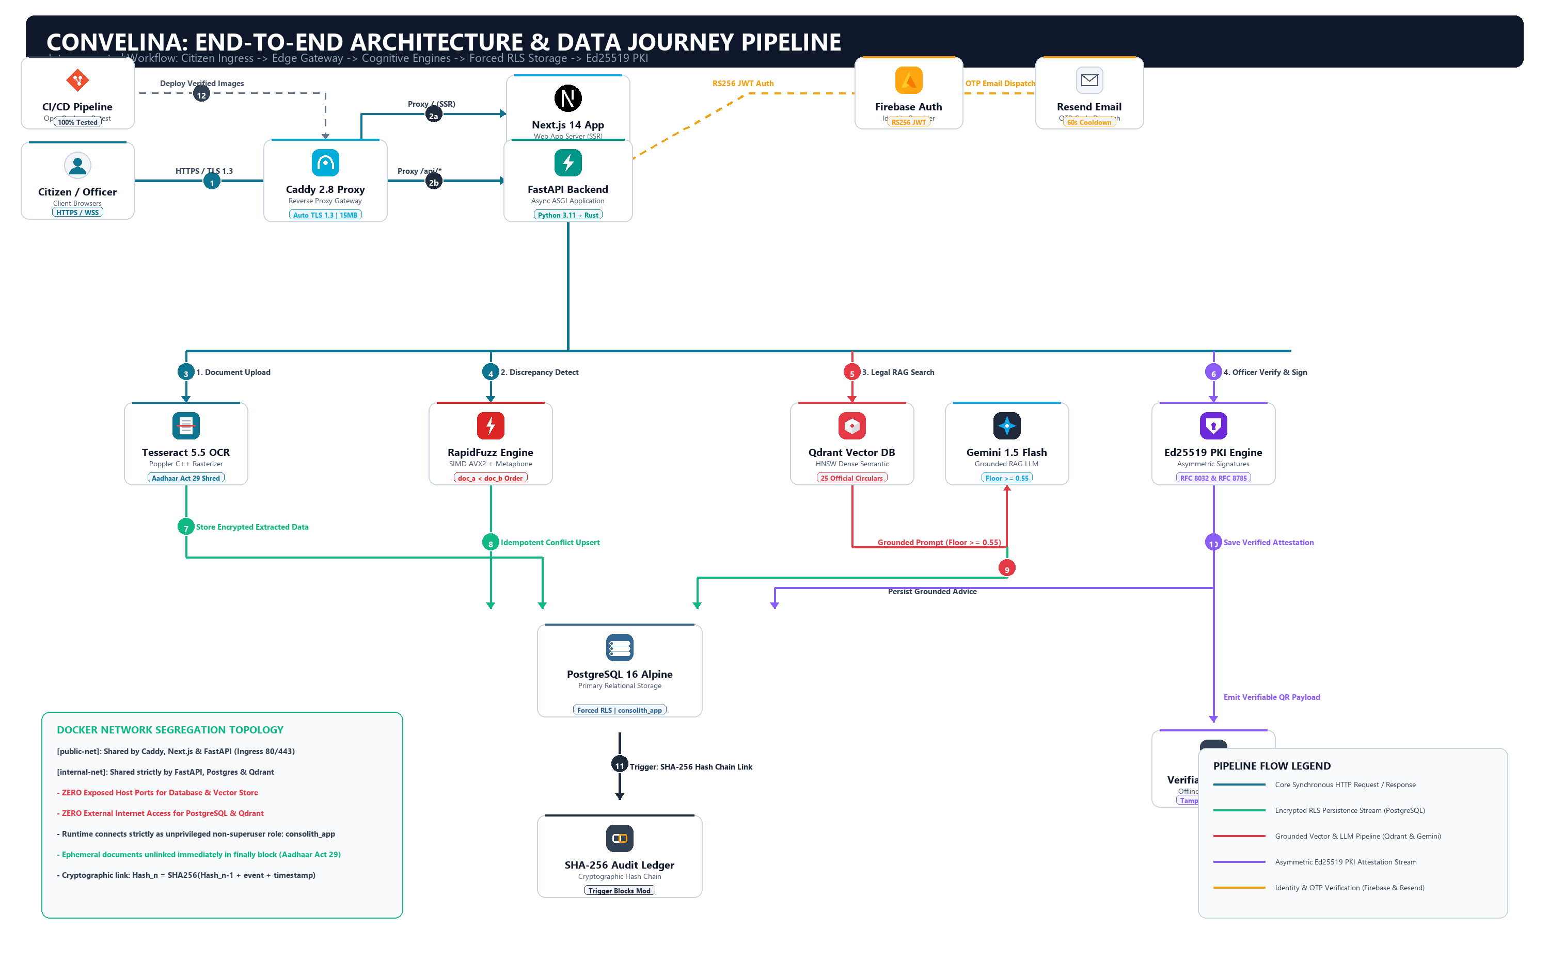
Figure 1: CONVELINA Master Production System Architecture Blueprint (ByteByteGo Standard)
2. Technology Ecosystem & Layer-by-Layer Inventory
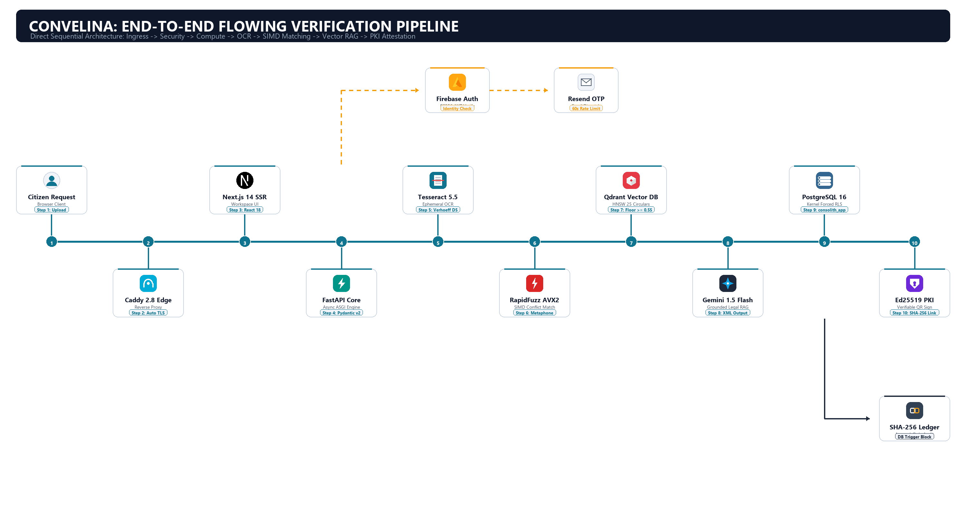
Figure 2: CONVELINA 7-Layer Production Technology Stack & Engineering Ecosystem
3. High-Assurance End-to-End Data Pipelines
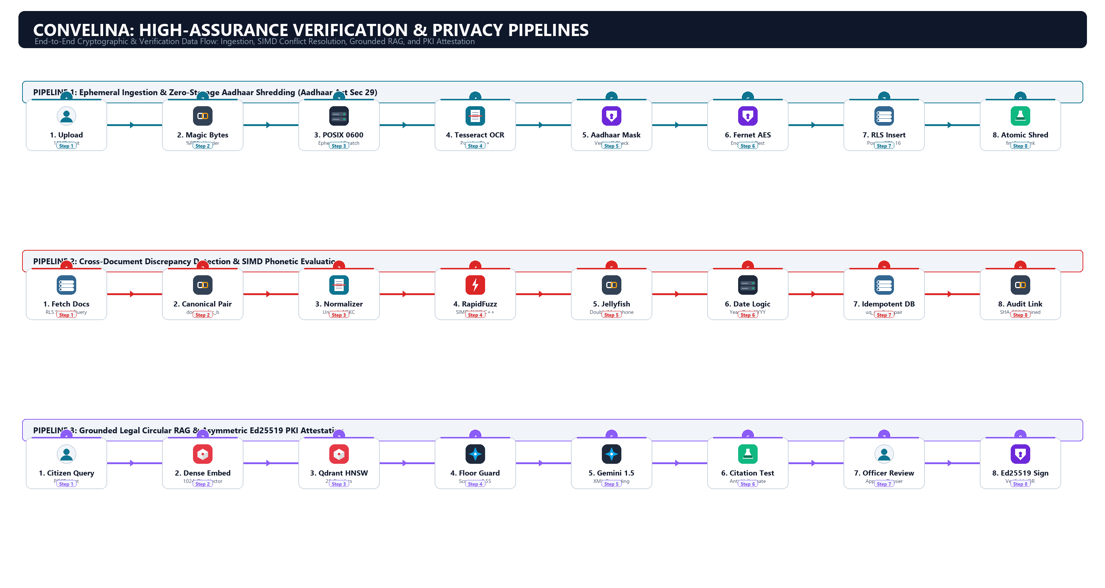
Figure 3: Detailed Step-by-Step Data Pipelines: Ingestion, SIMD Conflict Detection, RAG Legal Guidance, and Ed25519 PKI

