CONVELINA: MASTER SYSTEM ARCHITECTURE
High-Assurance AI-Powered Identity Discrepancy Detection & PKI Verification Platform
Classification: Enterprise Technical Blueprint | Version 2.0.0 | Date: October 2026
[IMPORTANT] Architectural Mandate & Invariant Rules
1. Aadhaar Act Section 29: Zero permanent storage of raw Aadhaar images or unmasked numbers. Ephemeral POSIX 0600 sandbox execution with mandatory atomic unlinking post-OCR.
2. Forced Row-Level Security: Every tenant table enforced at PostgreSQL kernel level. Runtime connects strictly as unprivileged non-superuser consolith_app.
3. Append-Only Tamper-Evident Audit: Database triggers block UPDATE and DELETE on audit_log; entries linked by cryptographic SHA-256 chain.
4. Zero-Hallucination Grounded AI: Qdrant vector retrieval with cosine score floor >= 0.55. Refuses unverified queries.
5. Ed25519 PKI Attestation: Approved correction dossiers cryptographically signed using RFC 8032 asymmetric keys with offline verifiable QR codes.

1. Master System Architecture & Component Layout
The diagram below illustrates the end-to-end multi-tier system topology of CONVELINA, mapping ingress routing through Caddy edge proxy, presentation containers, asynchronous FastAPI application workers, modular cognitive engines, and isolated persistence networks.
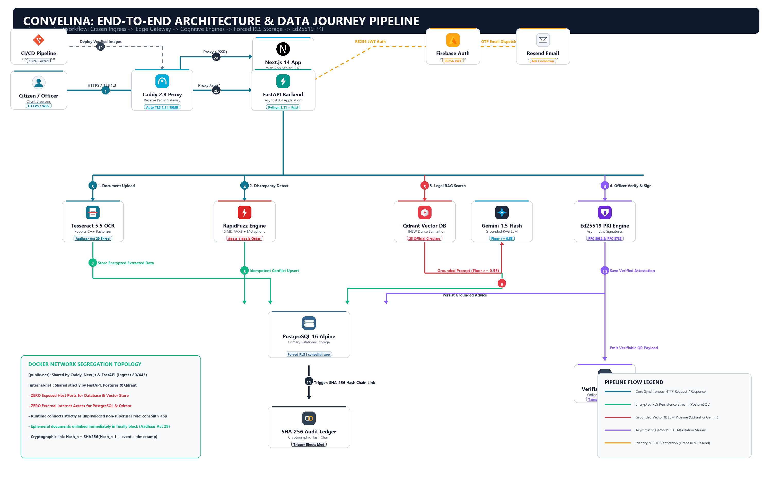
Figure 1: CONVELINA Master Production System Architecture & Network Ingress Topology (ByteByteGo Specification)
2. Technology Stack & Architectural Ecosystem
CONVELINA integrates specialized, battle-tested modern tools across all 7 functional layers of the architecture, prioritizing C/C++ native performance for computer vision and Rust-accelerated validation for JSON schemas.
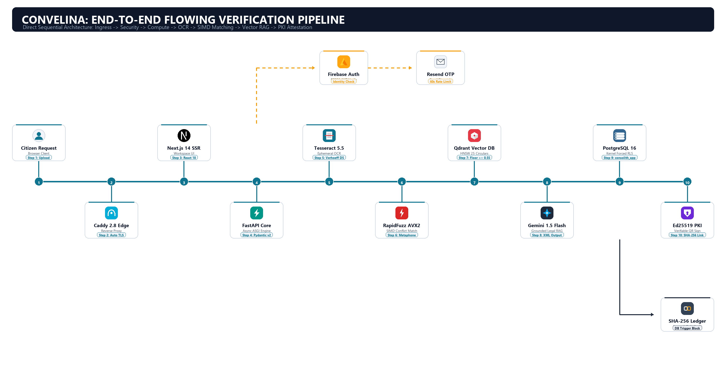
Figure 2: CONVELINA Layer-by-Layer Production Technology Inventory & Architectural Ecosystem Map
Functional Layer | Core Technology | Version | Architectural Role | Key Technical Rationale
Presentation | Next.js 14 / TypeScript | 14.2 / 5.4 | Citizen Workspace & Officer Console | Server-Side Rendering (SSR), layout streaming, strict static typing.
Edge Gateway | Caddy 2.8 Reverse Proxy | 2.8.4 | TLS Termination, Rate Limiting, DoS Shield | Memory-safe Go implementation, automatic Let's Encrypt TLS, 15MB ceiling.
API Runtime | FastAPI / Python 3.11 | 0.110 | Asynchronous ASGI Micro-Monolith API | Starlette event loop, Rust Pydantic v2 core, 10k+ concurrent connections.
Computer Vision | Tesseract 5.5 / Poppler | 5.5 / 24.x | Ephemeral OCR & Image Pre-processing | Native C++ execution, Poppler PDF rendering, adaptive thresholding.
Discrepancy Engine | RapidFuzz & Jellyfish | 3.8 / 1.0 | SIMD Phonetic & String Matching | C++ AVX2 vectorization, Double Metaphone Indian surname resolution.
Relational Storage | PostgreSQL 16 Alpine | 16.2 | ACID Tenant Persistence & Forced RLS | Kernel Row-Level Security, non-superuser role consolith_app.
Vector Database | Qdrant Vector DB | v1.11.0 | HNSW Semantic Legal Retrieval | 1024-dim dense vectors, sub-5ms cosine retrieval, memory fallback.
Cryptographic PKI | Ed25519 & Fernet AES | RFC 8032 | Attestation Signing & Field Encryption | Asymmetric digital signatures, RFC 8785 canonical JSON, AES-256 at rest.
Identity & Auth | Firebase Admin / Resend | 6.5 / v2 | RS256 JWT & Email OTP Verification | Hardware-backed RS256 token verification, CSPRNG OTPs, 60s cooldown.

3. High-Assurance End-to-End Verification Pipelines
The platform executes five distinct sequential data pipelines designed to eliminate identity fraud while enforcing citizen privacy rights under national data protection frameworks.
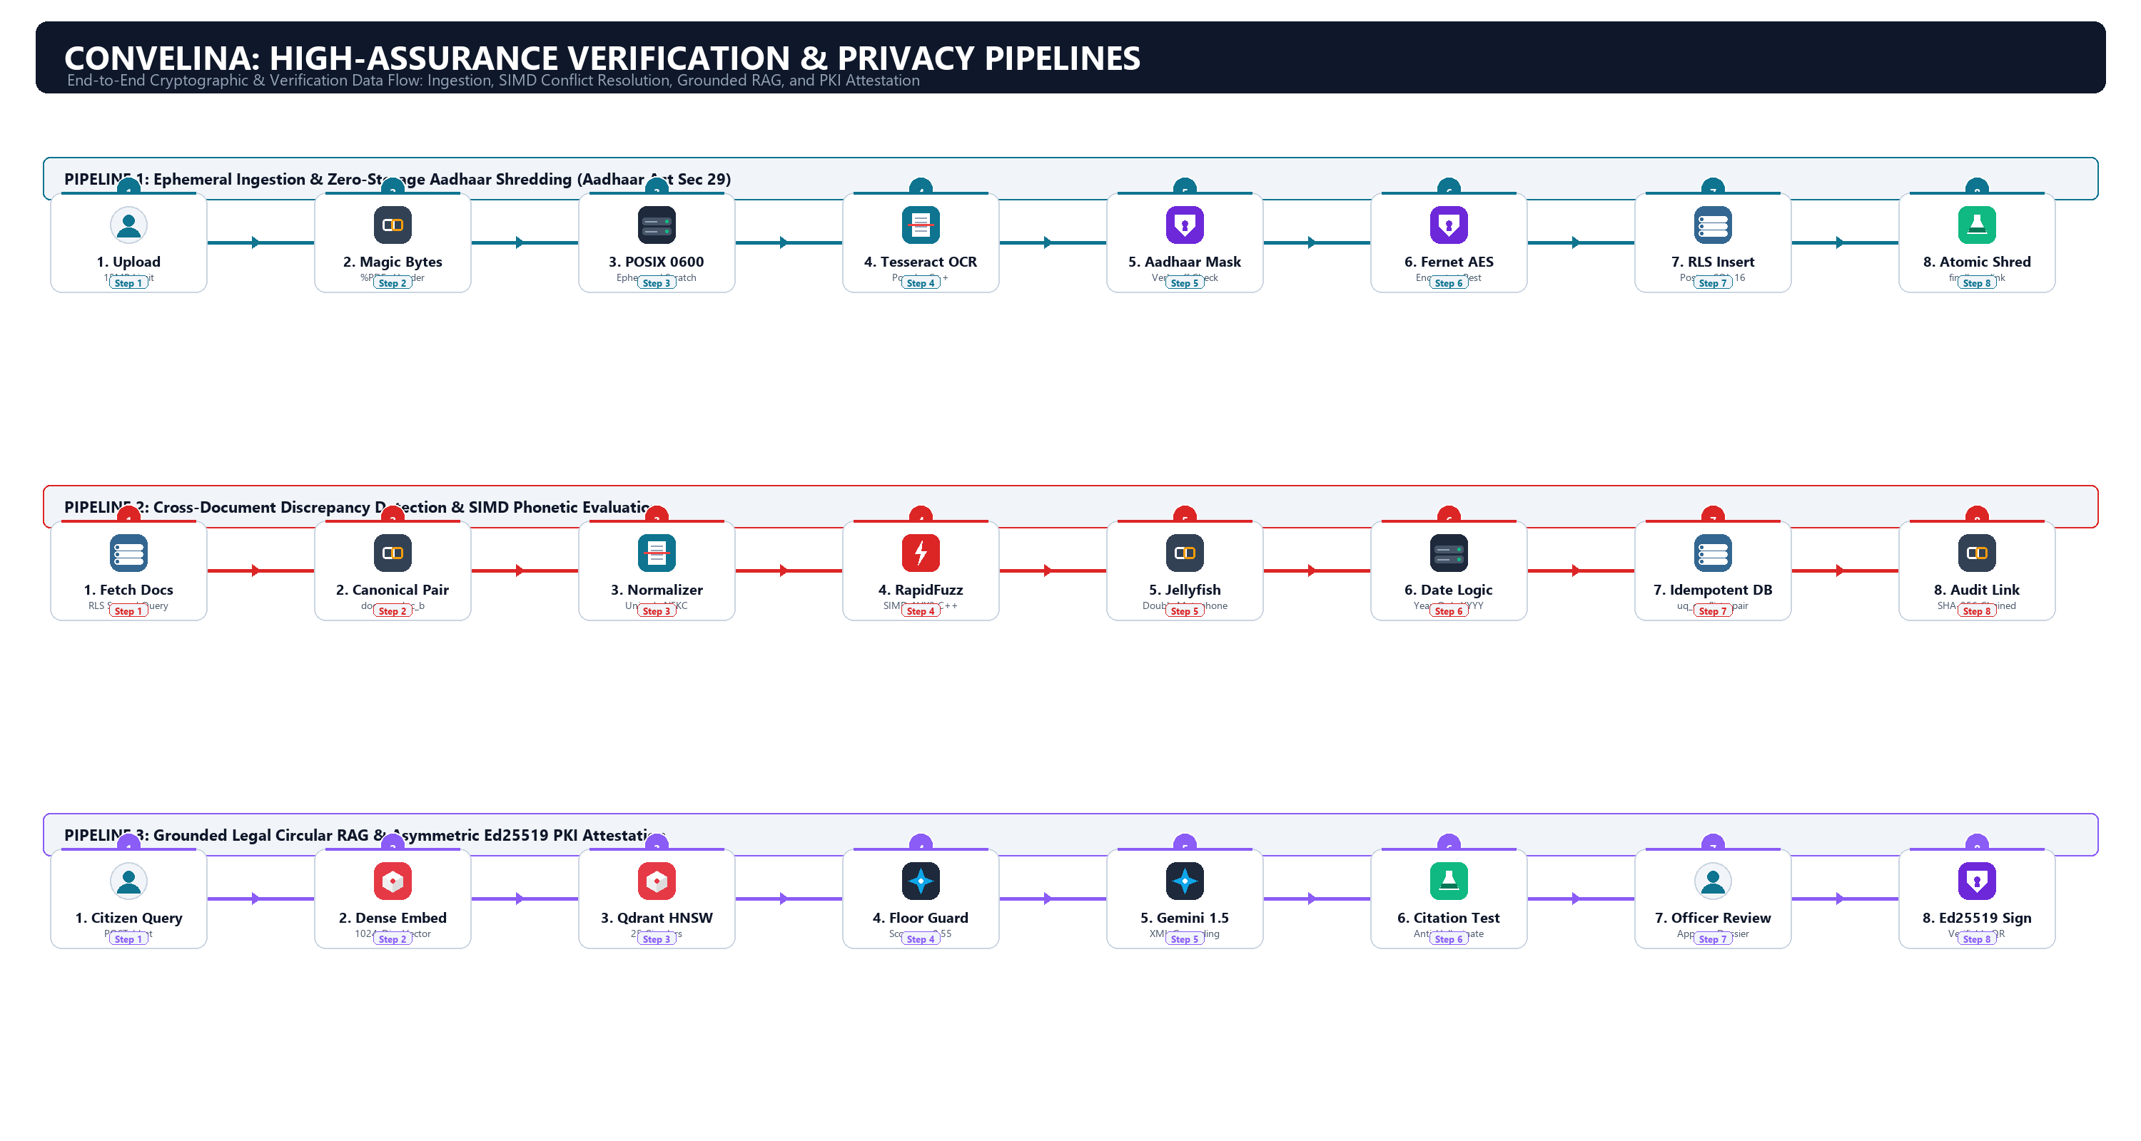
Figure 3: CONVELINA End-to-End Execution Pipelines: Ephemeral Ingestion, SIMD Conflict Detection, RAG Legal Guidance, and Ed25519 PKI Attestation
Pipeline 1: Ephemeral Document Ingestion & Magic-Byte Sniffing
- Multipart Ingestion Boundary: Client uploads chunked file streams (max 15MB). Caddy edge proxy rejects oversized payloads.
- Magic-Byte Inspection: The backend reads the first 8 bytes (%PDF-, \x89PNG, \xff\xd8\xff) to defeat MIME-spoofing attacks.
- POSIX 0600 Ephemeral Sandbox: Temporary files exist only in RAM/tmp with owner-only read permissions (0600) under non-root convelina user.
- Aadhaar Act 29 Compliance: Extracted Aadhaar numbers are verified via Verhoeff D5 algorithm, masked (XXXX-XXXX-1234), encrypted via Fernet AES-256, and the scratch file is shredded in a guaranteed finally block.
Pipeline 2: SIMD Discrepancy Matching & Phonetic Logic
- Canonical Pair Generator: Pairwise comparisons strictly locked to doc_a_id < doc_b_id, preventing duplicate evaluations.
- Deterministic Normalization: Unicode NFKC normalization, whitespace collapse, honorific stripping (Shri, Smt, Dr), and calendar date parsing.
- SIMD Accelerated Math: RapidFuzz AVX2 C++ bindings calculate Levenshtein distance and Token Sort Ratio in sub-microseconds.
- Double Metaphone Resolution: Phonetic matching resolves Indian linguistic surname variations (e.g. Laxmi vs Lakshmi, Chandra vs Chander).
- Idempotent Storage: Unique constraint uq_conflicts_pair_field guarantees zero duplicate alerts.
Pipeline 3: Grounded Zero-Hallucination Legal Circular RAG
- Dense Semantic Embedding: Query converted into 1024-dimensional dense vector.
- Qdrant HNSW Search: Cosine similarity search over 25 indexed official Indian Gazette circulars.
- Cosine Relevance Floor: Hard cutoff at score >= 0.55. Any query falling below threshold returns a grounded refusal.
- Citation Grounding: Pre-delivery validator checks that every generated citation token matches retrieved source text.
Pipeline 4: Officer Verification & Ed25519 PKI Attestation
- RFC 8785 Canonicalization: Dossier converted to deterministic canonical JSON with sorted keys and normalized encoding.
- Ed25519 Asymmetric Signature: Officer's private key signs SHA-512 digest, generating a compact 64-byte signature.
- Offline Verifiable QR: Payload packaged into high-density 2D QR code enabling offline verification by downstream authorities.
Pipeline 5: Append-Only Tamper-Evident SHA-256 Audit Trail
- Cryptographic Hash Link: Hash_n = SHA256(Hash_n-1 + user_id + action + entity_id + timestamp).
- Database Statement Trigger: Trigger block_audit_mutation strictly aborts any UPDATE or DELETE statement.
4. Network Isolation & Container Topology
Production containers are partitioned into two strictly isolated Docker bridge networks:
- public-net: Shared by Caddy reverse proxy, Next.js frontend, and FastAPI backend. Exposes ports 80/443 to the host.
- internal-net (internal: true): Dedicated network shared by FastAPI backend, PostgreSQL 16, and Qdrant. ZERO exposed host ports, ZERO external internet routing. PostgreSQL and Qdrant are completely invisible to the host network.
5. Architectural Decision Records (ADRs)
ADR # | Decision Title | Chosen Alternative | Rejected Alternative | Core Architectural Justification
ADR-01 | Application Framework | Python FastAPI + Next.js 14 | Java Spring Boot Monolith | Native C++ OCR libraries, AVX2 SIMD string matching, low memory footprint (~85MB vs ~600MB).
ADR-02 | Database Isolation | PostgreSQL Forced Kernel RLS | Application-Level WHERE Clauses | Kernel-level enforcement guarantees zero data leaks even if an API bug omits a filter.
ADR-03 | Runtime Database Role | consolith_app (Non-Superuser) | postgres (Superuser) | Prevents privilege escalation and prohibits DDL tampering at runtime.
ADR-04 | Identity Storage | Ephemeral Scratch + Fernet AES | S3 / Blob Permanent Image Store | Strict compliance with Aadhaar Act Section 29; zero persistent image liability.
ADR-05 | Vector Knowledge Base | Qdrant v1.11 HNSW Graph | PostgreSQL pgvector / Chroma | Sub-5ms retrieval latency, deterministic 1024-dim index, in-process test mode.

