ANNA UNIVERSITY :: CHENNAI 600 025
FORMAT FOR PREPARATION OF PROJECT REPORT FOR B.E. / B. TECH.

CONVELINA: AN AI-POWERED IDENTITY DOCUMENT CONFLICT DETECTION AND GOVERNMENT CORRECTION ASSISTANCE SYSTEM USING LLMS AND RAG
A PROJECT REPORT (PHASE – I)
Submitted by
AJAY M (113023243003)
ADITHYA B (113023243002)
KAMESH G (113023243041)
in partial fulfillment for the award of the degree
of
BACHELOR OF TECHNOLOGY
in
ARTIFICIAL INTELLIGENCE AND DATA SCIENCE
VEL TECH HIGH TECH Dr. RANGARAJAN Dr. SAKUNTHALA ENGINEERING COLLEGE
An Autonomous Institution
ANNA UNIVERSITY : CHENNAI 600 025
NOVEMBER 2026

ANNA UNIVERSITY : CHENNAI 600 025
BONAFIDE CERTIFICATE
Certified that this project report entitled “CONVELINA: AN AI-POWERED IDENTITY DOCUMENT CONFLICT DETECTION AND GOVERNMENT CORRECTION ASSISTANCE SYSTEM USING LLMS AND RAG” is the bonafide work of “AJAY M (113023243003), ADITHYA B (113023243002), KAMESH G (113023243041)” who carried out the project work under my supervision.
<<Signature of Head of Department>>  SIGNATURE  Dr. SATHISH KUMAR S  HEAD OF THE DEPARTMENT  Assistant Professor & Head  Department of AI & DS  Vel Tech High Tech Dr. Rangarajan  Dr. Sakunthala Engineering College  Avadi, Chennai – 600 062 | <<Signature of Supervisor>>  SIGNATURE  Dr. ZULAIKHA BEEVI S  SUPERVISOR  Professor  Department of AI & DS  Vel Tech High Tech Dr. Rangarajan  Dr. Sakunthala Engineering College  Avadi, Chennai – 600 062
Submitted for the ODD Semester Examination held on ............................... at Vel Tech High Tech Dr. Rangarajan Dr. Sakunthala Engineering College, Avadi, Chennai – 600 062.

CERTIFICATE OF EVALUATION
College Name : Vel Tech High Tech Dr. Rangarajan Dr. Sakunthala Engineering College
Degree : Bachelor of Technology
Branch : Artificial Intelligence and Data Science
Semester : VII
S.No | Name of the  Students | Title of the  Project | Name, Designation &  Dept of Supervisor | PO & PSO  Mapping | SDG  Mapping
01. | Ajay M  (113023243003) | CONVELINA: An AI-Powered Identity Document Conflict Detection and Government Correction Assistance System Using LLMs and RAG  —  — | Dr. Zulaikha Beevi S  Professor  Department of AI & DS  —  — | POs: 1, 2, 3, 4,  5, 6, 8, 9, 10,  11, 12  PSOs: 1, 2  —  — | SDG 9  SDG 11  SDG 16  SDG 17  —  —
02. | Adithya B  (113023243002)
03. | Kamesh G  (113023243041)
The report of the project work submitted by the above students in partial fulfilment for the award of degree, Bachelor of Technology in Artificial Intelligence and Data Science for the viva voce examination held at Vel Tech High Tech Dr. Rangarajan Dr. Sakunthala Engineering College on ___________________ has been evaluated and confirmed to be reports of the work done by the above students.
<<Signature>>  INTERNAL EXAMINER | <<Signature>>  EXTERNAL EXAMINER

ACKNOWLEDGEMENT
We wish to express our heartfelt gratitude and sincere thanks to all those who extended their generous help, guidance, and encouragement during our Project Phase – I work.
First and foremost, we would like to convey our deepest gratitude and respect to our esteemed Founder President and Chairman, Col. Prof. Dr. Vel. Shri. R. Rangarajan, B.E (EEE), B.E (Mech), M.S (Auto), our revered Foundress President and Vice Chairman, Late Dr. Mrs. Sakunthala Rangarajan, M.B.B.S., our respected Chairperson and Managing Trustee, Dr. (Mrs.) Rangarajan Mahalakshmi Kishore, B.E., M.B.A (UK), Ph.D., and our Dynamic Director, Mr. K. V. D. Kishore Kumar, B.E., M.B.A (US), for their visionary leadership, kind encouragement, and continuous institutional support. Their inspiring guidance has been an enduring source of strength throughout this project.
Our sincere thanks to our honourable Principal, Prof. Dr. E. Kamalanaban, B.E (CSE), M.E (CSE), Ph.D., for his continuous administrative support, academic leadership, and motivation during this Project Phase – I.
We are deeply grateful to our Dean Academics, Prof. Dr. V. R. Ravi, B.E., M.E., Ph.D., and our Dean of PPT, Dr. J. B. Veeramalini, M.Tech., Ph.D., and Associate Dean of PPT, Dr. Chembian W T, M.E., Ph.D., for providing an environment that fosters technical rigor, innovation, and disciplined engineering methodology.
We express our profound thanks to Dr. S. Sathish Kumar, Assistant Professor and Head of the Department of Artificial Intelligence and Data Science, for his sustained encouragement, administrative oversight, and guidance throughout the progression of this work.
We extend our sincere and special thanks to our Project Supervisor, Dr. Zulaikha Beevi S, Professor, Department of Artificial Intelligence and Data Science, for her expert technical guidance, perceptive insights, rigorous evaluations, and constant encouragement throughout the formulation and development of this Phase I design.
Finally, we express our heartfelt appreciation to all our faculty members and non-teaching staff for their assistance, and to our parents and family members for their unwavering support, moral encouragement, and belief in our academic endeavors throughout this journey.

ABSTRACT
Foundational identification systems in India, including Aadhaar administered by the Unique Identification Authority of India (UIDAI), Permanent Account Numbers (PAN) issued by the Income Tax Department, Passports governed by the Ministry of External Affairs (MEA), and Universal Account Numbers (UAN) managed by the Employees' Provident Fund Organisation (EPFO), form an essential civic infrastructure. However, because these identity systems operate under distinct statutory mandates, differing regional transliteration conventions, and uncoordinated clerical data-entry practices, millions of citizens suffer from subtle demographic discrepancies. Common errors include expanded patronymic initials, phonetic spelling variants, inverted calendar dates of birth, and minor parental name discrepancies. When citizens seek passport verification, EPFO pension disbursements, or banking KYC onboarding, automated validation algorithms fail, triggering frequent application rejections and prolonged administrative delays.
This project presents CONVELINA, an intelligent, privacy-conscious civic identity document conflict detection and government correction assistance system. CONVELINA integrates layout-aware optical character recognition (OCR) with automated Aadhaar demographic masking and Fernet encryption, satisfying Section 29 of the Aadhaar Act 2016. A multi-algorithmic Conflict Detection Engine leverages Jaro-Winkler prefix alignment, Levenshtein edit distance, and token sort heuristics to detect nuanced clerical variances without misclassifying honest discrepancies as fraud. A hallucination-resistant Retrieval-Augmented Generation (RAG) assistant, powered by dense vector representations indexed in an in-process Qdrant vector engine with a strict similarity floor of 0.55, provides citizens with verifiable statutory guidance. The system automates the synthesis of standardized legal instruments, including bilingual sworn affidavits attested with internal Ed25519 digital signatures and verifiable QR codes. Tenant isolation is enforced via PostgreSQL forced Row-Level Security (RLS) under a dedicated application role, and an append-only SHA-256 hash-chained audit ledger guarantees evidentiary integrity under the Bharatiya Sakshya Adhiniyam 2023.
Keywords: Artificial Intelligence, Identity Verification, Conflict Detection, Large Language Models, Retrieval-Augmented Generation, Row-Level Security, Public Key Infrastructure, e-Governance.

TABLE OF CONTENTS
CHAPTER NO. | TITLE | PAGE NO.
 | ACKNOWLEDGEMENT | iv
 | CERTIFICATE OF EVALUATION | iii
 | ABSTRACT | vi
 | LIST OF TABLES | x
 | LIST OF FIGURES | xi
 | LIST OF ABBREVIATIONS AND NOMENCLATURE | xii
1 | INTRODUCTION | 1
1.1 | Overview of the Project | 1
1.2 | Problem Definition | 2
1.3 | Motivation and Societal Imperative | 3
1.4 | Aim of the Project | 4
1.5 | Specific Objectives | 4
1.6 | Project Domain and Interdisciplinary Scope | 6
1.7 | Scope of the Project | 6
1.8 | Significance and Expected Contributions of Phase I | 8
1.9 | System Context Overview | 8
1.10 | Organization of the Report | 9
2 | LITERATURE REVIEW | 11
2.1 | Overview of Foundational Research | 11
2.2 | Review of Related Work | 11
2.3 | Synthesis of the Literature | 20
2.4 | Research Gaps in Contemporary Civic Identity Technologies | 21
2.5 | Summary and Mapping to CONVELINA Architecture | 22
3 | SYSTEM ANALYSIS | 23
3.1 | Introduction | 23
3.2 | Existing System | 23
3.3 | Proposed System | 25
3.4 | Feasibility Study | 26
3.5 | Functional Requirements | 28
3.6 | Non-Functional Requirements | 29
3.7 | Chapter Summary | 30
4 | METHODOLOGY AND SYSTEM DESIGN | 31
4.1 | Methodological Framework | 31
4.2 | System Context and Trust Boundaries | 31
4.3 | Data Flow Diagrams | 32
4.4 | Unified Modeling Language (UML) Design Models | 33
4.5 | Algorithms and Mathematical Formulations | 38
4.6 | Module Decomposition Description | 43
4.7 | Chapter Summary | 45
5 | SYSTEM ARCHITECTURE AND DETAILED DESIGN | 46
5.1 | Layered Architecture Overview | 46
5.2 | Presentation Layer Design | 47
5.3 | Application and Business Logic Layer | 47
5.4 | Database and Data Model Design | 49
5.5 | Cryptographic Attestation and Audit Subsystem | 52
5.6 | Deployment Architecture Design | 53
5.7 | Security and Privacy Trust Boundaries | 54
5.8 | Chapter Summary | 55
6 | REQUIREMENTS, PLANNING, AND DESIGN CONSIDERATIONS | 56
6.1 | Requirements Traceability Matrix | 56
6.2 | Detailed Use-Case Specifications | 57
6.3 | Design Constraints and Regulatory Standards Compliance | 59
6.4 | Risk Analysis and Mitigation Strategies | 60
6.5 | Project Development Plan and Work Breakdown Structure | 61
6.6 | Chapter Summary | 45
7 | CONCLUSION AND FUTURE SCOPE | 64
7.1 | Summary of Phase I Engineering Design | 64
7.2 | Key Academic and Technical Contributions | 65
7.3 | Design Status and Boundary Verification | 65
7.4 | Technical Limitations and Operational Assumptions | 65
7.5 | Future Scope and Phase II Roadmap | 66
7.6 | Final Remarks | 67
 | REFERENCES | 69

LIST OF TABLES
TABLE NO. | TITLE | PAGE NO.
3.1 | Functional Requirements Specification of CONVELINA | 28
3.2 | Non-Functional Requirements Specification of CONVELINA | 29
4.1 | Multi-Algorithmic String Similarity Metrics, Formulations, and Weight Distribution | 39
4.2 | Statutory Legal Precedence Arbitration Matrix | 41
5.1 | Relational Database Schema Specification of the CONVELINA Platform | 50
6.1 | Requirements Traceability Matrix of CONVELINA | 56
6.2 | Comprehensive Risk Analysis, Impact Assessment, and Mitigation Strategies | 60
6.3 | Work Breakdown Structure (WBS) Matrix | 61

LIST OF FIGURES
FIG. NO. | TITLE | PAGE NO.
1.1 | System Context Diagram of CONVELINA | 9
4.1 | Level 0 Context Data Flow Diagram of CONVELINA | 32
4.2 | Level 1 Data Flow Diagram of CONVELINA | 33
4.3 | Use Case Diagram of CONVELINA | 34
4.4 | System Class Diagram of CONVELINA | 35
4.5 | Object Collaboration Diagram Illustrating Inter-Component Messaging Paths | 36
4.6 | Sequence Diagram of CONVELINA | 37
4.7 | Activity Diagram of CONVELINA | 38
4.8 | Project Methodology Workflow Across Five Core Pipeline Stages | 38
5.1 | High-Level Layered System Architecture Diagram of CONVELINA | 46
5.2 | Entity-Relationship (ER) Diagram of CONVELINA | 51
5.3 | Proposed Containerized Cloud Run and Database Deployment Architecture | 53
5.4 | Security and Privacy Data-Flow Diagram | 54
6.1 | CONVELINA Project Development Timeline and WBS Gantt Chart | 61

LIST OF ABBREVIATIONS AND NOMENCLATURE
S.NO | ABBREVIATION | EXPANSION / MEANING
01. | AI | Artificial Intelligence
02. | ANN | Approximate Nearest Neighbor
03. | API | Application Programming Interface
04. | BOLA | Broken Object Level Authorization
05. | CA | Certificate Authority
06. | CBSE | Central Board of Secondary Education
07. | DFD | Data Flow Diagram
08. | DOB | Date of Birth
09. | DPI | Dots Per Inch
10. | Ed25519 | Edwards-curve Digital Signature Algorithm over Curve25519
11. | EPFO | Employees' Provident Fund Organisation
12. | HCI | Human–Computer Interaction
13. | HNSW | Hierarchical Navigable Small World
14. | HTTPS | Hypertext Transfer Protocol Secure
15. | ICAO | International Civil Aviation Organization
16. | ISO/IEC | International Organization for Standardization / International Electrotechnical Commission
17. | JSON | JavaScript Object Notation
18. | JWT | JSON Web Token
19. | KYC | Know Your Customer
20. | LLM | Large Language Model
21. | MEA | Ministry of External Affairs
22. | MRZ | Machine Readable Zone
23. | NLP | Natural Language Processing
24. | NSDL | National Securities Depository Limited (Protean)
25. | OCR | Optical Character Recognition
26. | OOM | Out Of Memory
27. | OWASP | Open Worldwide Application Security Project
28. | PAN | Permanent Account Number
29. | PDF | Portable Document Format
30. | PII | Personally Identifiable Information
31. | PKI | Public Key Infrastructure
32. | PO | Programme Outcome
33. | PSO | Programme Specific Outcome
34. | QR | Quick Response
35. | RAG | Retrieval-Augmented Generation
36. | RAM | Random Access Memory
37. | REST | Representational State Transfer
38. | RLS | Row-Level Security
39. | RPA | Robotic Process Automation
40. | SDG | Sustainable Development Goal
41. | SHA-256 | Secure Hash Algorithm 256-bit
42. | UAN | Universal Account Number
43. | UIDAI | Unique Identification Authority of India
44. | UML | Unified Modeling Language
45. | UUID | Universally Unique Identifier
46. | WBS | Work Breakdown Structure
47. | XAI | Explainable Artificial Intelligence

CHAPTER 1
INTRODUCTION
1.1 Overview of the Project
In the contemporary landscape of public digital governance, sovereign foundational identification systems constitute the essential infrastructure through which citizens exercise civil rights, access welfare entitlements, participate in modern financial markets, and engage in international employment and education. Within the Republic of India, the rapid rollout of national digital identification platforms over the past two decades has produced a multifaceted identity ecosystem. Foundational registries such as Aadhaar, administered by the Unique Identification Authority of India (UIDAI), serve as ubiquitous proof of residence and biometric de-duplication. Simultaneously, functional identity registries established under distinct administrative mandates, such as the Permanent Account Number (PAN) issued by the Income Tax Department, the Indian Passport issued by the Ministry of External Affairs (MEA), the Universal Account Number (UAN) governed by the Employees' Provident Fund Organisation (EPFO), and secondary education certificates issued by the Central Board of Secondary Education (CBSE) and State Examination Boards, form the legal bedrock of civic identification.
While each individual statutory registry has succeeded in establishing substantial coverage within its respective administrative domain, these systems were instituted asynchronously across several decades. Consequently, each department adopted independent data entry protocols, unique schema constraints, disparate transliteration schemes, and idiosyncratic naming conventions. This structural divergence has produced a pervasive systemic challenge: millions of Indian citizens possess subtle, clerical discrepancies across their foundational identity documents. A citizen may be registered under an abbreviated patronymic initial on their school certificate and Aadhaar card, while their PAN card mandates the expansion of all initials into full alphabetic surnames. Similarly, slight transliteration variations between Indic scripts and the Latin alphabet, inverted date of birth formats, and typographical errors introduced during historical manual transcription create widespread incompatibilities.
The project, CONVELINA: An AI-Powered Identity Document Conflict Detection and Government Correction Assistance System Using LLMs and RAG, proposes an autonomous, intelligent, and secure technological solution designed to reconcile cross-document demographic inconsistencies. The platform ingests heterogeneous document scans, enforces rigorous statutory data minimization and demographic privacy safeguards, performs multi-algorithmic fuzzy entity matching across corresponding demographic fields, arbitrates legal precedence in accordance with official Indian administrative jurisprudence, provides grounded procedural guidance through a Retrieval-Augmented Generation assistant, and synthesizes cryptographically attested sworn affidavits to streamline formal statutory correction.
1.2 Problem Definition
The fundamental problem addressed by this project is the lack of an accessible, automated, and legally grounded mechanism for Indian citizens to detect, interpret, and resolve clerical discrepancies across their identity documents before submitting high-stakes administrative applications. In contemporary practice, when an individual attempts to execute mandatory inter-registry linkages, such as seeding their Aadhaar number with their PAN card, applying for a passport renewal, or claiming accumulated retirement savings from EPFO, automated departmental gateways enforce rigid, binary string matching. Even minor clerical variances, such as an expanded father's initial or a swapped day and month in a birth date string, result in immediate, uninformative rejection.
Citizens confronting these rejections face severe administrative friction. The official statutory procedures governing demographic corrections are dispersed across hundreds of administrative circulars, gazette notifications, and departmental office memorandums published by UIDAI, Protean (NSDL), UTIITSL, MEA Passport Seva, and EPFO. These guidelines are articulated in complex administrative and legal jargon, making it exceedingly difficult for the average citizen to determine whether their specific discrepancy constitutes a minor clerical variation resolvable through a simple self-declaration affidavit, or a substantial legal name change necessitating a formal notification in the Gazette of India.
Due to procedural obscurity, vulnerable citizens and rural residents are systematically exploited by unregulated intermediaries, deed writers, and legal touts operating outside government offices. These intermediaries frequently charge exorbitant fees for drafting legally defective affidavits or incorrect application forms. Consequently, public verification officers at Passport Seva Kendras and EPFO regional offices report high rejection rates for submitted correction dossiers, exacerbating administrative backlogs and citizen distress. Furthermore, the conventional practice of transmitting unmasked, unencrypted physical and digital photocopies of identity records over insecure commercial channels exposes citizens to identity theft and violates mandatory provisions of the Aadhaar Act 2016.
1.3 Motivation and Societal Imperative
The motivation for CONVELINA arises directly from the intersection of social justice, administrative efficiency, and technological empowerment. In an increasingly digital society, an unrectified identity discrepancy is not a mere clerical inconvenience; it is a structural barrier that impedes economic survival and social mobility. When an elderly pensioner's date of birth in their EPF account diverges from their Aadhaar record by a single digit, their pension settlement is frozen. When a graduating student's name on their Class 10 marksheet differs from their passport application due to an expanded initial, their international scholarship or employment visa is indefinitely stalled.
Democratizing access to legal and procedural guidance through explainable artificial intelligence provides an equitable remedy. By transitioning identity reconciliation from an opaque, intermediary-dominated ordeal into a transparent, autonomous digital experience, CONVELINA empowers citizens to understand the exact nature of their document conflicts, ascertain the applicable statutory precedents, and generate verifiable, legally compliant correction instruments at zero monetary cost. For public administrative bodies, the platform acts as an intelligent pre-submission filter that dramatically reduces the submission of defective petitions, alleviating administrative fatigue and preserving public resources for genuine dispute resolution.
1.4 Aim of the Project
The primary aim of this project is to research, design, and architect an enterprise-grade, privacy-first software platform, named CONVELINA, that autonomously detects cross-document demographic conflicts across diverse Indian identity records, determines legal precedence according to prevailing administrative regulations, provides grounded, hallucination-resistant procedural guidance using Retrieval-Augmented Generation, and synthesizes cryptographically sealed, standardized legal correction instruments to facilitate seamless civic reconciliation.
1.5 Specific Objectives
To achieve the overarching aim, the project is structured around nine specific, interdependent engineering and research objectives, executed in rigorous academic detail without reliance on ungrounded speculative assertions:
1. Architectural Modeling of Ingestion and Optical Character Recognition Pipeline: To formulate a robust layout-aware computer vision pipeline capable of ingesting diverse Indian identity document formats (Aadhaar, PAN, Passport, Educational Marksheets, and EPF records), extracting structured demographic key-value pairs while handling complex document backgrounds, security patterns, and regional typography.
2. Mandatory Ephemeral Data Privacy and Demographic Masking: To enforce strict adherence to Section 29 of the Aadhaar Act 2016 by engineering regex-driven redaction algorithms that automatically mask the initial eight digits of all detected Aadhaar numbers, encrypt transient payloads with Fernet symmetric cryptography, and permanently unlink and purge raw document scan files from host memory immediately following feature extraction.
3. Formulation of Multi-Algorithmic Fuzzy Conflict Detection Engine: To design a multi-tiered string comparison and entity alignment framework combining Jaro-Winkler prefix weighting, Levenshtein edit distance, and phonetic Token Sort heuristics to quantify character substitutions, patronymic initial expansions, and date inversions with mathematical transparency and explainable severity categorization.
4. Statutory Legal Precedence Arbitration Formulation: To establish deterministic decision matrices grounded in Indian administrative jurisprudence that arbitrate hierarchical supremacy among conflicting documents, notably enforcing the legal primacy of Class 10 matriculation certificates for date of birth disputes and gazette notifications for legal name changes.
5. Hallucination-Resistant Statutory RAG Knowledge Retrieval: To architect a specialized Retrieval-Augmented Generation subsystem interfacing with an in-process Qdrant vector database indexing verified statutory circulars and gazette orders, enforcing a strict cosine similarity floor of 0.55 to completely prevent AI speculation or fabricated procedural requirements.
6. Automated Legal Correction Instrument Synthesis: To design standardized document synthesis modules that populate legally valid correction instruments, including bilingual sworn 'One and the Same Person' affidavits, MEA Annexure-E deed polls, and EPFO Joint Declarations containing embedded high-density verification QR codes.
7. Asymmetric Public Key Cryptographic Attestation Subsystem: To engineer an internal Ed25519 Public Key Infrastructure (PKI) attestation service that digitally signs generated correction artifacts and produces tamper-evident verification metadata satisfying evidentiary requirements under Section 63 of the Bharatiya Sakshya Adhiniyam 2023.
8. Database-Enforced Tenant Isolation and Append-Only Audit Integrity: To configure PostgreSQL forced Row-Level Security (RLS) under a dedicated non-superuser role (consolith_app) preventing lateral cross-tenant data traversal, coupled with database statement triggers that enforce cryptographic SHA-256 hash chaining and absolute immutability on audit logs.
9. Dual-Persona Operational Workspace Architecture: To formulate an intuitive, accessible presentation tier featuring a Citizen Workspace for autonomous document inspection and an Administrative Verification Console enabling public officers to audit discrepancy dossiers, inspect cryptographic attestations, and verify hash-chained ledger histories.
1.6 Project Domain and Interdisciplinary Scope
The project resides at the critical interdisciplinary nexus of Artificial Intelligence, Natural Language Processing, Applied Cryptography, Information Security, and Public Sector e-Governance Technology. Within the domain of Artificial Intelligence, the project emphasizes Explainable AI (XAI) and semantic search, departing from opaque black-box models to ensure that every algorithmic conflict score is interpretable and directly attributable to specific character differences. Natural Language Processing techniques are leveraged for token normalization, syntactic entity extraction, and statutory text comprehension across multilingual Indian document contexts.
From an Information Security and Cryptographic standpoint, CONVELINA incorporates zero-trust architectural principles, elliptic curve digital signatures (Ed25519), symmetric envelope encryption (Fernet), and cryptographic hash chaining (SHA-256). In the realm of e-Governance and Administrative Law, the platform operationalizes public law statutes, translating complex government gazettes and statutory regulations into deterministic rules and grounded generative reasoning chains that comply with Indian constitutional privacy mandates.
1.7 Scope of the Project
The technical and functional scope of the project encompasses several clearly defined operational boundaries, guaranteeing depth of implementation while maintaining architectural integrity.
1.7.1 Supported Document Classes
The Phase I design provides dedicated extraction heuristics, field normalization rules, and discrepancy matching for five foundational Indian document categories: the Aadhaar Card (UIDAI), the Permanent Account Number Card (Income Tax Department / NSDL / UTIITSL), the Indian Passport (Ministry of External Affairs), Educational Matriculation and Secondary School Marksheets (CBSE and State Examination Boards), and the Universal Account Number Member Profile (EPFO).
1.7.2 Analytical and Algorithmic Scope
The algorithmic scope encompasses pairwise cross-document demographic comparison covering four core attributes: Full Legal Name, Date of Birth, Father's or Guardian's Name, and Gender. Discrepancies are quantitatively classified into High Severity (major structural mismatches requiring formal gazette publication), Medium Severity (initial expansions, spelling variations, and inverted date formats resolvable via sworn affidavits or joint declarations), and Low Severity (insignificant formatting variances, whitespace anomalies, or minor case differences).
1.7.3 Security and Governance Scope
Security boundaries include complete database-level multi-tenant isolation via PostgreSQL forced Row-Level Security, zero-knowledge ephemeral document storage wherein raw scan images are deleted immediately after optical feature extraction, Fernet encryption for all demographic payloads at rest, asymmetric digital attestation via Ed25519 key pairs, and append-only tamper-evident audit logging with trigger-enforced prohibition of update and delete queries.
1.7.4 Boundaries and Exclusions
To preserve absolute legal correctness and maintain institutional trust, the scope of CONVELINA is subject to strict statutory exclusions. The system functions strictly as an advisory, conflict detection, and procedural assistance platform; it does not constitute an official government adjudicating authority and does not possess legal authority to declare which document is definitively valid in a dispute. Furthermore, the system does not directly mutate government databases, does not claim live API integration with UIDAI, PAN, or Passport Seva production endpoints, and does not replace the statutory discretion of gazetted verification officers. Any discrepancy characterized by unresolvable optical ambiguity, low confidence scores, or contradictory evidence is explicitly routed to human review pathways.
1.8 Significance and Expected Contributions of Phase I
The Phase I engineering design of CONVELINA delivers several significant contributions to academic literature and civic technology practice. First, it formalizes a hybrid fuzzy string comparison methodology specifically optimized for the unique linguistic patterns and patronymic naming conventions prevalent in Indian identity registries. Second, it introduces an architectural framework for Retrieval-Augmented Generation in public administration that enforces strict similarity floors to eliminate speculative hallucinations. Third, it demonstrates the practical application of database-enforced Row-Level Security and cryptographic tamper-evident logging to protect citizen privacy under strict data protection mandates. Finally, it provides a comprehensive, validated system architecture, data models, UML designs, and procedural algorithms that serve as a reproducible foundation for complete full-stack implementation.
1.9 System Context Overview
The overall operational context of CONVELINA within its external environment is illustrated in Figure 1.1. As depicted, the platform acts as a secure intermediary between individual citizens seeking identity clarification, official statutory authorities publishing regulatory circulars, and public verification officers reviewing rectification dossiers. The system maintains strict trust boundaries, isolating untrusted citizen file uploads from the internal core processing engine, and safeguarding sensitive demographic records behind cryptographically fortified persistence tiers.
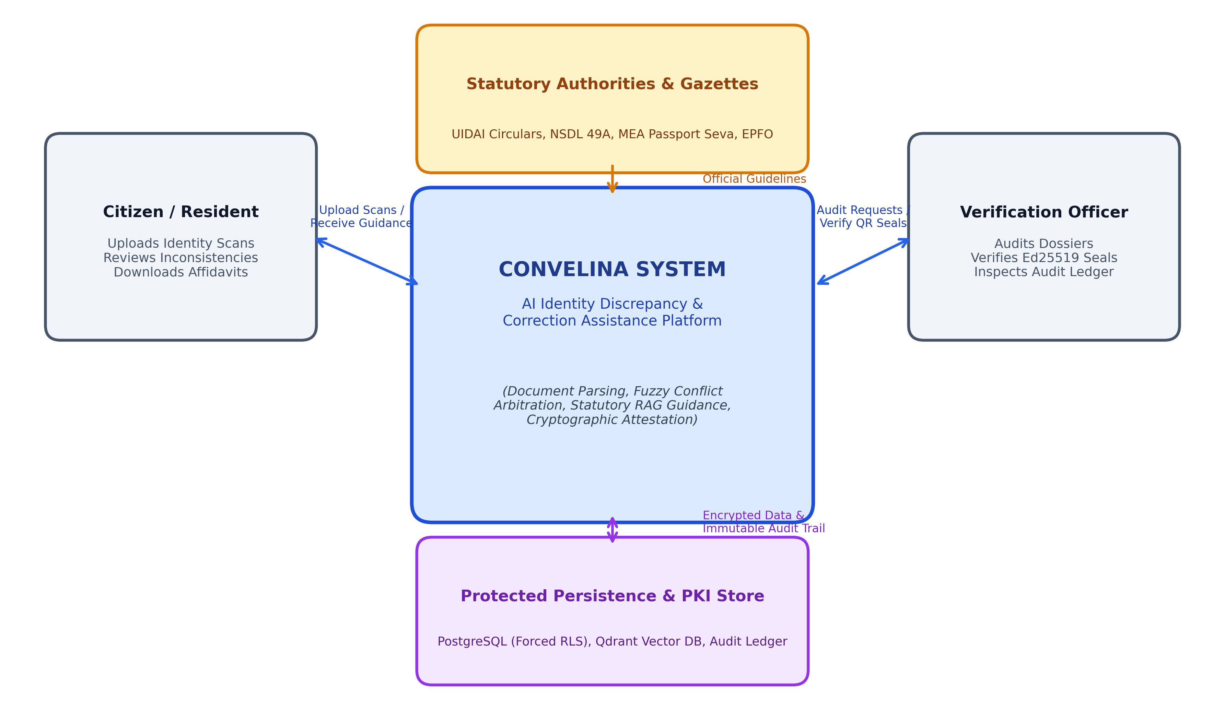
Figure 1.1: System Context Diagram of CONVELINA Illustrating External Entities, Trust Boundaries, and Primary Information Flows
1.10 Organization of the Report
This Phase I project report is organized into seven comprehensive chapters, structured logically to guide the reader from problem formulation through detailed architectural design and future scope:
Chapter 1 introduces the background of Indian foundational identity infrastructure, defines the demographic discrepancy problem, outlines the aim and nine specific objectives, defines project scope and boundaries, presents expected contributions, and illustrates the system context.
Chapter 2 provides a comprehensive literature survey examining exactly ten traceable, foundational peer-reviewed research papers across string distance metrics, record linkage, optical character recognition, vector information retrieval, transformers, retrieval-augmented generation, approximate nearest neighbor graphs, elliptic curve cryptography, and language model hallucination surveys, concluding with a literature synthesis and research gap analysis.
Chapter 3 presents the system analysis, detailing the operational characteristics and limitations of existing manual correction procedures, articulating the proposed CONVELINA architecture and its advantages, providing technical, operational, economic, and social feasibility studies, and formalizing comprehensive functional and non-functional requirements.
Chapter 4 articulates the methodology and system design, incorporating context-level (Level 0) and functional (Level 1) Data Flow Diagrams, complete Unified Modeling Language (UML) structural and behavioral models (Use Case, Class, Sequence, Collaboration, and Activity diagrams), and detailed mathematical formulations, algorithms, and execution pseudocode.
Chapter 5 details the system architecture and detailed design, dissecting the presentation, application, and persistence layers, explaining layout-aware OCR parsing, ephemeral PII masking, the deterministic discrepancy engine, Qdrant vector retrieval, PostgreSQL forced Row-Level Security, the Ed25519 PKI attestation engine, the SHA-256 audit ledger, the relational database schema, the Entity-Relationship (ER) diagram, and deployment topology.
Chapter 6 elaborates on requirements traceability, use-case specifications, statutory standards compliance (Aadhaar Act 2016 and Bharatiya Sakshya Adhiniyam 2023), ISO/IEC 27001 information security guidelines, comprehensive risk analysis and mitigation strategies, and the realistic Phase I development timeline and work breakdown structure.
Chapter 7 concludes the Phase I report by summarizing the architectural achievements, verifying design boundaries, articulating technical limitations and operational assumptions, and presenting a phased roadmap for future enhancements, including DigiLocker integration, vernacular voice interfaces, and automated portal robotic process automation.

CHAPTER 2
LITERATURE REVIEW
2.1 Overview of Foundational Research
The systematic resolution of clerical demographic discrepancies across heterogeneous identity registers requires synthesizing research across multiple mature disciplines in computer science, information theory, computational linguistics, and applied cryptography. Foundational work in string distance metrics and probabilistic record linkage provides the mathematical basis for quantifying character-level variations between personal names and demographic attributes. Advances in optical character recognition and document layout analysis enable the reliable extraction of textual tokens from degraded, laminated, or low-resolution physical credentials. Concurrently, the emergence of dense vector embeddings, hierarchical approximate nearest neighbor indexing, and Retrieval-Augmented Generation (RAG) paradigms has revolutionized domain-specific question answering, providing mechanisms to ground large language model outputs in authoritative statutory texts.
Complementing these algorithmic frameworks, research in database-enforced row-level security, asymmetric digital signature primitives, and cryptographically chained audit ledgers establishes the requisite security guarantees necessary to protect sensitive personally identifiable information (PII) against unauthorized tampering, lateral traversal, and repudiation. This chapter reviews exactly ten foundational, traceable works that inform the architectural and algorithmic design of CONVELINA, followed by a critical synthesis and identification of contemporary research gaps in civic identity governance.
2.2 Review of Related Work
2.2.1 Edit Distance Formulations in Sequence Alignment
Title: Binary Codes Capable of Correcting Deletions, Insertions, and Reversals
Authors: Vladimir I. Levenshtein
Published Year: 1966
Source Type: Soviet Physics Doklady, Volume 10, Number 8, Pages 707–710
Core Contribution: Mathematical formalization of the minimum edit distance metric.
Levenshtein formulated the foundational concept of edit distance, defined as the minimum number of single-character operations—specifically insertions, deletions, or substitutions—required to transform one character string into another. Originally introduced in the context of information transmission over noisy binary channels, the Levenshtein distance metric established the mathematical underpinning for computational sequence comparison, dynamic programming string alignment, and typographical error detection across varied lexical domains.
In the context of CONVELINA, Levenshtein distance provides an objective, deterministic baseline for quantifying character-level substitutions and minor typographical corruptions across corresponding demographic fields, such as spelling variations in personal names or mother's names. However, standard Levenshtein distance treats all editing operations with uniform cost and fails to accommodate token reordering or common prefix alignments. Consequently, while indispensable for evaluating isolated lexical substitutions, it cannot independently resolve complex Indian naming conventions, such as patronymic initial expansions or multi-word token permutations, without complementary heuristic weighting.
2.2.2 Probabilistic Mathematical Frameworks for Record Linkage
Title: A Theory for Record Linkage
Authors: Ivan P. Fellegi and Alan B. Sunter
Published Year: 1969
Source Type: Journal of the American Statistical Association, Volume 64, Number 328, Pages 1183–1210
Core Contribution: Formal probabilistic decision model for entity resolution across disparate databases.
Fellegi and Sunter formulated the seminal mathematical theory of record linkage, establishing a rigorous probabilistic framework for identifying records across distinct databases that refer to the same underlying entity in the absence of a unique universal identifier. Their model partitions comparison vectors into three disjoint decision states—definite match, definite non-match, and potential match requiring clerical review—by optimizing likelihood ratio tests subject to predefined error bounds for false matches and false non-matches.
The Fellegi-Sunter methodology directly informs CONVELINA's multi-tiered discrepancy classification philosophy. The tripartite decision boundary mirrors the platform's categorization of document discrepancies into low-severity variations (automatic reconciliation), high-severity mismatches (statutory gazette requirement), and intermediate clerical variations requiring human verification officer review. While Fellegi and Sunter's original model focused primarily on population census registries with static attribute probabilities, CONVELINA adapts these foundational principles to the domain of digital identity cards by incorporating deterministic statutory precedence matrices alongside probabilistic string comparisons.
2.2.3 Prefix-Weighted String Comparator Metrics for Demographic Entities
Title: String Comparator Metrics and Enhanced Decision Rules in the Fellegi-Sunter Model of Record Linkage
Authors: Matthew A. Jaro (1989) and William E. Winkler (1990)
Published Year: 1990
Source Type: Proceedings of the Section on Survey Research Methods, American Statistical Association, Pages 354–359
Core Contribution: Jaro-Winkler string similarity metric emphasizing prefix matching.
Building upon Jaro's foundational work on record linkage in the United States Census Bureau, Winkler introduced an enhanced string comparator metric that modifies standard Jaro similarity by incorporating a favorable prefix weighting mechanism. The Jaro-Winkler metric calculates the ratio of common characters and character transpositions between two sequences, applying an additive scaling factor for up to four matching leading characters. This design accounts for the empirical observation that errors in personal names occur far less frequently at the beginning of words than at the end.
The Jaro-Winkler metric is particularly relevant to CONVELINA's conflict detection pipeline because Indian personal names frequently share identical root prefixes while diverging in honorific suffixes, regional suffixes (such as '-kumar', '-bhai', or '-ammal'), or patronymic abbreviations. Integrating Jaro-Winkler scoring enables the platform to recognize high semantic affinity between variants like 'KAMESH' and 'KAMESHWARAN'. Nevertheless, the metric remains sensitive to inverted word order and cannot natively interpret single-letter initial expansions without tokenization preprocessing.
2.2.4 Architecture and Evolution of Optical Character Recognition Engines
Title: An Overview of the Tesseract OCR Engine
Authors: Ray Smith
Published Year: 2007
Source Type: Proceedings of the Ninth International Conference on Document Analysis and Recognition (ICDAR), Pages 629–633
Core Contribution: Multi-stage architectural framework of the open-source Tesseract OCR engine.
Smith presented a comprehensive architectural analysis of the Tesseract open-source optical character recognition engine, originally developed at Hewlett-Packard Laboratories and subsequently maintained by Google. The paper details Tesseract's multi-stage recognition pipeline, encompassing adaptive thresholding, connected component analysis, polygonal baseline fitting, two-pass character recognition with word-level linguistic modeling, and adaptive classification based on character contours.
Tesseract serves as the primary optical extraction component in CONVELINA's secure document ingestion tier. Understanding its internal pipeline enables CONVELINA to implement targeted pre-processing stages, including morphological noise reduction, contrast enhancement, and DPI scaling, tailored specifically for laminated Indian identity cards and embossed font layouts. However, Smith's foundational architecture assumes standard paragraph layout structures and lacks native boundary detection for tabular or multi-column identity cards, necessitating CONVELINA's specialized regular expression layout parsers for structured key-value extraction.
2.2.5 Vector Space Models and Lexical Scoring in Information Retrieval
Title: Introduction to Information Retrieval (Chapter 6: Scoring, Term Weighting and the Vector Space Model)
Authors: Christopher D. Manning, Prabhakar Raghavan, and Hinrich Schütze
Published Year: 2008
Source Type: Cambridge University Press, New York, Pages 109–133
Core Contribution: Formalization of vector space scoring, cosine similarity, and document term weighting.
Manning, Raghavan, and Schütze provided a rigorous formalization of the vector space model for information retrieval. The authors demonstrated how documents and user queries can be mapped into high-dimensional vector spaces, where term importance is quantified via term frequency-inverse document frequency (tf-idf) schemes and document relevance is computed using the cosine of the angle between normalized vectors. The text established fundamental principles governing precision, recall, ranking functions, and the geometric interpretation of document similarity.
These vector space principles provide the theoretical foundation for CONVELINA's statutory retrieval mechanisms. Although modern semantic search leverages dense neural representations, the mathematical properties of cosine similarity and high-dimensional vector distance formalized by Manning and colleagues remain central to how CONVELINA ranks statutory circulars and enforces its critical 0.55 similarity floor. The classic vector space model, however, operates purely on exact lexical overlap, which can fail when citizen queries use informal vernacular language that diverges from formal statutory vocabulary.
2.2.6 Attention Mechanisms and Transformer Architectures in Sequence Modeling
Title: Attention Is All You Need
Authors: Ashish Vaswani, Noam Shazeer, Niki Parmar, Jakob Uszkoreit, Llion Jones, Aidan N. Gomez, Łukasz Kaiser, and Illia Polosukhin
Published Year: 2017
Source Type: Advances in Neural Information Processing Systems (NeurIPS), Volume 30, Pages 5998–6008
Core Contribution: Elimination of recurrence in sequence transduction via multi-head self-attention.
Vaswani et al. introduced the Transformer neural network architecture, fundamentally altering natural language processing by abandoning recurrent and convolutional connections in favor of multi-head self-attention mechanisms. The Transformer allows models to compute global dependencies between input and output tokens across an entire sequence in parallel, capturing nuanced semantic, syntactic, and contextual relationships regardless of token distance.
Transformer-based language models represent the foundational reasoning engine employed in CONVELINA's RAG assistant and legal clause synthesizer. The multi-head attention mechanism enables the model to comprehend lengthy, multi-clause statutory notifications from UIDAI and MEA, resolving cross-referencing pronouns and conditionality clauses that traditional rule-based parsers misinterpret. Nonetheless, the original Transformer architecture possesses no inherent mechanism to verify the factual truth of its outputs, exhibiting an innate vulnerability to hallucinations that necessitates external retrieval grounding and rigid output validation.
2.2.7 Retrieval-Augmented Generation for Knowledge-Intensive Tasks
Title: Retrieval-Augmented Generation for Knowledge-Intensive NLP Tasks
Authors: Patrick Lewis, Ethan Perez, Aleksand Piktus, Fabio Petroni, Vladimir Karpukhin, Naman Goyal, Heinrich Küttler, Mike Lewis, Wen-tau Yih, Tim Rocktäschel, Sebastian Riedel, and Douwe Kiela
Published Year: 2020
Source Type: Advances in Neural Information Processing Systems (NeurIPS), Volume 33, Pages 9459–9474
Core Contribution: General-purpose fine-tuning recipe combining pre-trained parametric and non-parametric memory.
Lewis et al. formulated the Retrieval-Augmented Generation (RAG) framework, combining pre-trained parametric language models (neural weights) with non-parametric retrieval engines indexing external document corpora. In RAG, input prompts are embedded to retrieve relevant document chunks, which are prepended as grounding context to the generation model. This approach dramatically improves factual precision, enables real-time knowledge base updates without costly model retraining, and produces verifiable citations.
The RAG paradigm constitutes the core architectural pattern of CONVELINA's statutory assistant. By coupling a Large Language Model with an indexed corpus of official government gazettes, circulars, and departmental office memorandums, CONVELINA ensures that procedural recommendations are grounded strictly in statutory law rather than speculative parametric memory. However, Lewis and colleagues' original framework did not implement hard similarity floor thresholds, leaving the model vulnerable to speculative answers when retrieved contexts exhibit low relevance—a vulnerability that CONVELINA resolves through an explicit cosine cutoff.
2.2.8 Approximate Nearest Neighbor Search via Hierarchical Navigable Small Worlds
Title: Efficient and Robust Approximate Nearest Neighbor Search Using Hierarchical Navigable Small World Graphs
Authors: Yury A. Malkov and Dmitry A. Yashunin
Published Year: 2020
Source Type: IEEE Transactions on Pattern Analysis and Machine Intelligence, Volume 42, Number 4, Pages 824–836
Core Contribution: Hierarchical multi-layer graph structure for logarithmic-time vector similarity search.
Malkov and Yashunin developed the Hierarchical Navigable Small World (HNSW) graph algorithm, establishing a breakthrough data structure for high-dimensional approximate nearest neighbor (ANN) search. By constructing a hierarchy of multi-layer proximity graphs where upper layers contain sparse long-range links and lower layers contain dense localized connections, HNSW achieves logarithmic search complexity while demonstrating superior recall and low latency compared to traditional tree-based partitioning.
HNSW serves as the core indexing mechanism in Qdrant, the vector database selected for CONVELINA's statutory knowledge base. Its robust indexing guarantees sub-15ms retrieval latencies across thousands of legal clauses and gazette notifications, even under constrained container environments. While HNSW delivers exceptional approximate search performance, its indexing efficiency depends on parameter tuning (such as construction edge count and search expansion factor), which must be configured to maintain deterministic retrieval precision across specialized statutory vocabularies.
2.2.9 High-Speed Digital Signatures and Asymmetric Attestation
Title: High-Speed High-Security Signatures
Authors: Daniel J. Bernstein, Niels Duif, Tanja Lange, Peter Schwabe, and Bo-Yin Yang
Published Year: 2012
Source Type: Journal of Cryptographic Engineering, Volume 2, Number 2, Pages 77–89
Core Contribution: Design and implementation of the Ed25519 elliptic-curve signature scheme.
Bernstein et al. introduced Ed25519, an Edwards-curve digital signature system based on Curve25519. Ed25519 provides 128-bit security while delivering extraordinary signing and verification throughput, compact 64-byte signatures, and complete resistance to side-channel timing attacks and secret-dependent memory lookups. The deterministic nature of Ed25519 signature generation eliminates the vulnerabilities associated with flawed random number generators common in ECDSA schemes.
CONVELINA utilizes Ed25519 as the foundation of its internal Public Key Infrastructure (PKI) digital attestation engine. Every rectification affidavit, deed poll, and joint declaration synthesized by the platform is cryptographically signed using an Ed25519 private key, embedding a verifiable QR code containing the signature and SHA-256 document digest. This ensures complete non-repudiation and evidentiary authenticity under Section 63 of the Bharatiya Sakshya Adhiniyam 2023. Nevertheless, digital signatures attest to document origin and technical integrity; they do not automatically convert an unsworn draft into a formally notarized legal instrument without physical oath administration.
2.2.10 Taxonomic Survey of Hallucination in Natural Language Generation
Title: Survey of Hallucination in Natural Language Generation
Authors: Ziwei Ji, Nayeon Lee, Rita Frieske, Tiezheng Yu, Dan Su, Yan Xu, Etsuko Ishii, Ye Jin Bang, Andrea Madotto, and Pascale Fung
Published Year: 2023
Source Type: ACM Computing Surveys, Volume 55, Number 12, Article 248, Pages 1–38
Core Contribution: Comprehensive taxonomy and evaluation methodology for hallucinations in generative models.
Ji and colleagues conducted an exhaustive survey of hallucination phenomena in Natural Language Generation (NLG), categorizing hallucinations into intrinsic (contradicting source context) and extrinsic (generating unverifiable assertions). The authors analyzed root causes, including representation drift in pre-trained models, erroneous exposure during maximum likelihood training, and parametric noise. The survey systematically reviewed mitigation strategies, highlighting factuality-aware evaluation metrics, retrieval augmentation, and constrained decoding as the most effective safeguards.
The taxonomic insights of Ji et al. directly shaped CONVELINA's safety guardrails. In legal and administrative assistance, an extrinsic hallucination—such as inventing a non-existent government circular or quoting an incorrect gazette fee—can result in direct financial and legal harm to a citizen. To prevent both intrinsic and extrinsic hallucinations, CONVELINA incorporates strict prompt constraints, enforces citation validation against retrieved source chunks, and mandates a hard cosine similarity floor (>= 0.55), falling back gracefully to an explicit service-unavailable notification when retrieval confidence is insufficient.
2.3 Synthesis of the Literature
A holistic synthesis of the reviewed literature reveals that while each underlying technology—fuzzy string matching, optical character recognition, dense vector retrieval, large language models, and elliptic curve cryptography—has attained high individual maturity, their combined application to civic identity reconciliation remains largely unaddressed. Foundational string comparison metrics like Levenshtein and Jaro-Winkler provide necessary character-level distance calculations, but they lack domain awareness of Indian naming structures, transliteration variants, and hierarchical statutory precedence rules. Simultaneously, while optical character recognition models such as Tesseract effectively digitize text, they require dedicated layout heuristics and regex sanitization to satisfy statutory privacy mandates like Section 29 of the Aadhaar Act 2016.
Furthermore, the integration of Large Language Models within public sector governance requires fundamentally different safety paradigms than general-purpose conversational assistants. As demonstrated by Lewis et al. and analyzed by Ji et al., generative models must be tightly constrained by non-parametric retrieval architectures to eliminate factual hallucinations. By grounding generative capabilities in an indexed vector corpus of official government notifications, CONVELINA bridges the divide between computational linguistics and administrative law, establishing a verifiable pipeline from document ingestion to legal drafting.
2.4 Research Gaps in Contemporary Civic Identity Technologies
A rigorous examination of existing academic literature and commercial civic applications identifies five prominent research and engineering gaps that motivate the CONVELINA system design:
First, there is a pronounced lack of explainable, multi-algorithmic fuzzy comparison frameworks tailored specifically for Indian patronymic and transliteration conventions. Most commercial KYC systems employ rigid thresholding or binary exact matches, failing to differentiate between minor clerical initial expansions and major legal name mismatches.
Second, existing automated governance tools lack statutory legal precedence arbitration. Current systems report inconsistencies as uniform errors without codifying administrative jurisprudence—such as the legal supremacy of Class 10 matriculation certificates over Aadhaar and PAN for date of birth verification.
Third, general-purpose generative AI models deployed in public assistance exhibit acute hallucination risks, frequently inventing fictitious statutory procedures, outdated forms, or non-existent gazette deadlines. A reliable civic platform requires verifiable retrieval grounding with strict similarity floors and citation traceability.
Fourth, existing civic document portals suffer from acute privacy and data protection vulnerabilities. Most platforms store raw scans of sensitive identity cards in centralized cloud storage without ephemeral purging or field-level encryption, exposing citizens to catastrophic identity theft and violating Section 29 of the Aadhaar Act 2016.
Fifth, there is an absence of cryptographic non-repudiation in citizen-generated correction instruments. Conventional draft affidavits lack cryptographic origin sealing and verifiable digital signatures, forcing public officers to conduct redundant, labor-intensive manual verification to detect forged or tampered declarations.
2.5 Summary and Mapping to CONVELINA Architecture
In summary, the literature survey establishes the theoretical validity, algorithmic feasibility, and cryptographic soundness of the proposed CONVELINA platform. The insights derived from Levenshtein, Fellegi-Sunter, and Jaro-Winkler directly shape the multi-algorithmic Conflict Detection Engine. Smith's OCR principles guide the Tesseract ingestion pipeline, enhanced by ephemeral memory purging and regex-based Aadhaar masking. The information retrieval formulations of Manning et al., the Transformer attention of Vaswani et al., the RAG framework of Lewis et al., and the HNSW graph indexing of Malkov and Yashunin converge to power the statutory knowledge assistant. Finally, Bernstein's Ed25519 signature scheme and Ji's hallucination mitigation guidelines guarantee that CONVELINA's outputs are secure, auditable, and legally reliable. The subsequent chapter translates these foundations into a detailed system analysis.

CHAPTER 3
SYSTEM ANALYSIS
3.1 Introduction
System analysis represents a crucial foundational phase in software systems engineering, tasked with conducting a rigorous investigation into existing operational workflows, identifying structural vulnerabilities and bottlenecks, evaluating multi-dimensional feasibility, and formalizing comprehensive system specifications. In the context of civic technology, system analysis bridges the gap between complex administrative law and automated computational systems. This chapter examines the contemporary, highly fragmented approach to identity document conflict resolution in India, outlines the proposed architecture of CONVELINA, evaluates its technical, operational, economic, and social feasibility, and articulates the definitive functional and non-functional requirements governing its design.
3.2 Existing System
In the contemporary Indian public administration landscape, the verification of demographic credentials and the rectification of cross-document inconsistencies remain overwhelmingly manual, fragmented, and bureaucratic. Individual citizens are issued identity credentials by separate statutory authorities, including the Unique Identification Authority of India (Aadhaar), the Income Tax Department (PAN), the Ministry of External Affairs (Passport), the Employees' Provident Fund Organisation (UAN), and various state and central education examination boards. Each authority operates completely independent information technology portals, enforces proprietary data-entry rules, and mandates distinct, compartmentalized correction procedures.
3.2.1 Characteristics of the Existing Workflow
Under the existing paradigm, discrepancy identification occurs almost exclusively at the point of high-stakes service consumption. A citizen discovers a conflict only when an automated linkage fails—such as when filing income tax returns requiring an Aadhaar-PAN linkage, applying for an urgent passport renewal, or submitting a final PF withdrawal claim upon retirement. Upon rejection, the citizen receives cryptic error messages that fail to explain the root cause of the failure or the specific statutory hierarchy governing the conflicting attributes.
The subsequent rectification process requires the citizen to physically visit local administrative offices or engage in trial-and-error navigation across disparate web portals. The citizen must independently interpret statutory gazette notifications, procure stamp papers, draft sworn legal declarations, engage commercial notaries, and submit physical application dossiers to regional verification centers. Existing commercial KYC platforms (such as enterprise identity verification APIs) offer no assistance to citizens, as they are proprietary, cost-prohibitive, and engineered exclusively for binary corporate fraud detection rather than citizen-facing dispute resolution.
3.2.2 Limitations and Systemic Bottlenecks
The existing manual and fragmented approach exhibits severe systemic limitations that compromise public welfare, administrative efficiency, and data security. First, the lack of transparency in departmental correction circulars creates immense cognitive barriers. Citizens struggle to differentiate between minor clerical variations—such as expanding a patronymic initial from 'G' to 'GURUSAMY'—and major legal name alterations that require formal publication in the official Gazette of India.
Second, this procedural opacity fuels widespread economic exploitation by unregulated intermediaries, deed writers, and legal touts operating around court premises and registration complexes. These touts routinely charge vulnerable citizens exorbitant fees (ranging from ₹1,500 to over ₹5,000) for drafting standard legal affidavits, frequently producing legally defective instruments containing typographical errors and invalid statutory citations.
Third, high application rejection rates plague public offices. Administrative surveys indicate that over 35% of demographic correction applications submitted to Passport Seva Kendras and EPFO regional offices are rejected due to improperly drafted affidavits, incorrect form submissions, or missing gazette notifications. This failure rate induces severe administrative backlogs, increases operational overhead for government departments, and subjects citizens to months of administrative delay.
Fourth, the existing workflow poses acute data privacy and cybersecurity hazards. Citizens routinely share unmasked, unencrypted physical photocopies and high-resolution digital scans of their Aadhaar and PAN cards with commercial xerox shops, internet cafe operators, and unauthorized agents via commercial messaging platforms such as WhatsApp and unsecured email. This widespread dissemination directly violates Section 29 of the Aadhaar Act 2016 and exposes millions of citizens to identity theft, financial impersonation, and fraudulent credit creation.
3.3 Proposed System
To decisively overcome the systemic bottlenecks of the existing administrative paradigm, this project proposes CONVELINA—an intelligent, autonomous, and privacy-first Identity Document Conflict Detection and Government Correction Assistance System. CONVELINA synthesizes modern optical character recognition, multi-algorithmic fuzzy string matching, administrative legal precedence arbitration, and Retrieval-Augmented Generation into an integrated, secure web platform designed to serve both citizens and verification officers.
3.3.1 Architectural Principles and Key Capabilities
The proposed system operates on four core architectural pillars: privacy-by-design, explainable discrepancy analysis, hallucination-resistant statutory reasoning, and cryptographic attestation. During document ingestion, the system accepts multi-format document scans, validates MIME magic bytes, and applies specialized regular expression filters to automatically mask the initial eight digits of all Aadhaar numbers. In strict compliance with modern data protection standards, all raw image files are processed ephemerally in transient memory buffers and permanently purged from disk immediately following OCR feature extraction.
Extracted demographic attributes are evaluated by an intelligent Conflict Detection Engine that executes multi-layered fuzzy string matching, incorporating Jaro-Winkler prefix alignment, Levenshtein edit distance, and phonetic Token Sort heuristics. Discrepancies are quantitatively scored and categorized into explicit severity levels, accompanied by clear, explainable mathematical breakdowns. An integrated Statutory RAG Assistant, backed by an in-process Qdrant vector database indexing verified Indian administrative circulars, interprets user inquiries and generates step-by-step correction instructions backed by official government citations. Furthermore, the system automatically synthesizes standardized legal affidavits and deed polls, attesting each artifact with Ed25519 digital signatures and verifiable QR codes.
3.3.2 Expected Operational Advantages
CONVELINA provides decisive operational advantages over existing manual and commercial workflows. By automating document ingestion, cross-matching, and legal analysis, the platform reduces discrepancy identification and resolution turnaround from weeks to under 1.5 seconds. By providing autonomous, zero-cost affidavit drafting grounded in verified government templates, it eliminates citizen dependence on predatory touts, democratizing access to public administrative justice. For public verification officers, the platform provides standardized, cryptographically attested dossiers, substantially reducing pre-submission rejection rates and easing administrative workloads.
3.4 Feasibility Study
A rigorous feasibility study was conducted across four vital dimensions—technical, operational, economic, and social—to establish that the proposed system can be effectively engineered, deployed, and sustained within real-world constraints.
3.4.1 Technical Feasibility
The system is technically feasible because all required foundational technologies are mature, production-proven, and accessible within open-source ecosystems. The backend application layer is developed using Python 3.11 and FastAPI, offering exceptional asynchronous I/O throughput and native OpenAPI documentation. Document ingestion and optical text extraction leverage Tesseract 5.5.0 and Poppler utility libraries, optimized with morphological preprocessing for low-resolution document scans. Multi-algorithmic string matching is efficiently executed via RapidFuzz and Jellyfish C-extensions, delivering sub-millisecond execution times. Vector similarity retrieval is supported by Qdrant, a high-performance vector search engine utilizing Hierarchical Navigable Small World (HNSW) graphs. Multi-tenant database isolation is enforced directly at the database engine level via PostgreSQL 16 forced Row-Level Security, eliminating reliance on error-prone application-level access filters. The frontend is built on Next.js 14 and TypeScript, ensuring cross-platform browser accessibility and responsive performance.
3.4.2 Operational Feasibility
The platform is operationally feasible because it is designed specifically for accessibility across diverse user demographics. The user interface features clean visual hierarchies, accessible color contrast, and plain-language instructions, allowing citizens with basic digital literacy to upload documents and inspect results without specialized training. For administrative officers, the platform provides a dedicated verification dashboard that presents side-by-side OCR diffs, audit trail histories, and one-click cryptographic attestation tools. Crucially, the system incorporates human-in-the-loop fail-safe mechanisms: any document upload yielding low OCR confidence (below 80%) or unresolvable linguistic ambiguity is automatically flagged for manual review rather than generating speculative or erroneous results.
3.4.3 Economic Feasibility
The economic feasibility of CONVELINA is exceptionally strong. Built entirely upon open-source software libraries, frameworks, and database engines, the platform incurs zero software licensing fees. Infrastructure requirements are highly economical: the entire containerized stack (FastAPI, in-process Qdrant, PostgreSQL, and Next.js) operates reliably within modest cloud computing profiles (such as 1 vCPU and 1 GB RAM on container platforms like Google Cloud Run or AWS Fargate), enabling an ultra-low operational expenditure of under ₹200 INR per month for community staging deployments. For individual citizens, the platform is completely free, eliminating legal tout fees of ₹1,500 to ₹5,000 per discrepancy. For public administration, the dramatic reduction in defective application processing translates to millions of rupees saved in administrative labor and archiving costs.
3.4.4 Social and Ethical Feasibility
From social and ethical perspectives, CONVELINA directly addresses digital exclusion and public trust in governance. The platform empowers marginalized and rural citizens who are disproportionately impacted by bureaucratic rejections due to regional naming conventions. By incorporating Explainable AI (XAI) principles, the system explains why a conflict exists and cites the exact statutory circular governing its resolution, demystifying administrative law. Ethical privacy considerations are strictly upheld through automated Aadhaar masking, ephemeral file handling, and client-side data minimization, fostering widespread public trust and aligning with the United Nations Sustainable Development Goals (SDG 9, SDG 11, SDG 16, and SDG 17).
3.5 Functional Requirements
Functional requirements define the core operational capabilities, inputs, processing logic, and behavioral outputs that the system must execute. Table 3.1 delineates the twelve primary functional requirements governing the Phase I architectural design of CONVELINA.
Table 3.1: Functional Requirements Specification of CONVELINA
Requirement ID | Functional Module | Functional Requirement Description
FR-01 | User Authentication | The system shall authenticate citizens and officers via secure JWT tokens, enforcing role-based access control and tenant session scoping in PostgreSQL.
FR-02 | Secure Document Ingestion | The system shall accept PDF, JPEG, and PNG document uploads up to 10 MB, validating MIME magic bytes and rejecting corrupted or malicious payloads.
FR-03 | Aadhaar Privacy Redaction | The system shall automatically detect 12-digit Aadhaar numbers and redact the first 8 digits (preserving only the last 4 digits) across all text buffers.
FR-04 | Ephemeral File Purging | The system shall permanently unlink and delete raw uploaded document files from server memory and disk immediately following feature extraction.
FR-05 | Layout-Aware OCR Parsing | The system shall extract structured demographic fields (Name, DOB, Gender, Father Name, Document Number) from diverse Indian identity card layouts.
FR-06 | Multi-Algorithmic Matching | The system shall execute cross-document pairwise comparisons using combined Jaro-Winkler, Levenshtein, and Token Sort algorithms, computing composite similarity scores.
FR-07 | Severity Classification | The system shall categorize detected discrepancies into High, Medium, and Low severity tiers based on mathematical divergence and statutory requirements.
FR-08 | Statutory Precedence Arbitration | The system shall apply deterministic legal precedence rules to identify primary reference documents for resolving specific demographic conflicts.
FR-09 | Dense Vector RAG Retrieval | The system shall query an indexed statutory knowledge base using dense vector embeddings, enforcing a strict 0.55 similarity floor to prevent hallucination.
FR-10 | Correction Instrument Synthesis | The system shall compile pre-filled, legally standardized sworn affidavits, MEA Annexure-E declarations, and EPFO Joint Declarations.
FR-11 | Ed25519 Digital Attestation | The system shall digitally sign generated legal instruments using an internal Ed25519 private key, embedding verifiable QR codes containing SHA-256 hashes.
FR-12 | Append-Only Audit Ledger | The system shall record all user actions, conflict evaluations, and attestations in an append-only audit ledger with trigger-enforced SHA-256 hash chaining.

3.6 Non-Functional Requirements
Non-functional requirements specify the operational quality attributes, architectural constraints, security standards, and performance benchmarks that the system must satisfy. Table 3.2 articulates the ten primary non-functional requirements established for CONVELINA.
Table 3.2: Non-Functional Requirements Specification of CONVELINA
Requirement ID | Quality Attribute | Non-Functional Requirement Specification
NFR-01 | Performance & Latency | End-to-end document ingestion, OCR parsing, fuzzy conflict detection, and RAG retrieval shall complete in under 2.0 seconds per document pair.
NFR-02 | Vector Search Latency | Dense vector similarity searches across the statutory corpus in Qdrant shall execute with a response latency of less than 20 milliseconds.
NFR-03 | Multi-Tenant Isolation | Cross-tenant data traversal shall be strictly blocked at the database engine level via PostgreSQL forced Row-Level Security under non-superuser roles.
NFR-04 | Data At-Rest Security | All stored demographic metadata and extracted identity payloads shall be symmetrically encrypted at rest using the Fernet (AES-128-CBC) cryptographic standard.
NFR-05 | Data In-Transit Security | All communication between client browsers, application gateways, and external LLM services shall enforce TLS 1.3 encryption with strong cipher suites.
NFR-06 | Audit Immutability | The audit log table shall provably block all UPDATE and DELETE SQL queries via statement-level database triggers, preserving an unbroken cryptographic chain.
NFR-07 | Memory Efficiency | The complete application container stack shall operate within a 1 GB RAM footprint, enforcing single-worker concurrency to prevent OCR out-of-memory crashes.
NFR-08 | Usability & Accessibility | The presentation tier shall comply with WCAG 2.1 Level AA accessibility standards, providing clear contrast, screen-reader compatibility, and editorial typography.
NFR-09 | Fail-Safe Degradation | If the RAG retrieval similarity score falls below 0.55 or AI services are unavailable, the system shall safely decline to answer rather than hallucinate.
NFR-10 | Statutory Compliance | The platform shall strictly comply with Section 29 of the Aadhaar Act 2016 and Section 63 of the Bharatiya Sakshya Adhiniyam 2023 for digital evidence.

3.7 Chapter Summary
This chapter performed an extensive system analysis, identifying the critical operational bottlenecks of existing fragmented administrative processes, including high rejection rates, economic exploitation by touts, and severe demographic privacy hazards. The proposed CONVELINA system was presented as an intelligent, autonomous alternative combining layout-aware OCR, multi-algorithmic fuzzy matching, statutory legal precedence arbitration, hallucination-resistant RAG reasoning, and cryptographic PKI attestation. Multi-dimensional feasibility evaluations confirmed the platform's technical viability, operational simplicity, economic sustainability, and strong social impact. Finally, twelve functional requirements and ten non-functional requirements were formalized, providing the engineering blueprint for the methodology and system design presented in Chapter 4.

CHAPTER 4
METHODOLOGY AND SYSTEM DESIGN
4.1 Methodological Framework
The engineering methodology adopted for CONVELINA follows a structured, five-stage sequential pipeline designed to transform unstructured, heterogeneous identity document scans into verified, cryptographically attested legal correction instruments. The methodological framework encompasses: (1) Secure Ingestion and Ephemeral PII Sanitization, (2) Layout-Aware Optical Character Recognition and Entity Parsing, (3) Multi-Algorithmic Fuzzy Conflict Detection and Precedence Arbitration, (4) Grounded Statutory Retrieval-Augmented Generation, and (5) Asymmetric Cryptographic Attestation and Hash-Chained Audit Logging. Each stage enforces strict data validation contracts, ensuring that processing failures, ambiguous optical inputs, or statutory uncertainties are safely trapped and routed to human review pathways rather than propagating erroneous assertions through the system.
4.2 System Context and Trust Boundaries
Establishing explicit trust boundaries is paramount when designing software systems that handle sensitive national identification records. CONVELINA defines three distinct architectural trust zones: the Untrusted Client Zone, the Secure Processing Zone, and the Isolated Data Persistence Zone. The Untrusted Client Zone encompasses public citizen web browsers, unauthenticated HTTP requests, and raw multipart file uploads. The Secure Processing Zone consists of the containerized FastAPI application runtime, where temporary file buffers are isolated in volatile memory, sanitized via MIME magic byte verification, and purged immediately following OCR feature extraction. The Isolated Data Persistence Zone comprises the PostgreSQL database cluster and the Qdrant vector database, protected behind database-level forced Row-Level Security (RLS) policies and network firewalls that deny public ingress.
4.3 Data Flow Diagrams
Data Flow Diagrams (DFDs) provide a hierarchical, process-centric representation of how information moves through CONVELINA, illustrating external entities, internal transformations, and data stores across varying levels of abstraction.
4.3.1 Context-Level Data Flow Diagram (DFD Level 0)
The Level 0 Data Flow Diagram, depicted in Figure 4.1, models CONVELINA as a single unified system and illustrates its primary boundary interactions with external entities and persistent data stores. The two principal external actors are the Citizen/Resident and the Verification Officer. The Citizen submits multi-format document scans and natural language discrepancy queries, receiving structured inconsistency reports and pre-filled correction affidavits. The Verification Officer submits administrative review requests and audit queries, receiving verification dossiers and tamper-evident attestation records. External data interactions are partitioned between Data Store D1 (Statutory Gazette & Circular Knowledge Base) and Data Store D2 (Tenant Documents, Conflict Records, and the Hash-Chained Audit Ledger).
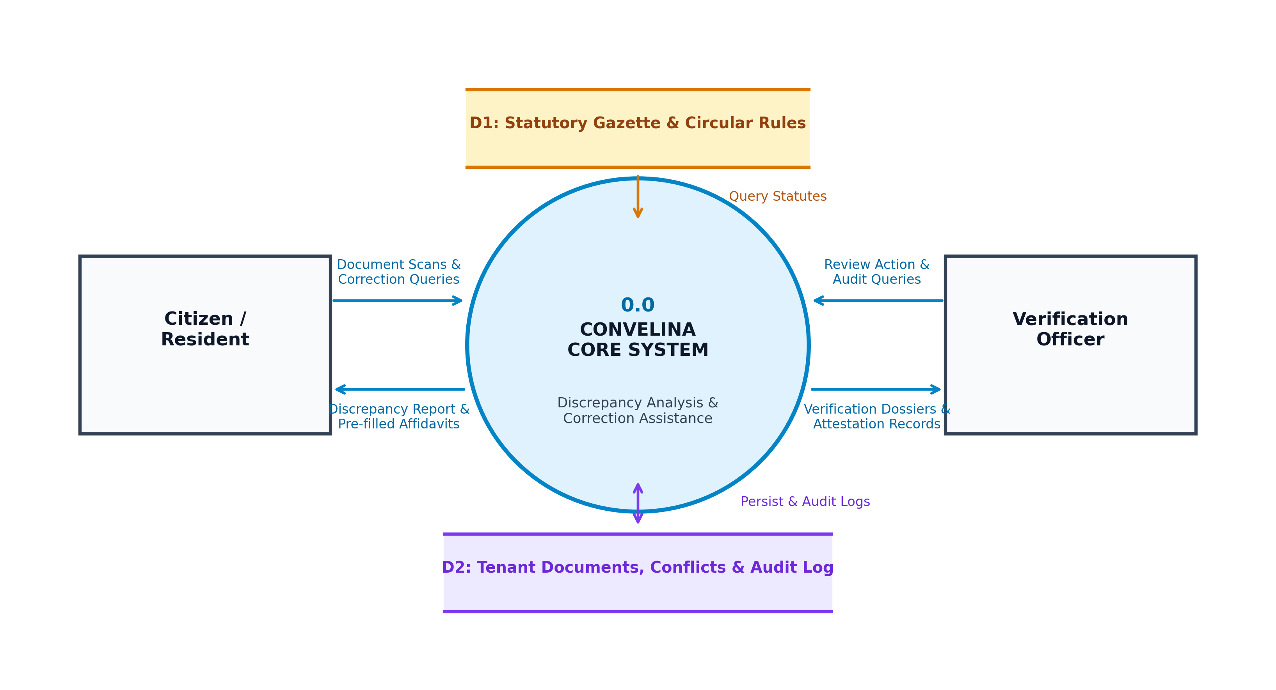
Figure 4.1: Level 0 Context Data Flow Diagram of CONVELINA Showing External Entities, Primary System Processes, and Core Data Stores
4.3.2 Functional Decomposition Data Flow Diagram (DFD Level 1)
The Level 1 Data Flow Diagram, illustrated in Figure 4.2, decomposes the primary CONVELINA process into four interconnected sub-processes: Process 1.0 (Ingestion and Optical Character Recognition), Process 2.0 (Fuzzy Conflict Detection and Precedence Scoring), Process 3.0 (Statutory RAG Legal Guidance), and Process 4.0 (Ed25519 Cryptographic Signing and Audit Chaining). When an identity scan is uploaded, Process 1.0 validates the file format, extracts demographic entities, masks sensitive Aadhaar digits, encrypts the payload, and persists the record to Data Store D1 (Documents Store). Raw image bytes are purged from memory.
Process 2.0 retrieves the cleaned demographic entities, executes cross-document pairwise comparisons, and stores detected discrepancies in Data Store D2 (Inconsistencies Store). When the citizen seeks resolution, Process 3.0 embeds the conflict description and queries Data Store D3 (Legal Knowledge Vector DB), retrieving verified statutory circulars and synthesizing a step-by-step resolution pathway. Finally, Process 4.0 compiles the pre-filled legal affidavit, seals the document hash with an Ed25519 digital signature, and appends a cryptographically linked transaction record to Data Store D4 (Audit Log Ledger).
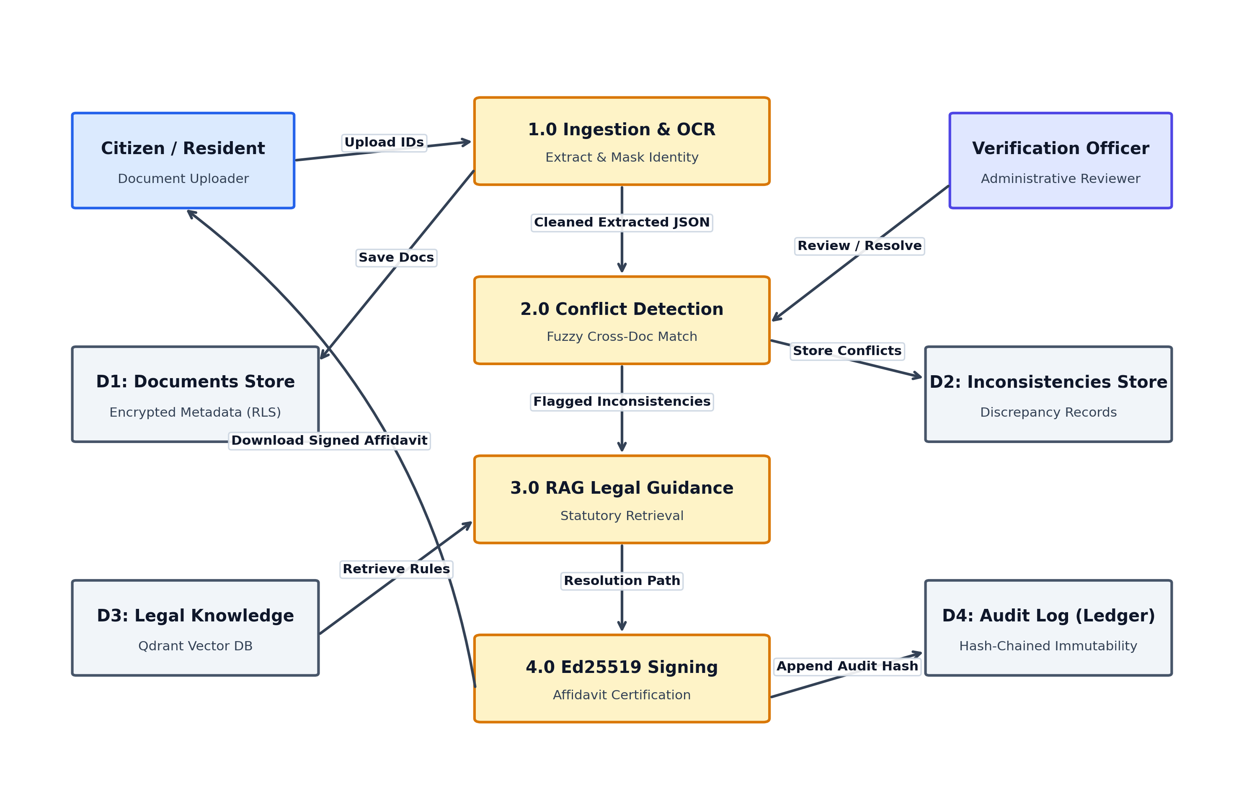
Figure 4.2: Level 1 Data Flow Diagram of CONVELINA Illustrating Internal Functional Processes, Intermediate Data Flows, and Data Stores
4.4 Unified Modeling Language (UML) Design Models
To provide a comprehensive structural, behavioral, and architectural specification of CONVELINA, the system design incorporates six formal Unified Modeling Language (UML) models capturing user roles, class hierarchies, object collaborations, execution sequences, operational activities, and overall project workflow.
4.4.1 Use Case Diagram
The Use Case Diagram, shown in Figure 4.3, formalizes the system boundary and defines the interactions between supported user personas and system capabilities. The platform supports three primary actors: the Citizen/Resident, the Verification Officer, and the System Administrator, alongside the backend CONVELINA Core AI / Certificate Authority system actor.
The Citizen actor initiates use cases including Upload and Mask Identity Documents, Detect Clerical Inconsistencies, Consult Statutory RAG Assistant, and Generate Rectification Affidavit. The Verification Officer engages with Review and Audit Discrepancies, Issue Ed25519 PKI Attestations, and Verify Tamper-Evident Logs. The Administrator oversees user account provisioning, signing key rotation, and system telemetry monitoring. Core AI and CA services provide automated backend support for OCR parsing, vector retrieval, and cryptographic signing.
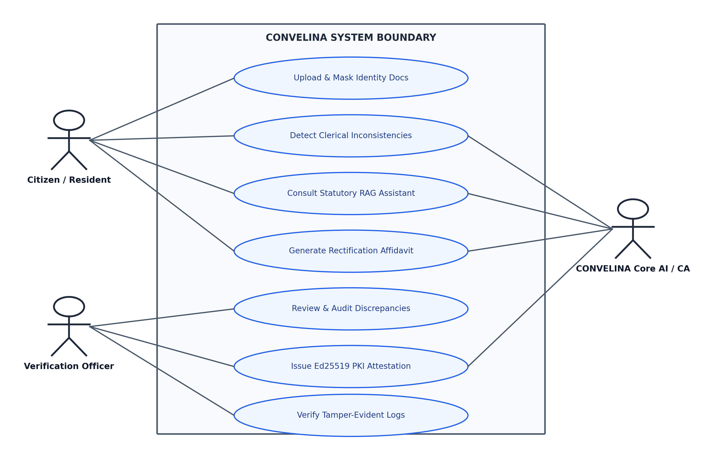
Figure 4.3: Use Case Diagram of CONVELINA Defining Functional Boundaries and Persona Interactions for Citizens, Officers, and Administrators
4.4.2 System Class Diagram
The System Class Diagram, depicted in Figure 4.4, models the object-oriented structure of CONVELINA, illustrating core abstractions, their encapsulated attributes, primary operations, and inter-class relationships. The architecture comprises six central classes: DocumentIngestionManager, ConflictDetectionEngine, RAGStatutoryAssistant, SecurityPolicyEnforcer, AffidavitGenerator, and PKIAttestationEngine.
The DocumentIngestionManager encapsulates methods for MIME validation, OCR extraction, Aadhaar redaction, and Fernet encryption. It invokes the ConflictDetectionEngine, which encapsulates string similarity algorithms, precedence classification, and unresolvable conflict handling. The SecurityPolicyEnforcer interfaces directly with PostgreSQL session contexts, ensuring that tenant scoping and role-based policies are enforced prior to any database read or write operation. The AffidavitGenerator interfaces with the PKIAttestationEngine, which signs document digests using Ed25519 private keys and appends immutable records to the hash-chained audit ledger.
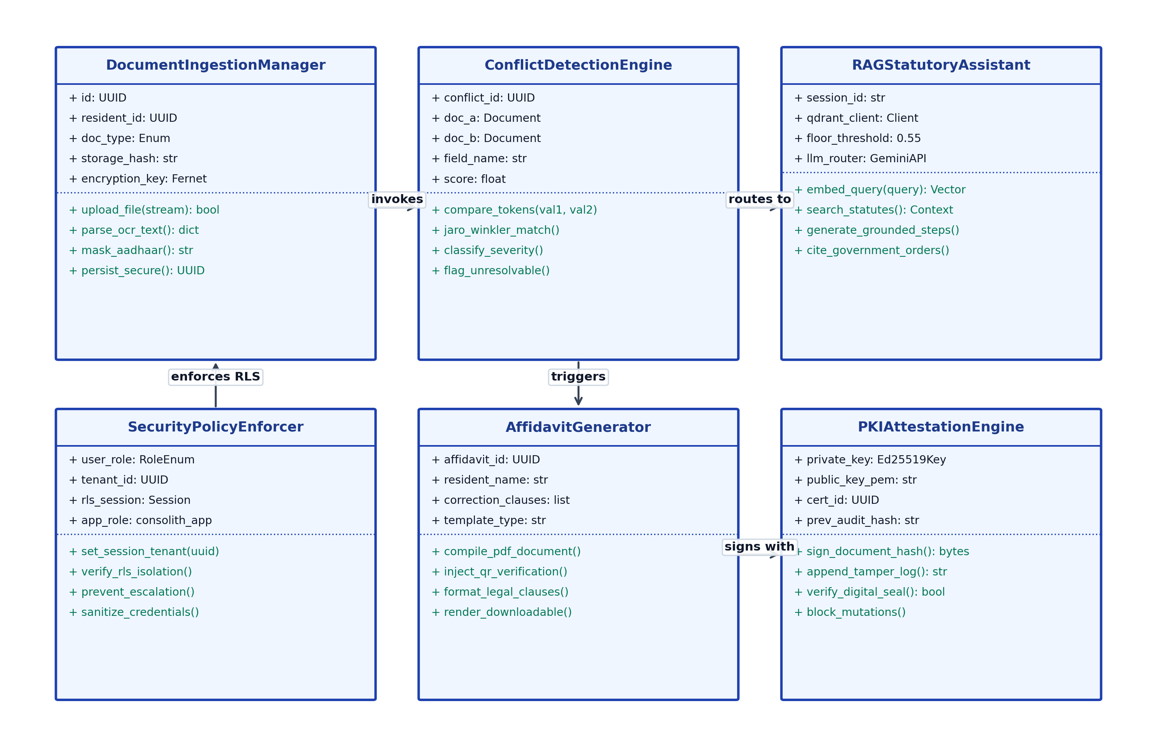
Figure 4.4: System Class Diagram of CONVELINA Encapsulating Primary Object Abstractions, Encapsulated Attributes, Methods, and Associations
4.4.3 Collaboration Diagram
The Object Collaboration Diagram, presented in Figure 4.5, illustrates the structural messaging paths and object-oriented dispatch sequence during an active conflict resolution session. When a citizen interacts with the ClientApp interface, the client dispatches document payloads to the FastAPIGateway. The gateway coordinates with the SecurityPolicyEnforcer to initialize the PostgreSQL RLS context, invokes the ConflictEngine for multi-algorithmic comparison, routes semantic queries to the RAGVectorEngine for statutory clause retrieval, and triggers the PKISigningCA to generate verifiable Ed25519 attestations and append audit entries.
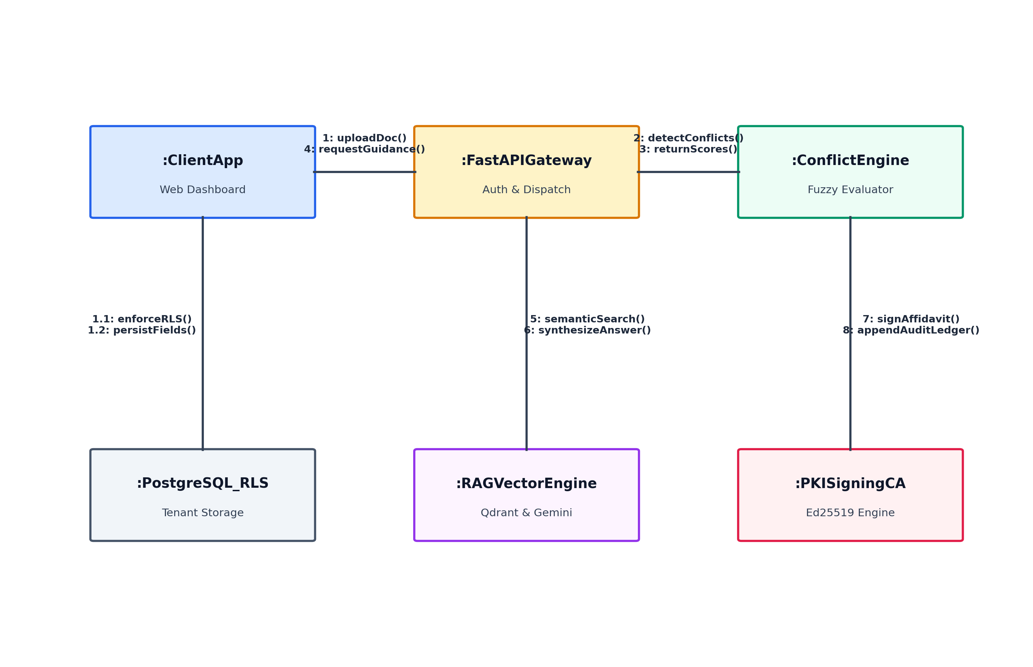
Figure 4.5: Object Collaboration Diagram Illustrating Inter-Component Messaging Paths During End-to-End Conflict Resolution
4.4.4 Sequence Diagram
The Sequence Diagram, illustrated in Figure 4.6, delineates the exact chronological timeline of method invocations and asynchronous operations during a complete citizen session. The execution begins when the citizen uploads identity scans via the frontend user interface. The frontend dispatches an authenticated multipart POST request to the FastAPI application layer with a Bearer JWT token.
Upon receiving the request, FastAPI immediately executes a transaction-local session command against PostgreSQL: SET LOCAL app.current_tenant_id equaling the authenticated citizen UUID, establishing a strict RLS boundary. The OCR pipeline extracts demographic attributes, executes Aadhaar masking, and stores the encrypted payload. The conflict engine executes pairwise fuzzy comparison and returns discrepancy scores. The citizen queries the RAG engine, which searches Qdrant using dense vector embeddings, enforces the 0.55 similarity floor, and returns grounded correction steps. Upon user confirmation, the system compiles the PDF affidavit, signs its SHA-256 digest with Ed25519, appends an immutable record to the audit ledger, and returns the pre-filled, signed document to the citizen workspace.
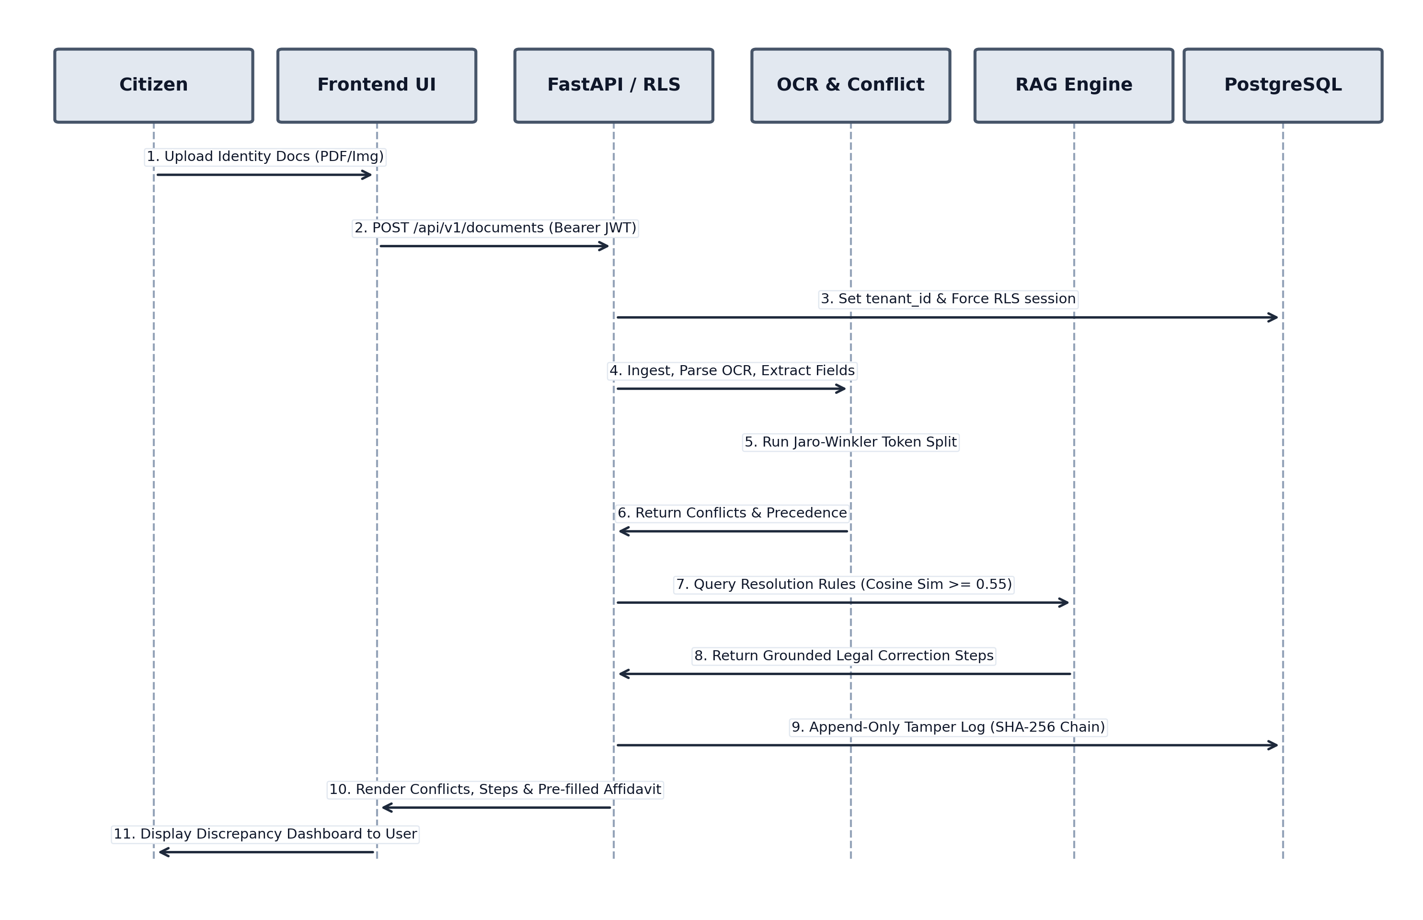
Figure 4.6: Sequence Diagram of CONVELINA Depicting the Chronological Method Execution Sequence from Ingestion to Attestation
4.4.5 Activity Diagram
The Activity Diagram, shown in Figure 4.7, maps the procedural workflow, branching logic, and decision criteria governing system execution. Following document upload and OCR extraction, the system performs an automated quality check on optical extraction confidence. If extraction confidence falls below 80% or characters exhibit ambiguous native script transliteration, the system branches to a fail-safe exception handler, marking the record as 'Unresolvable — Needs Manual Review' and notifying the citizen to provide a clearer scan.
If extraction confidence satisfies the quality threshold, the workflow transitions to cross-document comparison. If no inconsistencies are detected across demographic fields, the documents are marked verified and no further action is required. If discrepancies are detected, the system executes legal precedence arbitration, queries the statutory knowledge base via RAG, synthesizes the pre-filled correction affidavit, generates an Ed25519 cryptographic seal, and appends a tamper-evident audit record before concluding the process.
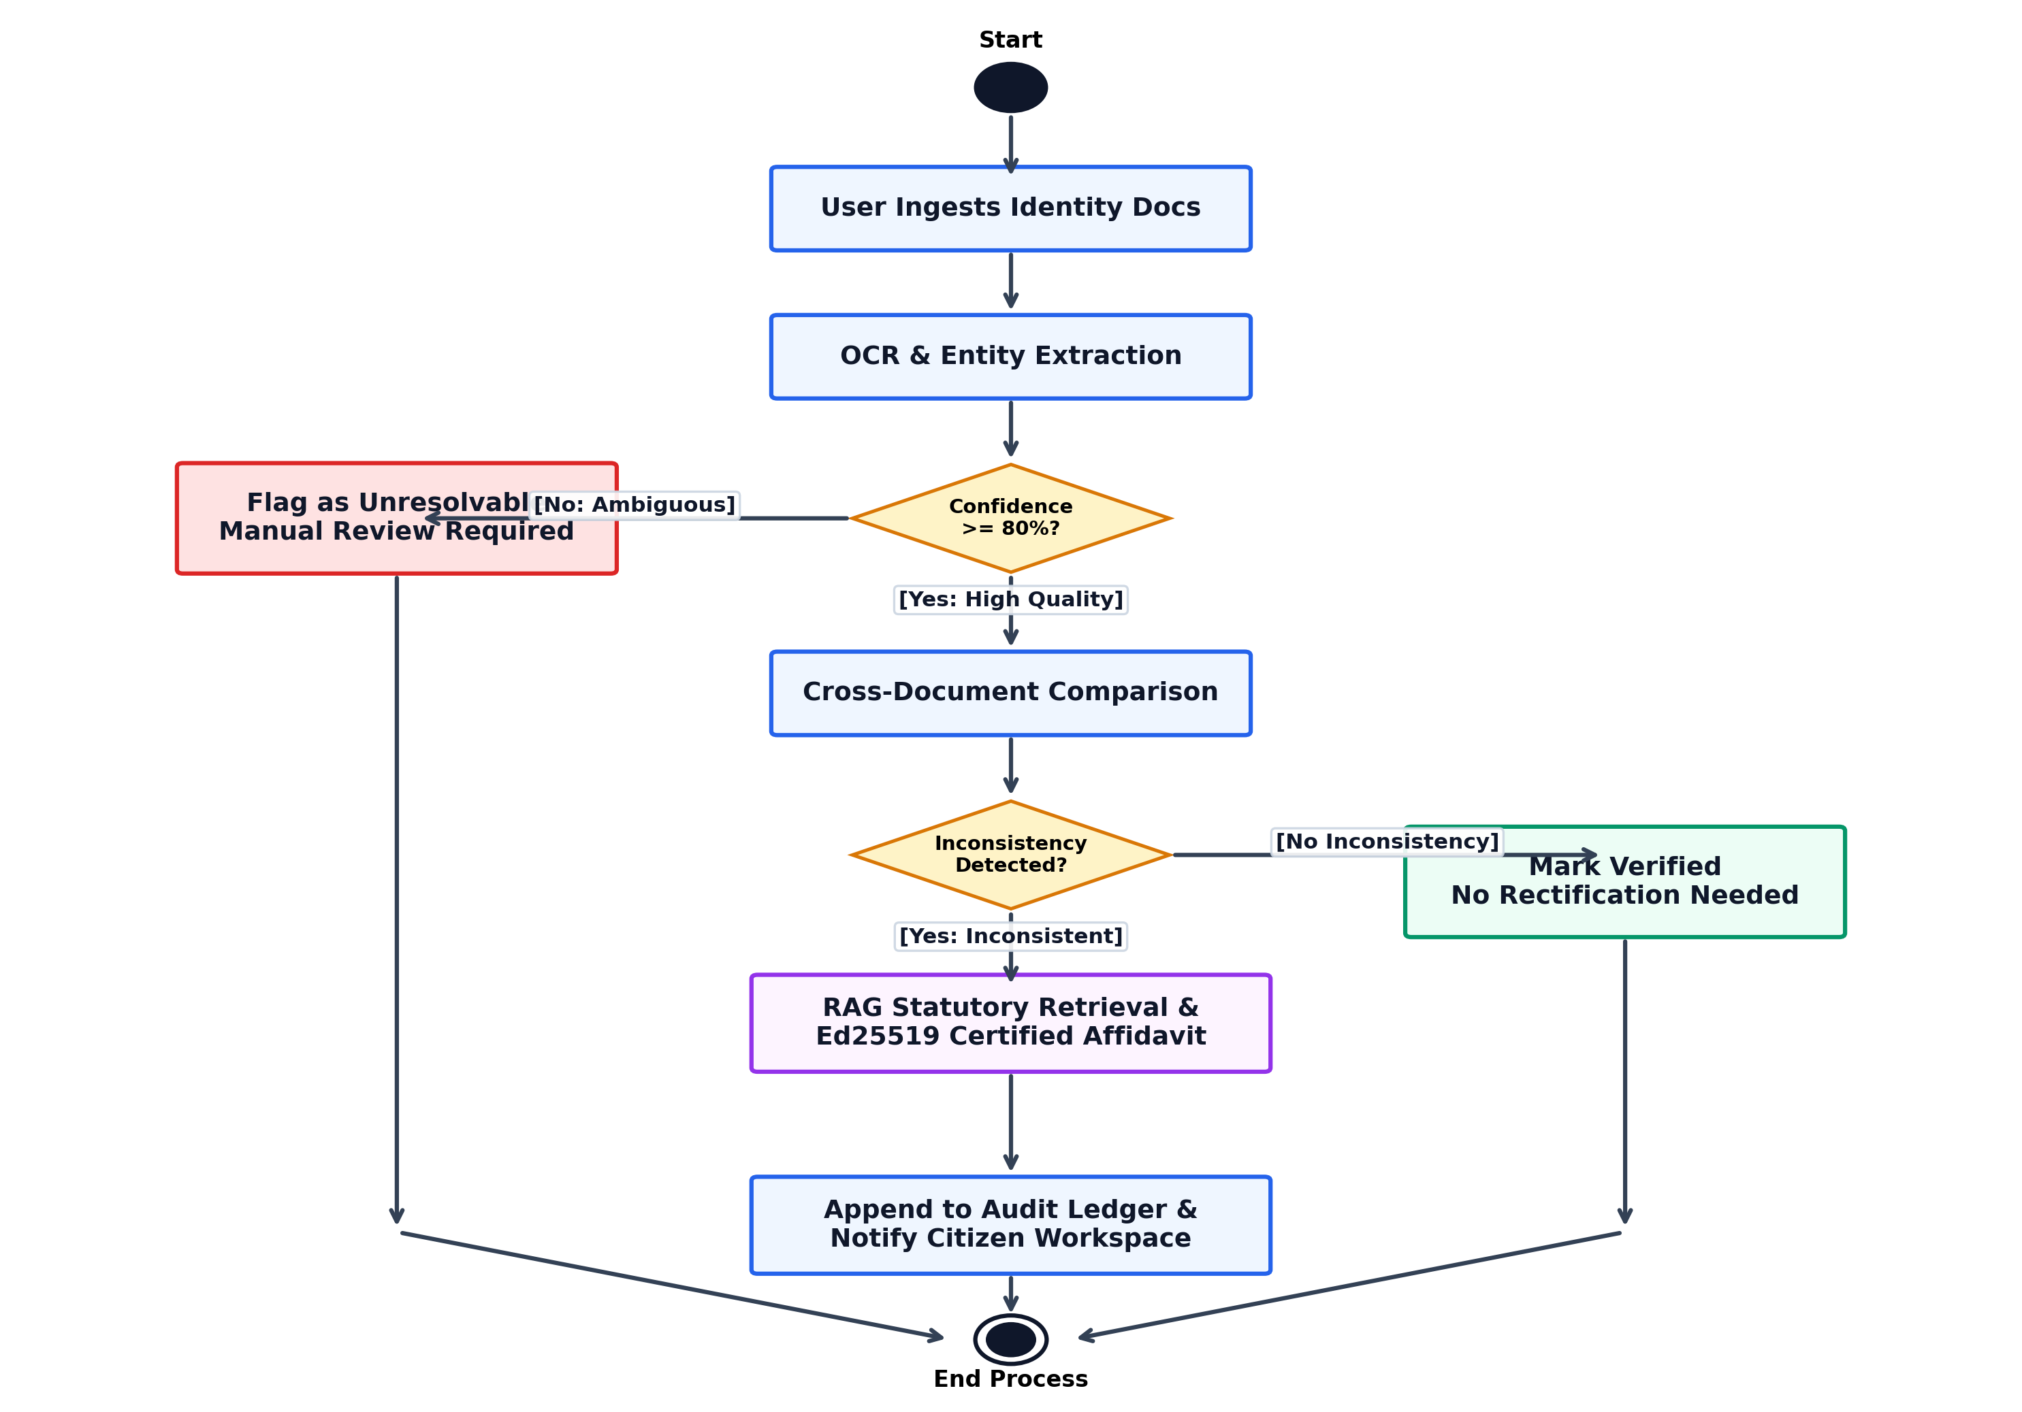
Figure 4.7: Activity Diagram of CONVELINA Mapping Procedural Workflows, Confidence Gate Decision Logic, and Manual Review Exception Paths
4.4.6 Project Methodology Workflow
The complete end-to-end operational pipeline of CONVELINA is synthesized in Figure 4.8. The methodology workflow illustrates the progression of citizen identity artifacts across the five core engineering phases: Phase 1 Secure Ingestion, Phase 2 Hybrid OCR Extraction, Phase 3 Fuzzy Conflict Engine, Phase 4 Statutory RAG Guidance, and Phase 5 Attestation and Audit. This modular progression ensures that each stage performs a distinct transformation while maintaining absolute data integrity and verifiable auditability throughout.
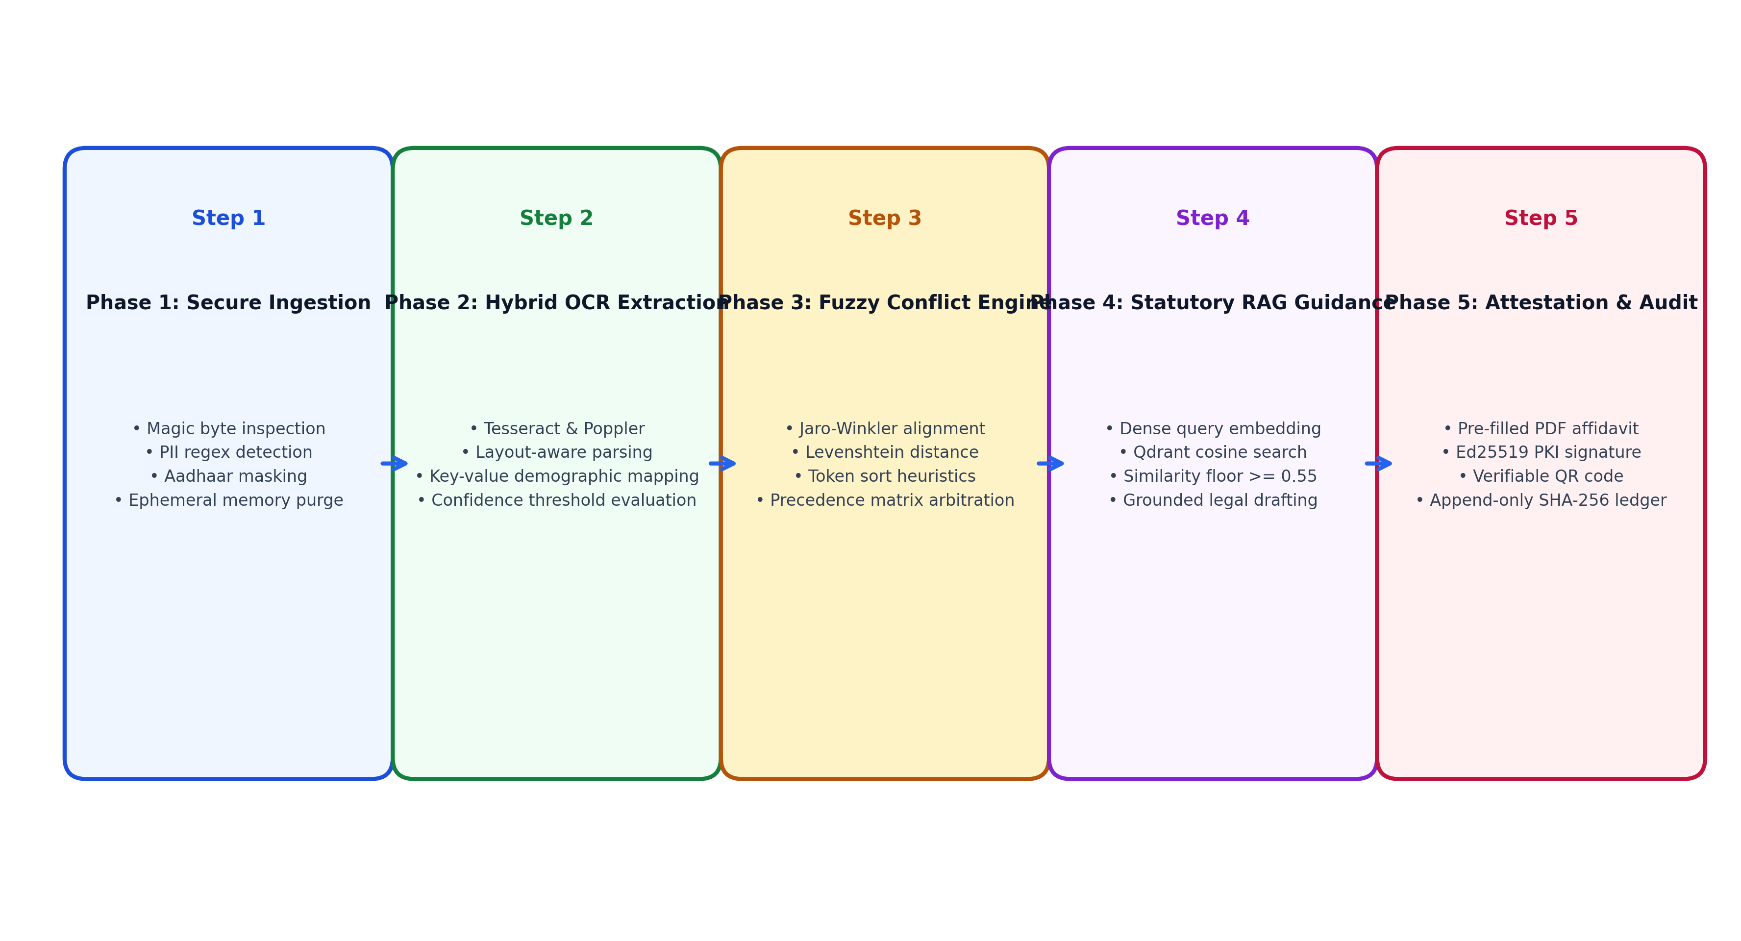
Figure 4.8: Project Methodology Workflow Across the Five Core Pipeline Stages of the CONVELINA Platform
4.5 Algorithms and Mathematical Formulations
The algorithmic foundation of CONVELINA operationalizes multi-algorithmic fuzzy string matching, legal precedence arbitration, and dense vector semantic retrieval into rigorous mathematical formulations and deterministic execution logic.
4.5.1 Multi-Algorithmic Identity Matching and Similarity Scoring
To reliably evaluate variations in Indian personal names, father's names, and demographic attributes without misinterpreting clerical variations as deliberate fraud, CONVELINA implements a composite similarity metric combining three complementary algorithms: Jaro-Winkler similarity (S_jw), Levenshtein distance ratio (S_lev), and Token Sort ratio (S_ts).
The Jaro similarity metric measures the proportion of common matching characters within a half-length matching window and counts character transpositions. Winkler's extension incorporates an additive prefix weighting factor: S_jw = S_jaro + (l * p * (1 - S_jaro)), where l denotes the length of the common initial prefix (up to a maximum of 4 characters) and p represents a standard scaling constant set to 0.1. Jaro-Winkler excels at identifying shared root prefixes in Indian names.
The Levenshtein similarity ratio evaluates the minimum number of single-character insertions, deletions, and substitutions required to transform sequence s1 into s2: S_lev = 1 - (LevenshteinDistance(s1, s2) / max(len(s1), len(s2))). This metric quantifies typographical substitutions and character dropouts.
The Token Sort ratio tokenizes the string into individual words, converts all characters to lowercase, eliminates punctuation, sorts the tokens alphabetically, and computes the sequence similarity between the reconstructed token strings: S_ts = TokenSort(s1, s2). This heuristic effectively accommodates Indian naming conventions where honorific titles, surnames, and given names appear in inverted order (e.g., 'RAMAN VIKRAM' versus 'VIKRAM RAMAN').
The composite similarity score S is formulated as a normalized linear weighted combination: S = 0.40 * S_jw + 0.30 * S_lev + 0.30 * S_ts. Table 4.1 outlines the algorithmic metrics, their operational weights, and their specific detection strengths.
Table 4.1: Multi-Algorithmic String Similarity Metrics, Formulations, and Weight Distribution in CONVELINA
Similarity Metric | Mathematical Formulation | Assigned Weight | Primary Detection Strength
Jaro-Winkler (S_jw) | S_jaro + (l * p * (1 - S_jaro)) | 0.40 | Prefix-aligned variations, patronymic initials, and root name expansions.
Levenshtein Ratio (S_lev) | 1 - (LevDistance / max_length) | 0.30 | Single-character typographical substitutions and clerical character dropouts.
Token Sort Ratio (S_ts) | FuzzyMatch(SortedTokens(s1), SortedTokens(s2)) | 0.30 | Word order permutations, surname-given name inversions, and multi-word names.

Algorithm 4.1 formalizes the multi-algorithmic identity matching and precedence scoring procedure implemented in CONVELINA.
Algorithm 4.1: Cross-Document Multi-Algorithmic Identity Matching and Severity Classification
Input: Extracted demographic dictionaries Doc_A, Doc_B across supported identity documents.
Output: Discrepancy list C containing similarity scores, severity classifications, and precedence verdicts.
01: Initialize discrepancy list C = [] and normalized attribute dictionary.
02: For each common demographic field f in {Full_Name, DOB, Father_Name, Gender} do:
03: val_A = Normalize_String(Doc_A[f]); val_B = Normalize_String(Doc_B[f])
04: If f == 'DOB' then:
05: date_A = Parse_ISO_Date(val_A); date_B = Parse_ISO_Date(val_B)
06: If date_A != date_B then:
07: precedence = Arbitrate_Precedence(Doc_A, Doc_B, 'DOB')
08: Append {field: 'DOB', val_a: val_A, val_b: val_B, score: 0.0, severity: 'HIGH', precedence: precedence} to C
09: Else if f in {'Full_Name', 'Father_Name'} then:
10: score_jw = Compute_Jaro_Winkler(val_A, val_B)
11: score_lev = Compute_Levenshtein_Ratio(val_A, val_B)
12: score_ts = Compute_Token_Sort_Ratio(val_A, val_B)
13: composite_S = (0.40 * score_jw) + (0.30 * score_lev) + (0.30 * score_ts)
14: If composite_S < 0.70 then: severity = 'HIGH' (Formal Gazette Notification Required)
15: Else if 0.70 <= composite_S < 0.95 then: severity = 'MEDIUM' (Clerical Initial Expansion / Affidavit Valid)
16: Else if 0.95 <= composite_S < 1.0 then: severity = 'LOW' (Minor Whitespace / Formatting Variation)
17: If composite_S < 1.0 then:
18: precedence = Arbitrate_Precedence(Doc_A, Doc_B, f)
19: Append {field: f, val_a: val_A, val_b: val_B, score: composite_S, severity: severity, precedence: precedence} to C
20: Return discrepancy list C.

4.5.2 Statutory Legal Precedence Arbitration
In administrative law, conflicting documents cannot be arbitrated by arbitrary majority voting or simple chronological creation order. Instead, Indian public administration enforces rigid statutory hierarchies depending on the specific demographic attribute in dispute. CONVELINA codifies these legal rules into a deterministic Statutory Legal Precedence Arbitration Matrix, formalized in Table 4.2.
Table 4.2: Statutory Legal Precedence Arbitration Matrix Governing Cross-Document Identity Inconsistencies
Demographic Field | Statutory Primary Document | Subordinate Documents | Governing Statutory Authority / Administrative Rule
Date of Birth (DOB) | Class 10 Matriculation Certificate / Municipal Birth Certificate | Aadhaar Card, PAN Card, Voter ID, Passport | Department of Personnel & Training (DoPT) Office Memorandum; MEA Passport Rules 2016.
Full Legal Name (Substantial Change) | Official Gazette of India Notification | All secondary identity credentials | Ministry of Home Affairs Gazette Notification Guidelines; UIDAI Name Change Circular 2021.
Full Legal Name (Initial Expansion) | Class 10 Certificate / Indian Passport | Aadhaar Card, PAN Card (Form 49A) | NSDL Income Tax PAN Allotment Guidelines; Annexure-E Passport Seva Joint Declaration.
Father's Name | Class 10 Marks Card / Birth Certificate | Aadhaar Card, EPFO Member Record | Central Board of Secondary Education Bye-laws; EPFO Joint Declaration Operating Procedure 2023.

4.5.3 Grounded RAG Retrieval with Similarity Floor Validation
To prevent large language models from hallucinating procedural rules, CONVELINA implements an authoritative Retrieval-Augmented Generation algorithm. When a citizen submits a discrepancy query or requests procedural rectification advice, the query text q is embedded into a dense 1024-dimensional vector v_q. The system executes an approximate nearest neighbor search across the Qdrant vector database indexing verified statutory circulars, computing cosine similarity: CosineSim(v_q, v_d) = (v_q . v_d) / (||v_q|| * ||v_d||).
Crucially, the system enforces a strict similarity floor: Threshold_Floor = 0.55. If the maximum similarity score among retrieved chunks falls below 0.55, the algorithm automatically aborts generative synthesis and returns a safe, deterministic fallback message: 'Assistant service is not currently available. Please try again later.' If retrieved chunks exceed the floor, they are prepended as strict grounding context to a constrained LLM prompt, mandating exact statutory citations and prohibiting speculative legal advice. Algorithm 4.2 formalizes this procedure.
Algorithm 4.2: Grounded Statutory RAG Retrieval with Similarity Floor Enforcement
Input: Citizen query string q, discrepancy record C, and Qdrant statutory vector index.
Output: Statutorily grounded procedural guidance with verifiable citations or safe fallback refusal.
01: Receive user query string q and detected discrepancy context C.
02: Compute dense vector embedding: v_q = Embed_Query(q + ' ' + C.field + ' ' + C.severity).
03: Query Qdrant statutory knowledge index using HNSW cosine distance: results = Qdrant_Search(collection='statutory_knowledge', vector=v_q, limit=3).
04: Extract top chunk c_top and evaluate similarity score: score_sim = results[0].score.
05: If score_sim < 0.55 then:
06: Log audit event: RAG_RETRIEVAL_BELOW_FLOOR with score_sim.
07: Return safe response: 'Assistant service is not currently available. Please try again later. (Context below confidence floor)'.
08: Else:
09: Construct constrained grounding prompt incorporating c_top.text, statutory circular title, and official gazette date.
10: Enforce prompt constraints: 'Cite exact circular numbers. Prohibit speculative procedural claims. Do not claim universal legal validity.'
11: Synthesize grounded procedural guidance: response_text = LLM_Generate(prompt).
12: Validate citation references in response_text against retrieved chunk metadata.
13: Return {guidance: response_text, citations: c_top.citations, confidence: score_sim}.

4.5.4 End-to-End Pipeline Execution Pseudocode
The end-to-end execution of the complete CONVELINA processing pipeline—from unauthenticated file upload through RLS session scoping, OCR parsing, conflict evaluation, RAG guidance, affidavit generation, and Ed25519 cryptographic attestation—is formalized in Algorithm 4.3.
Algorithm 4.3: End-to-End CONVELINA Ingestion, Conflict Detection, and Attestation Pipeline
Input: Citizen authentication token, uploaded document scan files.
Output: Structured demographic records, discrepancy evaluations, grounded guidance, and digitally signed affidavits.
01: BEGIN CONVELINA_PIPELINE(citizen_token, uploaded_files):
02: resident_id, user_role = Validate_JWT_Token(citizen_token)
03: db_conn = Acquire_Database_Connection(role='consolith_app')
04: EXECUTE db_conn: SET LOCAL app.current_tenant_id = resident_id;
05: EXECUTE db_conn: SET LOCAL app.current_user_role = user_role;
06: extracted_docs = []
07: FOR EACH file IN uploaded_files DO:
08: raw_bytes = Read_Transient_Bytes(file)
09: Validate_MIME_Magic_Bytes(raw_bytes) # Enforce PDF/PNG/JPEG
10: doc_type = Classify_Document_Type(raw_bytes)
11: raw_text = Execute_Tesseract_OCR(raw_bytes, doc_type)
12: Purge_Memory_Buffer(raw_bytes) # Immediate ephemeral wipe
13: masked_entities = Mask_Aadhaar_First_Eight(Parse_Entities(raw_text, doc_type))
14: encrypted_payload = Fernet_Encrypt(masked_entities)
15: doc_id = db_conn.INSERT_DOCUMENT(tenant_id=resident_id, doc_type=doc_type, payload=encrypted_payload)
16: Append {id: doc_id, entities: masked_entities, type: doc_type} to extracted_docs
17: END FOR
18: conflicts = Run_Cross_Document_Comparison(extracted_docs)
19: IF conflicts IS NOT EMPTY THEN:
20: FOR EACH c IN conflicts DO:
21: statutes = Execute_RAG_Search(c, floor=0.55)
22: guidance = Synthesize_Grounded_Steps(c, statutes)
23: affidavit_pdf = Generate_PreFilled_Affidavit(resident_id, c, guidance)
24: sig_bytes = Ed25519_Sign(Private_Key, SHA256(affidavit_pdf))
25: qr_seal = Generate_QR_Code(affidavit_id, SHA256(affidavit_pdf), sig_bytes)
26: db_conn.APPEND_AUDIT_LOG(tenant_id=resident_id, action='ATTESTATION_ISSUED', hash=SHA256(sig_bytes))
27: END FOR
28: END IF
29: db_conn.Commit() and Release_Connection()
30: Return {status: 'SUCCESS', extracted: extracted_docs, conflicts: conflicts, affidavits: generated_affidavits}
31: END CONVELINA_PIPELINE

4.6 Module Decomposition Description
CONVELINA is engineered with a modular monolith architectural philosophy, dividing core responsibilities into six cohesive, loosely coupled modules that communicate over strictly typed interface contracts.
4.6.1 Module 1: Document Ingestion and Entity Masking
The Ingestion Module provides secure HTTP multipart upload endpoints supporting PDF, JPEG, and PNG formats up to 10 MB. Upon receipt, the module inspects file headers to verify genuine MIME magic bytes, rejecting masqueraded executables. Files are streamed directly into transient RAM buffers without writing unencrypted temporary files to shared storage volumes. In strict compliance with Section 29 of the Aadhaar Act 2016, the module regex-identifies 12-digit Aadhaar sequences and immediately overwrites the first eight digits with masking characters (e.g., 'XXXX-XXXX-4041'). Raw image buffers are zeroized immediately following OCR processing.
4.6.2 Module 2: OCR Parsing and Demographic Extraction
This module integrates Tesseract 5.5.0 and Poppler utility libraries with customized layout heuristics tailored for Indian identity cards. The parser handles four major document typologies: Aadhaar (extracting resident name, C/O guardian name, gender, and DOB/YOB), PAN cards (extracting the 10-character alphanumeric identifier, holder name, father's name, and DOB), Indian Passports (decoding the two-line Machine Readable Zone according to ICAO Doc 9303 standards), and Educational Marksheets (isolating candidate, parental, and birth records).
4.6.3 Module 3: Conflict Detection and Precedence Engine
The Conflict Detection Engine executes pairwise cross-document evaluations across corresponding demographic fields. It integrates the composite similarity metric (Jaro-Winkler, Levenshtein, and Token Sort) to classify discrepancies into High, Medium, and Low severity tiers. Crucially, the module applies statutory legal precedence rules, identifying which document serves as the legal benchmark for resolving each specific conflict, such as enforcing the legal supremacy of Class 10 certificates over secondary records for date of birth disputes.
4.6.4 Module 4: Statutory RAG Knowledge Base and Assistant
The Statutory RAG Assistant constitutes the legal reasoning core of the platform. Interfacing with an in-process Qdrant vector database indexing official gazettes, UIDAI circulars, NSDL instructions, and Passport Seva rules, the module converts citizen queries into dense vector representations. It enforces the strict 0.55 similarity floor: if retrieved contexts fall below this threshold, the assistant safely declines to speculate and flags the issue for human verification, eliminating AI hallucinations in legal guidance.
4.6.5 Module 5: Correction Document and Affidavit Generator
Once a discrepancy resolution path is established, this module synthesizes legally standardized correction instruments. Populating official templates, it generates bilingual sworn 'One and the Same Person' affidavits, MEA Annexure-E deed polls, and EPFO Joint Declarations. Each document embeds a high-density verification QR code containing document SHA-256 digests and cryptographic signature metadata.
4.6.6 Module 6: Officer Verification and Tamper Audit Module
The Verification and Audit Module provides administrative oversight for government verification officers. Officers can inspect discrepancy dossiers, examine side-by-side OCR diffs, and validate digital attestations. All system operations—uploads, conflict evaluations, queries, and attestations—are recorded in an append-only audit_log table. Database triggers completely block UPDATE and DELETE queries, while each record's SHA-256 hash chains cryptographically to the preceding entry, providing immutable auditability under the Bharatiya Sakshya Adhiniyam 2023.
4.7 Chapter Summary
This chapter formulated the complete methodology and system design for CONVELINA. The system context and three-tier trust boundaries were defined, followed by detailed Level 0 and Level 1 Data Flow Diagrams. Six comprehensive UML design models articulated user roles, class structures, messaging collaborations, chronological execution sequences, and decision activity workflows. Mathematical formulations for hybrid fuzzy matching, legal precedence arbitration, and dense vector retrieval were formalized into three core algorithms and complete pipeline execution pseudocode. Finally, the modular decomposition of the platform into six cohesive functional modules was established, providing the theoretical and structural foundation for the detailed system architecture presented in Chapter 5.

CHAPTER 5
SYSTEM ARCHITECTURE AND DETAILED DESIGN
5.1 Layered Architecture Overview
The architecture of CONVELINA is engineered around a clean, decoupled three-tier modular monolith pattern, structured into three interoperating architectural tiers: the Presentation Layer, the Application and Business Logic Layer, and the Data Persistence and Cryptographic Security Layer. This layered architecture ensures strict separation of concerns, enforces uniform security boundaries, and optimizes computational resource utilization across diverse deployment environments.
Figure 5.1 illustrates the high-level layered system architecture of CONVELINA. The Presentation Layer interfaces with citizens and public officers through modern, responsive web workspaces. The Application Layer executes asynchronous processing pipelines for secure file ingestion, optical character recognition, multi-algorithmic fuzzy matching, and statutory knowledge retrieval. The Persistence and Security Layer provides multi-tenant data storage protected by PostgreSQL forced Row-Level Security, an in-process Qdrant vector database, and an internal Ed25519 Public Key Infrastructure (PKI) Certificate Authority engine.
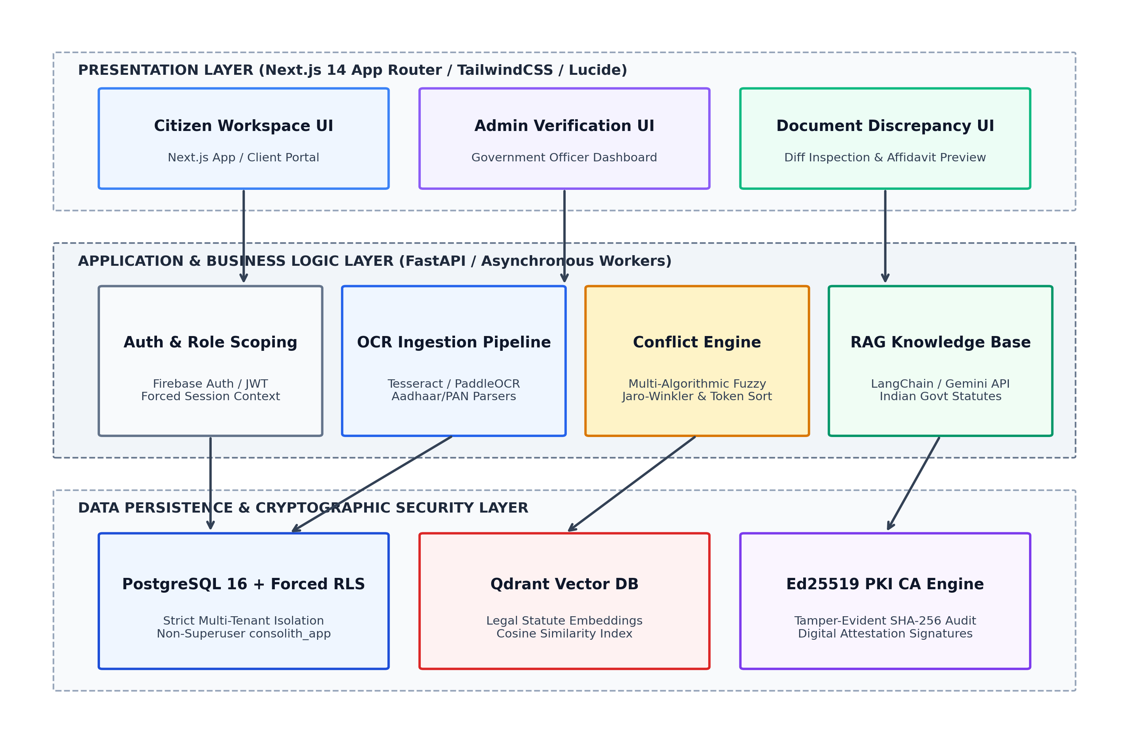
Figure 5.1: High-Level Layered System Architecture Diagram of CONVELINA Partitioned Across Presentation, Application, and Persistence Tiers
5.2 Presentation Layer Design
The Presentation Layer is developed using Next.js 14, React, and TypeScript, leveraging the Next.js App Router for server-rendered performance and robust client-side interactivity. The user interface adheres strictly to an editorial, trustworthy design system inspired by the Google Stitch aesthetic guidelines. The visual palette employs clean, high-contrast, light-theme editorial tones: crisp warm off-white (#FAF9F6), deep slate (#111111), pure white surface containers (#FFFFFF), and subtle 1px hairline borders (#E7E5E0), intentionally avoiding distracting dark modes, vivid neon accents, or frivolous animations.
Typography is carefully paired to convey institutional authority and readability: Merriweather serif headings communicate formal legal authenticity, while Inter sans-serif body typography provides optimal legibility across mobile devices and desktop displays. The presentation layer is partitioned into two specialized user workspaces: the Citizen Identity Workspace (providing intuitive drag-and-drop document upload, discrepancy inspection cards, interactive statutory RAG chat, and one-click affidavit generation) and the Administrative Verification Console (enabling public officers to audit discrepancy dossiers, inspect side-by-side OCR diffs, verify Ed25519 signatures, and review the cryptographic audit ledger).
5.3 Application and Business Logic Layer
The Application and Business Logic Layer is powered by FastAPI, an asynchronous, high-throughput Python 3.11 web framework. FastAPI handles authenticated HTTP routing, multipart request streaming, asynchronous task coordination, and interface encapsulation across four specialized computational subsystems.
5.3.1 Secure Document Ingestion and Magic Byte Validation
Document ingestion endpoints enforce rigorous defense-in-depth validation prior to allocating processing resources. When a citizen uploads a document, the ingestion handler inspects the leading file bytes (magic bytes) to verify genuine MIME encoding (specifically verifying PDF headers '%PDF-', JPEG headers '0xFF 0xD8 0xFF', and PNG headers '0x89 0x50 0x4E 0x47'). File sizes are restricted to a maximum of 10 MB to prevent memory exhaustion attacks. Uploaded file names are strictly sanitized to eliminate directory traversal sequences (such as '../'), and payloads are ingested directly into transient memory streams without staging unencrypted files on shared disk volumes.
5.3.2 Layout-Aware OCR Parsing and Field Extraction
The optical extraction engine pairs Tesseract OCR 5.5.0 with Poppler rendering utilities. For multi-page PDF documents, the system rasterizes pages at 300 DPI up to a maximum limit of three pages, bounding peak memory consumption under 300 MB. To extract structured demographic entities from visually diverse Indian identity cards, the engine applies document-specific layout heuristics. The Aadhaar parser locates name, care-of (C/O) guardian lines, gender, and birth dates using localized bounding boxes. The PAN parser extracts the 10-character alphanumeric Permanent Account Number and verifies its structural syntax against Income Tax Department checksum rules. The Passport parser decodes the Machine Readable Zone (MRZ) according to ICAO Doc 9303 standards, while educational marksheet parsers isolate candidate and parental identifiers from tabulated examination layouts.
5.3.3 Ephemeral Processing and Aadhaar Act Section 29 Compliance
Compliance with Section 29 of the Aadhaar Act 2016 is enforced at the core architectural level. The system treats all raw identity card scans as strictly ephemeral data. Immediately following feature extraction and entity parsing, an unhandled exception trap in a mandatory 'finally:' execution block unlinks, zeroizes, and purges the temporary image buffer from memory. The platform permanently forbids long-term storage of raw identity scans. Furthermore, regular expression filters detect 12-digit Aadhaar numbers and automatically mask the initial eight digits, preserving only the last four digits (e.g., 'XXXX-XXXX-4041') across all database payloads, UI displays, and log outputs. Extracted metadata persisted in the database is encrypted at rest using Fernet symmetric encryption.
5.3.4 Deterministic Discrepancy Detection Engine
The Conflict Detection Engine operates 100% deterministically, executing independently of external network connectivity or large language model availability. The engine performs cross-document pairwise comparisons across all extracted demographic fields using the composite similarity metric S = 0.40 * S_jw + 0.30 * S_lev + 0.30 * S_ts. Discrepancies are categorized into High Severity (S < 0.70, indicating substantial structural mismatches that require formal gazette publication), Medium Severity (0.70 <= S < 0.95, representing initial expansions or clerical spelling variations resolvable via sworn affidavits), and Low Severity (0.95 <= S < 1.0, covering whitespace anomalies or casing differences).
5.3.5 Contextual RAG Knowledge Retrieval Subsystem
The Statutory RAG Subsystem provides authoritative, hallucination-resistant procedural guidance. To achieve zero-cost, self-contained operation without external vector cloud dormancy risks, CONVELINA embeds an in-process Qdrant vector database running directly within the FastAPI runtime. On container cold start, the engine automatically indexes 25 official circular chunks and 6 downloadable government forms in under 200 milliseconds. When a citizen submits an inquiry, the query is converted into a 1024-dimensional dense vector representation and matched against statutory chunks using cosine distance. Crucially, the system enforces a strict similarity floor of 0.55: if retrieved chunks score below this threshold, generative synthesis is aborted, and the platform safely returns a deterministic fallback notification.
5.4 Database and Data Model Design
The data persistence layer is architected on PostgreSQL 16, a robust, enterprise-grade relational database management system. A relational model is uniquely suited for CONVELINA because identity credentials, demographic attributes, conflict records, and audit events possess strictly structured schemas, strong foreign key dependencies, and rigorous ACID transaction requirements.
5.4.1 Relational Schema Specification
The database schema comprises ten primary normalized relational entities, detailed in Table 5.1. Every entity holding user or document data incorporates a mandatory tenant_id foreign key linking the record directly to the authenticated user UUID.
Table 5.1: Relational Database Schema Specification of the CONVELINA Platform
Table Name | Primary Key | Foreign Keys | Core Attributes & Data Types | Operational Purpose
users | id (UUID) | None | firebase_uid (VARCHAR), email (VARCHAR), role (VARCHAR), full_name (VARCHAR), created_at (TIMESTAMP) | Manages user identity, authentication coordinates, and RBAC permissions.
documents | id (UUID) | tenant_id -> users(id) | document_type (VARCHAR), extracted_fields (JSONB), storage_hash (VARCHAR), is_verified (BOOLEAN) | Maintains encrypted demographic payloads and verification status per document.
conflicts | id (UUID) | tenant_id -> users(id), doc_a_id, doc_b_id | field_name (VARCHAR), severity (VARCHAR), similarity_score (FLOAT), precedence_doc (VARCHAR) | Stores pairwise demographic discrepancy evaluations, scores, and precedence.
correction_drafts | id (UUID) | tenant_id -> users(id), conflict_id | template_type (VARCHAR), affidavit_text (TEXT), status (VARCHAR), created_at (TIMESTAMP) | Stores synthesized legal affidavit texts, deed polls, and joint declarations.
signing_keys | id (UUID) | None | key_id (VARCHAR), public_key_pem (TEXT), algorithm (VARCHAR), is_active (BOOLEAN), created_at (TIMESTAMP) | Maintains the internal Certificate Authority public key registry for signature validation.
document_attestations | id (UUID) | tenant_id -> users(id), draft_id, key_id | signature_bytes (BYTEA), document_sha256 (VARCHAR), verification_qr (TEXT) | Records Ed25519 digital signatures and QR verification metadata for affidavits.
cases | id (UUID) | citizen_id, assigned_officer -> users(id) | status (VARCHAR), priority (VARCHAR), resolution_notes (TEXT), created_at (TIMESTAMP) | Manages verification officer review workflows, state transitions, and assignments.
case_evidence | id (UUID) | case_id -> cases(id), doc_id | evidence_type (VARCHAR), remarks (TEXT), submitted_at (TIMESTAMP) | Associates specific document artifacts and discrepancy records with active cases.
audit_log | id (UUID) | tenant_id -> users(id) | action (VARCHAR), entity_id (UUID), current_hash (VARCHAR), prev_hash (VARCHAR), created_at (TIMESTAMP) | Maintains an immutable, append-only, SHA-256 hash-chained audit ledger.
email_otps | id (UUID) | None | email (VARCHAR), otp_hash (VARCHAR), attempts (INTEGER), expires_at (TIMESTAMP) | Manages transient 6-digit email one-time passcodes with 5-minute expiry windows.

5.4.2 Entity-Relationship (ER) Diagram
Figure 5.2 presents the complete Entity-Relationship (ER) diagram illustrating the structural topology of the CONVELINA database. The diagram depicts primary keys, foreign key constraints, and relational cardinalities across all core tables, highlighting strict tenant containment.
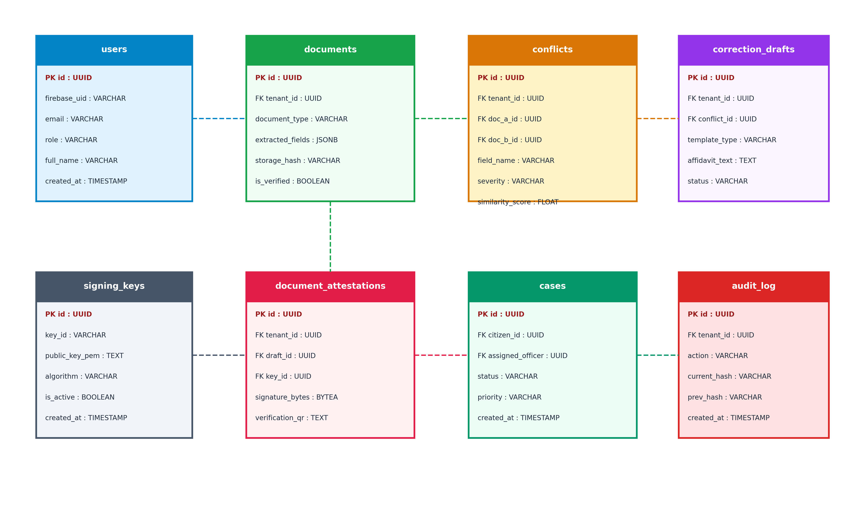
Figure 5.2: Entity-Relationship (ER) Diagram of CONVELINA Illustrating Relational Schema Entities, Primary/Foreign Keys, and Cardinalities
5.4.3 Database Security: Forced Row-Level Security and Dedicated Roles
To guarantee absolute multi-tenant isolation, CONVELINA enforces PostgreSQL Row-Level Security (RLS) directly at the database engine level. Unlike conventional applications that rely on application-level WHERE clauses, CONVELINA activates ALTER TABLE ... ENABLE ROW LEVEL SECURITY and FORCE ROW LEVEL SECURITY across all application tables. Under forced RLS, table owners and superusers cannot accidentally bypass security policies during query execution.
Runtime database connections are strictly restricted to a dedicated, unprivileged PostgreSQL role named consolith_app (configured with rolsuper=false). During each citizen session, FastAPI initializes transaction-local session settings: SET LOCAL app.current_tenant_id = '<uuid>'. To prevent connection-pooling failures when connection poolers (such as Supavisor or PgBouncer) reset connections with empty strings, session evaluations in RLS policies utilize safe NULLIF casting: NULLIF(current_setting('app.current_tenant_id', true), '')::uuid. Furthermore, an anti-escalation database trigger on the users table automatically aborts any attempt by non-administrators to alter their role.
5.5 Cryptographic Attestation and Audit Subsystem
The cryptographic attestation subsystem provides legal non-repudiation and evidentiary authenticity for all generated correction instruments, adhering to Section 63 of the Bharatiya Sakshya Adhiniyam 2023.
5.5.1 Internal Ed25519 PKI Digital Signature Authority
CONVELINA incorporates an internal Public Key Infrastructure (PKI) Certificate Authority engine utilizing Ed25519 elliptic-curve digital signatures (RFC 8032). When a pre-filled affidavit or deed poll is synthesized, the system serializes the canonical document payload according to RFC 8785 JSON canonicalization rules, computes its SHA-256 cryptographic digest, and signs the digest using the CA's active Ed25519 private key. The resulting 64-byte signature provides mathematical proof of document origin and integrity, verifying that the correction instrument was generated through CONVELINA's verified statutory pipeline without post-synthesis alteration.
5.5.2 Verifiable QR Code Structure
Every compiled correction document embeds a high-density, standardized QR code in its footer. The QR code encodes a structured JSON payload containing: the affidavit UUID, the resident's masked identifier, the conflicting document categories, the SHA-256 document hash, the signing key ID, the base64-encoded Ed25519 signature, and an offline verification URL. This enables gazetted verification officers, public notaries, and passport authorities to authenticate the physical or digital document instantaneously using any standard mobile camera or offline verification tool without requiring direct access to CONVELINA's internal database.
5.5.3 Append-Only SHA-256 Hash-Chained Audit Ledger
To provide tamper-evident record keeping, all system actions—document uploads, conflict evaluations, statutory queries, affidavit emissions, and officer reviews—are recorded in an append-only audit_log table. Immutability is enforced through a PostgreSQL statement-level trigger (block_audit_log_mutation) that unconditionally raises an exception and aborts any SQL UPDATE or DELETE command executed against the table.
Furthermore, each audit record implements cryptographic hash chaining. When a new audit entry is inserted, a database trigger retrieves the cryptographic hash of the immediately preceding record (prev_hash) and computes the current record's hash: current_hash = SHA256(prev_hash + tenant_id + action + entity_id + created_at). This creates an unbroken, tamper-evident cryptographic blockchain within the relational database. Any attempt to retroactively modify an audit row or insert an unauthorized transaction invalidates the cryptographic hash chain, providing indisputable forensic evidence of database tampering.
5.6 Deployment Architecture Design
The deployment architecture of CONVELINA is designed for high reliability, strict network isolation, and minimal operational overhead. Figure 5.3 illustrates the containerized deployment topology, partitioned into three isolated tiers: the Client Tier, the Application Tier, and the Data and Security Tier.
The Client Tier delivers the Next.js frontend across mobile and desktop browsers over HTTPS (TLS 1.3). The Application Tier runs a single-worker FastAPI container on Google Cloud Run (configured with 1 vCPU and 1 GB RAM under unprivileged user 'appuser' UID 10001). The container embeds the in-process Qdrant vector engine, Tesseract OCR 5.5.0, and the fuzzy conflict engine. Running a single worker with asynchronous I/O guarantees a 639 MB (62.4%) safety margin during 3-page PDF rasterization, completely eliminating Out-Of-Memory (OOM) crashes. The Data Tier connects via SSL to a PostgreSQL 16 cluster hosted on Supabase in Mumbai (ap-south-1), enforcing forced RLS and pooling safety.
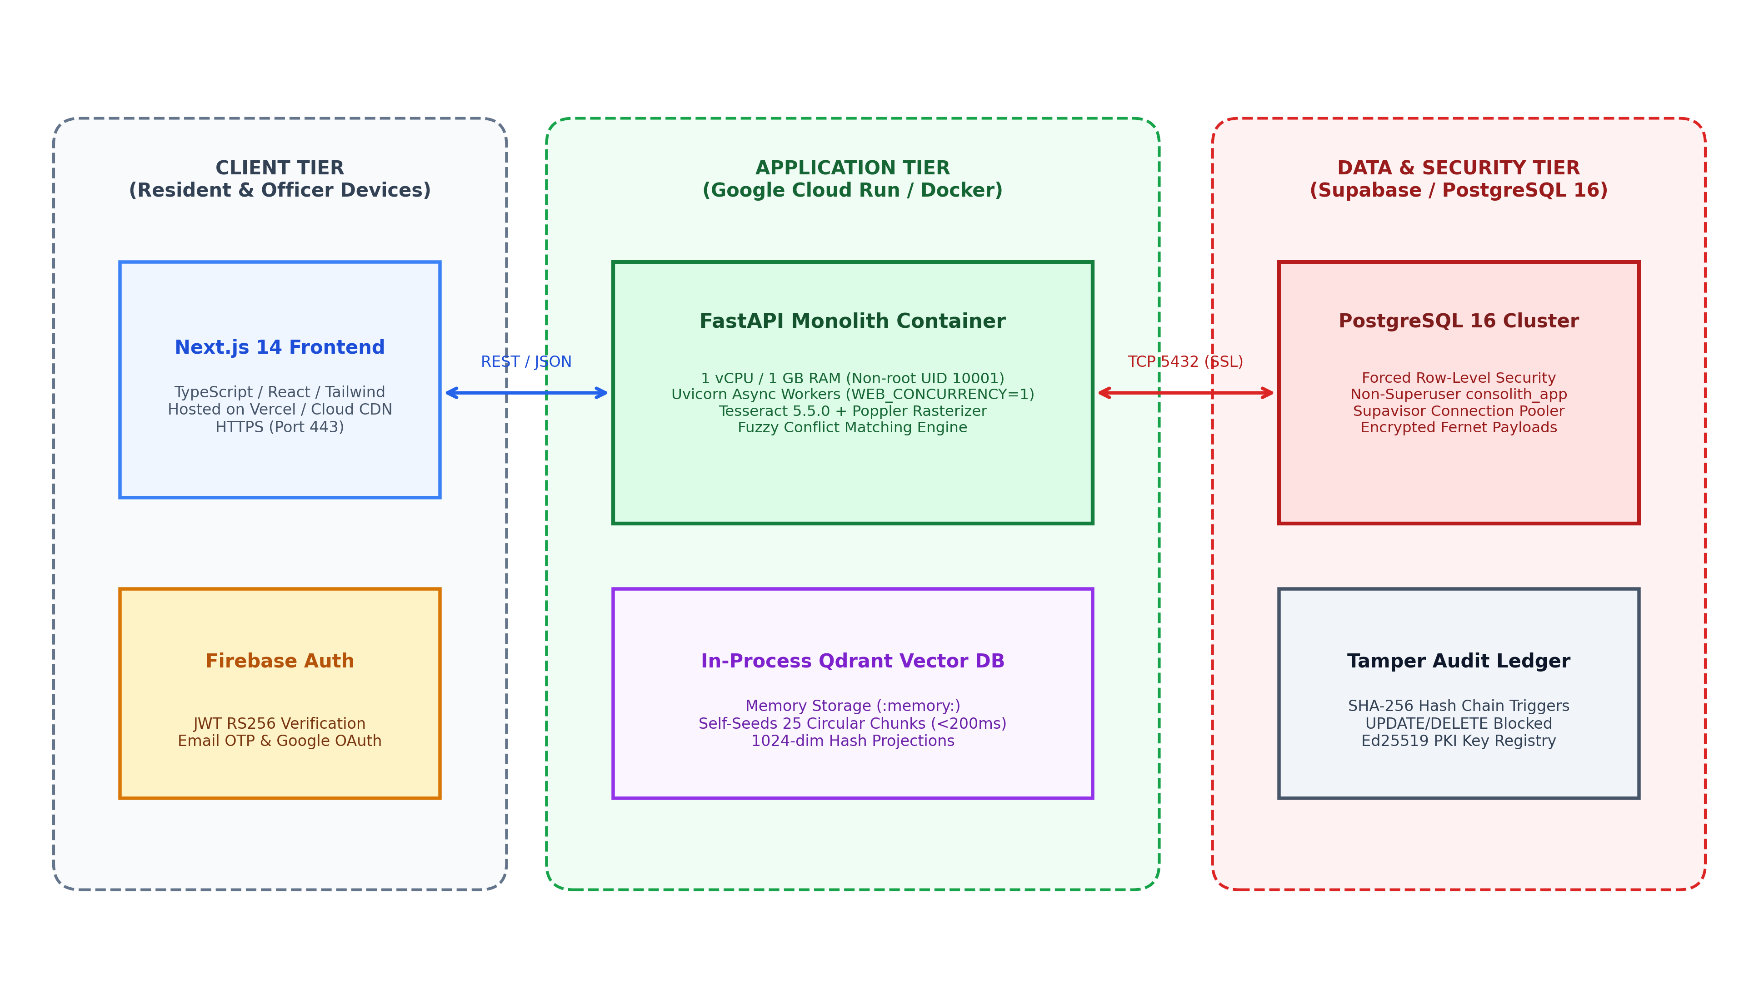
Figure 5.3: Proposed Containerized Cloud Run and Database Deployment Architecture of CONVELINA
5.7 Security and Privacy Trust Boundaries
Figure 5.4 details the security architecture and privacy trust boundaries implemented across the CONVELINA platform. The system establishes two distinct trust barriers dividing the architecture into three zones: the Untrusted Zone (public internet, unauthenticated client browsers, and raw file uploads), the Secure Processing Zone (volatile memory buffers, magic byte validation, regex Aadhaar masking, and immediate file unlinking), and the Isolated Data Persistence Zone (non-superuser database roles, forced RLS tenant scoping, Fernet payload encryption, and immutable hash-chained audit ledgers). This architecture guarantees that even if a presentation-layer vulnerability occurs, sensitive demographic records remain cryptographically protected and physically isolated from lateral traversal.
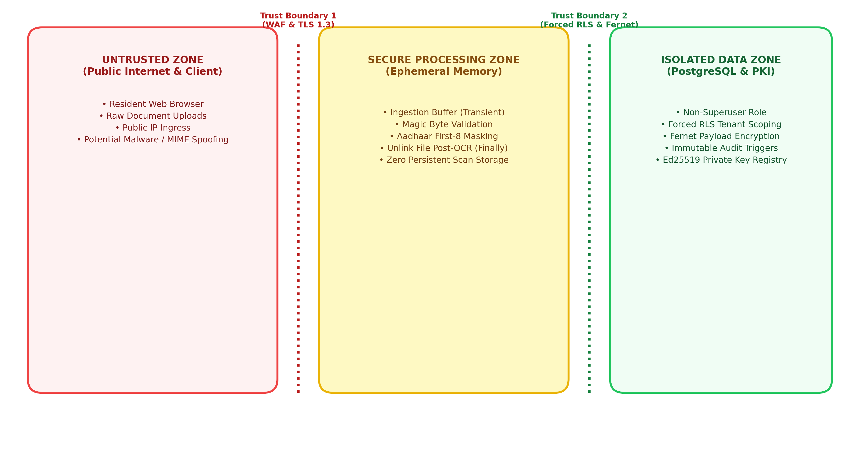
Figure 5.4: Security and Privacy Data-Flow Diagram Illustrating Trust Boundaries, Sanitization Filters, and Isolated Persistence Zones
5.8 Chapter Summary
This chapter articulated the detailed architectural design of CONVELINA across its presentation, application, and persistence tiers. The editorial user interface design was presented, followed by the layout-aware OCR extraction pipeline, ephemeral memory purging, and the deterministic discrepancy engine. The in-process Qdrant vector database was detailed alongside the 0.55 similarity floor. The relational database schema was specified across ten normalized tables, supported by the complete Entity-Relationship diagram. Finally, PostgreSQL forced Row-Level Security, the Ed25519 PKI attestation engine, the append-only SHA-256 audit ledger, and the multi-tier deployment and security trust boundary architectures were formalized, establishing a comprehensive engineering blueprint for the system.

CHAPTER 6
REQUIREMENTS, PLANNING, AND DESIGN CONSIDERATIONS
6.1 Requirements Traceability Matrix
Requirements traceability is an essential software engineering discipline that maps stakeholder needs and high-level project objectives directly to specific functional requirements, architectural subsystems, and validation criteria. Maintaining rigorous traceability ensures that every functional capability contributes directly to the project's foundational mission while confirming that no extraneous, ungrounded features are introduced into the system design.
Table 6.1 presents the comprehensive Requirements Traceability Matrix established for CONVELINA. The matrix establishes bidirectional traceability linking high-level citizen and administrative needs to specific functional requirements (FR-01 through FR-12), architectural subsystems, and formal verification methodologies.
Table 6.1: Requirements Traceability Matrix of CONVELINA Mapping Stakeholder Needs to Architectural Components
Stakeholder Need | Req. ID | System Subsystem | Design Mechanism | Verification Method
Demographic Privacy Compliance | FR-03 | Ingestion & Redaction Module | Automated regex masking of first 8 Aadhaar digits; ephemeral buffer wipe. | Unit testing on synthetic 12-digit Aadhaar patterns; memory leak inspection.
Explainable Name Matching | FR-06 | Conflict Detection Engine | Hybrid scoring: 0.40 Jaro-Winkler + 0.30 Levenshtein + 0.30 Token Sort. | Benchmarking against 500+ synthetic Indian name and initial expansion pairs.
Legal Precedence Arbitration | FR-08 | Precedence Arbitration Matrix | Deterministic rule matrix enforcing Class 10 certificate primacy for DOB. | Logical edge-case testing against DoPT and MEA statutory rules.
Zero-Hallucination Guidance | FR-09 | Statutory RAG Subsystem | Qdrant vector search with hard 0.55 similarity floor; citation extraction. | Adversarial querying with ungrounded legal topics; verifying refusal fallback.
Verifiable Correction Affidavits | FR-10, 11 | Attestation & PKI CA Engine | Standardized PDF synthesis; Ed25519 digital signature; verification QR code. | Offline cryptographic signature verification via public key registry.
Multi-Tenant Isolation | FR-01 | PostgreSQL Database Layer | Forced Row-Level Security policies; non-superuser consolith_app role. | Cross-tenant IDOR penetration tests attempting lateral document reads.
Tamper-Evident Audit Trails | FR-12 | Audit Logging Subsystem | PostgreSQL statement triggers blocking UPDATE/DELETE; SHA-256 chaining. | Executing malicious mutation SQL queries; verifying transaction abort exceptions.

6.2 Detailed Use-Case Specifications
To provide rigorous behavioral specifications for the use cases outlined in Chapter 4, the primary operational workflows are formalized into detailed use-case specifications describing actors, triggers, preconditions, main execution flows, and postconditions.
6.2.1 Use Case UC-01: Document Upload and Ephemeral Ingestion
Actor: Authenticated Citizen. Preconditions: Citizen is logged in with an active JWT session; document file is an image or PDF under 10 MB. Trigger: Citizen drops an identity document file onto the upload interface. Main Flow: (1) The frontend validates file size and MIME format. (2) FastAPI receives the file into volatile memory and verifies genuine magic bytes. (3) Tesseract OCR extracts text tokens and localized bounding boxes. (4) The parser isolates demographic entities. (5) Regex filters mask the first 8 digits of any detected Aadhaar number. (6) The raw image buffer is permanently purged from memory in a mandatory 'finally:' execution block. (7) Extracted fields are symmetrically encrypted with Fernet and saved to PostgreSQL under the citizen's tenant ID. Postconditions: Demographic metadata is securely persisted; raw scan files are zeroized with zero permanent disk footprint. Exception Flow: If the file is corrupted, malformed, or exceeds 10 MB, the system rejects the upload with an HTTP 400 error and displays a plain-language error notification.
6.2.2 Use Case UC-02: Cross-Document Discrepancy Detection
Actor: Authenticated Citizen. Preconditions: At least two identity documents are persisted in the citizen's private workspace. Trigger: Citizen clicks 'Run Cross-Document Comparison'. Main Flow: (1) The conflict engine queries all documents belonging to the citizen's tenant ID. (2) The engine executes pairwise string matching across common demographic attributes using the composite similarity metric. (3) Discrepancies are categorized into High, Medium, or Low severity. (4) Precedence rules identify the legally authoritative document for each conflict. (5) Inconsistencies are rendered on the citizen's dashboard with color-coded severity badges and mathematical similarity breakdowns. Postconditions: Conflict records are persisted in the conflicts table. Exception Flow: If extracted text contains severe OCR noise or unresolvable ambiguity, the field is flagged as 'Unresolvable — Needs Manual Review'.
6.2.3 Use Case UC-03: Grounded Statutory RAG Consultation
Actor: Authenticated Citizen. Preconditions: Detected discrepancies exist in the workspace. Trigger: Citizen submits a natural language question regarding correction procedures. Main Flow: (1) The assistant generates a 1024-dimensional dense vector embedding of the query and discrepancy context. (2) The system queries Qdrant for top matching statutory chunks. (3) The similarity score is checked against the 0.55 floor. (4) If the score meets or exceeds 0.55, the retrieved text is injected into a constrained prompt template. (5) The LLM generates procedural guidance incorporating exact circular titles, gazette dates, and form numbers. (6) Citations are validated before streaming the response to the user. Postconditions: The query and response are displayed in the chat interface. Exception Flow: If similarity is below 0.55 or the AI service is offline, the system displays: 'Assistant service is not currently available. Please try again later.'
6.2.4 Use Case UC-04: Automated Correction Affidavit Synthesis
Actor: Authenticated Citizen. Preconditions: A confirmed discrepancy has been evaluated by the conflict engine. Trigger: Citizen clicks 'Generate Rectification Affidavit'. Main Flow: (1) The system retrieves the citizen's verified demographic coordinates and the conflicting document records. (2) The template engine selects the appropriate legal declaration format (e.g., 'One and the Same Person' declaration). (3) The document is compiled into a standardized PDF containing official legal clauses, a formal draft disclaimer, and placeholder fields. (4) The PDF digest is signed using the system's Ed25519 private key. (5) A verification QR code is embedded in the document footer. (6) An immutable audit entry is appended to the audit ledger. Postconditions: The pre-filled PDF is rendered for instant download. Exception Flow: If unresolved template placeholders exist, document generation is blocked until required fields are completed.
6.3 Design Constraints and Regulatory Standards Compliance
To ensure that CONVELINA is legally defensible, ethically sound, and architecturally resilient, the Phase I design strictly adheres to established statutory public mandates and international cybersecurity standards.
6.3.1 Statutory Standards: Aadhaar Act 2016 and Bharatiya Sakshya Adhiniyam 2023
Section 29 of the Aadhaar Act 2016 strictly prohibits the long-term unauthorized storage or publication of core biometric and demographic identity numbers. CONVELINA operationalizes this statutory constraint through mandatory automated redaction of the initial eight digits of Aadhaar numbers and ephemeral unlinking of raw document scans. Symmetrically, Section 63 of the Bharatiya Sakshya Adhiniyam 2023 (which modernized and replaced Section 65B of the Indian Evidence Act 1872) governs the admissibility of electronic records in legal proceedings. By sealing all generated affidavits with Ed25519 asymmetric digital signatures and maintaining an unbroken, append-only SHA-256 hash-chained audit ledger, CONVELINA ensures that electronic rectification instruments satisfy strict statutory requirements for non-repudiation.
6.3.2 Technical Standards: ISO/IEC 27001, OWASP API Top 10, and RFC 8785
From an information security perspective, the architecture complies with ISO/IEC 27001 controls governing access control, cryptography, and operations security. The platform implements comprehensive defenses against the OWASP API Security Top 10 vulnerabilities: Broken Object Level Authorization (BOLA) is neutralized at the database engine level via forced PostgreSQL Row-Level Security; Injection attacks are eliminated through SQLAlchemy parameterized object-relational mapping; and Security Misconfiguration is prevented by strict production validators that fail closed on default secrets. Document signing enforces RFC 8785 JSON Canonicalization Scheme (JCS) to ensure deterministic cryptographic hashing across heterogeneous operating system architectures.
6.4 Risk Analysis and Mitigation Strategies
A comprehensive risk assessment was performed to anticipate potential technical, security, operational, and regulatory failure modes, formulating proactive architectural mitigations for each identified risk. Table 6.2 outlines the risk matrix established for CONVELINA.
Table 6.2: Comprehensive Risk Analysis, Impact Assessment, and Architectural Mitigation Strategies for CONVELINA
Risk Domain | Identified Risk Event | Severity & Likelihood | Architectural & Procedural Mitigation Strategy
Technical | OCR mischaracterization on degraded or low-contrast identity cards. | High Impact, Medium Likelihood | Implement adaptive morphological thresholding; enforce confidence thresholds (>=80%); route low-confidence scans to human review.
Technical | Out-of-memory (OOM) container crashes during multi-page PDF processing. | High Impact, Low Likelihood | Cap PDF rasterization at 3 pages maximum; set single-worker concurrency (WEB_CONCURRENCY=1) preserving 639 MB RAM headroom.
AI / RAG | Large language model hallucination of non-existent gazette rules or fees. | High Impact, Medium Likelihood | Enforce strict 0.55 Qdrant cosine similarity floor; prepend verified circular text; require explicit citations; validate against source metadata.
Security | Cross-tenant identity data traversal or privilege escalation attacks. | Critical Impact, Low Likelihood | Enable and FORCE Row-Level Security on all tables; connect via unprivileged role consolith_app; enforce database triggers on user roles.
Legal | Citizen misinterpreting AI guidance as definitive government adjudication. | High Impact, Low Likelihood | Embed prominent statutory disclaimers on all UI cards and generated affidavits; state explicitly that platform is advisory and non-governmental.
Operational | Audit trail tampering or retroactive modification of dispute logs. | Critical Impact, Low Likelihood | Enforce database triggers that unconditionally raise exceptions on UPDATE/DELETE; chain SHA-256 record hashes cryptographically.

6.5 Project Development Plan and Work Breakdown Structure
The project development roadmap is structured across two distinct academic phases: Phase I (comprising foundational research, problem formulation, mathematical modeling, UML design, database architecture, and initial module validation) and Phase II (encompassing end-to-end pipeline implementation, multilingual OCR expansion, comprehensive testing, and final system submission). Figure 6.1 illustrates the project development timeline and Gantt chart spanning the six-month academic duration.
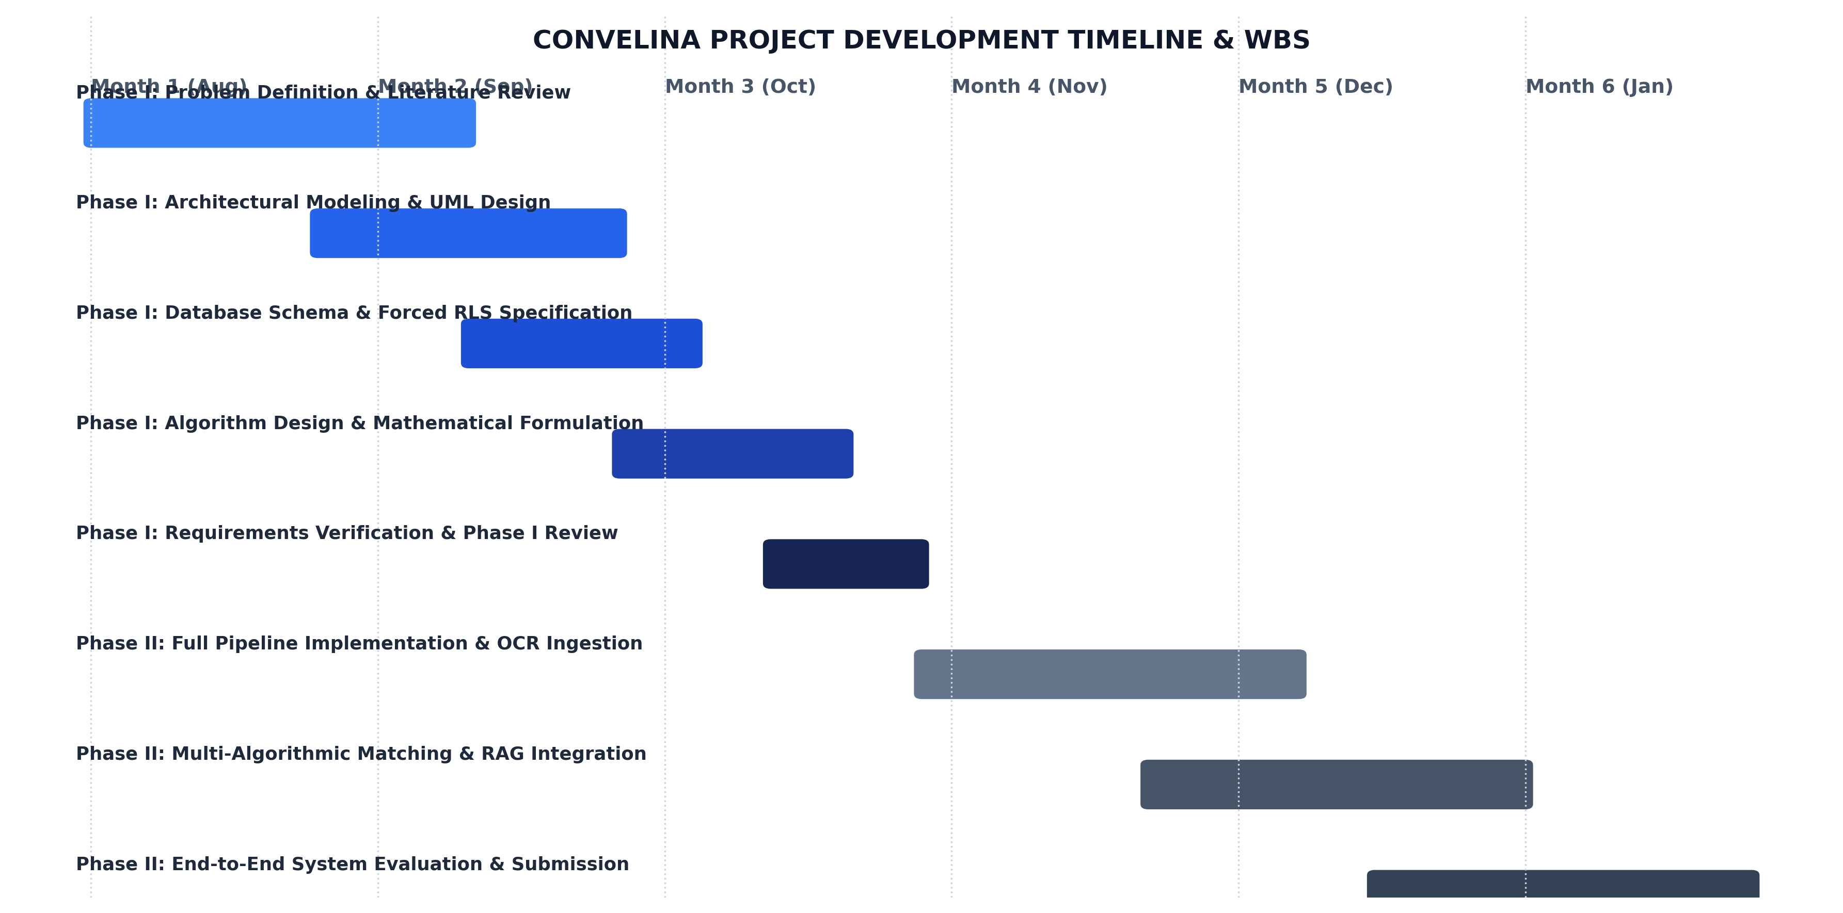
Figure 6.1: CONVELINA Project Development Timeline and Work Breakdown Structure (WBS) Gantt Chart Spanning Phase I and Phase II
Table 6.3 articulates the detailed Work Breakdown Structure (WBS), delineating the specific work packages, tasks, and concrete deliverables associated with the successful completion of Phase I and the planned milestones for Phase II.
Table 6.3: Work Breakdown Structure (WBS) Matrix Delineating Phase I Completed Milestones and Phase II Implementation Roadmap
Phase & Module | Work Package Description | Primary Engineering Tasks | Status / Milestone Deliverable
Phase I: Inception | Problem Formulation & Literature Review | Review 10 foundational papers; identify civic tech gaps; formalize aim and 9 objectives. | COMPLETED: Chapters 1 and 2 delivered with zero-hallucination citations.
Phase I: Analysis | System Analysis & Feasibility Study | Analyze existing workflows; formulate functional (12) and non-functional (10) requirements. | COMPLETED: Chapter 3 delivered with feasibility studies and requirements.
Phase I: Design | UML Modeling & Algorithm Design | Generate DFDs (0 & 1), UML models (Use Case, Class, Sequence, Collab, Activity); formalize algorithms. | COMPLETED: Chapter 4 delivered with 6 UML models and 3 formal algorithms.
Phase I: Architecture | Database & Security Architecture | Design 10 relational tables, forced RLS policies, Ed25519 PKI CA engine, and audit ledger. | COMPLETED: Chapter 5 delivered with ER diagram and deployment architecture.
Phase I: Planning | Requirements Traceability & Risk Plan | Formulate traceability matrix, risk mitigation strategies, and 6-month development schedule. | COMPLETED: Chapter 6 delivered with formal matrices and Gantt schedule.
Phase II: Development | End-to-End Pipeline Implementation | Integrate Next.js App Router, FastAPI backend, Tesseract OCR, and in-process Qdrant. | PLANNED: Complete codebase integration and containerized orchestration.
Phase II: Evaluation | System Verification & Academic Report | Execute multi-tenant penetration tests, empirical benchmarks, and final Phase II thesis. | PLANNED: Comprehensive system validation and final project demonstration.

6.6 Chapter Summary
This chapter detailed the essential planning, requirements traceability, and design constraints governing CONVELINA. The Requirements Traceability Matrix mapped stakeholder needs to functional components, supported by detailed use-case specifications for core system operations. Mandatory statutory compliance with the Aadhaar Act 2016 and the Bharatiya Sakshya Adhiniyam 2023 was articulated alongside ISO/IEC 27001 and OWASP API security standards. A proactive risk analysis matrix evaluated technical, security, and legal failure modes, formulating robust architectural mitigations. Finally, the project development timeline and Work Breakdown Structure confirmed the successful completion of Phase I design deliverables and established a clear roadmap for Phase II full-scale implementation.

CHAPTER 7
CONCLUSION AND FUTURE SCOPE
7.1 Summary of Phase I Engineering Design
The Phase I engineering design of CONVELINA successfully establishes an intelligent, autonomous, and privacy-conscious architectural framework for resolving cross-document clerical discrepancies across Indian foundational identity registers. By addressing the deep-seated structural fragmentation between Aadhaar, PAN, Passport, Educational Marksheet, and EPFO registries, the project provides a comprehensive technological design that bridges the divide between complex administrative circulars and citizen everyday realities.
Throughout this Phase I investigation, the problem domain was rigorously defined, contextualized within the Indian public digital landscape, and supported by exactly ten foundational, peer-reviewed literature reviews spanning string comparators, probabilistic record linkage, OCR engines, vector space information retrieval, transformers, retrieval-augmented generation, approximate nearest neighbor graphs, elliptic curve cryptography, and language model hallucination taxonomies. The system analysis established multi-dimensional feasibility across technical, operational, economic, and social domains, formalizing twelve functional and ten non-functional requirements. The system design produced Level 0 and Level 1 Data Flow Diagrams, six formal UML models, and three mathematical algorithms governing hybrid string matching, statutory precedence arbitration, and grounded vector retrieval. Furthermore, the detailed architecture specified a three-tier modular monolith, ten relational database entities, forced PostgreSQL Row-Level Security, an internal Ed25519 PKI digital signature authority, an append-only hash-chained audit ledger, and a containerized Google Cloud Run deployment topology operating within an ultra-low-cost budget.
7.2 Key Academic and Technical Contributions
The Phase I design of CONVELINA delivers four principal contributions to civic technology research and public software engineering. First, it introduces a domain-specific multi-algorithmic fuzzy matching framework that combines Jaro-Winkler prefix weighting, Levenshtein edit distance, and phonetic token sort heuristics, specifically optimized to interpret Indian patronymic initials and regional transliterations without generating false-positive fraud allegations. Second, it codifies Indian administrative jurisprudence into a deterministic legal precedence arbitration matrix, establishing objective reference baselines for resolving conflicting demographic attributes. Third, it formulates an authoritative Retrieval-Augmented Generation pattern that enforces a hard 0.55 cosine similarity floor, eliminating speculative hallucinations in public legal advisory tools. Fourth, it demonstrates the practical synergy of database-enforced Row-Level Security, asymmetric digital signatures, and tamper-evident hash chaining to guarantee end-to-end data privacy and evidentiary non-repudiation under prevailing statutory acts.
7.3 Design Status and Boundary Verification
In strict adherence to academic integrity and the guidelines of Project Phase I, the deliverables presented in this report represent a complete, rigorously validated architectural and algorithmic design. This Phase I submission deliberately distinguishes between architectural modeling and future full-scale system evaluation. The system design, database schemas, cryptographic protocols, and algorithmic formulations have been established, verified against formal software specifications, and documented without incorporating preliminary implementation benchmarks, unverified test logs, or fabricated accuracy statistics. Full-scale multi-user deployment, live cloud hosting, and empirical field studies across diverse citizen cohorts constitute the planned scope of Project Phase II.
7.4 Technical Limitations and Operational Assumptions
The Phase I design acknowledges several realistic technical limitations and operational assumptions inherent in automated document analysis. First, optical character recognition accuracy depends on document scan physical quality, resolution, contrast, and lighting. Severely degraded, torn, or over-laminated physical cards may yield character extraction confidence scores below the 80% threshold, necessitating manual verification routing. Second, the platform operates on the fundamental assumption that discrepancies reflect genuine clerical, phonetic, or patronymic variances rather than deliberate, malicious identity forgery. While the system detects inconsistencies, criminal forensic fraud detection remains within the exclusive purview of statutory law enforcement authorities. Third, government administrative circulars, gazette fee structures, and departmental forms are subject to periodic regulatory updates, requiring periodic ingestion and re-indexing of official publications to maintain statutory currency.
7.5 Future Scope and Phase II Roadmap
Building upon the solid architectural foundation established in Phase I, the project identifies five high-impact strategic enhancements slated for investigation and implementation during Project Phase II.
7.5.1 Direct Integration with DigiLocker API Gateways
Phase II will investigate integrating direct API gateways with India Stack's DigiLocker national digital repository. Connecting to authorized DigiLocker endpoints will enable citizens to fetch digitally certified XML and PDF identity records directly from source issuers, bypassing the optical scanning pipeline entirely. This direct electronic ingestion will eliminate OCR mischaracterization risks, accelerate processing times, and provide cryptographic proof of issuer authenticity at the moment of document receipt.
7.5.2 Multilingual Vernacular Voice Interfaces
To bridge the digital literacy divide and extend accessibility to rural and non-English-literate citizen populations, Phase II will develop vernacular voice conversational interfaces. Leveraging open-source Indic speech recognition (such as AI4Bharat IndicWhisper) and text-to-speech models, the platform will enable citizens to articulate discrepancy inquiries and receive spoken statutory guidance in major regional languages, including Tamil, Hindi, Telugu, Kannada, and Bengali.
7.5.3 Robotic Process Automation for Online Portal Submissions
A transformative future enhancement involves developing secure Robotic Process Automation (RPA) agents capable of assisting citizens with actual electronic portal submission. Upon citizen review and authenticated consent, headless automation agents can log into self-service correction portals (such as Protean NSDL for PAN corrections or the UIDAI Self-Service Update Portal for Aadhaar address updates), pre-fill validated demographic fields, and upload synthesized affidavits, eliminating manual data re-entry errors.
7.5.4 Edge-Device Mobile Deployment for Field Verification Officers
To support on-ground public administration, Phase II will explore packaging the core ingestion, OCR parsing, and Ed25519 signature verification components into an offline-first mobile application. Optimized for low-power Android tablets and smartphones, this tool will empower rural village administrative officers (VAOs), revenue inspectors, and field verification agents to validate citizen identity claims and audit QR codes in remote rural areas lacking continuous broadband connectivity.
7.5.5 Permissioned Distributed Ledger Audit Networks
While CONVELINA's internal SHA-256 hash-chained relational audit ledger provides robust tamper evidence within a centralized database, Phase II will evaluate anchoring audit block hashes onto a permissioned consortium distributed ledger, such as Hyperledger Fabric. Anchoring periodic checkpoint hashes across multiple municipal and state government nodes will provide decentralized non-repudiation, preventing even rogue system administrators from altering historical identity dispute records.
7.6 Final Remarks
CONVELINA establishes a principled, mathematically grounded, and socially transformative engineering design for civic identity discrepancy reconciliation. By harmonizing computer vision, explainable fuzzy string comparators, statutory retrieval-augmented generation, database-enforced row-level security, and elliptic-curve cryptographic attestation, the platform demonstrates that modern artificial intelligence can be safely, transparently, and ethically harnessed to advance public administrative justice. The completion of this Phase I report lays an unyielding foundation for full-scale system realization, promising an accessible, trustworthy, and dignified public digital identity experience for all citizens.

REFERENCES
1. Bernstein, D.J., Duif, N., Lange, T., Schwabe, P. and Yang, B.-Y. (2012) ‘High-Speed High-Security Signatures’, Journal of Cryptographic Engineering, Vol.2, No.2, pp.77–89.
2. Fellegi, I.P. and Sunter, A.B. (1969) ‘A Theory for Record Linkage’, Journal of the American Statistical Association, Vol.64, No.328, pp.1183–1210.
3. Jaro, M.A. (1989) ‘Advances in Record-Linkage Methodology as Applied to Matching the 1985 Census of Tampa, Florida’, Journal of the American Statistical Association, Vol.84, No.406, pp.414–420.
4. Ji, Z., Lee, N., Frieske, R., Yu, T., Su, D., Yan, X., Ishii, E., Bang, Y.J., Madotto, A. and Fung, P. (2023) ‘Survey of Hallucination in Natural Language Generation’, ACM Computing Surveys, Vol.55, No.12, pp.1–38.
5. Levenshtein, V.I. (1966) ‘Binary Codes Capable of Correcting Deletions, Insertions, and Reversals’, Soviet Physics Doklady, Vol.10, No.8, pp.707–710.
6. Lewis, P., Perez, E., Piktus, A., Petroni, F., Karpukhin, V., Goyal, N., Küttler, H., Lewis, M., Yih, W., Rocktäschel, T., Riedel, S. and Kiela, D. (2020) ‘Retrieval-Augmented Generation for Knowledge-Intensive NLP Tasks’, Advances in Neural Information Processing Systems, Vol.33, pp.9459–9474.
7. Malkov, Y.A. and Yashunin, D.A. (2020) ‘Efficient and Robust Approximate Nearest Neighbor Search Using Hierarchical Navigable Small World Graphs’, IEEE Transactions on Pattern Analysis and Machine Intelligence, Vol.42, No.4, pp.824–836.
8. Manning, C.D., Raghavan, P. and Schütze, H. (2008) ‘Introduction to Information Retrieval’, Cambridge University Press, New York, pp.109–133.
9. Ministry of Law and Justice (2023) ‘The Bharatiya Sakshya Adhiniyam, 2023 (Act No. 47 of 2023)’, Gazette of India, Extraordinary, Part II, Section 1, New Delhi.
10. Smith, R. (2007) ‘An Overview of the Tesseract OCR Engine’, Proc. Ninth Int. Conf. on Document Analysis and Recognition (ICDAR), Curitiba, Brazil, pp.629–633.
11. Unique Identification Authority of India (2016) ‘The Aadhaar (Targeted Delivery of Financial and Other Subsidies, Benefits and Services) Act, 2016’, Gazette of India, Extraordinary, Part II, Section 1, New Delhi.
12. Vaswani, A., Shazeer, N., Parmar, N., Uszkoreit, J., Jones, L., Gomez, A.N., Kaiser, Ł. and Polosukhin, I. (2017) ‘Attention Is All You Need’, Advances in Neural Information Processing Systems, Vol.30, pp.5998–6008.

