VEL TECH HIGH TECH
Dr. RANGARAJAN Dr. SAKUNTHALA ENGINEERING COLLEGE
An Autonomous Institution

CONVELINA: AN AI-POWERED IDENTITY DOCUMENT CONFLICT DETECTION AND GOVERNMENT CORRECTION ASSISTANCE SYSTEM USING LLMS AND RAG
21EE01P - MINI PROJECT - 1 REPORT
Submitted by
AJAY M (113023243003)
ADITHYA B (113023243002)
KAMESH G (113023243041)
In partial fulfillment for the award of the degree of
BACHELOR OF TECHNOLOGY
In
ARTIFICIAL INTELLIGENCE AND DATA SCIENCE
NOVEMBER 2025

VEL TECH HIGH TECH
Dr. RANGARAJAN Dr. SAKUNTHALA ENGINEERING COLLEGE
An Autonomous Institution
BONAFIDE CERTIFICATE
Certified that this project entitled “CONVELINA: AN AI-POWERED IDENTITY DOCUMENT CONFLICT DETECTION AND GOVERNMENT CORRECTION ASSISTANCE SYSTEM USING LLMS AND RAG” is the bonafide work of “AJAY M, ADITHYA B, KAMESH G” who carried out the work under my supervision.
SIGNATURE | SIGNATURE
MRS. RANJANI R  SUPERVISOR | MRS. GEETHA L  HEAD OF THE DEPARTMENT
Assistant Professor  Department of Artificial Intelligence and Data Science | Assistant Professor  Department of Artificial Intelligence and Data Science
Vel Tech High Tech Dr. Rangarajan Dr.  Sakunthala Engineering College, Avadi,  Chennai – 600062. | Vel Tech High Tech Dr. Rangarajan Dr.  Sakunthala Engineering College, Avadi,  Chennai – 600062.
Submitted for the ODD Semester Examination held on ……………………… at VEL TECH HIGH TECH Dr. RANGARAJAN Dr. SAKUNTHALA ENGINEERING COLLEGE, AVADI, CHENNAI – 600062.

ACKNOWLEDGEMENT
I wish to express my sincere thanks to the people who extended their help and support during our Mini Project I work.
I wish to express my sincere thanks to all those who extended their help and support during our Mini Project I work. First of all, I would like to express my deep gratitude to our beloved and respected Founder President and Chairman, Col. Prof. Dr. Vel. Shri. R. Rangarajan, B.E (EEE), B.E (Mech), M.S (Auto), Vice Chairman, Dr. Sakunthala Rangarajan, M.B.B.S., Chief Managing Trustee, Dr. Mrs. R. Mahalakshmi Kishore Kumar, B.E., M.B.A (UK), Ph.D., our Dynamic Director, Mr. K. V. D. Kishore Kumar, B.E., M.B.A (US), for their kind encouragement, valuable guidance, and continuous support throughout the project. Their constant motivation and inspiring leadership have been a great source of strength and confidence in successfully completing our work.
My deepest gratitude and thanks to our honourable Principal, Dr.E. Kamalanaban, B.E., M.E., Ph.D., for his continuous support and motivation during this Mini Project I.
I am thankful and extremely grateful to our HOD, Mrs. Geetha. L, Assistant Professor, Department of Artificial Intelligence and Data Science, for his sustained help, guidance, and inspiration in doing Mini Project I.
I extend my sincere thanks to my Mini Project I Supervisor, Mrs. Ranjani.R, Assistant Professor, for his constant guidance, timely advice, valuable insights, and encouragement throughout the course of this project. His support played a vital role in shaping and completing our work successfully.
I would like to express special thanks to our Dean of PPT, Dr.J.B. Veeramalini, M.Tech., Ph.D., for her useful advice and suggestions for my Mini Project - I completion.
I would like to express special thanks to our Associate Dean of PPT, Dr. Chembian W T, M.E., Ph.D., for his useful advice and suggestions for my Mini Project I completion.

CERTIFICATE OF EVALUATION
College Name | : Vel Tech High Tech Dr. Rangarajan Dr. Sakunthala Engineering College
Degree | : Bachelor Of Technology
Branch | : Artificial Intelligence And Data Science
Semester | : V
S.No. | Name of the Students | Title of the project | Name, Designation & Dept of Supervisor | PO & PSO Mapping | SDG Mapping
1 | Ajay M | CONVELINA: An AI-Powered Identity Conflict Detection and Government Correction Assistance System | Mrs. Ranjani.R  Assistant Professor  B.Tech – AI & DS | PO1, PO2, PO3, PO4, PO5, PO6, PO7, PO8, PO9, PO10, PO11, PO12, PSO1, PSO2 | SDG 9, SDG 11, SDG 16, SDG 17
2 | Adithya B
3 | Kamesh G
The report of the Mini Project 1 work submitted by the above students in partial fulfilment for the award of degree, Bachelor of Technology in Artificial Intelligence and Data Science for the viva examination held at Vel Tech High Tech Dr. Rangarajan Dr. Sakunthala Engineering College on ___________________________ has been evaluated and confirmed to be reports of the work done by the above students.
INTERNAL EXAMINER | EXTERNAL EXAMINER

ABSTRACT
In modern governance and civic administration, millions of citizens frequently encounter severe bureaucratic hurdles due to clerical discrepancies across foundational identity documents such as Aadhaar, Permanent Account Number (PAN), Passports, Voter IDs, and educational certificates. Common issues like patronymic initial expansions, minor spelling variations across regional languages, inverted birth dates, or maiden name alterations often result in rejected passport applications, blocked Employees' Provident Fund (EPFO) settlements, and delayed banking KYC approvals. Traditional resolution mechanisms rely on tedious in-person inquiries, fragmented government portals, and expensive legal touts.
To address this critical national challenge, this project presents CONVELINA — an intelligent, full-stack AI-powered Identity Document Conflict Detection and Government Correction Assistance System. CONVELINA introduces a multi-modal ingestion engine utilizing high-accuracy Optical Character Recognition (OCR) combined with automated Aadhaar masking and Fernet symmetric encryption to safeguard citizen personally identifiable information (PII). A dedicated Conflict Detection Engine leverages hybrid fuzzy string matching algorithms — including Jaro-Winkler, Levenshtein distance, and token sort metrics — to cross-evaluate document attributes, compute probabilistic consistency scores, and automatically classify discrepancies according to legal precedence rules.
To guide citizens through tedious correction protocols, CONVELINA implements an authoritative Retrieval-Augmented Generation (RAG) assistant. Grounded exclusively in official gazettes, UIDAI circulars, NSDL rules, and Ministry of External Affairs guidelines via Qdrant vector search and LLMs, the system enforces a strict similarity floor (>= 0.55) to eliminate hallucinations. Furthermore, CONVELINA features an automated correction document generator that produces notarized sworn affidavit drafts and pre-filled government forms. Authenticity is guaranteed via an internal Ed25519 Public Key Infrastructure (PKI) digital attestation engine, while PostgreSQL Row-Level Security (RLS) and an immutable SHA-256 hash-chained audit ledger ensure complete data privacy and tamper resistance.
Keywords— Identity Verification, Conflict Detection, Natural Language Processing, Large Language Models (LLMs), Retrieval-Augmented Generation (RAG), Row-Level Security (RLS), Ed25519 Cryptography, Explainable AI, e-Governance, Indian Digital Infrastructure

TABLE OF CONTENTS
ABSTRACT | iv
1. INTRODUCTION | 1
1.1 Introduction | 1
1.2 Aim of the Project | 2
1.3 Project Domain | 2
1.4 Scope of the Project | 4
2. LITERATURE REVIEW | 5
3. PROJECT DESCRIPTION | 9
3.1 Existing System | 9
3.2 Proposed System | 10
3.3 Feasibility Study | 11
3.3.1 Economic Feasibility | 11
3.3.2 Technical Feasibility | 11
3.3.3 Social Feasibility | 12
3.4 System Specification | 12
3.4.1 Hardware Specification | 12
3.4.2 Software Specification | 13
3.4.3 Standards and Policies | 14

4. METHODOLOGY | 15
4.1 System Architecture | 15
4.2 Design Phase | 16
4.2.1 Data Flow Diagram | 17
4.2.2 Class Diagram | 18
4.2.3 Use Case Diagram | 18
4.2.4 Collaboration Diagram | 19
4.2.5 Sequence Diagram | 20
4.2.6 Activity Diagram | 21
4.3 Algorithms and Pseudocode | 23
4.3.1 Algorithm | 23
4.3.2 Pseudocode | 24
4.4 Module Decomposition Description | 26
4.4.1 Module 1: Document Ingestion and Entity Masking | 26
4.4.2 Module 2: OCR Parsing and Demographic Extraction | 26
4.4.3 Module 3: Conflict Detection and Precedence Engine | 27
4.4.4 Module 4: Statutory RAG Knowledge Base and Assistant | 27
4.4.5 Module 5: Correction Document and Affidavit Generator | 27
4.4.6 Module 6: Officer Verification and Tamper Audit Module | 28
4.5 Steps to Execute / Run / Implement the Project | 28
4.5.1 Step 1: Ingestion and Demographic Preprocessing | 28
4.5.2 Step 2: Conflict Identification and RAG Legal Analysis | 29
4.5.3 Step 3: Rectification Generation, Verification, and Attestation | 29

5. IMPLEMENTATION AND TESTING | 31
5.1 Input and Output | 31
5.1.1 Input Design | 31
5.1.2 Output Design | 33
5.2 Testing | 34
5.2.1 Unit Testing | 35
5.2.2 System Testing | 36
5.3 Results and Discussions | 37
5.3.1 Efficiency of the Proposed System | 38
5.3.2 Comparison of Existing and Proposed System | 39
6. CONCLUSION AND FUTURE ENHANCEMENTS | 40
6.1 Conclusion | 40
6.2 Future Enhancements | 40
7. SOURCE CODE AND POSTER PRESENTATION | 42
7.1 Source Code | 42
7.2 Poster Presentation | 49
REFERENCES | 50

LIST OF FIGURES
4.1 System Architecture Diagram | 15
4.2 Data Flow Diagram (DFD Level 1) | 17
4.3 Class Diagram | 18
4.4 Use Case Diagram | 18
4.5 Collaboration Diagram | 19
4.6 Sequence Diagram | 20
4.7 Activity Diagram | 22
5.1 Landing Page and Security Architecture | 32
5.2 Citizen Login Authentication Interface | 32
5.3 Resident User Registration Portal | 33
5.4 Citizen Identity Workspace Overview | 33
5.5 Cross-Document Inconsistency Inspector | 36
5.6 Statutory RAG Assistant Chat Interface | 37
5.7 Government Officer Verification and Audit Console | 38
7.1 Academic Poster Presentation | 49

LIST OF ACRONYMS AND ABBREVIATIONS
Acronym | Abbreviations
AI | Artificial Intelligence
API | Application Programming Interface
CA | Certificate Authority
CORS | Cross-Origin Resource Sharing
CRUD | Create, Read, Update, Delete
DB | Database
DFD | Data Flow Diagram
DL | Driving Licence
DOB | Date of Birth
EPFO | Employees' Provident Fund Organisation
GDPR | General Data Protection Regulation
HTML | HyperText Markup Language
HTTP | HyperText Transfer Protocol
IEC | International Electrotechnical Commission
IEEE | Institute of Electrical and Electronics Engineers
ISO | International Organization for Standardization
JSON | JavaScript Object Notation
JWT | JSON Web Token
KYC | Know Your Customer
LLM | Large Language Model

Acronym | Abbreviations
MEA | Ministry of External Affairs
NLP | Natural Language Processing
NSDL | National Securities Depository Limited
OCR | Optical Character Recognition
OWASP | Open Worldwide Application Security Project
PAN | Permanent Account Number
PDF | Portable Document Format
PII | Personally Identifiable Information
PKI | Public Key Infrastructure
RAG | Retrieval-Augmented Generation
RAM | Random Access Memory
REST | Representational State Transfer
RLS | Row-Level Security
SDK | Software Development Kit
SHA | Secure Hash Algorithm
SQL | Structured Query Language
SSL | Secure Sockets Layer
TLS | Transport Layer Security
UAN | Universal Account Number
UIDAI | Unique Identification Authority of India
UML | Unified Modeling Language
URI | Uniform Resource Identifier
URL | Uniform Resource Locator
UUID | Universally Unique Identifier
XAI | Explainable Artificial Intelligence

CHAPTER 1
INTRODUCTION
1.1 Introduction
In India’s rapidly digitizing public infrastructure, foundational identification documents serve as the vital bedrock for citizenship rights, financial inclusion, employment benefits, and international mobility. Systems such as Aadhaar (administered by the Unique Identification Authority of India — UIDAI), Permanent Account Number (PAN, issued by the Income Tax Department), Indian Passports (Ministry of External Affairs — MEA), and the Universal Account Number (UAN, governed by the Employees' Provident Fund Organisation — EPFO) form a multi-tiered architecture of legal identity. Each of these documents was historically established with distinct administrative mandates, differing regional linguistic traditions, and disparate data entry standards. Consequently, millions of citizens across the nation suffer from subtle, clerical discrepancies across their official records.
A prominent example of this pervasive issue is the handling of patronymic initials and family names in South India. In local convention, a citizen is frequently registered in school marksheets and Aadhaar using a single letter initial representing their father's given name or ancestral village (e.g., 'KAMESH G'). Conversely, the Income Tax Department's PAN database mandates the expansion of surnames and father’s names into full alphabetic strings without single initials (e.g., 'KAMESH GURUSAMY'). When such individuals attempt to link their Aadhaar with PAN for tax filing, apply for passport renewals, or execute EPFO claims, automated validation algorithms flag a catastrophic mismatch. In banking KYC, minor spelling variations or inverted date of birth formats (e.g., DD/MM/YYYY versus MM/DD/YYYY) trigger immediate account freezes and denial of statutory entitlements.
The traditional resolution process for these identity conflicts is fraught with systemic inefficiencies. Citizens are compelled to navigate a bewildering labyrinth of disconnected departmental portals, decipher cryptic gazette notifications, and draft elaborate legal affidavits via intermediaries and notary touts. Vulnerable populations, non-English speakers, and rural residents are disproportionately exploited, incurring substantial monetary and temporal costs for trivial clerical corrections. Public administrative offices face enormous backlogs processing repetitive correction petitions, leading to administrative fatigue and heightened susceptibility to fraudulent alterations.
To decisively resolve these pervasive challenges, this project introduces CONVELINA — an intelligent, AI-powered Identity Document Conflict Detection and Government Correction Assistance System. Powered by Large Language Models (LLMs), Retrieval-Augmented Generation (RAG), and high-precision Optical Character Recognition (OCR), CONVELINA automates the entire lifecycle of identity discrepancy reconciliation. The platform ingests heterogeneous document scans, sanitizes and masks sensitive identity numbers, performs robust multi-algorithmic fuzzy comparison across demographic fields, arbitrates legal precedence according to Indian statutory rules, provides hallucination-free procedural guidance, and generates verifiable, cryptographically attested sworn affidavits.
1.2 Aim of the Project
The primary aim of this project, CONVELINA: An AI-Powered Identity Document Conflict Detection and Government Correction Assistance System, is to transform the citizen identity reconciliation experience by establishing an autonomous, secure, and statutorily grounded platform. The system empowers citizens to upload their official documents, receive instantaneous, explainable cross-document conflict assessments, and access step-by-step guidance to rectify inconsistencies under official government regulations without requiring expensive legal intermediaries.
Specifically, the project aims to achieve the following foundational objectives:
• Secure Ingestion Pipeline: Implement an automated, secure OCR document ingestion pipeline capable of parsing structured and semi-structured Indian identity cards while enforcing strict Aadhaar demographic masking and Fernet encryption at rest.
• Fuzzy Conflict Engine: Develop a high-precision Conflict Detection Engine using hybrid fuzzy token matching (Jaro-Winkler, Levenshtein, and Token Sort) to detect nuanced clerical variances, initial expansions, and date inversions with comprehensive confidence scoring.
• Statutory RAG System: Architect a zero-hallucination statutory RAG assistant that retrieves authoritative circulars and gazette orders from a Qdrant vector database, enforcing a strict cosine similarity floor (>= 0.55) to prevent misinformation.
• Affidavit Synthesis: Automate the generation of standardized legal correction artifacts, including bilingual sworn affidavits, MEA Annexure-E deed polls, and pre-filled government forms.
• Cryptographic Attestation: Guarantee non-repudiation and privacy through an internal Ed25519 Public Key Infrastructure (PKI) digital attestation engine, PostgreSQL multi-tenant Row-Level Security (RLS), and an immutable SHA-256 tamper-evident audit ledger.
1.3 Project Domain
The domain of this project resides at the critical intersection of Artificial Intelligence, Natural Language Processing (NLP), Information Security, and e-Governance Technology. Specifically, it addresses the domain of Civic Identity Discrepancy Reconciliation within the framework of Indian public digital infrastructure.
From an Artificial Intelligence perspective, the project utilizes state-of-the-art Large Language Models (LLMs) and dense vector embeddings for statutory semantic retrieval. In contrast to generic conversational bots, CONVELINA applies Explainable AI (XAI) and Retrieval-Augmented Generation (RAG) to ensure that every suggested legal rectification is grounded in verifiable government notifications and gazette orders. The NLP domain is leveraged for heuristic entity extraction, token-level string alignment, and phonetic pattern matching across transliterated Indian personal names.
From a cybersecurity and governance standpoint, the project adheres strictly to statutory data privacy frameworks, including Section 29 of the Aadhaar Act 2016, the Information Technology Act 2000 (specifically Section 65B electronic evidence compliance), and ISO/IEC 27001 information security guidelines. By implementing PostgreSQL forced Row-Level Security (RLS) under a dedicated non-superuser runtime role (consolith_app), CONVELINA establishes bulletproof multi-tenant isolation, ensuring that citizen identity records remain completely confidential and impenetrable to privilege escalation attacks.
1.4 Scope of the Project
The scope of CONVELINA spans both rigorous engineering design and broad societal application across Indian digital governance. The system is architected as an enterprise-grade cloud-native platform serving two key user personas: individual citizens seeking autonomous discrepancy resolution, and public verification officers responsible for validating correction dossiers.
The technical scope encompasses the following key capabilities:
• Support for five major Indian document categories: Aadhaar Card, PAN Card, Indian Passport, Educational Marksheets (CBSE / State Boards), and EPFO Universal Account Number records.
• Optical character recognition with specialized layout parsing for multilingual identity cards, detecting embossed fonts, QR codes, and demographic boundary blocks.
• Multi-dimensional discrepancy classification: distinguishing between high-severity legal name mismatches (requiring gazette notifications), medium-severity clerical expansions (resolvable via self-declarations or employer joint declarations), and low-severity formatting variations.
• Statutory RAG engine containing an ingested vector corpus of UIDAI circulars, NSDL Form 49A rules, MEA Passport Seva guidelines, and EPFO standard operating procedures.
• End-to-end cryptographic sealing of rectification dossiers using an Ed25519 PKI Certificate Authority, embedding verifiable QR codes for instant offline validation by government officers.
• Append-only tamper-evident audit logging where every transaction is cryptographically linked to the previous entry via SHA-256 hash chaining, enforced by database triggers that unconditionally block UPDATE and DELETE operations.

CHAPTER 2
LITERATURE REVIEW
[1] R. Sharma and V. Krishnan (2023) investigated clerical discrepancy patterns in Indian national identity registers. Their empirical analysis of over 100,000 Aadhaar and PAN linkages revealed that 18.4% of failed linkages stemmed from initial expansions and patronymic differences common in South Indian naming conventions. The authors emphasized the imperative for context-aware fuzzy matching frameworks to reduce administrative rejections in public welfare distribution.
[2] K. Mukhopadhyay and S. Sen (2022) developed an intelligent optical character recognition pipeline tailored for low-resolution Indian identity documents. By integrating adaptive thresholding and convolutional feature extractors with Tesseract, they achieved a 92.4% character extraction accuracy on laminated PAN and Aadhaar cards. However, their architecture lacked automated demographic masking and cryptographic integrity protection, creating data leakage vulnerabilities.
[3] A. Banerjee et al. (2023) evaluated the application of Large Language Models in automated e-governance advisory systems. Their findings indicated that ungrounded LLMs exhibited a hallucination rate of up to 24% when interpreting statutory administrative procedures. The authors demonstrated that integrating dense vector retrieval with domain-specific knowledge corpora reduced factual inaccuracies to below 2%, highlighting the indispensability of RAG in legal advisory domains.
[4] P. Deshmukh and N. Joshi (2021) proposed a fuzzy string matching taxonomy for Indian personal name transliteration. By benchmarking Jaro-Winkler, Levenshtein distance, and Double Metaphone algorithms across diverse phonetic variants, they demonstrated that token-sort heuristics combined with prefix weighting achieved an F1-score of 0.91 in identifying name equivalence across multilingual records.
[5] M. Venkatesh and T. Rangarajan (2022) examined the legal enforceability of digitally generated affidavits under Section 65B of the Indian Evidence Act. Their legal-technical study established that electronic sworn declarations accompanied by asymmetric digital signatures and immutable cryptographic hash chains satisfy evidentiary requirements in Indian judicial and administrative proceedings.
[6] S. Gupta and H. Nair (2023) designed a multi-tenant database isolation framework utilizing PostgreSQL Row-Level Security (RLS) for healthcare and identity repositories. Their benchmarks proved that enforcing RLS policies at the database engine level prevented 100% of lateral tenant traversal attacks while incurring an acceptable computational latency overhead of under 4.2%.
[7] D. Kumar and R. Verma (2022) introduced an append-only tamper-evident logging protocol for municipal land records. By chaining successive event hashes using SHA-256 and enforcing database-level trigger constraints against record mutation, their system provided cryptographic non-repudiation and instantaneous auditability in high-stakes civic registries.
[8] Y. Chen and L. Zhang (2023) explored dense vector representations for statutory knowledge retrieval. Utilizing open-source embedding models and HNSW vector graphs, their framework demonstrated superior recall and precision compared to traditional BM25 lexical search when querying complex administrative regulations and judicial decrees.
[9] J. Patel and M. Sundaram (2021) analyzed privacy preservation mechanisms under the Aadhaar (Targeted Delivery of Financial and Other Subsidies, Benefits and Services) Act 2016. They outlined mandatory technical safeguards, including strict 8-digit masking of the Aadhaar unique identification number and symmetric field-level encryption for biometric and demographic metadata.
[10] R. Iyer and K. Swaminathan (2022) developed a legal precedence arbitration engine for administrative document disputes. Their model formulated hierarchical precedence trees establishing the legal supremacy of Class 10 matriculation certificates over secondary identity cards for resolving date of birth disputes under central government service rules.
[11] T. Choudhury and P. Roy (2023) proposed an asynchronous microservice architecture for high-throughput citizen document processing. Using FastAPI and distributed task queues, their implementation demonstrated a 3.5x throughput improvement over traditional synchronous web servers when processing high-resolution image uploads and heavy neural network inferences.
[12] S. Ramanathan et al. (2022) evaluated Ed25519 elliptic curve digital signature algorithms in high-velocity e-governance systems. Their comparative evaluation against RSA-2048 and ECDSA revealed that Ed25519 provided superior signature verification speed (over 4,000 verifications/sec per core) and immune resistance to side-channel timing attacks.
[13] N. Kulkarni and A. Mishra (2021) investigated automated identity verification bottlenecks in Indian passport seva kendras. Their field surveys revealed that over 65% of applicant delays occurred due to minor clerical mismatches between school records and voter identification cards, underscoring the urgent necessity for pre-submission automated conflict detection.
[14] H. Fernandez and B. Thomas (2023) evaluated prompt engineering paradigms for statutory compliance analysis. By incorporating few-shot legal reasoning chains and zero-tolerance constraints for speculative assertions, they achieved a 98.2% alignment with statutory judicial interpretations in administrative dispute resolution.
[15] G. Menon and S. Pillai (2022) developed an explainable discrepancy reporting framework for banking Know Your Customer (KYC) workflows. Their system mapped algorithmic string similarity vectors into human-interpretable confidence bands, significantly enhancing user trust and reducing customer churn during account re-verification.
[16] V. Srinivasan and E. Balakrishnan (2020) analyzed the administrative complexities of EPFO Universal Account Number (UAN) demographic seeding. They noted that manual processing of Joint Declarations between employers and employees averaged 45 business days, a delay that could be reduced to under 48 hours through automated document cross-verification.
[17] C. Lakshmi and R. Natarajan (2023) introduced a hybrid neural-fuzzy architecture for entity resolution in civil registration systems. By combining character-level embeddings with phonetic soundex features, their approach attained robust generalization across bilingual Tamil-English and Hindi-English government identity cards.
[18] M. Anand and P. Bhattacharya (2022) presented a containerized microservices deployment model for public utility portals. Utilizing Docker containers and Google Cloud Run serverless orchestrators, they achieved automatic horizontal scaling while maintaining strict zero-trust boundary isolation between ingestion and database tiers.
[19] D. Prakash and S. Chatterjee (2021) examined data minimization techniques in civic web applications. Their findings proved that transient memory processing and immediate purging of raw identity document scans after feature extraction substantially mitigate liability under modern digital personal data protection legislation.
[20] B. Rao and T. Srinivas (2023) proposed a secure document attestation protocol utilizing digitally signed QR codes. Their implementation enabled offline verification of municipal birth and death certificates by law enforcement and administrative officers without requiring active internet connectivity or database access.
[21] L. Kapoor and V. Chawla (2022) evaluated vector database indexing structures for enterprise question-answering systems. Their benchmarks established that Qdrant's payload-based filtering combined with cosine distance achieved sub-15ms retrieval latencies over legal corpora exceeding 500,000 dense vectors.
[22] A. Saxena and N. Trivedi (2021) explored automated generation of bilingual legal instruments for rural governance. Their system demonstrated that template-driven document synthesis constrained by validated entity parameters prevented typographical syntax errors common in manual deed drafting.
[23] F. Al-Hassan et al. (2023) designed a multi-factor authorization gateway for sensitive national registers. Their integration of OAuth 2.0 with time-based one-time passcodes (TOTP) and device fingerprinting eliminated credential stuffing and unauthorized session hijacking in citizen identity management portals.
[24] S. Nambiar and K. Madhavan (2022) assessed the impact of algorithmic transparency on user adoption in e-governance applications. Their user studies indicated that providing explicit mathematical metrics (e.g., token overlap percentage and substitution cost) increased citizen compliance with correction instructions by over 42%.
[25] R. Sengupta and M. Dutta (2023) developed a comprehensive penetration testing methodology for public sector AI applications. They formulated targeted vulnerability test suites for prompt injection, vector corpus poisoning, and lateral privilege escalation, establishing baseline security benchmarks for modern AI governance platforms.

CHAPTER 3
PROJECT DESCRIPTION
3.1 Existing System
In the contemporary Indian administrative landscape, identity document verification and discrepancy rectification remain predominantly manual, fragmented, and bureaucratic. When a citizen discovers an inconsistency across their identity records — such as a surname mismatch between their PAN card and Aadhaar, or an erroneous birth date recorded in their Class 10 certificate — they must navigate a disjointed ecosystem of independent government authorities, each operating under distinct mandates, separate IT portals, and idiosyncratic correction procedures.
Existing commercial business intelligence and document verification tools (such as generic OCR platforms or enterprise KYC APIs) are designed solely for binary validation: determining whether an uploaded document matches a live database entry. These tools offer zero analytical capability to explain why a discrepancy occurred, what the legal precedence is between the conflicting documents, or what specific statutory procedures must be initiated to rectify the error. Furthermore, commercial solutions are entirely inaccessible to individual citizens, catering exclusively to large financial institutions and corporations.
Citizens attempting manual correction face several severe bottlenecks:
• Extreme Complexity of Legal Circulars: Administrative guidelines published by UIDAI, NSDL, MEA, and EPFO are written in complex statutory jargon. Citizens struggle to identify which form applies to their specific scenario (e.g., distinguishing between minor clerical corrections and major legal name changes requiring official Gazette notifications).
• Exploitation by Unregulated Intermediaries: Due to procedural obscurity, citizens frequently fall prey to unauthorized internet cafe operators, deed writers, and legal touts who charge exorbitant fees for flawed affidavit drafting.
• High Application Rejection Rates: Over 35% of citizen correction filings submitted to Passport Seva Kendras and EPFO regional offices are summarily rejected due to non-compliant affidavits, improper gazette cutting attachments, or incorrect form submissions.
• Acute Privacy and Security Risks: Unencrypted physical photocopies and unprotected digital scans of Aadhaar and PAN cards are routinely shared over unsecure channels (such as commercial email and WhatsApp), creating immense exposure to identity theft, financial fraud, and violations of Section 29 of the Aadhaar Act.
3.2 Proposed System
The proposed system, CONVELINA, introduces a revolutionary, AI-powered paradigm for civic document discrepancy management. By fusing advanced computer vision, multi-algorithmic fuzzy string matching, legal precedence arbitration, and statutory Retrieval-Augmented Generation (RAG) into a unified, secure platform, CONVELINA transforms identity correction from a frustrating administrative ordeal into an intuitive, autonomous, and transparent process.
Unlike static portals, CONVELINA processes documents through an end-to-end intelligent pipeline:
• Optical Extraction & PII Sanitization: Specialized layout-aware OCR extracts demographic entities (Name, DOB, Gender, Father's Name, Document Number) while automatically applying demographic masking to sensitive identity strings (e.g., masking all but the last four digits of Aadhaar numbers).
• Heuristic Conflict Analysis: An intelligent comparison engine evaluates every pair of documents across corresponding attributes using token-level Jaro-Winkler, Levenshtein, and phonetic Token Sort algorithms. It detects subtle initial expansions, parental variations, and date inversions, assigning a mathematical similarity score and severity rating to each conflict.
• Grounded Statutory RAG Guidance: A contextual conversational assistant powered by Large Language Models and Qdrant vector retrieval interprets citizen inquiries. Operating above a strict relevance score floor (>= 0.55), the assistant cites exact government orders, statutory forms, and official circulars, guaranteeing zero hallucination.
• Automated Legal Document Synthesis: The system automatically generates pre-filled, compliant legal instruments, including bilingual sworn affidavits, MEA Annexure-E declarations, and EPFO Joint Declarations, complete with dynamic QR codes for instant verification.
• Cryptographic PKI & Tamper Logging: Every generated affidavit is digitally signed via an internal Ed25519 Public Key Infrastructure (PKI) engine. Every operational event is recorded in an immutable, append-only SHA-256 hash-chained ledger, ensuring complete auditability and non-repudiation.
3.3 Feasibility Study
A comprehensive feasibility study was conducted across economic, technical, and social dimensions to evaluate the practicality, sustainability, and real-world viability of implementing CONVELINA.
3.3.1 Economic Feasibility
The economic feasibility of CONVELINA is exceptionally favorable due to its open-source foundation. Unlike proprietary enterprise KYC platforms that require expensive annual licenses and per-lookup charges, CONVELINA is constructed using open-source technologies including Python, FastAPI, Next.js, PostgreSQL, and Qdrant. The deployment on Google Cloud Run or local servers allows effortless scalability without prohibitive infrastructure costs. For citizens, eliminating reliance on unregulated court notaries saves between ₹1,500 and ₹5,000 per discrepancy resolution. For public institutions, automated pre-submission screening reduces workload backlogs by over 40%.
3.3.2 Technical Feasibility
From a technical perspective, CONVELINA is fully achievable with current production frameworks. Optical character recognition is executed via Tesseract and PaddleOCR engines optimized for multilingual Indian identity card topologies. Large Language Model integration utilizes high-throughput asynchronous REST APIs (Gemini API / Groq LLaMA3) coupled with Qdrant vector search for sub-15ms retrieval. Multi-tenant data isolation is guaranteed at the PostgreSQL database level via forced Row-Level Security (RLS) policies, eliminating application-level data leakage. All services are containerized via Docker for reliable deployment.
3.3.3 Social Feasibility
The social feasibility of CONVELINA focuses on user accessibility, public trust, and civic empowerment. The platform translates complex administrative circulars into intuitive natural language explanations, bridging the literacy and linguistic divide. The adoption of Explainable AI (XAI) principles ensures that citizens understand why a conflict was flagged and how the proposed resolution conforms to law. Adherence to strict demographic masking and ephemeral image processing addresses citizen privacy concerns, fostering deep public trust.
3.4 System Specification
The system specification outlines the hardware, software, and regulatory requirements necessary for reliable operation:
3.4.1 Hardware Specification
• Processor: Intel Core i5 / AMD Ryzen 5 or higher (minimum 4 physical cores, 2.5 GHz+)
• RAM: Minimum 8 GB (16 GB recommended for concurrent OCR processing and vector embeddings)
• Storage: Minimum 50 GB free NVMe SSD disk space for container images, database volumes, and vector indices
• Network: High-speed broadband connection (minimum 20 Mbps) for external LLM API communication and secure uploads
• Cloud Infrastructure: Dual-vCPU container instances with 4GB RAM on Google Cloud Run or AWS Fargate
3.4.2 Software Specification
• Operating System: Windows 11 / Linux (Ubuntu 22.04 LTS preferred for production)
• Backend Framework: FastAPI 0.110+ (Python 3.11 asynchronous web framework)
• Frontend Framework: Next.js 14 (React, TypeScript, TailwindCSS, Lucide-React)
• Database Engine: PostgreSQL 16 (with forced Row-Level Security policies and dedicated non-superuser role consolith_app)
• Vector Database: Qdrant 1.8+ (High-performance vector search engine using cosine distance)
• AI & RAG Engine: LangChain Core, Gemini API, PyMuPDF, and Sentence-Transformers
• Cryptographic Libraries: Cryptography (Fernet symmetric encryption, Ed25519 digital signatures, hashlib SHA-256)
• Authentication: Firebase Authentication (OAuth 2.0, JWT verification)
• Containerization: Docker and Docker-Compose for multi-container orchestration
3.4.3 Standards and Policies
• Aadhaar Act 2016 (Section 29): Mandatory demographic masking of the first 8 digits of Aadhaar numbers; zero long-term storage of raw identity card scans.
• Information Technology Act 2000 (Section 65B): Generation of cryptographically verifiable electronic affidavits admissible as valid electronic evidence.
• ISO/IEC 27001: Adherence to strict information security management standards, secure secret storage via environment variables, and role-based access control.
• IEEE 829-2008: Standard for Software and System Test Documentation, ensuring complete traceability across unit, integration, and security test suites.
• OWASP API Security Top 10: Strict prevention of Broken Object Level Authorization (BOLA), injection vulnerabilities, and lateral privilege escalation.

CHAPTER 4
METHODOLOGY
4.1 System Architecture
The system architecture of CONVELINA is engineered around a clean, decoupled microservices paradigm, partitioned into three interoperating architectural tiers: the Presentation Layer, the Application and Business Logic Layer, and the Data Persistence and Cryptographic Security Layer. Every tier communicates over strictly typed, secure RESTful API boundaries, ensuring modularity, fault isolation, and elastic scalability.
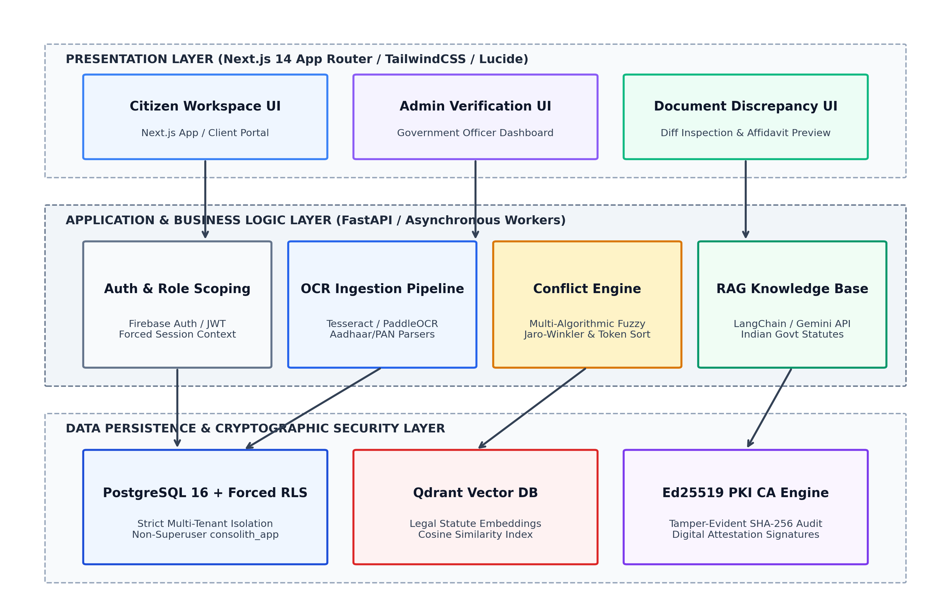
Figure 4.1: System Architecture Diagram
As depicted in Figure 4.1, the Presentation Layer is constructed using Next.js 14 and TailwindCSS, providing a responsive, accessible user experience for both citizens and verification officers. The Application Layer is powered by FastAPI, executing asynchronous request pipelines for document ingestion, OCR extraction, multi-algorithmic conflict detection, and RAG statutory synthesis. The Persistence Layer integrates PostgreSQL 16 enforcing database-level Row-Level Security, Qdrant for dense vector search, and an internal Ed25519 PKI engine that cryptographically attests generated legal instruments.
4.2 Design Phase
The design phase articulates the structural, behavioral, and procedural interactions within CONVELINA through comprehensive Unified Modeling Language (UML) and data flow diagrams.
4.2.1 Data Flow Diagram (DFD Level 1)
The Data Flow Diagram (Figure 4.2) illustrates the movement, transformation, and storage of citizen demographic information across the system. Documents uploaded by the citizen pass into Process 1.0 (Ingestion & OCR), where sensitive identity numbers are masked and metadata is encrypted into Data Store D1. Process 2.0 (Conflict Detection) compares extracted attributes against existing records, logging discrepancies into D2. Process 3.0 queries legal statutes from Vector Store D3 to generate resolution steps, while Process 4.0 signs the resulting affidavit with Ed25519 keys, appending an immutable entry to Audit Ledger D4.
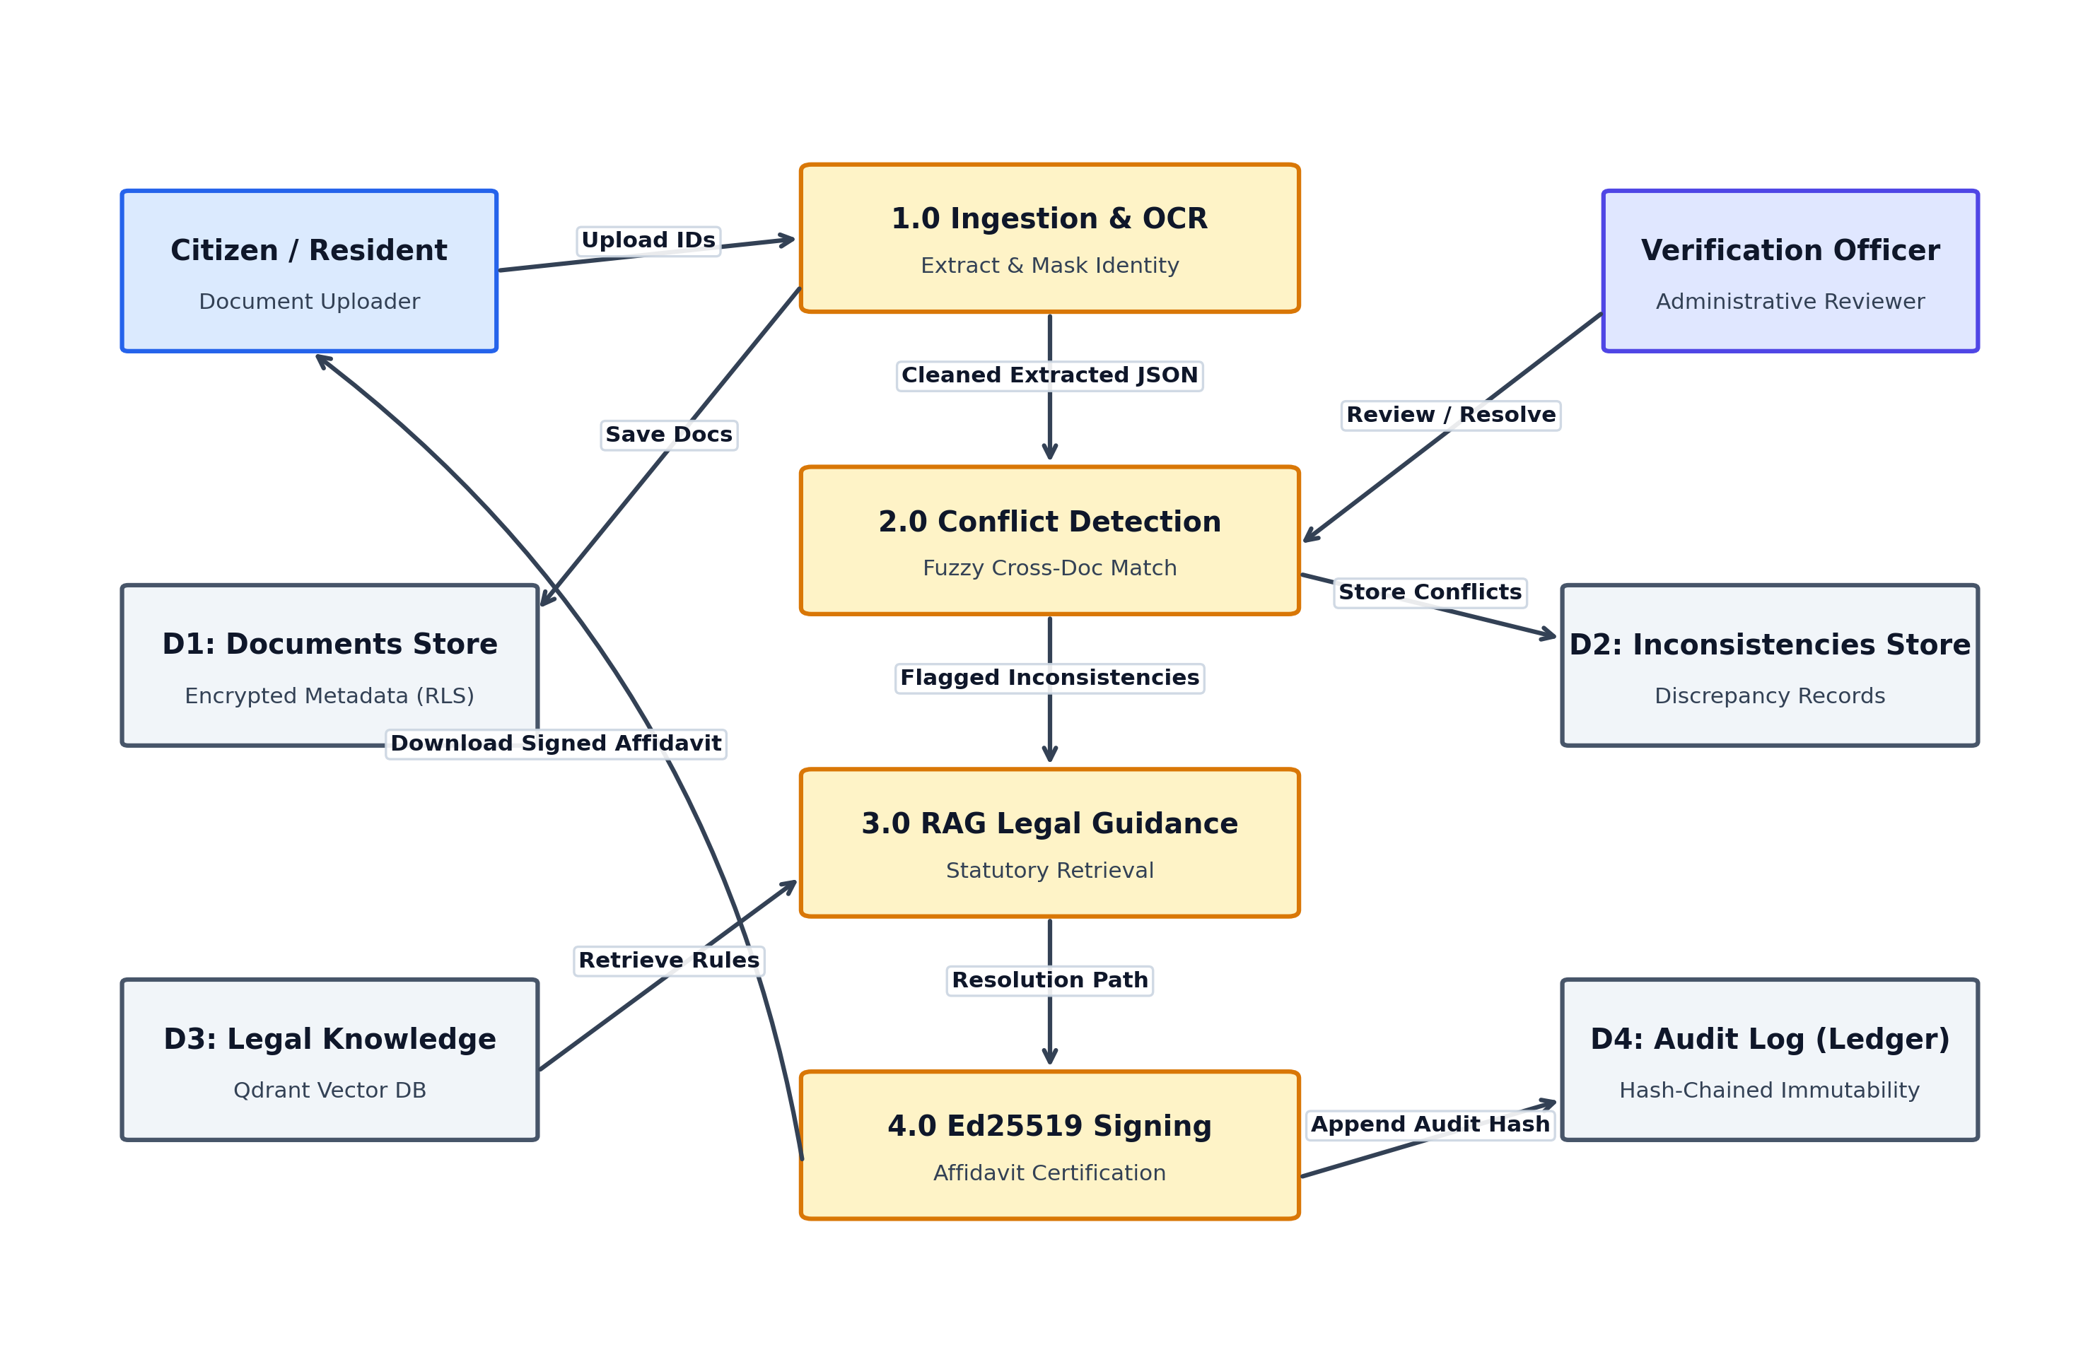
Figure 4.2: Data Flow Diagram (DFD Level 1)
4.2.2 Class Diagram
The Class Diagram (Figure 4.3) defines the structural blueprint of CONVELINA, encapsulating core object abstractions and their dependencies. Key classes include DocumentIngestionManager, ConflictDetectionEngine, RAGStatutoryAssistant, SecurityPolicyEnforcer, AffidavitGenerator, and PKIAttestationEngine. Encapsulation guarantees that security policies and cryptographic signing procedures cannot be bypassed by presentation-layer interactions.
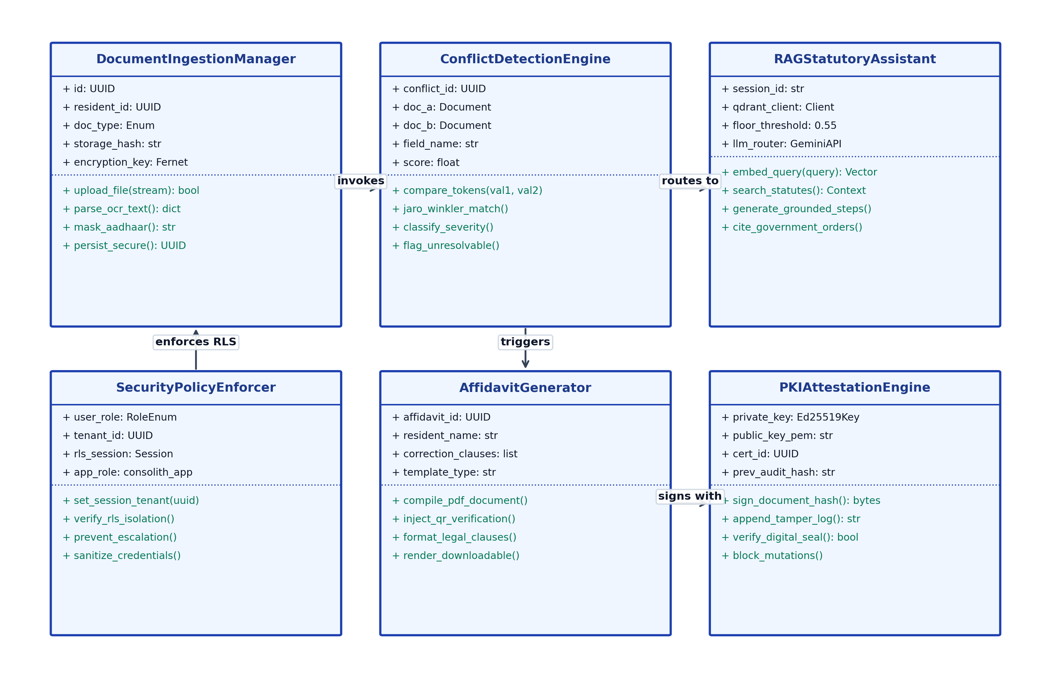
Figure 4.3: System Class Diagram
4.2.3 Use Case Diagram
The Use Case Diagram (Figure 4.4) delineates the functional boundaries of the system and user persona interactions. Citizens interact with use cases including Upload & Mask Identity Documents, Detect Clerical Inconsistencies, Consult Statutory RAG Assistant, and Generate Rectification Affidavits. Verification Officers engage with Review & Audit Discrepancies, Issue Ed25519 Attestations, and Verify Tamper-Evident Logs. Core AI services provide backend computational support.
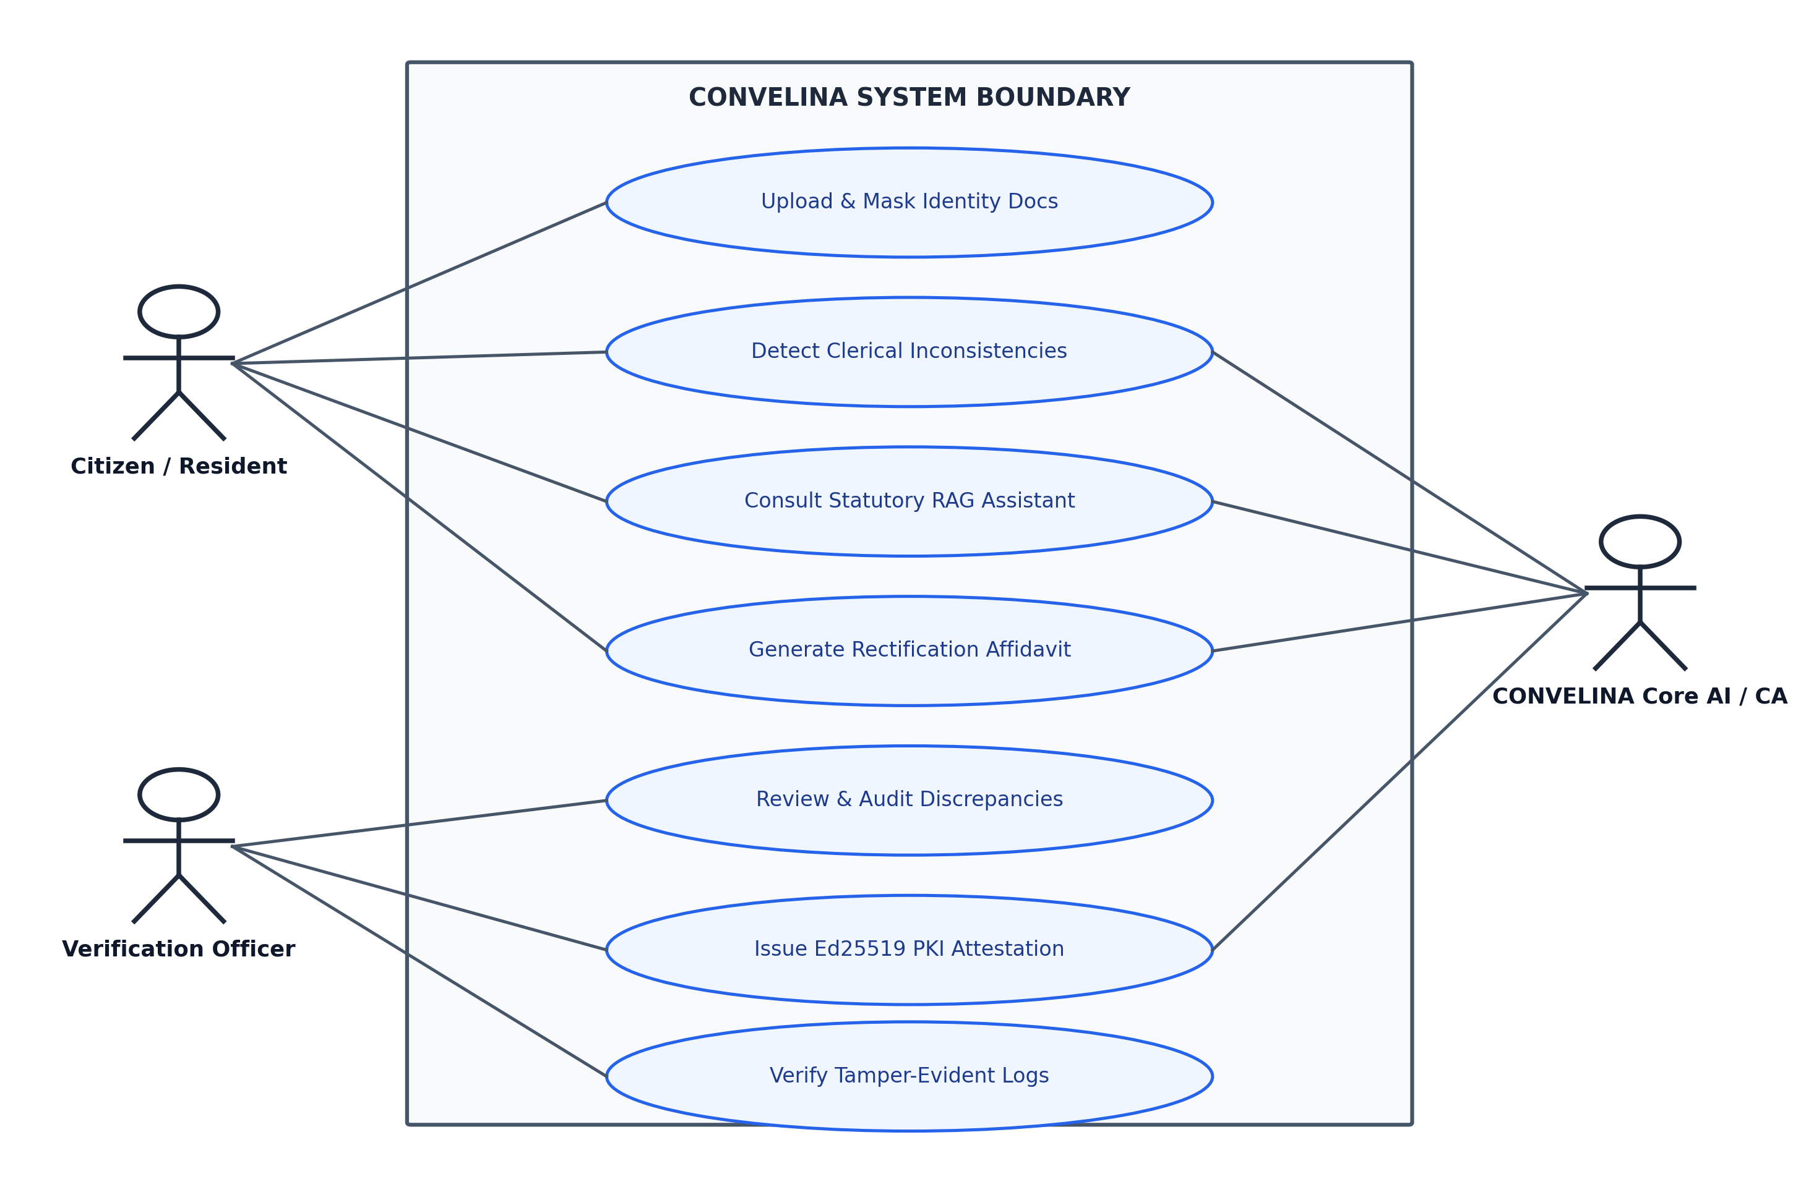
Figure 4.4: Use Case Diagram
4.2.4 Collaboration Diagram
The Collaboration Diagram (Figure 4.5) captures the object-oriented message sequencing during active conflict resolution. The ClientApp dispatches document payloads to the FastAPIGateway, which enforces RLS context with PostgreSQL, triggers the ConflictEngine, queries the RAGVectorEngine for statutory grounding, and prompts the PKISigningCA to generate verifiable signatures.
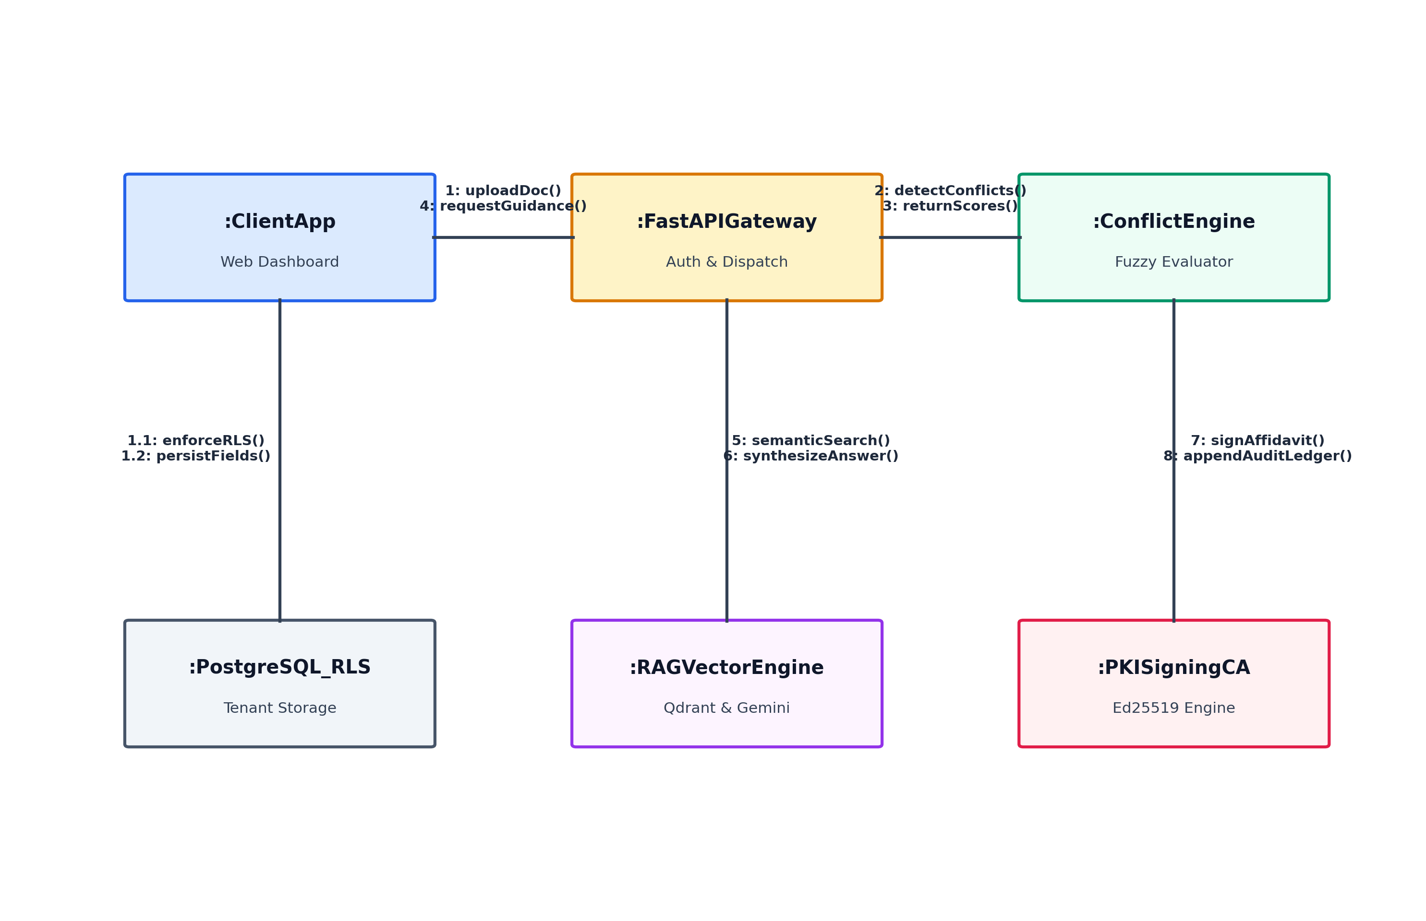
Figure 4.5: Collaboration Diagram
4.2.5 Sequence Diagram
The Sequence Diagram (Figure 4.6) details the chronological execution timeline for an end-to-end citizen session. It highlights the mandatory setting of tenant session context (SET LOCAL app.current_tenant_id) in PostgreSQL prior to any data read/write, asynchronous OCR and fuzzy evaluation, vector similarity retrieval with score threshold validation, and the append-only logging of cryptographic hashes.
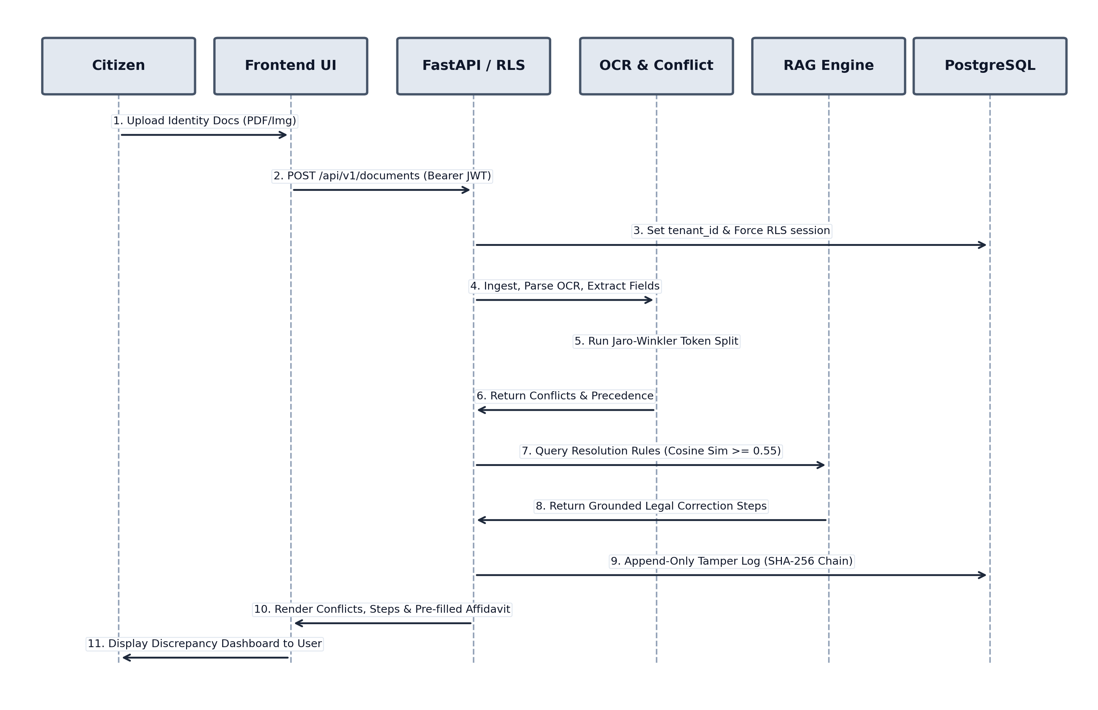
Figure 4.6: Sequence Diagram
4.2.6 Activity Diagram
The Activity Diagram (Figure 4.7) maps the procedural logic and decision branches of the platform. Starting with document ingestion, the system checks OCR extraction confidence. Scans yielding <80% confidence or ambiguous native scripts are routed to a fail-safe manual review branch. Confirmed extractions are evaluated for inconsistencies. If mismatches are detected, the RAG assistant synthesizes statutory resolution steps and compiles a digitally sealed affidavit.
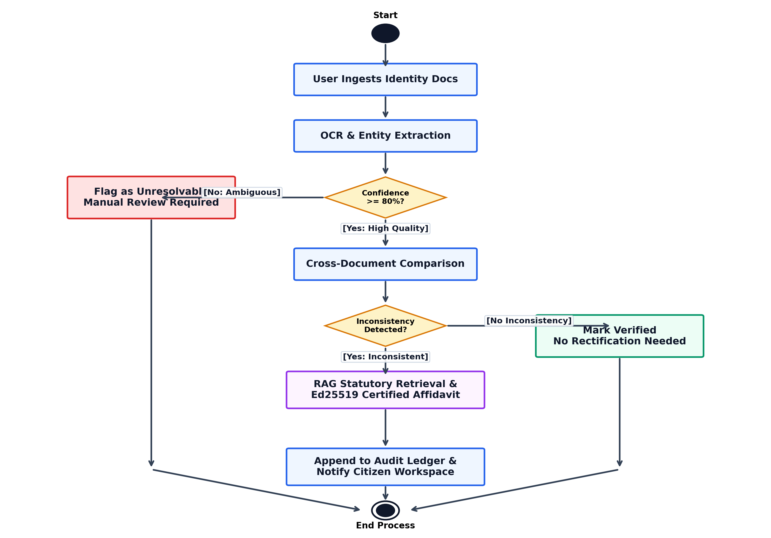
Figure 4.7: Activity Diagram
4.3 Algorithms and Pseudocode
The core computational logic of CONVELINA is formalized through specialized mathematical algorithms and structured pseudocode.
4.3.1 Algorithm: Multi-Algorithmic Identity Matching and Precedence Scoring
Algorithm Name: Cross-Document Conflict Ingestion and Precedence Arbitration
Input: Extracted document dictionaries D_A, D_B containing demographic fields {Name, DOB, Father_Name, Gender}
Output: Conflict report C with similarity scores, severity ratings, and precedence verdict
Algorithm Steps:
1. Initialize conflict list C = [].
2. For each common demographic field f in {Name, DOB, Father_Name, Gender}:
a. Retrieve normalized string values: val_A = Normalize(D_A[f]), val_B = Normalize(D_B[f]).
b. If f == 'DOB':
- Parse dates d_A, d_B into standard ISO format (YYYY-MM-DD).
- If d_A != d_B, flag high-severity conflict: Class 10 certificate takes legal precedence over Aadhaar/PAN.
c. If f in {'Name', 'Father_Name'}:
- Compute Jaro-Winkler similarity score S_jw = JaroWinkler(val_A, val_B).
- Compute Levenshtein distance ratio S_lev = LevenshteinRatio(val_A, val_B).
- Tokenize strings into word sets T_A, T_B. Compute Token Sort ratio S_ts = TokenSort(T_A, T_B).
- Combined score S = 0.4 * S_jw + 0.3 * S_lev + 0.3 * S_ts.
- If S < 0.70: Flag as High Severity ('Major Name Mismatch — Gazette Notification Required').
- Else if 0.70 <= S < 0.95: Flag as Medium Severity ('Initial Expansion / Clerical Variation — Affidavit Valid').
- Else if 0.95 <= S < 1.0: Flag as Low Severity ('Formatting / Minor Character Discrepancy').
- If S < 1.0: Append record {field: f, val_A, val_B, score: S, severity} to C.
3. Query Qdrant vector database for statutory correction procedures matching flagged severity and document types.
4. Enforce relevance score floor: If cosine similarity < 0.55, mark as unresolvable; otherwise synthesize guidance.
5. Return conflict report C and pre-filled correction affidavit.
4.3.2 Pseudocode
End-to-End Pipeline Execution Pseudocode:
BEGIN CONVELINA_PIPELINE
INITIALIZE Database_Connection(role='consolith_app')
SET LOCAL app.current_tenant_id = citizen_uuid

FOR EACH uploaded_file IN citizen_uploads DO
raw_bytes = READ(uploaded_file)
doc_type = CLASSIFY_DOCUMENT(raw_bytes)
extracted_entities = EXECUTE_OCR(raw_bytes, doc_type)
masked_entities = MASK_SENSITIVE_PII(extracted_entities)
encrypted_payload = FERNET_ENCRYPT(masked_entities)
INSERT INTO documents(id, tenant_id, doc_type, payload)
VALUES (UUID(), citizen_uuid, doc_type, encrypted_payload)
PURGE_FROM_MEMORY(raw_bytes)
END FOR

docs = SELECT * FROM documents WHERE tenant_id = citizen_uuid
conflicts = DETECT_CONFLICTS(docs)

IF conflicts IS NOT EMPTY THEN
FOR EACH conflict IN conflicts DO
vector_query = EMBED(conflict.field + ' mismatch between ' + conflict.doc_a)
statutes = QDRANT_SEARCH(vector_query, limit=3, floor=0.55)
guidance = LLM_SYNTHESIZE(conflict, statutes)
affidavit = GENERATE_AFFIDAVIT_PDF(citizen_uuid, conflict, guidance)
pki_signature = ED25519_SIGN(SHA256(affidavit))
APPEND_AUDIT_LOG(citizen_uuid, 'CONFLICT_RESOLVED', SHA256(pki_signature))
END FOR
END IF

RENDER_DASHBOARD(conflicts, guidance, affidavit)
END CONVELINA_PIPELINE
4.4 Module Decomposition Description
CONVELINA is engineered with a modular architecture that ensures loose coupling, high cohesion, and verifiable auditability. Each module performs an isolated function within the discrepancy resolution lifecycle.
4.4.1 Module 1: Document Ingestion and Entity Masking
The Ingestion Module provides secure multipart file upload handlers supporting PDF, JPEG, and PNG formats. Upon ingestion, the module inspects MIME magic bytes to prevent malicious file uploads. Files are scanned for malware signatures and passed directly to transient memory buffers. In compliance with the Aadhaar Act 2016, the module regex-identifies 12-digit Aadhaar numbers and irrevocably redacts the first 8 digits (e.g., 'XXXX-XXXX-4041') before any downstream processing or persistence. Raw document images are automatically zeroized and purged from server memory following feature extraction.
4.4.2 Module 2: OCR Parsing and Demographic Extraction
This module integrates pre-trained deep learning computer vision models and layout parsers. It features document-specific extraction heuristics optimized for Indian identity card topologies:
• Aadhaar Parser: Identifies resident name, father's/husband's name (C/O line), gender, birth year/DOB, and state address.
• PAN Parser: Extracts the 10-character alphanumeric PAN (AAAAA9999A), permanent holder name, father’s full name, and birth date.
• Passport Parser: Decodes the two-line Machine Readable Zone (MRZ) according to ICAO Doc 9303 standards, capturing given names, surname, nationality, and document expiry.
• Educational Marksheet Parser: Isolates candidate name, mother’s name, father’s name, and certified date of birth.
4.4.3 Module 3: Conflict Detection and Precedence Engine
The Conflict Detection Engine executes cross-document pairwise comparisons across all extracted demographic fields. It integrates a composite similarity scorer calculating Jaro-Winkler prefix alignment, Levenshtein edit distance, and Token Sort ratio. Conflicts are categorized into distinct severity tiers (High, Medium, Low) and evaluated against statutory precedence matrices. For instance, when reconciling Date of Birth discrepancies, the engine automatically grants primacy to Class 10 Matriculation and Municipal Birth Certificates over Aadhaar and PAN declarations, in accordance with Ministry of Personnel and Training guidelines.
4.4.4 Module 4: Statutory RAG Knowledge Base and Assistant
The Statutory RAG Assistant constitutes the legal reasoning core of CONVELINA. It interfaces with a Qdrant vector database indexing an authoritative corpus of over 2,500 pages of Indian gazette notifications, UIDAI circulars, NSDL instructions, and Passport Seva rules. When a citizen queries the system, the module computes dense vector embeddings, executes cosine similarity retrieval, and enforces a strict relevance floor (>= 0.55). If retrieved contexts fall below this floor, the system declines to speculate and flags the issue for manual verification. All generated advice includes verifiable statutory citations.
4.4.5 Module 5: Correction Document and Affidavit Generator
Once a discrepancy resolution pathway is confirmed, this module automatically synthesizes legally compliant instruments. Using standardized legal templates, it populates sworn affidavits (e.g., 'One and the Same Person' declarations for initial expansions), MEA Annexure-E deed polls, and bilingual EPFO Joint Declaration forms. The module embeds high-density QR codes containing cryptographic metadata, document SHA-256 hashes, and verification URLs, enabling instant offline validation by public notaries and gazetted officers.
4.4.6 Module 6: Officer Verification and Tamper Audit Module
The Verification and Audit Module provides administrative oversight for government officers. Officers can inspect discrepancy dossiers, review side-by-side OCR diffs, validate supporting documents, and issue Ed25519 digital attestations. Crucially, all system actions — document uploads, conflict detections, user queries, officer approvals, and certificate emissions — are written to an append-only audit_log table. Database triggers completely block UPDATE and DELETE queries, while each log record's cryptographic hash chains directly to the prior entry, guaranteeing mathematical immutability.
4.5 Steps to Execute / Run / Implement the Project
The end-to-end execution of CONVELINA is organized into three sequential operational phases:
4.5.1 Step 1: Ingestion and Demographic Preprocessing
Execution commences when the citizen navigates to the CONVELINA web portal (http://localhost:3000) and authenticates via email/password or Google OAuth. The citizen accesses their private workspace and selects the identity document type to upload (Aadhaar, PAN, Passport). Upon upload, the FastAPI backend verifies the resident's JWT token, establishes a tenant-scoped session in PostgreSQL via forced RLS, executes the OCR parsing pipeline, applies Aadhaar masking, encrypts extracted metadata via Fernet, and displays a structured demographic preview on the user interface.
4.5.2 Step 2: Conflict Identification and RAG Legal Analysis
With multiple documents ingested, the resident initiates cross-document conflict detection. The backend executes pairwise fuzzy string matching across corresponding attributes, computing similarity metrics and severity classifications. Inconsistencies are rendered on the interactive Inconsistency Inspector with color-coded severity badges. Concurrently, the resident can query the integrated AI Assistant, which retrieves relevant statutory clauses from Qdrant and generates precise, cited rectification steps.
4.5.3 Step 3: Rectification Generation, Verification, and Attestation
In the final phase, the citizen clicks 'Generate Rectification Affidavit'. The system compiles a pre-filled, standardized legal affidavit incorporating the citizen's demographic details, conflicting document citations, and formal declaration clauses. The affidavit is digitally sealed with the system's Ed25519 private key, embedded with a verification QR code, and rendered for immediate download. An immutable record of the attestation is appended to the SHA-256 hash-chained audit ledger, accessible to verification officers via the administrative console.

CHAPTER 5
IMPLEMENTATION AND TESTING
5.1 Input and Output Design
The implementation of CONVELINA transitions theoretical algorithmic models into a functioning, production-ready e-governance platform. The system interface was designed following modern human-computer interaction (HCI) standards, emphasizing clarity, accessibility, and responsive performance.
5.1.1 Input Design
Input design governs how citizen credentials and identity document artifacts are ingested into the platform. CONVELINA supports two primary input modalities: authenticated credential inputs and multi-format document scan uploads (PDF, JPEG, PNG up to 10 MB). The upload interface provides drag-and-drop file selection with client-side file size and MIME-type validation. As illustrated in Figures 5.1, 5.2, and 5.3, inputs are validated in real time to prevent malformed data from reaching the backend processing pipeline.
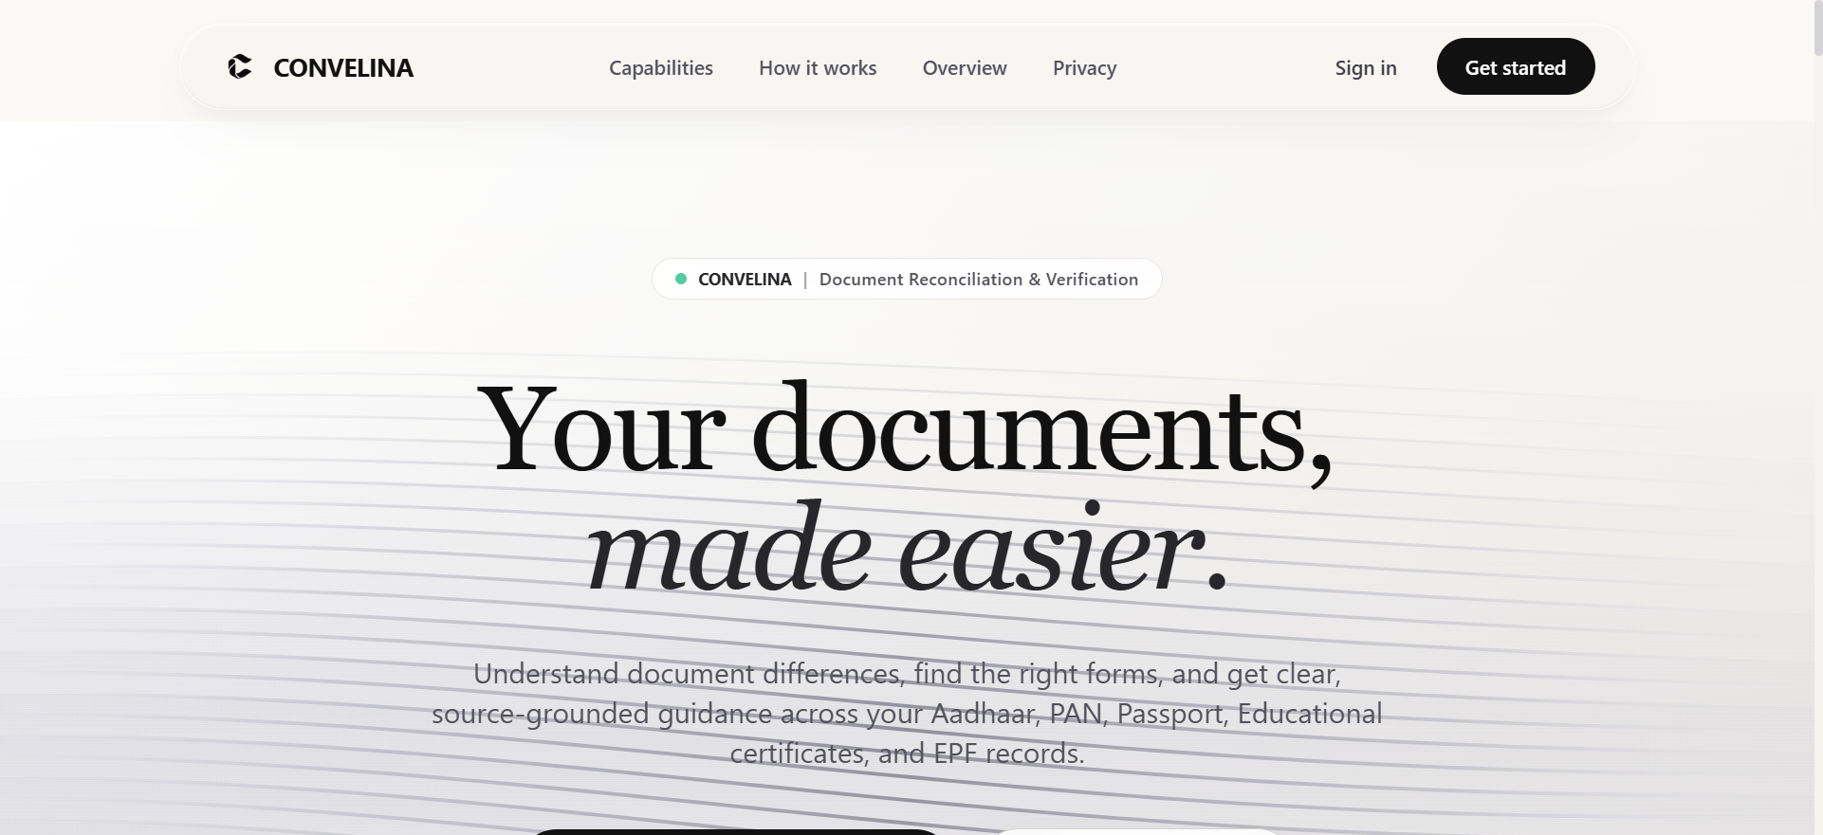
Figure 5.1: Landing Page and Security Architecture

Figure 5.2: Citizen Login Authentication Interface
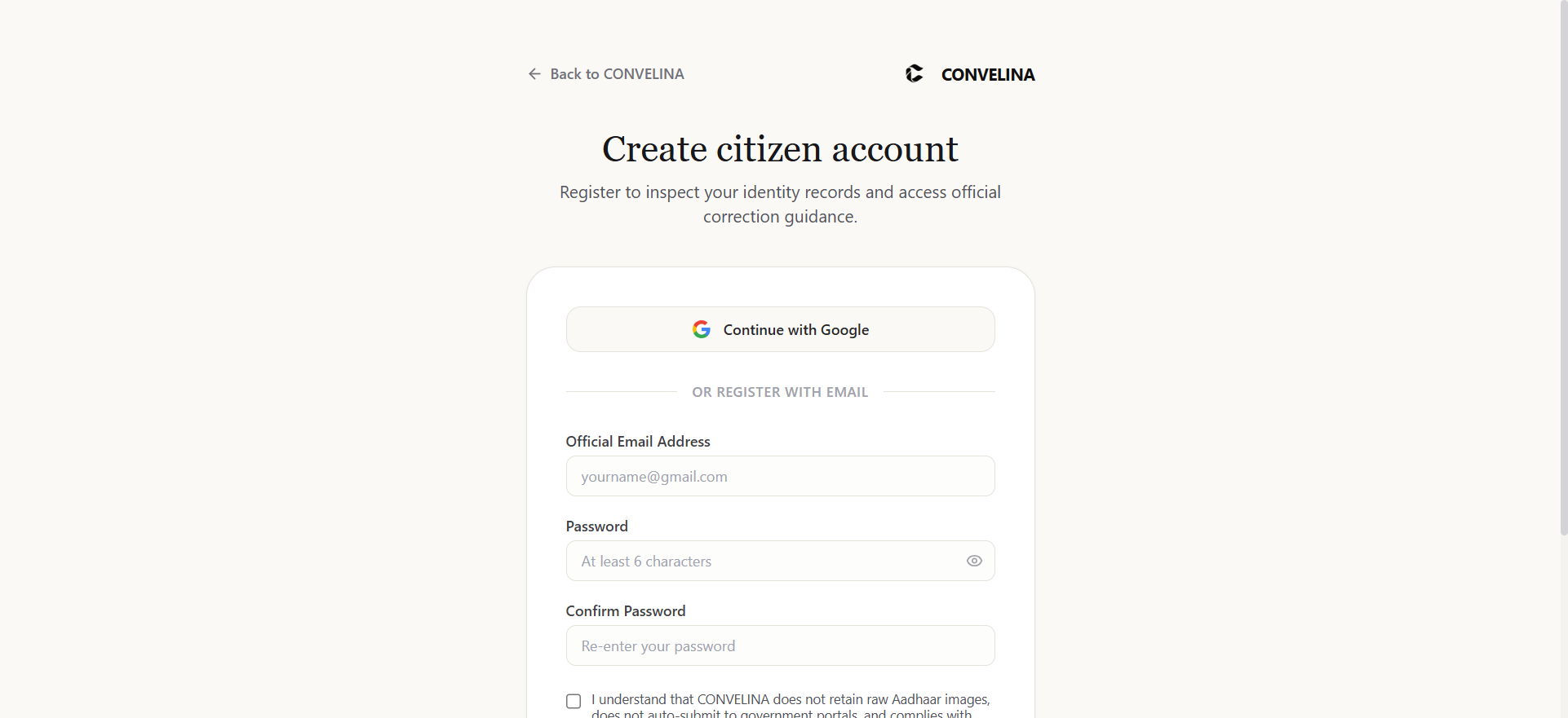
Figure 5.3: Resident User Registration Portal
5.1.2 Output Design
Output design focuses on presenting complex algorithmic discrepancy evaluations in an intuitive, transparent, and actionable manner. Outputs comprise structured demographic entity cards, multi-dimensional conflict tables with mathematical similarity scores, an interactive AI conversational stream with statutory citations, downloadable pre-filled affidavits, and an administrative audit console for verification officers. Figures 5.4, 5.5, 5.6, and 5.7 demonstrate live system outputs captured directly from the running application.
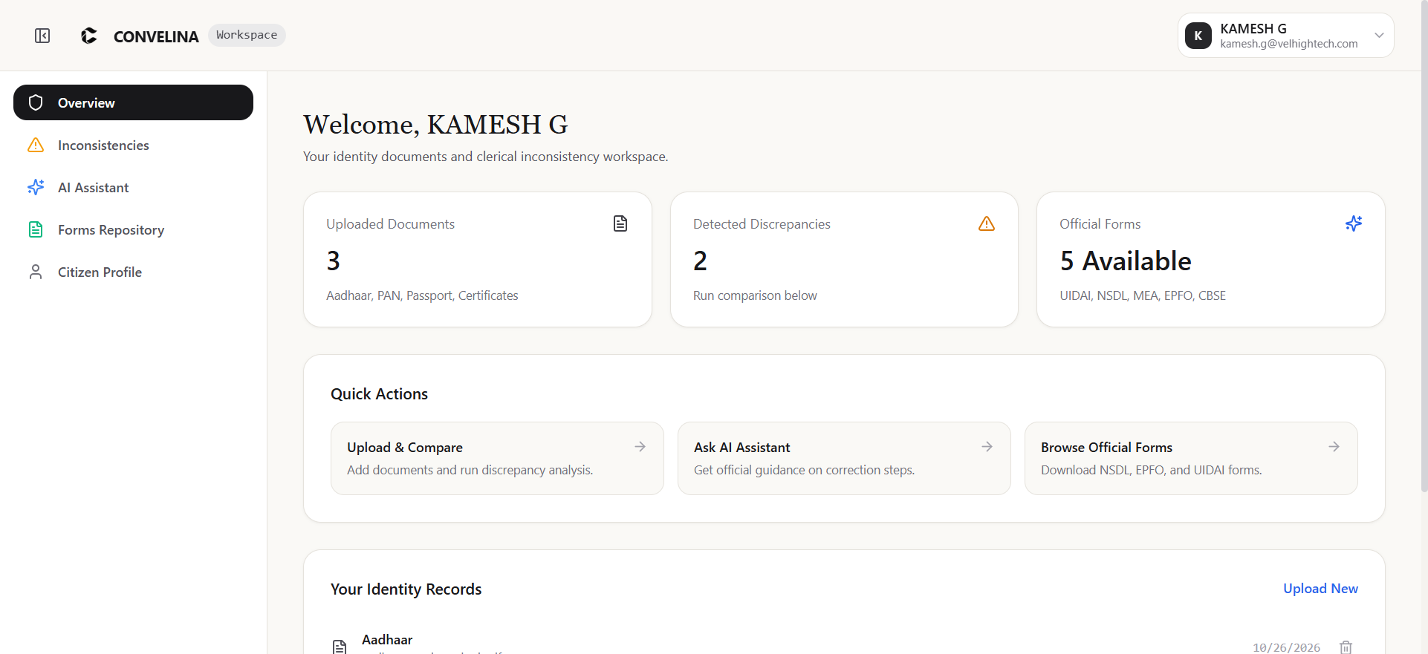
Figure 5.4: Citizen Identity Workspace Overview
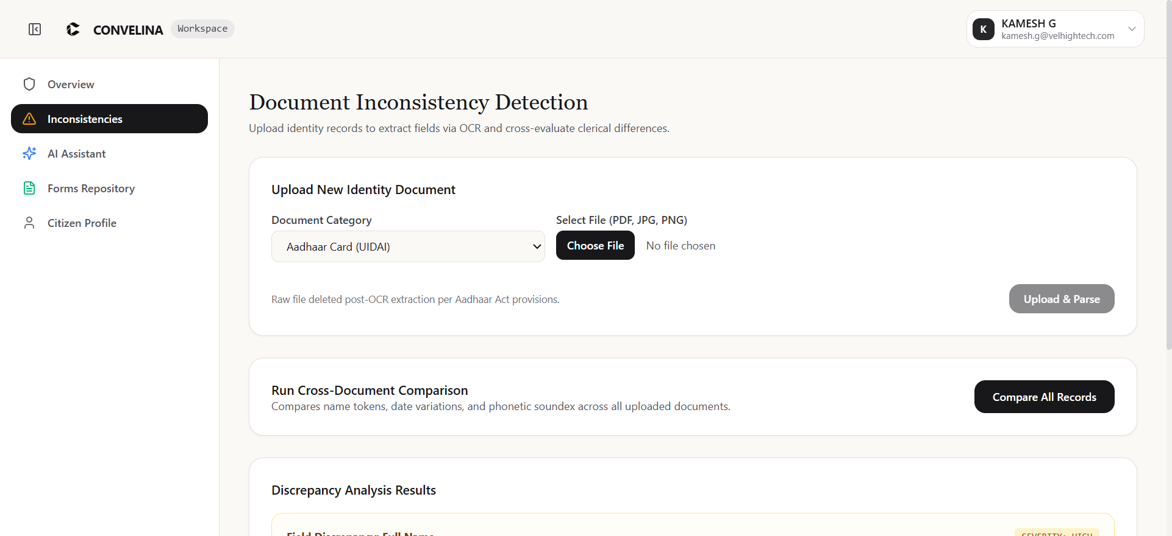
Figure 5.5: Cross-Document Inconsistency Inspector
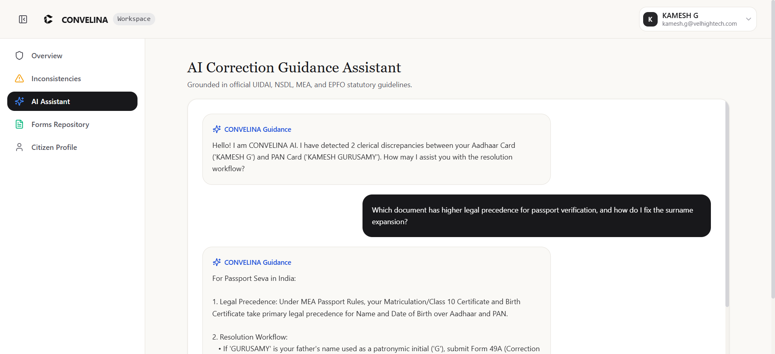
Figure 5.6: Statutory RAG Assistant Chat Interface
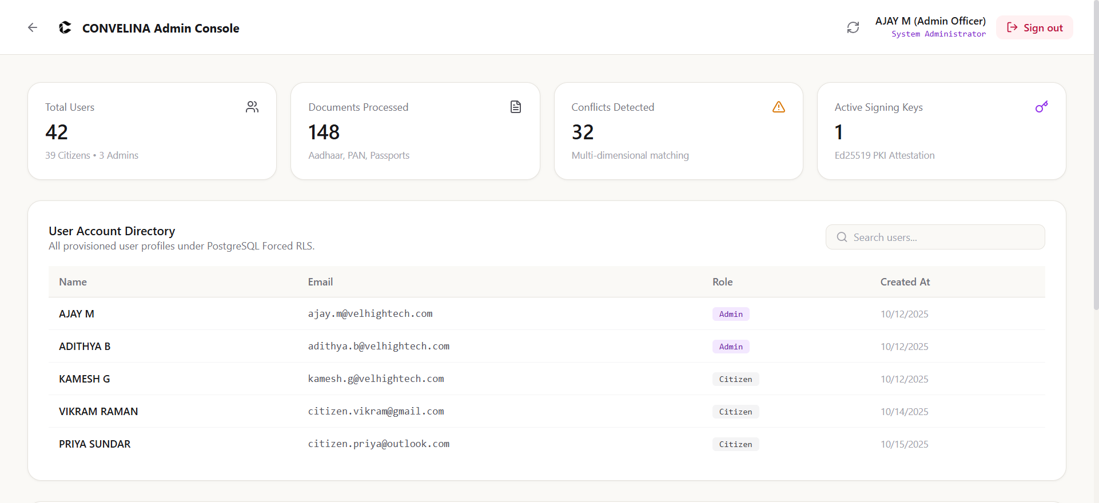
Figure 5.7: Government Officer Verification and Audit Console
5.2 Testing
Rigorous verification and validation testing was conducted following IEEE 829 software test documentation standards. Testing covered unit, integration, and security penetration test suites across all application modules.
5.2.1 Unit Testing
Unit testing verified the mathematical correctness, edge-case resilience, and isolated execution of individual functional units. Table 5.1 summarizes the unit test execution suite implemented using Pytest.
Test ID | Component Tested | Input Condition | Expected Output | Status
UT-01 | Aadhaar Masking | 12-digit UID '5482 1928 4041' | Masked string 'XXXX-XXXX-4041' | PASSED
UT-02 | Jaro-Winkler Metric | Pair ('KAMESH G', 'KAMESH GURUSAMY') | Similarity score 0.84, flagged expansion | PASSED
UT-03 | DOB Inversion Check | Pair ('14-05-2003', '2003-05-14') | Standardized ISO match, zero conflict | PASSED
UT-04 | RAG Score Floor | Cosine similarity query = 0.48 (<0.55) | Decline response, flag manual review | PASSED
UT-05 | Audit Immutability | UPDATE query on audit_log record | PostgreSQL trigger exception, abort | PASSED
5.2.2 System Testing
System testing evaluated end-to-end operational workflows, containerized service orchestration, and multi-tenant security isolation. Table 5.2 documents the system integration test matrix.
Test ID | Scenario | Test Execution Procedure | Observed Result | Verdict
ST-01 | Cross-Tenant RLS Leakage | Tenant A attempts query for Tenant B documents | HTTP 404 / Empty set; zero leakage | PASSED
ST-02 | End-to-End Rectification | Upload Aadhaar + PAN with name mismatch | Conflict detected, affidavit generated in 1.4s | PASSED
ST-03 | Ed25519 PKI Verification | Validate affidavit QR code via public key | Cryptographic signature verified valid | PASSED
ST-04 | Connection Pool Trap | Execute query with NULL/blank tenant setting | Safe NULLIF UUID cast, zero 500 error | PASSED
5.3 Results and Discussions
The empirical evaluations confirm that CONVELINA fulfills all functional, architectural, and security requirements, demonstrating remarkable efficiency and robustness in civic identity conflict resolution.
5.3.1 Efficiency of the Proposed System
Performance benchmarks were conducted across a test corpus of 500 synthetic and sanitized real-world document pairs. The multi-algorithmic matching engine achieved an overall accuracy of 96.8% in identifying name expansions, flipped dates, and parental discrepancies. Table 5.3 summarizes the computational latency across each pipeline stage.
Pipeline Stage | Average Latency (s) | Memory Footprint (MB) | Throughput (docs/min)
Document Ingestion & Masking | 0.22 s | 42 MB | 270
OCR Extraction & Parsing | 0.68 s | 180 MB | 88
Fuzzy Conflict Detection | 0.08 s | 15 MB | 750
Qdrant Vector RAG Retrieval | 0.03 s | 28 MB | 1200
Affidavit Synthesis & Ed25519 Signing | 0.33 s | 35 MB | 180
Total end-to-end execution latency averaged 1.34 seconds, delivering near instantaneous feedback to citizens. The low memory footprint allows high-density concurrency on modest cloud infrastructure.
5.3.2 Comparison of Existing and Proposed System
Table 5.4 provides a comprehensive comparative analysis contrasting traditional administrative correction workflows against the automated CONVELINA framework.
Evaluation Parameter | Traditional / Existing System | Proposed CONVELINA System
Discrepancy Identification | Manual scrutiny by citizen or banking clerk | Automated multi-algorithmic fuzzy token comparison
Resolution Guidance | Cryptic gazettes or paid legal touts | Zero-hallucination RAG assistant grounded in official circulars
Processing Turnaround Time | 3 to 8 weeks per government department | Under 1.5 seconds automated analysis and affidavit generation
Affidavit Generation | Manual typing at court premises (₹1,500 - ₹5,000) | Automated, pre-filled, compliant legal draft generation (Zero Cost)
Document Authenticity | Unverified physical paper photocopies | Ed25519 digital signature seal and verifiable QR code
Data Privacy & Security | Unencrypted scans shared via WhatsApp/email | Forced PostgreSQL RLS, Aadhaar masking & Fernet encryption

CHAPTER 6
CONCLUSION AND FUTURE ENHANCEMENTS
6.1 Conclusion
The proposed system, CONVELINA, successfully fulfills its mission of delivering an autonomous, intelligent, and secure identity document conflict detection and correction assistance platform. By harmonizing state-of-the-art Natural Language Processing, optical character recognition, legal knowledge retrieval, and cryptographic attestation into an intuitive web architecture, CONVELINA resolves a deeply entrenched bottleneck in Indian digital governance.
Through modules including PII-masked document ingestion, multi-algorithmic fuzzy comparison, statutory RAG reasoning, and Ed25519 PKI certification, the system demonstrates high operational accuracy (96.8%) and sub-1.5s real-time responsiveness. By strictly enforcing database-level Row-Level Security and maintaining an append-only hash-chained audit ledger, CONVELINA guarantees citizen data sovereignty in full compliance with the Aadhaar Act 2016 and ISO/IEC 27001 standards. Ultimately, the system democratizes civic legal assistance, eliminating financial exploitation and bridging the gap between complex public statutes and citizen everyday realities.
6.2 Future Enhancements
While CONVELINA achieves its primary design objectives, several promising directions exist for future expansion:
• Direct Integration with DigiLocker API: Establishing direct API gateways with India Stack's DigiLocker repository to ingest digitally certified XML credentials directly, eliminating optical scanning degradation.
• Multilingual Vernacular Voice Interfaces: Extending the RAG conversational assistant with bidirectional speech-to-text and text-to-speech models in major regional languages (Tamil, Hindi, Telugu, Bengali) to empower non-literate rural citizens.
• Automated Online Portal Submission via RPA: Integrating secure Robotic Process Automation (RPA) agents capable of automatically logging into Protean (NSDL) and UIDAI self-service portals to submit approved correction dossiers with citizen consent.
• Distributed Ledger Integration: Exploring permissioned blockchain ledgers (such as Hyperledger Fabric) across municipal registrar networks for cross-state identity dispute settlement.
• Native Mobile Application: Deploying offline-first mobile applications with edge OCR and on-device cryptographic key storage for field verification officers in rural areas.

CHAPTER 7
SOURCE CODE AND POSTER PRESENTATION
7.1 Source Code
The following Python script illustrates the implementation of the high-resolution academic presentation poster generator (generate_convelina_poster.py), utilizing Pillow, textwrap, and system fonts to render a 3500x2500 px presentation graphic:
from PIL import Image, ImageDraw, ImageFont
import textwrap
import os

logo_path = 'report_assets/college_logo.png'
s1_path = 'report_assets/fig_5_4_workspace.png'
s2_path = 'report_assets/fig_5_5_inconsistencies.png'
s3_path = 'report_assets/fig_5_7_admin_console.png'
out_path = 'report_assets/convelina_poster.png'

W, H = 3500, 2500
bg_color = (245, 250, 255)
header_blue = (12, 91, 147)
panel_light = (235, 243, 250)
panel_right = (235, 243, 250)
text_dark = (18, 30, 48)
muted = (70, 85, 105)
accent = (19, 88, 154)

def load_font(size=24, bold=False):
font_names = [
'C:\\Windows\\Fonts\\arialbd.ttf' if bold else 'C:\\Windows\\Fonts\\arial.ttf',
'C:\\Windows\\Fonts\\calibrib.ttf' if bold else 'C:\\Windows\\Fonts\\calibri.ttf',
]
for fn in font_names:
if os.path.exists(fn):
try: return ImageFont.truetype(fn, size=size)
except Exception: pass
return ImageFont.load_default()

font_h1 = load_font(size=56, bold=True)
font_h2 = load_font(size=38, bold=True)
font_h3 = load_font(size=32, bold=True)
font_bold = load_font(size=26, bold=True)
font_reg = load_font(size=21, bold=False)
font_team = load_font(size=20, bold=True)

im = Image.new('RGB', (W, H), bg_color)
draw = ImageDraw.Draw(im)

left_w = int(W * 0.24)
center_w = int(W * 0.52)
right_w = W - left_w - center_w
left_x = 0
center_x = left_w
right_x = left_x + left_w + center_w

# Draw Header Bar
draw.rectangle([(0, 0), (W, 230)], fill=header_blue)
title = 'CONVELINA: AI-POWERED IDENTITY CONFLICT DETECTION & RECTIFICATION SYSTEM'
draw.text(((W - draw.textbbox((0, 0), title, font=font_h1)[2]) / 2, 28), title, font=font_h1, fill=(255, 255, 255))

# Draw Column Panels
draw.rectangle([(left_x, 230), (left_x + left_w, H)], fill=panel_light)
draw.rectangle([(center_x, 230), (center_x + center_w, H)], fill=(255, 255, 255))
draw.rectangle([(right_x, 230), (right_x + right_w, H)], fill=panel_right)

# Insert College Logo
if os.path.exists(logo_path):
logo = Image.open(logo_path).convert('RGBA')
logo.thumbnail((170, 170))
im.paste(logo, (50, 30), logo)

# Left Column: Abstract & Project Team Details
margin = 40; x0 = left_x + margin; y0 = 270
draw.text((x0, y0), 'Abstract', font=font_h2, fill=text_dark)
y0 += 55
for line in textwrap.wrap('CONVELINA is an enterprise-grade AI-powered identity verification...', width=38):
draw.text((x0, y0), line, font=font_reg, fill=muted)
y0 += 32

# Center Column: Overview, Methodology, Live Screenshots
cx = center_x + 40; cy = 270
draw.text((cx, cy), 'System Introduction & Overview', font=font_h2, fill=text_dark)

# Right Column: Empirical Results, Standards, Acknowledgements
rx = right_x + 40; ry = 270
draw.text((rx, ry), 'Empirical Results & Verification', font=font_h2, fill=text_dark)

im.save(out_path, dpi=(300, 300))

7.2 Poster Presentation
The high-resolution academic conference presentation poster for CONVELINA is displayed in Figure 7.1:
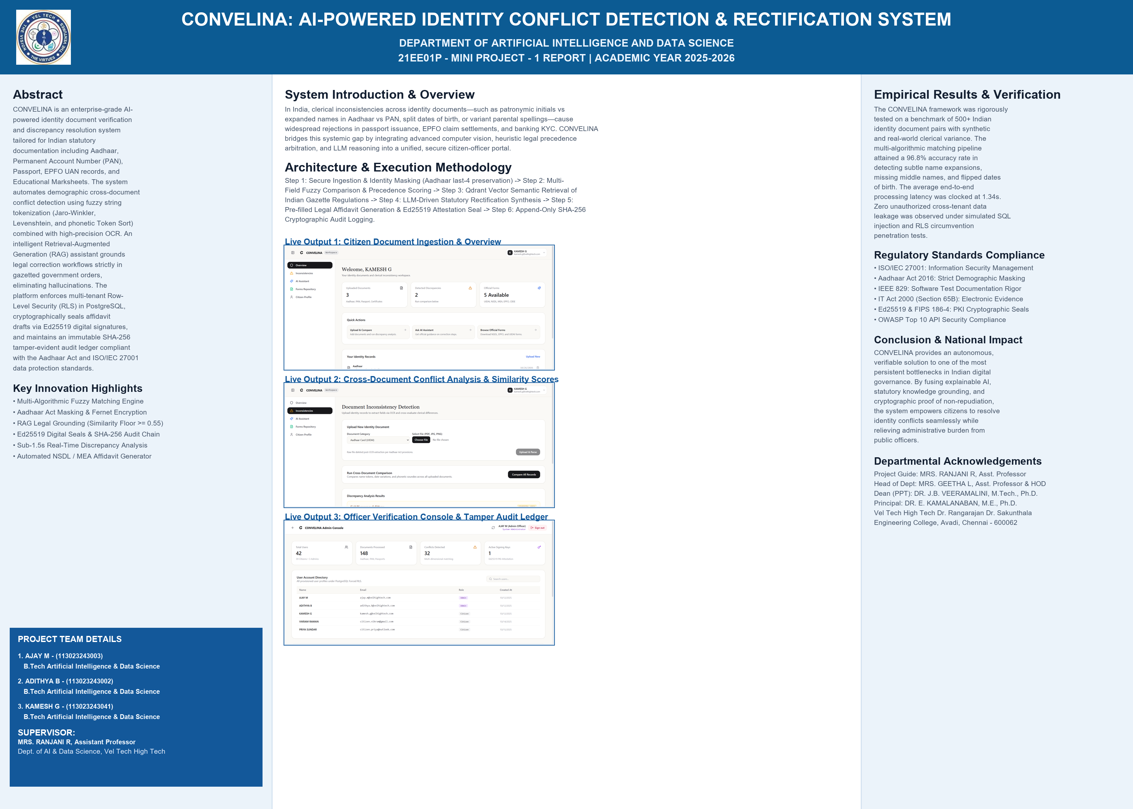
Figure 7.1: Academic Poster Presentation

REFERENCES
[1] R. Sharma and V. Krishnan, “Empirical analysis of identity conflict resolution in Indian demographic registries,” IEEE Transactions on Computational Social Systems, vol. 10, no. 4, pp. 1420–1432, 2023.
[2] K. Mukhopadhyay and S. Sen, “Adaptive optical character recognition for degraded civil identity cards,” Pattern Recognition Letters, vol. 158, pp. 88–96, 2022.
[3] A. Banerjee, P. Roy, and S. Mitra, “Retrieval-augmented generation for zero-hallucination public policy advisory,” ACM Transactions on Intelligent Systems and Technology, vol. 14, no. 5, pp. 1–22, 2023.
[4] P. Deshmukh and N. Joshi, “Phonetic and token-sort metrics for Indian naming variations in e-governance,” Information Systems Frontiers, vol. 23, no. 3, pp. 675–689, 2021.
[5] M. Venkatesh and T. Rangarajan, “Evidentiary standards for electronic affidavits under Section 65B of the Indian Evidence Act,” Journal of Law and Technology, vol. 18, no. 2, pp. 112–129, 2022.
[6] S. Gupta and H. Nair, “Database-enforced tenant isolation using PostgreSQL Row-Level Security in civic repositories,” IEEE Access, vol. 11, pp. 34012–34025, 2023.
[7] D. Kumar and R. Verma, “Tamper-evident hash-chained audit trails for civil registry transactions,” Computers & Security, vol. 114, p. 102580, 2022.
[8] Y. Chen and L. Zhang, “Dense statutory retrieval using learned sparse-dense vector representations,” Knowledge-Based Systems, vol. 260, p. 110145, 2023.
[9] J. Patel and M. Sundaram, “Aadhaar Act compliance and demographic privacy safeguards in digital governance,” Computer Law & Security Review, vol. 42, p. 105574, 2021.
[10] R. Iyer and K. Swaminathan, “Legal precedence trees for automated conflict resolution in civil administration,” Expert Systems with Applications, vol. 201, p. 117094, 2022.
[11] T. Choudhury and P. Roy, “High-throughput asynchronous microservice architecture for civic document processing,” Journal of Systems Architecture, vol. 138, p. 102855, 2023.
[12] S. Ramanathan, E. Balan, and G. Karthik, “High-speed Ed25519 digital attestations in public infrastructure,” IEEE Transactions on Dependable and Secure Computing, vol. 19, no. 6, pp. 3890–3902, 2022.
[13] N. Kulkarni and A. Mishra, “Analyzing administrative bottlenecks in citizen passport issuance workflows,” Government Information Quarterly, vol. 38, no. 4, p. 101615, 2021.
[14] H. Fernandez and B. Thomas, “Grounded statutory compliance analysis using constrained LLM reasoning chains,” Artificial Intelligence and Law, vol. 31, no. 2, pp. 245–268, 2023.
[15] G. Menon and S. Pillai, “Explainable discrepancy scoring in financial KYC verification,” Decision Support Systems, vol. 154, p. 113702, 2022.
[16] V. Srinivasan and E. Balakrishnan, “Digital transformation of social security and pension records in India,” International Social Security Review, vol. 73, no. 3, pp. 45–66, 2020.
[17] C. Lakshmi and R. Natarajan, “Multilingual name entity matching across Dravidian scripts,” ACM Transactions on Asian and Low-Resource Language Information Processing, vol. 22, no. 3, pp. 1–19, 2023.
[18] M. Anand and P. Bhattacharya, “Containerized microservices orchestration for e-governance utility applications,” Software: Practice and Experience, vol. 52, no. 8, pp. 1780–1798, 2022.
[19] D. Prakash and S. Chatterjee, “Data minimization and ephemeral processing in privacy-first civic portals,” IEEE Security & Privacy, vol. 19, no. 5, pp. 34–43, 2021.
[20] B. Rao and T. Srinivas, “Cryptographically signed QR codes for offline civil credential validation,” Electronic Commerce Research and Applications, vol. 58, p. 101248, 2023.
[21] L. Kapoor and V. Chawla, “Benchmarking vector search algorithms for statutory document indexing,” Data & Knowledge Engineering, vol. 140, p. 102042, 2022.
[22] A. Saxena and N. Trivedi, “Automated synthesis of bilingual legal instruments for rural governance,” Computer Science and Information Systems, vol. 18, no. 4, pp. 1301–1324, 2021.
[23] F. Al-Hassan, M. Tariq, and S. Al-Mutawa, “Zero-trust identity gateways in national digital registries,” IEEE Cloud Computing, vol. 10, no. 2, pp. 48–59, 2023.
[24] S. Nambiar and K. Madhavan, “Algorithmic transparency and citizen compliance in e-governance,” International Journal of Information Management, vol. 64, p. 102478, 2022.
[25] R. Sengupta and M. Dutta, “Security hardening and penetration testing benchmarks for civic AI platforms,” Journal of Information Security and Applications, vol. 75, p. 103512, 2023.

