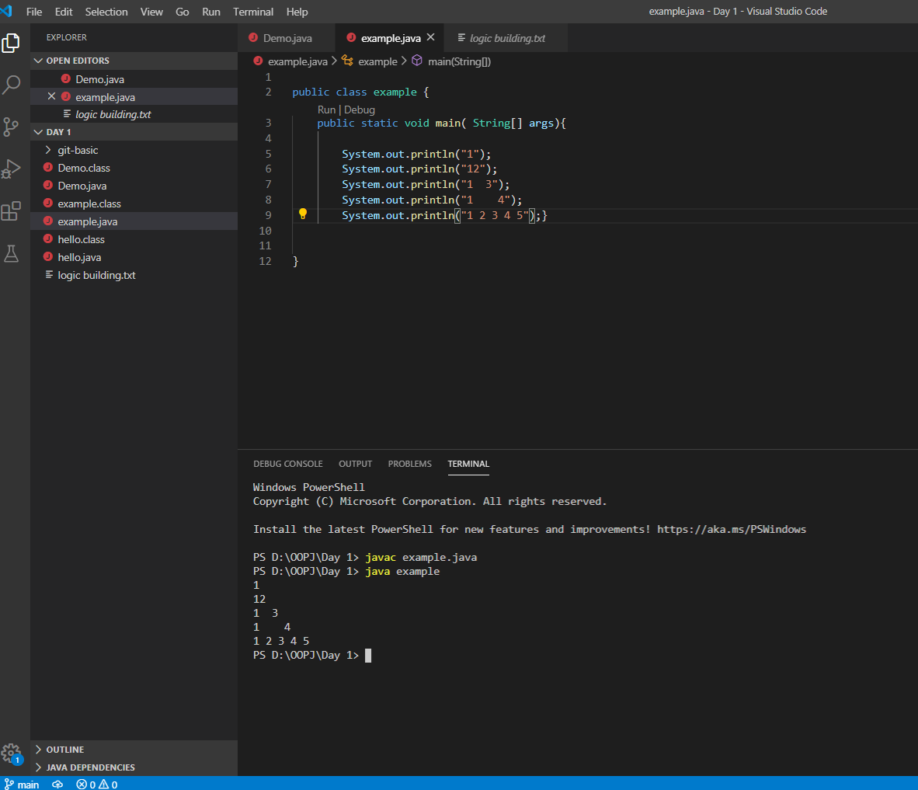

Q4 to print hollow right angle triangle of numbers