AI ARENA
Multi-Model AI Workspace & Comparison Platform
Master Implementation Blueprint
React + TypeScript + Fastify + Supabase PostgreSQL + Upstash Redis + AI Provider Gateway
Infrastructure decision: Supabase PostgreSQL and Upstash Redis are mandatory for every MVP environment. Docker is not a project prerequisite.
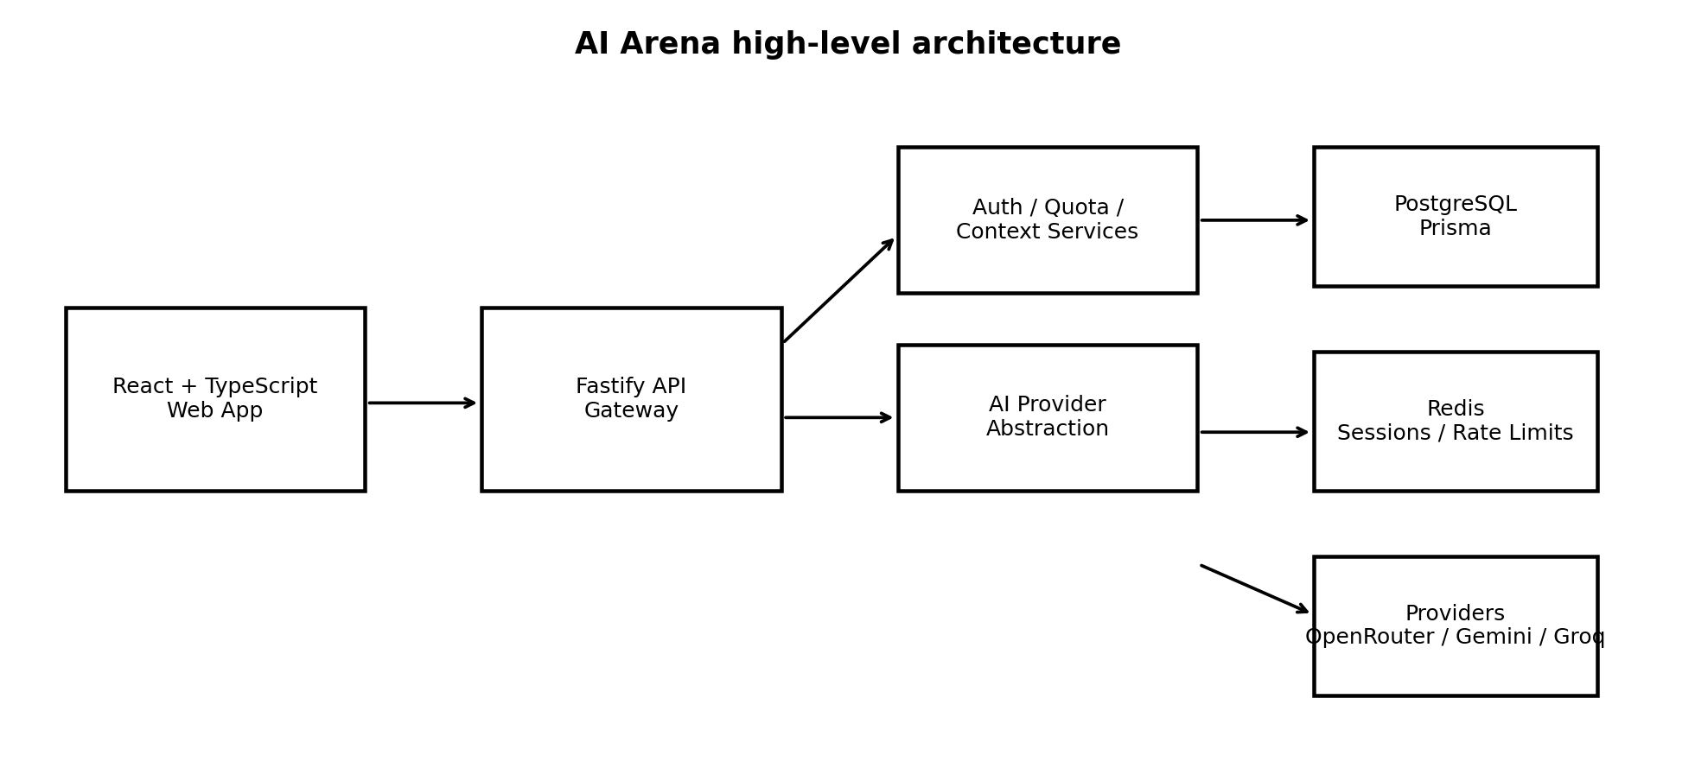
Implementation philosophy: small feature slices, test each slice, and do not mark a phase complete until its acceptance gate passes.

Document map
1. Product definition and success criteria
2. Product modes: Guest and Authenticated
3. Technology stack decisions
4. System architecture
5. Frontend architecture
6. Backend architecture
7. AI provider abstraction
8. Database and temporary state design
9. API contract
10. Chat, streaming, tokens and context
11. Model comparison engine
12. Image, video and audio architecture
13. Security, rate limits and abuse protection
14. Observability and error handling
15. Testing and zero-known-bug phase gate
16. Phase-by-phase implementation plan
17. Claude Code task protocol
18. Deployment and environment plan
19. Definition of done
20. Final implementation tracker

1. Product definition and success criteria
AI Arena is a production-style AI workspace where a user can chat with one model, compare the same prompt across multiple models, inspect latency/token usage, and later use multimodal generation. The application is intentionally provider-agnostic so models can be added or replaced without rewriting the UI or core business logic.

Primary product goals
- Provide a clean ChatGPT-like chat experience using a provider-neutral backend.
- Allow side-by-side comparison of the same prompt across multiple models in parallel.
- Track input tokens, output tokens, total tokens, context utilization, latency, status and estimated cost.
- Support guest usage with temporary sessions and quotas; support authenticated users with persistent conversations.
- Use a shared provider interface so OpenRouter, Gemini, Groq, and future/local providers can be added independently.
- Handle rate limits, provider timeouts and transient failures with deterministic retry/fallback rules.
- Design for future image, video, speech-to-text and text-to-speech workflows without coupling them to chat code.

Non-negotiable engineering rule
Phase gate rule
A phase is not DONE because code exists. It is DONE only when implementation, unit tests, integration tests, manual QA, failure-path checks, and a completion report all pass. No known critical/high defects may remain open at phase sign-off. Unknown bugs can never be guaranteed away, so the project uses automated regression coverage and explicit phase gates rather than claiming impossible bug-free software.

2. Product modes: Guest and Authenticated
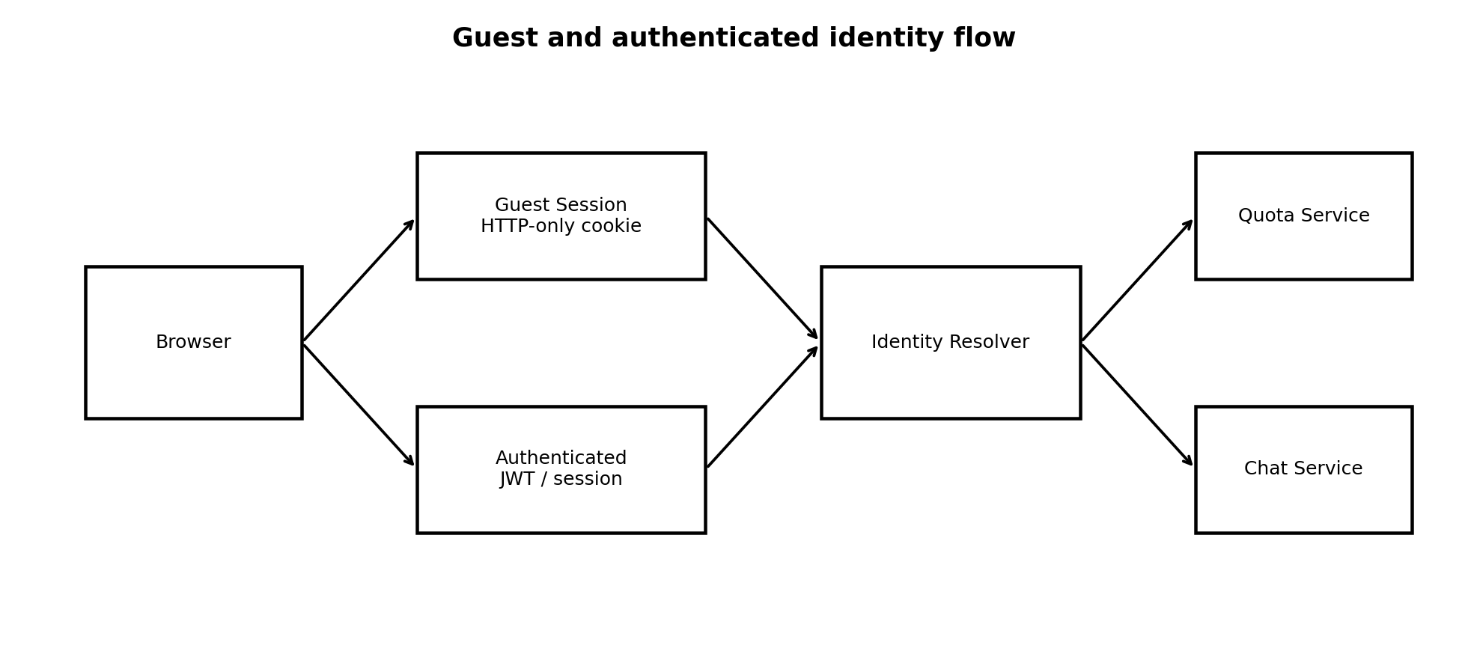

Guest mode
- No login required to try the product.
- Use a secure HTTP-only cookie-backed guest session identifier.
- Store guest quota, temporary context and temporary conversation data in temporary session storage backed by Supabase PostgreSQL for the current MVP. Do not treat guest sessions as permanent user history.
- Enforce limits on the server; never trust frontend counters.
- Guest sessions use an expiration timestamp and scheduled cleanup. They are never presented as permanent account history.
- Optionally migrate an active guest conversation into a new account after signup/login.

Authenticated mode
- Persistent user identity and saved conversations.
- Conversation history, model runs and usage analytics stored in PostgreSQL.
- Higher configurable quotas than guest mode.
- Saved model preferences, settings and future plan/subscription state.
Capability | Guest | Authenticated
Chat | Yes, limited | Yes
Compare models | Yes, limited models | Yes
Persistent history | No | Yes
Temporary session | Yes | Not required
Usage quota | Redis enforced | Upstash Redis + DB enforced
Analytics history | Temporary | Persistent
Image/Video | Limited/optional | Feature gated
Migration after signup | N/A | Receives guest data if policy allows

3. Technology stack decisions
Layer | Decision | Reason
Frontend | React + TypeScript + Vite | Strong component model, type safety and fast dev loop.
UI | Tailwind CSS + shadcn/ui | Consistent UI primitives and fast product iteration.
Client state | Zustand | Simple local state for model selection, UI state and session state.
Server data | TanStack Query | Caching, mutation states and request lifecycle management.
Forms/validation | React Hook Form + Zod | Typed form schemas and reusable validation.
Backend | Fastify + TypeScript | Low overhead, plugin architecture, schema-friendly APIs and strong fit for API gateway workloads.
DB | PostgreSQL + Prisma | Reliable relational persistence and type-safe ORM.
Cache / ephemeral state | Redis | Guest sessions, rate limits, quotas, short-lived context, job coordination.
AI gateway | Custom provider abstraction | Prevents provider logic from leaking into routes/UI.
Streaming | Server-Sent Events (SSE) | Simple browser-native one-way token streaming.
Async generation | Job pattern + polling/SSE | Image/video generation can run longer than a normal request.
Testing | Vitest/Jest + API integration tests + Playwright | Unit, integration and end-to-end coverage.
Deployment | Vercel frontend + managed Node host + Supabase Postgres + Upstash Redis | Simple production topology with independently scalable components.

Why Fastify instead of Express
Express remains an excellent and widely used Node framework. For this project, Fastify is the selected framework because it provides a structured plugin model, low request overhead, strong TypeScript ergonomics, and a clean fit for an API gateway that will handle streaming, validation, quotas and provider orchestration. The decision is architectural, not a claim that Fastify automatically makes AI requests faster; upstream model latency will usually dominate.

4. System architecture

Core request path
- Browser sends an authenticated or guest request to the Fastify API.
- Identity middleware resolves guest or authenticated identity.
- Quota service checks message/model/action allowance before provider work starts.
- Chat service builds a bounded context using token budget rules.
- Provider abstraction selects the requested provider/model adapter.
- AI call streams tokens where supported; backend emits normalized SSE events.
- Usage and latency metrics are recorded.
- Authenticated runs are persisted; guest data remains temporary unless migrated by policy.
- Frontend receives a consistent normalized response regardless of provider.

Key architectural principle
Provider independence
UI code never imports an SDK for a specific AI provider. Provider SDKs are isolated inside provider adapters. This makes it possible to add or replace models without changing chat components, quota logic or database structures.

5. Frontend architecture
src/
├── app/
│ ├── router.tsx
│ ├── providers.tsx
│ └── store.ts
├── components/
│ ├── ui/
│ ├── chat/
│ ├── comparison/
│ ├── models/
│ └── layout/
├── features/
│ ├── auth/
│ ├── guest/
│ ├── chat/
│ ├── compare/
│ ├── image/
│ ├── video/
│ ├── audio/
│ └── history/
├── services/
│ ├── api.ts
│ ├── chat.service.ts
│ ├── compare.service.ts
│ └── models.service.ts
├── hooks/
├── types/
├── utils/
└── pages/

Frontend responsibilities
- Render state and interaction; never own provider secrets.
- Use normalized API types rather than provider-specific response shapes.
- Render streaming text incrementally without duplicating business logic.
- Show quota and provider status as server truth.
- Keep comparison columns independently resilient so one provider failure does not collapse the entire comparison view.
- Provide accessible loading, error and retry states.

Primary routes
Route | Access | Purpose
/ | Public | Landing page and guest entry.
/login | Public | Login.
/signup | Public | Signup.
/dashboard | Protected | Usage and shortcuts.
/chat | Guest or protected | Single-model chat.
/compare | Guest or protected | Parallel model comparison.
/image | Feature gated | Image workspace.
/video | Feature gated | Video workspace.
/history | Protected | Saved conversations and runs.
/models | Protected/admin later | Model registry visibility.
/settings | Protected | User and application settings.

6. Backend architecture
src/
├── server.ts
├── app.ts
├── plugins/
│ ├── auth.ts
│ ├── database.ts
│ ├── redis.ts
│ ├── cors.ts
│ └── observability.ts
├── modules/
│ ├── auth/
│ ├── users/
│ ├── guest/
│ ├── chat/
│ ├── conversations/
│ ├── models/
│ ├── comparison/
│ ├── image/
│ ├── video/
│ ├── audio/
│ └── usage/
├── providers/
│ ├── provider.interface.ts
│ ├── openrouter/
│ ├── gemini/
│ ├── groq/
│ └── local/
├── services/
│ ├── context.service.ts
│ ├── quota.service.ts
│ ├── routing.service.ts
│ └── migration.service.ts
├── shared/
│ ├── errors/
│ ├── types/
│ └── utils/
└── database/
└── prisma/

Backend rules
- Routes are thin: validate input, authorize/identify, call a service, map response.
- Services contain business rules; providers contain external SDK logic; repositories/Prisma handle persistence.
- All external failures are converted into normalized application errors before reaching the frontend.
- All provider calls have timeout and cancellation behavior.
- Every request gets a correlation/request ID for logs and debugging.
- Secrets are read only from server-side environment variables.

7. AI provider abstraction
export type AIChatRequest = {
model: string;
messages: AIMessage[];
temperature?: number;
maxOutputTokens?: number;
signal?: AbortSignal;
};
export interface AIProvider {
id: string;
chat(request: AIChatRequest): Promise<AIResponse>;
stream(request: AIChatRequest): AsyncIterable<AIStreamChunk>;
getModels(): Promise<AIModel[]>;
}
export type AIModel = {
id: string;
provider: string;
name: string;
category: 'text' | 'vision' | 'image' | 'video' | 'audio';
contextWindow: number;
supportsStreaming: boolean;
supportsVision: boolean;
supportsTools: boolean;
availability: 'free' | 'free-tier' | 'paid';
};

Provider adapters
Adapter | Responsibilities | Must not do
OpenRouter | Map normalized request to OpenRouter; normalize stream/usage/errors. | Decide user quotas or write UI state.
Gemini | Map Gemini request/response and streaming events. | Persist conversations directly.
Groq | Map Groq request/response, streaming and provider errors. | Know which frontend page called it.
Local | Optional local/open model adapter. | Bypass shared abstractions.

Model registry
Store model metadata in a registry layer so UI and routing rules use capabilities rather than hard-coded names. Model IDs, context windows, pricing and availability can change, so the registry must be configurable and versioned.

8. Database and temporary state design

PostgreSQL core tables
Table | Key fields | Purpose
users | id, email, passwordHash, createdAt | Authenticated identities.
sessions | id, userId, expiresAt | Optional persistent auth session records.
conversations | id, userId, title, summary, createdAt, updatedAt | Saved conversation container.
messages | id, conversationId, role, content, createdAt | User/assistant/system messages.
model_runs | id, messageId, provider, model, status, latencyMs, inputTokens, outputTokens, estimatedCost | Provider execution telemetry.
attachments | id, conversationId, kind, storageKey, metadata | Future multimodal assets.
usage_events | id, userId, action, units, createdAt | Durable analytics rollups/events.
model_registry | id, provider, modelId, capability metadata | Configurable model metadata.

Temporary session records
guest:session:{sessionId} -> guest identity + TTL
guest:usage:{sessionId}:{day} -> message/model quota
rate:{scope}:{key}:{window} -> rate limit counters
context:{conversationId} -> short-lived cached context data
job:{jobId} -> async generation state

Guest-to-user migration
- Guest completes signup/login while the guest cookie is present.
- Migration service validates ownership of the active guest session.
- Temporary guest conversation records are read from the guest-session tables and deleted after expiration/cleanup.
- Records are created under the authenticated user inside one database transaction where applicable.
- Migration is idempotent: repeating the request does not duplicate messages.
- Guest session is invalidated after successful migration.

9. API contract
Method | Endpoint | Purpose | Access
POST | /api/auth/signup | Create account | Public
POST | /api/auth/login | Authenticate | Public
POST | /api/auth/logout | End session | Authenticated
GET | /api/me | Current identity | Guest/auth depending on design
GET | /api/models | List enabled models | Public/auth
POST | /api/chat | Create/stream chat | Guest/auth
GET | /api/conversations | List saved chats | Authenticated
GET | /api/conversations/:id | Read a saved chat | Authenticated
POST | /api/compare | Run parallel model comparison | Guest/auth
GET | /api/usage | Read usage/quota | Authenticated or guest summary
POST | /api/guest/migrate | Migrate guest data after signup/login | Authenticated
POST | /api/image/generate | Start image job | Feature gated
GET | /api/image/:id | Image job status | Feature gated
POST | /api/video/generate | Start video job | Feature gated
GET | /api/video/:id | Video job status | Feature gated

Chat streaming protocol
event: message.start
data: {"runId":"...","model":"..."}
event: message.delta
data: {"text":"Hello"}
event: usage
data: {"inputTokens":10,"outputTokens":12,"totalTokens":22}
event: message.done
data: {"runId":"...","status":"completed"}
event: error
data: {"code":"PROVIDER_TIMEOUT","retryable":true}

10. Chat, streaming, tokens and context

Token lifecycle
- Receive the request and conversation metadata.
- Estimate/count input tokens using the selected model tokenizer or provider token count mechanism where available.
- Reserve a context budget for system instructions and output.
- Build a bounded request context.
- Stream model output.
- Capture provider usage if supplied; otherwise mark estimation vs exact usage explicitly.
- Persist normalized run metrics after completion/failure.
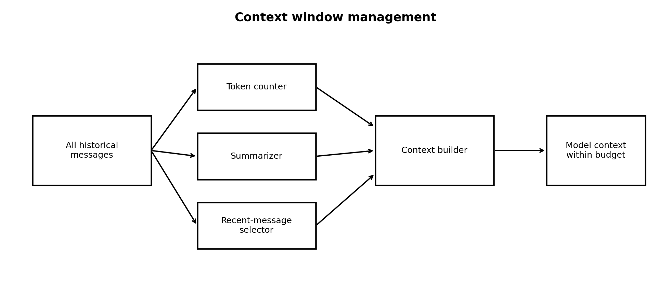

Context algorithm
function buildContext({ systemPrompt, summary, messages, maxContextTokens, outputReserve }) {
const budget = maxContextTokens - outputReserve;
// 1) reserve system prompt
// 2) include durable conversation summary when present
// 3) walk recent messages newest -> oldest until budget is reached
// 4) return ordered context oldest -> newest
// 5) never exceed the model context budget
}
Required behavior
The context builder must be deterministic, testable and provider-independent. If the selected model cannot fit the requested context, the system must summarize/trim or return a clear user-facing error rather than silently exceeding the provider limit.

11. Model comparison engine
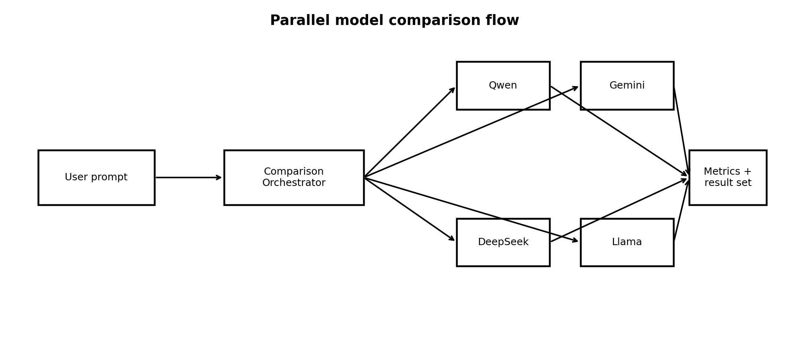

Parallel execution rules
- Validate all selected models before starting execution.
- Create one run record per provider/model pair.
- Execute independent provider calls concurrently with per-run timeouts.
- A failed model run must produce a visible error card and must not cancel successful sibling runs.
- Normalize all outputs into one comparison response shape.
- Record latency from backend request start to terminal provider event.
- Record exact usage when supplied and clearly label estimated usage when not supplied.

Comparison result shape
type ComparisonRun = {
runId: string;
provider: string;
model: string;
status: 'running' | 'completed' | 'failed' | 'timeout';
text?: string;
latencyMs?: number;
usage?: { inputTokens?: number; outputTokens?: number; totalTokens?: number };
estimatedCost?: number;
error?: { code: string; message: string; retryable: boolean };
};

12. Image, video and audio architecture
Multimodal generation must be designed as capability-specific services rather than forcing everything through the synchronous chat route.
Capability | API pattern | Execution | Persistence
Vision chat | /api/chat | Streaming request | Conversation + message + run
Image generation | POST job + GET status | Async job | Job + attachment
Video generation | POST job + GET status | Async job | Job + attachment
Speech-to-text | Upload + process | Async or short request | Transcript + optional message
Text-to-speech | POST + stream/file | Async/streaming | Audio attachment or temporary URL

Provider-neutral job state
type GenerationJob = {
id: string;
kind: 'image' | 'video' | 'audio';
provider: string;
model: string;
status: 'queued' | 'processing' | 'completed' | 'failed' | 'cancelled';
progress?: number;
outputUrl?: string;
error?: string;
};

13. Security, rate limits and abuse protection
- Provider API keys are server-side only and never shipped to the browser.
- Use HTTP-only, Secure, SameSite-aware cookies or a secure session strategy for guest/auth identity.
- Validate every request with Zod or Fastify schemas before business logic.
- Limit payload sizes and reject unsupported file types before processing.
- Apply per-session/per-user rate limits at the Fastify API layer using the mandatory Upstash Redis store. Guest sessions, quotas, temporary context, throttling counters and distributed coordination must use the Redis abstraction from the first implementation. No application-local in-memory rate-limit store is acceptable for the MVP.
- Add IP-aware throttling as a secondary anti-abuse signal, not as the only identity control.
- Use provider-specific concurrency limits to avoid runaway spend or quota exhaustion.
- Sanitize error messages so provider secrets, internal stack traces and keys never reach the client.
- Record security-relevant events without storing unnecessary sensitive content.

Quota examples
Plan | Chat messages/day | Comparison models/run | Persistence
Guest | Configurable small limit | 2 recommended | No permanent history
Free user | Configurable higher limit | 4 recommended | Yes
Pro/Future | Configurable high limit | Configurable | Yes

Server-side enforcement sequence
- Resolve identity.
- Check quota.
- Check rate limit.
- Validate model capability.
- Reserve/track usage.
- Call provider.
- Finalize usage and quota counters.

14. Observability and error handling

Error taxonomy
Code | Meaning | Retryable
AUTH_REQUIRED | Protected action needs login | No
QUOTA_EXCEEDED | User/session quota exhausted | No until reset/upgrade
RATE_LIMITED | Request rate too high | Yes after backoff
MODEL_UNAVAILABLE | Model/provider temporarily unavailable | Maybe
PROVIDER_TIMEOUT | Provider exceeded timeout | Yes
PROVIDER_BAD_RESPONSE | Unexpected provider payload | Usually no
CONTEXT_TOO_LARGE | Request cannot fit selected model | No, user/context action required
VALIDATION_ERROR | Invalid client input | No
INTERNAL_ERROR | Unexpected server problem | Possibly

Minimum logging fields
timestamp
requestId
userId or guestSessionId hash
route
provider
model
status
latencyMs
inputTokens
outputTokens
errorCode

Health and readiness
- GET /health checks process liveness only.
- GET /ready checks all required dependencies, including Supabase PostgreSQL connectivity, Upstash Redis connectivity and provider configuration. A Redis outage is a readiness failure because Redis is mandatory for the MVP.
- Provider health should be measured separately; one provider being degraded must not make the entire API appear dead.
- Use structured logs and request IDs so a UI error can be traced to a server run and provider call.

15. Testing and zero-known-bug phase gate
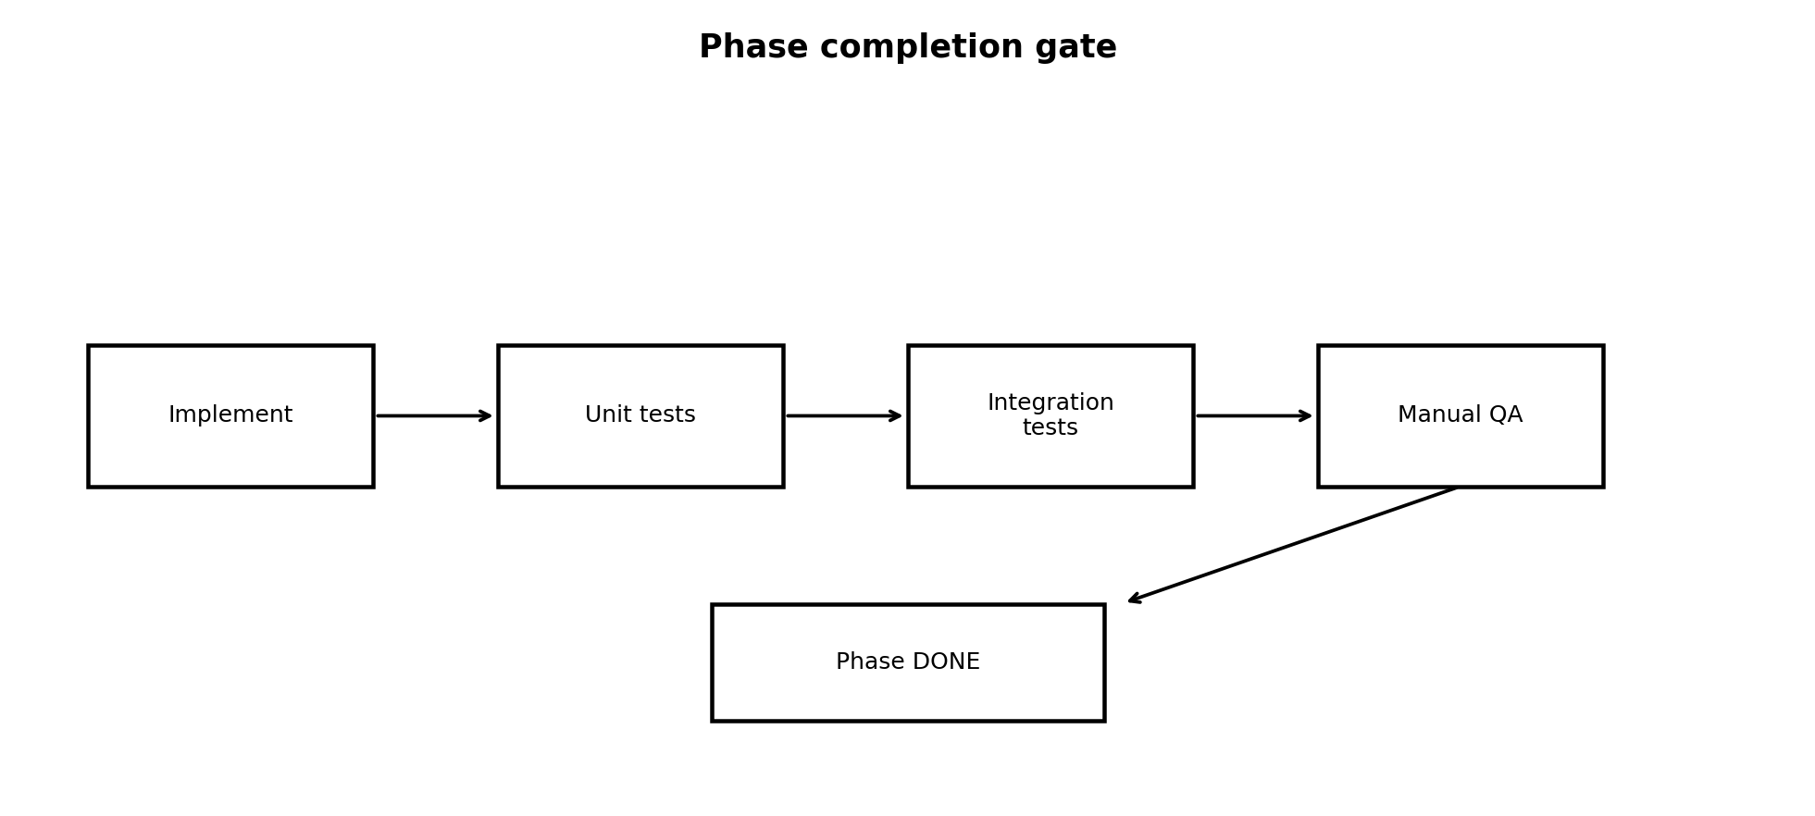

Testing layers
Layer | Examples | Required
Unit | Quota rules, token budgeting, context builder, provider mappers | Every phase
Integration | Fastify routes + DB + Redis + provider mocks | Every backend phase
E2E | Signup, guest chat, comparison, history, migration | Feature phases
Failure-path | Timeout, 429, provider error, malformed payload | Provider phases
Manual QA | Responsive UI, streaming, retry, empty states | Every user-facing phase
Regression | Full suite from completed phases | Every phase gate

Phase completion checklist
- Feature implemented in the intended module/folder.
- TypeScript build passes with no new errors.
- Lint/format checks pass.
- Unit tests pass.
- Integration tests pass.
- Relevant E2E tests pass.
- Failure paths are tested.
- Manual happy-path and unhappy-path QA completed.
- No TODO/FIXME remains for the phase scope.
- No known P0/P1/P2 defect remains for the phase scope.
- Database migrations are applied and reproducible.
- Environment variables are documented.
- Completion report names files/modules changed and tests executed.

16. Phase-by-phase implementation plan

Phase 0 — Foundation and architecture
Monorepo, React app, Fastify app, env validation, Supabase PostgreSQL/Prisma, mandatory Upstash Redis integration, CI checks, provider interface skeleton. Docker is not required for development or deployment in the MVP.
Gate: No business feature should be called complete until the app boots, Supabase DB connects, configuration validation passes, and the test harness works.

Phase 1 — Auth + Guest identity
Signup/login/logout, guest session cookie, identity resolver, quota service skeleton, protected routes.
Gate: Guest and user identity must both reach the API correctly; unauthorized/expired states tested.

Phase 2 — Single-model chat
Chat UI, message persistence for users, temporary guest chat, SSE streaming, Gemini/OpenRouter/Groq adapter.
Gate: Complete chat loop including reconnect/failure states.

Phase 3 — Model registry + selector
Central model registry, capability metadata, model picker, model availability state.
Gate: UI never hard-codes provider logic.

Phase 4 — Comparison engine
Parallel provider calls, normalized comparison runs, latency/tokens/errors, comparison UI.
Gate: One failed model must not break sibling results.

Phase 5 — Context + token management
Token budget, trimming, summarization hooks, context cache, usage normalization.
Gate: Context never exceeds selected model budget in tested scenarios.

Phase 6 — Fallback + routing
Provider health, retries, model/provider fallback, request cancellation.
Gate: Deterministic fallback rules with tests for timeout/429/provider failure.

Phase 7 — History + analytics
Saved history search/filter, run detail, token/cost/latency dashboard.
Gate: All durable runs trace back to user/conversation.

Phase 8 — Vision + image
File upload, vision input, image generation job abstraction.
Gate: Uploads validated and securely handled.

Phase 9 — Video + audio
Video jobs, STT, TTS, async job state.
Gate: Long jobs are resilient to refresh/reconnect.

Phase 10 — Hardening + deployment
Security review, performance, observability, production env, backups, rollback docs.
Gate: Release candidate passes full regression suite and smoke test.

17. Claude Code task protocol
The implementation should be driven by small, reviewable Claude Code tasks. Do not ask Claude to generate the entire product in one prompt. Each task must have a bounded scope, explicit file locations, acceptance criteria and tests.

Standard Claude task format
TASK ID: P0-T01
TITLE: Bootstrap monorepo and application shells
GOAL
Create the frontend and backend shells only. Do not implement chat or authentication yet.
FILES / AREAS
- apps/web
- apps/api
- package manager workspace files
- shared config files
REQUIREMENTS
1. React + TypeScript app boots.
2. Fastify + TypeScript app boots.
3. Shared lint/typecheck commands work.
4. Environment schema exists but contains no secrets.
TESTS
- build passes
- typecheck passes
- lint passes
- frontend smoke test passes
- backend /health returns 200
STOP CONDITION
Do not continue to the next phase. Report exact files changed and test output.

Claude completion response required
IMPLEMENTED
- <exact file/module>
- <exact file/module>
TESTED
- <command> -> PASS
- <command> -> PASS
BEHAVIOR VERIFIED
- <user/system behavior>
KNOWN ISSUES
- None OR explicit list
NEXT TASK
- <one next task only>

Recommended task granularity
- One infrastructure concern at a time.
- One route family at a time.
- One provider adapter at a time.
- One UI workflow at a time.
- Never combine database migration + provider integration + major UI redesign in one task unless the feature cannot be split.

18. Deployment and environment plan

Environment variables
NODE_ENV=development
PORT=3000
DATABASE_URL=...
REDIS_URL=...
AUTH_SECRET=...
OPENROUTER_API_KEY=...
GEMINI_API_KEY=...
GROQ_API_KEY=...
WEB_ORIGIN=http://localhost:5173
Never commit secret values. Maintain .env.example with names only. CI should verify that required variables are present for deployment without printing their values.

Deployment topology
- Frontend: Vercel or equivalent static/edge hosting.
- Fastify API: Render/Railway/Fly or another managed Node host.
- PostgreSQL: Supabase managed PostgreSQL is the required database for ModelArena MVP.
- Redis: mandatory for MVP and provided by Upstash. Redis/Upstash is used for distributed rate limiting, guest sessions, temporary state, quota counters, locks, provider throttling and future background-job coordination.
- Object storage: only when multimodal attachments are introduced; use signed URLs and lifecycle rules.

Release checklist
- Run migrations
- Run typecheck/lint/tests
- Run E2E smoke suite
- Verify health/readiness endpoints
- Verify CORS/origin rules
- Verify secret presence
- Verify provider quotas
- Verify error pages
- Verify logs and request IDs
- Record release commit/version

19. Definition of done
A feature is complete only when all of the following are true:
- The feature exists in the correct architectural layer.
- Its API contract is documented and validated.
- Its UI has loading, success, empty and error states.
- Its happy path is tested.
- Its primary failure paths are tested.
- Its data behavior is covered by integration tests.
- Its security/authorization behavior is checked.
- Its telemetry is sufficient to debug failures.
- Its environment and deployment requirements are documented.
- The phase regression suite passes.
- No known critical/high severity defect is open for the feature scope.
- The implementation report identifies exactly what changed and where.

Project-level final release gate
- All phase gates passed in order.
- Full unit + integration + E2E regression suite passes.
- Guest mode works from a clean browser session.
- Authenticated mode works from signup through saved history.
- Guest-to-user migration is idempotent and tested.
- Single-model streaming works.
- Multi-model comparison works with partial provider failure.
- Quota/rate limiting is server-enforced.
- Context management is bounded and tested.
- Provider keys are server-side only.
- Production health/readiness checks work.
- Rollback procedure is documented.
- Known issue register contains no release-blocking issues.

20. Final implementation tracker
Phase | Feature | Status | Implemented where | Tests / verification
Phase 0 | Foundation and architecture | NOT STARTED
Phase 1 | Auth + Guest identity | NOT STARTED
Phase 2 | Single-model chat | NOT STARTED
Phase 3 | Model registry + selector | NOT STARTED
Phase 4 | Comparison engine | NOT STARTED
Phase 5 | Context + token management | NOT STARTED
Phase 6 | Fallback + routing | NOT STARTED
Phase 7 | History + analytics | NOT STARTED
Phase 8 | Vision + image | NOT STARTED
Phase 9 | Video + audio | NOT STARTED
Phase 10 | Hardening + deployment | NOT STARTED

Use this table as the authoritative project tracker. When a phase is completed, replace NOT STARTED with DONE only after the phase gate passes. The “Implemented where” column must name the actual folders/files, and “Tests / verification” must name the exact commands or test suites that passed.

Appendix A — Initial project package map
ai-arena/
├── apps/
│ ├── web/
│ └── api/
├── packages/
│ ├── shared-types/
│ ├── config/
│ └── eslint-config/
├── prisma/
├── docs/
│ ├── architecture.md
│ ├── api.md
│ ├── phases.md
│ └── decisions.md
├── tests/
│ ├── integration/
│ └── e2e/
├── .env.example
├── package.json
└── README.md

Appendix B — Important product decisions already locked
Decision | Locked choice
Backend framework | Fastify
Frontend | React + TypeScript
Database | PostgreSQL
ORM | Prisma
Ephemeral/limits store | Redis
Streaming | SSE
AI architecture | Provider abstraction
Guest identity | HTTP-only session cookie + Upstash Redis
Authenticated history | PostgreSQL
Guest persistence | Temporary; optional migration after signup
Comparison | Parallel model execution
Completion standard | Phase gate with tests + manual QA + no known release-blocking defects
Implementation style | Small Claude Code tasks with explicit test evidence

21. GitHub repository architecture
The GitHub repository is part of the implementation architecture, not an afterthought. The repository structure below is authoritative and should be created during Phase 0. It is intentionally organized as a monorepo so the React frontend, Fastify API, shared TypeScript packages, database schema and engineering documentation evolve together.

21.1 Repository name and top-level structure
modelarena/
├── apps/
│ ├── web/
│ └── api/
├── packages/
│ ├── shared-types/
│ ├── ai-core/
│ ├── ai-providers/
│ ├── validation/
│ └── config/
├── prisma/
│ ├── schema.prisma
│ ├── migrations/
│ └── seed.ts
├── docs/
│ ├── architecture/
│ ├── api/
│ ├── development/
│ └── decisions/
├── scripts/
├── tests/
│ ├── integration/
│ └── e2e/
├── .github/
│ ├── workflows/
│ ├── ISSUE_TEMPLATE/
│ └── pull_request_template.md
├── .env.example
├── .gitignore
├── package.json
├── pnpm-workspace.yaml
├── turbo.json
├── README.md
└── LICENSE

21.2 Frontend repository boundary
apps/web/src/
├── app/
├── pages/
├── components/
│ ├── ui/
│ ├── layout/
│ ├── chat/
│ ├── comparison/
│ └── models/
├── features/
│ ├── auth/
│ ├── guest/
│ ├── chat/
│ ├── comparison/
│ ├── models/
│ ├── history/
│ ├── image/
│ ├── video/
│ └── audio/
├── hooks/
├── services/
├── stores/
├── lib/
└── types/
- Frontend owns presentation, interaction state, client-side data fetching, accessibility and optimistic UI where appropriate.
- Frontend never imports provider SDKs and never contains provider API keys or provider-specific secrets.
- Frontend consumes normalized backend contracts from shared types instead of coupling UI code to external provider response formats.

21.3 Backend repository boundary
apps/api/src/
├── app.ts
├── server.ts
├── plugins/
│ ├── auth.ts
│ ├── prisma.ts
│ ├── redis.ts
│ ├── cors.ts
│ └── observability.ts
├── modules/
│ ├── auth/
│ ├── guest/
│ ├── users/
│ ├── conversations/
│ ├── chat/
│ ├── models/
│ ├── comparison/
│ ├── usage/
│ ├── image/
│ ├── video/
│ └── audio/
├── ai/
│ ├── ai.service.ts
│ ├── model-router.ts
│ ├── fallback.service.ts
│ └── token.service.ts
├── providers/
│ ├── openrouter/
│ ├── gemini/
│ ├── groq/
│ └── provider.interface.ts
├── repositories/
├── schemas/
├── middleware/
└── shared/
├── errors/
├── constants/
└── utils/
- Routes are thin and should validate, identify, authorize, call a service and map a normalized response.
- Business rules belong in services; database persistence belongs behind Prisma/repositories; external SDK code belongs inside provider adapters.

21.4 Shared packages
Shared packages prevent duplicated types and validation rules across web and API.
Package | Purpose | Allowed dependencies
shared-types | Canonical API, AI, auth, model, usage and domain types. | Type-only dependencies preferred.
ai-core | Provider-neutral AI contracts, normalized events, capability interfaces and run state. | No provider SDKs.
ai-providers | Reusable provider adapters and provider-specific mapping utilities. | Provider SDKs/API clients only.
validation | Shared Zod schemas for request/response validation where browser-safe. | Zod and shared-types.
config | Typed environment/config contracts that do not expose secrets to the browser. | Minimal runtime dependencies.

21.5 Git branches and development flow
main
└── develop
├── feature/auth
├── feature/guest-mode
├── feature/ai-provider-openrouter
├── feature/ai-provider-gemini
├── feature/model-comparison
├── feature/context-management
├── feature/image-generation
└── feature/video-audio
- main is release-ready only. Direct pushes to main are disabled.
- develop is the integration branch for completed phase work.
- Every meaningful feature is developed on a short-lived feature branch and merged through a pull request.
- Branch names should describe one bounded scope. Do not combine unrelated features in one branch.
- The phase number and task ID should be referenced in the branch name or commit message when practical, for example feature/p2-chat-streaming-P2-T04.

21.6 Commit message convention
feat(chat): add normalized SSE streaming
fix(quota): reject guest requests after limit
refactor(ai): extract provider interface
test(comparison): cover partial provider failure
docs(architecture): document guest identity flow
chore(ci): add integration test job
- Commits should be small enough to explain in one sentence and should keep the repository buildable whenever practical.

21.7 GitHub Issues and task IDs
Every implementation task should have a stable ID so Claude Code output, commits, pull requests, tests and phase reports can reference the same work item.
MODEL-001 Initialize monorepo
MODEL-002 Configure React application
MODEL-003 Configure Fastify API
MODEL-004 Configure Prisma
MODEL-005 Configure Supabase database and guest-session persistence
MODEL-006 Implement authentication
MODEL-007 Implement guest sessions and expiration/cleanup
MODEL-008 Create AI provider interface
MODEL-009 Implement OpenRouter provider
MODEL-010 Implement Gemini provider
MODEL-011 Implement streaming
MODEL-012 Persist conversations
MODEL-013 Implement model registry
MODEL-014 Implement model comparison

21.8 Issue template
TITLE
MODEL-XXX <short action>
GOAL
What user/system behavior is being added?
SCOPE
Included files/modules and explicit exclusions.
IMPLEMENTATION
Expected architecture and important constraints.
ACCEPTANCE CRITERIA
- Functional behavior
- Error behavior
- Security behavior
- Data behavior
TESTS
Unit / integration / E2E / manual checks.
DONE WHEN
All acceptance criteria pass and no scoped known defect remains.

21.9 Pull request rules
- PR title must include the task ID, for example: MODEL-011 Add normalized chat streaming.
- PR description must list changed files/modules, behavior added, tests executed, migration impact, environment-variable changes and known issues.
- A PR cannot be considered complete when tests are skipped because the code is expected to be fixed later.
- Database migrations must be included with the feature that requires them and must be reproducible from a clean database.
- Any changed public API contract must update docs/api and shared types in the same PR.

21.10 GitHub Actions CI/CD
.github/workflows/
├── ci.yml
├── test.yml
└── deploy.yml
Every pull request must run the quality gate before merge:
Pull Request
-> install dependencies
-> typecheck
-> lint
-> unit tests
-> integration tests
-> build web
-> build api
-> E2E smoke tests (when environment is available)
-> result required before merge
- CI must fail on TypeScript errors, lint errors, failed tests or failed builds.
- Secrets are injected through GitHub Actions secrets/environments and are never printed.
- Deploy workflows promote only commits that have passed the required checks.

21.11 GitHub documentation map
docs/
├── architecture/
│ ├── system-architecture.md
│ ├── repository-architecture.md
│ ├── guest-mode.md
│ ├── provider-abstraction.md
│ ├── comparison-engine.md
│ └── context-management.md
├── api/
│ ├── auth.md
│ ├── chat.md
│ ├── models.md
│ ├── comparison.md
│ └── generation.md
├── development/
│ ├── roadmap.md
│ ├── phase-0.md
│ ├── phase-1.md
│ ├── phase-2.md
│ └── release-checklist.md
└── decisions/
├── ADR-001-fastify.md
├── ADR-002-guest-session.md
├── ADR-003-provider-abstraction.md
└── ADR-004-monorepo.md
- Architecture Decision Records (ADRs) should be used whenever a locked project decision has meaningful long-term trade-offs.

22. Claude Code operating protocol
This section is the operating contract for Claude Code. Claude must treat this master blueprint and the repository documentation as the source of truth, and must never silently skip functionality to reach a milestone.

22.1 Before every Claude task
- Read the relevant phase in docs/development and the related architecture/API documents.
- Inspect the current repository state instead of assuming files or features exist.
- Identify the exact task ID and its acceptance criteria.
- List dependencies and confirm the task scope is bounded.

22.2 Implementation rule
- Implement only the requested slice unless the slice cannot work without a directly related supporting change.
- Preserve existing behavior and tests.
- Do not leave placeholder TODOs for required behavior inside a task marked complete.
- When a task exposes a missing prerequisite, implement the smallest required prerequisite or mark the task blocked rather than pretending it is done.

22.3 Required Claude completion report
TASK
MODEL-XXX <title>
IMPLEMENTED
- exact file/path + responsibility
- exact file/path + responsibility
TESTED
- pnpm typecheck -> PASS
- pnpm lint -> PASS
- pnpm test -> PASS
- relevant integration/E2E command -> PASS
BEHAVIOR VERIFIED
- expected user/system behavior
- primary error behavior
DATA / MIGRATION
- migration created/applied or N/A
ENVIRONMENT
- variables added/changed or N/A
KNOWN ISSUE
- NONE, or explicit blocker/defect with issue ID
NEXT TASK
- exact next MODEL-XXX ID

22.4 Phase completion report
PHASE
P0 / P1 / P2 / ...
STATUS
DONE only when the phase gate passes.
IMPLEMENTED WHERE
- repository paths/modules
- API routes
- database tables/migrations
- Temporary session records
- UI routes/components
VERIFICATION
- typecheck PASS
- lint PASS
- unit PASS
- integration PASS
- E2E PASS
- manual QA PASS
- failure-path QA PASS
REGRESSION
- previous phase tests PASS
KNOWN DEFECTS
- NONE for release-blocking severities, otherwise list issue IDs
RELEASE / MERGE
- PR number / commit SHA / date

22.5 No-pending-functionality rule
- A phase cannot be marked DONE when a required function, route, UI state, database migration, error path or test is still pending.
- A stub counts as incomplete unless the task explicitly defines it as a deliberate extension point and all current acceptance criteria are satisfied.
- If a later phase is intentionally deferred, the current phase must document the deferred boundary without claiming the deferred feature is implemented.
- Known bugs must be recorded with severity and issue ID. P0/P1 defects block phase completion. P2 defects block completion when they affect the acceptance criteria or data integrity.

22.6 Recommended Claude task prompt header
You are implementing MODEL-XXX for ModelArena.
Read the master blueprint and the relevant docs before changing code.
Implement only this task scope. Do not silently omit required behavior.
After implementation, run the required checks and report exact files changed, tests passed, behavior verified, migrations/env changes, and any known issue.
Do not mark the task or phase complete if required functionality is pending or broken.

23. Authoritative ModelArena repository tree
This tree supersedes any abbreviated package-map examples earlier in the document. It is the target repository layout for the finished project; intermediate phases may create only the folders required for the current phase.
modelarena/
├── apps/
│ ├── web/
│ │ └── src/
│ │ ├── app/
│ │ ├── pages/
│ │ ├── components/
│ │ ├── features/
│ │ │ ├── auth/
│ │ │ ├── guest/
│ │ │ ├── chat/
│ │ │ ├── comparison/
│ │ │ ├── models/
│ │ │ ├── history/
│ │ │ ├── image/
│ │ │ ├── video/
│ │ │ └── audio/
│ │ ├── hooks/
│ │ ├── services/
│ │ ├── stores/
│ │ ├── lib/
│ │ └── types/
│ └── api/
│ └── src/
│ ├── app.ts
│ ├── server.ts
│ ├── plugins/
│ ├── modules/
│ ├── ai/
│ ├── providers/
│ ├── repositories/
│ ├── schemas/
│ ├── middleware/
│ └── shared/
├── packages/
│ ├── shared-types/
│ ├── ai-core/
│ ├── ai-providers/
│ ├── validation/
│ └── config/
├── prisma/
├── docs/
├── scripts/
├── tests/
├── .github/
├── .env.example
├── package.json
├── pnpm-workspace.yaml
├── turbo.json
├── README.md
└── LICENSE

24. GitHub project board and phase tracking
Use GitHub Issues + Project board as the visible execution tracker. The DOCX remains the master architecture specification; GitHub tracks execution state.
BACKLOG
-> READY
-> IN PROGRESS
-> CODE COMPLETE
-> VERIFICATION
-> DONE
-> BLOCKED (only when an explicit external dependency prevents progress)
- CODE COMPLETE means implementation is finished but tests/verification are not yet fully passed.
- DONE means the full task acceptance criteria and required checks passed.
- BLOCKED must include the blocker, owner/dependency and a concrete next action.

25. Updated definition of project completion
The ModelArena project is considered release-ready only when the software, repository, documentation and CI/CD process are all complete. A working demo alone is not sufficient.
- All phases 0 through 10 have passed their individual gates.
- The GitHub repository follows the authoritative monorepo structure.
- All required routes, services, providers, database migrations and guest-session/cleanup behaviors are implemented. No Docker or Upstash dependency is required for the MVP.
- Guest mode, authentication, quota enforcement and guest-to-user migration are verified.
- Single-model streaming and multi-model comparison are verified with partial provider failures.
- Token/context management is bounded and tested against context-overflow scenarios.
- Image, video and audio capabilities are implemented according to the phases actually marked DONE; unsupported provider capabilities are not falsely exposed.
- CI blocks merges when required checks fail.
- The final implementation tracker contains exact paths and test evidence for every completed phase.
- No release-blocking known defects remain.

26. GitHub + Claude execution tracker fields
Field | Example | Required | Owner | Completion rule
Task ID | MODEL-011 | Yes | Developer/Claude | Unique and traceable
GitHub issue | Issue #42 | Yes | Project maintainer | Acceptance criteria present
Branch | feature/p2-streaming-MODEL-011 | Yes | Developer/Claude | Single bounded scope
PR | PR #57 | Yes | Developer/Reviewer | CI green before merge
Implemented where | apps/api/src/modules/chat/* | Yes | Developer/Claude | Exact paths listed
Tests | typecheck/lint/unit/integration/E2E | Yes | Developer/Claude | Required checks PASS
Migration | prisma/migrations/... | When applicable | Developer/Claude | Reproducible
Environment | GEMINI_API_KEY | When applicable | Developer | Documented in .env.example
Known issues | None / MODEL-xxx | Yes | Developer/Claude | Explicit; no hidden defects
Phase status | DONE | Yes | Maintainer | Gate passed

INFRASTRUCTURE DECISION — MVP
Decision: ModelArena MVP does not require Docker, but Upstash Redis is mandatory infrastructure.
Database: Supabase PostgreSQL is the single persistent data store. Prisma connects to Supabase using the project database connection string.
Guest sessions: Guest identity, usage counters, expiration timestamps and temporary conversation state are stored in Upstash Redis with TTLs. Redis expiration is the primary cleanup mechanism. Guest data is never treated as permanent user history; only explicitly migrated conversations become durable user data in Supabase PostgreSQL after signup/login.
Rate limiting: Use Fastify rate limiting backed by the mandatory Upstash Redis adapter from the initial deployment. The business-level quota service and rate-limit service must use a storage interface so Redis-backed behavior remains isolated from business logic.
Why Upstash now: Upstash provides the shared Redis state required for reliable guest quotas, rate limiting, temporary context, provider throttling and safe operation when the API scales beyond a single instance.
Why no Docker now: Supabase provides PostgreSQL and the deployment providers run the Node/Fastify application directly. Docker is therefore optional infrastructure, not a project prerequisite.
Scale-out behavior: Redis/Upstash is already part of the MVP. Future scale-out must reuse the same Redis abstractions for distributed locks, queue coordination, shared counters and multi-instance rate limiting without changing chat/model business logic.
Non-negotiable rule: Upstash Redis is an explicit required dependency. Docker must not be required. All Redis usage must be explicit, configured, tested, health-checked and documented in code, environment variables, tests, deployment instructions and Claude Code prompts.

MVP Environment Variables
- DATABASE_URL=Supabase PostgreSQL connection string
- DIRECT_URL=Supabase direct database URL (when required by Prisma migrations)
- JWT_SECRET=server-only secret
- OPENROUTER_API_KEY=server-only provider key
- GEMINI_API_KEY=server-only provider key
- GROQ_API_KEY=server-only provider key
- CORS_ORIGIN=frontend origin
- GUEST_SESSION_TTL_MINUTES=configuration value
- GUEST_DAILY_MESSAGE_LIMIT=configuration value
- REDIS_URL=Upstash Redis connection URL (required)

MVP Infrastructure Acceptance Checklist
- Fresh clone works without Docker.
- Fresh clone has a valid Upstash Redis configuration available.
- Supabase database migration succeeds.
- Fastify API starts with only required environment variables.
- Guest chat works and enforces the quota server-side.
- Expired guest sessions are cleaned up.
- Logged-in conversations persist in PostgreSQL.
- Rate limiting works through Upstash Redis and remains correct across API restarts.
- Health/readiness checks fail clearly when the mandatory Upstash Redis dependency is unavailable.
- Tests use Supabase/PostgreSQL and an Upstash Redis test configuration or controlled Redis test adapter; no local PostgreSQL/Redis container is required.
Architecture status: Supabase PostgreSQL = required. Upstash Redis = required. Docker = not required.

