**ROBAN SYSTEMS**

**AN HELPING HAND FOR DISABLED PEOPLE**

**A PROJECT REPORT**

submitted by

**Ajay Das K, Fathima Irfana T P, Muhammed Fayis M T, Rabeeh C**

**Register Number: CCV19CS002, CCV19CS007, CCV19CS015, CCV19CS019**

**TO**

The APJ Abdul Kalam Technological University

in partial fulfilment of the requirements for the award of the Degree of

Bachelor Of Technology

In

Computer Science and Engineering



**Department Of Computer Science and Engineering**

**MGM COLLEGE OF ENGINEERING ANDPHARAMACEUTICAL**

**SCIENCES**

VALANCHERY

January 2023

**DECLARATION**

I undersigned hereby declare that the main project report " **Roban systems - An helping hand for disabled people**", submitted for partial fulfilment of the requirements for the award of degree of bachelor of Technology of the APJ Abdul Kalam Technological University, Kerala is a Bonafede work done by me under supervision of **MS NASRIN JUMANA K T**, Asst. Professor, Department of Computer Science and Engineering. This submission represents my ideas in my own words and where ideas or words of others have been included, we have adequately and accurately cited and referenced the original sources. We also declare that we have adhered to ethics of academic honesty and integrity and have not misrepresented or fabricated any data or idea or fact or source in our submission. We understand that any violation of the above will be a cause for disciplinary action by the institute and/or the University and can also evoke penal action from the sources which have thus not been properly cited or from whom proper permission has not been obtained. This report has not been previously formed the basis for the award of any degree, diploma or similar title of any other University.

Place: Valanchery Signature

Date: 06 January 2023 Ajay Das K (CCV19CS002)

Fathima Irfana T P(CCV19CS007)

Muhammed Fayis M T (CCV19CS015)

Rabeeh C (CCV19CS019)

**DEPARTMENT OF COMPUTER SCIENCE AND ENGINEERING MGM COLLEGE OF ENGINEERING AND PHARMACEUTICAL SCIENCES, VALANCHERY**



**CERTIFICATE**

This is to certify that the project report entitled " **Roban systems - An helping hand for disabledpeople** " submitted by Ajay Das K, Fathima Irfana T P, Muhammed Fayis M T, Rabeeh C( CCV19CS002, CCV19CS007, CCV19CS015, CCV19CS019 )to the APJ Abdul Kalam Technological University in partial fulfilment of the requirements for the award of the Degree of Master of Technology in Computer Science and Engineering is a bonafide record of the project work carried out by her under my guidance and supervision during the year 2022- 2023.This report in any form has not been submitted to any other University or Institute for any purpose

Internal Supervisor External Supervisor Head of the Department

**ACKNOWLEDGEMENT**

Alone we can do so little; together we can do so much. Likewise, the present project work has been undertaken and completed with direct and indirect help from many people and I would like to acknowledge the same.

First and foremost, I take immense pleasure in thanking the **Management** and respected principal **DR. PROF BABU JOHN,** for providing me with the wider facilities.

We express our sincere thanks to **MS. MEERA K**, Head of Department of Computer Science and Engineering for giving me opportunity to present this project and for timely suggestions.

I wish to express my deep sense of gratitude to the project coordinator **MS. MEERA K**, Head of Department of Computer Science and Engineering, who coordinated in right path. Words are inadequate in offering my thanks to **MS NASRIN JUMANA K T** , Asst professor Department of Computer Science and Engineering, for her encouragement and guidance in carrying out the project.

Needless to mention that the teaching and the non-teaching faculty members had been the source of inspiration and timely support in the conduct of our project. We would like to express our heartfelt thanks to our beloved parents for their blessings, our classmates for their help and wishes for the successful completion of this project.

Above all we would like to thank the Almighty God for the blessings that helped us to complete the venture smoothly with us. Without their support, it would be impossible for us to finish our work. That is why we wish to dedicate this section to recognize their support.

AJAY DAS K

FATHIMA IRFANA T P

MUHAMMED FAYIS M T

RABEEH C

**ABSTRACT**

Smart home applications are pervasive and have gained popularity due to the overwhelming use of Internet of Things (IoT). The revolution in IoT technologies made homes more convenient, efficient and perhaps more secure. The need to advance smart home technology is necessary at this stage as IoT is abundantly used in automation industry. However, most of the proposed solutions are lacking in certain key areas of the system i.e., high interoperability, data independence, privacy, and optimization in general. The use of machine learning algorithms requires high-end hardware and are usually deployed on servers, where computation is convenient, but at the cost of bandwidth. However, more recently edge AI enabled systems are being proposed to shift the computation burden from the server side to the client side enabling smart devices. In this paper, we take advantage of the edge AI enabled technology to propose a fully featured cohesive system for smart home based on IoT and edge computing. The proposed system makes use of industry standards adopted for fog computing as well as providing robust responses from connected IoT sensors in a typical smart home. The proposed system employs edge devices as a computational platform in terms of reducing energy costs and provides security, while remotely controlling all appliances behind a secure gateway. A case study of human fall detection is evaluated by a custom lightweight deep neural network architecture implemented over the edge device of the proposed framework. The case study was validated using the Le2i dataset. During the training, the early stopping threshold was achieved with 98% accuracy for training set and 94% for validation set. The model size of the network was 6.4 MB which is significantly lower than other networks with similar performance.

Keyword:- Artificial intelligence, Edge intelligence , IoT, Smart home, Deep learning, Human fall detection

**CONTENTS**

**CHAPTER 1**

**INTRODUCTION**

Over the last few decades, many researchers have focused on connecting everyday objects and weaving a web of interconnected devices. These can be physical devices, automobiles, embedded systems or everyday home appliances. The connectivity of these devices is enabled by the underlying technology known as Internet of Things (IoT) [1]. These devices can communicate with one another and seamlessly collect and transfer data in between to adapt and reciprocate to dynamic situations. The IoT is gaining tremendous traction from the IT industry as well as individual enthusiast alike. This is due to the fact that microcontroller technologies have evolved that enable these complex infrastructures and are more accessible to average developers. The use of single board computers also refers to as System on Chip (SoC) in IoT based systems, which enables rapid interconnection of environmental sensors and decent computational capabilities along with vision sensors that make it easy to develop fairly in large applications. Advancements in machine learning algorithms for mobile and low-power devices also pave way for intelligent devices in IoT systems. A typical home automation system connects heterogeneous devices, collects data, and decides based on the observed data from these sensors. The means of communication between these devices is typically a Wi-Fi or Bluetooth, and in some cases a cellular network (3G/4G/5G) [2]. We were focusing on how IoT can drastically improve the lives of disabled people addressing limited access in many ways. We also spoke about how smart homes and home automation systems are rising in popularity, allowing people to control various aspects of their home from a single place without getting up. However, for disabled people, this technology holds much more significance. It is not adding additional value but solving some of their biggest hurdles like being unable to access specific items or devices. Smart homes single-handedly allow disabled people to live more independently with an easy-access lifestyle. With the sophistication of IoT technology, it has become a possibility for disabled people to rely lesser on their caregivers

**CHAPTER 2**

**LITERATURE SURVEY**

**2.1 Enabling Automation And-Edge Intelligence Over Resource Const**

Smart home applications are pervasive and have gained popularity due to the overwhelming use of Internet of Things (IoT). The revolution in IoT technologies made homes more convenient, efficient and perhaps more secure. The need to advance smart home technology is necessary at this stage as IoT is abundantly used in automation industry. However, most of the proposed solutions are lacking in certain key areas of the system i.e., high interoperability, data independence, privacy, and optimization in general. The use of machine learning algorithms requires high-end hardware and are usually deployed on servers, where computation is convenient, but at the cost of bandwidth. However, more recently edge AI enabled systems are being proposed to shift the computation burden from the server side to the client side enabling smart devices. In this paper, we take advantage of the edge AI enabled technology to propose a fully featured cohesive system for smart home based on IoT and edge computing. The proposed system makes use of industry standards adopted for fog computing as well as providing robust responses from connected IoT sensors in a typical smart home. The proposed system employs edge devices as a computational platform in terms of reducing energy costs and provides security, while remotely controlling all appliances behind a secure gateway. A case study of human fall detection is evaluated by a custom lightweight deep neural network architecture implemented over the edge device of the proposed framework. The case study was validated using the Le2i dataset. During the training, the early stopping threshold was achieved with 98% accuracy for training set and 94% for validation set. The model size of the network was 6.4 MB which is significantly lower than other networks with similar performance.

**2.2 Interacting with a Digital Twin using Amazon Alexa**

The Digital Twin is an evolving concept with many facets and applications in, for instance, engineering simulation, system control, and product-centric information management. This article focuses on the latter where literature uses the Product Avatar concept to refer to a product's digital counterpart. Such an avatar used to have one or more graphical interfaces to support user interactions with information about a product item. Over the last few years, voice user interfaces became more mature, and companies, such as Amazon and Google, used them to create digital assistants that support their users during tasks or by taking them over directly. This paper focuses on the hypothesis that a company could use a voice-enabled digital assistant to interact with item-level information. Our study used product tracking and tracing, and quality control in the production as a realistic application case. The design of the assistant bases on the information needs outlined in the Electronic Product Code Information Services (EPCIS) standard. We implemented this design in a small-scale demonstrator on an Echo Show 5 smart speaker with an integrated touch display and an embedded Amazon Alexa assistant. This paper concludes that significant technological barriers, such as low transcription accuracy for object identifier information and the handling of factory noise, remain. A significant non-technological barrier is the mistrust regarding the closed voice assistant technologies from companies, such as Amazon and Google. An approach to address the latter barrier is to use open technologies, such as the privacy-focused assistant Mycroft or Mozilla's transcription solution DeepSpeech.

**2.3 Amazon Alexa traffic traces**

The number of devices that make up the Internet of Things (IoT) has been increasing every year, including smart speakers such as Amazon Echo devices. These devices have become very popular around the world where users with a smart speaker are estimated to be about 83 million in 2020. However, there has also been great concern about how they can affect the privacy and security of their users [1]. Responding to voice commands requires devices to continuously listen for the corresponding wake word, with the privacy implications that this entails. Additionally, the interactions that users may have with the virtual assistant can reveal private information about the user. In this document we publicly share two datasets that can help conduct privacy and security studies from the Amazon Echo Dot smart speaker. The included data contains 300.000 raw PCAP traces containing all the communications between the device and Amazon servers from 100 different voice commands on two different languages. The data can be used to train machine learning algorithms in order to find patterns that can characterize both, the voice commands and people using the device as well as Alexa as the device generating the traffic..

**2.4 Iot-Based Electro Synthesis Ecosystem**

In this paper, we presented the electro synthesis ecosystem using esp8266 with OTA com- pilation integrated, the MQTT Broker for the control system that would be installed on a Raspberry Pi and MQTT protocol for the wireless data transfer layer which provides the electrosysnthesis machine to work 24/7 and with the AI that can be implemented, the whole ecosystem would be smart and the data-driven can be used in QC verifica- tion. This system is designed and simulated and the source codes are available via GitHub (https://github.com/iraniothome/ChemIoT).

**2.5 Access Control And Surveillance In A Smart Home**

In the past years smart homes solutions have become more and more popular with the introduction of a high number of both Internet of Things (IoT) applications and smart devices. Home automation and security systems market is in a continuous growth, traditional security systems are evolving fast, and more and more people choose Smart home solutions. In this paper, we propose two IoT based systems in the context of Smart homes: qToggle for multiple home automation, and MotionEyeOS, a video surveillance OS for single-board computers. Most qToggle devices are based on ESP8266/ESP8285 chips or on Raspberry Pi boards and smart sensors, while MotionEye uses Raspberry Pi boards.

**2.6 Smart Iot Surveillance Multi-Camera Monitoring System**

The surveillance digital monitoring process market has changed aggressively over the last 15 years. Where the process was needed for people to secure their business by a simple surveillance camera system to give them that much needed peace of mind. However, the existing monitoring systems are very expensive due to internal specific SDK configuration which was embedded in the camera itself. Some of them provide a solution such as a high-priced customized command center that has several screens view which communicates with several cameras to monitor the cameras with a specific detection analysis module. In this paper, a cheaper solution to the monitoring system for existing surveillance cameras is introduced to overcome the solution. This system only implements open source image processing methods to produce a monitoring system with customizable modules for video analytics (video content analysis) with the input of live video sources. This is to allow a wider range of camera models that can be used for this system. A real-time analysis module will assist in the use of the system to ease the user. The combined video stream and the module will help the user immensely for surveillance propose. Based on the result, the proposed system achieved a higher affordability level up to 95% with 90% usability compared to existing products.

**2.7 Trustbuilder: A Non-Repudiation Scheme For Iot Cloud Applications**

The IoT cloud computing paradigm is emerging for IoT applications. In such a paradigm, how to guaran- tee non-repudiation service provisioning has attracted research effort s recently. While existing solutions could work for distributed IoT cloud applications, storage, computation, and economic cost is still a prac- tical challenging concern. In this paper, we propose a new, cost-lower non-repudiation scheme for IoT cloud applications. The proposed scheme guarantees that neither the IoT client nor the cloud could re- pudiate a service enjoyment and provisioning. Specifically, the proposed scheme employs a blockchain to achieve non-repudiation. First, when the cloud provides a service, it encrypts the service, stores a cryp- tographic hash digest of the encrypted service on the blockchain, and then sends the encrypted service to the IoT client. Second, the IoT client needs to acknowledge the hash digest on the blockchain to ob- tain the service. Third, the cloud sends the decryption key to the blockchain under the IoT client’s public key to finish a service provisioning. We show that the proposed scheme achieves non-repudiation fairly. We prototyped, evaluated, and open-sourced the proposed scheme. Experimental results confirmed the efficiency of the proposed scheme and the speedup compared with the state-of-the-art solution..

**2.8 Accuracy Determination Using Deep Learning Technique In Cloud-Based Iot Sensor Environment**

devices. However, when connected to wireless connections, unlimited access to IoT gadgets poses potential risks. As it eases cost constraints on sensor nodes, the cloud service with IoT networks has received greater attention. In addition, the high complexity of the distribution and networking of IoT makes them vulnerable to attacks. Intrusion detection systems (IDSs) are selected to ensure the security of reliable information and operations. IDS successfully detects anomalies in complex network situations and guarantees network security. Deep Convolution Network (DCN) IDS have a slow learning curve and poor categorization precision. Deep Learning (DL) methods are often used in a wide range of safety data processing, imaging, and signal processing like Poor transfer learning ability, reusability of modules, and integration. To overcome the constraints of Machine Learning (ML) IDS is intended to provide a comprehensive mechanism to learn the detection mechanism for multicloud IoT environments. The proposed IDS approach increases training efficiencies while increasing detection accuracy. Experimental investigations of the proposed system using the considered database confirms that the performance of the proposed system is capable and in the range of acceptance with relative to existing methods. Further, achieving detection capability, reliability, and accuracy of 97.51, 96.28, and 94.41% respectively are achieved.

**2.9 Self Secured Model For Cloud Based IOT Systems**

A difficult problem to solve concerns the secure installation and startup of devices connected to the Internet of Things (IoT) via the Internet.To provide additional value-added services, this article deals with the verified configuration of IoT devices in a secure manner using the Internet. Following a review of the safe selfconfiguration limitations imposed on IoT and Cloud technologies; offer a Cloud-based architecture that enables the communication between IoT devices and several federated Cloud services. Specifically discuss two situations, one cloud environment and federated cloud infrastructure interact with IoT devices, and handle unique issues.In addition, it provides many operational design features that take into account the truly open hardware and software products already on the market.

**2.10 Taking MQTT And Nodemcu To IOT: Communication In Internet Of Things**

Internet of Things (IoT) allow connection among devices using internet with the ability to gather and exchange data. These devices are usually attached with micro-controllers like Arduino, sensors, actuators and internet connectivity. In this context, Message Queuing Telemetry Transport protocol (MQTT) plays an important role to exchange the data or information between the devices in IoT without knowing the identities of each other. This paper presents different service models for communication in Internet of Things(IoT). Model A presents use of serial USB as transmission medium while Model B uses the Message Queuing Telemetry Transport protocol (MQTT) which deploy a Wi-Fi module (ESP8266-12) to connect the system to internet. For communication, concept of publisher and subscriber is used. Messages are published or subscribed with the help of a broker or server. This agent is in charge of dispersing messages to intent clients depending on the choice of the topic of a message. Broker in MQTT is also called server. Some brokers used in MQTT are: -Mosquitto, Adafruit, hiveMQ

**CHAPTER 3**

5

4

2

1

3

**MODULES**

Bed

and Ventilation

Medical

Aid

Basic

Needs

Security and Entertainment

Patient Monitor

Fig 3 modules of Roban System

#### 3.1 Bed and Ventilation Module

#### Bed and ventilation module is used to adjust the bed position and adjust the ventilation by sliding the curtains .Disabled people can adjust the bed positions by themselves through voice commands , so they can acquire their comfortable positions . By controlling the ventilation system by voice command they can adjust the natural lighting and ventilation.

#### 3.2 Basic Needs Module

#### Bed and ventilation module is used to adjust the bed position and adjust the ventilation by sliding the curtains .Disabled people can adjust the bed positions by themselves through voice commands , so they can acquire their comfortable positions . By controlling the ventilation system by voice command they can adjust the natural lighting and ventilation

#### 3.3 Patient Monitor Module

#### Bed and ventilation module is used to adjust the bed position and adjust the ventilation by sliding the curtains .Disabled people can adjust the bed positions by themselves through voice commands , so they can acquire their comfortable positions . By controlling the ventilation system by voice command they can adjust the natural lighting and ventilation

#### 3.4 Medical Aid Module

#### Bed and ventilation module is used to adjust the bed position and adjust the ventilation by sliding the curtains .Disabled people can adjust the bed positions by themselves through voice commands , so they can acquire their comfortable positions . By controlling the ventilation system by voice command they can adjust the natural lighting and ventilation

#### 3.5 security and Entertainment Module

Bed and ventilation module is used to adjust the bed position and adjust the ventilation by sliding the curtains .Disabled people can adjust the bed positions by themselves through voice commands , so they can acquire their comfortable positions . By controlling the ventilation system by voice command they can adjust the natural lighting and ventilation

#### Self-driving cars

Another unique application of object detection technique is definitely self-driving cars.  A self-driving car can only navigate through a street safely if it could detect all the objects such as people, other cars, road signs on the road, in order to decide what action to take.

#### Detecting a vehicle

In a road full of speeding vehicles object detection can help in a big way by tracking a particular vehicle and even its number plate. So, if a car gets into an accident or, breaks traffic rules then it is easier to detect that particular car using object detection model and thereby decreasing the rate of crime while enhancing security

.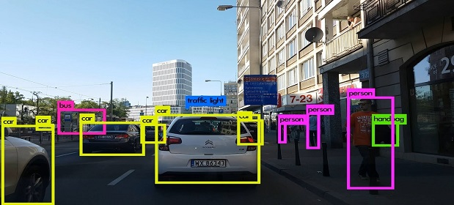

#### Detecting anomaly

Another useful application of object detection is definitely spotting an anomaly and it has industry specific usages.  For instance, in the field of agriculture object detection helps in identifying infected crops and thereby helps the farmers take measures accordingly.  It could also help identify skin problems in healthcare.  In the manufacturing industry the object detection technique can help in detecting problematic parts really fast and thereby allow the company to take the right step.

Object detection technology has the potential to transform our world in multiple ways. However, the models still need to be developed further so that these can be applied across devices and platforms in real-time to offer cutting-edge solutions.

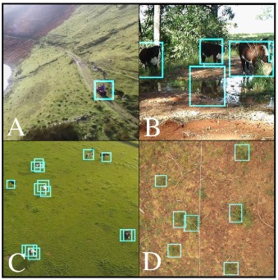

**MOTIVATION**

Automatic target detection plays a major role in automated war operations. The key concept behind automated target detection is military objects recognition from the captured images. For object recognition in the given image, Convolutional Neural Network (CNN) is a powerful classification network. But in general CNNs are trained for general object recognition. But, the performance of CNN depends mainly on the size of the training set. The size of the training data is generally available in less proportion for military objects due to its operational and security issues. Hence the performance of CNN may degrade sharply. To address the issue of military objects, a relatively new neural network architecture called Capsule Network (CapsNet) is introduced. Hence, in this article, a variant of CapsNet called Multi-level CapsNet framework is projected for military object recognition under the case of small training set. The introduced framework of this paper is validated on a dataset of military objects which are collected from the internet. The dataset contains particularly five military objects and the similar civil ones. The proposed framework demonstrates a large improvement of 96.54% of accuracy for military object recognition. Experiments demonstrate that the proposed framework can accomplish a high recognition precision, superior to many other algorithms such as conventional Support Vector Machines and transfer learning based CNNs.

So we decided to make a REAL TIME OBJECT DETECTION System. We are interested in this project after we went through few papers in this area. As a result we are highly motivated to develop a system that recognizes objects in the real time environment

**OBJECTIVE**

In this paper we proposed efficient and accurate object detection has been an important topic in the advancement of computer vision systems. With the advent of deep learning techniques, the accuracy for object detection has increased drastically. A major challenge in many of the object detection systems is the dependency on other computer vision techniques for helping the deep learning- based approach, which leads to slow and non-optimal performance. The main aim of object detection is to find the exact location of an object in each picture accurately and mark. This can be applicable military and many other fields.

**PROJECT OUTLINE**

The project report is organized in such a way that, first part includes the introduction section which explains the General Background, Objectives of the project,Scope of the project and the Organization of thesis in detail. In the second section literature survey is included. Third section is proposed system which contains System architecture and Module description,and fourth section is the expected outcome and then the last section is references.

**CHAPTER 2**

**LITERATURE SURVEY**

2**.1. R-CNN (Region based convolutional neural network)**

To find a way around the problem of choosing a vast number of regions, Ross Girshick et al. papered a method in which he use a discriminating search to dig out just 2000 regions from a image and he called them region proposals. Therefore, now, as an alternative of trying to categorize a huge number of regions, we can just effort with 2000 regions.

**2.2. Fast R-CNN**

The similar author of earlier paper (R- CNN) also solved some of drawback of R-CNN to construct the object detection algorithm called fast R-CNN. This algorithm is similar to the previous R-CNN algorithm. But instead feed region proposals to CNN, we can provide the input image to build the convolutional map. This is fast than R-CNN because there is no need to feed proposals of 2000 region to convolutional neural network each time. Instead of this, the convolution operation is made only one time per image and a feature map generates from it.

**2.3. Faster R-CNN**

R-CNN & Fast R-CNN finds region proposal using selective search. This is a timeconsuming & slow process which affects the performance of network. Due to this problem, Shaoqing Ren et al. built an algorithm of object detection that eliminate the discriminating search algorithm and let the network learn the region proposal. Same as fast R-CNN, the image is provided to a convolutional network as an input that will provide the convolutional feature map. A different network is used to guess the region proposals instead using of selective search algorithm on the feature map to recognize the region proposals. Reshaping of the region proposals which are predicted is done using a RoI pooling layer which classifies the image within the planned region and guess the offset value for bounding boxes.

**2.4. YOLO (You Only Look Once)**

All of the earlier object detection algorithms use regions to localize the object inside the image. Apart from the above seen algorithms which are region based, You Only Look Once or YOLO is an algorithm based on object detection which is much different. The only convolutional network predicts the bounding boxes and the class probabilities for these boxes in YOLO.

**2.5. SSD (Single Shot Detection)**

A one single shot can be taken to detect numerous objects inside the image in SSD, while regional proposal network (RPN) approaches such as R- CNN series which requires two shots, one for proposal of generating regions and the other for detection of object of every proposal. Hence, SSD is faster than RPN based approach.

**CHAPTER 3**

**PROPOSED SYSTEM**

**PROBLEM STATEMENT**

The major challenge in this problem is that of the variable dimension of the output which is caused due to the variable number of objects that can be present in any given input image. Any general deep learning task requires a fixed dimension of input and output for the model to be trained. Another important obstacle for widespread adoption of object detection systems is the requirement of real-time (30fps) while being accurate in detection. The more complex the model is, the more time it requires for inference; and the less complex the model is, the less is the accuracy. This trade-off between accuracy and performance needs to be chosen as per the application. Classifications as well as regression are the major problems involved which is leading the model to be learnt simultaneously. This adds to the complexity of the problem. A lot of work is there in object detection by the use of traditional computer vision techniques (sliding windows, deformable part models). However, lack of accuracy of deep learning-based techniques. Among the deep learning-based techniques, two broad class of methods are prevalent: two stage detection (RCNN [1], Fast RCNN [2], Faster RCNN [3]) and unified detection (Yolo [4], SSD [5]. The robot used here follows a line to transport the object from source to destination; the irregularity in the line can make the robot to halt unnecessarily. Moreover, the path surface should be even so that the carrier robot can move back and forth flawlessly.

**PROPOSED METHDOLOGY**

4.1 SSD Sliding window detection, as its name suggests, slides a local window across the image and identifies at each location whether the window contains any object of interests or not. Multi-scale increases the robustness of the detection by considering windows of different sizes. Such a brute force strategy can be unreliable and expensive: successful detection requests the right information being sampled from the image, which usually means a fine-grained resolution to slide the window and testing a large cardinality of local windows at each location. Input and Output: The input to an SSD is an image which is of fixed size, for example, 512x512 image for SSD512. The fixed size constraint is mainly for efficient training with batched data. Being fully convolutional, the network can run inference on images of different sizes. The output of SSD is a prediction map. Each location in this map stores classes confidence and bounding box information as there are indeed an object of interests in every location. Obviously, there will be a lot of false alarms, so a further process is used to select a list of most likely prediction based on simple heuristics.

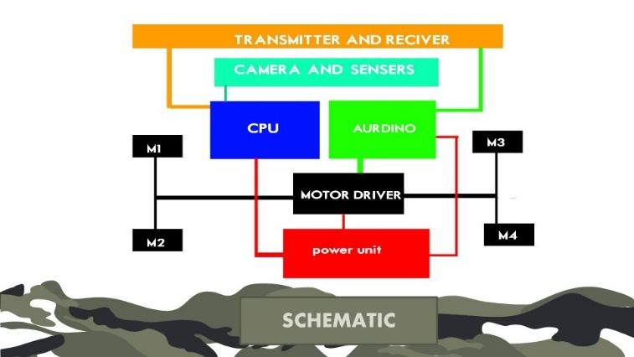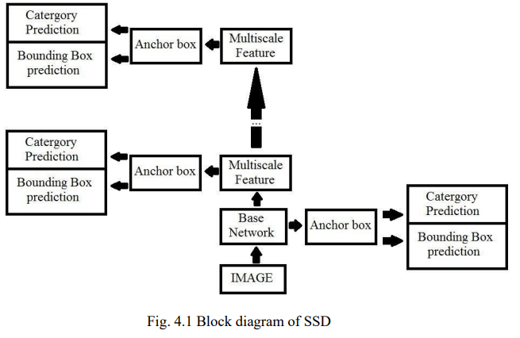

**MODULE DESCRIPTION**

**Acrylic Sheets**

* Acrylic is a transparent plastic material with outstanding strength, stiffness, and optical clarity
* Acrylic sheet is easy to fabricate, bonds well with adhesives and solvents, and is easy to thermoform.
* It has superior weathering properties compared to many other transparent plastics.

**3d printed wheels**

* 3D printing or additive manufacturing is the construction of a three-dimensional object from a CAD model or a digital 3D model.
* It can be done in a variety of processes in which material is deposited, joined or solidified under computer control, with material being added together, typically layer by layer.

For cad [www.thingivers](files:https://www.thingiverse.com/thing:1462917)

Video:[www.youtube.com](https://www.youtube.com/watch?v=Cy6zA4NFGd4)

**Gear motor**

* A gearmotor(or geared motor) is a small electric motor (AC induction, permanent magnet DC, or brushless DC) designed with an integral (non-separable) gear reducer (gearhead) attached
* Working of gear motor:
* [You tube](https://www.youtube.com/watch?v=B_u99Pt62qA)

**L298n motor driver**

* The L298N is a dual H-Bridge motor driver which allows speed and direction control of two DC motors at the same time.
* The module can drive DC motors that have voltages between 5 and 35V, with a peak current up to 2A.
* L298n motor driver working:[You tube](https://www.youtube.com/watch?v=PVyAcgYkzDs)

**Aurdino board**

* Arduino is an open-source electronics platform based on easy-to-use hardware and software.
* Arduino boards are able to read inputs - light on a sensor, a finger on a button, or a Twitter message - and turn it into an output - activating a motor, turning on an LED, publishing something online.

**Arduino Software (IDE)**

* The Arduino Integrated Development Environment - or Arduino Software (IDE) - contains a text editor for writing code, a message area, a text console, a toolbar with buttons for common functions and a series of menus.
* It connects to the Arduino hardware to upload programs and communicate with them.

**Arduino program**

* Arduino code is written in C++ with an addition of special methods and functions, which we’ll mention later on.
* C++ is a human-readable programming language. When you create a ‘sketch’ (the name given to Arduino code files), it is processed and compiled to machine language.
* The program code:  [Drone code](bt%20drone%20code.text)

**Hc05 Bluetooth module**

* HC-05 Bluetooth Module is an easy to use Bluetooth SPP (Serial Port Protocol) module, designed for transparent wireless serial connection setup.
* Its communication is via serial communication which makes an easy way to interface with controller or PC.

**LED lights**

* The light-emitting diode (LED) is today's most energy-efficient and rapidly-developing lighting technology.
* Quality LED light bulbs last longer, are more durable, and offer comparable or better light quality than other types of lighting.

**Li Ion Battery and B M S Circuit**

* A lithium-ion battery
* Li-ion battery is a type of rechargeable battery composed of cells in which lithium ions move from the negative electrode through an electrolyte to the positive electrode during discharge and back when charging.
* Li-ion battery BMS
* A BMS (Battery Management System) is essential in a Lithium-Ion battery system. This device manages a real-time control of each battery cell, communicates with external devices, manages SOC calculation, measures temperature and voltage, etc.

**The rover controlling app Project Rower RC**

The app is built for communicating the RC rover and smartphone through the Bluetooth medium

By the controller we can control the rover speed, movements and 4 additional channels used for destructions, lights, and signaling.

**IMPLEMENTATION**

The RC drone Is controlled with

**THE CONSIDERED ARCHITECTURE**

The idea behind the scheme is YOLO algorithm. Compared to the approach taken by object detection algorithms before YOLO, which repurpose classifiers to perform detection, YOLO proposes the use of an end-to-end neural network that makes predictions of bounding boxes and class probabilities all at once.

Following a fundamentally different approach to object detection, YOLO achieves state-of-the-art results beating other real-time object detection algorithms by a large margin.

In addition to increased accuracy in predictions and a better Intersection over Union in bounding boxes (compared to real-time object detectors), YOLO has the inherent advantage of speed.

YOLO is a much faster algorithm than its counterparts, running at as high as 45 FPS.

While algorithms like Faster RCNN work by detecting possible regions of interest using the Region Proposal Network and then perform recognition on those regions separately, YOLO performs all of its predictions with the help of a single fully connected layer.

Methods that use Region Proposal Networks thus end up performing multiple iterations for the same image, while YOLO gets away with a single iteration.  The YOLO algorithm works by dividing the image into N grids, each having an equal dimensional region of SxS. Each of these N grids is responsible for the detection and localization of the object it contains.

Correspondingly, these grids predict B bounding box coordinates relative to their cell coordinates, along with the object label and probability of the object being present in the cell.

This process greatly lowers the computation as both detection and recognition are handled by cells from the image, but It brings forth a lot of duplicate predictions due to multiple cells predicting the same object with different bounding box predictions.

YOLO makes use of Non Maximal Suppression to deal with this issue.

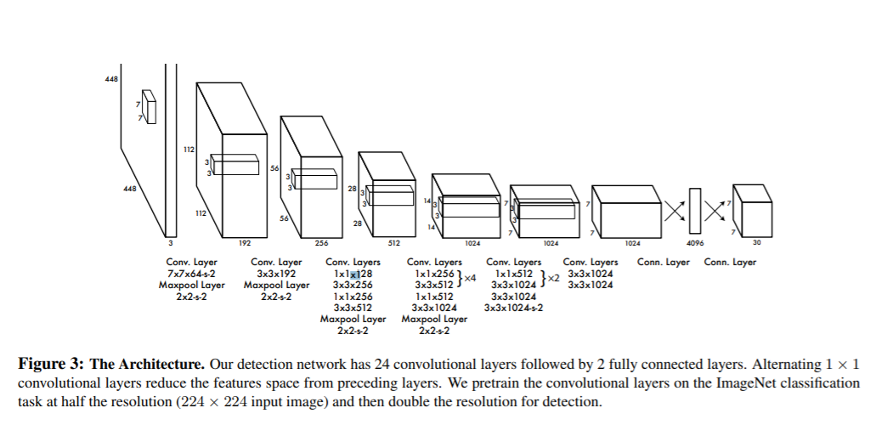

**CHAPTER 4**

**DATA SETS**

**DA** Creating a custom model to detect your objects is an iterative process of collecting and organizing images, labeling your objects of interest, training a model, deploying it into the wild to make predictions, and then using that deployed model to collect examples of edge cases to repeat and improve.

### **1. Create Dataset**

YOLOv5 models must be trained on labelled data in order to learn classes of objects in that data. There are two options for creating your dataset before you start training:

**Collect Images**

Your model will learn by example. Training on images similar to the ones it will see in the wild is of the utmost importance. Ideally, you will collect a wide variety of images from the same configuration (camera, angle, lighting, etc) as you will ultimately deploy your project.If this is not possible, you can start from a public dataset to train your initial model and then sample images from the wild during inference to improve your dataset and model iteratively.

### **Create Labels**

Once you have collected images, you will need to annotate the objects of interest to create a ground truth for your model to learn from. Roboflow Annotate is a simple web-based tool for managing and labeling your images with your team and exporting them in YOLOv5's annotation format.

**CHAPTER 5**

**EXPERIMENTAL RESULTS**

**5.1 TRAINING THE DATA**

Train a YOLOv5s model on COCO128 by specifying dataset, batch-size, image size and either pre-trained --weights yolov5s.pt (recommended), or randomly initialized --weights '' --cfg yolov5s.yaml (not recommended). Pre-trained weights are auto-downloaded from the latest YOLOv5 release.

# Train YOLOv5s on COCO128 for 3 epochs

$ python train.py --img 640 --batch 16 --epochs 3 --data coco128.yaml --weights yolov5s.pt

All training results are saved to runs/train/ with incrementing run directories, i.e. runs/train/exp2, runs/train/exp3 etc.

#### 5.2 Local Logging

All results are logged by default to runs/train, with a new experiment directory created for each new training as runs/train/exp2, runs/train/exp3, etc. View train and val jpgs to see mosaics, labels, predictions and augmentation effects. Note an Ultralytics **Mosaic Dataloader** is used for training (shown below), which combines 4 images into 1 mosaic during training.

train_batch0.jpg shows train batch 0 mosaics and labels:

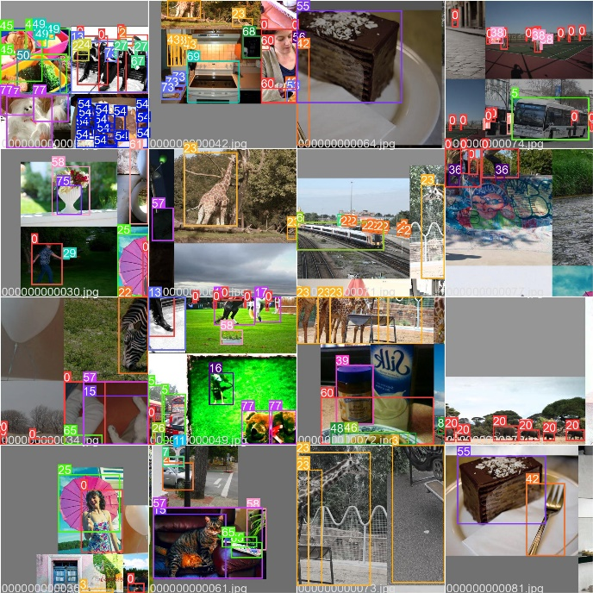

val_batch0_labels.jpg shows val batch 0 labels:

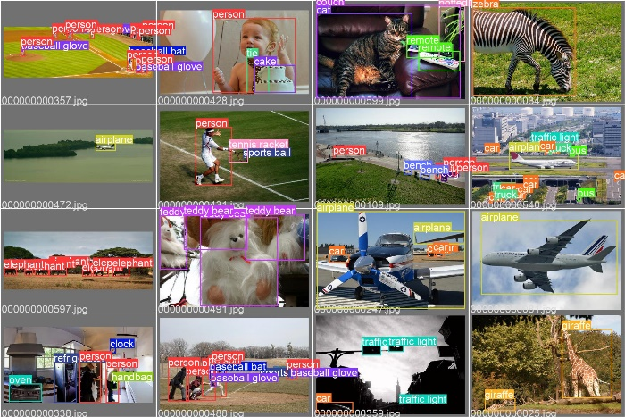

val_batch0_pred.jpg shows val batch 0 predictions:

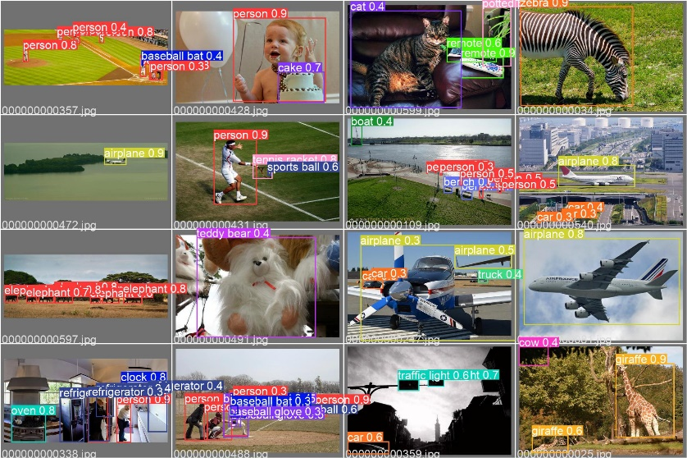

**5.3 PERFORMANCE ANALYSIS**

Training results are automatically logged to Tensorboard and CSV as results.csv, which is plotted as results.png (below) after training completes. You can also plot any results.csv file manually:

from utils.plots import plot_results

plot_results('path/to/results.csv') # plot 'results.csv' as 'results.png'

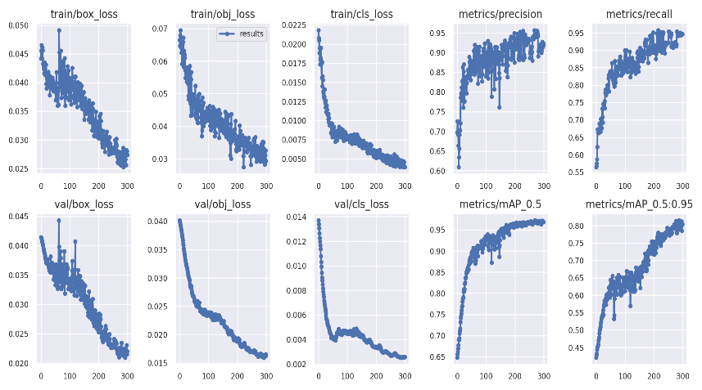

**5.4 EVALUATION OF PROPOSED METHOD**

The first YOLO model was introduced by Joseph Redmon et all in their 2015 [paper](https://arxiv.org/pdf/1506.02640.pdf) titled “You Only Look Once: Unified, Real-Time Object Detection”. Till that time RCNN models were the most sought-after models for object detection. Although the RCNN family of models were accurate but were relatively slow because it was a multi-step process of finding the proposed region for the bounding box and then do classification on these regions and finally do post-processing to refine the output. YOLO was created with the goal to do away with multistage and perform object detection in just a single stage, thus increasing the inference time.

**CHAPTER 6 CONCLUSION**