1. **Write a program to perform basic arithmetic operations**

<head>

<title>Arithmetical Operators</title>

</head>

<body>

<?php

$a = 42;

$b = 20;

$c = $a + $b;

echo "Addtion Operation Result: $c <br/>";

$c = $a - $b;

echo "Substraction Operation Result: $c <br/>";

$c = $a * $b;

echo "Multiplication Operation Result: $c <br/>";

$c = $a / $b;

echo "Division Operation Result: $c <br/>";

$c = $a % $b;

echo "Modulus Operation Result: $c <br/>";

$c = $a++;

echo "Increment Operation Result: $c <br/>";

$c = $a--;

echo "Decrement Operation Result: $c <br/>";

?>

</body>

</html>

**Output :**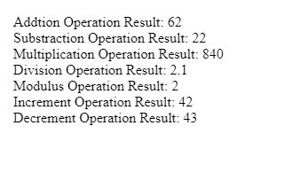

1. **Write a program for finding the greatest number among two numbers.**

<!DOCTYPE html>

<html>

<body>

<?php

$num1=20;

$num2=22;

if($num2>$num1){

echo $num2;

}

else

echo $num1;

?>

</body>

</html>

**Output:**



1. **Write a program for finding the greatest number among three numbers.**

<!DOCTYPE html>

<html>

<body>

<?php

$num1=20;

$num2=15;

$num3=22;

if($num1>$num2 && $num1>$num3){

echo $num1;

}

else{

if($num2>$num1 && $num2>$num3){

echo $num2;

}

else

echo $num3;

}

?>

</body>

</html>

**Output:**



1. **Write a program for finding an even and an odd.**

<!DOCTYPE html>

<html>

<body>

<?php

$number=1233456;

if($number%2==0)

{

echo "$number is Even Number";

}

else

{

echo "$number is Odd Number";

}

?>

</body>

</html>

**Output:**

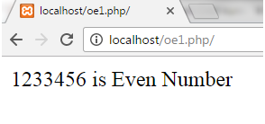

1. **Write a program for finding leaf year.**

<!DOCTYPE html>

<html>

<body>

<?php

function year_check($my_year){

if ($my_year % 400 == 0)

print("It is a leap year");

else if ($my_year % 100 == 0)

print("It is not a leap year");

else if ($my_year % 4 == 0)

print("It is a leap year");

else

print("It is not a leap year");

}

$my_year = 1900;

year_check($my_year);

?>

</body>

</html>

**Output:**

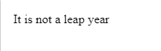

1. **Write a program to swap two numbers using a third variable.**

<!DOCTYPE html>

<html>

<body>

<?php

$a = 45;

$b = 78;

// Swapping Logic

$third = $a;

$a = $b;

$b = $third;

echo "After swapping:<br><br>";

echo "a =".$a." b=".$b;

?>

</body>

</html>

**Output:**

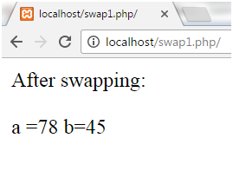

1. **Write a program to swap two numbers without a third variable.**

<!DOCTYPE html>

<html>

<body>

<?php

$a=234;

$b=345;

//using arithmetic operation

$a=$a+$b;

$b=$a-$b;

$a=$a-$b;

echo "Value of a: $a</br>";

echo "Value of b: $b</br>";

?>

</body>

</html>

**Output:**

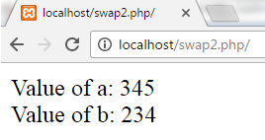

1. **Write a program to generate a multiplication of the table which is given by the user.**

<!DOCTYPE html>

<html>

<body>

<center>

<form method="POST">

Enter a number:

<input type="text" name="number">

<input type="Submit"

value="Get Multiplication Table">

</form>

</center>

<?php

if($_POST) {

$num = $_POST["number"];

echo nl2br("<p style='text-align: center;'>

Multiplication Table of $num: </p>

");

for ($i = 1; $i <= 10; $i++) {

echo ("<p style='text-align: center;'>$num"

. " X " . "$i" . " = "

. $num * $i . "</p>

");

}

}

?>

</body>

</html>

**Output:**

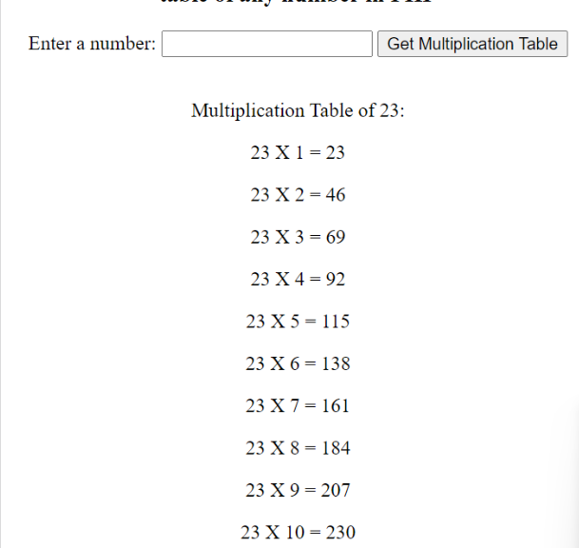

1. **Write a program to generate a multiplication of the table with the given condition.**

<!DOCTYPE html>

<html>

<body>

<table align="center" border='1' width="100%">

<?php

// filename : multiplication_table.php

$num = 10;

for($i = 1; $i <= 10; $i++)

{

echo "<tr>";

for($j =1; $j <= $num; $j++)

{

$multiplication_table = ($i * $j);

echo "<td>$j x $i = $multiplication_table </td>";

}

echo "<tr/>";

}

?>

</table>

</body>

</html>

**Output:**

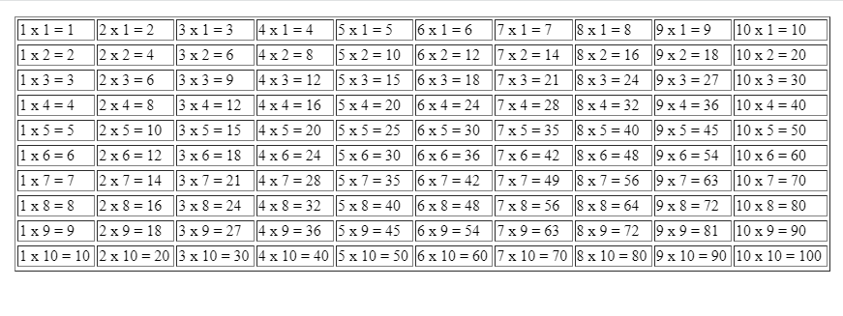

1. **Write a program to check if a given number is prime or not.**

<!DOCTYPE html>

<html>

<body>

<?php

function check_prime($num)

{

if ($num == 1)

return 0;

for ($i = 2; $i <= $num/2; $i++)

{

if ($num % $i == 0)

return 0;

}

return 1;

}

$num = 47;

$flag_val = check_prime($num);

if ($flag_val == 1)

echo "It is a prime number";

else

echo "It is a non-prime number"

?>

</body>

</html>

**Output:**



1. **Write a program for printing the Fibonacci series.**

<html>

<head>

<title>Fibonacci series</title>

</head>

<body>

<?php

$num = 0;

$n1 = 0;

$n2 = 1;

echo "<h3>Fibonacci series for first 12 numbers: </h3>";

echo "\n";

echo $n1.' '.$n2.' ';

while ($num < 10 )

{

$n3 = $n2 + $n1;

echo $n3.' ';

$n1 = $n2;

$n2 = $n3;

$num = $num + 1;

}

?>

</body>

</html>

**Output:**



1. **Write a program to find the sum & average of array elements.**

<html>

<head>

<title>Arithmetical Operators</title>

</head>

<body>

<?php

$a = array(1,2,3,4,5); // array declaration

$b = count($a); // counting array elements

$c = array_sum($a); // addition of array integers

echo "Number of integers present in array are: ", $b ,"<br>";

echo "Sum of integers present in array is: ", $c ,"<br>";

$d = $c/$b;

echo "Average of array numbers is: ",$d;

?>

</body>

</html>

**Output:**

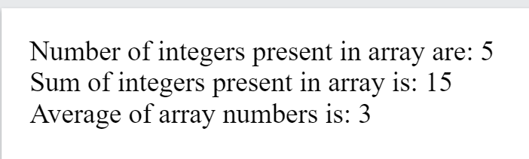

1. **Write a program for finding the area of shapes using functions. a. Rectangle b. Square c. Circle d. Triangle.**

<html>

<head>

<title>Arithmetical Operators</title>

</head>

<body>

<?php

$length = 14;

$width = 12;

$PI = 3.14;

$a = 8;

$side = 4;

function Circle( $a)

{

global $PI;

return ($PI / 4 ) *

$a * $a;

}

function areaSquare($side)

{

$area = $side * $side;

return $area;

}

echo "area of Rectangle is $length * $width = " . ($length * $width) . "<br />";

echo "area of Triangle is $length * $width = " . (($length * $width) / 2) . "<br />";

echo "area of Square is $side * $side = ", areaSquare($side) . "<br />";

echo "area of Circle is ($PI / 4 ) * $a * $a = " , Circle($a). "<br />";

?>

</body>

</html>

**Output:**

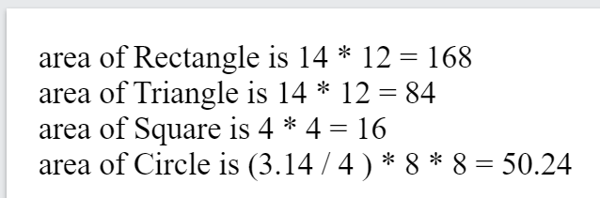

1. **Write a program for arithmetic operation using switch case.**

<!DOCTYPE html>

<html>

<head> </head>

<body><center>

<h1>ARITHMETIC OPERATIONS DEMO USING SWITCH CASE IN PHP

</h1>

<h3>Option-1 = Addition</h3>

<h3>Option-2 = Subtraction</h3>

<h3>Option-3 = Multiplication</h3>

<h3>Option-4 = Division</h3>

<form method="post">

<table border="0">

<tr>

<!-- Taking value 1 in an text box -->

<td> <input type="text" name="num1"

value="" placeholder="Enter value 1"/>

</td>

</tr>

<tr>

<!-- Taking value 1 in an text box -->

<td> <input type="text" name="num2" value=""

placeholder="Enter value 2"/>

</td>

</tr>

<tr>

<!-- Taking option in an text box -->

<td> <input type="text" name="option" value=""

placeholder="Enter option 1-4 only"/>

</td>

</tr>

<tr>

<td> <input type="submit" name="submit"

value="Submit"/>

</td>

</tr>

</table>

</form>

</center>

<?php

// Checking submit condition

if(isset($_POST['submit'])) {

// Taking first number from the

// form data to variable 'a'

$a = $_POST['num1'];

// Taking second number from the

// form data to a variable 'b'

$b = $_POST['num2'];

// Taking option from the form

// data to a variable 'ch'

$ch = $_POST['option'];

switch($ch) {

case 1:

$r = $a + $b;

echo " Addition of two numbers = " . $r ;

break;

case 2:

$r = $a - $b;

echo " Subtraction of two numbers= " . $r ;

break;

case 3:

$r = $a * $b;

echo " Multiplication of two numbers = " . $r ;

break;

case 4:

$r = $a / $b;

echo " Division of two numbers = " . $r ;

break;

default:

echo ("invalid option\n");

}

return 0;

}

?>

</body>

</html>

**Output:**

