CMTH 642 Data Analytics: Advanced Methods

Assignment 1 (10%)

Ajay Herod

CMTH642 D10 500764104

#### 1. Read the csv files in the folder. (3 points)

loc = getwd()  
macro = read.csv(paste(loc, "USDA_Macronutrients.csv", sep = "/"))  
micro = read.csv(paste(loc, "USDA_Micronutrients.csv", sep = "/"))

#### 2. Merge the data frames using the variable “ID”. Name the Merged Data Frame “USDA”. (6 points)

USDA = merge(macro, micro)

#### 3. Check the datatypes of the attributes. Delete the commas in the Sodium and Potasium records. Assign Sodium and Potasium as numeric data types. (6 points)

sapply(USDA, class)

## ID Description Calories Protein TotalFat Carbohydrate   
## "integer" "factor" "integer" "numeric" "numeric" "numeric"   
## Sodium Cholesterol Sugar Calcium Iron Potassium   
## "factor" "integer" "numeric" "integer" "numeric" "factor"   
## VitaminC VitaminE VitaminD   
## "numeric" "numeric" "numeric"

USDA$Sodium = gsub(",", "", USDA$Sodium)  
USDA$Potassium = gsub(",", "", USDA$Potassium)  
USDA$Sodium = as.numeric(USDA$Sodium)  
USDA$Potassium = as.numeric(USDA$Potassium)

#### 4. Remove records (rows) with missing values in more than 4 attributes (columns). How many records remain in the data frame? (6 points)

na_count = apply(is.na(USDA), 1, sum)  
USDA = USDA[na_count < 5,]  
cat("Number of records remaning: ", nrow(USDA))

## Number of records remaning: 6887

#### 5. For records with missing values for Sugar, Vitamin E and Vitamin D, replace missing values with mean value for the respective variable. (6 points)

USDA$Sugar[is.na(USDA$Sugar)] = mean(USDA$Sugar[!is.na(USDA$Sugar)])  
USDA$VitaminE[is.na(USDA$VitaminE)] = mean(USDA$VitaminE[!is.na(USDA$VitaminE)])  
USDA$VitaminD[is.na(USDA$VitaminD)] = mean(USDA$VitaminD[!is.na(USDA$VitaminD)])

#### 6. With a single line of code, remove all remaining records with missing values. Name the new Data Frame “USDAclean”. How many records remain in the data frame? (6 points)

USDAclean = USDA[complete.cases(USDA),]  
cat("Number of records remiaining: ", nrow(USDAclean))

## Number of records remiaining: 6310

#### 7. Which food has the highest sodium level? (6 points)

as.character(USDAclean$Description[USDAclean$Sodium == max(USDAclean$Sodium)])

## [1] "SALT,TABLE"

#### 8. Create a histogram of Vitamin C distribution in foods. (6 points)

hist(USDAclean$VitaminC)

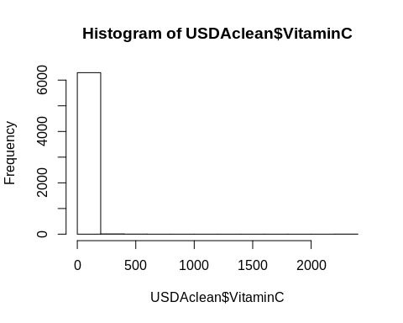

#### 9. Create a boxplot to illustrate the distribution of values for TotalFat, Protein and Carbohydrate. (6 points)

with(USDAclean, boxplot(TotalFat, Protein, Carbohydrate))

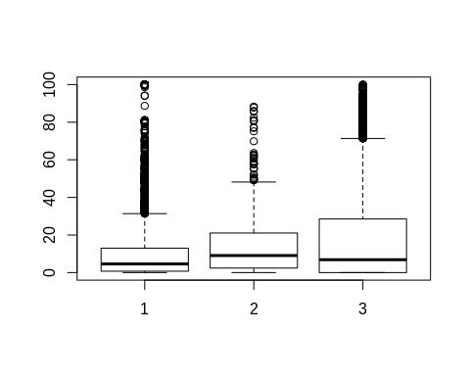

#### 10. Create a scatterplot to illustrate the relationship between a food’s TotalFat content and its Calorie content. (6 points)

with(USDAclean, plot(TotalFat, Calories))

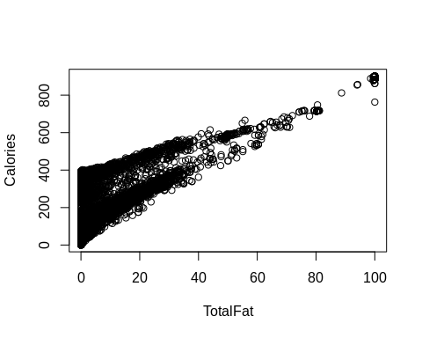

#### 11. Add a variable to the data frame that takes value 1 if the food has higher sodium than average, 0 otherwise. Call this variable HighSodium. Do the same for High Calories, High Protein, High Sugar, and High Fat. How many foods have both high sodium and high fat? (8 points)

USDAclean$HighSodium = 0  
USDAclean$HighSodium[USDAclean$Sodium > mean(USDAclean$Sodium)] = 1  
  
USDAclean$HighCalories = 0  
USDAclean$HighCalories[USDAclean$Calories > mean(USDAclean$Calories)] = 1  
  
USDAclean$HighProtein = 0  
USDAclean$HighProtein[USDAclean$Protein > mean(USDAclean$Protein)] = 1  
  
USDAclean$HighSugar = 0  
USDAclean$HighSugar[USDAclean$Sugar > mean(USDAclean$Sugar)] = 1  
  
USDAclean$HighFat = 0  
USDAclean$HighFat[USDAclean$TotalFat > mean(USDAclean$TotalFat)] = 1  
  
cat(sum(apply(USDAclean[c("HighSodium", "HighFat")], 1, function(x) sum(x) == 2)), " foods have both high sodium and high fat.")

## 644 foods have both high sodium and high fat.

#### 12. Calculate the average amount of iron, for high and low protein foods. (8 points)

with(USDAclean, tapply(Iron, HighProtein, mean))

## 0 1   
## 2.696634 3.069541

#### 13. Create a script for a “HealthCheck” program to detect unhealthy foods. Use the algorithm flowchart below as a basis for this script. (8 points)

require(jpeg)

## Loading required package: jpeg

img<-readJPEG("HealthCheck.jpg")  
plot(1:4, ty = 'n', ann = F, xaxt = 'n', yaxt = 'n')  
rasterImage(img,1,1,4,4)

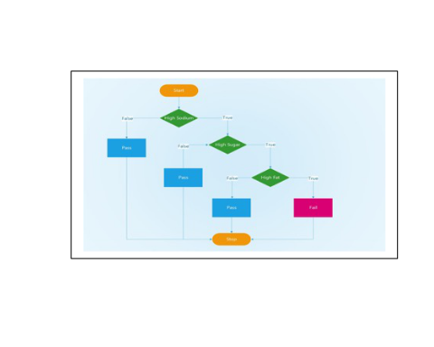

healthcheck = function(x) {  
 if (x$HighSodium == 0)  
 return("Pass")  
 else if (x$HighSugar == 0)  
 return("Pass")  
 else if (x$HighFat == 0)  
 return("Pass")  
 else return("Fail")  
}

#### 14. Add a new variable called HealthCheck to the data frame using the output of the function. (8 points)

for (i in 1:nrow(USDAclean)){  
 USDAclean$HealthCheck[i] = healthcheck(USDAclean[i,])  
}

#### 15. How many foods in the USDAclean data frame fail the HealthCheck? (8 points)

cat("Number of foods that fail the HealthCheck: ", sum(USDAclean$HealthCheck == 'Fail'))

## Number of foods that fail the HealthCheck: 237

#### 16. Save your final data frame as “USDAclean_ [your last name].” (3 points)

write.csv(USDAclean, "USDAclean_Herod")

This is the end of Assignment 1

Ceni Babaoglu, PhD