CIND119 – D20 Assignment 3

Ajay Herod 500764104

Nov 29, 2020

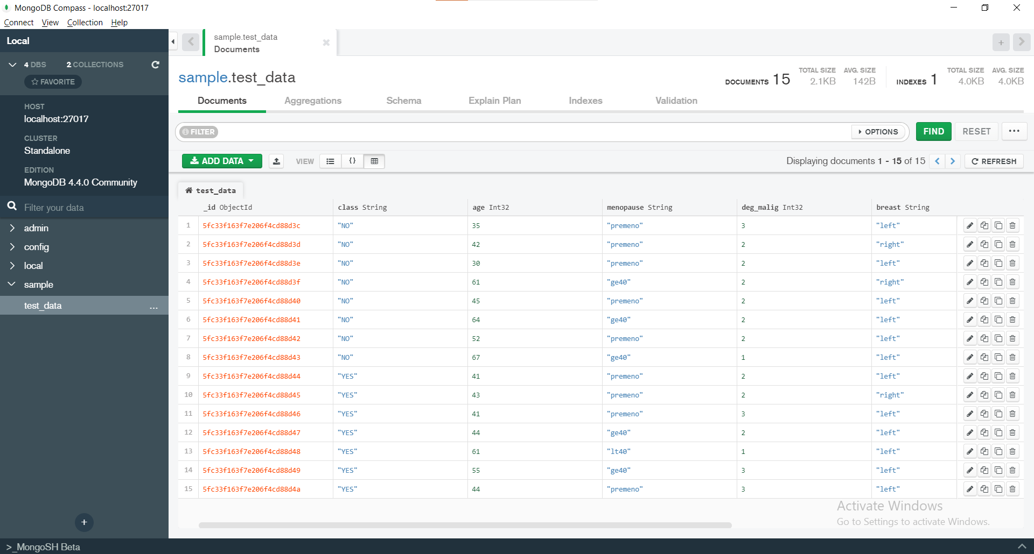

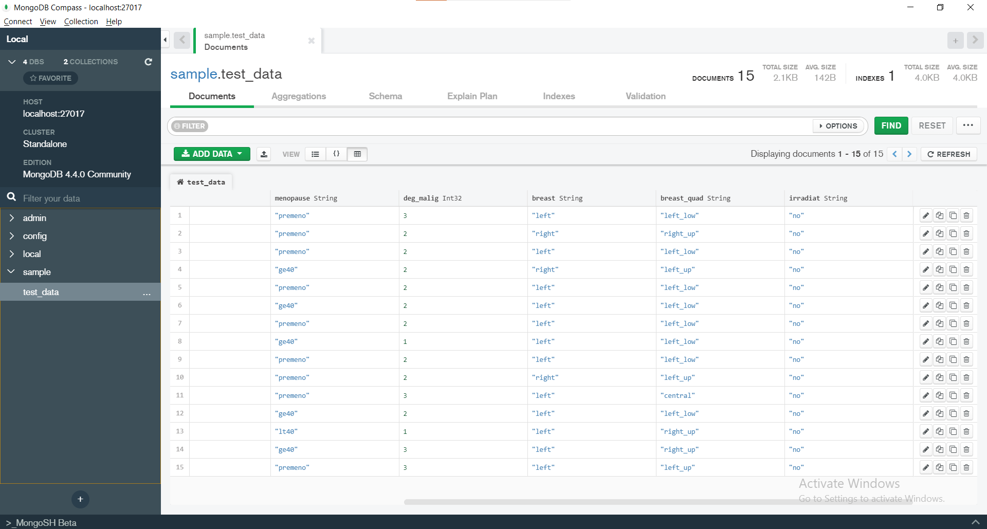

3. a.

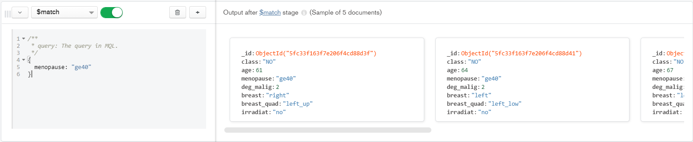

3. b.

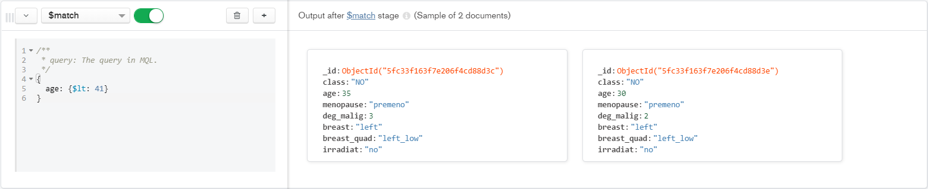

3. c.

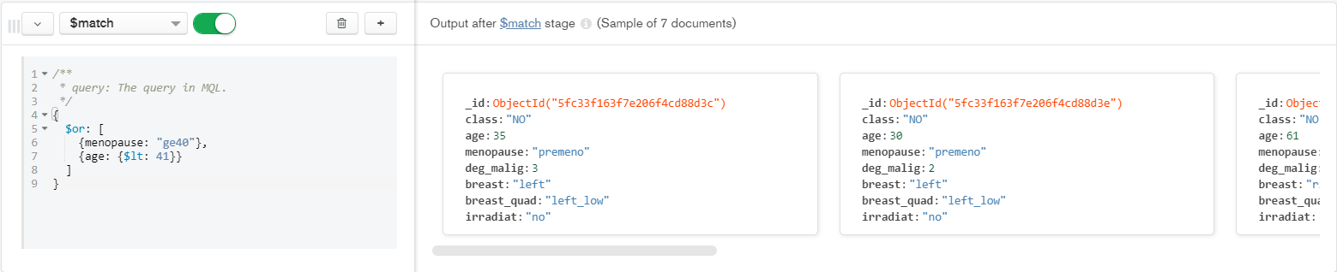

3. d.

