DIGITAL ASSIGNMENT 2 — FIRST REVIEW
Business Sales Analysis System (AI-Driven)

1. Literature Survey

1.1 Database Normalization & BCNF
The concept of normalization was formally introduced by E.F. Codd [1] to eliminate data redundancy and ensure data integrity in relational databases. Boyce-Codd Normal Form (BCNF), a stricter extension of Third Normal Form (3NF), requires that for every non-trivial functional dependency X → Y, X must be a superkey [3]. In this project, all five tables — Customers, Products, Orders, Order_Items, and Audit_Log — are designed to strictly comply with BCNF, eliminating all partial and transitive dependencies.

Prior work in enterprise database design [5] demonstrates that BCNF compliance is critical for systems handling transactional sales data, where redundancy can lead to update anomalies across thousands of records. The separation of Order_Items as a junction table, rather than storing product quantities as columns within Orders, is a direct application of this principle.

1.2 Audit Logging & Database Triggers
Database audit logging is a well-established technique for maintaining a complete, tamper-evident history of data changes. MySQL's native trigger mechanism [6] — which fires automatically on INSERT, UPDATE, and DELETE operations — provides an infrastructure-level solution that requires no changes to application code. This approach is architecturally superior to application-level logging because it captures all changes regardless of which client or process modifies the data.

Fowler's Patterns of Enterprise Application Architecture [5] identifies the Event Sourcing pattern — storing a log of state-changing events rather than only the current state — as a foundational design for auditable, time-reversible systems. This project implements a lightweight variant of Event Sourcing using MySQL triggers writing to a JSON-typed Audit_Log table, enabling a 'Database Time Machine' capability.

1.3 AI-Driven Business Intelligence
The integration of large language models (LLMs) into business analytics represents an emerging research direction. Traditional business intelligence tools require domain experts to manually interpret data trends. Google's Gemini model family [4] — specifically Gemini 2.5 Flash Lite — offers a cost-effective API for natural language analysis of structured data.

Existing literature on AI-driven analytics focuses primarily on structured query generation (Text-to-SQL). This project takes a novel approach: rather than generating queries, the system feeds structured audit log data directly to Gemini and requests strategic business recommendations in natural language. This bypasses the Text-to-SQL pipeline entirely and leverages the LLM's reasoning capabilities on pre-aggregated change history.

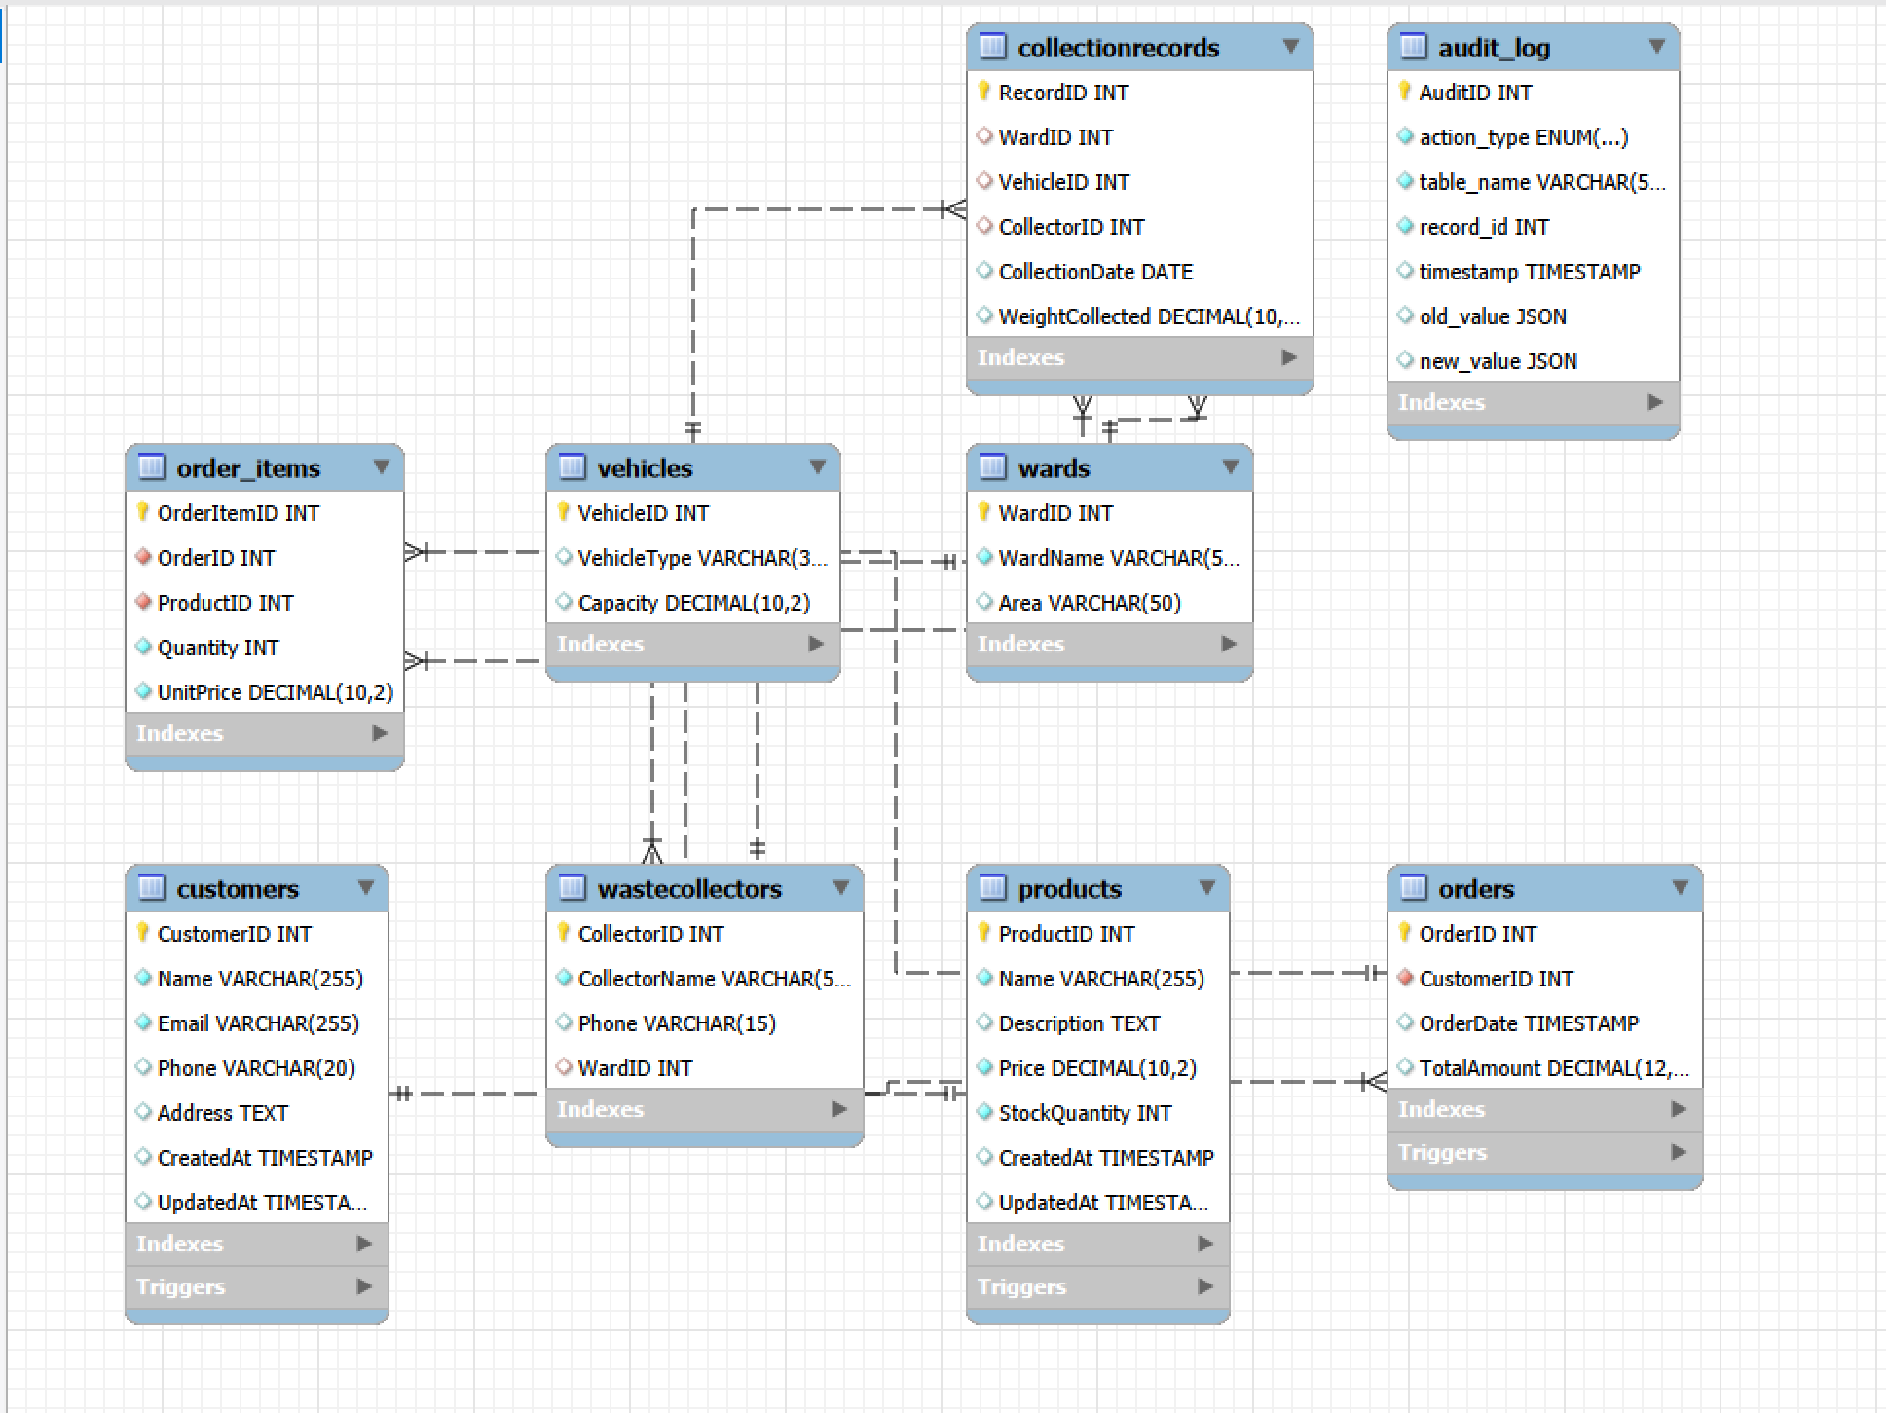

2. Methodology

2.1 Problem Statement
Small and medium businesses generate significant transactional data across customers, products, and orders. However, they typically lack the tools to (a) maintain a tamper-proof audit trail of all data changes, and (b) automatically extract strategic insights from that audit trail without requiring a data analyst. This project builds a full-stack system that solves both problems simultaneously.

2.2 System Architecture
The system follows a three-tier architecture:
- Frontend: React (Vite) + Tailwind CSS + Recharts — provides the Dashboard, Audit Logs, and AI Insights pages.
- Backend: Node.js + Express + Sequelize ORM — exposes a REST API on port 5000 and orchestrates all business logic.
- Database: MySQL 8.0 — stores all data in a BCNF-normalized schema with triggers for automatic audit logging.

The AI layer is implemented as a service module (geminiService.js) within the backend, which uses the @google/generative-ai npm package to interface with Google's Gemini API. The GEMINI_API_KEY is stored securely in a .env file and never exposed to the frontend.

2.3 Database Design (BCNF Compliance)
The schema consists of five tables with the following functional dependencies:
- Customers: CustomerID → Name, Email, Phone, Address (CustomerID is the sole superkey)
- Products: ProductID → Name, Description, Price, StockQuantity
- Orders: OrderID → CustomerID, TotalAmount, Status, OrderDate
- Order_Items: (OrderID, ProductID) → Quantity, UnitPrice (composite superkey)
- Audit_Log: AuditID → action_type, table_name, record_id, old_value, new_value, timestamp

No table contains a non-trivial dependency where the determinant is not a superkey — confirming BCNF compliance across all five tables.

2.4 Novel Aspect: Trigger-to-LLM Audit Pipeline
The defining innovation of this project is the automated pipeline from database mutations to AI-generated insights:

Step | Component | What Happens
1 | MySQL Trigger | Fires automatically on every INSERT, UPDATE, DELETE across Customers, Products, and Orders tables
2 | Audit_Log Table | Trigger writes a JSON snapshot of old_value and new_value into the Audit_Log table — no app code involved
3 | auditController.js | GET /api/audit-logs endpoint reads the Audit_Log table and serves it to the frontend
4 | geminiService.js | GET /api/ai/insights endpoint fetches recent audit records and constructs a structured prompt for Gemini
5 | Gemini 2.5 Flash Lite | LLM analyzes the audit trail and returns strategic business recommendations in natural language
6 | AIInsights.jsx | Frontend page renders the Gemini response to the business user

3. Partial Implementation & Preliminary Results

3.1 Completed Components
The following components are fully implemented and functional as of the First Review date:

Component | Key File(s)
MySQL BCNF Schema (5 tables) | database/schema.sql
MySQL Triggers (9 triggers, 3 per table) | database/schema.sql
Express REST API Server | backend/server.js
MySQL ↔ Sequelize ORM Connection | backend/config/database.js
Sequelize Models (5 models) | backend/models/*.js
Sales & Order Controllers | backend/controllers/salesController.js
Audit Log Controller & API | backend/controllers/auditController.js
Gemini AI Service Integration | backend/services/geminiService.js
AI Insights Controller & API | backend/controllers/aiController.js
React Frontend — AI Insights Page | frontend/src/pages/AIInsights.jsx
Axios API Client (Frontend ↔ Backend) | frontend/src/services/api.js

3.2 Preliminary Results
The following outcomes have been verified through functional testing:

- Trigger Verification: On executing POST /api/customers, the customers_after_insert trigger automatically fires and writes a JSON record to the Audit_Log table — confirmed via GET /api/audit-logs.
- Update Tracking: On executing PUT /api/products/:id with a new price, the customers_after_update trigger captures both old_value (original price) and new_value (updated price) as JSON objects — enabling precise change history.
- Cascaded Audit on Delete: On deleting a customer record, the trigger logs the deleted row's complete snapshot before removal, and the ON DELETE CASCADE foreign key removes all associated orders — all operations reflected in the audit log.
- AI Insights Generation: GET /api/ai/insights successfully calls Gemini 2.5 Flash Lite with the audit log payload and returns a structured natural language analysis of business trends and recommendations.
- Frontend Integration: All three React pages (Dashboard, Audit Logs, AI Insights) successfully fetch and render live data from the Express backend.

3.3 API Endpoints Verified
Method | Endpoint | Purpose
POST | /api/customers | Add a new customer (triggers INSERT audit log entry)
POST | /api/products | Add a new product (triggers INSERT audit log entry)
POST | /api/orders | Create an order with line items (triggers INSERT on Orders + Order_Items)
PUT | /api/products/:id | Update product price/stock (triggers UPDATE audit log entry)
GET | /api/audit-logs | Retrieve full audit trail — the Time Machine feed
GET | /api/ai/insights | Trigger Gemini analysis of audit logs — returns AI recommendations

4. References
Ref | Author(s) | Title | Source
[1] | Ramakrishnan, R. & Gehrke, J. | Database Management Systems, 3rd ed. | McGraw-Hill, 2003
[2] | Codd, E.F. | A Relational Model of Data for Large Shared Data Banks | CACM, 1970
[3] | Elmasri & Navathe | Fundamentals of Database Systems, 7th ed. | Pearson, 2016
[4] | Google DeepMind | Gemini: A Family of Highly Capable Multimodal Models | arXiv:2312.11805, 2023
[5] | Fowler, M. | Patterns of Enterprise Application Architecture | Addison-Wesley, 2002
[6] | MySQL Documentation | MySQL 8.0 Triggers and Events Reference | dev.mysql.com, 2024

