Barchart1.png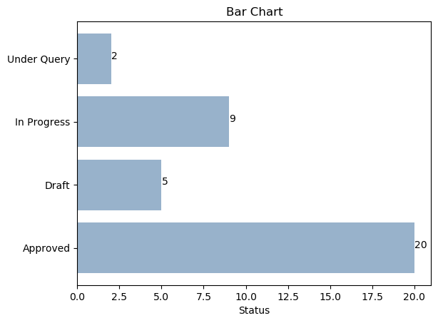

Barchart10.png

Barchart11.png

Barchart2.png

Barchart5.png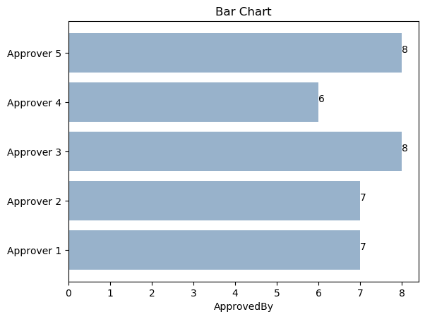

Line-plot-chart3.png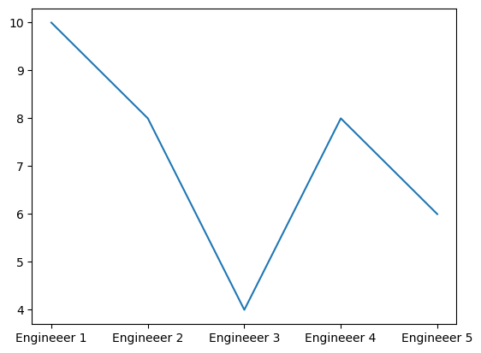

Line-plot-chart9.png

Piechart0.png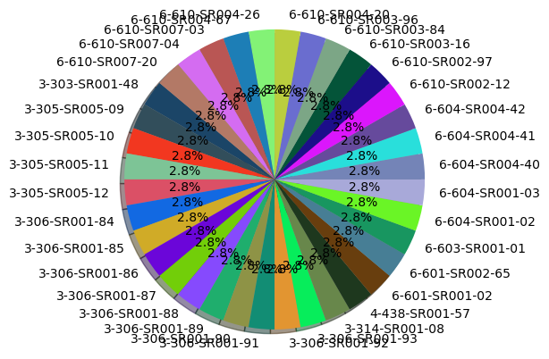

Piechart6.png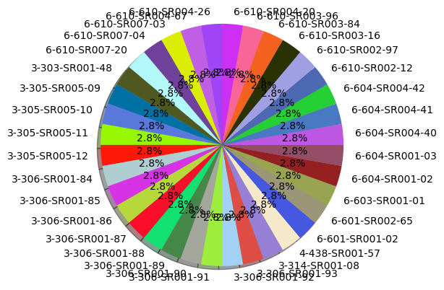

Scatter-plot-chart7.png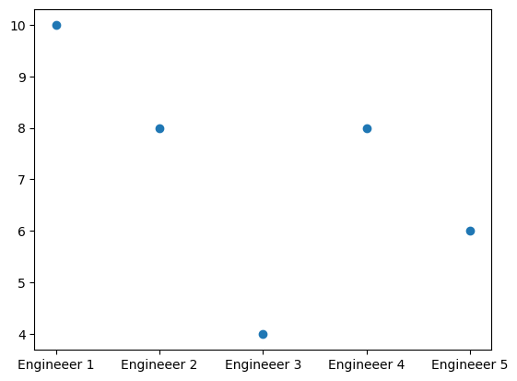

Scatter-plot-chart8.png