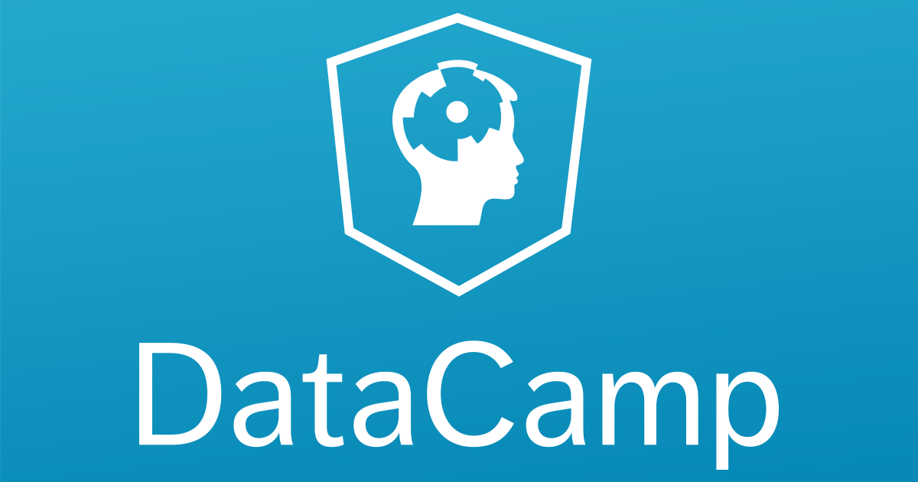
Arjun Kondabathini

Mobile: +91 9491150688 arjun.kondabathini@gmail.com
____________________________________________________________________________________________
PROFESSIONAL SUMMARY:
- Experienced and driven Data Scientist, Associated Business Analyst with 5.5 years of experience in the IT industry.
- Actively participated in all phases of the project lifecycle including data acquisition, data cleaning, data engineering, feature selection, features scaling & statistical modeling (Regression, Classification and Clustering models), testing, validation and data visualization for Machine Learning algorithms.
- Experienced in Machine learning techniques like: Linear Regression, Logistics Regression, Decision Tree, Random Forest, K-Nearest Neighbors, K-means, SVM, Time Series Analysis and Association Rule Mining.
- Experience in creating data visualization with proprietary code in Python, or using other visualization and reporting tool like Tableau.
- Experience in Data Modeling in Python using advanced libraries like Pandas, Numpy, Scipy, Sklearn and Matplotlib.
- Implemented Machine Learning Techniques is part of testing for predictive testing, Good Working Knowledge on SDLC and STLC of Agile Methodology & Scrum development environment.
- Experience in interacting with Business Analysts, Developers, and Technical Support help them in base line the requirement specifications.
- Experience to prepare data, develop experiments, and deploy models at cloud scale on using Azure Machine Learning.
- Good Knowledge on Deep learning technologies: ANN, CNN, RNN, Text Mining technologies.
__________________________________________________________________________________
WORK EXPERIENCE:
- Working as a Junior Data Scientist in Prolifics Corporation Limited from March 2018 to till date.
- Worked as an Associate Business Analyst in Optum Global Services (UnitedHealth Group), Hyderabad from January 2013 to till March 2018.
__________________________________________________________________________________
SKILLS AND CERTIFICATIONS:
- DataCamp Certified Data Scientist
- Programming Tools: Python, R, Spyder, PyCharm, Anaconda, Jupyter
- Machine Learning: Linear Regression, Logistic Regression, Decision Trees, Random Forest, Support Vector Machine, K-Nearest Neighbors, K-Means Clustering, Association Rule Mining, Time Series Analysis
- Statistical Methods: Correlation, Descriptive statistics, Inferential statistics, Hypothesis testing, Chi Squared Tests, Confidence intervals and Predictive Analytics.
- Visualization: Matplotlib, Tablue, PowerPoint, etc.
- Agile Tracking Tool :Rally (CA Technologies)
- Defect Management Tools : HP ALM 11.0
__________________________________________________________________________________
EDUCATIONAL QUALIFICATION:
- Master Of Business Administration (2010-12) from Sun Institute of Technology and Management, Hyderabad, Affiliated to Guwahati University.
- Bachelor of Technology in Computer Science Engineering (2004-2008) from Jyothishmathi College of Engg & Tech, Affiliated to Jawaharlal Nehru Technological University, Hyderabad.

_________________________________________________________________________________
PROFESSIONAL EXPERIENCE:
Project Profile# 4
Title : iEnroll
Description : This project is for visualize time series, trend &seasonality spotting and forecast Enrollment data. In this project, I used/checked variety of algorithms to forecast accurately.
iEnroll is basically an enrollment application for Medicare Advantage plans for Ovations. IEnroll provides various methods of enrollment solutions: –Online-Telesales-eModel. Online are the people who go near the people by taking an Appointment or Meeting with their convenient time and explain them the plans eligible according to the State, Period and Age. Telesales people are different from Online and it’s a type of call center where the people call to the call center and give their details. Telesales agent enrolls the enrollee using iEnroll Application. Telesales has a feature with which we can change the plan after some days, but the plan should be available in the state plans list. eModel is an office. Some of the online agents fill the details of Customers or enrollees in the paper format and send them to the nearest eModel office. eModel office people enroll the details of enrollee into iEnroll.
Responsibilities:
- Used ARIMA to find the parameters and assumptions made by the model.
- Used how to fit an ARIMA model to data and make it forecasts.
- Checking how to Work on configure the ARIMA model on time series problem.
- Building, visualizing and exploring time series objects
- Transformations for variance stabilization
- Used AR, MA, ARIMA, exponential smoothing to build models to taken care of proper residual analysis
- ACF and PACF analysis and deciding with correct method to build the model
- Increased forecast accuracy by choosing appropriate time series algorithm
- Time series cross validation for best model
- Dynamic regression to include independent variables in the model
- Applied methods to handle more complicated seasonality

Project Profile# 3
Title : MyUhc Member Portal
Description : This project deals with trauma cases coming to the hospital for treatment. The main objective is to find out the relationship and association between injury types. By using these hidden relationships, associations & patterns doctors/physicians recommend different tests and scanning.
MyUhc Member Portal, which provides convenient and secure combination of e-health information with comprehensive health plan information and services. Also customers can review preferred topics; check recent claims history, find physician and facility, access pharmacy on line, manage Flexible Spending Account on line and much more. By using Treatment Cost Estimator, user can find out the average amount paid for health care services in his/her geographic area, and use this information to make choices about health care, discuss treatment options with the doctor, and decide which benefit plan makes sense.
Responsibilities:
- Interpreted data from databases and information technology team.
- Finding out missing values and fill na’s, mean, median, mode, outlier capping.
- Used Apriori algorithm to build the strong association rules(ARM)
- Checking different data formats for mining using python
- Build data mining with multiple minimum supports.
- Used Rule strength measures like Support, Confidence, lift - key metrics to consider the evaluating association rules
- Find all rules that satisfy the user-specified minimum support value and minimum confidence value.
- Mining exploits of given data to perform high minimum support and high minimum confidence values.

Project Profile# 2
Title : ICUE
Description : ICUE stands for Integrated Clinical User Experience. It integrates multiple clinical tools into one system to deliver a more coordinated user experience across the continuum of care. ICUE includes three core components with a variety of features and functions, all designed to help us deliver our services effectively: CPM, Advisor and HSR.
ICUE is Case Management and Disease Program Management application. This Application Deals with Health Service Case Initiate Intake, Clinical Program Management, Member Engagement, Letters Generation for Commercial and Government Business Members to be handled by Hospitals, Nurses, and Medical care Takers.
Responsibilities:
- Performed Data Profiling to learn about user behaviour
- Merged user data from multiple data sources
- Data preprocessing with label encoder, one hot encoder, creating dummy variables for categorical data.
- Performed Exploratory Data Analysis using Python
- Performed Data Cleaning, visualization of data, data scaling and preprocessing data
- Developed novel approach to build machine learning algorithm and implement it in a production environment
- Developed Performance metrics to evaluate Algorithm’s performance
- Fine tune the algorithm using regularization term to overcome the problem of over fitting
- Customized reports and presentations were generated autonomously using tool for different models using Python packages like Pandas, Numpy, Scipy, Sklearn, Matplotlib.
- Provided Daily Status report, checklist documents and weekly status reports to the Project Manager

Project Profile# 1
Title : Product Materials
Project Description :
UnitedHealth Care Medicare & Retirement is part of the family of companies that make UnitedHealth Group one of the leaders across most major segments of the US health care system. Materials Automations is to automate required and non-required materials for Medicare members using CMS models as input based on product types like ANOC, EOC, SB and Baag. Any materials that use the same benefits, the data required to automate is available, if material type meets cost effective criteria and also documents that are not highly customized can be programmed for automation.
Responsibilities:
- Analyzed business requirements documents for all the projects to get a better understanding of the system from both technical and business perspectives.
- Tracking of daily status and reviewing the work done.
- Involved in preparing test scenarios and test data preparations activities.
- Designed, developed and executed test scenarios and test procedures based on the functional specifications of the project.
- Performed peer-to-peer reviews
- Involved in Unit Testing, Regression Testing and UAT Activities and helped the team members to finish the work in time.
- Logged defects and created various defect reports using bug tracking tool.
- Interacting with the Development team and giving possible solutions work around for the issues found in application.
- Preparing and sending the testing status reports on daily basis and monthly status reports to Project Management team.
- Worked on managing test data using different data sources like Excel files.

