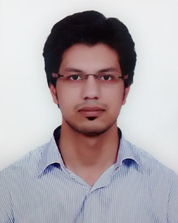

Abhinav Chauhan

|  |  |  |  |
| --- | --- | --- | --- |
| E-mail: | me.abhinavchauhan@gmail.com | LinkedIn: | <https://in.linkedin.com/in/meabhinavchauhan> |
| Phone: | +91-9741233064 | Address: | B3 Vijaya Regency, Mahadevapura, Bangalore, Karnataka – 560048 |

|  |
| --- |
| Work Experience |
| |  |  | | --- | --- | | Flipkart (Android / iOS development) Software Development Engineer | Apr 2015 – Present | | Samsung R&D Institute India, Noida (SRI-N) (Android development) Software Engineer | Jun 2014 – Apr 2015 | |
| Projects |
| |  |  | | --- | --- | | Flipkart Seller Hub - iOS (<https://itunes.apple.com/in/app/flipkart-seller-hub/id1097721446>)  Single handedly developed and delivered the Flipkart seller app for iOS. | Nov 2015 – Present | | Flipkart Seller Hub – Android (<https://play.google.com/store/apps/details?id=com.flipkart.seller&hl=en>) | Apr 2015 – Nov 2015 | | Samsung clock A custom clock app shipped with Samsung phones | June 2014 – Apr 2015 | | Hobby Projects |  | | Sentiment analysis tool for Flipkart seller app feedbacks (<http://meabhinav.pythonanywhere.com/>) | Aug 2016 – Present | |
| Certifications |
| |  |  | | --- | --- | | Machine Learning (<https://www.coursera.org/account/accomplishments/certificate/PG6G4CAYA6GX>) | Completed on: May 27, 2016 | | Skills |  | | Programming Languages / Technologies Java (Android), React Native, Swift (iOS), Python (beginner), Data Science & Machine Learning C |  | | Operating Systems / Tools Mac OS X, Android Studio, Xcode, Pycharm, iPython etc |  | |
| Interests |
| Mobile technologies (Android / iOS), React native, Data science, Machine learning, Data Structures and Algorithms |