**Task 23**

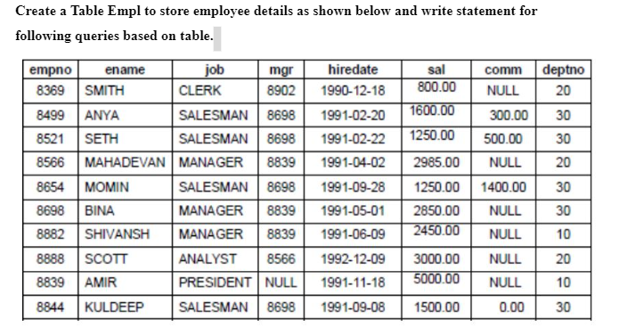

**Database table**

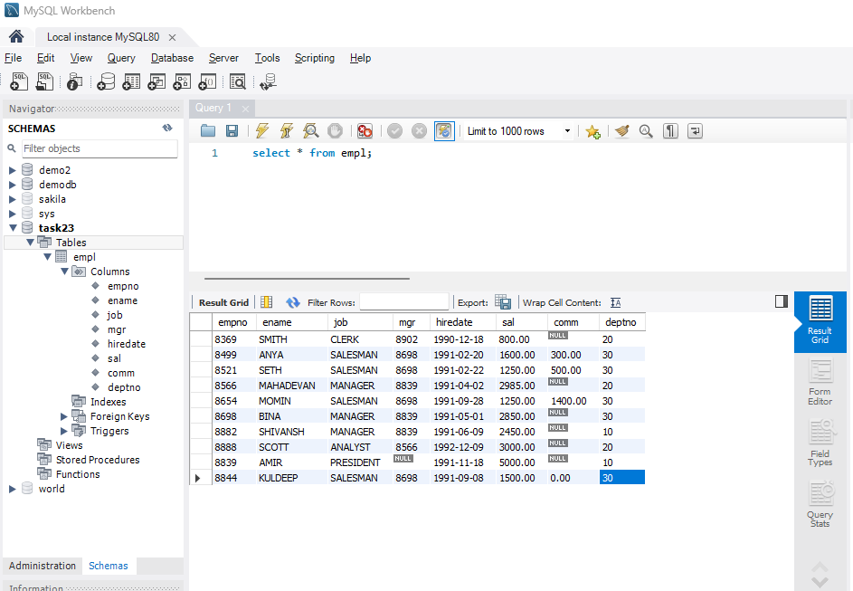

1. **Consider the Employee table and write SQL command to get the following.**

**A. Write a query to display EName and Sal of employees whose salary are greater than or equal to 2200?**

SELECT ename , sal FROM empl WHERE sal>='2200';

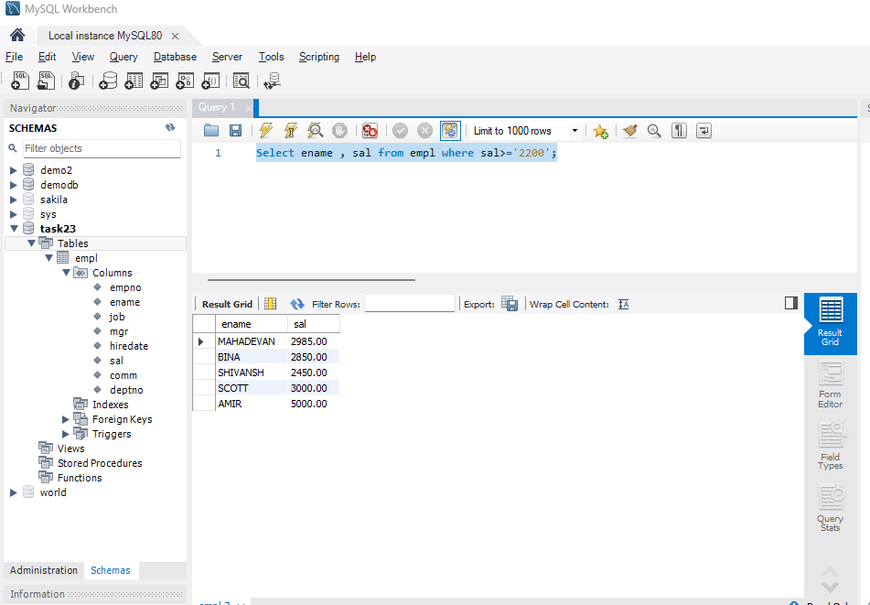

**B. Write a query to display details of employees who are not getting commission?**

SELECT * FROM empl where job='SALESMAN' and comm='0';

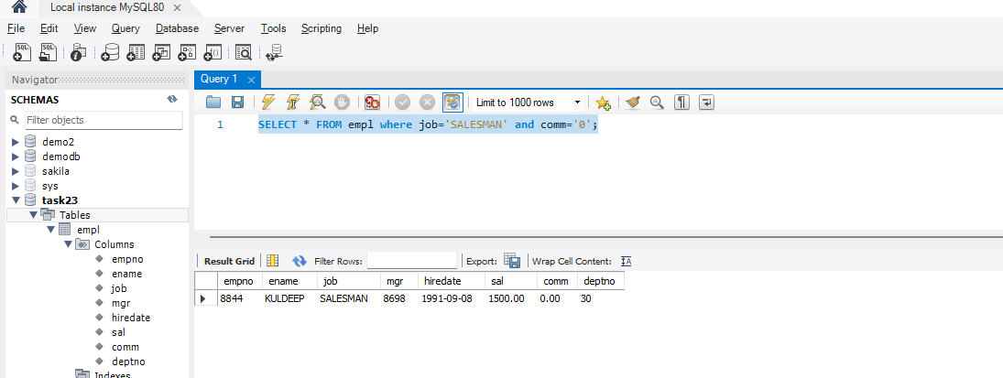

**C. Write a query to display employee name and salary of those employees who don't have their salary in the range of 2500 to 4000?.**

SELECT ename, sal FROM empl WHERE sal NOT BETWEEN 2500 AND 4000;

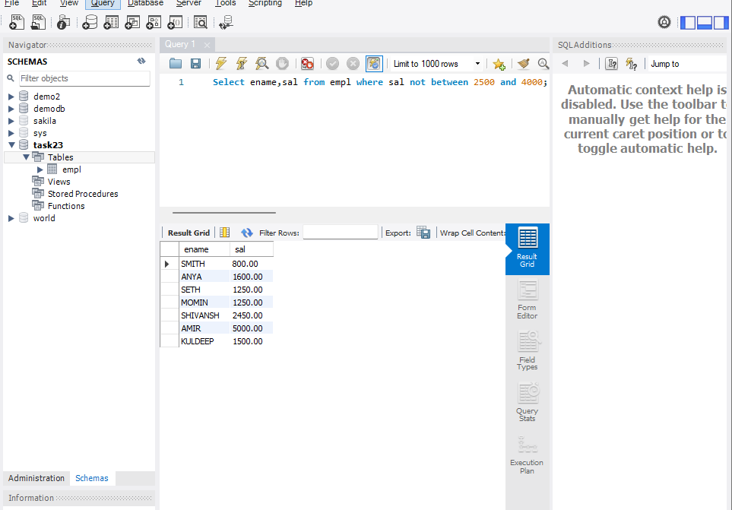

**D. Write a query to display the name, job title and salary of employees who don't have a manager?**

**select ename,job,sal from empl where mgr is null;**

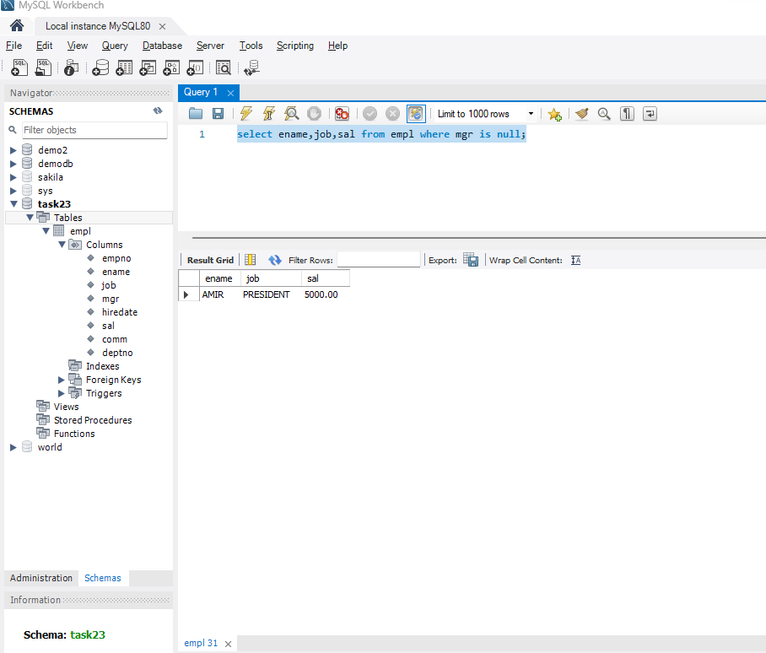

**E. Write a query to display the name of an employee whose name contains "A" as third alphabet?**

Select ename from empl where ename like ‘__A%’;

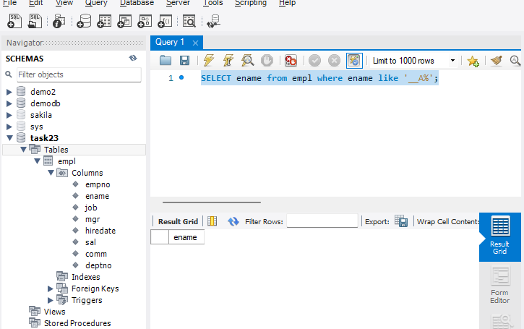

**No data with that condition**

**F. Write a query to display the name of an employee whose name contains T as the last alphabet?**

**select ename from empl where ename like '%T';**

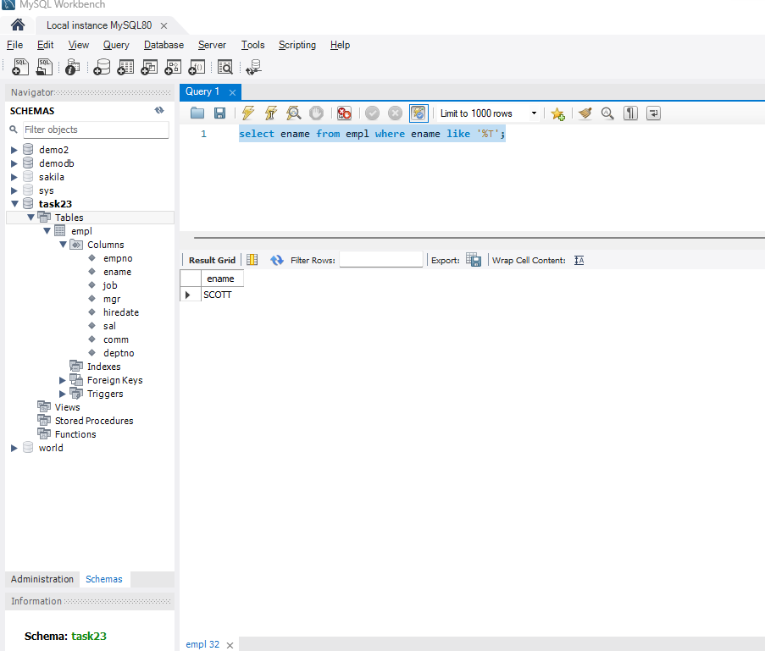

**Q2 Write a Program for JDBC to connectivity and insert the below data**

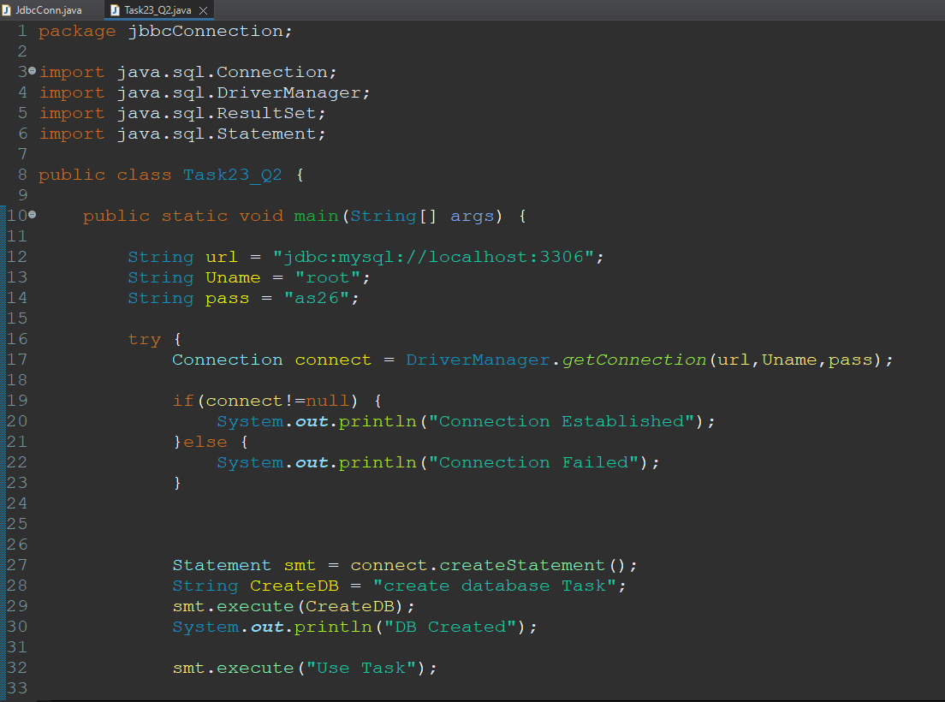

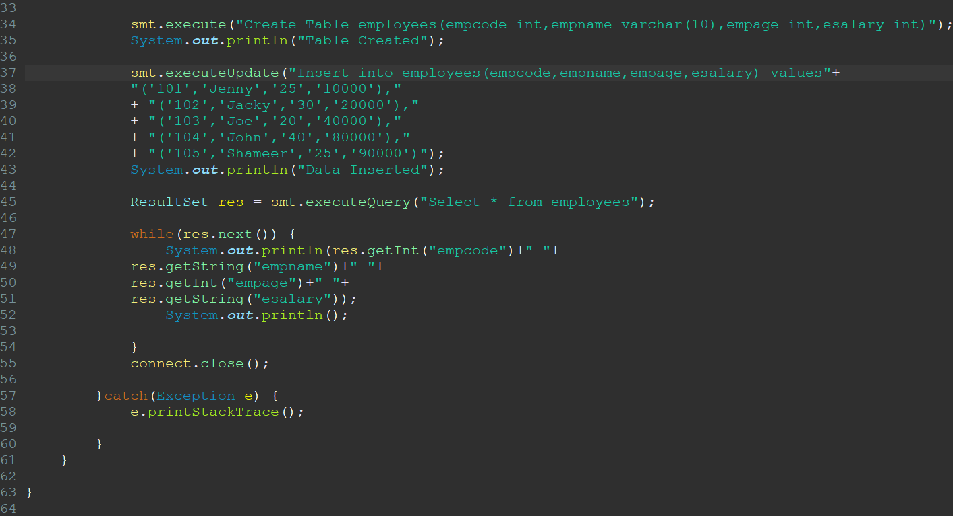

**Output**