Ajaykumar Mudaliar

Battle of the neighborhoods

# **Data:**

* We will Wikipedia to retrieve the postcodes of neighborhoods in Toronto, link = <https://en.wikipedia.org/wiki/List_of_postal_codes_of_Canada:_M>

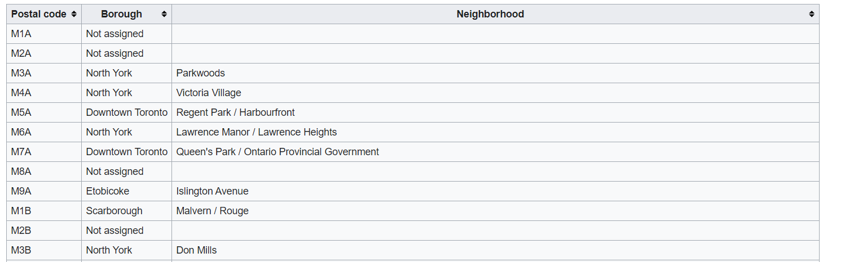

* We use a python modules and a .csv file containing latitude and longitudes of the neighborhoods of Toronto to update each neighborhood with their longitude and latitudes.

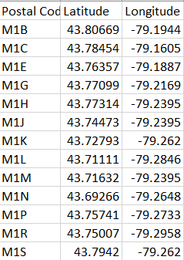

* We will use Foursquare to retrieve reviews and popular venues in Toronto.

A Query request to get the venues will look like this:



The data is retrieved in form of a dictionary, a snapshot of which is shown below:

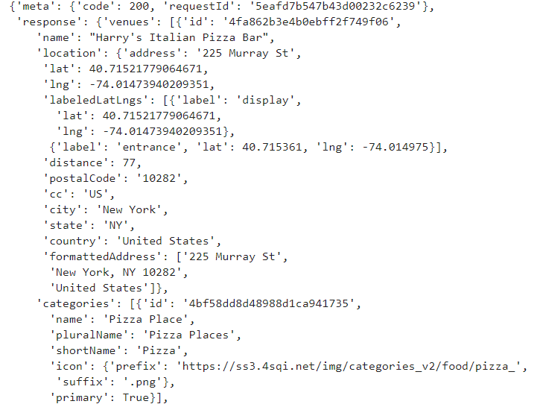

This information will be processed to be of the form:

