Lab Exercise 19- ClusterIP in Service in Kubernetes

Name : Zuhair Ahmad
Sap : 500119134
Roll No : R2142230479
Batch 1








apiVersion: apps/v1 kind: Deployment metadata:
name: nginx-app spec:
replicas: 2 selector:
matchLabels:
app: nginx # MUST match template labels template:
metadata:
labels:
app: nginx # MUST match service selector spec:

A ClusterIP is the default type of service in Kubernetes. It provides a stable internal IP address for the service, which is accessible only within the cluster. This is useful for internal communication between services within the cluster.

Step 1: Create Deployment (Correct Labels)
Create file:

nginx-deployment.yaml

containers:
- name: nginx image: nginx ports:
- containerPort: 80
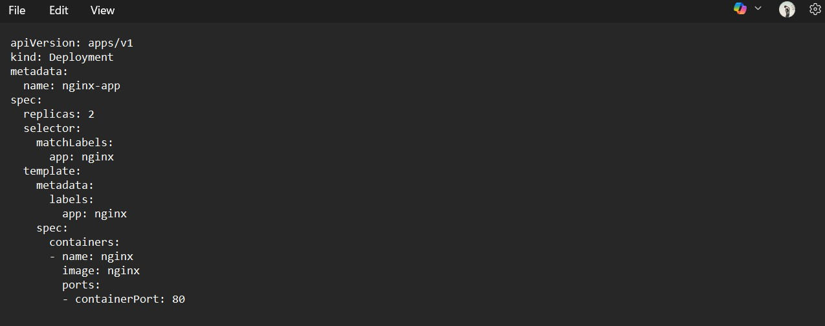

Save file.

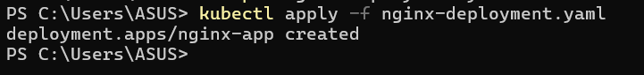
kubectl apply -f nginx-deployment.yaml

Verify:
kubectl get pods --show-labels

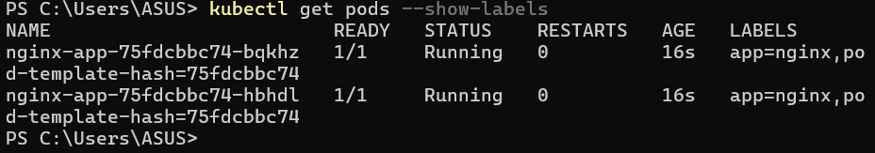

You should see:
app=nginx

Step 2: Create ClusterIP Service (Matching Selector)

Create file:

nginx-service.yaml

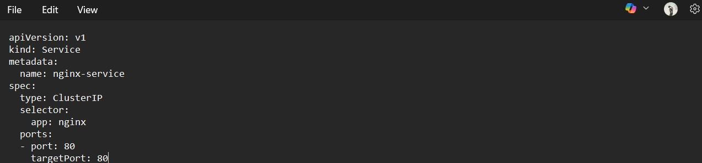
apiVersion: v1 kind: Service metadata:
name: nginx-service spec:
type: ClusterIP selector:
app: nginx # MUST match pod label ports:
- port: 80
targetPort: 80

Apply:
kubectl apply -f nginx-service.yaml
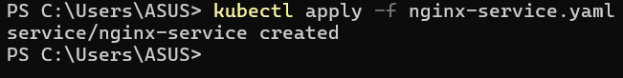

Step 3: Verify It Is Working Check Service
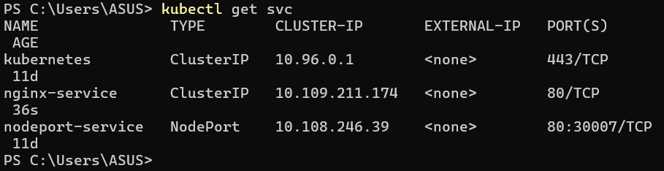
kubectl get svc

You should see:
TYPE
CLUSTER-IP
ClusterIP 10.x.x.x

MOST IMPORTANT CHECK

kubectl get endpoints nginx-service

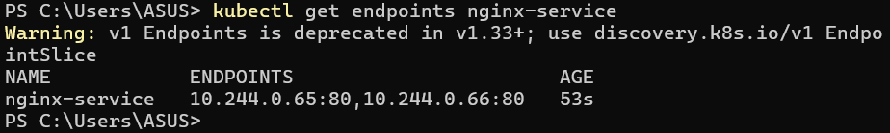

Now you should see something like:
10.244.x.x:80, 10.244.x.x:80

Step 4: Test From Inside Cluster
Run test pod:
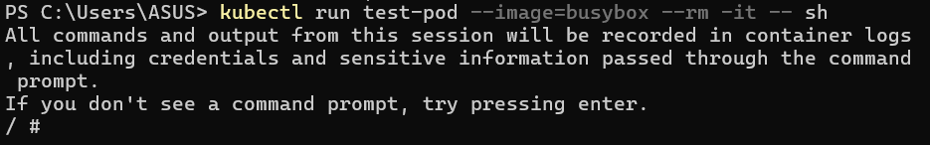
kubectl run test-pod --image=busybox --rm -it -- sh

Inside pod:
wget -qO- http://nginx-service
You should see:
Welcome to nginx!

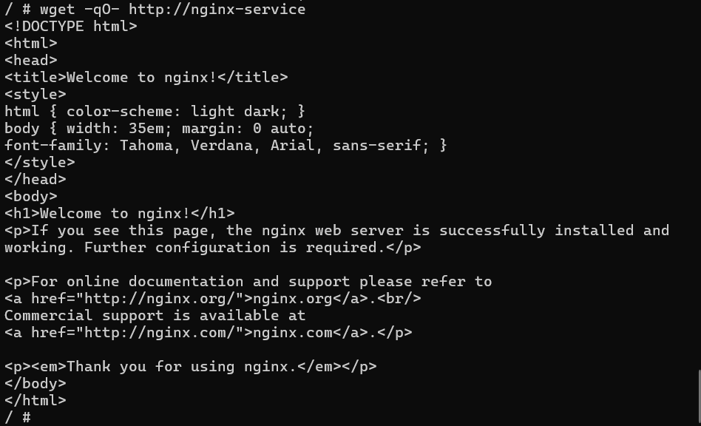

Exit:
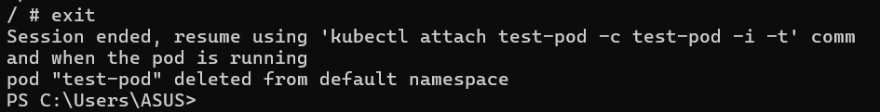
exit

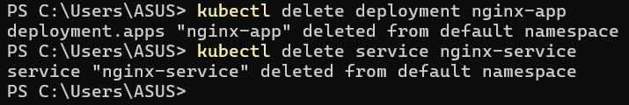

Step 5: Test From Outside (It Will Fail)

From your local machine:

curl http://<CLUSTER-IP>

It will NOT work. That proves:
ClusterIP works only inside cluster.

