Lab Exercise 11- Deployments with Rolling Update and Recreate Strategies

Name : Zuhair Ahmad
Sap : 500119134
Roll No : R2142230479
Batch 1

Understand how to use the rolling update and recreate strategies for deploying applications using Kubernetes Deployments.

Step 1: Create a Deployment with Rolling Update Strategy

Create a YAML file for the deployment:

Create a file named nginx-deployment-rolling.yaml with the following content:

apiVersion: apps/v1 kind: Deployment metadata:
name: nginx-deployment-rolling spec:
replicas: 10
minReadySeconds: 10 selector: matchLabels:
app: web strategy:
type: RollingUpdate

rollingUpdate: maxUnavailable: 1
maxSurge: 5 template:
metadata:
labels:
app: web spec:
containers:
- name: nginx
image: hkshitesh/kubedemo:1.0 ports:
- containerPort: 80

Apply the deployment:

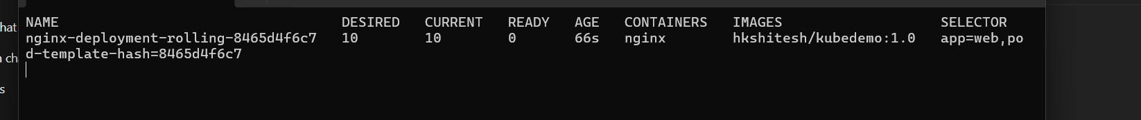
kubectl apply -f nginx-deployment-rolling.yaml ; watch "kubectl get rs -o wide"

Verify the deployment:

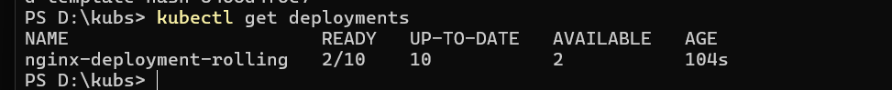
kubectl get deployments

kubectl get pods -l app=web

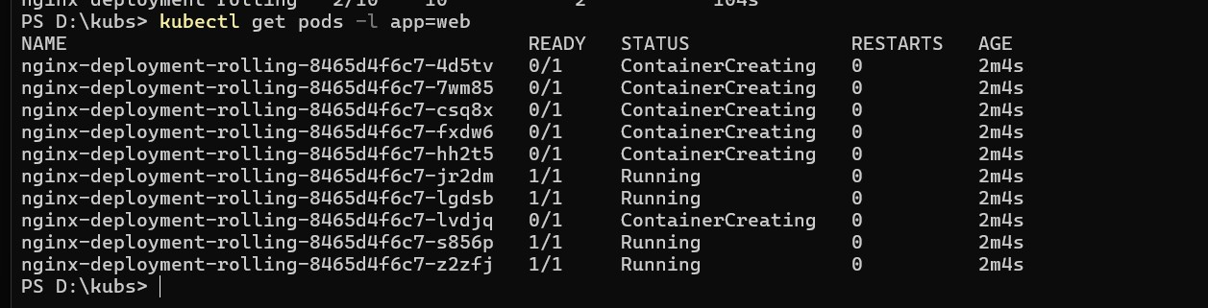

Update the deployment to a new image:

kubectl set image deployment/nginx-deployment-rolling nginx= hkshitesh/kubedemo:2.0

Monitor the rolling update:

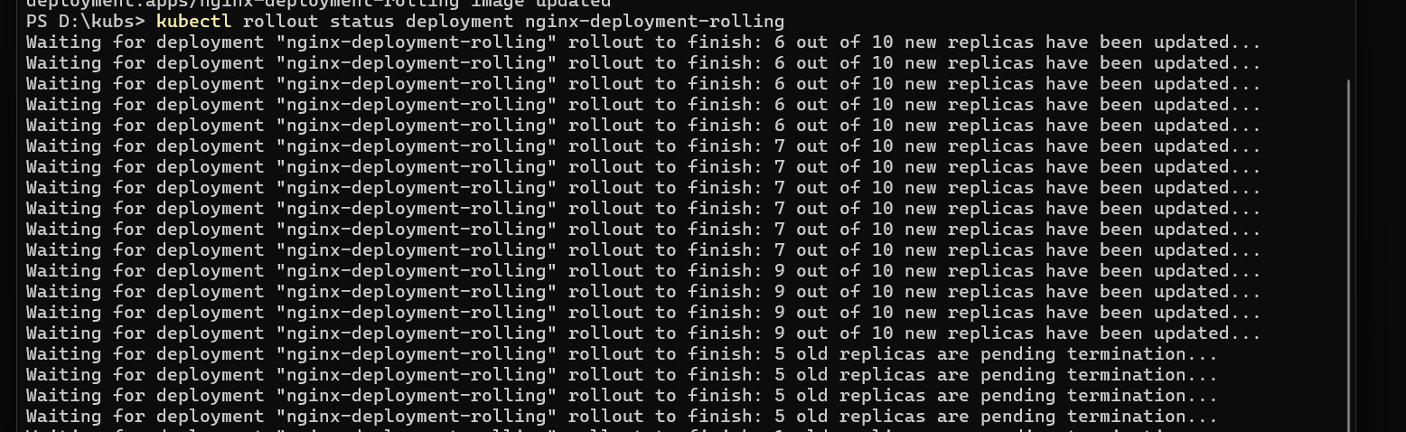
kubectl rollout status deployment nginx-deployment-rolling

Verify the updated pods:

kubectl get pods -l app=web -o wide

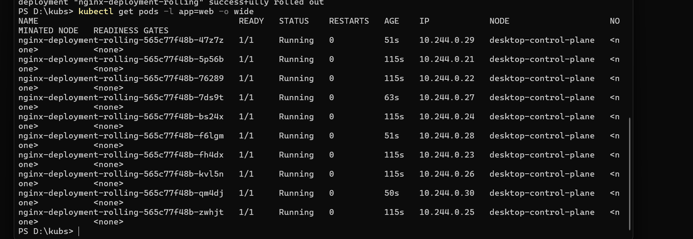

Step 2: Create a Deployment with Recreate Strategy

Create a YAML file for the deployment:

Create a file named nginx-deployment-recreate.yaml with the following content:

apiVersion: apps/v1 kind: Deployment metadata:
name: nginx-deployment-recreate spec:
replicas: 10 selector: matchLabels:
app: web strategy:
type: Recreate template:

metadata:
labels:
app: web spec:
containers:
- name: nginx
image: nginx: hkshitesh/kubedemo:1.0 ports:
- containerPort: 80

Apply the deployment:

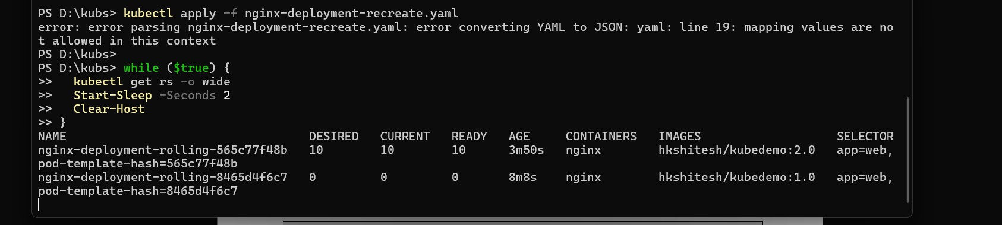
kubectl apply -f nginx-deployment-recreate.yaml ; watch "kubectl get rs -o wide"

kubectl apply -f nginx-deployment-recreate.yaml

while ($true) {
kubectl get rs -o wide Start-Sleep -Seconds 2 Clear-Host
}

Verify the deployment:

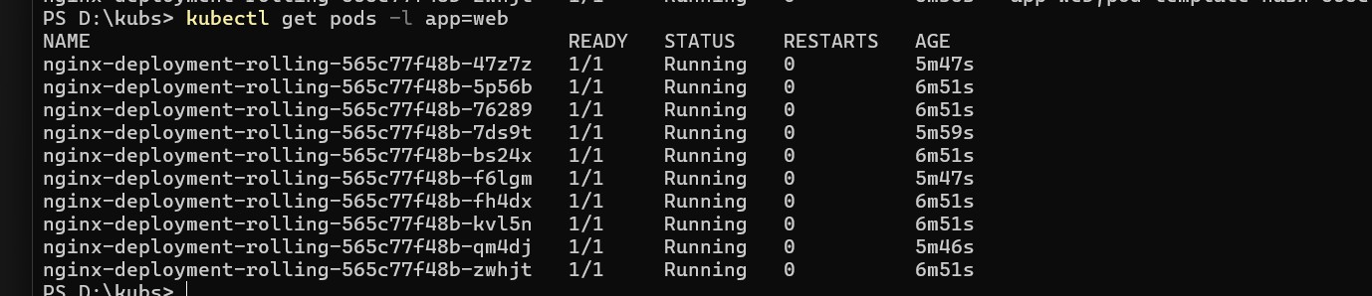
kubectl get deployments

kubectl get pods -l app=nginx-recreate

Update the deployment to a new image:

kubectl set image deployment/nginx-deployment-recreate nginx=nginx:1.21.1

Monitor the update:

kubectl rollout status deployment nginx-deployment-recreate

Verify the updated pods:

kubectl get pods -l app=nginx-recreate -o wide

Step 3: Clean Up

Delete the deployments:

kubectl delete deployment nginx-deployment-rolling kubectl delete deployment nginx-deployment-recreate

Verify that all resources are cleaned up:

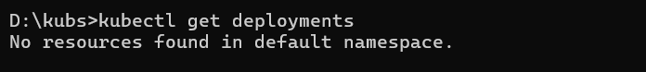
kubectl get deployments

kubectl get pods -l app=nginx

kubectl get pods -l app=nginx-recreate

