Lab Exercise 12 - Start and Access Kubernetes Dashboard

Name : Zuhair Ahmad
Sap : 500119134
Roll No : R2142230479
Batch 1

Objective

To enable Kubernetes in Docker Desktop, deploy the Kubernetes Dashboard, and access it securely using a web browser on Windows.

Prerequisites

- Windows 10 / 11

- Docker Desktop installed

- Docker Desktop Kubernetes enabled

- Internet connection

- kubectl (comes bundled with Docker Desktop)

Step 1: Enable Kubernetes in Docker Desktop

- Open Docker Desktop

- Go to Settings

- Select Kubernetes

- Check Enable Kubernetes

- Click Apply s Restart

Wait until Kubernetes status shows Running (green).

Step 2: Verify Kubernetes Cluster

Open PowerShell or Command Prompt and run:

  - kubectl version –client
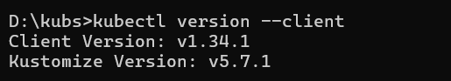

  - Check cluster status:

  - kubectl cluster-info

Check nodes:
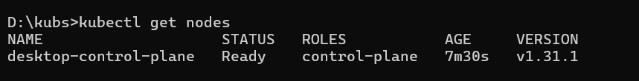
kubectl get nodes
Expected output:

Node status should be Ready

Step 3: Deploy Kubernetes Dashboard

Apply the official Kubernetes Dashboard manifest:

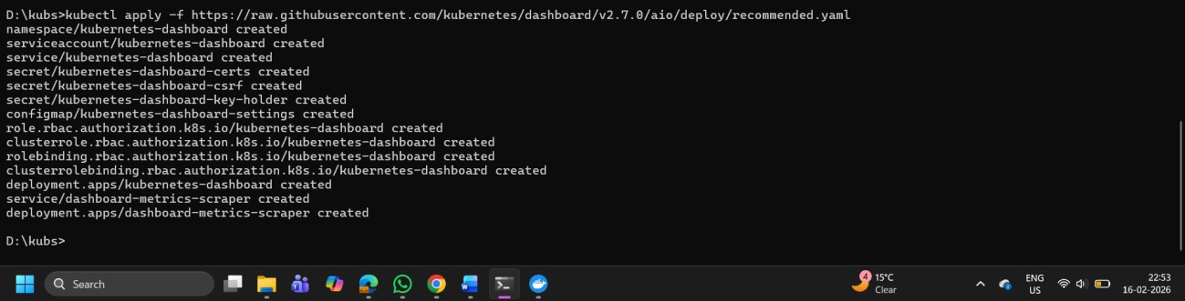
kubectl apply -f https://raw.githubusercontent.com/kubernetes/dashboard/v2.7.0/aio/deploy/recommen ded.yaml

Verify namespace creation:
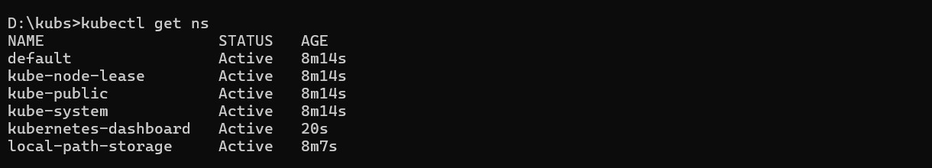
kubectl get ns

You should see:
kubernetes-dashboard

Step 4: Verify Dashboard Pods

Check dashboard pods:
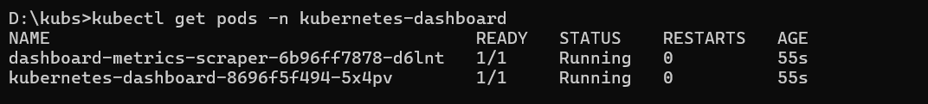
kubectl get pods -n kubernetes-dashboard

Expected status: Running

Step 5: Create Admin User for Dashboard Access

Create a service account:
kubectl create serviceaccount dashboard-admin -n kubernetes-dashboard

Create cluster role binding:
kubectl create clusterrolebinding dashboard-admin-binding --clusterrole=cluster-admin -

-serviceaccount=kubernetes-dashboard:dashboard-admin

Step 6: Generate Dashboard Login Token

Run the following command to get the token:
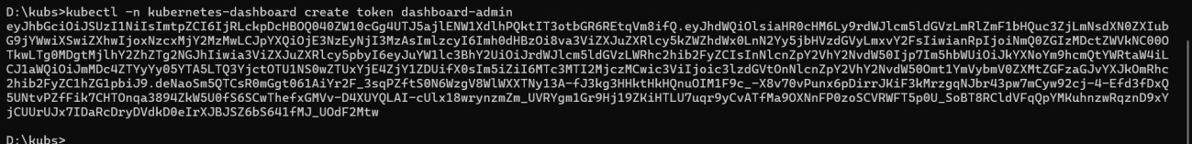
kubectl -n kubernetes-dashboard create token dashboard-admin

Copy the generated token (you will paste it in the browser later).

Step 7: Start Kubernetes Dashboard

Run the proxy command:
kubectl proxy

Keep this terminal running.

Step 8: Access Kubernetes Dashboard in Browser

Open a web browser and paste the following URL:
http://localhost:8001/api/v1/namespaces/kubernetes- dashboard/services/https:kubernetes-dashboard:/proxy/

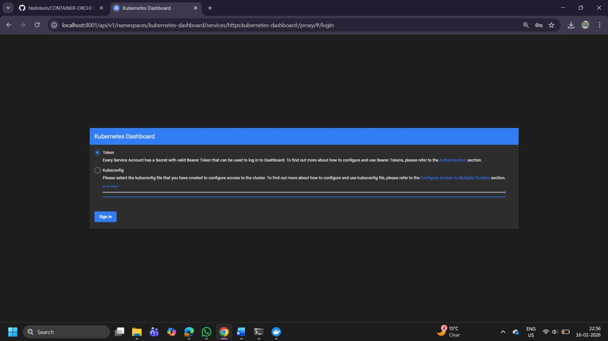

Step G: Login to Dashboard

- Select Token authentication

- Paste the token generated earlier

- Click Sign In

You should now see the Kubernetes Dashboard UI.

Step 10: Explore Dashboard

You can now view:

  - Nodes

  - Pods

  - Deployments

  - Services

  - Namespaces

  - ConfigMaps and Secrets
