Lab Exercise 6- Docker-Compose file

Name : Zuhair Ahmad
Sap : 500119134
Roll No : R2142230479
Batch 1

Objective:
Set up a WordPress environment using Docker Compose, including a MySQL database as the backend.

Prerequisites:

- Docker and Docker Compose installed on your system.

Step 1: Create a docker-compose.yml File

- In the project directory, create a file named docker-compose.yml.

- Add the following content to docker-compose.yml:
docker-compose.yml
version: '3.8'

services:
wordpress:
image: wordpress:latest ports:
- "8002:80"
environment: WORDPRESS_DB_HOST: db:3306
WORDPRESS_DB_USER: wp_user WORDPRESS_DB_PASSWORD: wp_pass WORDPRESS_DB_NAME: wp_database depends_on:
- db

db:
image: mysql:latest environment:
MYSQL_ROOT_PASSWORD: root_password MYSQL_DATABASE: wp_database MYSQL_USER: wp_user MYSQL_PASSWORD: wp_pass
volumes:
- db_data:/var/lib/mysql

volumes: db_data:

Step 2: Start the Containers
- Run the following command to start the containers:
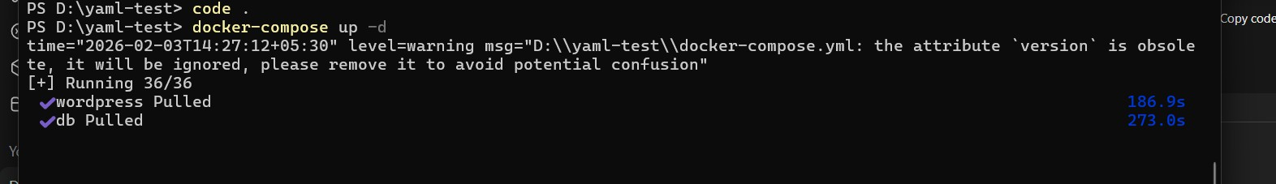
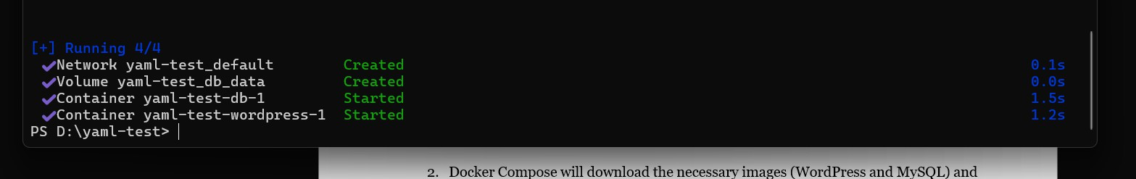
docker-compose up -d

- Docker Compose will download the necessary images (WordPress and MySQL) and start both services.

Step 4: Access WordPress
- Open your web browser and go to http://localhost:8002
- Follow the WordPress installation steps to set up your site.

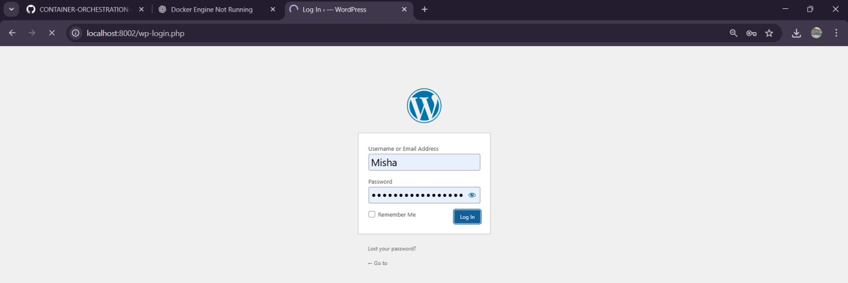
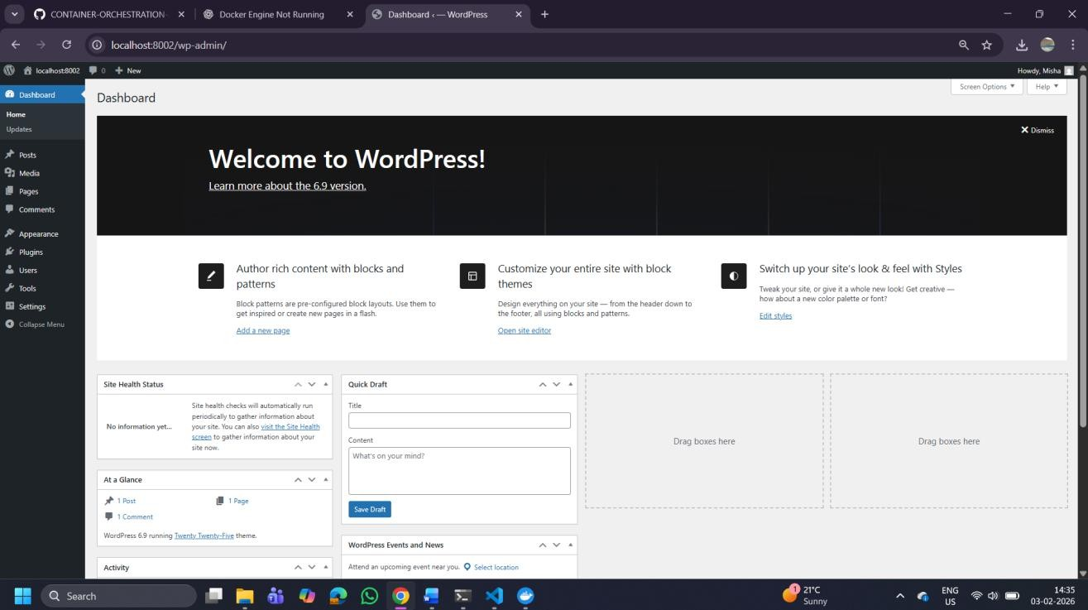
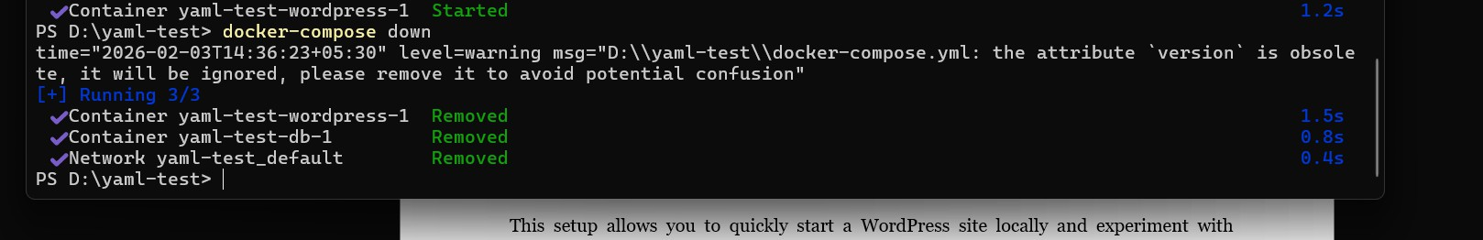

Step 5: Stop and Remove Containers

To stop the containers and remove the associated resources, run:
docker-compose down

Explanation of docker-compose.yml:

  - wordpress: Sets up the WordPress container, mapping port 80 inside the container to port 8002 on your local machine.
  - db: Sets up the MySQL container with a volume (db_data) for persistent storage.

Additional Notes:
  - Modify the environment variables as needed for different configurations.
  - To view logs, use docker-compose logs -f.

This setup allows you to quickly start a WordPress site locally and experiment with configurations.

