Lab Exercise 8- Create POD in Kubernetes

Objective:

- Understand the basic structure and syntax of a Kubernetes Pod definition file (YAML).
- Learn to create, inspect, and delete a Pod in a Kubernetes cluster.

Prerequisites

- Kubernetes Cluster: You need a running Kubernetes cluster. You can set up a local cluster using tools like Minikube or kind, or use a cloud-based Kubernetes service.
- kubectl: Install and configure kubectl to interact with your Kubernetes cluster.
- Basic Knowledge of YAML: Familiarity with YAML format will be helpful as Kubernetes resource definitions are written in YAML.

Step-by-Step Guide

Step 1: Create a YAML File for the Pod
We'll create a Pod configuration file named pod-example.yaml

apiVersion: v1
kind: Pod
metadata:
name: my-pod
labels:
app: web
spec:
containers:
- name: my-container
image: nginx:latest

Explanation of the YAML File

- apiVersion: Specifies the version of the Kubernetes API to use. For Pods, it's typically v1.
- kind: The type of object being created. Here it's a Pod.
- metadata: Provides metadata about the object, including name and labels. The name must be unique within the namespace, and labels help in identifying and organizing Pods.
- spec: Contains the specifications of the Pod, including:
  - containers: Lists all containers that will run inside the Pod. Each container needs:
    - name: A unique name within the Pod.
    - image: The Docker image to use for the container.
    - ports: The ports that this container exposes.
    - env: Environment variables passed to the container.

Step 2: Apply the YAML File to Create the Pod

Use the kubectl apply command to create the Pod based on the YAML configuration file.

kubectl apply -f pod-example.yaml

This command tells Kubernetes to create a Pod as specified in the pod-example.yaml file.

Step 3: Verify the Pod Creation

To check the status of the Pod and ensure it's running, use:

kubectl get pods
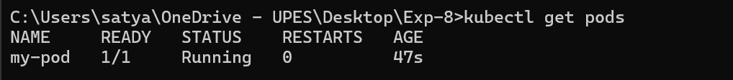

This command lists all the Pods in the current namespace, showing their status, restart count, and other details.

You can get detailed information about the Pod using:

kubectl describe pod my-pod
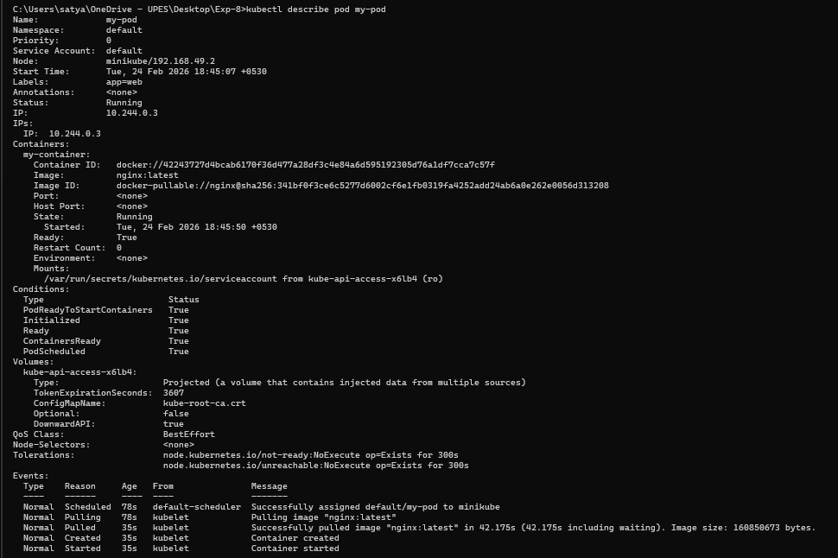

This command provides detailed information about the Pod, including its events, container specifications, and resource usage.

Step 4: Interact with the Pod

You can interact with the running Pod in various ways, such as accessing the logs or executing commands inside the container.

View Logs: To view the logs of the container in the Pod:

kubectl logs my-pod
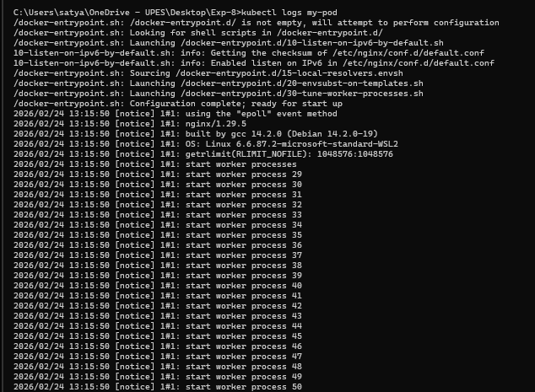

Execute a Command: To run a command inside the container:

kubectl exec -it my-pod -- /bin/bash

The -it flag opens an interactive terminal session inside the container, allowing you to run commands.

Step 5: Delete the Pod

To clean up and remove the Pod when you're done, use the following command:

kubectl delete pod my-pod

This command deletes the specified Pod from the cluster.

