AI BASED DIABETES PREDICTION SYSTEM

SUBMITTED BY

AJAY S – 710021106001

DEPARTMENT OF ELECTRONICS AND COMMUNICATION ENGINEERING

ANNA UNIVERSITY REGIONAL CAMPUS COIMBATORE

ABSTRACT

Diabetes is one of the most deadly and chronic diseases which cause an increase in blood sugar. If diabetes remains untreated and unidentified many difficulties may arise due to that. The tedious work is in identifying the process which results in visiting the clinic and consulting the doctor. But this tedious work has been solved with the rise in the approaches used by machine learning. This project gives a comprehensive prospect of work accomplished to develop a model that can predict the possibility of diabetes in patients with extreme accuracy. Therefore, various machine learning classification algorithms namely genetic algorithm, decision tree, random forest, Logistic regression, SVM and Naive Bayes are used for detecting diabetes. Further we have done the comparison among various performances of all the different algorithms. The performances are categories of various measures like Precision, Accuracy, F-Measure and Recall. The project helps in identifying the algorithm to classify the risk of diabetes. Different techniques were applied to the algorithms for improving the robustness. Additionally, the findings suggest that the best performance of disease risk classification is done with the help of a genetic algorithm.

PROBLEM STATEMENT

The problem we aim to address is the early prediction of diabetes using Artificial Intelligence (AI) to improve healthcare outcomes. Diabetes is a widespread chronic disease with severe health implications, and early detection is crucial for effective management and prevention of complications.

The AI-based diabetes prediction system is a cutting-edge application of artificial intelligence and machine learning techniques aimed at early detection and management of diabetes. This system leverages data from various sources, including medical records, wearable devices, and lifestyle information, to provide accurate predictions of an individual's risk of developing diabetes. By identifying at-risk individuals and offering personalized recommendations, the system can help in preventing or managing diabetes effectively. This abstract outlines the key components and design thinking behind this innovative solution.

Details about the dataset:
The datasets consists of several medical predictor variables and one target variable, Outcome. Predictor variables includes the number of pregnancies the patient has had, their BMI, insulin level, age, and so on.
- Pregnancies: Number of times pregnant
- Glucose: Plasma glucose concentration a 2 hours in an oral glucose tolerance test
- BloodPressure: Diastolic blood pressure (mm Hg)
- SkinThickness: Triceps skin fold thickness (mm)
- Insulin: 2-Hour serum insulin (mu U/ml)
- BMI: Body mass index (weight in kg/(height in m)^2)
- DiabetesPedigreeFunction: Diabetes pedigree function
- Age: Age (years)
- Outcome: Class variable (0 or 1)

1) Exploratory Data Analysis
In [1]:

#Installation of required libraries
import numpy as np
import pandas as pd
import statsmodels.api as sm
import seaborn as sns
import matplotlib.pyplot as plt
from sklearn.preprocessing import scale, StandardScaler
from sklearn.model_selection import train_test_split, GridSearchCV, cross_val_score
from sklearn.metrics import confusion_matrix, accuracy_score, mean_squared_error, r2_score, roc_auc_score, roc_curve, classification_report
from sklearn.linear_model import LogisticRegression
from sklearn.neighbors import KNeighborsClassifier
from sklearn.svm import SVC
from sklearn.neural_network import MLPClassifier
from sklearn.tree import DecisionTreeClassifier
from sklearn.ensemble import RandomForestClassifier
from sklearn.ensemble import GradientBoostingClassifier
from lightgbm import LGBMClassifier
from sklearn.model_selection import KFold
import warnings
warnings.simplefilter(action = "ignore")

In [2]:

#Reading the dataset
df = pd.read_csv("../input/pima-indians-diabetes-database/diabetes.csv")
In [3]:

# The first 5 observation units of the data set were accessed.
df.head()

Out[3]:
 | Pregnancies | Glucose | BloodPressure | SkinThickness | Insulin | BMI | DiabetesPedigreeFunction | Age | Outcome
0 | 6 | 148 | 72 | 35 | 0 | 33.6 | 0.627 | 50 | 1
1 | 1 | 85 | 66 | 29 | 0 | 26.6 | 0.351 | 31 | 0
2 | 8 | 183 | 64 | 0 | 0 | 23.3 | 0.672 | 32 | 1
3 | 1 | 89 | 66 | 23 | 94 | 28.1 | 0.167 | 21 | 0
4 | 0 | 137 | 40 | 35 | 168 | 43.1 | 2.288 | 33 | 1

In [4]:

# The size of the data set was examined. It consists of 768 observation units and 9 variables.
df.shape

Out[4]:

(768, 9)
In [5]:

#Feature information
df.info()
<class 'pandas.core.frame.DataFrame'>
RangeIndex: 768 entries, 0 to 767

Data columns (total 9 columns):
# Column Non-Null Count Dtype
--- ------ -------------- -----
0 Pregnancies 768 non-null int64
1 Glucose 768 non-null int64
2 BloodPressure 768 non-null int64
3 SkinThickness 768 non-null int64
4 Insulin 768 non-null int64
5 BMI 768 non-null float64
6 DiabetesPedigreeFunction 768 non-null float64
7 Age 768 non-null int64
8 Outcome 768 non-null int64
dtypes: float64(2), int64(7)
memory usage: 54.1 KB

In [6]:

# Descriptive statistics of the data set accessed.
df.describe([0.10,0.25,0.50,0.75,0.90,0.95,0.99]).T

Out[6]:
 | count | mean | std | min | 10% | 25% | 50% | 75% | 90% | 95% | 99% | max
Pregnancies | 768.0 | 3.845052 | 3.369578 | 0.000 | 0.000 | 1.00000 | 3.0000 | 6.00000 | 9.0000 | 10.00000 | 13.00000 | 17.00
Glucose | 768.0 | 120.894531 | 31.972618 | 0.000 | 85.000 | 99.00000 | 117.0000 | 140.25000 | 167.0000 | 181.00000 | 196.00000 | 199.00
BloodPressure | 768.0 | 69.105469 | 19.355807 | 0.000 | 54.000 | 62.00000 | 72.0000 | 80.00000 | 88.0000 | 90.00000 | 106.00000 | 122.00
SkinThickness | 768.0 | 20.536458 | 15.952218 | 0.000 | 0.000 | 0.00000 | 23.0000 | 32.00000 | 40.0000 | 44.00000 | 51.33000 | 99.00
Insulin | 768.0 | 79.799479 | 115.244002 | 0.000 | 0.000 | 0.00000 | 30.5000 | 127.25000 | 210.0000 | 293.00000 | 519.90000 | 846.00
BMI | 768.0 | 31.992578 | 7.884160 | 0.000 | 23.600 | 27.30000 | 32.0000 | 36.60000 | 41.5000 | 44.39500 | 50.75900 | 67.10
DiabetesPedigreeFunction | 768.0 | 0.471876 | 0.331329 | 0.078 | 0.165 | 0.24375 | 0.3725 | 0.62625 | 0.8786 | 1.13285 | 1.69833 | 2.42
Age | 768.0 | 33.240885 | 11.760232 | 21.000 | 22.000 | 24.00000 | 29.0000 | 41.00000 | 51.0000 | 58.00000 | 67.00000 | 81.00
Outcome | 768.0 | 0.348958 | 0.476951 | 0.000 | 0.000 | 0.00000 | 0.0000 | 1.00000 | 1.0000 | 1.00000 | 1.00000 | 1.00

In [7]:

# The distribution of the Outcome variable was examined.
df["Outcome"].value_counts()*100/len(df)

Out[7]:

0 65.104167
1 34.895833
Name: Outcome, dtype: float64

In [8]:

# The classes of the outcome variable were examined.
df.Outcome.value_counts()

Out[8]:

0 500
1 268
Name: Outcome, dtype: int64

In [9]:

# The histagram of the Age variable was reached.
df["Age"].hist(edgecolor = "black");
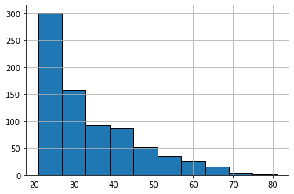

In [10]:

print("Max Age: " + str(df["Age"].max()) + " Min Age: " + str(df["Age"].min()))
Max Age: 81 Min Age: 21

In [11]:

# Histogram and density graphs of all variables were accessed.
fig, ax = plt.subplots(4,2, figsize=(16,16))
sns.distplot(df.Age, bins = 20, ax=ax[0,0])
sns.distplot(df.Pregnancies, bins = 20, ax=ax[0,1])
sns.distplot(df.Glucose, bins = 20, ax=ax[1,0])
sns.distplot(df.BloodPressure, bins = 20, ax=ax[1,1])
sns.distplot(df.SkinThickness, bins = 20, ax=ax[2,0])
sns.distplot(df.Insulin, bins = 20, ax=ax[2,1])
sns.distplot(df.DiabetesPedigreeFunction, bins = 20, ax=ax[3,0])
sns.distplot(df.BMI, bins = 20, ax=ax[3,1])

Out[11]:
<matplotlib.axes._subplots.AxesSubplot at 0x7f77b83d5950>
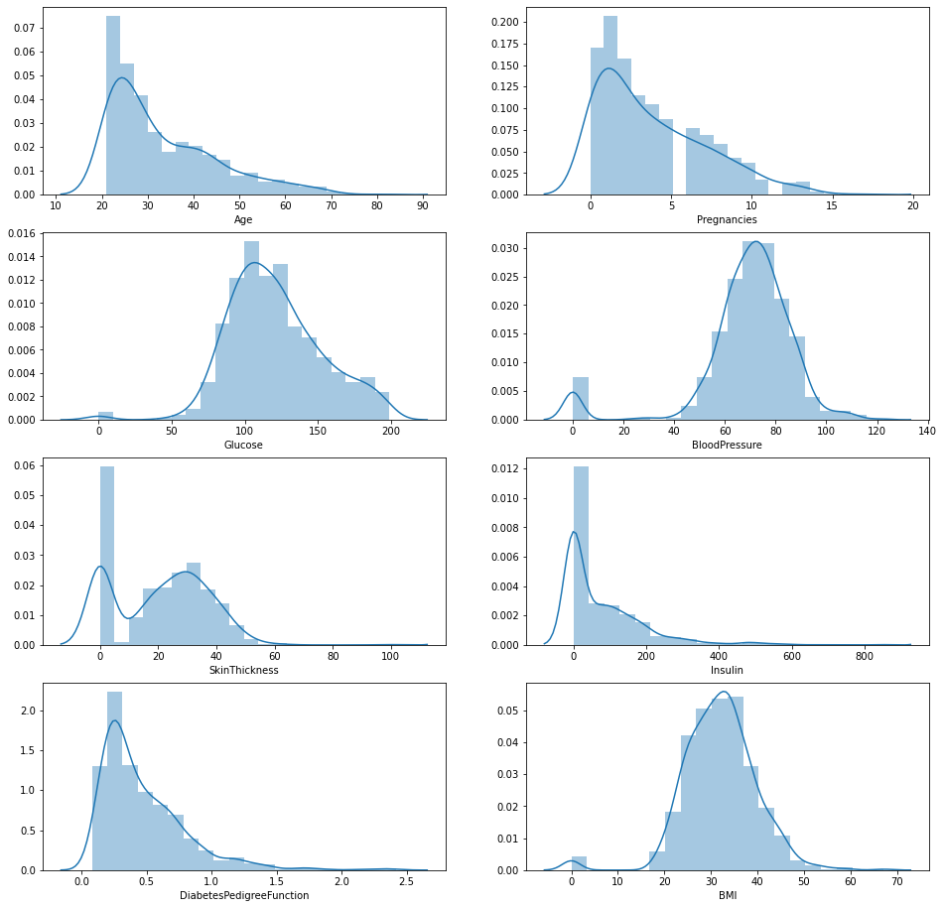

In [12]:
df.groupby("Outcome").agg({"Pregnancies":"mean"})

Out[12]:
 | Pregnancies
Outcome
0 | 3.298000
1 | 4.865672

In [13]:
df.groupby("Outcome").agg({"Age":"mean"})

Out[13]:
 | Age
Outcome
0 | 31.190000
1 | 37.067164
In [14]:
df.groupby("Outcome").agg({"Age":"max"})
Out[14]:
 | Age
Outcome
0 | 81
1 | 70
In [15]:

df.groupby("Outcome").agg({"Insulin": "mean"})
Out[15]:

 | Insulin
Outcome
0 | 68.792000
1 | 100.335821
In [16]:

df.groupby("Outcome").agg({"Insulin": "max"})

Out[16]:
 | Insulin
Outcome
0 | 744
1 | 846
In [17]:

df.groupby("Outcome").agg({"Glucose": "mean"})

Out[17]:
 | Glucose
Outcome
0 | 109.980000
1 | 141.257463
In [18]:

df.groupby("Outcome").agg({"Glucose": "max"})

Out[18]:
 | Glucose
Outcome
0 | 197
1 | 199

In [19]:

df.groupby("Outcome").agg({"BMI": "mean"})

Out[19]:
 | BMI
Outcome
0 | 30.304200
1 | 35.142537
In [20]:

# The distribution of the outcome variable in the data was examined and visualized.

f,ax=plt.subplots(1,2,figsize=(18,8))
df['Outcome'].value_counts().plot.pie(explode=[0,0.1],autopct='%1.1f%%',ax=ax[0],shadow=True)
ax[0].set_title('target')
ax[0].set_ylabel('')
sns.countplot('Outcome',data=df,ax=ax[1])
ax[1].set_title('Outcome')
plt.show()

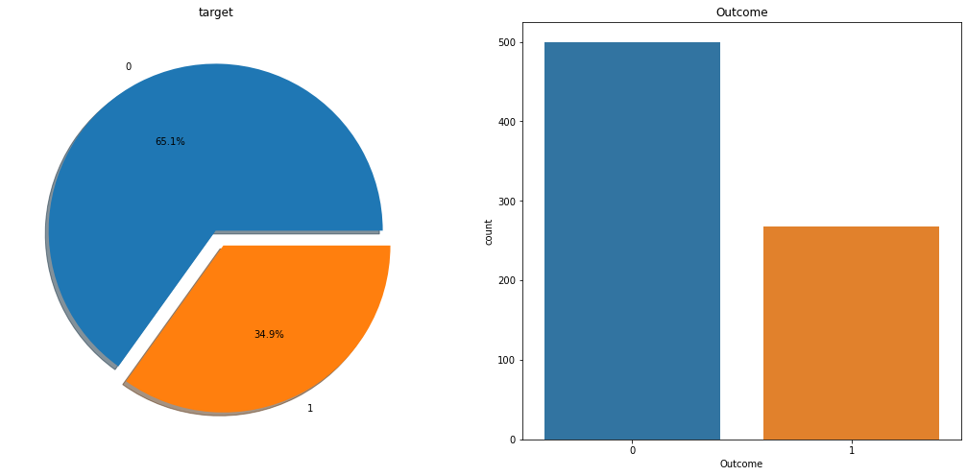

In [21]:

# Access to the correlation of the data set was provided. What kind of relationship is examined between the variables.
# If the correlation value is> 0, there is a positive correlation. While the value of one variable increases, the value of the other variable also increases.
# Correlation = 0 means no correlation.
# If the correlation is <0, there is a negative correlation. While one variable increases, the other variable decreases.
# When the correlations are examined, there are 2 variables that act as a positive correlation to the Salary dependent variable.
# These variables are Glucose. As these increase, Outcome variable increases.
df.corr()

Out[21]:
 | Pregnancies | Glucose | BloodPressure | SkinThickness | Insulin | BMI | DiabetesPedigreeFunction | Age | Outcome
Pregnancies | 1.000000 | 0.129459 | 0.141282 | -0.081672 | -0.073535 | 0.017683 | -0.033523 | 0.544341 | 0.221898
Glucose | 0.129459 | 1.000000 | 0.152590 | 0.057328 | 0.331357 | 0.221071 | 0.137337 | 0.263514 | 0.466581
BloodPressure | 0.141282 | 0.152590 | 1.000000 | 0.207371 | 0.088933 | 0.281805 | 0.041265 | 0.239528 | 0.065068
SkinThickness | -0.081672 | 0.057328 | 0.207371 | 1.000000 | 0.436783 | 0.392573 | 0.183928 | -0.113970 | 0.074752
Insulin | -0.073535 | 0.331357 | 0.088933 | 0.436783 | 1.000000 | 0.197859 | 0.185071 | -0.042163 | 0.130548
BMI | 0.017683 | 0.221071 | 0.281805 | 0.392573 | 0.197859 | 1.000000 | 0.140647 | 0.036242 | 0.292695
DiabetesPedigreeFunction | -0.033523 | 0.137337 | 0.041265 | 0.183928 | 0.185071 | 0.140647 | 1.000000 | 0.033561 | 0.173844
Age | 0.544341 | 0.263514 | 0.239528 | -0.113970 | -0.042163 | 0.036242 | 0.033561 | 1.000000 | 0.238356
Outcome | 0.221898 | 0.466581 | 0.065068 | 0.074752 | 0.130548 | 0.292695 | 0.173844 | 0.238356 | 1.000000
In [22]:

# Correlation matrix graph of the data set
f, ax = plt.subplots(figsize= [20,15])
sns.heatmap(df.corr(), annot=True, fmt=".2f", ax=ax, cmap = "magma" )
ax.set_title("Correlation Matrix", fontsize=20)
plt.show()

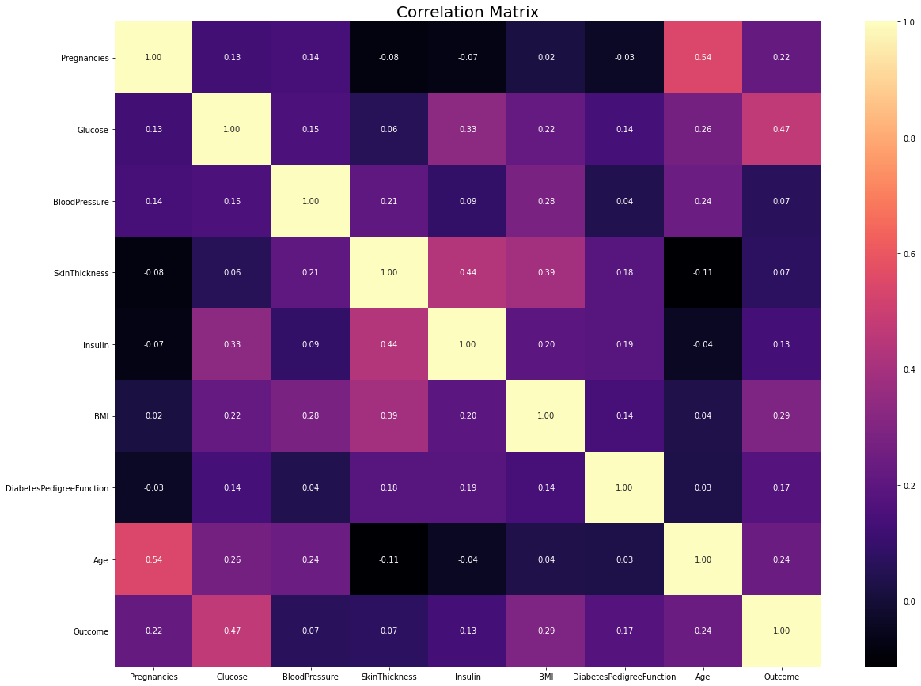

2) Data Preprocessing

2.1) Missing Observation Analysis
We saw on df.head() that some features contain 0, it doesn't make sense here and this indicates missing value Below we replace 0 value by NaN:

In [23]:
df[['Glucose','BloodPressure','SkinThickness','Insulin','BMI']] = df[['Glucose','BloodPressure','SkinThickness','Insulin','BMI']].replace(0,np.NaN)
In [24]:
df.head()
Out[24]:
 | Pregnancies | Glucose | BloodPressure | SkinThickness | Insulin | BMI | DiabetesPedigreeFunction | Age | Outcome
0 | 6 | 148.0 | 72.0 | 35.0 | NaN | 33.6 | 0.627 | 50 | 1
1 | 1 | 85.0 | 66.0 | 29.0 | NaN | 26.6 | 0.351 | 31 | 0
2 | 8 | 183.0 | 64.0 | NaN | NaN | 23.3 | 0.672 | 32 | 1
3 | 1 | 89.0 | 66.0 | 23.0 | 94.0 | 28.1 | 0.167 | 21 | 0
4 | 0 | 137.0 | 40.0 | 35.0 | 168.0 | 43.1 | 2.288 | 33 | 1
In [25]:

# Now, we can look at where are missing values
df.isnull().sum()

Out[25]:

Pregnancies 0
Glucose 5
BloodPressure 35
SkinThickness 227
Insulin 374
BMI 11
DiabetesPedigreeFunction 0
Age 0
Outcome 0
dtype: int64

In [26]:

# Have been visualized using the missingno library for the visualization of missing observations.
# Plotting
import missingno as msno
msno.bar(df);

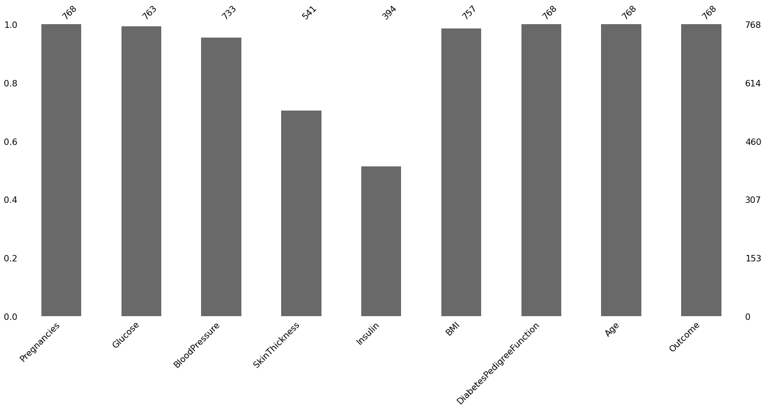
In [27]:

# The missing values ​​will be filled with the median values ​​of each variable.
def median_target(var):
temp = df[df[var].notnull()]
temp = temp[[var, 'Outcome']].groupby(['Outcome'])[[var]].median().reset_index()
return temp

In [28]:
# The values to be given for incomplete observations are given the median value of people who are not sick and the median values of people who are sick.
columns = df.columns
columns = columns.drop("Outcome")
for i in columns:
median_target(i)
df.loc[(df['Outcome'] == 0 ) & (df[i].isnull()), i] = median_target(i)[i][0]
df.loc[(df['Outcome'] == 1 ) & (df[i].isnull()), i] = median_target(i)[i][1]

In [29]:
df.head()

Out[29]:
 | Pregnancies | Glucose | BloodPressure | SkinThickness |  | Insulin | BMI | DiabetesPedigreeFunction | Age | Outcome
0 | 6 | 148.0 | 72.0 | 35.0 |  | 169.5 | 33.6 | 0.627 | 50 | 1
1 | 1 | 85.0 | 66.0 | 29.0 |  | 102.5 | 26.6 | 0.351 | 31 | 0
2 | 8 | 183.0 | 64.0 | 32.0 |  | 169.5 | 23.3 | 0.672 | 32 | 1
3 | 1 | 89.0 | 66.0 | 23.0 |  | 94.0 | 28.1 | 0.167 | 21 | 0
4 | 0 | 137.0 | 40.0 | 35.0 |  | 168.0 | 43.1 | 2.288 | 33 | 1

In [30]:

# Missing values were filled.
df.isnull().sum()

Out[30]:

Pregnancies 0
Glucose 0
BloodPressure 0
SkinThickness 0
Insulin 0
BMI 0
DiabetesPedigreeFunction 0
Age 0
Outcome 0
dtype: int64

2.2) Outlier Observation Analysis
In [31]:

# In the data set, there were asked whether there were any outlier observations compared to the 25% and 75% quarters.
# It was found to be an outlier observation.
for feature in df:

Q1 = df[feature].quantile(0.25)
Q3 = df[feature].quantile(0.75)
IQR = Q3-Q1
lower = Q1- 1.5*IQR
upper = Q3 + 1.5*IQR

if df[(df[feature] > upper)].any(axis=None):
print(feature,"yes")
else:
print(feature, "no")
Pregnancies yes
Glucose no
BloodPressure yes
SkinThickness yes
Insulin yes
BMI yes
DiabetesPedigreeFunction yes
Age yes
Outcome no

In [32]:

# The process of visualizing the Insulin variable with boxplot method was done. We find the outlier observations on the chart.
import seaborn as sns
sns.boxplot(x = df["Insulin"]);
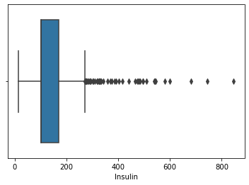

In [33]:

#We conduct a stand alone observation review for the Insulin variable
#We suppress contradictory values
Q1 = df.Insulin.quantile(0.25)
Q3 = df.Insulin.quantile(0.75)
IQR = Q3-Q1
lower = Q1 - 1.5*IQR
upper = Q3 + 1.5*IQR
df.loc[df["Insulin"] > upper,"Insulin"] = upper

In [34]:
import seaborn as sns
sns.boxplot(x = df["Insulin"]);
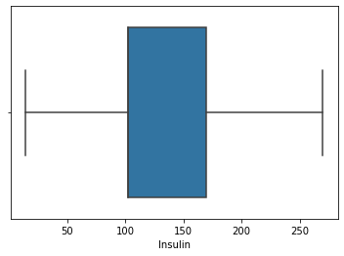

2.3) Local Outlier Factor (LOF)
In [35]:

# We determine outliers between all variables with the LOF method
from sklearn.neighbors import LocalOutlierFactor
lof =LocalOutlierFactor(n_neighbors= 10)
lof.fit_predict(df)
Out[35]:

array([ 1, 1, 1, 1, 1, 1, 1, 1, 1, 1, 1, 1, 1, 1, 1, 1, 1,
1, -1, 1, 1, 1, 1, 1, 1, 1, 1, 1, 1, 1, 1, 1, 1, 1,
1, 1, 1, 1, 1, 1, 1, 1, 1, 1, 1, 1, 1, 1, 1, 1, 1,
1, 1, 1, 1, 1, 1, -1, 1, 1, 1, 1, -1, 1, 1, 1, 1, 1,
1, 1, 1, 1, 1, 1, 1, 1, 1, 1, 1, 1, 1, 1, 1, 1, 1,
1, 1, 1, 1, 1, 1, 1, 1, 1, 1, 1, 1, 1, 1, 1, 1, 1,
1, 1, 1, 1, -1, 1, 1, 1, 1, 1, 1, 1, 1, 1, 1, 1, 1,
1, -1, 1, 1, 1, 1, -1, 1, 1, 1, 1, 1, 1, 1, 1, 1, 1,
1, 1, 1, 1, 1, 1, 1, 1, 1, 1, 1, 1, 1, 1, 1, 1, 1,
1, 1, 1, 1, 1, 1, 1, 1, 1, 1, 1, 1, 1, 1, 1, 1, 1,
1, 1, 1, 1, 1, 1, 1, -1, 1, 1, 1, 1, 1, 1, 1, 1, 1,
1, 1, 1, 1, 1, 1, 1, 1, 1, 1, 1, 1, 1, 1, 1, 1, 1,
1, 1, 1, 1, 1, 1, 1, 1, 1, 1, 1, 1, 1, 1, 1, 1, 1,
1, 1, -1, 1, 1, 1, 1, 1, 1, 1, 1, 1, 1, 1, 1, 1, 1,
1, 1, 1, 1, 1, 1, 1, 1, 1, 1, 1, 1, -1, 1, 1, 1, 1,
1, 1, 1, 1, 1, 1, 1, 1, 1, 1, 1, 1, 1, 1, 1, 1, 1,
1, 1, 1, 1, 1, 1, 1, 1, 1, 1, 1, 1, 1, 1, 1, 1, 1,
1, 1, 1, 1, 1, 1, 1, 1, 1, 1, 1, 1, 1, 1, 1, 1, 1,
1, 1, 1, 1, 1, 1, 1, 1, 1, 1, 1, 1, 1, 1, 1, 1, 1,
-1, 1, 1, 1, 1, 1, 1, 1, 1, 1, 1, 1, 1, 1, 1, 1, 1,
1, 1, 1, 1, 1, 1, -1, 1, 1, 1, 1, 1, 1, 1, 1, 1, 1,
1, 1, 1, 1, 1, -1, 1, 1, 1, 1, 1, 1, 1, 1, 1, 1, 1,
1, 1, 1, 1, 1, 1, 1, 1, 1, 1, 1, 1, 1, 1, 1, 1, 1,
1, 1, -1, 1, 1, -1, 1, 1, 1, 1, 1, 1, 1, 1, 1, 1, 1,
1, 1, 1, 1, 1, 1, 1, 1, 1, 1, 1, 1, 1, 1, 1, 1, 1,
1, 1, 1, 1, 1, 1, 1, 1, 1, 1, 1, 1, 1, 1, 1, 1, 1,
1, 1, 1, -1, 1, 1, 1, 1, 1, 1, 1, 1, 1, 1, 1, 1, 1,
-1, -1, 1, 1, 1, 1, 1, 1, 1, 1, 1, 1, 1, 1, 1, 1, 1,
1, 1, 1, 1, 1, 1, 1, -1, 1, 1, 1, 1, 1, 1, 1, 1, 1,
1, 1, 1, 1, 1, 1, 1, 1, 1, 1, 1, 1, 1, 1, 1, 1, 1,
1, 1, 1, 1, 1, 1, 1, 1, 1, 1, 1, 1, 1, 1, 1, 1, 1,
1, 1, 1, 1, 1, 1, 1, 1, 1, 1, -1, 1, 1, 1, 1, 1, 1,
1, 1, 1, 1, -1, 1, 1, 1, 1, 1, 1, 1, 1, 1, 1, 1, 1,
1, 1, 1, 1, 1, 1, -1, 1, 1, 1, 1, 1, 1, 1, 1, 1, 1,
1, -1, 1, 1, 1, 1, 1, 1, 1, 1, 1, 1, 1, 1, 1, 1, 1,
1, 1, -1, 1, 1, 1, 1, 1, 1, 1, 1, 1, 1, 1, 1, 1, 1,
1, 1, 1, 1, 1, 1, 1, 1, 1, 1, 1, 1, 1, 1, 1, 1, 1,
1, 1, 1, 1, 1, 1, 1, 1, 1, 1, 1, 1, 1, 1, 1, 1, 1,
1, 1, 1, 1, 1, 1, 1, 1, 1, 1, 1, 1, 1, 1, 1, 1, 1,
1, 1, 1, 1, 1, -1, 1, 1, 1, -1, 1, 1, 1, 1, 1, 1, 1,
1, 1, 1, 1, 1, 1, 1, 1, 1, 1, 1, 1, 1, 1, 1, 1, 1,
1, 1, 1, 1, 1, 1, 1, 1, 1, 1, 1, 1, 1, 1, -1, 1, 1,
1, 1, 1, 1, 1, 1, 1, 1, 1, 1, 1, 1, 1, 1, 1, 1, 1,
1, 1, 1, 1, 1, 1, 1, 1, 1, 1, 1, 1, 1, 1, 1, 1, 1,
1, 1, 1, 1, 1, 1, 1, 1, 1, 1, 1, 1, 1, 1, 1, 1, 1,
1, 1, 1])

In [36]:

df_scores = lof.negative_outlier_factor_
np.sort(df_scores)[0:30]

Out[36]:
array([-3.05893469, -2.37289269, -2.15297995, -2.09708735, -2.0772561 ,
-1.95255968, -1.86384019, -1.74003158, -1.72703492, -1.71674689,
-1.70343883, -1.6688722 , -1.64296768, -1.64190437, -1.61620872,
-1.61369917, -1.60057603, -1.5988774 , -1.59608032, -1.57027568,
-1.55876022, -1.55674614, -1.51852389, -1.50843907, -1.50280943,
-1.50160698, -1.48391514, -1.4752983 , -1.4713427 , -1.47006248])

In [37]:
#We choose the threshold value according to lof scores
threshold = np.sort(df_scores)[7]
threshold

Out[37]:
-1.740031580305444

In [38]:
#We delete those that are higher than the threshold
outlier = df_scores > threshold
df = df[outlier]

In [39]:
# The size of the data set was examined.
df.shape

Out[39]:
(760, 9)

CONCLUSION

The AI-based diabetes prediction system is a proactive solution to the problem of late diabetes diagnosis. By applying a design thinking approach, we have developed a system that leverages advanced AI techniques to predict diabetes risk early, enabling timely interventions and personalized healthcare. This system has the potential to improve the lives of individuals at risk of diabetes and enhance the efficiency of healthcare delivery. Early diagnosis is the key to better managing diabetes and reducing its long-term complications, and our AI system is a step forward in achieving this goal.

