**MAIN STORY LINE**

**Name of the Game:** El Juan’s Takedown

***INTRODUCTION:***

[UNKNOWN NAME], a SWAT team has breached through the main entrance of the **El Juan Enterprise.**

The El Juan Enterprise is the biggest Cocaine Dealing Service in Mexico. They have made upwards of $500 million dollar in sales by selling their good to the neighbouring nation, USA. Their Enterprise and main HQ is the centre of this cocaine production.

You, as a member of [UNKNOWN NAME] must infiltrate El Juan Enterprise’s stronghold. You are our last resort.

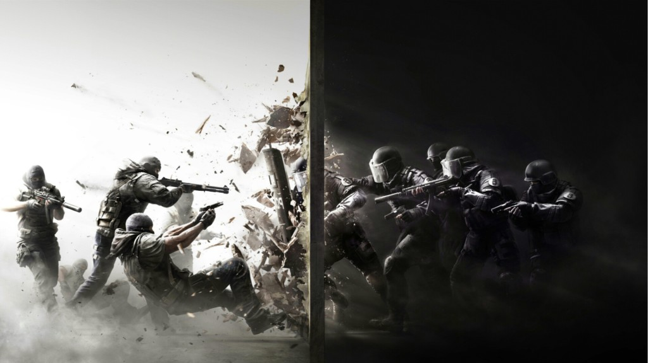

*(Rainbow 6 - LOL) : Similar concept I guess*