Submitted by:
N. Ajay Hemanth
23054-CPS-019
Department of Cyber Physical Systems and Security
Government Institute of Electronics, Secunderabad

SENTINEL SHIELD
  - Pre-Network Data Leak Protection System

SENTINEL SHIELD: PRE-NETWORK DATA LEAK PROTECTION SYSTEM

Abstract
SentinelShield is a comprehensive, system-wide Data Leak Prevention (DLP) solution engineered to detect, analyze, and prevent sensitive data exposure at the earliest possible stage—before it exits the host environment. Unlike conventional security systems that operate primarily at network perimeters, SentinelShield adopts a deep, multi-layered interception strategy, embedding itself within critical data flow points across the operating system.
The platform is powered by a high-performance detection engine designed for real-time analysis with minimal latency overhead. This engine employs a hybrid detection methodology combining:
- Entropy-based analysis to identify high-randomness data patterns typical of encrypted content, API keys, tokens, and confidential identifiers.
- Rule-based pattern matching, leveraging customizable signatures for detecting structured sensitive data such as credentials, financial information, personally identifiable information (PII), and proprietary code fragments.
- Context-aware filtering, enabling the system to differentiate between benign and risky data usage based on application context, destination, and behavioral patterns.
SentinelShield’s interception-first design ensures that data is evaluated prior to transmission, rather than reacting post-exposure. When sensitive content is detected, the system can enforce dynamic policies such as blocking, redacting, alerting, or logging the event for further analysis. This proactive model significantly reduces the risk of both accidental leaks and deliberate exfiltration attempts.
The architecture is built with a strong emphasis on modularity and extensibility, allowing individual components—such as detection modules, interception layers, and policy engines—to operate independently or be enhanced without impacting the overall system. This modular design supports rapid integration of new detection techniques and adaptability to evolving threat landscapes.
In modern computing environments—where data flows continuously across browsers, applications, APIs, and cloud services—SentinelShield provides a unified and intelligent defense layer. By combining deep system integration, advanced detection techniques, and real-time policy enforcement, it transforms endpoint security from a passive monitoring tool into an active guardian of sensitive information.

Introduction
In the modern digital landscape, data flows continuously across a complex web of applications, cloud infrastructures, and external communication platforms. Everyday user activities—such as copying text, uploading files, interacting with APIs, or using AI-powered tools—generate a constant stream of outbound data. With the rapid adoption of intelligent assistants, messaging platforms, and collaborative environments, users frequently and often unknowingly transmit sensitive information beyond the boundaries of their local systems.
This shift has significantly increased the attack surface for data exposure. Sensitive elements such as API keys, authentication tokens, credentials, proprietary code, and personally identifiable information (PII) are no longer confined to secure environments. Instead, they move dynamically across browsers, third-party integrations, and cloud-based services. In many cases, these transmissions occur through encrypted channels, making traditional inspection mechanisms less effective. As a result, even well-intentioned users can inadvertently leak critical information simply through routine workflows.
Traditional security solutions have largely focused on perimeter-based defense models, such as firewalls, intrusion detection systems, and network-level monitoring tools. While these systems are effective at identifying external threats and unauthorized access attempts, they struggle to provide visibility into encrypted outbound traffic or data that originates within trusted environments. The widespread use of HTTPS, end-to-end encryption, and decentralized application architectures further complicates the ability to inspect data at the network boundary without introducing performance bottlenecks or privacy concerns.
Moreover, modern application ecosystems are highly fragmented. A single user action may involve multiple layers—local applications, browser extensions, APIs, and remote servers—all interacting simultaneously. This complexity creates critical blind spots where sensitive data can bypass traditional controls. For example, a user copying a secret key into an AI chatbot or uploading a configuration file to a cloud service may unintentionally expose confidential information without triggering any network-level alerts.
These challenges highlight a fundamental gap in conventional security strategies: the lack of control at the data origin point. Once data leaves the system, it becomes significantly harder to track, control, or revoke. Therefore, the need for a more proactive and internally integrated security approach becomes essential.

Objectives
The main objective of SentinelShield is to provide real-time prevention of sensitive data leakage across all applications running on a system.
Specific objectives include:
- Monitoring all outgoing data channels including network requests and clipboard usage.
- Detecting sensitive information using efficient and reliable algorithms.
- Preventing transmission of high-risk data through automated blocking mechanisms.
- Maintaining minimal performance overhead to ensure smooth user experience.
- Providing clear visibility into detected events through logging and monitoring interfaces.

System Overview
SentinelShield operates as an integrated system composed of multiple interacting components. Each component is responsible for monitoring a specific data flow within the system.
The network interceptor captures outgoing traffic using a system proxy. The clipboard guard monitors copied data and prevents unsafe pasting. The detection engine analyzes data using entropy calculations and rule-based techniques. The dashboard provides visibility into system activity.
These components work together to provide continuous and comprehensive protection across all applications.

Methodology
The working of SentinelShield follows a structured pipeline.
First, data is intercepted before leaving the system. This includes network requests and clipboard content. The intercepted data is then passed to the detection engine.
The detection engine evaluates the data using entropy calculations and pattern matching. Based on the analysis, the system determines whether the data is sensitive.
If sensitive data is detected, the system blocks the transmission or clears the clipboard. If no risk is identified, the data is allowed to proceed.
All events are logged for monitoring and analysis, ensuring transparency and traceability.

Implementation Details
The implementation of SentinelShield involves integration of system-level monitoring techniques with efficient processing mechanisms.
The proxy system redirects all network traffic through a local inspection point. Clipboard monitoring is implemented using system APIs that detect changes and user actions. The detection engine processes data efficiently to avoid delays.
Synchronization between components ensures that decisions are made in real-time without interrupting normal system operations.

Algorithms and Techniques
SentinelShield uses entropy-based detection to identify high randomness strings that typically represent secrets such as API keys and tokens. This method allows detection of unknown patterns that do not match predefined rules.
In addition, rule-based pattern matching is used to identify known formats of sensitive data. Combining both techniques improves detection accuracy and reduces false negatives.

Features and Functionalities

1. Multi-Layered Comprehensive Coverage
SentinelShield implements a defense-in-depth approach by monitoring multiple data channels simultaneously. It intercepts data at the browser level before it reaches the network stack, while a system-wide proxy ensures that non-browser applications are also covered. Additionally, the Clipboard Guardian monitors data movement within the system, preventing sensitive information from being transferred to insecure environments. This layered design ensures complete system-wide protection.

2. Pre-Network “Source-Side” Intervention
Unlike traditional DLP systems that operate at the network boundary, SentinelShield analyzes data at the source before transmission. By hooking into application-level actions such as sending or pasting data, it ensures that sensitive content is validated before leaving the system. The system also provides immediate user feedback, helping users understand and avoid risky behavior.

3. High-Performance Native Analysis
SentinelShield uses a hybrid architecture optimized for performance. Intensive computations such as pattern matching and entropy analysis are handled efficiently, enabling real-time detection with minimal latency. This ensures that the system maintains smooth operation without affecting user experience.

4. Context-Aware Policy Enforcement
The system applies intelligent, context-based decisions instead of rigid rules. It distinguishes between safe and risky scenarios based on application context and usage patterns. This allows normal workflows to continue without interruption while still enforcing strict security where required.

5. Advanced Secret Detection
SentinelShield combines entropy-based analysis with rule-based pattern matching to detect both known and unknown sensitive data. This hybrid approach enables accurate identification of secrets such as API keys, tokens, and credentials, even when they do not match predefined formats.

6. Privacy-First Logging
The system ensures data privacy by redacting sensitive information before logging. Only essential metadata and masked previews are stored, preventing exposure of actual secrets even if logs are accessed.

7. Modular and Extensible Design
SentinelShield follows a modular architecture where components operate independently. This allows easy updates, scalability, and integration with external security tools, making the system adaptable to evolving requirements.

Advantages

1. Multi-Channel Comprehensive Coverage
SentinelShield provides a defense-in-depth approach by monitoring multiple data channels simultaneously. Through browser-level interception, a system-wide proxy, and a clipboard guard, it ensures there are no blind spots. This allows protection of both web traffic and background application data, keeping sensitive information secure regardless of how it is transmitted.

2. Proactive Pre-Transmission Protection
Unlike traditional reactive systems, SentinelShield intercepts data at the source before transmission. By hooking into application events and network requests, it validates data in its raw form. This prevents sensitive information from leaving the system, significantly reducing the risk of data leaks.

3. High Performance with Minimal Latency
SentinelShield uses efficient algorithms to maintain fast performance. Intensive operations such as pattern matching and entropy analysis are optimized, enabling real-time detection without noticeable delay. This ensures strong security without affecting user experience.

4. Context-Aware Intelligent Filtering
The system applies context-aware logic to distinguish between safe and risky actions. It allows legitimate operations while blocking suspicious ones, reducing false positives and ensuring smooth workflow without unnecessary interruptions.

5. Privacy-First Data Handling
SentinelShield follows a privacy-focused approach by redacting sensitive data before logging. Only essential metadata and masked information are stored, ensuring that logs do not expose actual secrets while still providing useful insights.

Limitations
Certain applications using advanced security mechanisms such as certificate pinning cannot be fully inspected. The system is also dependent on specific operating system features, which may limit portability.
Despite these limitations, SentinelShield provides strong protection for the majority of common use cases.

Execution Flow
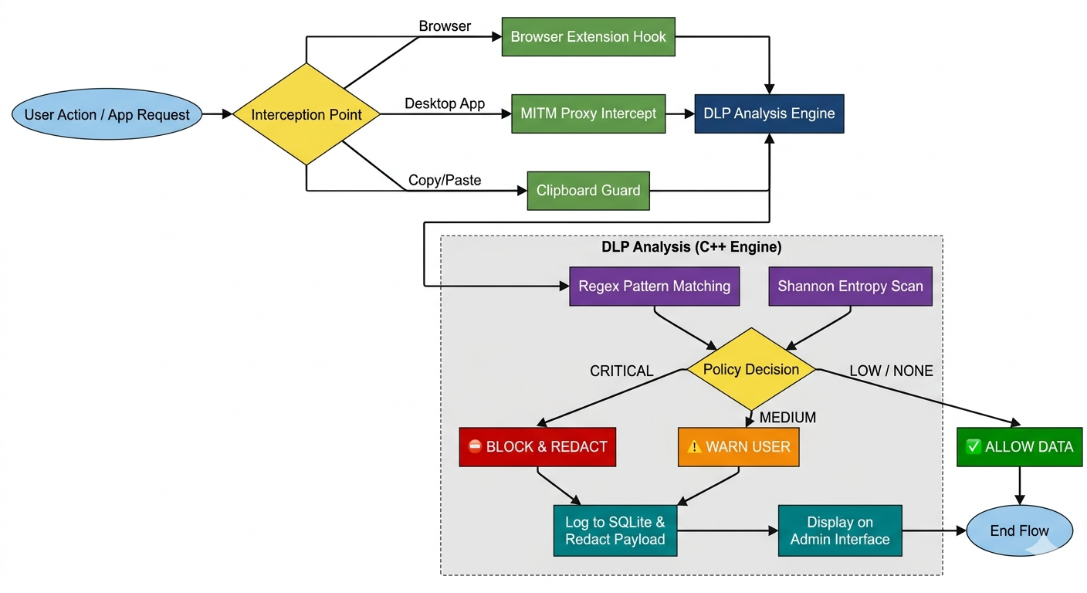

1. System Initialization and Activation
The execution begins with system initialization, where all monitoring and interception components are activated. The main service configures the system-wide proxy to route traffic through a local interception layer and installs the required certificate for secure HTTPS inspection. At the same time, clipboard monitoring and browser-level interception are enabled, creating a complete system-wide protection environment before any user activity begins.

2. Real-Time Data Interception and Analysis
As data flows through the system—via network requests, application calls, or clipboard actions—it is continuously monitored and analyzed. Each outgoing payload is processed by the detection engine, where pattern matching and entropy analysis are applied to identify sensitive information.
If a payload is classified as high-risk, the system immediately blocks or modifies it before transmission. This real-time decision-making ensures that sensitive data is stopped at the source, preventing exposure to external services.

3. Logging and Monitoring
After enforcement, the system securely logs each event. Sensitive data is redacted before storage to maintain privacy. The logs are stored locally and can be accessed through a monitoring dashboard, which provides real-time insights, severity levels, and event history.
This centralized monitoring enables administrators to track system activity, identify risky patterns, and update security rules when required.

Conclusion
SentinelShield represents an effective approach to modern data leak prevention. By focusing on pre-network interception and real-time analysis, it addresses critical gaps in traditional security systems.
The system demonstrates how combining multiple monitoring techniques can provide robust protection while maintaining performance and usability.

