STUDENT PERFORMANCE ANALYSIS
A Data Analysis Project Report
Submitted by
Ajay Koleti
B.Tech CSE (Data Science) — 3rd Year, Semester 3.1
Sree Vahini Institute of Science and Technology
July 2026

1. Introduction
This project performs an Exploratory Data Analysis (EDA) on a student performance dataset containing 1000 student records. The dataset includes demographic and background information such as gender, race/ethnicity, parental level of education, lunch type, and test preparation course status, along with scores obtained in Math, Reading, and Writing. The goal is to identify patterns and factors that influence student academic performance, and to build a simple predictive model.

2. Objectives
- To explore and clean the student performance dataset.
- To visualize relationships between student background factors and exam scores.
- To identify key factors influencing performance (gender, parental education, test preparation, lunch type).
- To build a basic Logistic Regression model to predict Pass/Fail outcomes.

3. Tools & Technologies Used
- Google Colab (Python 3 environment)
- Pandas, NumPy — data handling
- Matplotlib, Seaborn — data visualization
- Scikit-learn — machine learning (Logistic Regression)

4. Dataset Description
Total Records: 1000 | Total Columns: 8
- gender — Male / Female
- race/ethnicity — Group A to Group E
- parental level of education — highest education level of parent
- lunch — standard or free/reduced
- test preparation course — none or completed
- math score, reading score, writing score — exam scores out of 100
No missing values or duplicate records were found in the dataset.

5. Data Loading and Cleaning
import pandas as pd
import numpy as np
import matplotlib.pyplot as plt
import seaborn as sns
df = pd.read_csv('StudentsPerformance.csv')
df.head()
df.shape
df.info()
df.describe()
df.isnull().sum()
df['average_score'] = (df['math score'] + df['reading score'] + df['writing score']) / 3
The dataset was loaded using Pandas and checked for missing values and data types. A new column, average_score, was created by averaging the three subject scores for each student.

6. Summary Statistics
Metric | Math | Reading | Writing | Average
Mean | 67.94 | 71.77 | 70.69 | 70.13
Std Dev | 15.27 | 14.06 | 15.65 | 9.53
Min | 18 | 27 | 22 | 37.33
Max | 100 | 100 | 100 | 97.67

7. Data Visualization & Analysis

7.1 Score Distribution
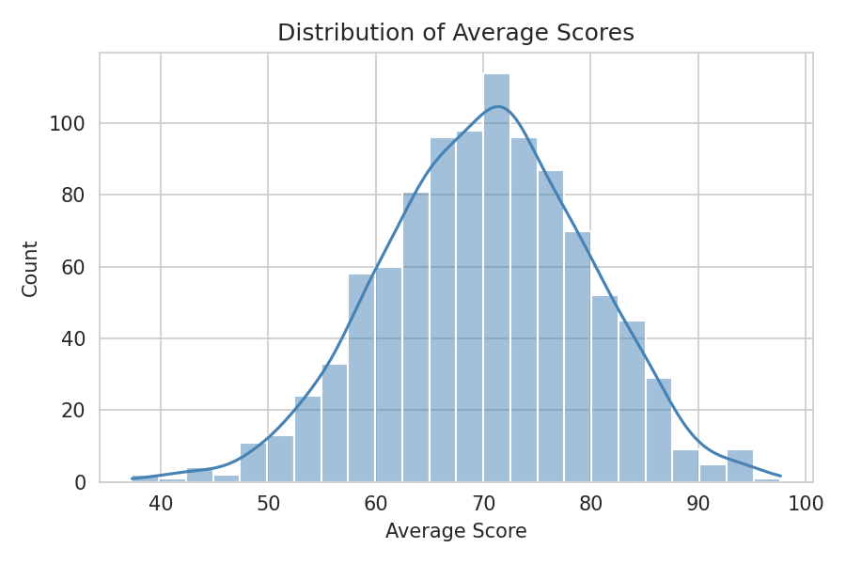
Most students scored between 60 and 82, with the distribution roughly bell-shaped around a mean of about 70.

7.2 Gender vs Average Score
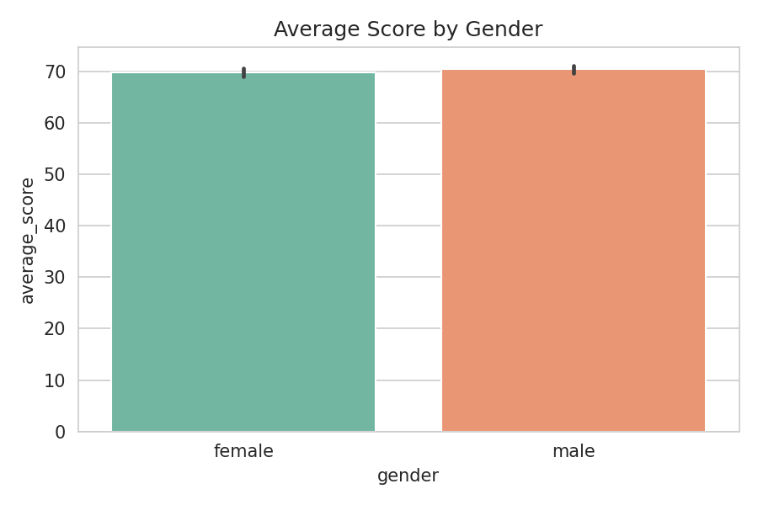
Average scores between male and female students are very close (69.81 vs 70.45), indicating gender has minimal impact on overall performance.

7.3 Test Preparation Course vs Score
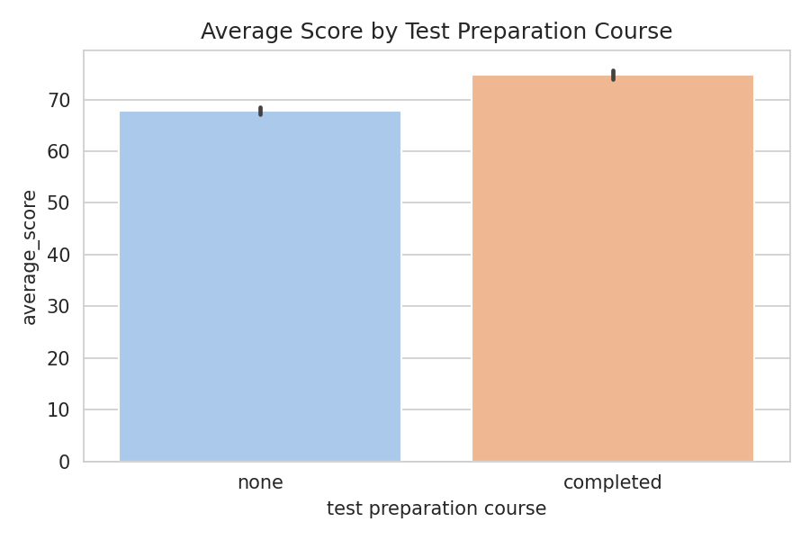
Students who completed the test preparation course scored about 7 points higher on average (74.78) than those who did not (67.83), showing a clear positive effect of preparation.

7.4 Parental Level of Education vs Score
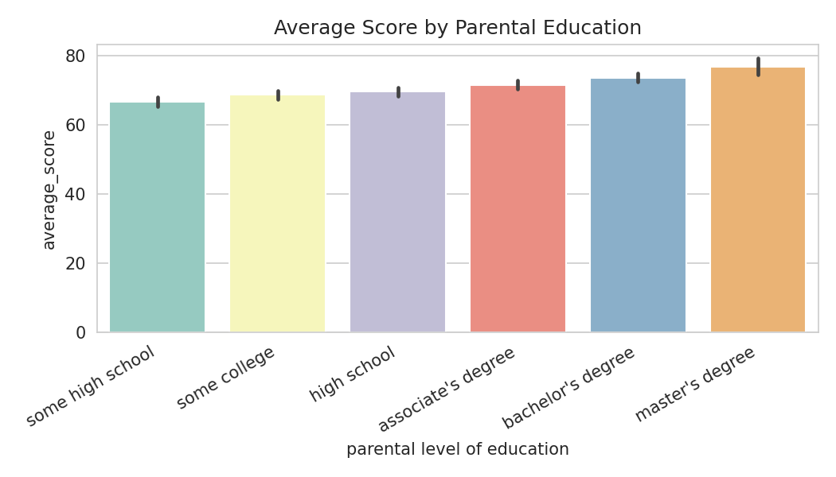
Students whose parents hold a bachelor's or master's degree tend to score higher on average compared to students whose parents completed only some high school.

7.5 Correlation Between Subjects
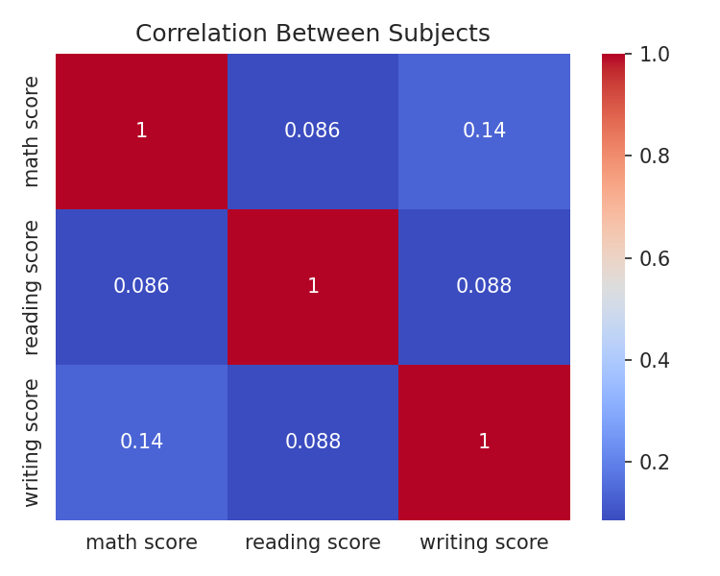
Math, Reading, and Writing scores show a positive correlation, meaning students who perform well in one subject tend to also perform reasonably well in the others.

8. Predictive Model — Pass/Fail Classification
A Logistic Regression model was built to predict whether a student passes (average score ≥ 40) or fails, using test preparation course completion as the input feature.
df['result'] = df['average_score'].apply(lambda x: 'Pass' if x>=40 else 'Fail')
from sklearn.model_selection import train_test_split
from sklearn.preprocessing import LabelEncoder
from sklearn.linear_model import LogisticRegression
le = LabelEncoder()
df['test_prep_encoded'] = le.fit_transform(df['test preparation course'])
X = df[['test_prep_encoded']]
y = df['result']
X_train, X_test, y_train, y_test = train_test_split(X, y, test_size=0.2, random_state=42)
model = LogisticRegression()
model.fit(X_train, y_train)
print('Accuracy:', model.score(X_test, y_test))
Model Accuracy: 0.995 (99.5%)
This high accuracy reflects the fact that most students in the dataset scored above the pass threshold of 40, making the classification task relatively easy.

9. Key Insights
- Test preparation course completion is linked to a noticeable score improvement (~7 points on average).
- Lunch type shows a gap: students with standard lunch average higher scores than those with free/reduced lunch, hinting at a socio-economic effect.
- Higher parental education levels are associated with higher average student scores.
- Gender differences in average score are relatively minor.
- Math, Reading, and Writing scores are positively correlated with one another.

10. Conclusion
The analysis shows that socio-economic and preparation-related factors — such as lunch type, test preparation course completion, and parental education — have a measurable relationship with student academic performance, while gender plays a comparatively smaller role. These insights suggest that promoting test-preparation programs and providing additional support to under-resourced students could help improve overall academic outcomes.

11. Future Scope
- Include more features (e.g., attendance, study hours) for a more robust prediction model.
- Try other ML algorithms such as Decision Trees or Random Forest for comparison.
- Build an interactive dashboard for real-time performance tracking.

