**My Digital Info Service:**

Service contract is built using OpenAPI 3.0 and can be view at editor.swagger.io by uploading the DigitalInfoService.json file and attaching screenshot for reference:

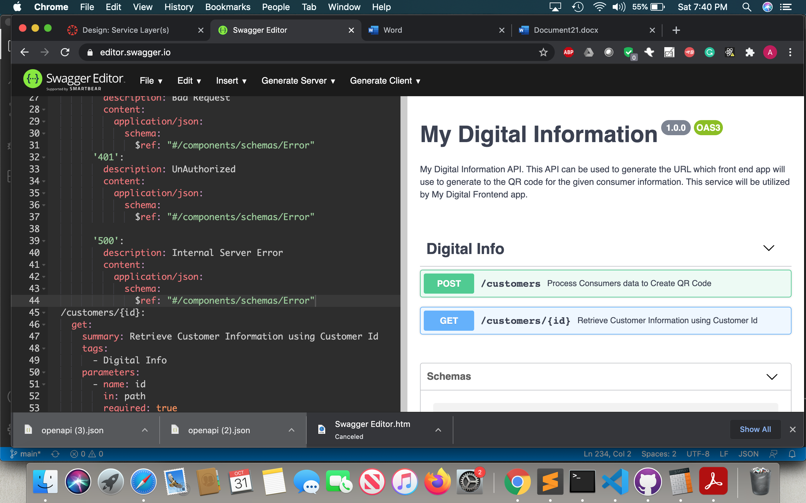

URL to open the swagger: <https://editor.swagger.io/>

DigitalInfoService.json is attached with assignment.

**Service Details**:

* My Digital Info Service Endpoint Details:
* **Endpoint**: /customers
  + **Description**: This endpoint can be used frontend app to add consumer information for example, Ansh marathon runner can provide the details on frontend which will call this endpoint to persist the consumer information and return unique id and qrCode URL to generate the QR Code.
  + **Endpoint**: /customers
  + **Method**: Post
  + **Sample Request**:

{

"name": "XYZ ABC",

"addressLine": "123 Kettering Blvd",

"city": "Dayton",

"state": "OH",

"zipCode": "45420",

"phoneNumber": "1234567890",

"fever": true,

"cough": true,

"travel": true,

"virusExposure": true

}

* + **Sample Response:**

{ "id": "1234567890", "qrCodeURL": "https://xyz.com/customer/1234567890"}

* + Error Responses:

1) HTTP 400 -> Bad Request

{ "code": 400, "message": "Bad Request – Invalid <Field Name>"}

Example:

{"code": 400, "message": "Bad Request – Invalid **Zip Code**"}

Description: This error will be returned if invalid data is sent in the input.

2) HTTP 401 -> UnAuthorized

{"code": 401, "message": "UnAuthorized Access"}

Description: This errror will be returned if non authorized user try to access this service.

3) HTTP 500 -> Internal Server Error

{"code": 500, "message": "Internal Server Error "}

Description: This error will be returned if any exception generated while performing the transaction such as DB is down or timeout issues

* **Endpoint**: /customers/{id}
  + **Description**: This endpoint can be used frontend app to retrieve the consumer information by customer id. This endpoint will be used by Medical Assistant to retrieve the consumer information by scanning the QR Code. QR Code will have imbedded the QR Code and will open the front end with consumer information retrieved from this endpoint response.
  + **Method**: GET
  + **Sampe Request**:

<https://xyz.com/customers/1234567890>

Highlighted is path parameter in request which is customer id

* + **Sample Response:**

**HTTP 200: SUCCESS**

{

"name": "XYZ ABC",

"addressLine": "123 Kettering Blvd",

"city": "Dayton",

"state": "OH"

"zipCode": "45420", "phoneNumber": "1234567890"

"fever": true,

"cough": true, "travel": true, "virusExposure": true}

* + Error Responses:

1) **HTTP 400 -> Bad Request**

{ "code": 400, "message": "Bad Request – Invalid Transaction Id"}

Example:

{"code": 400, "message": "Bad Request – Expired Transaction Id"}

Description: This error will be returned if invalid data is sent in the input.

2) **HTTP 401 -> UnAuthorized**

{"code": 401, "message": "UnAuthorized Access"}

Description: This errror will be returned if non authorized user try to access this service.

3) **HTTP 500 -> Internal Server Error**

{"code": 500, "message": "Internal Server Error "}

Description: This error will be returned if any exception generated while performing the transaction such as DB is down or timeout issues