Shell launch (/bin/bash) by execv
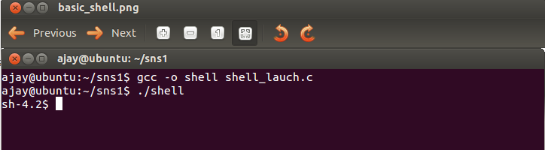
Launching shell by given assembly shellcode
Write about execution issues such as stack guard executable stack...

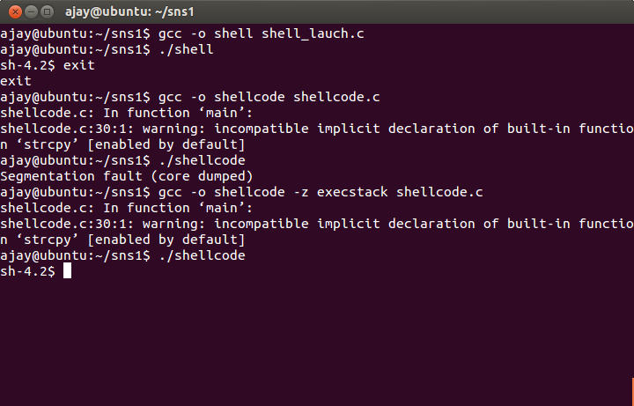

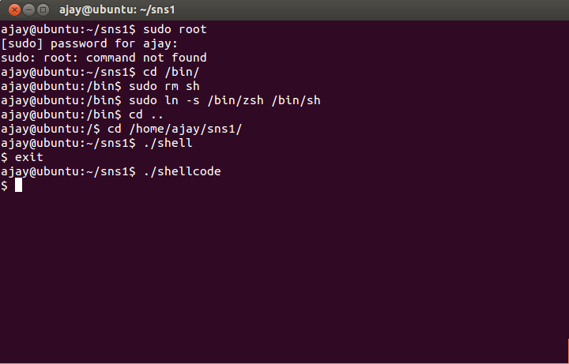
Write about switching shells.....

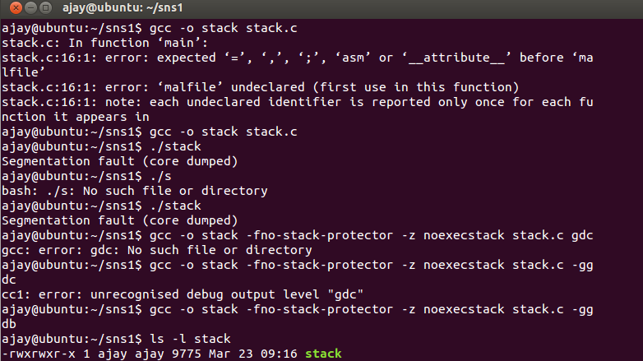
Stack compiling by turning off all the defense......
Then writing exploit by getting buffer address
stack program with debugger,.....
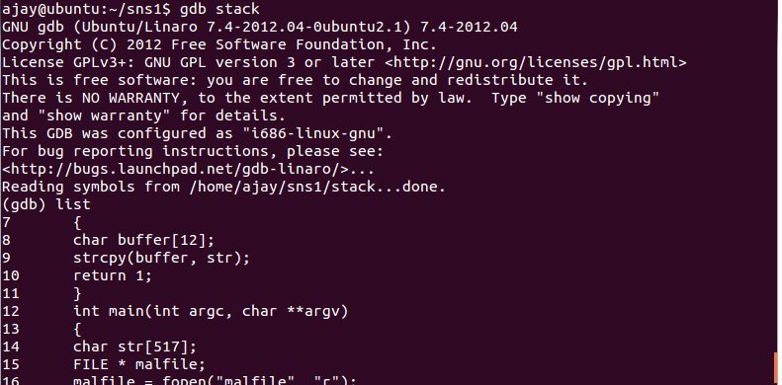

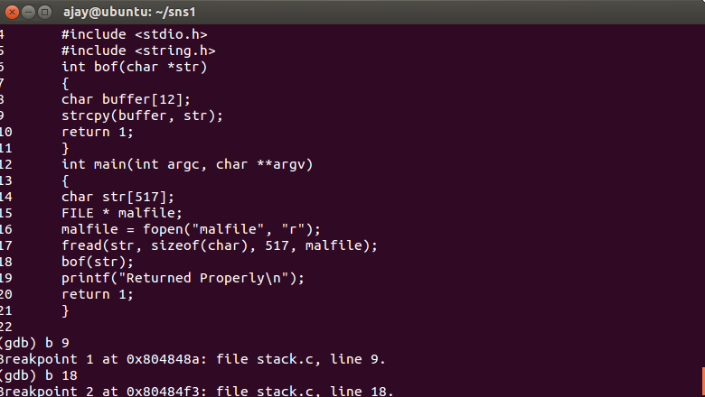

Analysing breakpoints and observations:
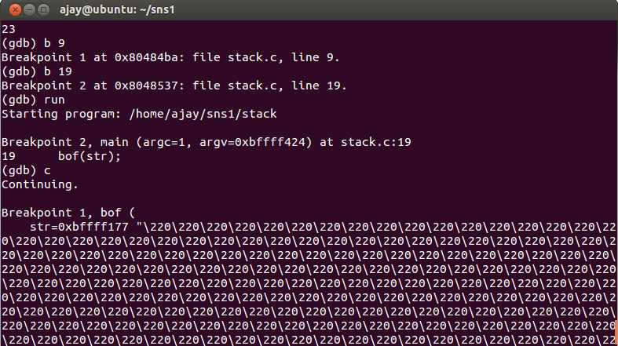

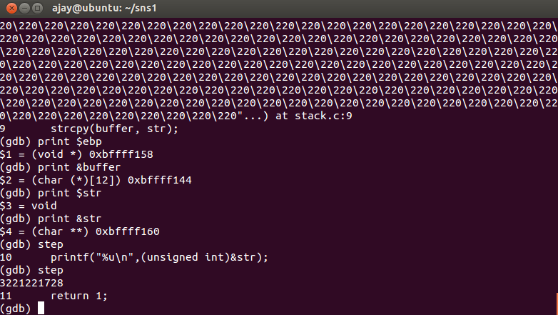

code snipped for buffer writing.
Writing the malfile for shellcode in buffer.

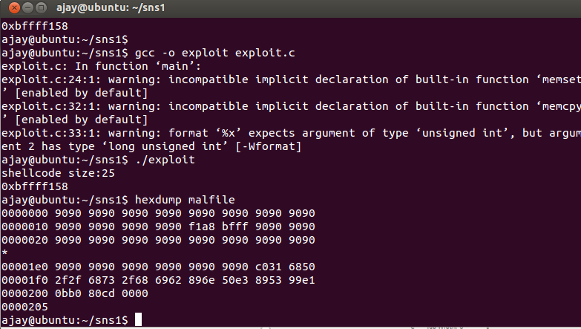

writing exploit by address writing content of buffer by offset calculation.

Finally making the attack..
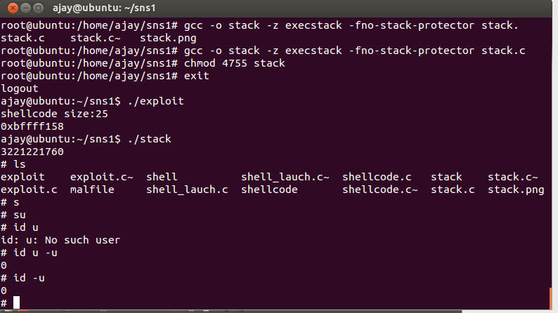

Attack on turning back to /bin/bash

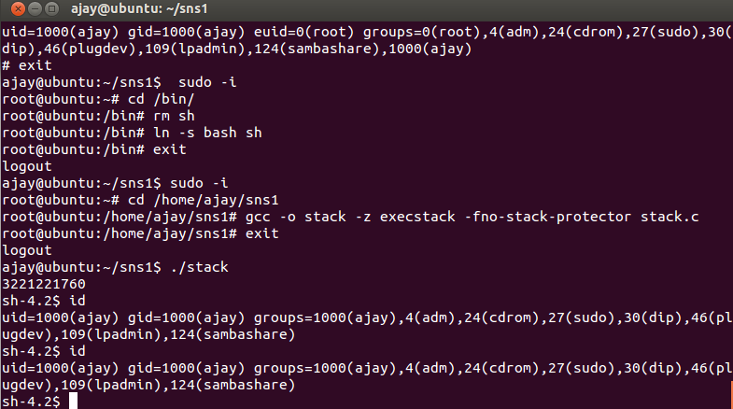

Turning on the defenses and checking the attack.

