Seaborn for Data Analytics
Complete Study Notes with Titanic Dataset Examples
Dataset Used: Titanic (891 passengers)
Features: PassengerId, Survived, Pclass, Sex, Age, SibSp, Parch, Fare, Embarked, Deck
Topics Covered: 8 Sections | 20+ Plot Types | 100+ Code Examples

Section 1: Introduction & Setup
Seaborn is a Python data visualization library built on top of Matplotlib. It provides a high-level interface for creating attractive, informative statistical graphics with minimal code.

1.1 What is Seaborn?
Attribute | Details
Creator | Michael Waskom (2012)
Built on | Matplotlib + NumPy + Pandas
Purpose | Statistical data visualization
Key Feature | Works directly with Pandas DataFrames

1.2 Installation
# Install seaborn
pip install seaborn

# Standard imports for data analytics
import seaborn as sns
import matplotlib.pyplot as plt
import pandas as pd
import numpy as np

1.3 Loading the Titanic Dataset
# Load Titanic dataset (from Kaggle / seaborn built-in)
df = pd.read_csv("titanic.csv")
print(df.shape) # (891, 10)
print(df.columns.tolist())
# [PassengerId, Survived, Pclass, Sex, Age, SibSp, Parch, Fare, Embarked, Deck]

1.4 Figure Styles & Contexts
# Available styles
sns.set_style("whitegrid") # Grid lines on white bg
sns.set_style("darkgrid") # Grid lines on dark bg
sns.set_style("ticks") # Axis ticks only
sns.set_style("white") # Clean white, no grid

# Available contexts (controls font/element sizes)
sns.set_context("paper") # Smallest
sns.set_context("notebook") # Default
sns.set_context("talk") # Presentations
sns.set_context("poster") # Largest
Pro Tip: Always call sns.set_theme() at the top of your notebook to ensure consistent styling across all plots.

1.5 Color Palettes
# Qualitative (categories)
sns.color_palette("tab10") # 10 distinct colors
sns.color_palette("Set2") # Pastel, colorblind-friendly

# Sequential (magnitude)
sns.color_palette("Blues") # Light to dark blue
sns.color_palette("viridis") # Perceptually uniform

# Diverging (pos/neg)
sns.color_palette("coolwarm") # Blue-white-red
sns.color_palette("RdBu") # Red-white-blue

# Apply globally
sns.set_palette("Set2")

Section 2: Distribution Plots
Distribution plots help you understand how values are spread across a dataset — finding the shape, center, spread, and skewness of your data.

2.1 histplot() — Histogram
Histplot divides data into bins and counts observations per bin. Ideal for seeing frequency distributions.
sns.histplot(data=df, x="Age", hue="Survived", bins=25, kde=True)
# hue → color by category
# bins → number of bars
# kde=True → overlay smooth curve
plt.title("Age Distribution by Survival")
plt.show()
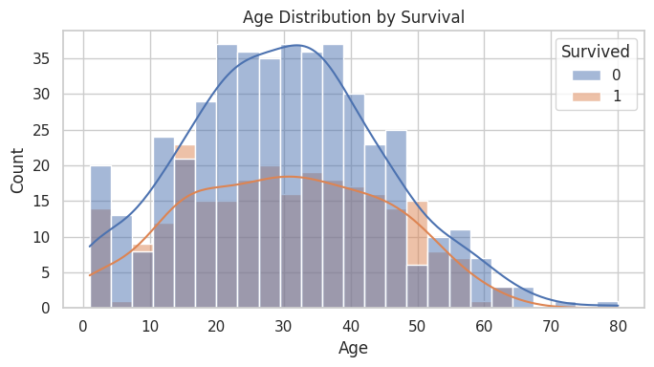

2.2 kdeplot() — Kernel Density Estimate
KDE plots draw a smooth continuous curve representing the probability density of your data. Better than histograms for comparing distributions.
sns.kdeplot(data=df, x="Age", hue="Sex", fill=True)
# fill=True → shaded area under the curve
# bw_adjust → controls smoothness (default=1)
# common_norm=False → each group normalized independently
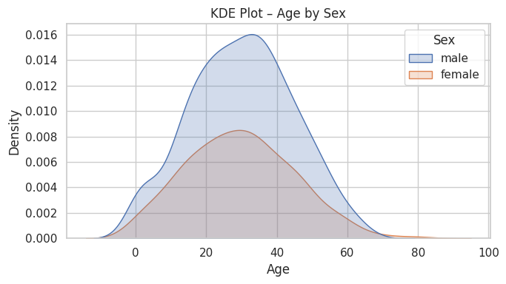

2.3 ecdfplot() — Empirical CDF
The ECDF shows the proportion of data at or below each value. Useful for comparing distributions without assumptions.
sns.ecdfplot(data=df, x="Fare", hue="Pclass")
# y-axis: proportion of values ≤ x
# Stat="proportion" (default) or "count"
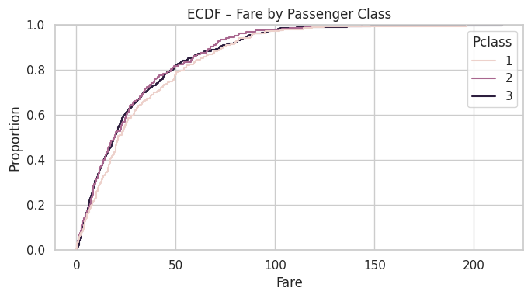

2.4 rugplot() — Rug Plot
Places a small tick mark for each data point along the axis. Usually combined with KDE or histogram.
sns.kdeplot(data=df, x="Fare")
sns.rugplot(data=df, x="Fare", height=0.05, color="coral")
# height → tick height as fraction of axis
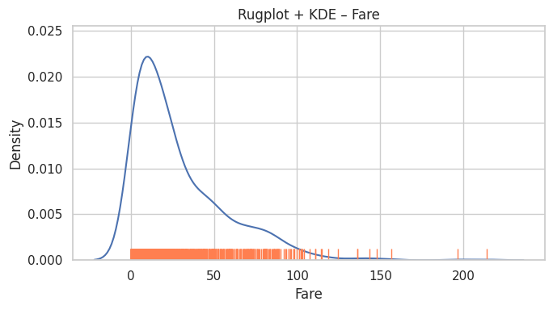

2.5 displot() — Unified Distribution API
displot() is the figure-level function that combines histplot, kdeplot, and ecdfplot into one interface, and supports faceting.
# Histogram with KDE
sns.displot(data=df, x="Age", hue="Survived", kind="hist", kde=True)

# KDE only
sns.displot(data=df, x="Age", kind="kde", fill=True)

# With column faceting
sns.displot(data=df, x="Fare", col="Pclass", kind="hist", bins=20)
Key Difference: histplot/kdeplot are axes-level (draw on existing axes). displot() is figure-level (creates its own figure). Use displot for faceting, axes-level for subplots.

Section 3: Categorical Plots
Categorical plots display the distribution or relationship of a numeric variable across different categories.

3.1 barplot() — Bar Plot
Shows the mean (or other estimator) of a numeric variable for each category, with a confidence interval error bar.
sns.barplot(data=df, x="Pclass", y="Survived", hue="Sex")
# estimator=np.mean (default) → shows average
# ci=95 → 95% confidence interval bars
# errorbar=("ci", 95) in newer seaborn versions
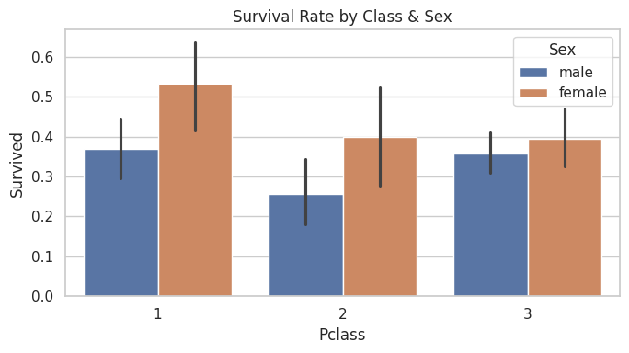

3.2 countplot() — Count Plot
Counts occurrences of each category value. Equivalent to a bar plot where the y-axis is the count.
sns.countplot(data=df, x="Pclass", hue="Sex")
# order=["3","2","1"] → custom ordering
# No y parameter — count is always the y
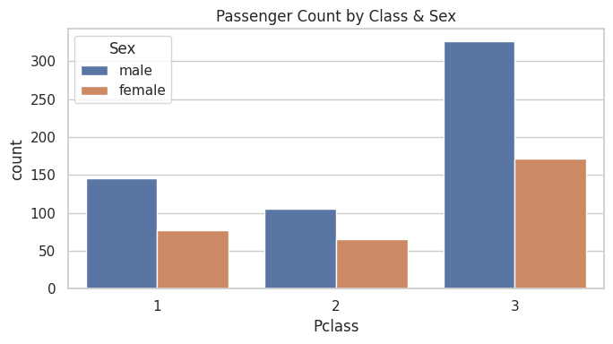

3.3 boxplot() — Box Plot
Shows median, IQR (box), whiskers (1.5×IQR), and outliers. Best for comparing spread and skewness across categories.
sns.boxplot(data=df, x="Pclass", y="Fare", hue="Survived")
# Box: 25th–75th percentile (IQR)
# Line in box: median
# Whiskers: 1.5 × IQR from box edges
# Dots: outliers beyond whiskers
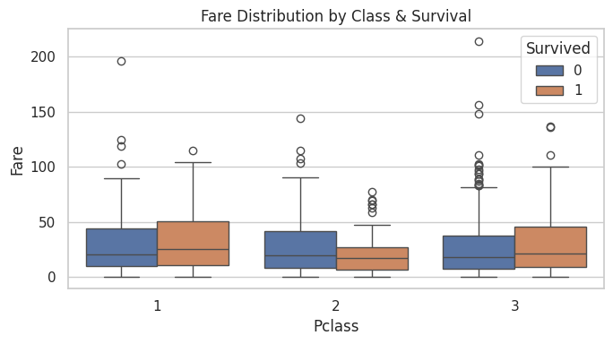

3.4 violinplot() — Violin Plot
Combines boxplot and KDE. Shows the full distribution shape, not just summary statistics.
# split=True → mirror halves for two hue groups
sns.violinplot(data=df, x="Pclass", y="Age", hue="Sex", split=True)
# inner="box" → show boxplot inside
# inner="quart" → show quartile lines
# inner="point" → show data points
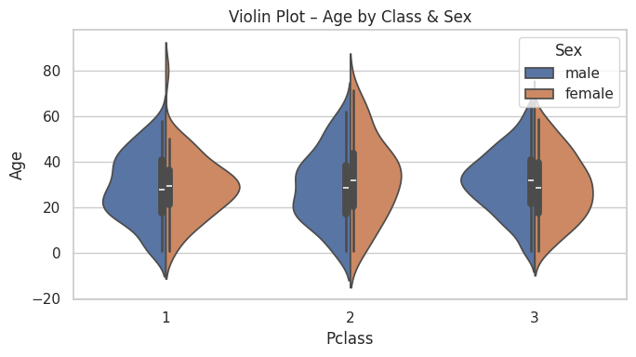

3.5 stripplot() — Strip Plot
Draws all individual data points scattered along the category axis. Good for small datasets.
sns.stripplot(data=df, x="Pclass", y="Fare", hue="Survived",
dodge=True, alpha=0.5, jitter=True)
# dodge=True → separate hue groups
# jitter=True → spread points to avoid overlap
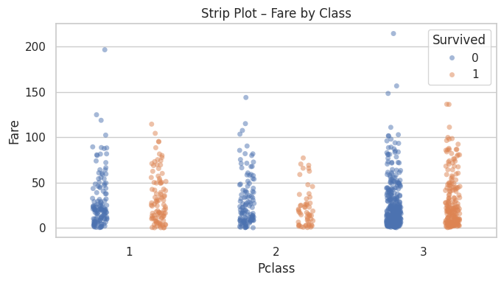

3.6 Other Categorical Plots
Function | Best Used For
swarmplot() | Non-overlapping points, small datasets
boxenplot() | Large datasets, more quantile detail than boxplot
pointplot() | Show mean + CI, good for comparing trends
catplot() | Figure-level wrapper for all categorical plots
# catplot() — universal figure-level function
sns.catplot(data=df, x="Pclass", y="Fare", kind="box", col="Sex")
# kind: "strip","swarm","box","violin","boxen","point","bar","count"
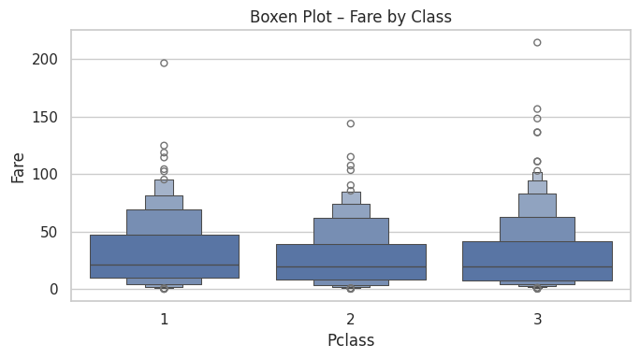

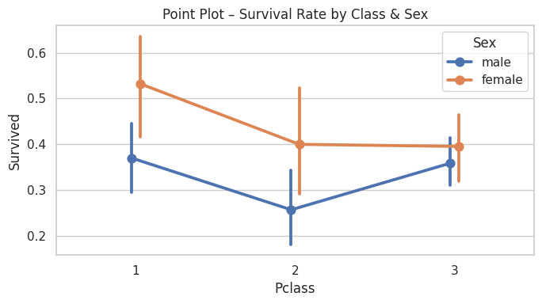

Section 4: Relational Plots
Relational plots visualize the relationship between two numeric variables, optionally encoded with additional dimensions using hue, size, and style.

4.1 scatterplot() — Scatter Plot
Each point represents one observation. Use hue, size, and style to encode up to 4 dimensions.
sns.scatterplot(data=df, x="Age", y="Fare",
hue="Survived", style="Sex", alpha=0.6)
# hue → color by category or numeric value
# style → marker shape by category
# size → point size by numeric value
# alpha → transparency (0=transparent, 1=solid)
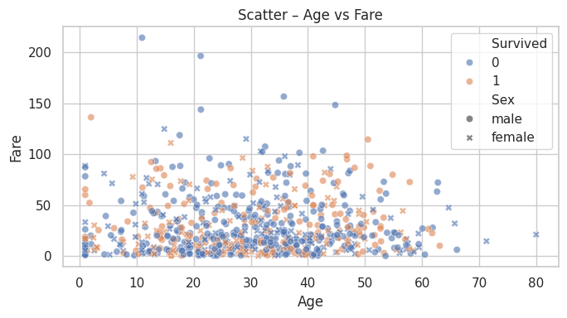

4.2 lineplot() — Line Plot
Connects points with a line. By default aggregates multiple y-values per x and shows a confidence interval band.
# Automatically computes mean + CI for repeated x values
sns.lineplot(data=df, x="AgeGroup", y="Fare")

# Disable aggregation for raw time series
sns.lineplot(data=df, x="PassengerId", y="Fare",
estimator=None, linewidth=0.8)

# With hue for multiple lines
sns.lineplot(data=df, x="Pclass", y="Fare", hue="Sex")
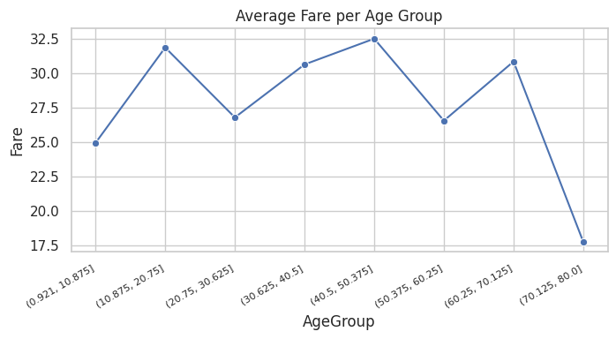

4.3 relplot() — Unified Relational API
Figure-level function for scatter and line plots. Supports faceting with row/col parameters.
# Faceted scatter plot
sns.relplot(data=df, x="Age", y="Fare",
col="Pclass", hue="Survived",
kind="scatter", alpha=0.5)

# Faceted line plot
sns.relplot(data=df, x="Pclass", y="Fare",
row="Sex", kind="line")
Semantic Mappings: hue + style + size can all be used simultaneously. For example: hue="Survived", style="Sex", size="Pclass" encodes 3 extra dimensions on one scatter plot.

Section 5: Regression & Statistical Plots
Regression plots fit a statistical model to your data and visualize it alongside the raw scatter. Essential for understanding linear and non-linear relationships.

5.1 regplot() — Regression Plot
Draws a scatter plot with a fitted regression line and 95% confidence interval band. Axes-level function.
sns.regplot(data=df, x="Age", y="Fare", scatter_kws={"alpha":0.3})

# Polynomial regression
sns.regplot(data=df, x="Age", y="Fare", order=2)

# Logistic regression (binary y)
sns.regplot(data=df, x="Fare", y="Survived", logistic=True,
scatter_kws={"alpha":0.3})

# Suppress scatter (line only)
sns.regplot(data=df, x="Age", y="Fare", scatter=False)
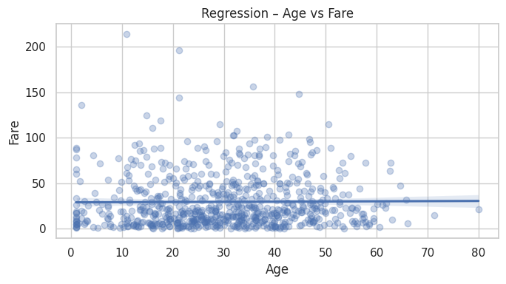

5.2 lmplot() — Linear Model Plot
Figure-level version of regplot. Supports faceting and hue grouping — draws a separate regression line per group.
# Separate regression line per sex
sns.lmplot(data=df, x="Age", y="Fare", hue="Sex")

# Faceted by class
sns.lmplot(data=df, x="Age", y="Fare",
col="Pclass", hue="Survived")

# No confidence interval
sns.lmplot(data=df, x="Age", y="Fare", ci=None)

5.3 residplot() — Residual Plot
After fitting a regression, the residuals (actual − predicted) should be randomly scattered around zero. Patterns indicate the model is missing something.
sns.residplot(data=df, x="Age", y="Fare",
scatter_kws={"alpha": 0.3})
# Random scatter = good fit
# Funnel shape = heteroscedasticity
# Curve = non-linear relationship missed
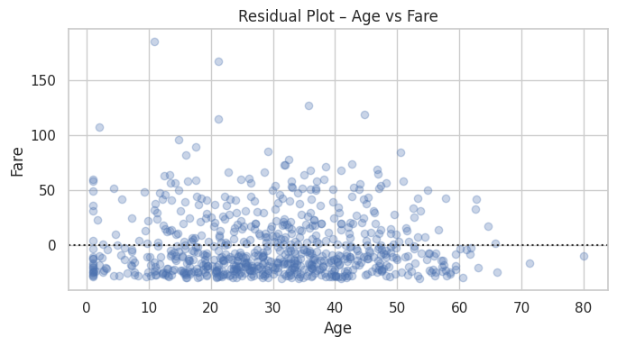
Interpret Residuals: If the residual plot shows a pattern (curve, funnel), try polynomial regression (order=2) or transform your variables with log/sqrt.

Section 6: Matrix & Heatmap Plots
Heatmaps encode a 2D matrix of numbers as colors. Most commonly used for correlation matrices, confusion matrices, and pivot tables.

6.1 heatmap() — Heatmap
The most popular Seaborn plot for data analytics. Pass any 2D rectangular data and it renders as a color-coded grid.
# Correlation heatmap (most common use case)
corr = df[["Survived","Pclass","Age","Fare","SibSp","Parch"]].corr()
sns.heatmap(corr, annot=True, fmt=".2f",
cmap="coolwarm", center=0)

# Key parameters:
# annot=True → show values in cells
# fmt=".2f" → format as 2 decimal floats
# cmap → color palette
# center=0 → anchor colormap at 0
# vmin / vmax → set color scale range
# linewidths → cell border thickness
# mask → hide upper/lower triangle
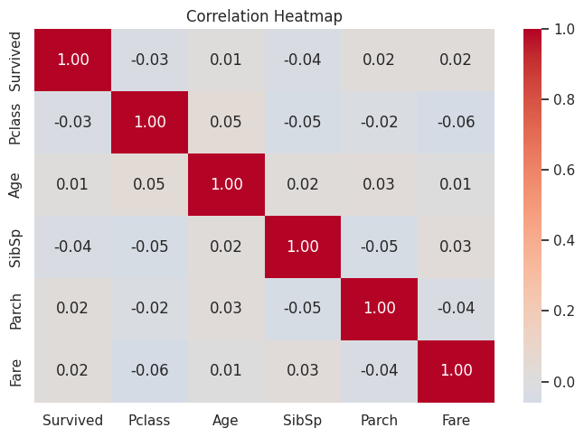

6.2 Masking a Correlation Heatmap
Correlation matrices are symmetric — you can hide the upper triangle to reduce redundancy.
mask = np.triu(np.ones_like(corr, dtype=bool))
sns.heatmap(corr, mask=mask, annot=True, fmt=".2f",
cmap="coolwarm", center=0)

6.3 Pivot Table Heatmap
# Survival rate by Class × Embarked port
pivot = df.pivot_table(values="Survived",
index="Pclass", columns="Embarked")
sns.heatmap(pivot, annot=True, fmt=".2f", cmap="YlOrRd")

6.4 clustermap() — Clustered Heatmap
Applies hierarchical clustering to reorder both rows and columns so similar items are grouped together.
sns.clustermap(corr, annot=True, fmt=".2f",
cmap="coolwarm", center=0, figsize=(8,8))
# method="ward" → linkage algorithm
# metric="euclidean" → distance metric
# z_score=0 → standardize rows (0) or cols (1)
# col_cluster=False → cluster rows only
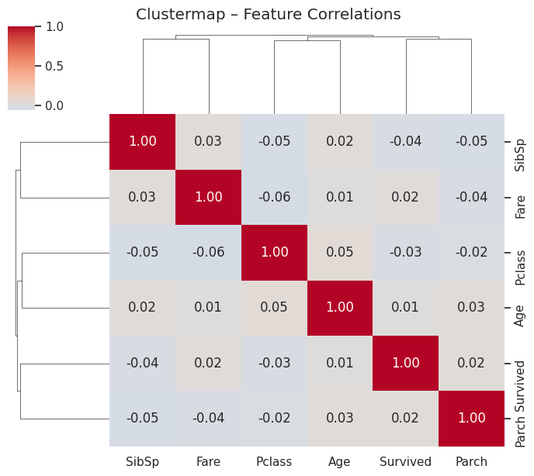

Section 7: Multi-plot Grids
Grid functions let you automatically create multiple plots — either faceting one variable across a grid of subplots, or plotting every pair of variables against each other.

7.1 pairplot() — Pair Plot
Creates a grid where every numeric column is plotted against every other. Diagonal shows individual distributions; off-diagonal shows scatter plots.
sns.pairplot(df[["Age","Fare","Pclass","Survived"]].dropna(),
hue="Survived", plot_kws={"alpha":0.4})

# diag_kind="kde" → KDE on diagonal instead of hist
# kind="reg" → regression lines off-diagonal
# corner=True → show only lower triangle
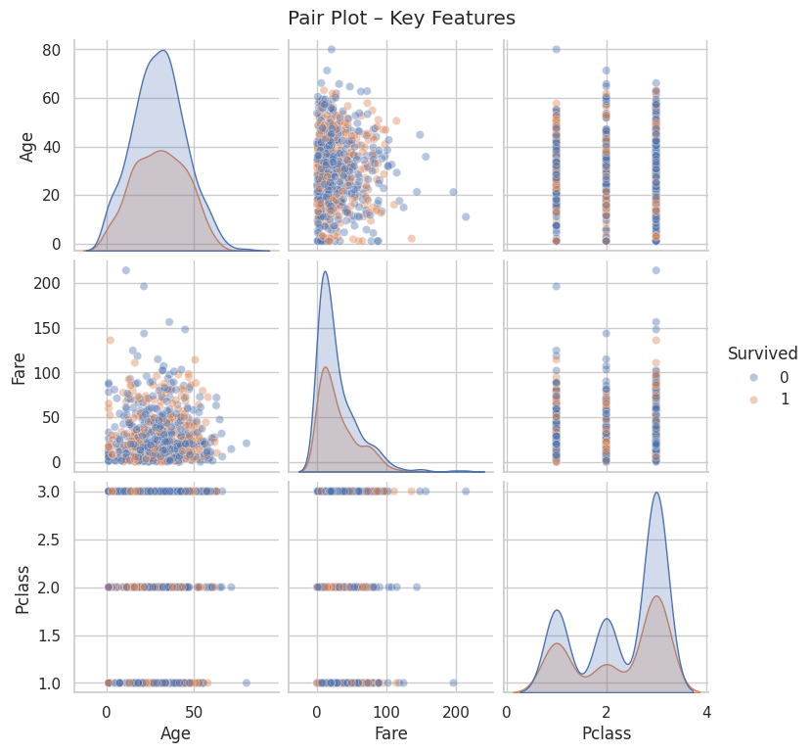

7.2 FacetGrid — Custom Faceted Plots
The most flexible multi-plot tool. Creates a grid of subplots based on a categorical variable, then maps any plot function onto it.
# Create the grid
g = sns.FacetGrid(df, col="Pclass", hue="Survived",
height=3, aspect=1.1)

# Map any seaborn/matplotlib function
g.map(sns.histplot, "Age", bins=15)

# Add legend and title
g.add_legend()
g.fig.suptitle("Age Distribution by Class", y=1.05)

# Map scatter plot
g2 = sns.FacetGrid(df, col="Sex", row="Pclass")
g2.map_dataframe(sns.scatterplot, x="Age", y="Fare")
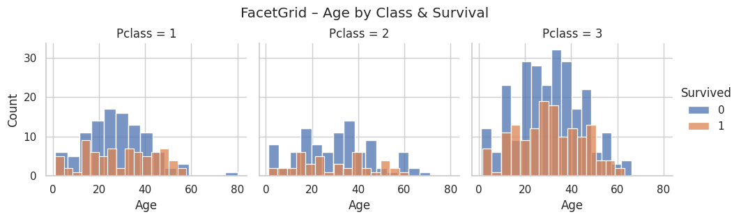

7.3 jointplot() — Joint Distribution
Combines a central bivariate plot with marginal univariate distributions on the top and right axes.
sns.jointplot(data=df, x="Age", y="Fare",
hue="Survived", kind="scatter")

# kind options:
# "scatter" → scatter + histograms
# "kde" → KDE contours + marginal KDE
# "hex" → hexbin + histograms
# "reg" → regression line + KDE margins
# "resid" → residuals
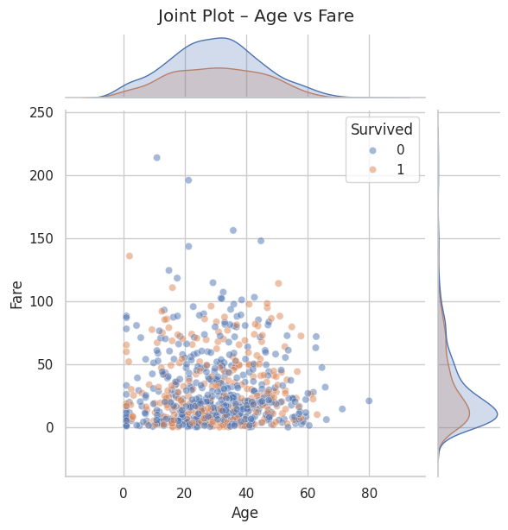

7.4 PairGrid — Custom Pair Plots
Like pairplot but with full control over what is plotted on diagonal, upper, and lower triangles.
g = sns.PairGrid(df[["Age","Fare","Pclass"]].dropna())

# Set different plots per region
g.map_upper(sns.scatterplot, alpha=0.3)
g.map_lower(sns.kdeplot)
g.map_diag(sns.histplot, bins=15)

Section 8: Customization & Integration
Seaborn integrates tightly with Matplotlib, giving you the best of both: Seaborn's easy high-level API and Matplotlib's complete control over every element.

8.1 Themes and Styles
# Modern unified theme setter (Seaborn v0.11+)
sns.set_theme(style="whitegrid", palette="Set2",
font="Arial", font_scale=1.1)

# Control element size (for different output targets)
sns.set_context("notebook", font_scale=1.2,
rc={"lines.linewidth": 2})

# Reset to matplotlib defaults
sns.reset_defaults()

8.2 Adding Titles, Labels, and Legends
fig, ax = plt.subplots(figsize=(8, 5))
sns.boxplot(data=df, x="Pclass", y="Fare", ax=ax)

# Axes-level customization via Matplotlib
ax.set_title("Fare by Passenger Class", fontsize=16, fontweight="bold")
ax.set_xlabel("Passenger Class")
ax.set_ylabel("Fare (£)")
ax.set_xticklabels(["1st Class", "2nd Class", "3rd Class"])

# Move or customize legend
ax.legend(title="Survived", loc="upper right")

# Remove legend if using hue as label
ax.get_legend().remove()

8.3 Custom Color Palettes
# Custom hex colors
my_palette = ["#E74C3C", "#3498DB", "#2ECC71"]
sns.barplot(data=df, x="Pclass", y="Fare", palette=my_palette)

# Built-in palettes
sns.barplot(data=df, x="Pclass", y="Fare",
palette="RdYlGn") # diverging

# Palette from hue variable range
sns.scatterplot(data=df, x="Age", y="Fare",
hue="Fare", palette="viridis") # continuous

8.4 Working with Subplots (Matplotlib Integration)
# Place multiple seaborn plots on one figure
fig, axes = plt.subplots(1, 2, figsize=(12, 5))

sns.histplot(data=df, x="Age", ax=axes[0])
axes[0].set_title("Age Distribution")

sns.boxplot(data=df, x="Pclass", y="Fare", ax=axes[1])
axes[1].set_title("Fare by Class")

plt.suptitle("Titanic Dataset Overview", fontsize=16)
plt.tight_layout()
plt.show()

8.5 Working with Long-form vs Wide-form Data
Format | Description
Long-form | One row per observation; columns are variables. Preferred by Seaborn.
Wide-form | One row per group; each column is a variable. Needs reshaping.
# Long-form (preferred by Seaborn)
# df has columns: Age, Fare, Survived
sns.boxplot(data=df, x="Pclass", y="Fare", hue="Survived")

# Convert wide to long with pandas melt()
wide = df[["Fare","Age"]].dropna()
long = wide.melt(var_name="Metric", value_name="Value")
sns.boxplot(data=long, x="Metric", y="Value")

8.6 Saving Figures
# High-resolution PNG for reports
plt.savefig("plot.png", dpi=300, bbox_inches="tight")

# Vector PDF for print / publication
plt.savefig("plot.pdf", bbox_inches="tight")

# SVG for web
plt.savefig("plot.svg", bbox_inches="tight")

# Always call before plt.show()

Golden Rule: Use bbox_inches="tight" when saving — it prevents titles and labels from being clipped at the edges.

Quick Reference: All Seaborn Functions
Category | Function | Use Case
Distribution | histplot() | Frequency histograms with optional KDE
 | kdeplot() | Smooth density curves
 | ecdfplot() | Cumulative distribution function
 | rugplot() | Raw data tick marks on axis
 | displot() | Figure-level wrapper for all above
Categorical | barplot() | Mean with CI by category
 | countplot() | Count observations per category
 | boxplot() | Five-number summary + outliers
 | violinplot() | Distribution shape via KDE
 | stripplot() | Individual points per category
 | swarmplot() | Non-overlapping points
 | boxenplot() | Extended box for large data
 | pointplot() | Mean + CI as connected points
 | catplot() | Figure-level wrapper for all above
Relational | scatterplot() | Bivariate relationships
 | lineplot() | Trends over ordered x-values
 | relplot() | Figure-level wrapper for above
Regression | regplot() | Scatter + regression line + CI
 | lmplot() | Figure-level, supports faceting
 | residplot() | Regression residual diagnostics
Matrix | heatmap() | Color-coded 2D matrix
 | clustermap() | Heatmap + hierarchical clustering
Grids | pairplot() | All-vs-all variable pair grid
 | jointplot() | Bivariate + marginal distributions
 | FacetGrid | Custom multi-plot grids
 | PairGrid | Custom pair plot control

