JSON:

Node JS:

rm -rf public/*.bundle.*

files=($(ls /app/MScsspSIT-React/public | grep "app.bundle.*"))

declare -p files

len=${#files[@]}

for ((j=0; j<${len}; j++ ))

do

cp /app/MScsspSIT-React/public/${files[$j]} public

done

cp /app/MScsspSIT-React/public/index.html public

rm -rf public/app.bundle.js.map

sed -i "s/m.d.bid/7.17.0/g" config/main.js

#sed -i "s/10.10.0/11.12.0/g" config/main.js

WEBMS_NODE_IMAGE="${ACR_LOGINSERVER_SIT}/sit_nodejsms:kube${BUILD_NUMBER}"

docker build -t $WEBMS_NODE_IMAGE . -f Https.Dockerfile

#docker build -t $WEBMS_NODE_IMAGE /app/MScsspSIT-NodeJSNew

docker login ${ACR_LOGINSERVER_SIT} -u ${ACR_ID} -p ${ACR_PASSWORD}

docker push $WEBMS_NODE_IMAGE

sed -i "s/sit_nodejsms:kube0/sit_nodejsms:kube$BUILD_NUMBER/g" sit_yaml/nodeJS_Deployment.yaml

kubectl config use-context ghs-ncci-cndt-s-aks-c03

kubectl apply -f sit_yaml/nodeJS_Deployment.yaml

sed -i "s/mssit_node_appeals:kube0/sit_nodejsms:kube$BUILD_NUMBER/g" sit_yaml/nodeAppeals_Deployment.yaml

kubectl apply -f sit_yaml/nodeAppeals_Deployment.yaml

sed -i "s/mssit_node_ar:kube0/sit_nodejsms:kube$BUILD_NUMBER/g" sit_yaml/nodeAR_Deployment.yaml

kubectl apply -f sit_yaml/nodeAR_Deployment.yaml

sed -i "s/mssit_node_createaccount:kube0/sit_nodejsms:kube$BUILD_NUMBER/g" sit_yaml/nodeCreateAccount_Deployment.yaml

kubectl apply -f sit_yaml/nodeCreateAccount_Deployment.yaml

sed -i "s/mssit_node_dashboard_retreive:kube0/sit_nodejsms:kube$BUILD_NUMBER/g" sit_yaml/nodeDashboardRetreive_Deployment.yaml

kubectl apply -f sit_yaml/nodeDashboardRetreive_Deployment.yaml

sed -i "s/mssit_node_document:kube0/sit_nodejsms:kube$BUILD_NUMBER/g" sit_yaml/nodeDocument_Deployment.yaml

kubectl apply -f sit_yaml/nodeDocument_Deployment.yaml

#sed -i "s/mssit_node_mybenefits:kube0/sit_nodejsms:kube$BUILD_NUMBER/g" sit_yaml/nodeMyBenefits_Deployment.yaml

#kubectl apply -f sit_yaml/nodeMyBenefits_Deployment.yaml

sed -i "s/mssit_node_pdf:kube0/sit_nodejsms:kube$BUILD_NUMBER/g" sit_yaml/nodePdf_Deployment.yaml

kubectl apply -f sit_yaml/nodePdf_Deployment.yaml

#sed -i "s/mssit_node_pdfcic:kube0/sit_nodejsms:kube$BUILD_NUMBER/g" sit_yaml/nodePdfCIC_Deployment.yaml

#kubectl apply -f sit_yaml/nodePdfCIC_Deployment.yaml

sed -i "s/mssit_node_save:kube0/sit_nodejsms:kube$BUILD_NUMBER/g" sit_yaml/nodeSave_Deployment.yaml

kubectl apply -f sit_yaml/nodeSave_Deployment.yaml

#sed -i "s/mssit_node_savecic:kube0/sit_nodejsms:kube$BUILD_NUMBER/g" sit_yaml/nodeSaveCIC_Deployment.yaml

#kubectl apply -f sit_yaml/nodeSaveCIC_Deployment.yaml

sed -i "s/mssit_node_submit:kube0/sit_nodejsms:kube$BUILD_NUMBER/g" sit_yaml/nodeSubmit_Deployment.yaml

kubectl apply -f sit_yaml/nodeSubmit_Deployment.yaml

sed -i "s/mssit_node_cic:kube0/sit_nodejsms:kube$BUILD_NUMBER/g" sit_yaml/nodeCICBackend_Deployment.yaml

kubectl apply -f sit_yaml/nodeCICBackend_Deployment.yaml

sed -i "s/mssit_node_renew:kube0/sit_nodejsms:kube$BUILD_NUMBER/g" sit_yaml/nodeRenewBackend_Deployment.yaml

kubectl apply -f sit_yaml/nodeRenewBackend_Deployment.yaml

sed -i "s/mssit_node_pdfrenew:kube0/sit_nodejsms:kube$BUILD_NUMBER/g" sit_yaml/nodePdfRenew_Deployment.yaml

kubectl apply -f sit_yaml/nodePdfRenew_Deployment.yaml

SIT admin node:

Admin react

Integ node:

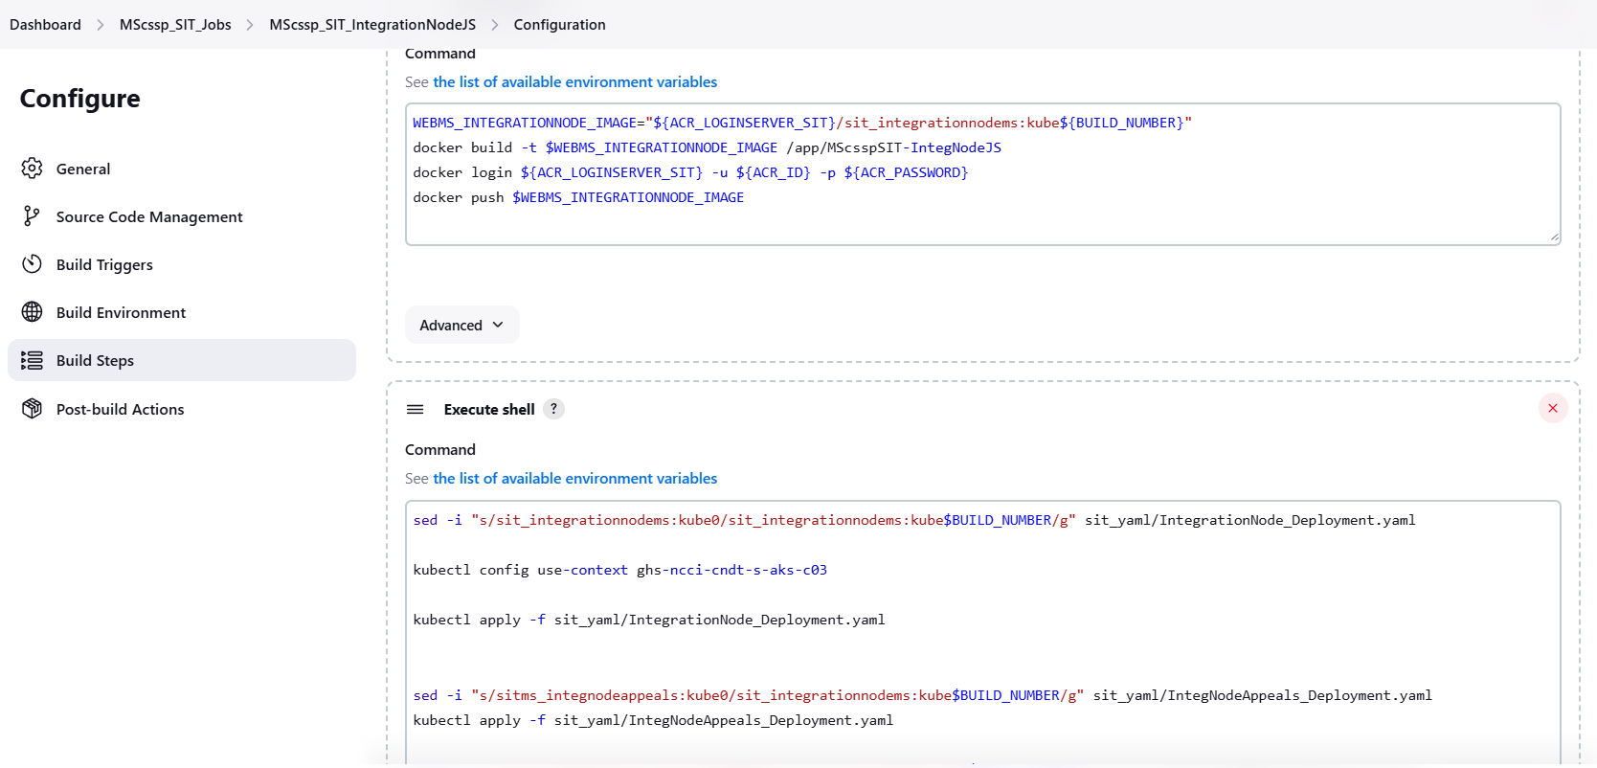

Audit build

APP_AUDIT_IMAGE="${ACR_LOGINSERVER_SIT}/mssit_audit_svc:kube${BUILD_NUMBER}"

docker build -t $APP_AUDIT_IMAGE /app/MScsspSIT-Audit

docker login ${ACR_LOGINSERVER_SIT} -u ${ACR_ID} -p ${ACR_PASSWORD}

docker push $APP_AUDIT_IMAGE

sed -i "s/mssit_audit_svc:kube0/mssit_audit_svc:kube$BUILD_NUMBER/g" sit_yaml/AuditService_Deployment.yaml

kubectl config use-context ghs-ncci-cndt-s-aks-c03

kubectl apply -f sit_yaml/AuditService_Deployment.yaml

admin next node dep:

pipeline {

agent {

node {

label 'master'

customWorkspace '/app/MS_SIT_Admin_NodePipeline'

}

}

stages {

stage('Source Code Management') {

steps {

// Checkout source code from Azure Repos

git url: 'https://conduent-ghs-02.visualstudio.com/MS_SSP_Rollout/_git/MS_Admin_NodeJS',

branch: 'MS_Admin_Upgrade_SIT',

credentialsId: 'GITTOKEN',

changelog: true,

poll: true

// Checkout YAML Repository from Azure Repos

checkout scm: [$class: 'GitSCM',

userRemoteConfigs: [[url: 'https://conduent-ghs-02.visualstudio.com/MS_SSP_Rollout/_git/MS_SSP_YAML', credentialsId: 'GITTOKEN']],

branches: [[name: '*/Sit_Deployment']],

extensions: [[$class: 'RelativeTargetDirectory', relativeTargetDir: 'sit_yaml']]],

changelog: false,

poll: false

}

}

stage('Docker Build and Push') {

steps {

withCredentials([usernamePassword(credentialsId: 'ACR_Access', passwordVariable: 'ACR_PASSWORD', usernameVariable: 'ACR_ID')]) {

sh '''

sed -i "s/m.d.bid/7.2.1/g" config/main.js

rsync -a /app/MS_SIT_Admin_ReactPipeline/build/ public/

ADMIN_NODE_IMAGE="${ACR_LOGINSERVER_SIT}/adminnode_mssit:kube${BUILD_NUMBER}"

docker build -t $ADMIN_NODE_IMAGE . -f Https.Dockerfile

docker login ${ACR_LOGINSERVER_SIT} -u ${ACR_ID} -p ${ACR_PASSWORD}

docker push $ADMIN_NODE_IMAGE

'''

}

}

}

stage('Deploy to AKS') {

steps {

sh '''

sed -i "s/adminnode_mssit:kube0/adminnode_mssit:kube${BUILD_NUMBER}/g" sit_yaml/adminportalnodeJS_Deployment.yaml

kubectl config use-context ghs-ncci-cndt-s-aks-c03

kubectl apply -f sit_yaml/adminportalnodeJS_Deployment.yaml

'''

}

}

}

}

Admin react:

pipeline {

agent {

node {

label 'master'

customWorkspace '/app/MS_SIT_Admin_ReactPipeline'

}

}

environment {

DOCKER_IMAGE = "${ACR_LOGINSERVER}/mssit_admin_react_build:v${BUILD_NUMBER}"

LOCAL_DIR = "${WORKSPACE}/build"

}

stages {

stage('Source Code Management') {

steps {

// Checkout source code from Azure Repos

git url: 'https://conduent-ghs-02.visualstudio.com/MS_SSP_Rollout/_git/MS_Admin_ReactJS',

branch: 'MS_Admin_Upgrade_SIT',

credentialsId: 'GITTOKEN',

changelog: true,

poll: true

}

}

stage('Docker Build and Push') {

steps {

withCredentials([usernamePassword(credentialsId: 'ACR_Access', passwordVariable: 'ACR_PASSWORD', usernameVariable: 'ACR_ID')]) {

sh '''

sed -i "s/m.d.bid/7.2.1/g" src/app/admin/config/config.dev.js

docker build -t ${DOCKER_IMAGE} .

docker login ${ACR_LOGINSERVER_SIT} -u ${ACR_ID} -p ${ACR_PASSWORD}

docker push ${DOCKER_IMAGE}

'''

}

}

}

stage('Extract out Folder') {

steps {

script {

sh "rm -rf build"

def container_id = sh(script: "docker create ${DOCKER_IMAGE}", returnStdout: true).trim()

sh "docker cp ${container_id}:/out ${LOCAL_DIR}"

sh "docker rm ${container_id}"

}

}

}

}

}