MAJOR PROJECT

*Mid Evaluation Report* - *Major Project*



**Deception Detection of familiar/unfamiliar faces using EEG signals**

         04.10.2019

Ajay Kumar   16103177

Akash Gupta 16103201

Saurabh Gupta 16103065

Supervisor :  Mrs. Indu Chawla

External Panel :  Mrs. Anuja Arora , Mr. Prashant Kaushik

INTRODUCTION

EEG Electroencephalography is measurement of electrical activities inside the brain to different stimuli,which will measured by using the different electrodes placed in scalp.Humans have a unique ability to express their emotions feeling and thinking skills which convey through neurons of the brain. Neurons, also called as brain cells communicate with the neuron cells in the central nervous system in electrical pulse form.

This presence of electrical currents in the brain was discovered by Richard Caton, a British physician in 1875. It is one of the significant brain signal using in Brain-Computer Interface (BCI) applications and in many others which had been come up in the early 1930s after the German neurologist Hans Berger revealed that the weaker currents from the brain could be measured even without opening the scalp. Berger called the name ‘**electroencephalogram**’ for the electrical potentials from the brain.

There are two mode of measurements of EEG either from cortical surface known as electrocorticogram or with the help of depth probes called electrogram. We have focused on the measurement from the scalp surface because it is effortless to acquire and very cheap. Also, there will be no risk for the user to receive the EEG signals and its a non-invasive technique. EEG signals used for clinical as well as research purposes. In the research domain, EEG signals are used mostly in cognitive science, cognitive psychology, detection of seizures, neurolinguistics, etc. EEG signal analysis for the study of the brain function has more advantages than other existing methods. Like, the hardware cost for EEG signal acquisition devices is significantly lesser than the majority of the different techniques. Also, EEG sensors are very weightless and easy to place on the scalp. Always EEG will measure and analysis in the order of millisecond not in second because of its high temporal resolution. Usually, the signal is measured in terms of the peak to peak voltage with amplitude ranges in between 0.5 to 100 *µ*V. We can use both dry and wet EEG electrodes to measure the signal that is postsynaptic potentials of neurons. The standard size of an EEG electrode is always below 10mm diameter. This size of the electrode will make a better connection between the conducting fluid of tissue where the electrical signal was generated and the amplifier circuit.

The electroencephalogram (EEG) is a recording of the electrical activity of the brain from the scalp. The recorded waveforms reflect the cortical electrical activity.  EEG activity is quite small, measured in microvolts (mV). The main frequencies of the human EEG waves are: Delta, Theta, Alpha, Beta

Brain-computer interface (BCI) is a collaboration between a brain and a device that enables signals from the brain to direct some external activity, such as control of a cursor or a prosthetic limb. The interface enables a direct communication pathway between the brain and the object to be controlled

PROBLEM STATEMENT

Earlier technique like polygraph does not provide accuracy in determining mental behaviour. Lately, it is possible to study psychological response of a person using electroencephalogram (EEG) for many use cases like Deception Detection, Detection of familiar/unfamiliar faces, Study of how visual/audio/olfactory memory works, etc.

PROPOSED SOLUTION

We have focused on the measurement from the scalp surface because it is effortless to acquire and very cheap. Also, there will be no risk for the user to receive the EEG signals and its a non-invasive technique. EEG signals used for clinical as well as research purposes. In the research domain, EEG signals are used mostly in cognitive science, cognitive psychology, detection of seizures, neurolinguistics, etc. EEG signal analysis for the study of the brain function has more advantages than other existing methods. Like, the hardware cost for EEG signal acquisition devices is significantly lesser than the majority of the different techniques.

DATASET SOURCE

For the collection of data, we chose 13 healthy subjects. We beforehand confirmed

that all ten subjects have no health problems as well as neurological disorders. All

the selected subjects were in the age of 22-25 years. All have a normal or normal to-corrected vision. Our primary target was to collect images that are very familiar

to the subjects and unfamiliar images which should be completely strange to all of

them. To subjects, we have a better awareness and instructions to follow while doing the data recording. All the subjects have good knowledge of the experiment. All were instructed to minimize their movements, and facial expressions to reduce the noise in the recorded signals. Since EEG have very less signal to noise ratio, we took care to minimize artifacts as maximum as possible.

IMPLEMENTATION DETAILS

* Thresholding - The soft thresholding is also called wavelet shrinkage, as values for both positive and negative coefficients are being "shrunk" towards zero, in contrary to hard thresholding which either keeps or removes values of coefficients.
* Random forest Classification

Random forest, like its name implies, consists of a large number of individual decision trees that operate as an [ensemble](https://en.wikipedia.org/wiki/Ensemble_learning). Each individual tree in the random forest spits out a class prediction and the class with the most votes becomes our model’s prediction.

The fundamental concept behind random forest is a simple but powerful one — the wisdom of crowds. In data science speak, the reason that the random forest model works so well is:

A large number of relatively uncorrelated models (trees) operating as a committee will outperform any of the individual constituent models.

* Support Vector Machine

A Support Vector Machine (SVM) is a discriminative classifier formally defined by a separating hyperplane. In other words, given labeled training data (supervised learning), the algorithm outputs an optimal hyperplane which categorizes new examples. In two dimensional space this hyperplane is a line dividing a plane in two parts where in each class lay in either side.

**Dataset :**

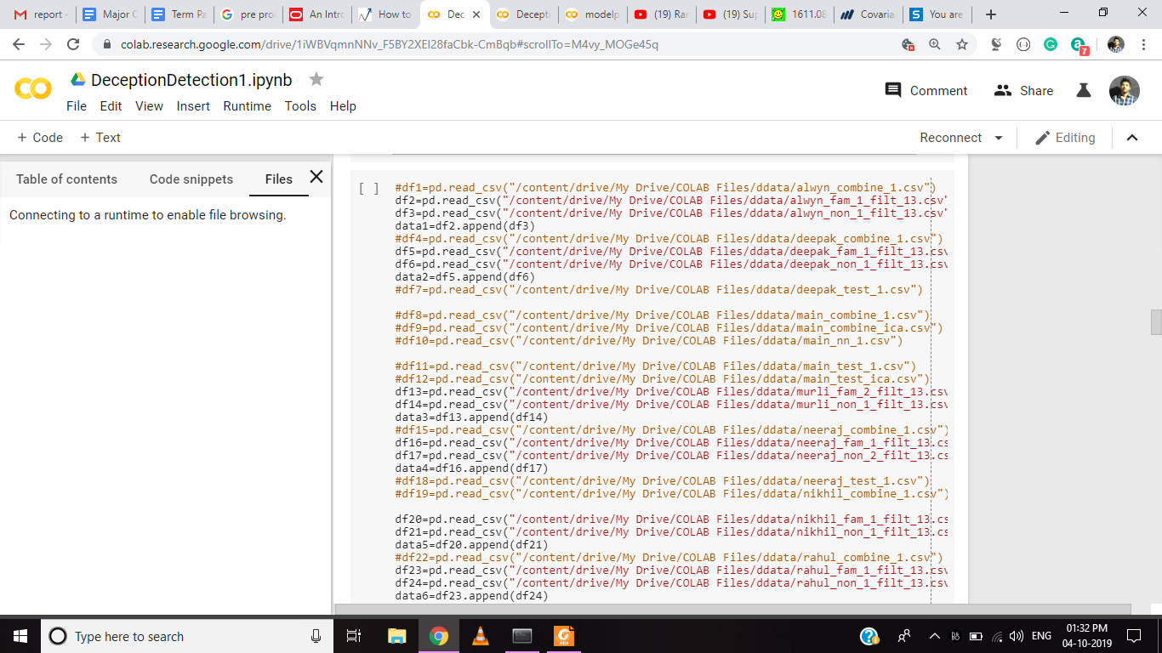

**Thresholding:**

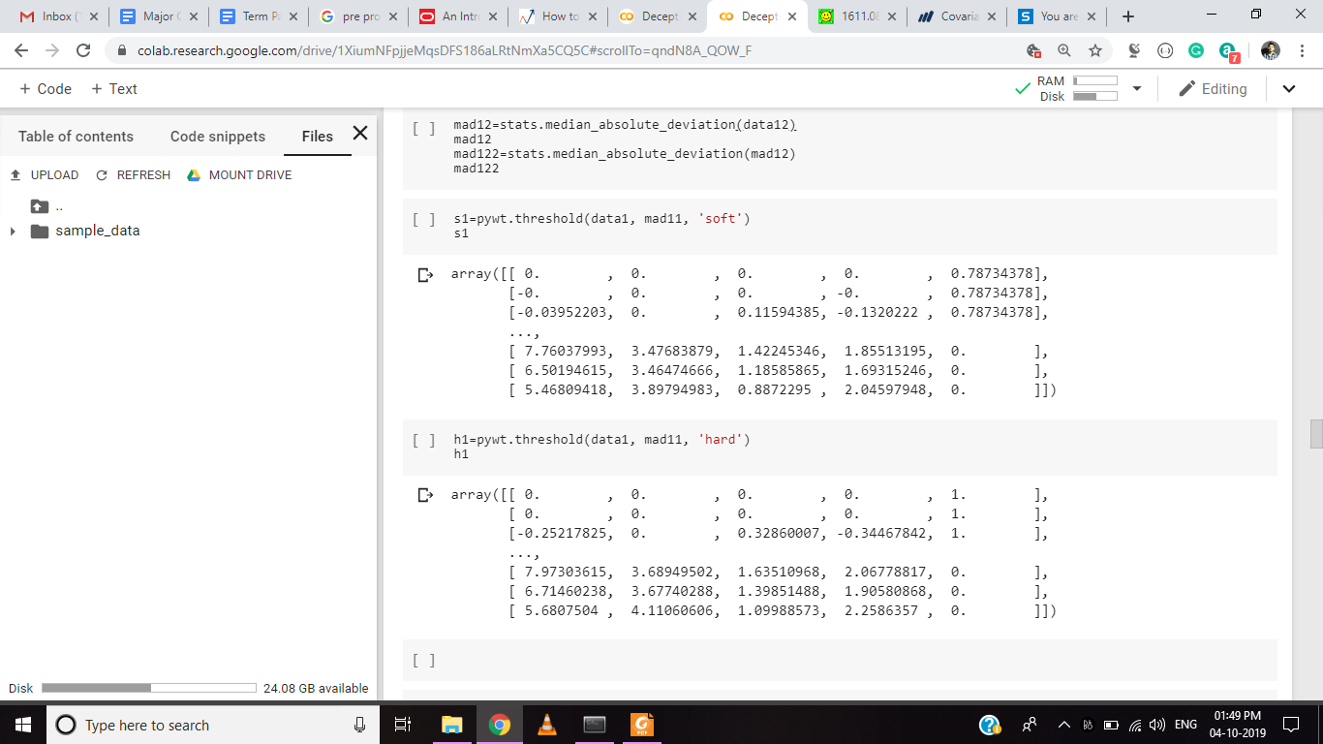

**Random forest:**

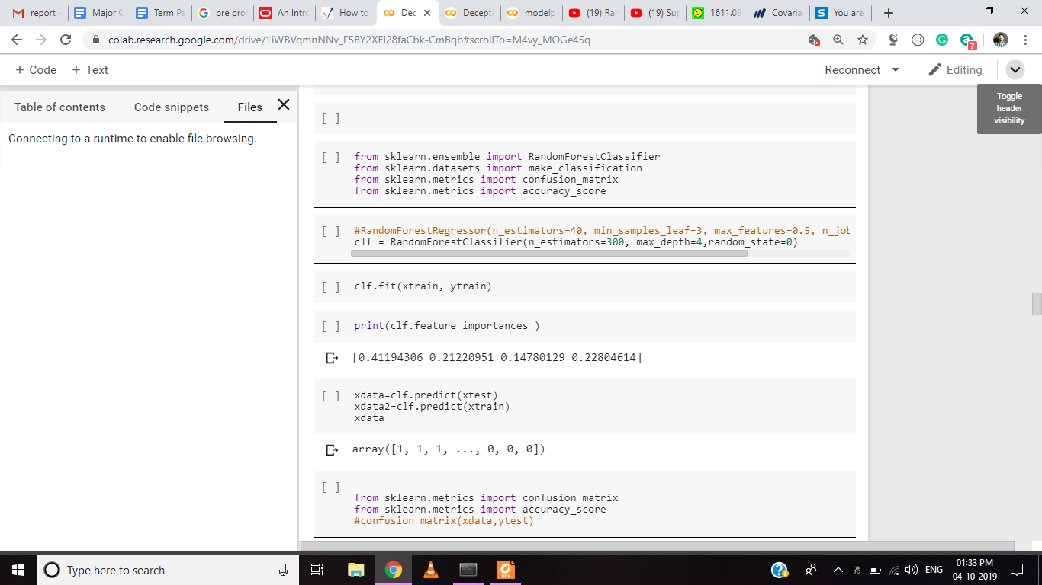

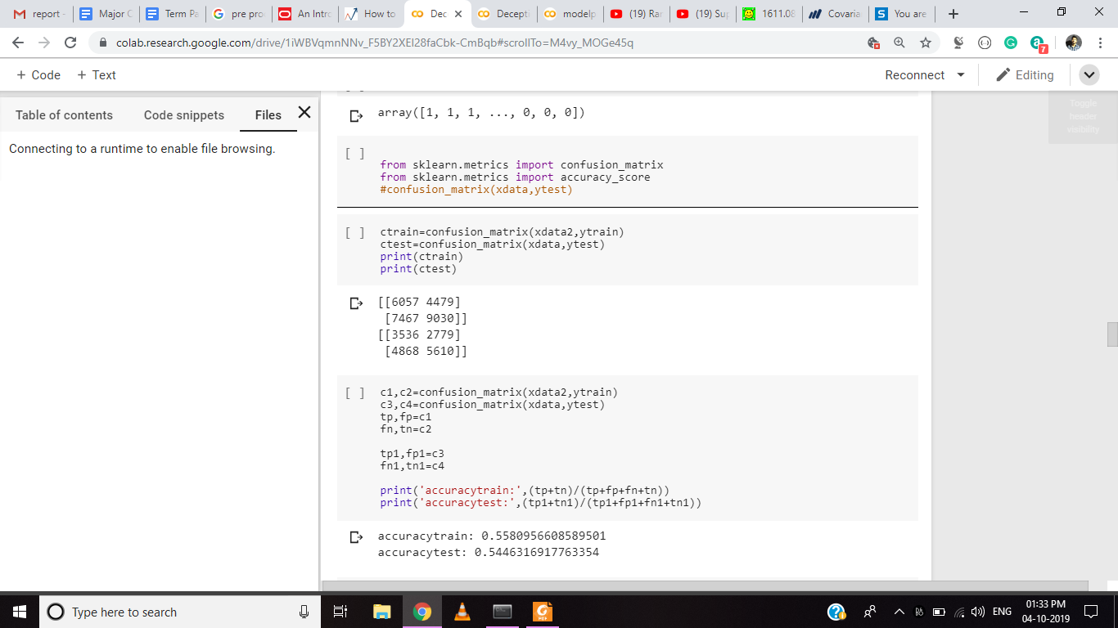

**Dataset Plot:**

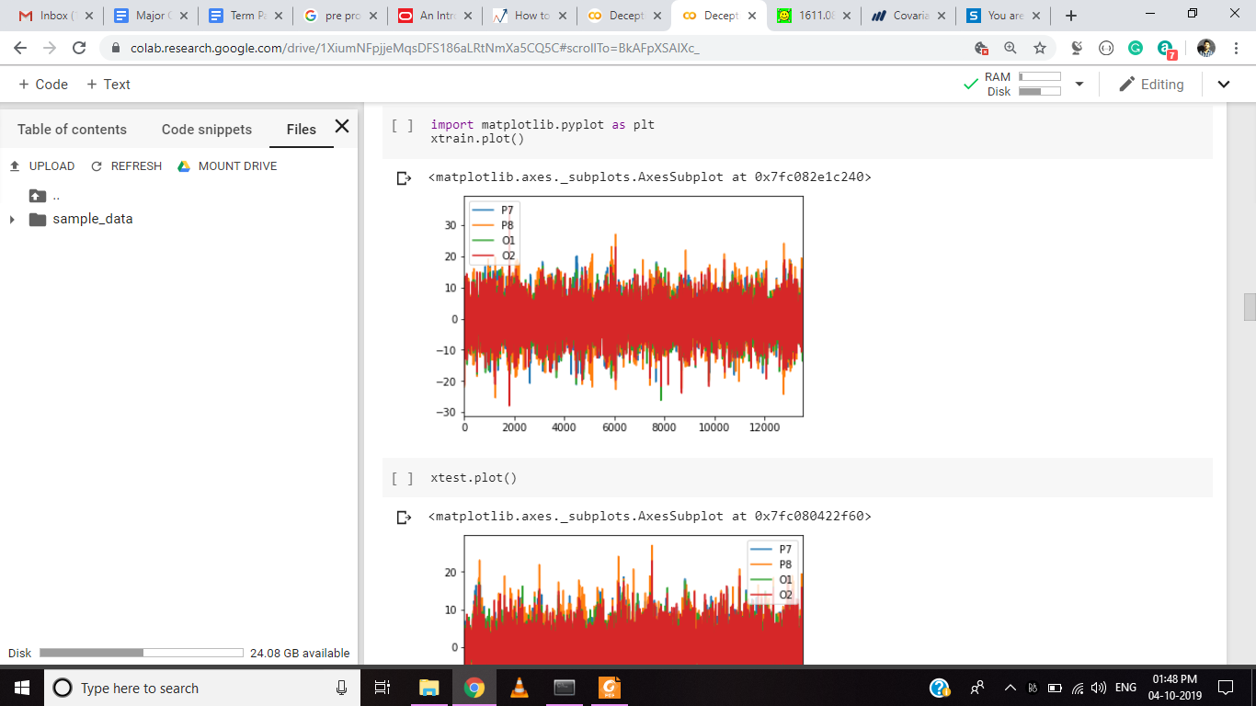

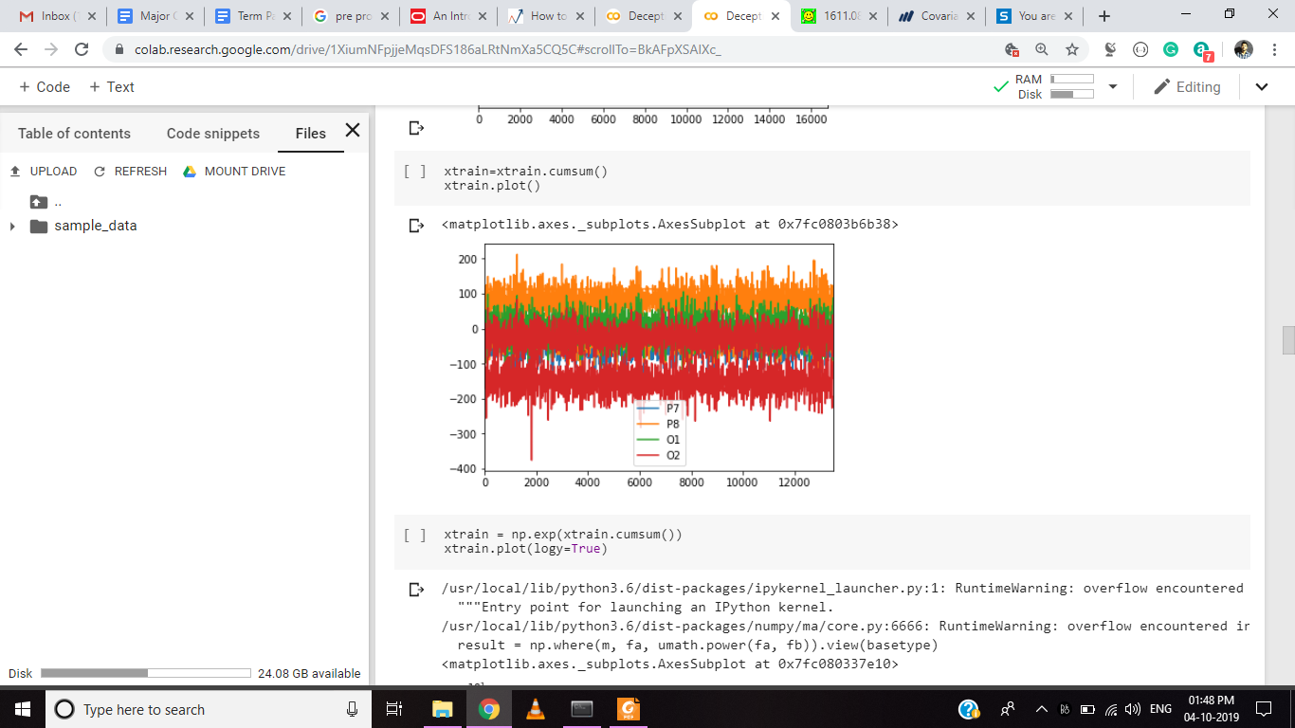

**SVM:**

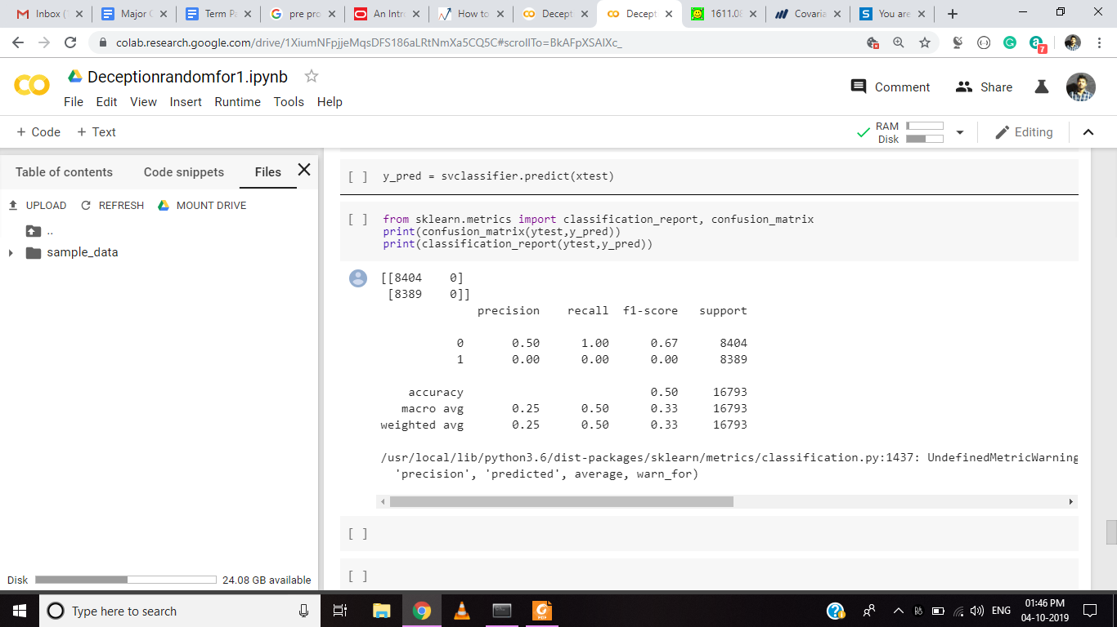

REFERENCES

[1.] **Better than random? A closer look on BCI results** : Gernot R. Müller-Putz, Reinhold Scherer, Clemens Brunner, Robert Leeb, Gert Pfurtscheller

[2.] **Classification of EEG Signals by using Support Vector Machines** : K. Sercan Bayram, M. Ayyüce Kızrak, Bülent Bolat

[3.] **Analysis of EEG Signals for Deception Detection** : Roshani J. Khandelwal, Juilee D. Mahajan, Ujjwala P. Bombatkar, Snehal G. Badhe

[4.] **Lie Detection Based EEG-P300 Signal Classified by ANFIS Method :** Arjon Turnip, M. Faizal Amri, M. Agung Suhendra, and Dwi Esti Kusumandari

[5.] **Classification of EEG Signals by using Support Vector Machines  :** K. Sercan Bayram, M. Ayyüce Kızrak