***Jaypee Institute of Information Technology, Noida***

*[](https://www.google.co.in/url?sa=i&rct=j&q=&esrc=s&source=images&cd=&cad=rja&uact=8&ved=0ahUKEwj_5oq2r-3VAhXJvI8KHRKnAS4QjRwIBw&url=https://en.wikipedia.org/wiki/File:Logo-jiit.png&psig=AFQjCNEaFJGVWWsMgvazGOckkaZ9Q0y0CA&ust=1503578190957930)*

***Project Report***

***INTRODUCTION TO MOBILE APPLICATION***

***PROJECT:Family Member Locator***

***Team Members:***

* ***Ajay Kumar 16103177***

***FAMILY LOCATOR APP***

***Description:***

*This app will going to help in day to day life and make life easy at some extent .This App is basically helps to trace the location of all the members in the family. We can also add or update the group to share their locations.*

*This app will be very useful for the safety purpose, specially for girls. Now a days the crime and eve teasing are increasing day by day. This will help the family member to get all the details of any kind of problem and this app can stop before something happens*

*The application offers an ability to work with location sensitive information. It will allow the user to login/register to the system. The user can also make friends by searching the application users and sending request to them. He/she can also accept or reject the request received by him/her from other application users.*

*He can select particular friend from his friend list and can trace his/her current location, provided that he owes Android GPS based mobile phone and his GPS facility should be activated.*

*Application gives surety that user’s personal and location based information is never shared without users permission. For accessing this application, user has to be connected through internet.*

***Language used in Project:***

*Java*

***Used in Project:***

* *Setup Java Development Kit(JDK)*
* *Navigation activity used menus*
* *Intent is used to connect the layouts*
* *Layout Editors: XML Layout files*
* *Location Service is used*

***Features of this Project:***

* *Safety*
* *Can keep an eye on family members*
* *It trace location of family members*
* *Solve real life problem*

***Additional Component :***

*There are additional components which will be used in the construction of*

*above mentioned entities, their logic, and wiring between them.*

*They are :*

* *Fragments*

*Represent a behavior or a portion of user interface in an Activity.*

* *View*

*UI elements that are drawn onscreen including buttons, lists forms etc*

* *Layouts*

*View hierarchies that control screen format and appearance of the views*

* *Intents*

*Messages wiring components together.*

* *Resources*

*External elements, such as strings, constants and drawable pictures*

* *Manifest*

*Configuration file for the application*

***Application Component***

*Application components are the essential building blocks of an Android application.*

*These component are loosely coupled by the application manifest file, i.e;*

*Android-*

*-Manifest.xml*

*Following four main component that can be used within an Android application :*

* *Activities :-*

*They dictate the UI and handle the user interaction to the smartphone*

*screen public class MainActivity extends Activity*

*{ }*

* *Services :-*

*They handle background processing associated with an application*

*public class MyService extends Service*

*{ }*

* *Broadcast Receivers :-*

*They handle communication between Android OS and applications*

*public class MyReceiver extends BroadcastReceiver*

*{ }*

* *Content Providers :-*

*They handle data and database management*

*issues. public class MyContentProvider extends ContentProvider*

*{ }*

*DATA FLOW DIAGRA:-*

User

Admin

*Coding:-*

*CREATE ACTIVITY*

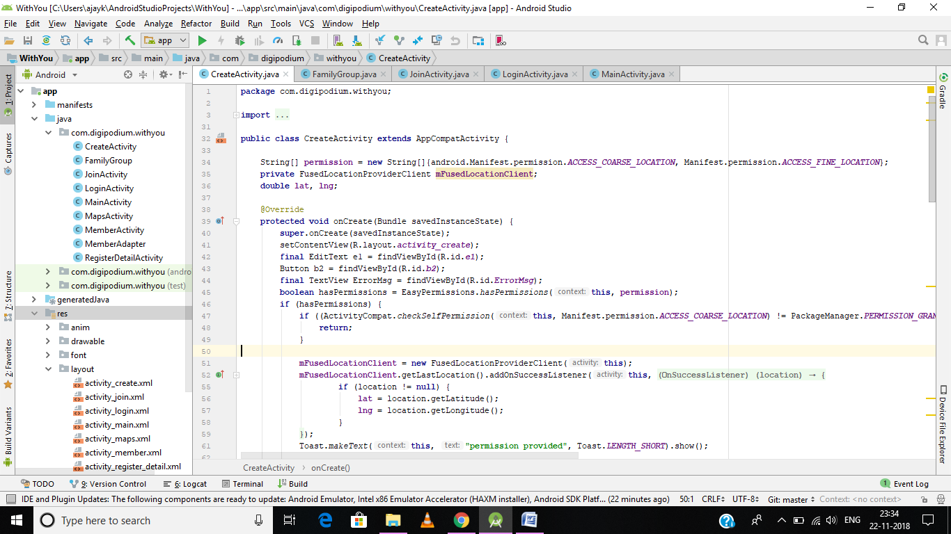

JOIN ACTIVITY

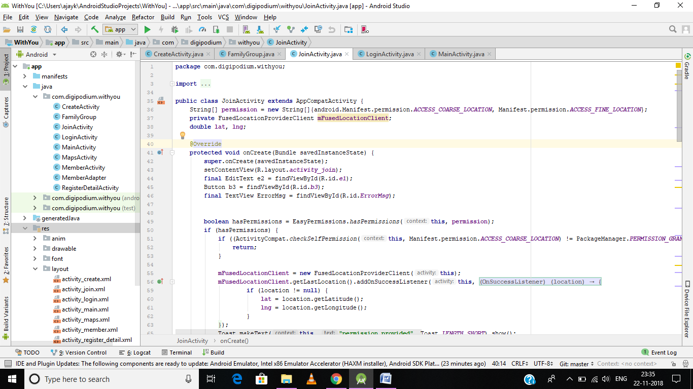

LOGIN ACTIVITY

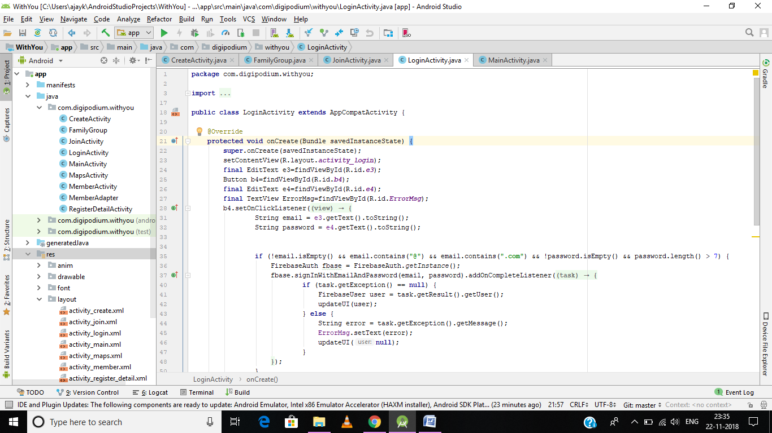

MAIN ACTIVITY

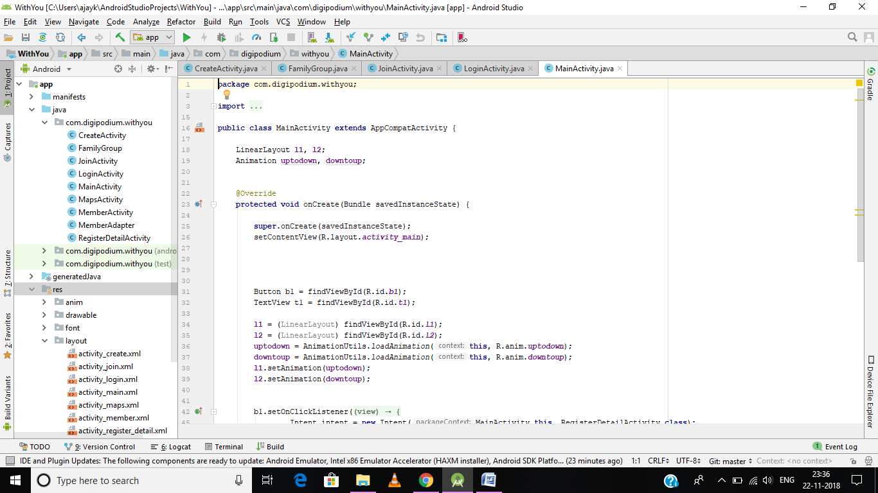

MAPS ACTIVITY

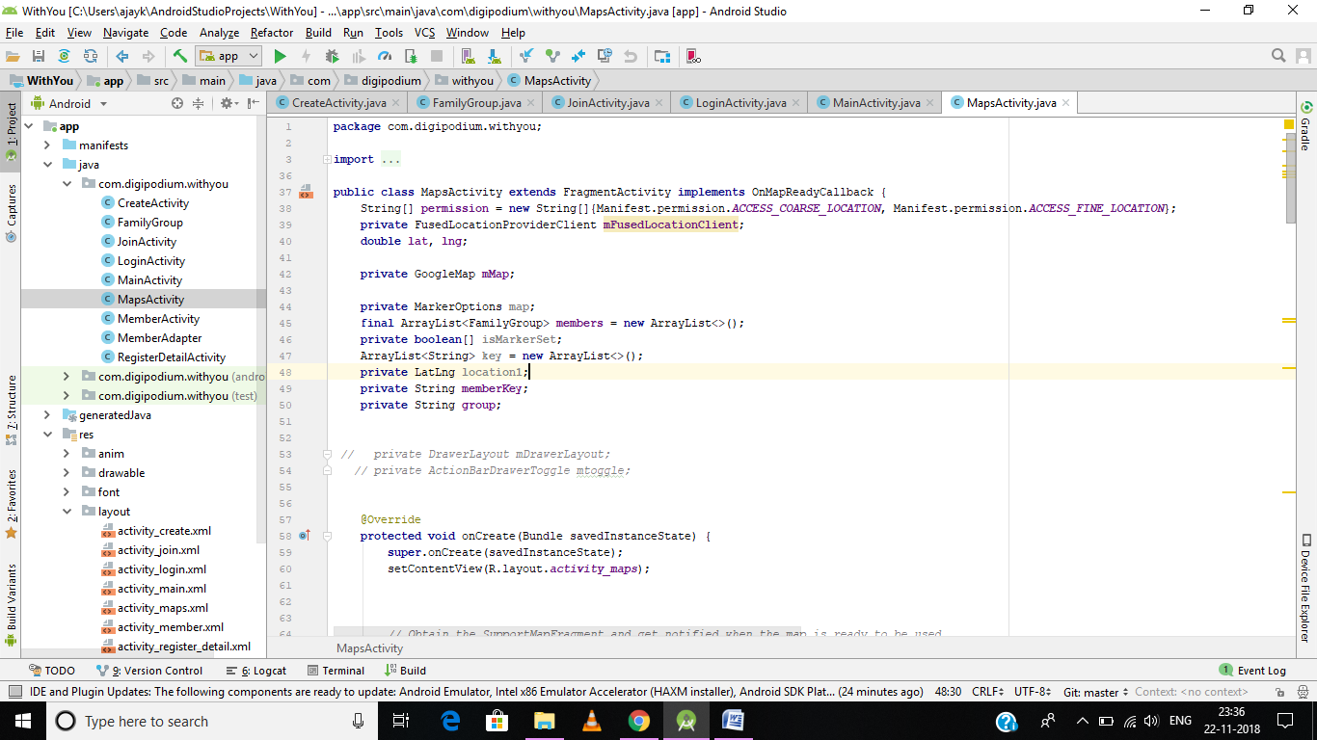

REGISTER ACTIVITY

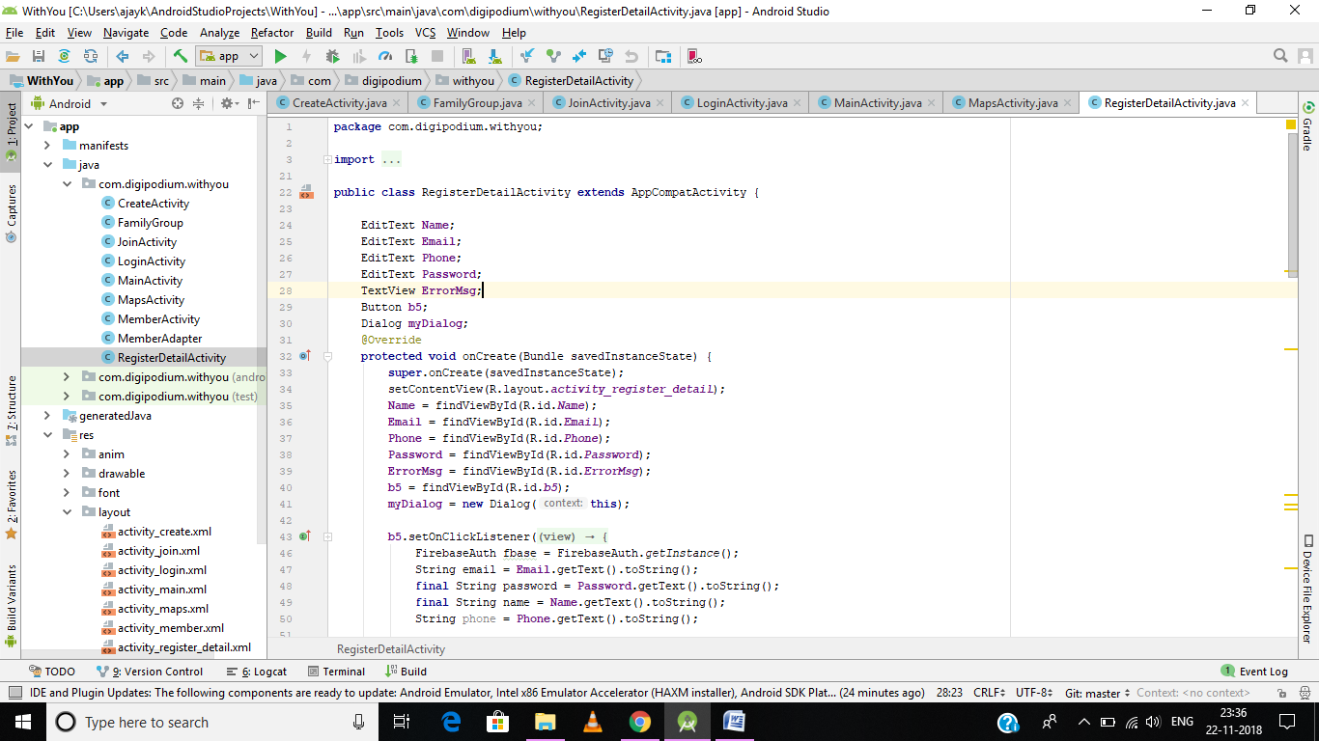

DATA STRUCTURE

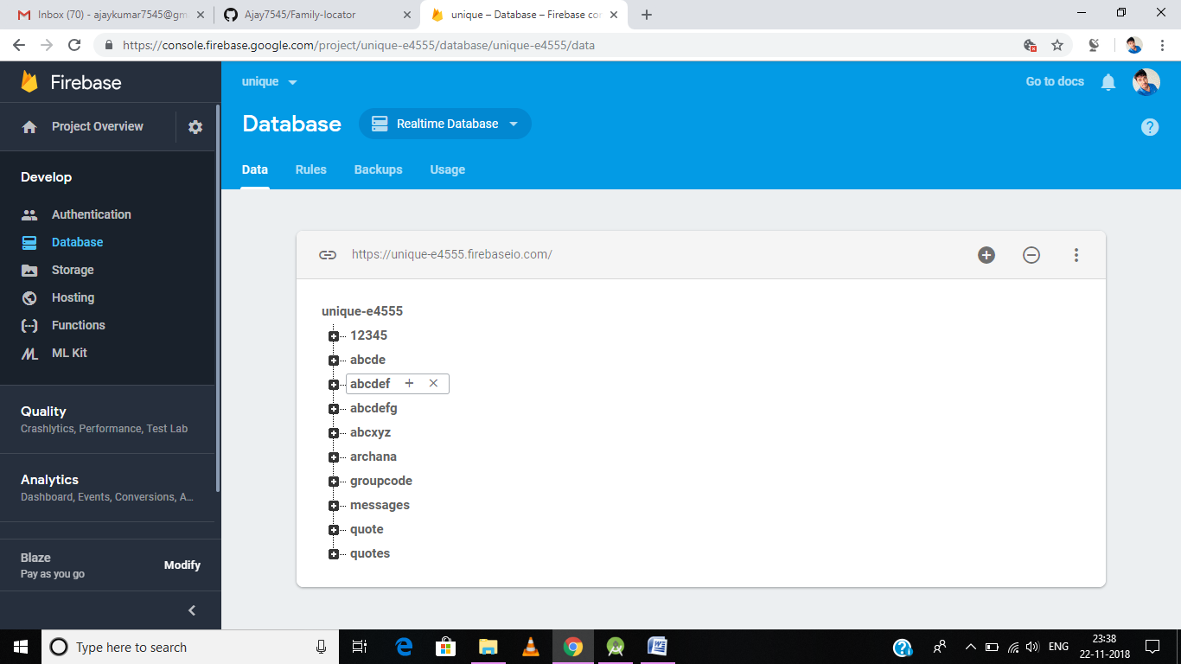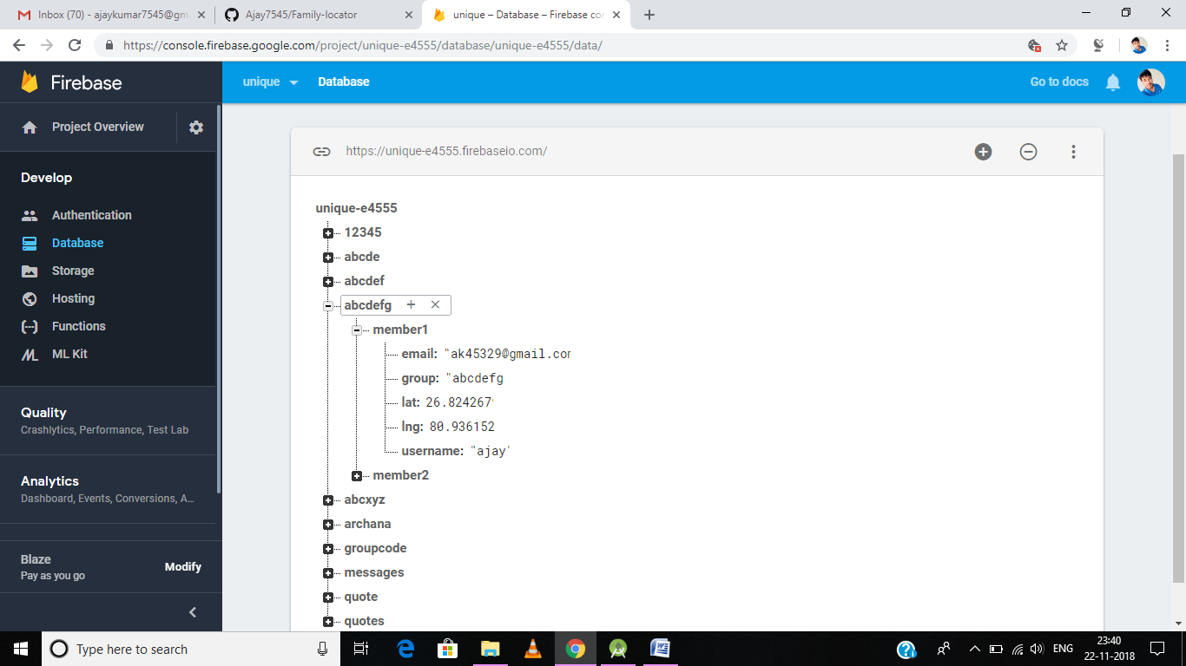

TESTING

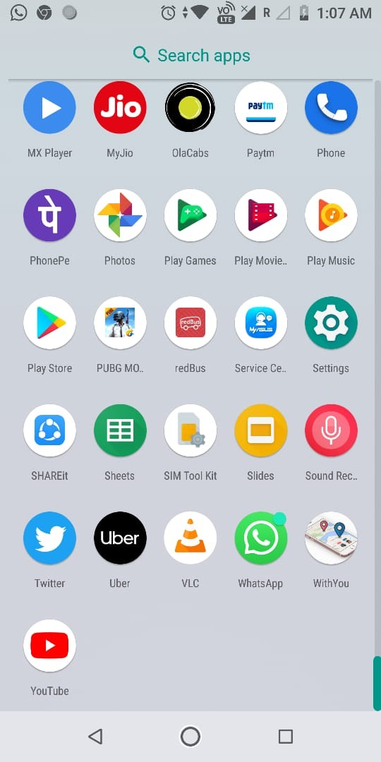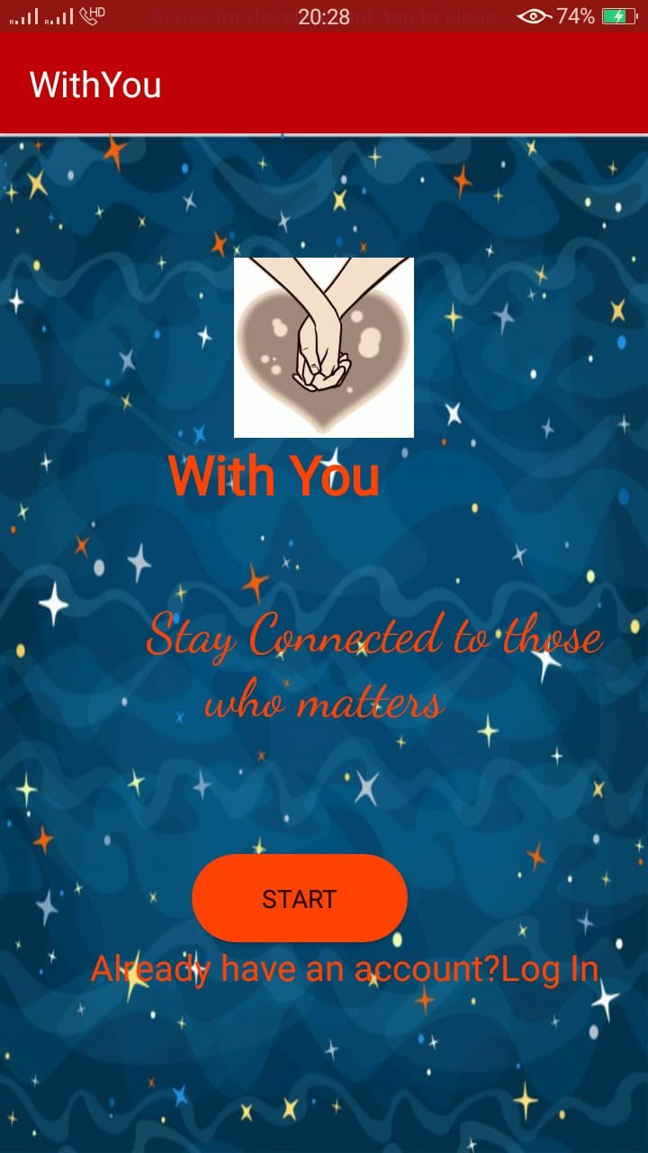

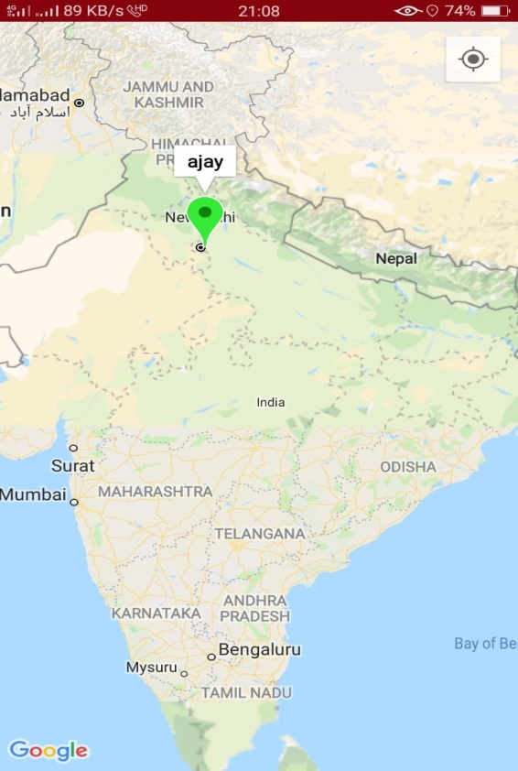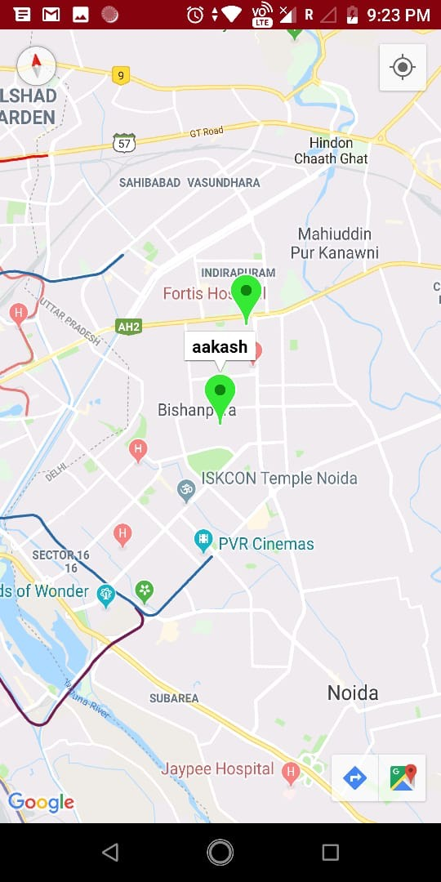

***Summary***

*After completing this project, I concluded that this project was thegood opportunity to implement my information that I have learntduring my internship program.*

*This project is more informative andmore helpful for understanding the concept of the android app development.*

*This project is only a small and easy one but it is enoughto implement my concept. I can further try much harder to makemuch more efficient and useful app that can benefit to other.*

***References***

*Following are the links from which all the information have been taken :*

*1. https://developer.android.com/training/basics/index.html*

*2. https://developer.android.com/training/basics/concept/creatingproject.html*

*3. http://www.hiddenbrains.com/android-application-development.html*