**Module-6**

**PC Hardware**

**Introduction:**

The motherboard, also known as the mainboard or system board, is a critical component in a computer that connects various hardware components to work together.

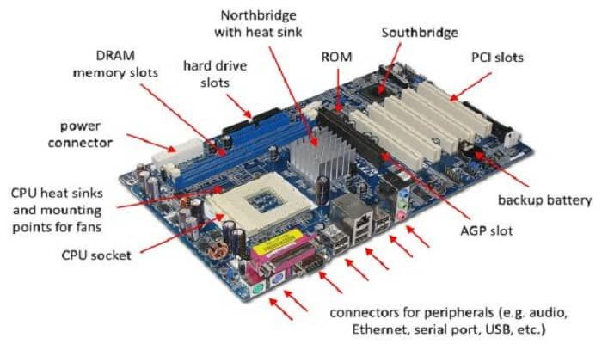

**Main components found on a motherboard:**

1. **CPU Socket (Central Processing Unit):** This is where the processor (CPU) is installed. The CPU is often considered as the brain of the computer. It controls overall components of the system.

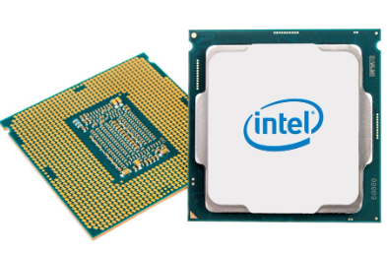

1. **RAM Slots (Random Access Memory):** These slots hold the system memory (RAM), which is used by the CPU to store and quickly retrieve data that is actively being used or processed.

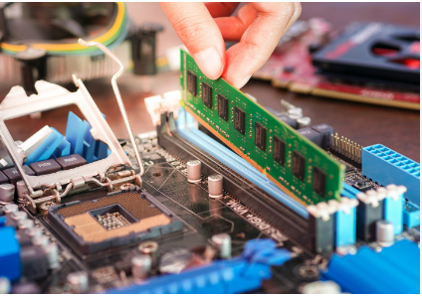

1. **Expansion Slots (PCIe, PCI, etc.):** PCI Stands for Peripheral Component Interconnect. These slots allow for the installation of additional components such as graphics cards, sound cards, network cards, and other expansion cards.

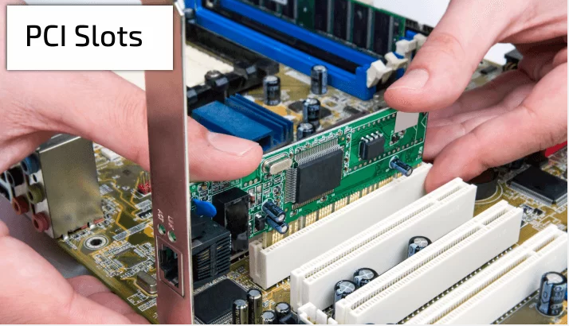

1. **Chipset:** The chipset is a set of chips on the motherboard that controls the flow of data between the CPU, memory, peripherals, and other components. It includes the Northbridge and Southbridge (or their modern equivalents).

* **Northbridge:** Manages communication between the CPU, RAM, and the graphics card (if integrated).
* **Southbridge:** Manages communication between the CPU, storage devices, USB ports, I/O (Input/Output) interface, network interface and other peripherals.

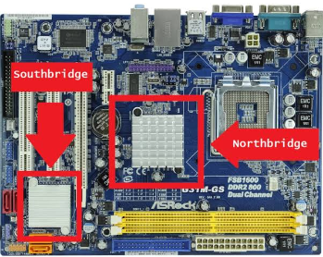

1. **BIOS/UEFI Chip:** This is a chip that stores the Basic Input/Output System (BIOS) or the Unified Extensible Firmware Interface (UEFI), which is essential for the system to boot and initialize hardware.

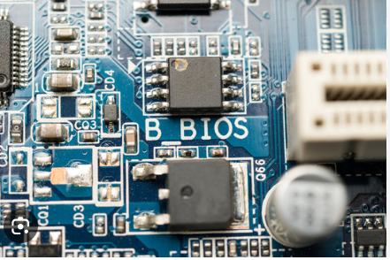

1. **Power Connectors:** These connectors provide power to the motherboard. Common ones include the main ATX power connector and additional power connectors for CPU and graphics cards.

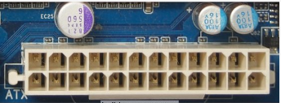

1. **Storage Connectors:** SATA (Serial ATA) and/or NVMe connectors for connecting hard drives, solid-state drives, and other storage devices.

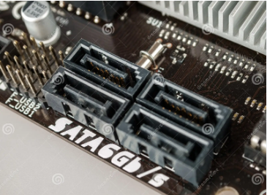

1. **Front Panel Connectors:** These connectors include power buttons, reset buttons, front panel audio jacks, and indicator LEDs.

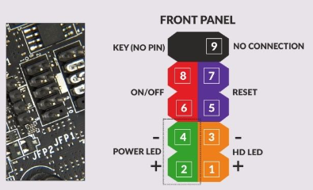

1. **Back I/O Ports:** These are the ports on the back of the motherboard that allow for connection to external devices. Common ports include USB, HDMI, Ethernet, audio jacks, and more.

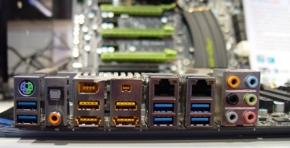

1. **Network Interface Controller (NIC):** This is the component responsible for network connectivity. It can be integrated into the motherboard or provided as a separate expansion card.

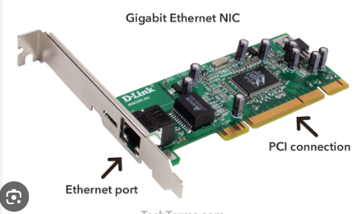

1. **Voltage Regulators/VRMs:** These components regulate and distribute power to the CPU and other critical components.

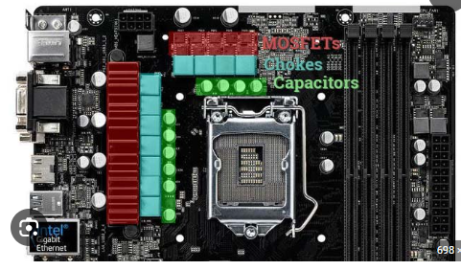

1. **SMPS:** The SMPS (Switched-Mode Power Supply) in the context of a computer refers to the power supply unit that converts electrical power from an external source (such as a wall outlet) into the appropriate voltages needed to power the components on the motherboard and other parts of the computer.

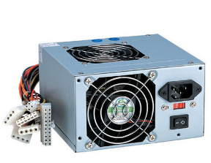

1. **CMOS:** A complementary metal-oxide semiconductor (CMOS) is the semiconductor technology used in most of today's integrated circuits (ICs), also known as chips or microchips. The main purpose of CMOS in computers is to store important system settings and configurations such as the date and time, boot order, hardware settings, and password information.

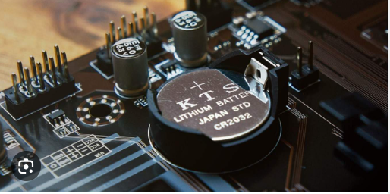

**Sub-Module: 6.2 Systems and Application Installation**

**BIOS (Basic Input/Output System)**

* BIOS is a firmware that is built into the motherboard of a computer. It is responsible for initializing and providing the communication between various hardware components of the system, such as the CPU, memory, and storage devices, during the boot process.
* Traditional BIOS has been used for a long time, but it has some limitations, such as the 2.2 TB limit on disk size and a lack of support for modern technologies.

**UEFI (Unified Extensible Firmware Interface)**

* UEFI is a more modern and versatile firmware interface that has largely replaced traditional BIOS in newer computers.
* UEFI provides a standardized interface between the operating system and the firmware, allowing for more advanced features and capabilities during the boot process.
* Some advantages of UEFI over BIOS include faster boot times, support for larger disk sizes, a graphical user interface (GUI), and the ability to use mouse input.

**Difference between BIOS and UEFI:**

|  |  |  |
| --- | --- | --- |
| **S.N** | **BIOS** | **UEFI** |
| 1. | Older/Legacy Technology. | Modern Technology |
| 2. | Operates in 16 bit real mode. | Operates in 32 bit or 64 bit real mode. |
| 3. | Uses MBR (Master Boot Record) Partitioning. | Uses GPT (GUID Partition Table) Partitioning. |
| 4. | Limitation on disk size i.e. 2.2 TB | No limitation on disk sizes. |
| 5. | Text based interface. | Offers a graphical interface. |
| 6. | Limited hardware supports. | Advance hardware support. |
| 7. | Less secure. | High secure. |
| 8. | Doesn’t support secure boot. | Support secure boot. |
| 9. | Slower speed | Faster speed |
| 10 | Low performance | High performance |

**Conversion from MBR to GPT or GPT to MBR**

Converting a disk from MBR (Master Boot Record) to GPT (GUID Partition Table) involves several steps, and it's important to note that this process will result in data loss. Therefore, make sure to back up any important data on the disk before proceeding. The following steps provide a general guide for converting MBR to GPT using the Windows built-in tools:

**Using Disk Management:**

1. **Open Disk Management:** Press Win + X and choose "Disk Management."
2. **Identify the Disk:** Identify the disk you want to convert from MBR to GPT. Make a note of the disk number.
3. **Backup Data:** Ensure that you have a backup of all data on the disk, as the conversion process will erase the existing partitions.
4. **Open Command Prompt as Administrator:** Press Win + X and select "Command Prompt (Admin)" or "Windows PowerShell (Admin)."
5. **Run Diskpart:** In the Command Prompt, type **diskpart** and press Enter.
6. **List Disk:** Type **list disk** to display all connected disks.
7. **Select Disk:** Type **select disk X** (replace X with the disk number you noted earlier).
8. **Clean the Disk:** Type clean to remove all partitions and data from the disk.
9. **Convert to GPT:** Type convert gpt to convert the disk to the GPT format.
10. **Exit Diskpart:** Type exit to exit the Diskpart utility.
11. **Initialize the Disk:** Go back to Disk Management, right-click on the disk that was just converted, and choose "Initialize Disk." Select GPT as the partition style.
12. **Create New Partitions:** Right-click on the unallocated space on the disk and create new partitions as needed.

**Operating System**

* An operating system (OS) is system software that serves as an intermediary (मध्यस्थ) between computer hardware and the computer user. It manages and controls computer hardware, provides services for computer programs, and allows users to interact with the computer
* Common examples of operating systems include **Microsoft Windows, macOS, Linux, and UNIX**. Each type of OS has its strengths, features, and use cases, catering to the needs of different users and computing environments.

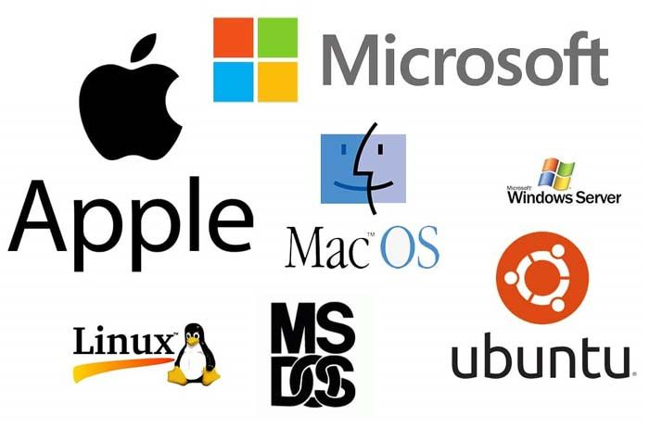

**Operating System (OS) installation process**

The process of installing an operating system can vary depending on the specific OS and the type of installation method you choose. Below is a generalized overview of the steps involved in installing an operating system:

**1. Preparation:**

**Backup:** Before installation, ensure you have a backup of important data in case anything goes wrong during the installation process.

**System Requirements:** Verify that your hardware meets the minimum requirements for the chosen operating system.

**2. Choose Installation Media:**

Installation Disc/USB: Create a bootable installation disc or USB drive containing the operating system.

**3. BIOS/UEFI Settings:**

**Access BIOS/UEFI:** Restart the computer and enter the BIOS or UEFI settings. You can usually do this by pressing a specific key during the boot process (common keys include F2, Del, Esc, F10, F12 or other).

**Boot Order:** Set the boot order to prioritize the installation media (disc or USB) so that the computer boots from it.

**4. Boot from Installation Media:**

**Insert Disc/USB:** Insert the installation disc or connect the USB drive.

**Restart Computer:** Restart the computer, and it should boot from the installation media.

**5. Follow Installation Wizard:**

**Language and Region:** Choose your preferred language, time zone, and region.

**Product Key:** Enter the product key if required.

**Partitioning:** Decide on the partitioning scheme for your hard drive. You might create new partitions or choose an existing one.

**Format and Install:** Format the chosen partition and initiate the installation process.

**6. Configure Settings:**

**User Account:** Set up a user account with a password.

**Network Settings:** Configure network settings, if applicable.

**Customization:** Customize system settings and preferences.

**7. Finalize Installation:**

**Install Drivers:** Some operating systems might require additional drivers for specific hardware. Install these if needed.

**Updates:** Check for and install system updates.

**Reboot:** Restart the computer to complete the installation.

**8. Post-Installation:**

**Install Software:** Install additional software and applications as needed.

**Restore Data:** If you backed up data, restore it to the system.

**9. Verification:**

**Verify Installation:** Ensure the operating system is functioning correctly, check for updates, and confirm that all drivers are working.

**10. Security Measures:**

**Antivirus:** Install antivirus software for system security.

**Firewall:** Configure a firewall to control incoming and outgoing network traffic.

**Steps for creating bootable USB drive:**

**For Windows:**

1. **Using Rufus:**

**Download Rufus:** Go to the Rufus website and download the latest version of Rufus.

1. **Insert USB Drive:** Insert the USB flash drive into a USB port on your computer.
2. **Run Rufus:** Run the Rufus application.
3. **Select USB Drive:** In Rufus, select your USB drive under the "Device" dropdown.
4. **Select Bootable Image:** Click on the "Select" button next to "Boot selection" and choose the ISO file of the operating system you want to install.
5. **Configure Settings:** Adjust any necessary settings, like the partition scheme (usually MBR for BIOS or UEFI for GPT), file system, and cluster size.
6. **Start the Process:** Click "Start" and confirm any warnings about data loss on the USB drive.
7. **Wait for Completion:** Rufus will format the USB drive and copy the necessary files. Wait for the process to complete.
8. **Completion:** Once the process is finished, you will see "READY" in green. You can now close Rufus.

**Device Driver:**

A device driver, often referred to simply as a "driver," is a specialized software component that allows an operating system to communicate with and control a specific hardware device. It acts as an intermediary between the hardware device and the operating system or applications, enabling them to interact seamlessly. For example: Printer Driver, Audio Driver, Network Driver .etc.

Function of Driver:

* Makes different types of hardware devices (like printers, graphics cards, etc.) understandable to the computer.
* Helps get the hardware ready to work when you turn on your computer.
* Makes it easy for the computer to recognize and use new devices you plug in.
* Makes sure you can see graphics, print documents, and use different hardware features through your computer.

**Driver Installation:**

1. **Download Driver:** Visit the manufacturer's website and download the latest driver for your hardware.
2. **Run Installer:** Double-click on the downloaded file to run the installer.
3. **Follow Wizard:** Follow the on-screen instructions in the installation wizard.
4. **Restart:** Restart your computer if prompted.
5. **Check Device Manager:** Open Device Manager to verify successful installation.

**Application Software:**

Application software, commonly known as applications or apps, refers to computer programs designed to perform specific tasks or provide specific functions for end-users. Unlike system software, which manages and supports the computer infrastructure, application software is user-focused and aims to fulfill the needs and requirements of individuals or organizations. For example: Microsoft Office Package, Chrome, PDF Reader .etc.

**Application Software Installation:**

1. Download the installer from the official website.
2. Run the installer file.
3. Accept the license agreement.
4. Start the installation process.
5. Wait for the installation to complete.
6. Finish the installation.
7. Optionally, launch the application.



**Antivirus**

An antivirus (or anti-virus) is a type of software designed to detect, prevent, and remove malicious software from computer systems. It helps protect your system from harmful software called malware, which includes viruses and other bad stuff. The antivirus scans your computer, looks for signs of these threats, and removes or quarantines them to keep your computer safe. Example of antivirus software: eScan, K7, MSecurity .etc.

**Antivirus Installation Process:**

1. Choose antivirus software.
2. Download the installer from the official website.
3. Run the installer and follow the on-screen instructions.
4. Customize settings if needed.
5. Wait for the installation to complete.
6. Register or activate the software if required.
7. Update the antivirus to get the latest protection.
8. Optionally, perform an initial scan.
9. Restart your computer if prompted.
10. Look for the antivirus icon in the system tray to ensure it's running.



**Disk Partition:**

Disk partitioning is like dividing your computer's storage into separate sections, each with its own specific job. It helps organize data, allows for different uses, and makes it easier to manage and protect your digital information.

Following steps are required to be followed for creating disk partition:

1. **Open Disk Management:** Press Win + X and choose "Disk Management" from the menu.
2. **Locate the Disk:** In the Disk Management window, find the disk you want to partition. Be cautious to select the correct disk.
3. **Shrink Existing Partition:** Right-click on the existing partition and choose "Shrink Volume “and enter the amount of space you want to allocate for the new partition. This creates unallocated space.
4. **Create a New Partition:** Right-click on the unallocated space and select "New Simple Volume." Follow the wizard to set the size, assign a drive letter, and choose the file system (usually NTFS).
5. **Complete the Wizard:** Complete the wizard, and your new partition is created.

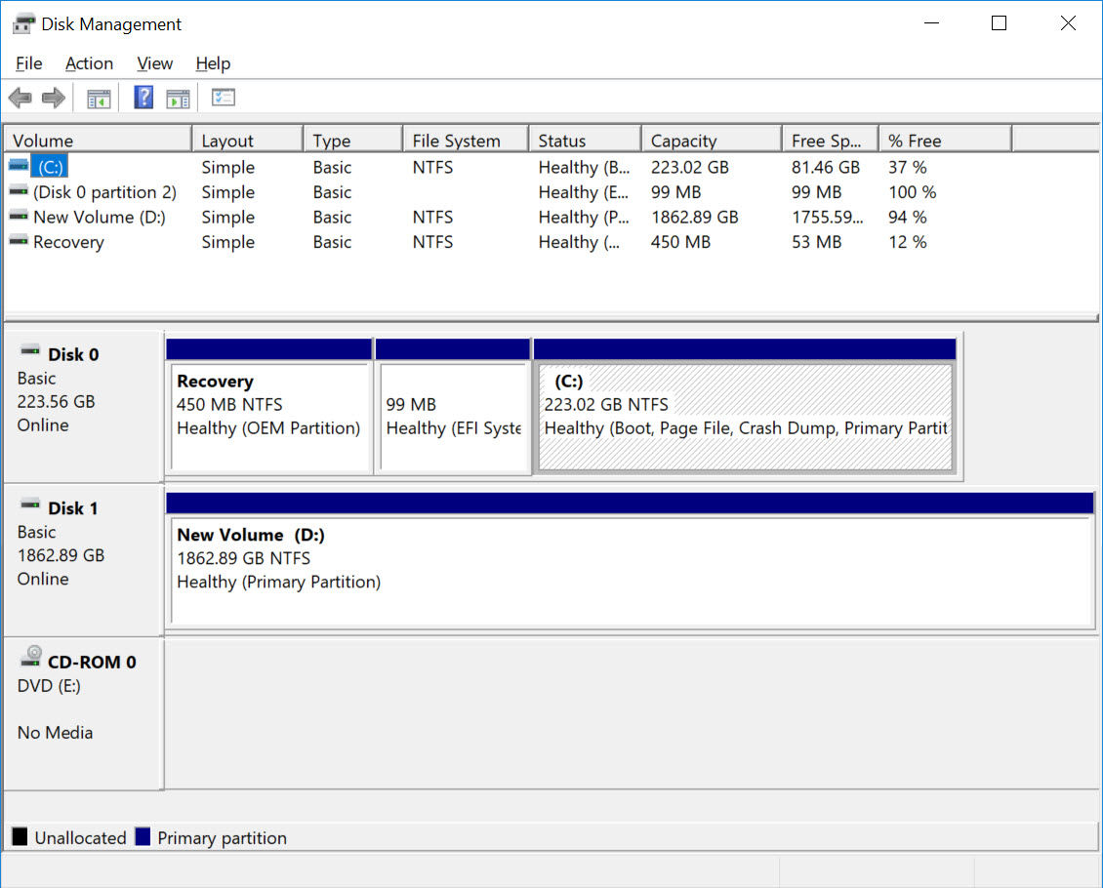

**Recovery disk**

A recovery disk is a bootable media or set of files designed to help troubleshoot, repair, and restore a computer's operating system in the event of system failures, errors, or other critical issues. It provides a means to recover the system to a functional state.

**Steps for creating a Recovery Disk on Windows:**

1. **Insert a USB Drive:** Insert a USB flash drive with sufficient storage capacity (at least 8GB) into your computer.
2. **Open Control Panel:** Open the Control Panel on your Windows computer.
3. **Navigate to "Backup and Restore (Windows 7)":** Go to "System and Security" > "Backup and Restore (Windows 7)."
4. **Create a System Repair Disk:** In the left pane, click on "Create a system repair disk."
5. **Select USB Drive:** Choose your USB drive from the list and click "Create." This process will copy the necessary files to the USB drive, making it a bootable recovery disk.

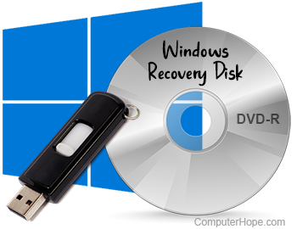

**Creating System Restore Point**

Creating a System Restore Point on Windows allows you to capture a snapshot of your system's settings and configuration at a specific point in time. If anything goes wrong later, you can use this restore point to revert your system to a previous state. Here are the steps to create a System Restore Point on Windows:

**Using Windows 10:**

1. **Open System Properties**: Right-click on the "Start" button and select "create restore point."
2. **Access System Protection:** In the System window, click on "System Protection" in the left sidebar.
3. **Create a Restore Point:** In the System Properties window, under the "System Protection" tab, click on the "Create" button.
4. **Name the Restore Point:** Provide a descriptive name for the restore point. This helps you identify it later.
5. **Create:** Click "Create" and wait for the process to complete. It may take a few moments.
6. **Finish:** Once the restore point is created, you'll see a confirmation message. Click "Close" to finish.

**CD/DVD**

Compact Discs (CDs) and Digital Versatile Discs (DVDs) are optical storage mediums that have been widely used for storing and distributing digital data, including music, videos, software, and other types of files. To create a bootable media using disc blank CD/DVD is required. There are different software that are used to burn disc such as PowerISO, Imgburn.

**Bootable CD/DVD**

Steps to create a bootable CD/DVD using PowerISO:

1. **Download and Install PowerISO:** Download and install PowerISO from the official website: PowerISO.
2. **Open PowerISO:** Launch PowerISO on your computer.
3. **Insert Blank DVD:** Insert a blank DVD into your computer's DVD writer.
4. **Choose "Burn to Disc":** In PowerISO, go to the "Tools" menu and select "Burn to Disc."
5. **Select ISO File:** Select the ISO file you want to burn to the DVD.
6. **Configure Burning Settings:** Configure burning settings such as the burning speed..
7. **Start Burning:** Click on the "Burn" button to start the burning process.
8. **Wait for Completion:** Allow the burning process to complete. Once finished, PowerISO will notify you.

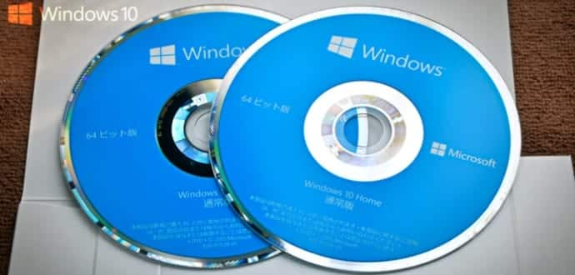

**UPS (Uninterruptible Power Supply)**

In a computer system, a UPS (Uninterruptible Power Supply) is a critical component that provides power backup and protection to connected devices, such as computers, monitors, and network equipment in case of electrical outages(विधुत कटौती) or fluctuations(उतार चढाव).

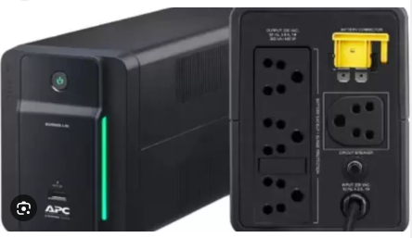

**Utility tools (Hiren’s boot CD)**

Hiren's boot CD can fix issues like hard drive failure and virus infections, perform password & data recovery, and execute other operations on your PC. It's commonly used by technicians, IT professionals, and individuals for troubleshooting and fixing issues with computer systems.

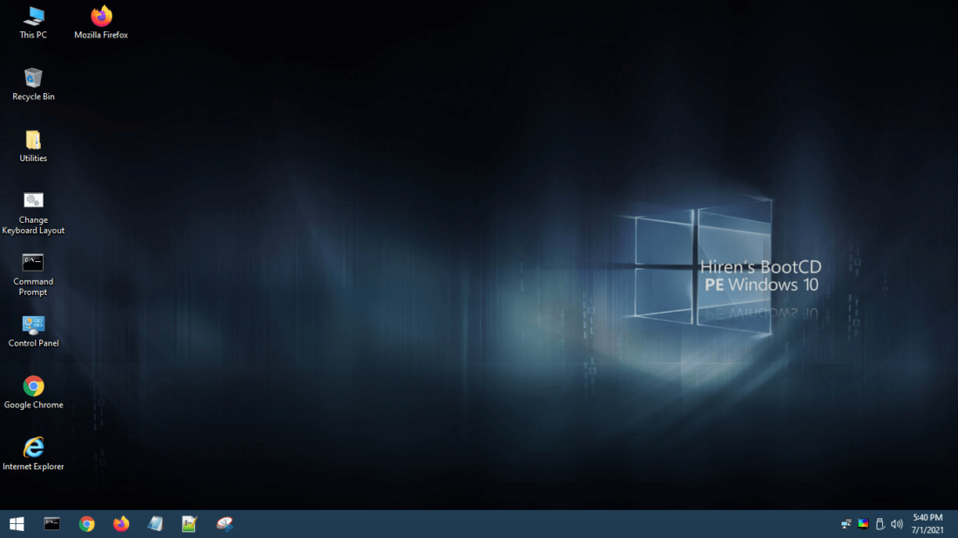

**Sub-module: 6.4 Hardware Upgrading**

**1.`Motherboard Upgrade**

Steps involved in motherboard upgrading:

1. Screw Driver n] Casing vf]Ng] .
2. k'/fgf] Motherboard af6 Power Connectors, SATA/PATA/SSD Data Cable, front Panel Connectors, RAM / Processor ;a} lemSg] .
3. Screw Driver n] Motherboard sf ;a} k]rx? vf]Ng] / Motherboard nfO{ Chasis af6 lemSg] .
4. Higher Model cyjf Higher Series sf] Motherboard nfO{ Chasis df /fVg] / ldnfP/ Screw Driver n] k]]rx? s:g] .
5. Higher Model sf] gof+ Motherboard df Processor / RAM lkm6 ug]{ .
6. Power Connectors, SATA/PATA/ SSD Data Cable, Front Panel Connectors x? klg hf]8\g] .
7. ca Computer ON ug]{ / gof+ Motherboard sf ;Dk"0f{ Driver x? Install ug]{ .
8. Now system is ready to operate.

**2. RAM Upgrade**

Steps involved in RAM upgrading:

1. Screw Driver n] Casing vf]Ng] .
2. Motherboard बाट RAM झिक्ने ।
3. नयाँ RAM को Version Motherboard सँग Compatible भए नभएको check गर्ने
4. Compatible ePsf] v08df a9L Space ePsf] gof+ RAM nfO{ Motherboard sf] Slot df Fit ug]{ .
5. b'a} gof+ / k'/f+gf] RAM x? rnfpg] xf] eg] gof+ RAM nfO{ csf{] Slot df Fit ug]{ .
6. ca Computer ON ug]{
7. Now system is ready to operate.

**3. Hard Disk Upgrade**

Steps involved in Hard Disk Upgrading are listed below:

1. Screw Driver n] Casing vf]Ng] .
2. al9 Space / RPM sf] Hard Disk nfO{ k'/fgf] Hard Disk sf] PATA Cable d} hf]8\g] cyjf 5'6\6} SATA/PATA/SSD Data Cable n] Motherboard ;+u hf]8\g] / Fit ug]{ .
3. gofF / k'/fgf] b'j} Hard Disk x? Pp6} PATA Cable df hf]l8Psf] xf] eg] jumper Configuration ul/ master / slave agfpg] .
4. gof+ Hard Disk Pp6f dfq} rnfpg] xf] eg] k'/fgf] Hard Disk nfO{ k]r vf]n]/ data, Power Connector x? 5'6fP/ lemSg] / To;sf] 7fpFdf gofF Hard Disk Fit ug]{ .
5. gof+ Hard Disk df Data Cable / Power Connector hf]8\g] .
6. gofF Hard Disk nfO{ Format ug]{ / cfa:ostf cg';f/ Operating System Install klg ug]{ .
7. Now system is ready to operate.

**4.. Processor Upgrade**

Steps involved in Processor Upgrading are listed below:

1. Screw Driver n] Casing vf]Ng] .
2. Cooling Fan sf] Power Connector Motherboard af6 lemSg] .
3. Cooling Fan / Heat sink Processor Socket af6 lemSg] .
4. k'/f+gf] Processor nfO{ Processor Socket af6 lemSg] .
5. gofF high speed sf] Processor / Motherboard sf] Compatibility Check ug]{ .
6. Compatible ePsf] ख08df gof+ High Speed sf] Processor nfO{ Processor Socket df /fVg] .
7. gof+ Processor dfly Cooling Paste nufpg] .
8. ca Heat Sink / Cooling Fan klg Processor Socket df Fit ug{] / Cooling Fan sf] Power Connector Motherboard df hf]8\g] .
9. Now your system is ready to operate.

.

.

.

**Sub-module 6.6: Set Death Case Hardware troubleshooting**

**1. Power Supply (SMPS) Troubleshoot**

Troubleshooting issues with a Switched-Mode Power Supply (SMPS), commonly known as a power supply unit (PSU), involves identifying and addressing problems related to power delivery in a computer or electronic device. The amount of current that flow through each pin is shown in the given diagram:

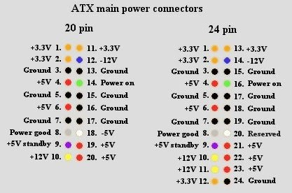

Here are some steps you can take to troubleshoot issues with an SMPS:

1. SMPS sf] P1 Power Connector sf] xl/of] tf/sf] Kjfn / sfnf] tf/sf] KjfnnfO{ ;fgf] tf/n] ;6 ug]{ / SMPS nfO{ Power lbg] .
2. SMPS nfO{ Power lbO{ ;s]kl5 o:sf] Fan 3'Dof] of 3'd]g x]g]{ .
3. SMPS sf] Fan 3'd]g / Power ;+rf/ ePg eg] gofF SMPS n] Replace ug]{ .
4. SMPS sf] Fan 3'd]g eg] SMPS df hf]8\g] Power Cable Check ug]{ .
5. Power Cable lalu{Psf] v08df Power Cable km]g]{ .
6. SMPS sf] Fan 3'd]sf] 5 eg] P1 Power Connector sf tf/x?df cfPsf] Voltage Multimeter n] hfFr ug]{
7. P1 Power Connector sf] /ftf] tf/df % ef]N6, kx]nf] tf/df !@ ef]N6, ;]tf] tf/df –% ef]N6, lgnf] tf/df —!@ ef]N6 / ;'Gtnf /Ësf] tf/df —# ef]N6 cfPsf] 5 5}g Multimeter n] Check ug]{ .
8. cfjZos Voltage cfPsf] 5}g eg] Screw Driver n] SMPS vf]Ng] / Loose ePsf tf/x? 5g\ eg] Soldering Iron / Soldering Wire k|of]u u/L tL tf/x?nfO{ Soldering ug]{ .
9. ;f]N8l/ª u/] kl5 tf/x?af6 lgoldt cfpg' kg]{ Voltage cfPg eg] gofF SMPS n] Replace ug]{ .

.

**2. Motherboard troubleshoot**

Here are the steps to troubleshoot common motherboard issues :

1. Operating System Install ubf{ ub}{ Installation k|lqmof /f]lsP/ Monitor df lgnf] Screen df Message Display eof] eg] Motherboard Replace ug]{ .
2. Computer ON ubf{ Motherboard df Power cfPg / CPU Fan 3'd]g eg] Motherboard Replace ug]{ .
3. Processor, RAM / Display Card l7s eP/ klg Monitor df Display cfPg eg] Motherboard Replace ug]{ .­­
4. Motherboard df hlt gofF RAM Replace ubf{ klg Memory ;d:ofsf] beep sound lbof] eg] Motherboard Replace ug]{ .
5. Motherboard sf ;a} expansion Card x? lems]/ / ;a SATA÷PATA/SSD Cable lems]/ Motherboard nfO{ klg Chasis af6 lgsfn]/ aflx/af6 Connect ubf{ klg Power ;+rf/ ePg eg]]] Motherboard Replace ug]{ .
6. Motherboard sf] GMCH (Graphic memory controller hub) Chip Heat x'g] ;d:of l7s ePg eg] / Computer Hang dfq} eof] eg]]] Motherboard Replace ug]{ .

**3. Processor troubleshoot**

Here are the steps to troubleshoot Processor issues :

1. Computer ON ubf{ System Loading ePg / Boot x'g] Process cl3 a9]g eg] gofF Processor n] Replace ug]{ .
2. Motherboard, RAM / display÷VGA Card l7s ePsf] v08df olb Monitor df Display cfPg eg] gofF Processor n] Replace ug]{ .
3. w]/} sfo{ -Multitask_ ubf{ cyjf 7"nf7"nf ;fO{hsf Program x? Load ubf{ Computer Hang eof] eg] k'/fgf] Processor sf] eGbf al9 Speed ePsf] Processor n] Replace ug]{ .
4. Processor tfltP/ Hang ePsf] xf] eg] Cooling Fan / Heat sink lemSg] / Processor dfly Cooling Paste nufP/ Heat sink / Cooling Fan /fd|/L Fit ug]{ .

**4. RAM Troubleshooting**

Here are the steps to troubleshoot RAM issues :

1. Computer ON u/]kl5 tLg rf]6L qmdzM lak sound cfof] eg] gofF RAM n] Replace ug]{ .
2. Computer ON ubf{ olb Monitor df Display cfPg eg] RAM Check ug]{ .
3. RAM nfO{ Slot af6 lemSg] / csf]{ Slot df Fit ug]{ .
4. k'g Display cfPg eg] km]/L RAM nfO{ lemSg] / a|';n] RAM sf Slot x?nfO{ /fd|/L ;kmf ug]{ / RAM sf] Pin / Lock ;kmf ug]{
5. RAM Slot / RAM sf] ;kmfO{ u/]kl5 ca RAM nfO{ Slot df Fit ug]{ / Display Check ug]{ .
6. olb Pp6f eGbf a9L RAM 5g\ eg] ;a} RAM x? lemSg] / Pp6f Pp6f u/]/ ;a} RAM x?nfO{ kfn} kfnf] ;a} Slot x?df Fit u/]/ Check ug]{ .
7. olb olt ubf{ पनि Monitor df Display cfPg eg] gofF RAM n] Replace ug]{ .
8. olb Computer Hofb} l9nf] Boot eof] / Computerdf programx? l9nf] Loading eP k'/fgf] RAM sf] eGbf a9L Space sf] RAM n] Replace ug{] .

**5. BIOS Troubleshooting**

Here are the steps to troubleshoot BIOS issues :

1. Motherboard sf] Manual df BIOS ;DalGw laj/0f cWoog ug]{ .
2. Motherboard sf] BIOS Setup Key÷Configure Key gf]6 ug]{ .
3. Computer ON ug]{ .
4. Keyboard df BIOS Setup Key÷Configure Key nuftf/ lyRg] / BIOS Setting nfO{ Default df Nofpg]
5. BIOS Setting nfO{ Default df Nofpg csf]{ tl/sf ckgfpg] xf] eg] Motherboard sf] BIOS jumper nfO{ ;fg]{ / Computer ON ug]{ .
6. Computer ON u/]/ F2÷Delete Key lyr]/ BIOS df hfg] / Default Setting Load ug]{ / Computer OFF ug]{ .
7. ;fl/Psf] jumper nfO{ klxn]s} 7fpdf ÷ klxn]s} ca:yfdf /flvlbg]

**6. CMOS Battery Troubleshoot**

Here are the key steps to troubleshoot CMOS Battery issues:

1. Motherboard sf] Manual df CMOS Battery ;DalGw laj/0f cWoog ug]{ .
2. Motherboard af6 CMOS Battery lgsfNg] .
3. Multimeter n] BIOS Battery sf] Voltage # ef]N6 5÷5}g Check ug]{ .
4. BIOS Battery sf] Voltage # ef]N6 5}g eg] gofF BIOS Battery n] Replace ug]{ .

**Sub-module: 6.7 No Set Death Case Hardware Troubleshooting**

.

**1. Hard Disk Troubleshooting**

Here are the key steps to troubleshoot Hard Disk issues:

1. Computer ON ug]{ / DEL/F2 Key lyr]/ BIOS df hfg] .
2. BIOS df Hard Drive detect ePsf] 5 of 5}g Check ug]{ .
3. BIOS df Hard Drive detect ePsf] 5}g eg] ;'?df Drive sf] SATA/PATA/SSD Cable Replace ug]{ .
4. Hard Disk df hf]l8Psf] Power Cable df ;d:of 5 of 5}g hfFr u/]/ ;d:of eP csf{] Power Connector nufpg] .
5. o;f] u/]/ klg BIOS df Hard Drive Detect ePg eg] Motherboard df Hard Drive sf] SATA/PATA/SSD Cable lemSg] / csf]{ IDE÷SATA Port df hf]8\g] .
6. ;d:of ;dfwfg ePg eg] k'/fgf] Hard Drive lemSg] / gofFn] Replace ug]{ .
7. Computer Boot x'g] a]nfdf æHard Disk FailureÆ eg]/ Message cfof] eg] klg l;w} gofF Hard Drive n] Replace ug]{ .]]
8. Computer Boot x'g] a]nfdf !&)) Series sf] Error Code Message Display eof] eg] klg l;w} gofF Hard Drive n] Replace ug]{ .
9. Hard Drive nfO{ Format ug{{ vf]Hbf olb Format x'b} ePg eg] klg l;w} gofF Hard Drive n] Replace ug]{ .

**2. Keyboard troubleshooting**

Here are key steps to troubleshoot Keyboard issues:

1. Computer Start ubf{ Keyboard grn]sf] v0bdf Keyboard sf] Cable 5'6fpg] .
2. Keyboard sf] PS/2 Connector sf] Pin x? aflËPsf eP lrD6fn] l;wf kfg]{ .
3. USB Connector ePsf] Keyboard eP csf]{ USB Port df hf]8]/ hfFr ug]{ .
4. dflysf] sfo{ ubf{ klg Keyboard n] sfd u/]g eg] Screw Driver n] Keyboard vf]Ng] / a'|;n] klxn] ;a} 3'nf] kmfNg] .
5. Keyboard sf] circuit board nfO{ / Key grid nfO{ IPA liquid k|of]u u/L a|';n] /fd|/L Chemical Wash ug]{ .
6. xn'sf leh]sf] sk8fn] Key Pad / Key switch df ePsf] d}nf] ;kmf ug]{ .
7. dflysf] sfo{ ubf{ klg Keyboard n] sfd u/]g eg] Keyboard Replace ug]{ .

.

**3. Mouse Troubleshooting**

Here are key steps to troubleshoot Mouse issues:

1. Computer Start ubf{ Mouse grn]sf] v0bdf Mouse sf] Cable 5'6fpg] .
2. Mouse sf] PS/2 Connector sf] Pin x? aflËPsf eP lrD6fn] l;wf kfg]{ .
3. USB Connector Mouse eP csf]{ USB Port df hf]8]/ hfFr ug]{ .
4. dflysf] sfo{ ubf{ klg Mouse n] sfd u/]g eg] Screw Driver n] Mouse vf]Ng] / a'|;n] klxn] ;a} 3'nf] kmfNg] .
5. dflysf] sfo{ ubf{ klg mousen] sfd u/]g eg] Mouse Replace ug]{ .

**4. Error Message Troubleshooting**

Here are key steps to troubleshoot error message issues:

1. Computer Boot x'b} ubf{ æHard Disk FailureÆ eg]/ Message cfof] eg] Hard Disk Replace ug]{ .
2. olb !&)) Series sf] Error Code Message cfof] eg] klg Hard Disk Replace ug]{ .
3. olb !)) Series sf] Error Code Message cfof] eg] Motherboard Replace ug]{ .
4. olb #)) Series sf] Error Code Message cfof] eg] Keyboard Replace ug]{ .
5. Computer Boot x'b} ubf{ æBoot failureÆ, æSelect Proper Boot DevicesÆ eg]/ Message cfof] eg] klxnf BIOS df Boot Sequence ldnfpg] / ;d:of ;dfwfg ePg eg] Hard Disk sf] SATA/PATA/SSD Cable km]g]{ / geP Hard Disk g} km]g]{ .
6. Computer Boot ubf{ æNTDLR Missing/bootmgr missingÆ eg]/ Message cfof] eg] recovery console rnfO{ missing file recover ug]{ cyjf Operating System ReInstall ug]{ .
7. Computer Boot ubf{ æSet Date and TimeÆ eg]/ Message cfof] eg] CMOS Battery km]g]{ / BIOS df uP/ Date / Time Set ug]{ .

**5. Display Troubleshooting**

Here are key steps to troubleshoot display issues:

1. Motherboard sf] CMOS Battery glhssf] CMOS clear ug]{ Jumper sf] :yfg % b]lv !) ldg]6 ;Dd kl/jt{g ug]{ .
2. :yfg kl/jt{g u/]sf] Jumper nfO{ k'/fg} :yfg df /fVg] .
3. of] u/]df CMOS Setting Clear eP/ Display cfpF5 t/ olb Display cfPg eg] ca CMOS Battery Check ug]{ .
4. Multimeter n] CMOS Battery sf] Voltage # ef]N6 5 of 5}g Check ug]{ / olb # ef]N6 5}g eg] CMOS Battery km]g]{ / Display Check ug]{ .
5. cem} ePg eg] Motherboard df ;a} SATA/PATA/SSD Cable x? / Expansion Card x? 5'6fpg] / Display Check ug{] .
6. km]l/ klg Display gcfPsf] v08df Motherboard nfO{ Casing af6 lemSg] / aflx/af6 g} Computer ON u/]/ Display Check ug]{ .
7. cem} Display gcfPsf] v08df RAM nfO{ lemSg] / csf]{ Slot df Fit ug]{ / Display Check ug]{ .
8. cem} ePg eg] ca k'/fgf] RAM nfO{ gofF RAM n] Replace ug]{ .
9. ePg eg] ca Motherboard sf] PCI Slot df gofF VGA Card /fv]/ Display Check ug]{ .
10. RAM / VGA Card km]/]/ klg Display cfPg eg] ca gofF Motherboard n] Replace ug]{ .
11. gofF Motherboard Replace u/]/ klg Display cfPg eg] cTodf CPU ÷Processor g} Replace ug]{ / Display Check ug]{ .
12. Display cfPsf] v08df Motherboard Replace u/]sf] 5 eg] gofF Motherboard sf] ;Dk"0f{ Driver x? CD/DVD af6 Install ug]{ .
13. Monitor df ;d:of ePsf] v08df jf Monitor lalu|Psf] ca:yfdf gofF Monitor n] Replace ug]{ .

.

**6. Software Troubleshooting**

Here are key steps to troubleshoot software issues:

1. Software÷program slow / hang ePdf RAM df Load ePsf] ;a} Software÷program nfO{ Close ug]{ .
2. Software÷program nfO{ Re-open ug
3. Re-open ubf{ Software÷program n] sfd u/]g eg] Computer nfO{ Restart ug]{ .
4. Computer Restart ubf{ Software÷ program rn]g eg] Software÷ program unInstall ug]{ .
5. km]l/ Software÷program Install ug]{ .
6. Install ul/Psf] Software÷program Files nfO{ Antivirus Software n] scan ug]{ .
7. dflysf sfo{x?af6 ;d:of ;dfwfg ePg eg] Internet sf] k|of]u u/L ;d:ofsf] ;dfwfg vf]Hg] .

.

**7. Internal DOS Command**

DOS (Disk Operating System) commands are text-based commands used to perform various tasks in the MS-DOS. An internal command is the MS-DOS command stored in system memory and loaded from command.com or cmd.exe. Here are some common internal DOS commands:

| **Command** | **Description** | | **Example** |
| --- | --- | --- | --- |
|  |  | | **DIR** |
| **CD** | **DIR** | | Directory Listing |
| **MD** | Make Directory | | **MD [directory_name]** |
| **RD** | Remove Directory | | **RD [directory_name]** |
| **COPY** | Copy Files | | **COPY [source] [destination]** |
| **DEL** | Delete Files | | **DEL [file_name]** |
| **REN** | Rename Files | | **REN [old_file_name] [new_file_name]** |
| **TYPE** | Display Content of Text File | | **TYPE [file_name]** |
| **CLS** | Clear Screen | | **CLS** |
| **EXIT** | Exit Command Prompt | | **EXIT** |
| **VER** | Display Operating System Version | | **VER** |
| **DATE** | Display or Set Date | | **DATE** |
| **TIME** | Display or Set Time | | **TIME** |
| **ECHO** | Display Messages | | **ECHO [message]** |
| **MOVE** | Move Files | | **MOVE [source] [destination]** |
| **VOL** | Volume Label | | **VOL [drive_letter:]** |
| **COLOR** | Change Console Color | | **COLOR [background][foreground]** |
| **COPY CON** | | * **COPY CON MyFile.txt** - Create or edit a text file directly from the command line * Type text, then press Ctrl + Z and Enter to save | **COPY CON [filename]** |
| 1. **?** 2. **\*** | 1. **DIR image?.jpg** - List files like "image1.jpg", "imageA.jpg", etc. 2. **Dir file\*** - List files starting with “file” | | 1. **DIR file? .jpg** 2. **DIR file\*** |
|  |  | |  |

**8. External DOS Command**

External commands in MS-DOS and Windows Command Prompt are commands that are not built into the command interpreter. Instead, they are separate executable files (.exe) that perform specific tasks when called from the command prompt. Here are some common external commands:

| **Command** | **Description** | **Example** |
| --- | --- | --- |
| **FORMAT** | Format a disk | **FORMAT C: /FS:NTFS** |
| **CHKDSK** | Check and fix disk errors | **CHKDSK C: /F or /r**  **F = fix errors**  **R = recover** |
| **DISKPART** | Manage disk partitions | **Steps to create partition :**   1. diskpart 2. list disk 3. select disk 1 4. create partition primary size=50000 5. format fs=ntfs label="Data" 6. assign letter=D 7. exit   **Steps to delete partition:**   1. diskpart 2. list disk 3. select disk 1 4. list partition 5. select partition 1 6. delete partition 7. exit |
| **XCOPY** | Copy files and directories with extended options | **XCOPY C:\Source\*.* D:\Destination\ /E /C /H /R /Y**  **where**  /E: Copies directories and subdirectories, including empty ones.  /C: Continues copying even if errors occur.  /H: Copies hidden and system files.  /R: Overwrites read-only files. |
| **PING** | Test network connection to a specific IP address | **PING www.example.com** |
| **IPCONFIG** | Display network configuration information | **IPCONFIG /all** |
| **NET** | Manage network resources | **Display users:**  **-** net user  **Add user:**  **-** net user [username] [password] /add  **Change Password :**  - net user [username] [newpassword]  **Delete user:**  - net user [username] /delete |
| **FIND** | Search for a specific string in files | **FIND "keyword" filename.txt** |
| **TREE** | Display directory structure of a drive or path | **TREE C:\** |
| **MORE** | Display contents of a text file one screen at a time | **MORE filename.txt /C /P /S**  /C: Clear the screen before displaying the next screen of text.  /P: Pause after each screen of text, allowing you to press a key before continuing.  /S: Squeeze multiple blank lines into a single line. |
| **ATTRIB** | Display or change file attributes | **ATTRIB +R -H filename.txt** |
| **LABEL** | Display or set volume label of a disk | **LABEL C: MyDisk** |
| **SORT** | Sort lines of text file or command output | **SORT filename.txt** |
| **Notepad** | Open notepad | **notepad** |