Test Case Studies :
1. Design a minimum 10- project and product items

#projects
1.Online exams system
2.ATM system
3.Railway Ticket booking
4.Fake news detection
5.Pet home Service
6.college management system
7.E-learning Application
8.Airline Booking System
9.Student Attendance Management System
10.Online Ticket Booking System

# products

1.Zomato
2. LinkedIn
3.spotify
4. Uber
5.Netflix
6.Google Maps
7.Flipkart
8.Amazon
9.SuperMoney
10.Naukri.com

Case Study -3
> Black Box Test case design techniques
1. Equivalance class partitioning

1.Design Equivalance class partition for an Application Number field excepts 1 to 500 digits ..

enter the image it will do like this ….

take any image do like this table

Normal Test Data | Divide Values into Equivalence Classes | Test Data using ECP
1 | -100 to 0 → -50 (Invalid) | -50
2 | 1–100 → 30 (Valid) | 30
3 | 101–200 → 160 (Valid) | 160
4 | 201–300 → 250 (Valid) | 250
. | 301–400 → 320 (Valid) | 320
. | 401–500 → 450 (Valid) | 450
500 | 501–600 → 550 (Invalid) | 550

1 Example workers eligibilty 18 to 70
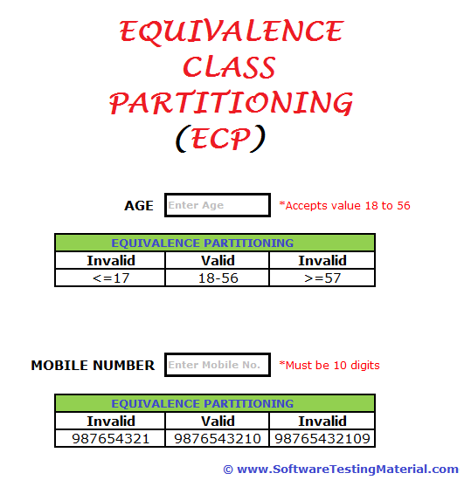
if age >18 valid

Normal Test Data | Divide Values into Equivalence Classes | Test Data using ECP
1 0-17 → 10 (invalid) 10
2 18-56 → 35(invalid) 35
3 57- 60 → (invalid) 60

Normal Test Data | Divide Values into Equivalence Classes | Test Data using ECP

1 | <10→ 987654321 | 987654321
2 | == 10→ 9876543210 (Valid) | 9876543210
3 | > 10→ 98765432109 (Invalid) | 98765432109

3. Valid Range of Integer Input:

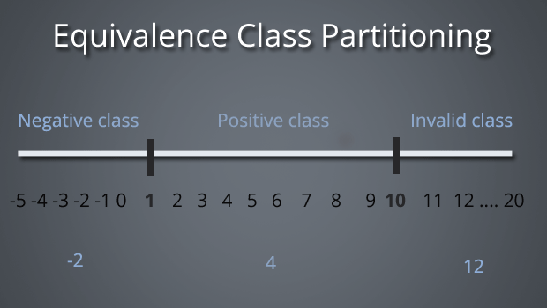

S. No | Normal Test Data | Divide values into equivalence class | Test Data Using ECP
1 | -2 | Negative Class – Values from -5 to 0 | -2
2 | 4 | Positive Class – Values from 1 to 10 | 4
3 | 12 | Invalid Class – Values from 11 to 20 | 12

4. Age Validation Using Equivalence Class Partitioning:
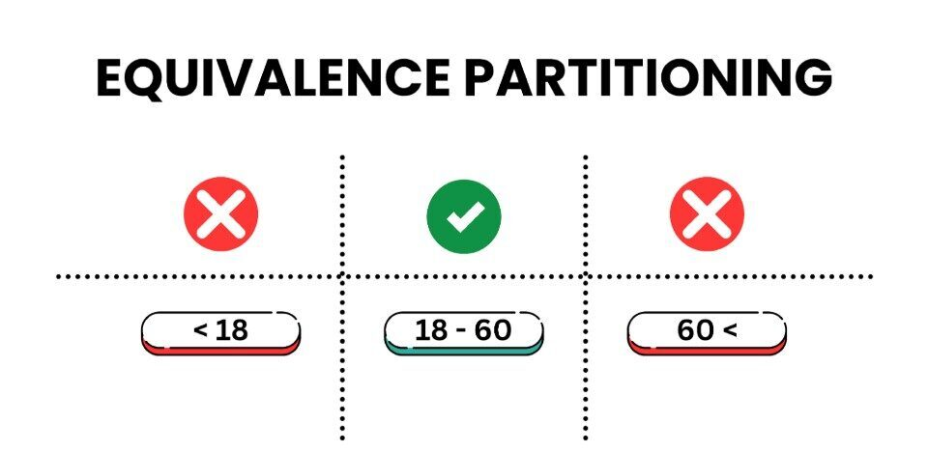

S. No | Normal Test Data | Divide values into equivalence class | Test Data Using ECP
1 | 15 | Invalid Class – Age less than 18 | 15
2 | 35 | Valid Class – Age from 18 to 60 | 35
3 | 65 | Invalid Class – Age greater than 60 | 65

5. Marks/Score Validation Using Equivalence Class Partitioning:

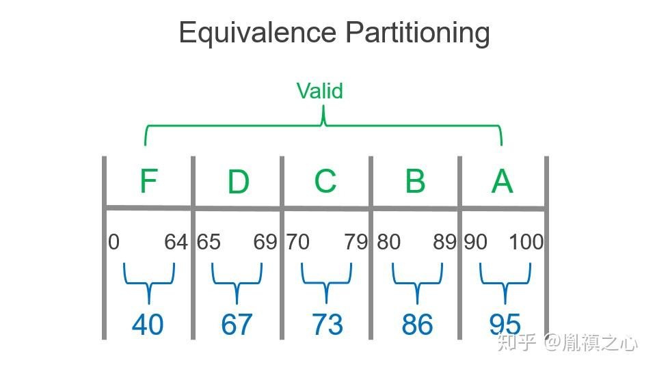

S. No | Normal Test Data | Divide values into equivalence class | Test Data Using ECP
1 | 40 | Valid Class – F Grade: 0–64 | 40
2 | 68 | Valid Class – D Grade: 65–69 | 68
3 | 77 | Valid Class – C Grade: 70–79 | 77
4 | 87 | Valid Class – B Grade: 80–89 | 87
5 | 93 | Valid Class – A Grade: 90–100 | 93

6.Password Length Validation:
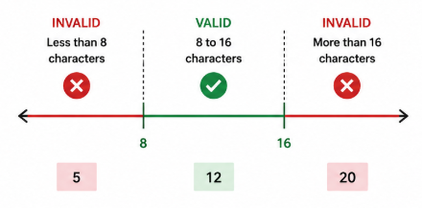

S. No | Normal Test Data | Divide values into equivalence class | Test Data Using ECP
1 | 5characters | Invalid Class – Less than 8 characters | 5
2 | 12 characters | Valid Class – 8 to 16 characters | 12
3 | 20 characters | Invalid Class – More than 16 characters | 20

2.Case Study for Decision Table:

Search 5 tables for decision table. Create condition based on corresponding actions.

1.Decision Table for Flight Discount Eligibility:
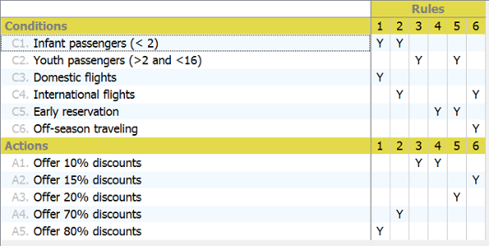

Conditions:
- Infant passengers (< 2)
- Youth passengers (> 2 and < 16)
- Domestic flights
- International flights
- Early reservation
- Off-season traveling
Actions:
- Offer 10% discount
- Offer 15% discount
- Offer 20% discount
- Offer 70% discount
- Offer 80% discount

2. Decision Table for Bank Withdrawal Validation:
Conditions:
- Withdrawal Amount ≤ Account Balance
- Credit Granted
Actions:
1.Withdrawal Granted

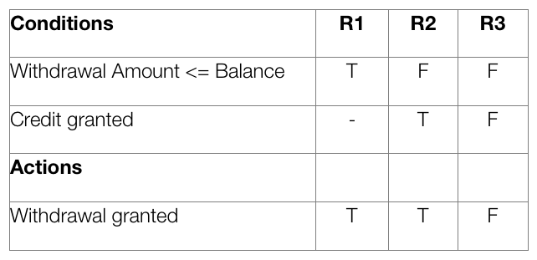

3. Decision Table for Customer Discount and Bonus Coupon:

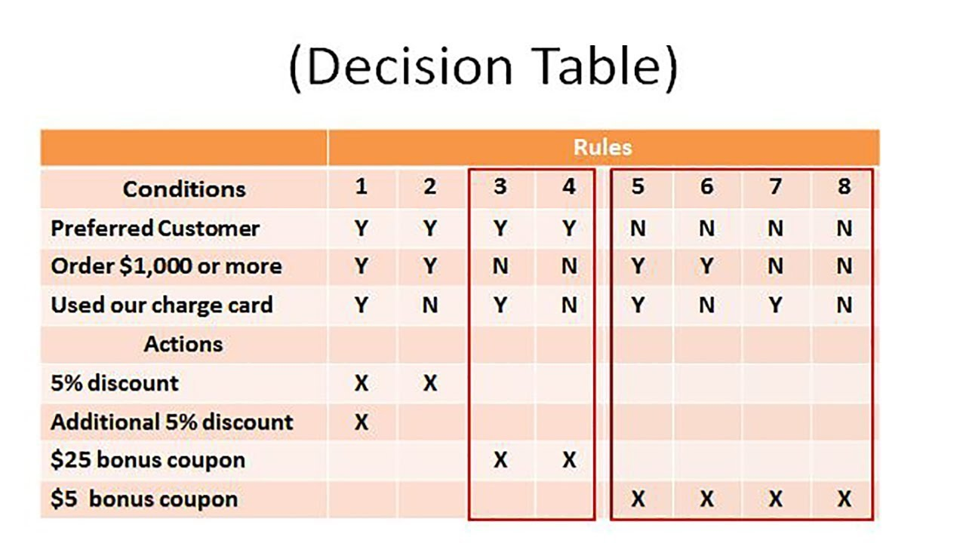

Conditions:
- Preferred Customer
- Order is $1,000 or more
- Used our charge card
Actions:
- 5% discount
- Additional 5% discount
- $25 bonus coupon
- $5 bonus coupon

4. Decision Table for User Registration and Password Validation:

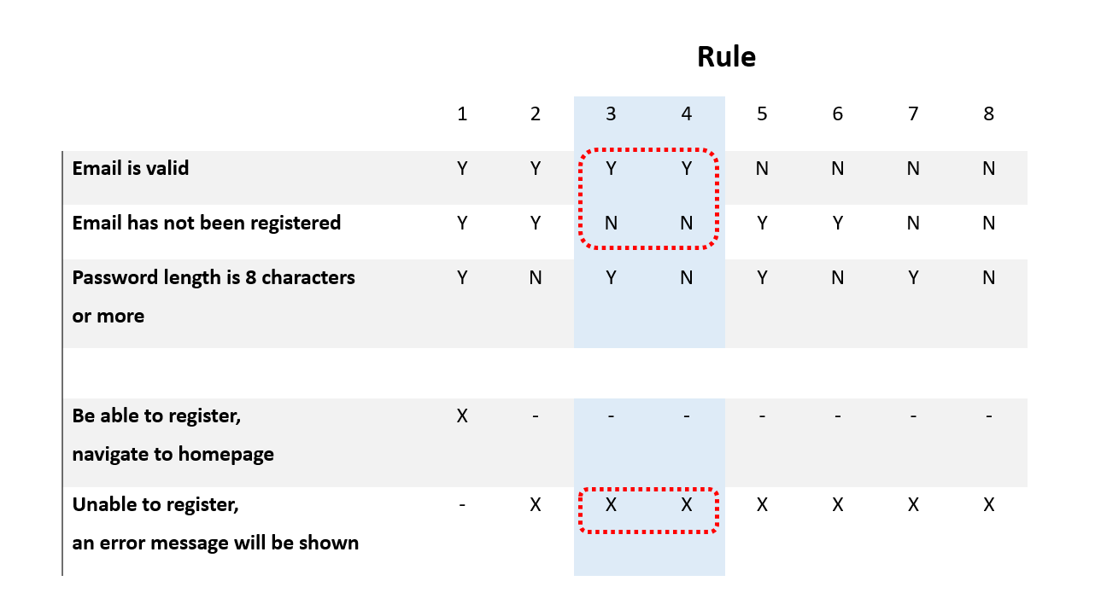
Conditions:
- Email is valid
- Email has not been registered
- Password length is 8 characters or more
Actions:
- User is able to register and navigate to the homepage
- User is unable to register and an error message is displayed

5. Decision Table for Printer Troubleshooting:
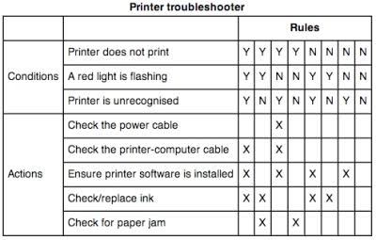
Conditions:
- Printer does not print
- A red light is flashing
- Printer is unrecognized
Actions:
- Check the power cable
- Check the printer-computer cable
- Ensure printer software is installed
- Check/replace ink
- Check for paper jam

Case Study for State Transition Technique:

1. Atm pin Authentication State Transition Diagram

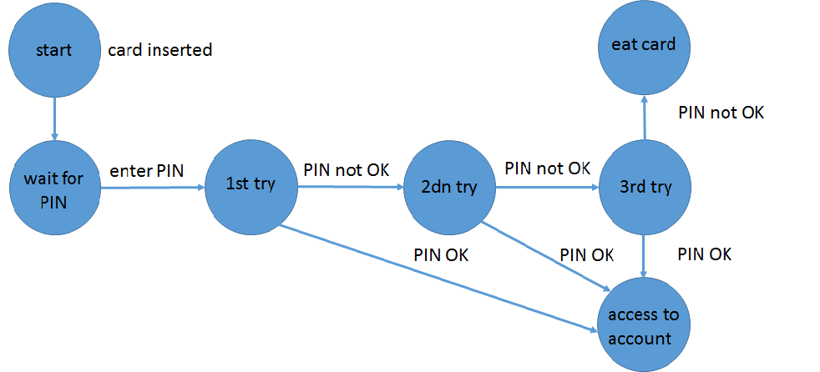

states:
idle → card inserted → pin verification → transaction → cash dispensed / card blocked
valid transitions:
- valid card at idle → pin verification
- correct pin at pin verification → transaction
- valid amount at transaction → cash dispensed
invalid transitions:
- invalid card at idle → card rejected
- incorrect pin at pin verification → pin verification
- insufficient balance at transaction → transaction
final transitions:
- successful withdrawal → cash dispensed
- card removed → idle
- three consecutive incorrect pin attempts → card blocked
- login system

2. Login System for State Transition Diagram

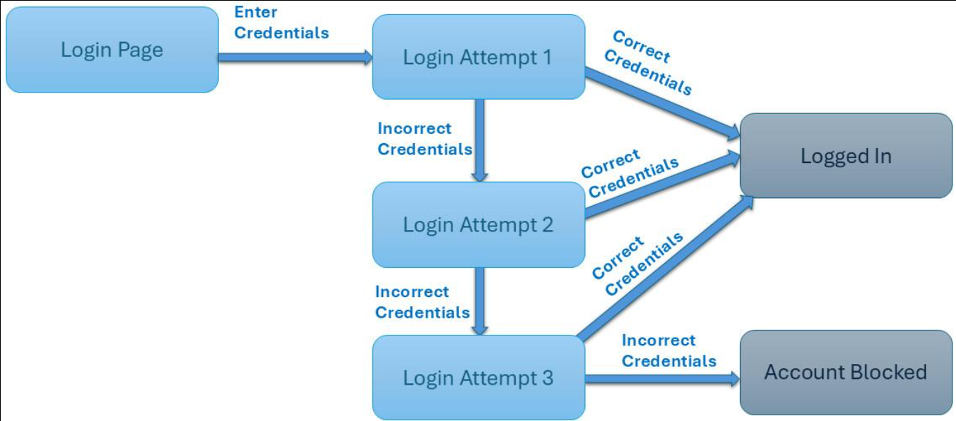

States:
First Attempt → Second Attempt → Third Attempt → Home Page / Account Locked
Valid Transitions:
- Correct credentials at First Attempt → Home Page
- Correct credentials at Second Attempt → Home Page
- Correct credentials at Third Attempt → Home Page
Invalid Transitions:
- Incorrect credentials at First Attempt → Second Attempt
- Incorrect credentials at Second Attempt → Third Attempt
- Incorrect credentials at Third Attempt → Account Locked
Final Transitions:
- Correct credentials → Home Page
- Three consecutive failed attempts → Account Locked
- Login attempt after account locked → Account Locked

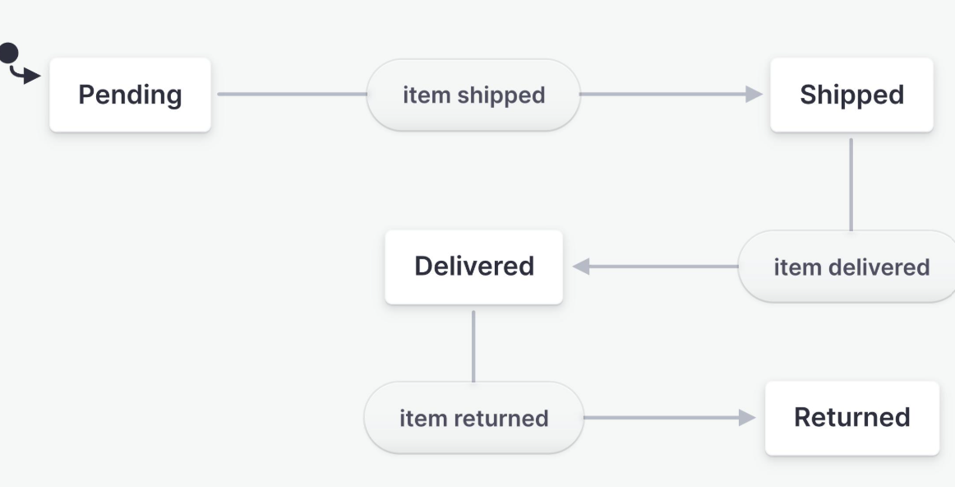
3.Online Shopping for State Transition Diagram
States:
Cart → Payment → Order Confirmed → Shipped → Delivered / Cancelation
Valid Transitions:
- Product added to Cart → Payment
- Successful payment → Order Confirmed
- Order dispatched → Shipped
Invalid Transitions:
- Payment failed → Payment
- Out of stock product → Cart
- Invalid payment details → Payment
Final Transitions:
- Successful payment → Order Confirmed
- Package delivered → Delivered
- Customer cancels order → Cancelled
4. Washing Machine for State Transition Diagram

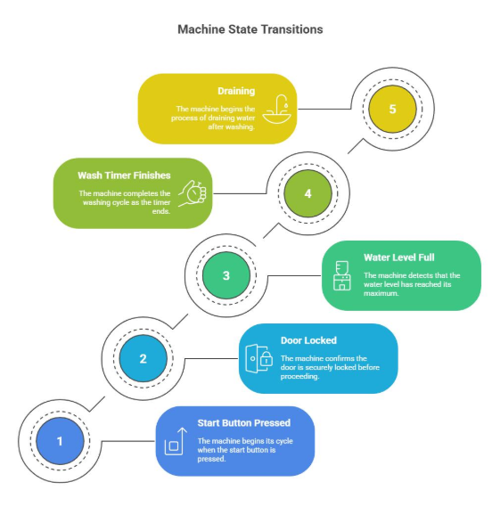

States:
Idle → Washing → Rinsing → Spinning → Completed
Valid Transitions:
- Start button pressed at Idle → Washing
- Washing completed → Rinsing
- Rinsing completed → Spinning
Invalid Transitions:
- Start button without power → Idle
- Door opened during Washing → Washing
- Invalid program selected → Idle
Final Transitions:
- Washing cycle completed → Completed
- Cancel button pressed → Idle
- Power switched off → Idle

5. Traffic Light for State Transition Diagram

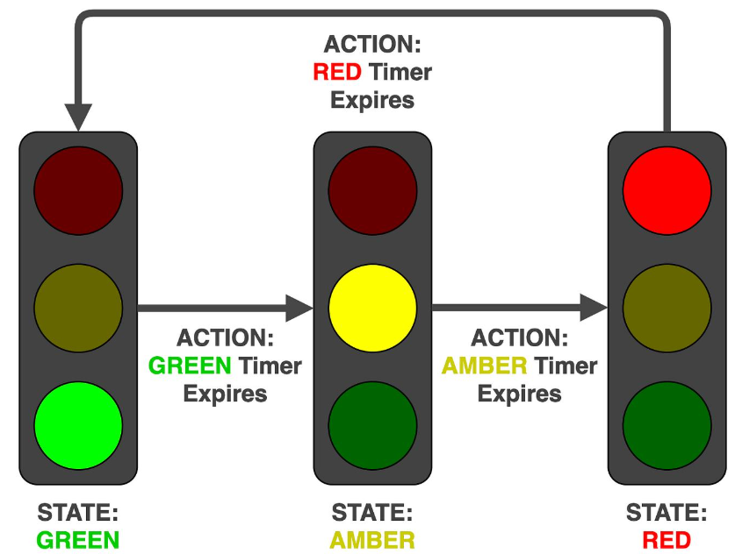
States:
Red → Green → Yellow → Red
Valid Transitions:
- Timer expires at Red → Green
- Timer expires at Green → Yellow
- Timer expires at Yellow → Red
Invalid Transitions:
- Red → Yellow
- Green → Red
- Yellow → Green
Final Transitions:
- Red signal completed → Green
- Green signal completed → Yellow
- Yellow signal completed → Red

