Model Based Design

Project Report

# Topic: Modeling an Anti-Lock Braking System in Simulink.

By :

Ajay Shewale

Unique ID:2005504

Abstract:

Anti-lock Braking system (ABS) is a safety and control tool implemented in vehicles that prevents the wheel lock-up during severe or panic braking. The existing ABS controls have the ability to control and regulate the level of pressure to optimally maintain the wheel slip within the vehicle stability range. However, the ABS shows strong nonlinear characteristics for which the vehicle equipped with existing controllers have a tendency to over steer and become unstable. In this paper a mathematical model of ABS with Bang-Bang control algorithm have been implemented in Simulink and extensive simulation studies is also performed to verify the effectiveness of the controller and the results shows that proposed controller is able to maintain the wheel slip at the desired reference value. The braking performance in both ABS mode and Non-ABS mode has been evaluated by simulation.

Introduction:

Antilock breaking system (ABS) is used in advanced automobiles to prevent slip and locking of wheel after brakes applied. it is automobile safety system, the controller is provided to control the necessary torque to maintain optimum slip ration. The slip ratio denotes in terms of vehicle speed and wheel rotation. The world’s first abs controller for passenger cars was introduced in 1978 by Bosch, with the primary objectives of preventing wheellock, reducing stopping distance and enhancing steerability during braking.

A. Objectives of ABS: (1) to reduce stopping distances, (2) to improve stability, and (3) to improve steerability during braking.

1) Stopping distance: the distance to stop is a function of the mass of the vehicle, the initial velocity, and the braking force. By maximizing the braking force the stopping distance will be minimized if all other factors remain constant.

2) Stability: Although decelerating and stopping vehicles constitutes a fundamental purpose of braking systems, maximum friction force may not be desirable in all cases, for example not if the vehicle is on a so-called p-split surface (asphalt and ice, for example), such that significantly more braking force is obtained on one side of the vehicle than on the other side.

3) Steerability: Good peak frictional force control is necessary in order to achieve satisfactory lateral forces and, therefore, satisfactory steerability. Steerability while braking is important not only for minor course

corrections but also for the possible of steering around an obstacle. Tire characteristics play an important role in the braking and steering response of a vehicle. For ABS-equipped vehicle the tire performance is of critical significance.

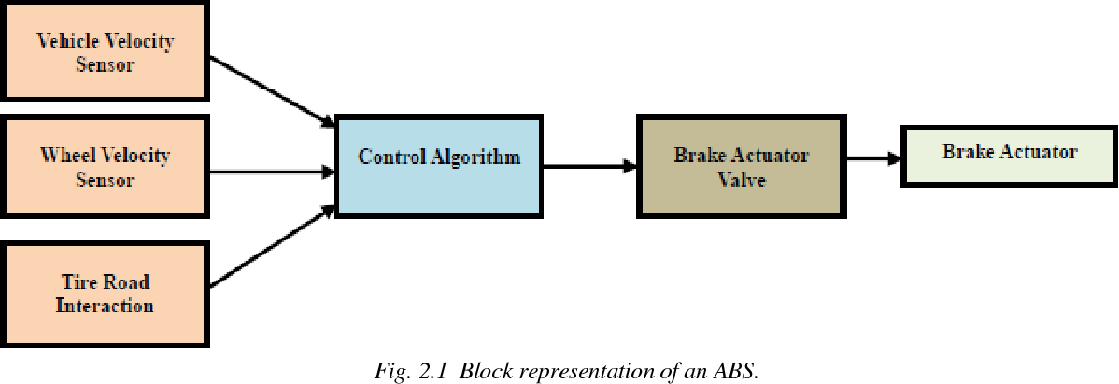

SCOPE & OBJECTIVE OF PRESENT WORK:

During the design of ABS, nonlinear vehicle dynamics and unknown environment characters as well as parameters, change due to mechanical wear have to be considered. PI controller are very easy to understand and easy to implement. However PI loop require continuous monitoring and adjustments. In this line there is a scope to understand BangBang controllers with mathematical models. The present work, it is planned to understand and obtain the dynamic solution of quarter car vehicle model to obtain the time varying vehicle velocity and wheel. After identification of system dynamics a slip factor defined at each instance of time will be modified to desired value by means of a control scheme. Various feedback control schemes can be used for this purpose. Simulation are carried out to achieve a desired slip factor with control scheme such as Bang-Bang controller Graphs of linear velocity, stopping distance and slip ratio for each system is plotted and compared with each other.

MATHEMATICAL MODELING AND SIMULATION :

Mathematical modeling is the first and most crucial task in developing a control algorithm for the antilock braking system. However, modeling an antilock braking system is really a difficult tusk,considering the ABS dynamics being highly nonlinear and time varying .However, in this paper, a simplified model for controller design and computer simulation is used. Towards the above goal, the mathematical model of an ABS has been implemented in Simulink, which employs a quarter car vehicle model undergoing a straight line braking maneuver[14]. The model also incorporates a hydraulic brake actuator dynamics and road-tire friction. The road-tire friction model [15] is given in the form of an empirical function describing the nonlinear relation between adhesion coefficient and wheel slip. A Bang-Bang controller has been implemented with the above model for controlling wheel slip at given desired reference value. The braking performances in both in ABS mode & nonABS mode have been evaluated by simulation.

$$\omega_v = \frac{V}{R} \mbox{ (equals the wheel angular speed if there is no slip)}$$

**Equation 1**

$$ \omega_v = \frac{V_v}{R_r}$$

$$slip=1-\frac{\omega_w}{\omega_v}$$

$$\omega_v = \mbox{ vehicle speed divided by wheel radius}$$

$$ V_v = \mbox{ vehicle linear velocity}$$

$$ R_r = \mbox{ wheel radius}$$

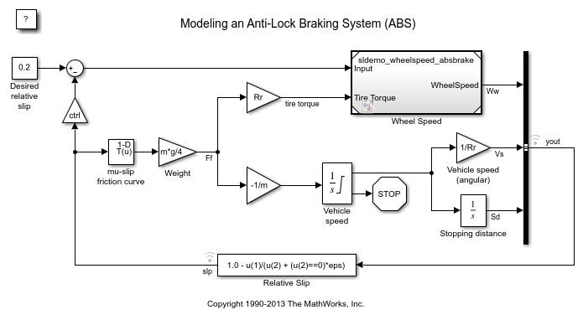

Wheel Speed subsystem in the model , Given the wheel slip, the desired wheel slip, and the tire torque, this subsystem calculates the wheel angular speed.

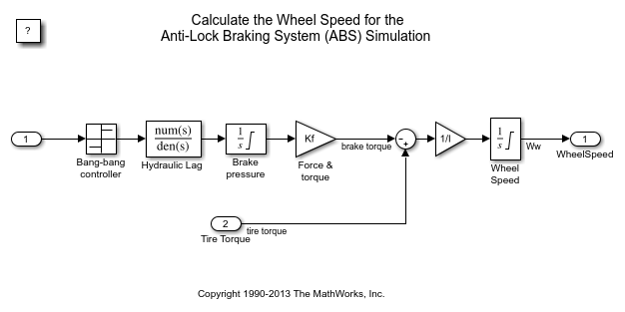

Following functions available in Simulink used in system to achieve better implementation of the System.

Callbacks:

Callbacks are a powerful way to customize your Simulink model. A callback executes when you perform actions on your model, such as double-clicking a block or starting a simulation. You can use callbacks to execute MATLAB code. used this tool to easy access to initialised data in model.every time going to workspace for initiating values or to change the data is diificult task , callback made it easy.

Data Inspector

You can use the Simulation Data Inspector to visualize the data you generate throughout the design process. Simulation data that you log in a Simulink® model logs to the Simulation Data inspector.Used data inspector to visualize Vss and slip feedback signal in the model.In the model data inspector is to compare slip signals on small changes in the inputs.

Solver selection strategy

Auto solver chooses a suitable solver and sets the maximum step size of the simulation.For new models, Simulink selects auto solver and sets the type to variable-step by default.both the top model and the referenced model in our system uses a variable step solver.

MATLAB function block

MATLAB Function blocks enable you to define custom functionality in Simulink® models by using the MATLAB® language. They are the easiest way to bring MATLAB code into Simulink.In the model MATLAB function block used to demonstrate the function of Bang bang controller.

Look-up table

A lookup table block uses an array of data to map input values to output values, approximating a mathematical function. Given input values, Simulink performs a “lookup” operation to retrieve the corresponding output values from the table In the model lookup table used in mu-slip friction curve to provide output.

The Signal Builder

The [Signal Builder](https://in.mathworks.com/help/simulink/ug/working-with-signal-groups.html) is a source block in the [Simulink](https://in.mathworks.com/products/simulink.html) library that lets you quickly develop and modify test input data that you want to incorporate with your model. You create and modify signal groups via the Signal Builder dialog editor, which also lets you view sets of inputs on a common time scale so that you can identify sequences of events and logic.

SIMULATION:

Running the simulation with ABS Mode:

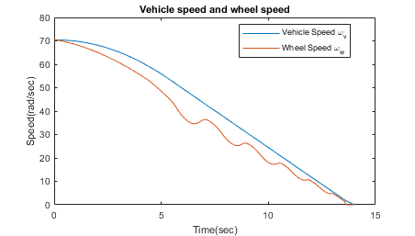

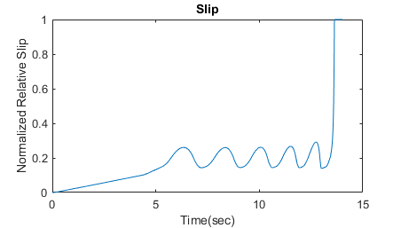

Running Simulation without ABS Mode:

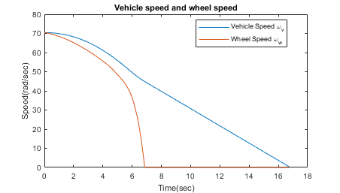

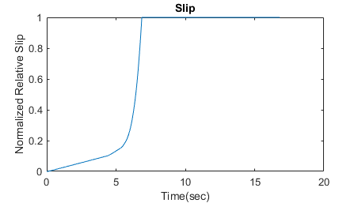

Braking with ABS vs Braking without ABS:

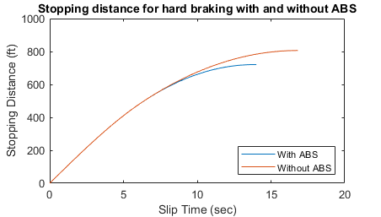

Conclusion :

This model shows how you can use Simulink to simulate a braking system under the action of an ABS controller. The controller in this example is idealized, but you can use any proposed control algorithm in its place to evaluate the system's performance. You can also use the Simulink® Coder™ with Simulink as a valuable tool for rapid prototyping of the proposed algorithm. C code is generated and compiled for the controller hardware to test the concept in a vehicle. This significantly reduces the time needed to prove new ideas by enabling actual testing early in the development cycle.

For a hardware-in-the-loop braking system simulation, you can remove the 'bang-bang' controller and run the equations of motion on real-time hardware to emulate the wheel and vehicle dynamics. You can do this by generating real-time C code for this model using the Simulink Coder. You can then test an actual ABS controller by interfacing it to the real-time hardware, which runs the generated code. In this scenario, the real-time model would send the wheel speed to the controller, and the controller would send brake action to the model.

References :

<https://in.mathworks.com/help/simulink/slref/modeling-an-anti-lock-braking-system.html;jsessionid=9a2286c904127c61b9d8c7a13624>

<http://oaji.net/articles/2017/1948-1514029908.pdf>

<https://in.mathworks.com/help/?s_tid=srchtitle>