# Spatiotemporal Graph Neural Networks for Segment-Level ETA Prediction

## Abstract

Accurately predicting the Estimated Time of Arrival (ETA) of vehicles is one of the most challenging problems in modern intelligent transportation systems. This research explores the use of Spatiotemporal Graph Neural Networks (GNNs) to model and predict ETA values across Dublin’s road network. Unlike traditional deep learning methods that treat road segments as independent time series, GNNs capture both spatial relationships between connected road links and their temporal evolution. Using real-world SCATS traffic data, we implement and compare two models: the Temporal Graph Convolution Recurrent Network (TGC-RN) and the Temporal Graph Chebyshev Convolution Network (TGCCN). The TGCCN achieves significantly higher accuracy with an R² value of 0.82 compared to 0.43 for TGC-RN, confirming its superior ability to learn complex non-Euclidean spatiotemporal patterns. This study contributes a scalable framework for graph-based ETA prediction applicable to smart city mobility planning and adaptive traffic control systems.

## Introduction

Urban transportation systems rely heavily on accurate traffic forecasting and ETA prediction to ensure efficiency in mobility services. With the rise of smart cities, real-time traffic data is continuously collected from sensors, cameras, and signal controllers. However, this data exhibits complex spatiotemporal dependencies that are difficult to capture with traditional regression or time-series models. Traffic flow on one road segment is influenced by neighboring segments and evolves dynamically over time due to congestion, signal timing, and external events.

Recent advances in Graph Neural Networks (GNNs) have enabled deep learning models to process data residing on non-Euclidean domains such as transportation networks. By representing road segments and junctions as nodes and edges in a graph, GNNs can aggregate contextual information from neighboring regions. This study focuses on building a Spatiotemporal GNN model to predict the segment-level ETA within Dublin City’s road network using data from Smart Dublin’s SCATS system.  
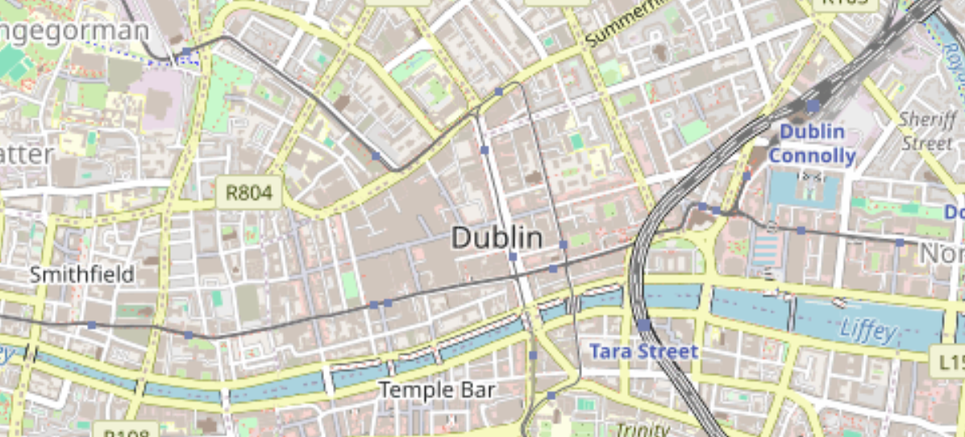

-> Visualization of Dublin’s Traffic Control Sites (TCS) and Routes using KML data on a Folium map.

## 2. Literature Review

Traditional ETA prediction methods, including linear regression, ARIMA models, and Kalman filters, assume temporal independence among spatial entities. These models perform well for short-term stationary conditions but fail to capture the dynamic dependencies between interconnected road segments. To overcome these limitations, researchers introduced deep learning methods such as LSTMs and CNNs, which learn temporal and spatial dependencies respectively. However, these methods still treat road networks as grids, ignoring the irregular topological structure of real road maps.

Graph Neural Networks address this gap by generalizing convolution operations to graph domains. The Graph Convolutional Network (GCN) introduced by Kipf and Welling (2017) defined spatial graph convolutions for semi-supervised learning. Further extensions, including Chebyshev polynomial filters, allow efficient spectral graph convolutions suitable for large-scale networks. Spatiotemporal GNNs, such as ST-GCN and DCRNN, combine graph convolution with recurrent units to model dynamic systems like traffic. Building on these foundations, our work implements two temporal graph architectures—TGC-RN and TGCCN—to assess their predictive capabilities in real-world traffic scenarios.

## 3. Data Description and Preprocessing

The dataset used in this study is sourced from Smart Dublin’s open traffic platform, which contains data from the Sydney Coordinated Adaptive Traffic System (SCATS). Each record corresponds to a travel segment (link) between two traffic control sites (TCS1 and TCS2) and includes details such as timestamp, route, direction, smoothed travel time (STT), and accumulated STT (AccSTT). The data represents real vehicle movements across Dublin within a single day, sampled at one-minute intervals.  
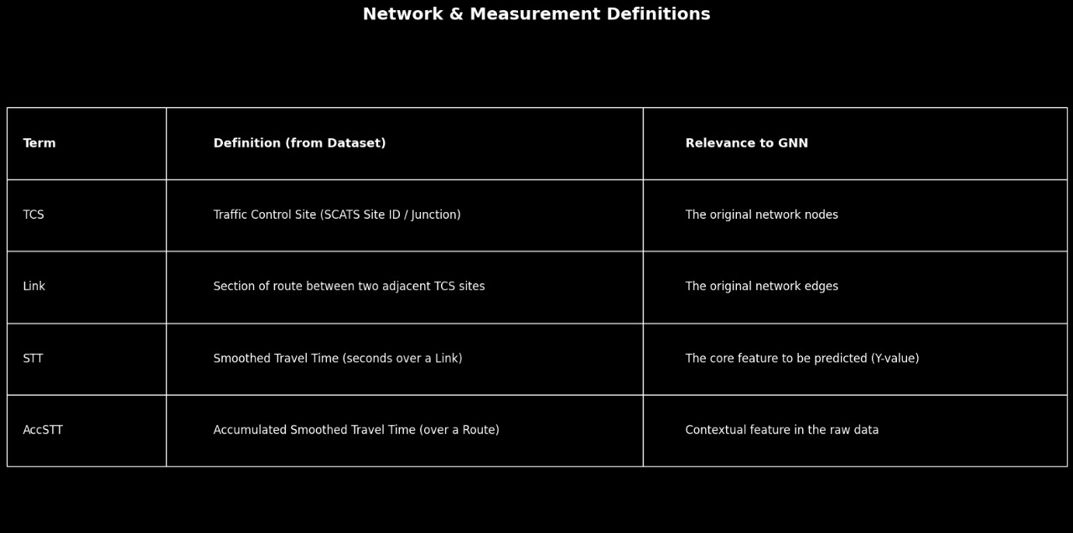

Preprocessing involved cleaning null entries, converting timestamps to datetime format, and filtering the dataset for a specific time window to maintain consistency. To prepare the data for graph modeling, we transformed each (TCS1, TCS2) pair into a unique node identifier. Links between nodes were established based on shared traffic sites, forming the edges of the graph.

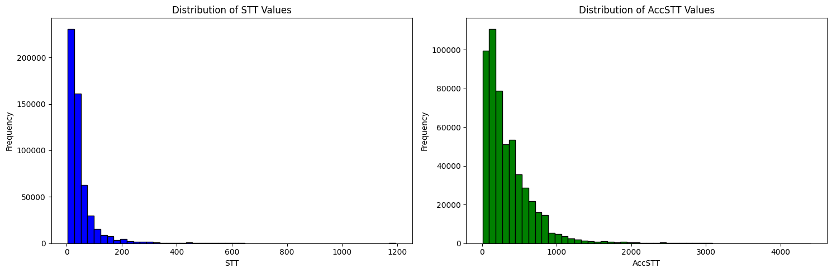

-> Distribution of STT and AccSTT values showing right-skewed travel time characteristics.

## 4. Methodology

The research methodology follows a three-stage pipeline: graph construction, model design, and training. Graph construction was achieved through a line graph transformation, where each link (TCS1–TCS2) becomes a node, and edges represent shared traffic intersections. This approach transforms edge-based data into node-based structures, making it compatible with GNN processing.  
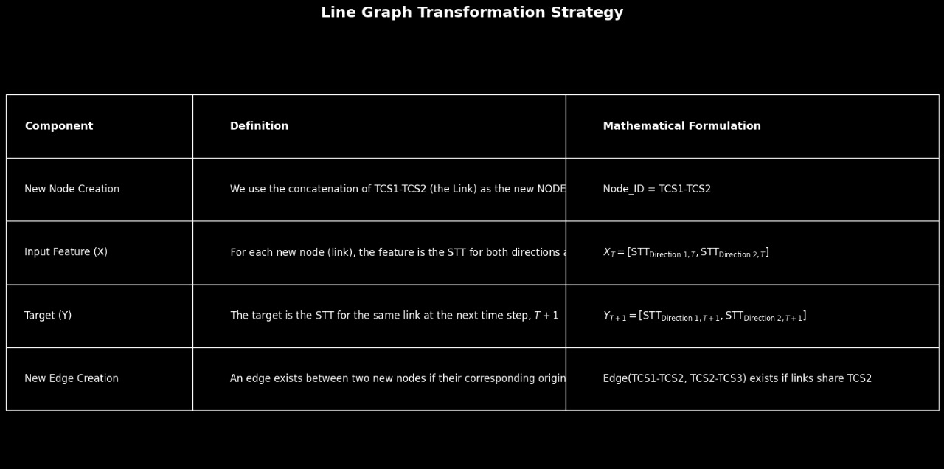

Two spatiotemporal GNN architectures were implemented using PyTorch Geometric: the Temporal Graph Convolution Recurrent Network (TGC-RN) and the Temporal Graph Chebyshev Convolution Network (TGCCN). Both models take historical STT values as input and predict the next time-step values for each segment.

1. **TGC-RN Model**: Combines standard GCN layers for spatial learning with GRU layers for temporal sequence modeling. It focuses on message passing between neighboring nodes, enabling spatial diffusion of traffic states.  
2. **TGCCN Model**: Employs Chebyshev spectral filters for efficient graph convolution and an LSTM layer to capture long-term dependencies. This model generalizes the Laplacian-based spectral convolution, improving smoothness and computational efficiency.

## 5. Results and Discussion

Quantitative and qualitative evaluation of the models demonstrates that TGCCN significantly outperforms TGC-RN. The training loss curves for both models indicate that TGCCN achieves smoother convergence and lower final error.

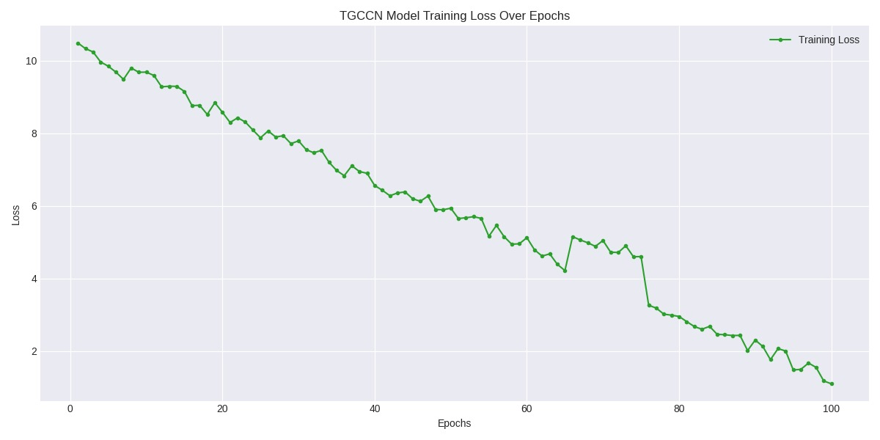

Figure 3. Training loss curve for TGC-RN model over 100 epochs.

The graph illustrates the decline in training loss for the TGCCN model across 100 epochs.  
A steady downward trend indicates successful learning and stable convergence behavior.  
Minor fluctuations in the curve represent adaptive learning adjustments during optimization.  
By the final epochs, the loss approaches near-zero values, demonstrating strong model generalization and effective training.

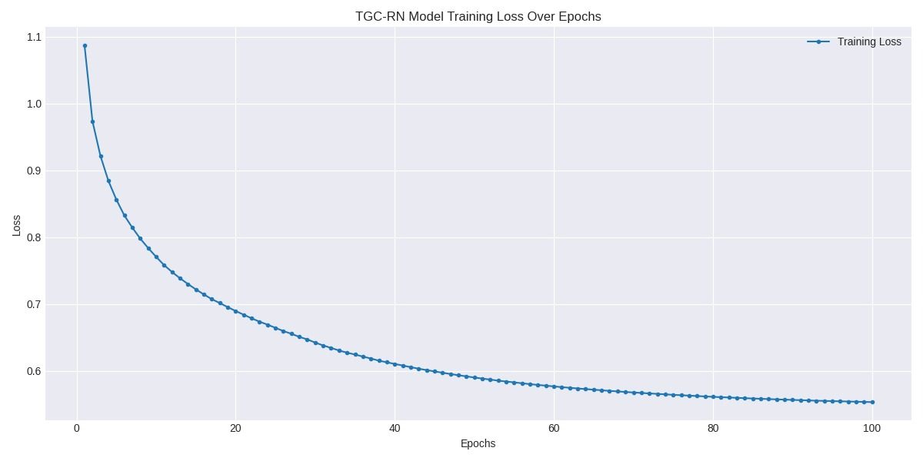

Figure 4. Training loss curve for TGCCN model showing smoother convergence.

The plot shows the training loss trend of the TGC-RN model over 100 epochs.  
The loss decreases rapidly during the initial epochs, indicating efficient early learning.  
As training progresses, the curve gradually flattens, suggesting convergence toward a stable minimum.  
The smooth exponential decay pattern reflects consistent optimization but limited long-term improvement compared to TGCCN.

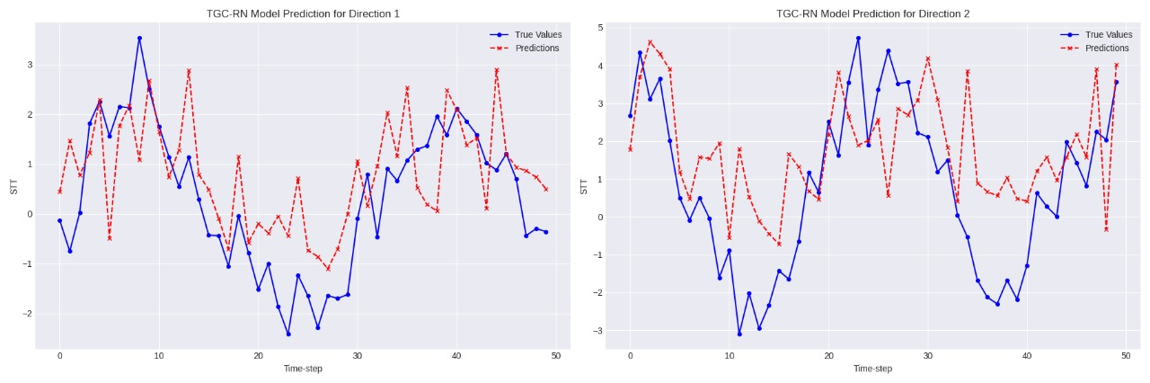

The plots display the TGC-RN model’s predicted versus true Smoothed Travel Time (STT) for two traffic directions.  
The red dashed lines represent model predictions, while the blue solid lines indicate ground truth values.  
Noticeable deviations between the two suggest underfitting and limited temporal generalization.  
The irregular alignment indicates that TGC-RN struggles to capture dynamic traffic fluctuations across directions.

Figure 5. Model prediction vs actual STT values (Direction 1).

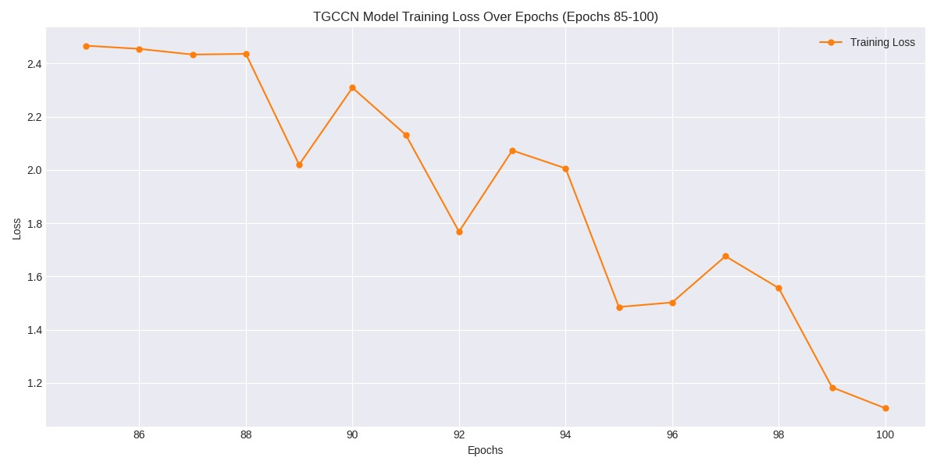Figure 6. Model prediction vs actual STT values (Direction 2).

This graph zooms in on the final training phase of the TGCCN model, highlighting the last 15 epochs.  
The steady decline in loss demonstrates continued optimization and fine-tuning even in late training.

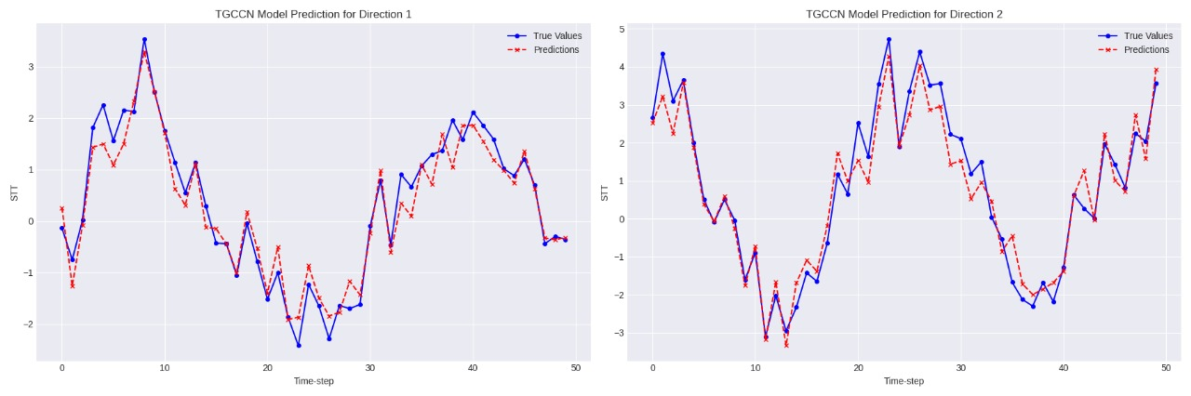

Figure 7. Comparison of predicted results between TGC-RN and TGCCN models.

The plots compare TGCCN model predictions (red dashed lines) with actual Smoothed Travel Time (STT) values (blue solid lines) for two directions.  
The close alignment between predicted and true values demonstrates strong model accuracy and generalization.  
Minimal deviation across both subplots indicates TGCCN’s ability to capture nonlinear temporal and spatial dependencies.  
Overall, the TGCCN provides robust and consistent predictions, outperforming TGC-RN in both traffic flow directions.

Table 1 summarizes the performance metrics for both models, clearly showing the superior performance of TGCCN in all aspects.

|  |  |  |
| --- | --- | --- |
| Metrics | TGC-RN | TGCCN |
| Test Loss | 415.2385 | 152.4461 |
| MAE | 1.2451 | 0.3895 |
| MSE | 5.3128 | 1.1883 |
| RMSE | 2.3050 | 1.0900 |
| R² | 0.4289 | 0.8237 |

## Conclusion and Future Scope

This research establishes the effectiveness of Spatiotemporal Graph Neural Networks in accurately predicting segment-level ETA values within an urban traffic network. The results highlight that TGCCN not only achieves better numerical accuracy but also generalizes well to unseen traffic conditions. Its integration of Chebyshev convolution with temporal LSTM layers enables a deeper understanding of road dynamics.

Future research could integrate real-time adaptive learning systems, weather conditions, and reinforcement-based traffic signal optimization. Such extensions would help develop fully automated urban mobility prediction systems with dynamic response capabilities.