**DEVOPS**

**DAY-3**

To create a one Directory

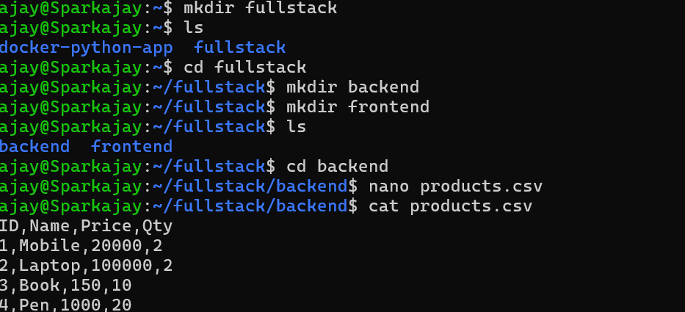

To install python:

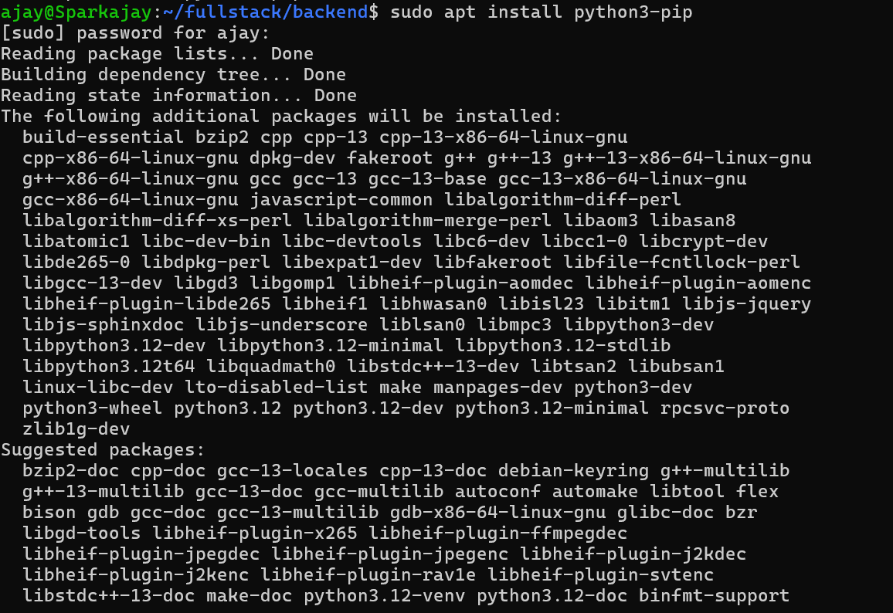

After Creating Python, Create an **Backend** and store the files,

**App.py**

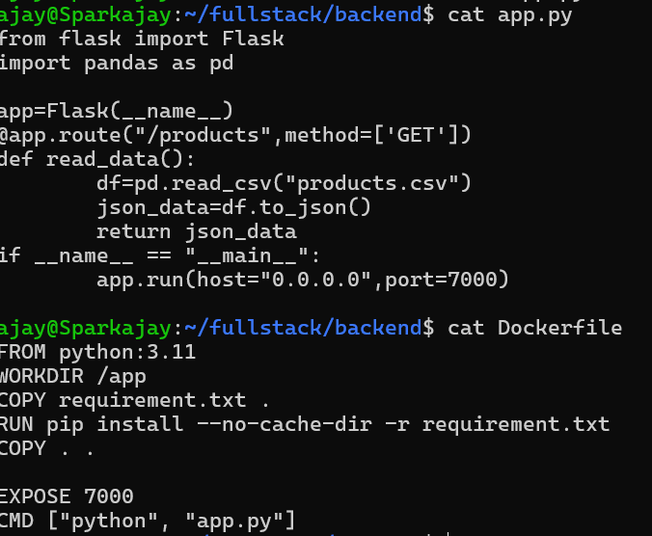

**Docker**



**Requirements.txt:**



**docker-compose.yml**

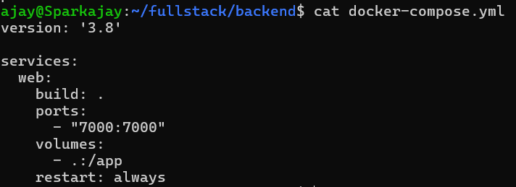

then build Docker and Run the Docker

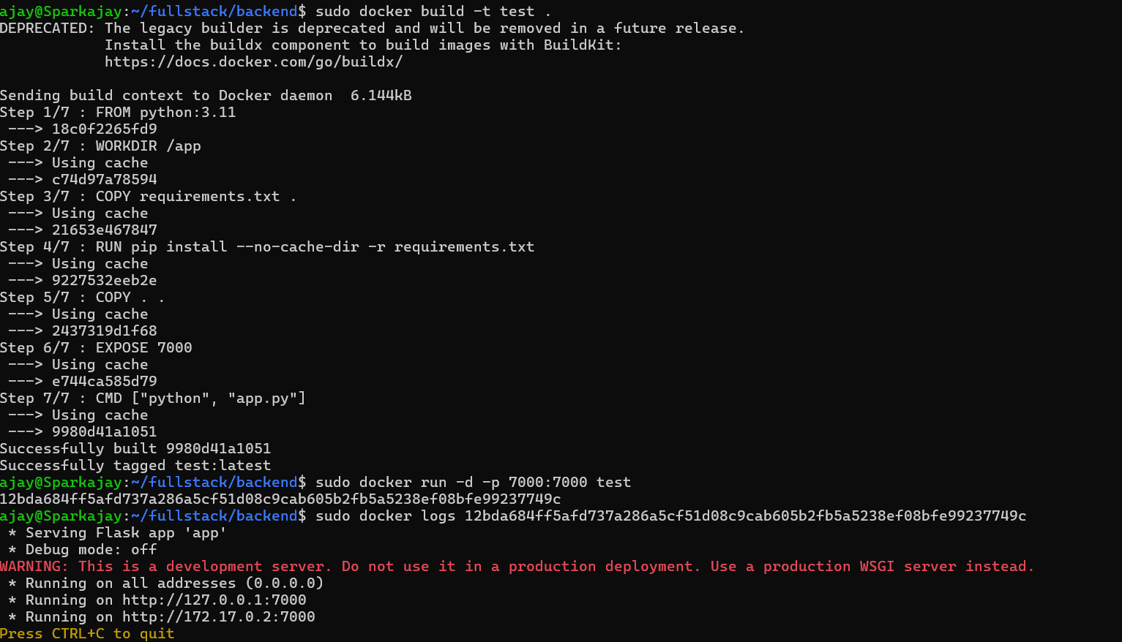

**To see the Output, goto the website and put the URL:**

then it will display the Json format in website

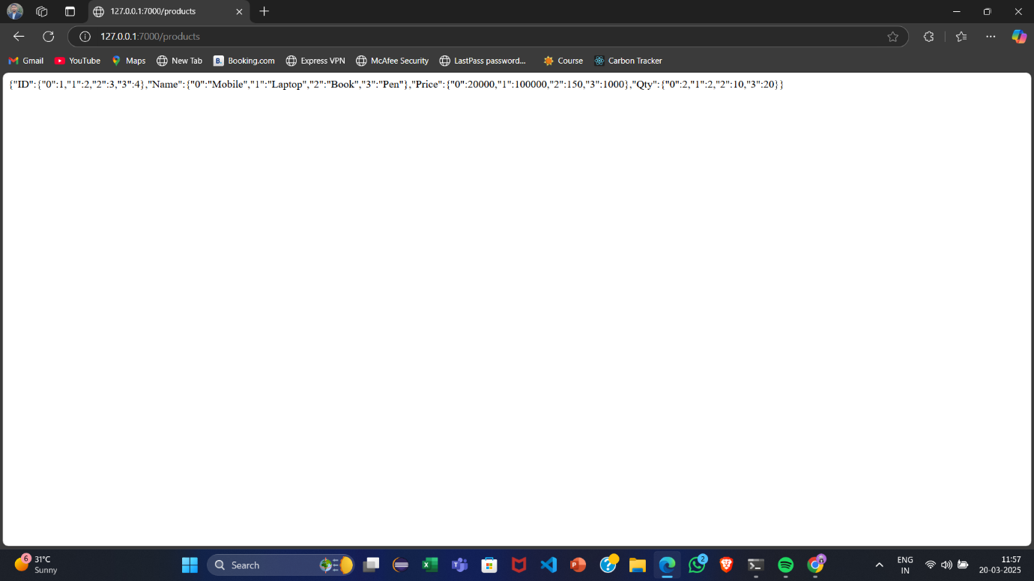

In **frontend**, Create the files like

**index.html**

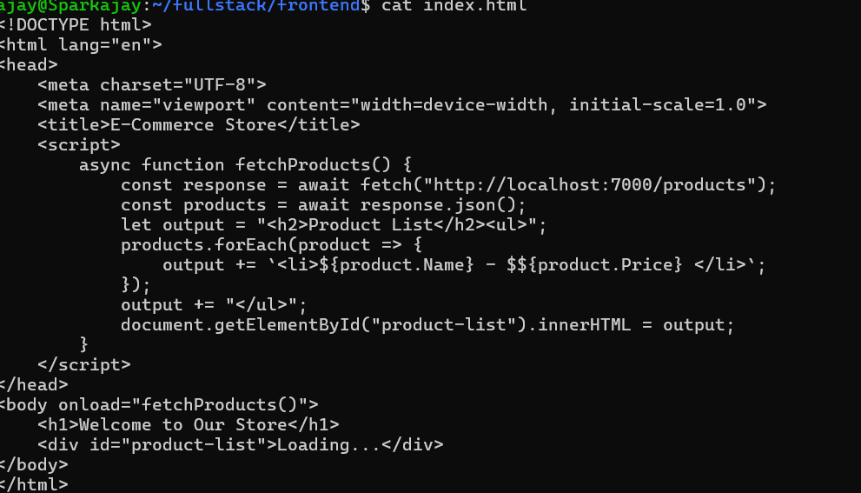

**Dockerfile**

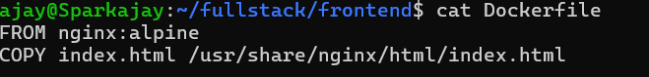

**Build the Docker image in Frontend**

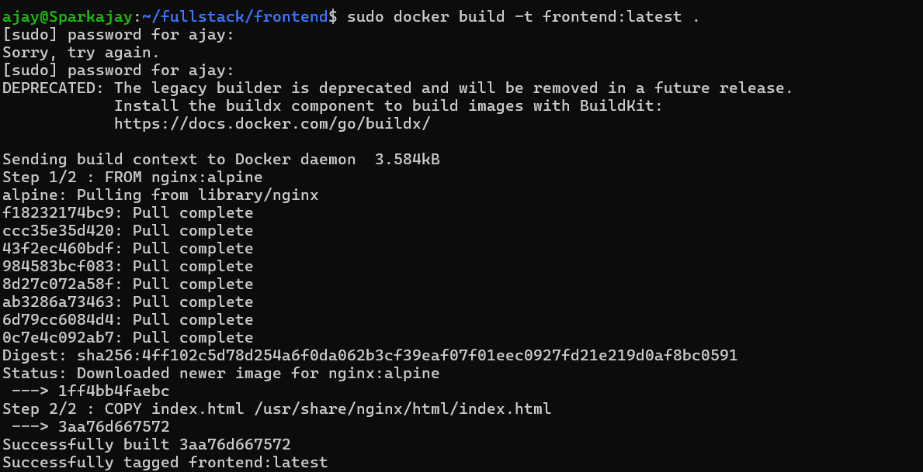

**To create an k8s folder in fullstack using mkdir command:**

**For deployment use Kubernetes**

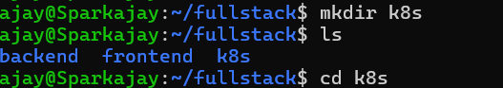

**Deployment.yaml (for Backend)**

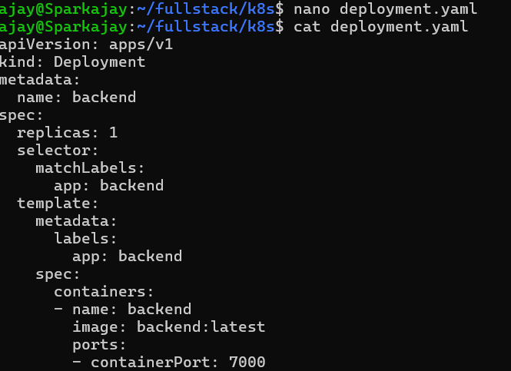

**Deployment.yaml (for Frontend)**

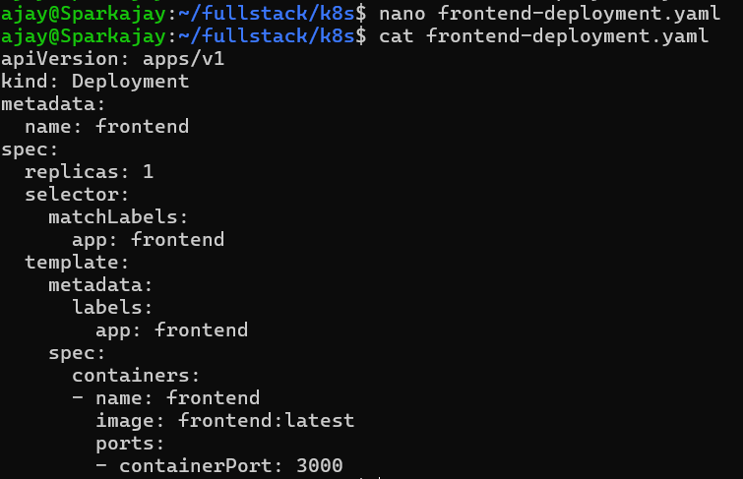

**Service.yaml:**

For **frontend-** nodeport **backend-**cluster IP

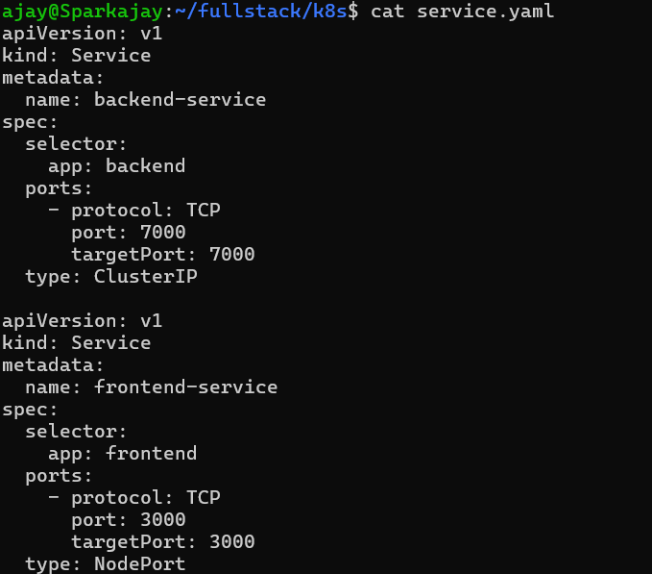

**Configmap.yaml:**

