**Ajay Babu Gorantla**

**Artificial Intelligence**

**Programming 1**

**8 Puzzle Problem:**

The objective of this experiment is to search for path from initial state to the goal state of “12345678b” using Greedy Best First search algorithm and A* search algorithm.

For the convenience of programming, I have considered ‘b’ (blank) as 0 in the code

Before beginning the search process, we can determine if the goal state is achievable from the given initial state i.e. the parity of number of inversions in initial state should match the parity of number of inversion in the goal state. As the goal state is fixed for this assignment and its parity is even, I have implemented the code that checks the parity of number inversions in the initial state to make sure it matches with that of goal state. If it doesn’t the it will not search for any path and just informs that the goal state cannot be reached.

The three heuristic functions that I considered are H1, H2, and H3, where

H1 : The Manhattan distance of each misplaced to its position in the goal state

H2 : Number of misplaced tiles when compared to the goal state

H3 : A combination of H1 and H2 i.e. H1+H2

I have made trials on 5 different initial states.

**Heuristic 1 (Manhattan Distance)**

**Initial State 1 –** 2351b6874



**Initial State 2 –** 5236b8174



**Initial State 3 –** 15b482763

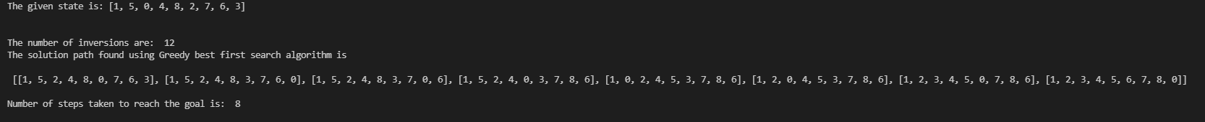



**Initial State 4 –** 13645278b

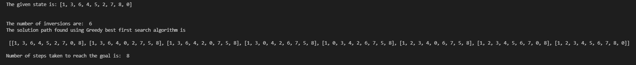



**Initial State 5 –** 163405728

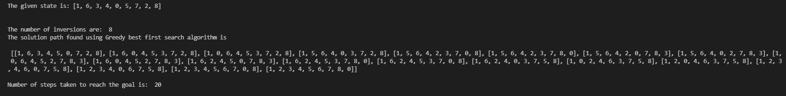



**The average number of steps for Greedy Best First search algorithm is :** 37.2

**The average number of steps for A* search algorithm is :** 12

**Heuristic 2 (Misplace Tiles)**

**Initial State 1 –** 2351b6874



**Initial State 2 –** 5236b8174



**Initial State 3 –** 15b482763





**Initial State 4 –** 13645278b

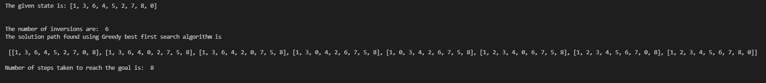



**Initial State 5 –** 163405728

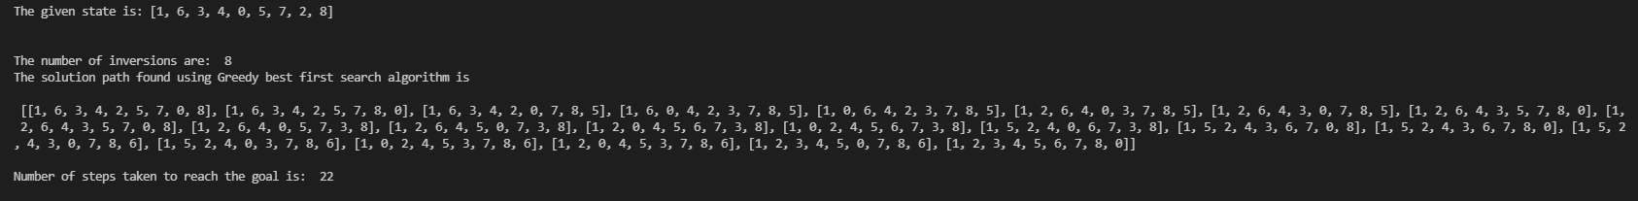



**The average number of steps for Greedy Best First search algorithm is :** 20.4

**The average number of steps for A* search algorithm is :** 12

**Heuristic 3 (Manhattan Distance + Misplaced Tiles)**

**Initial State 1 –** 2351b6874



**Initial State 2 –** 5236b8174



**Initial State 3 –** 15b482763

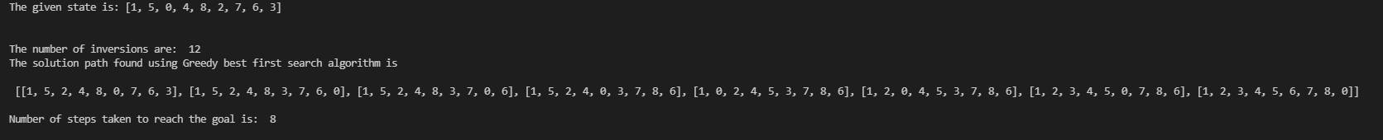



**Initial State 4 –** 13645278b

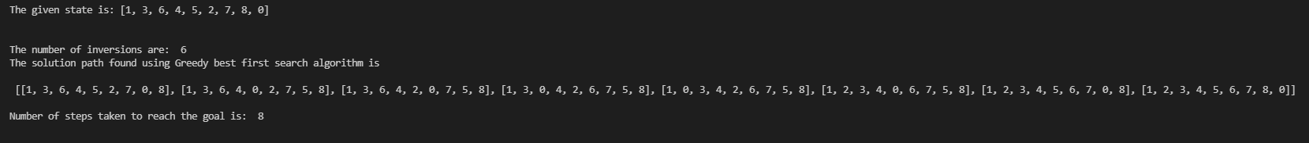



**Initial State 5 –** 163405728

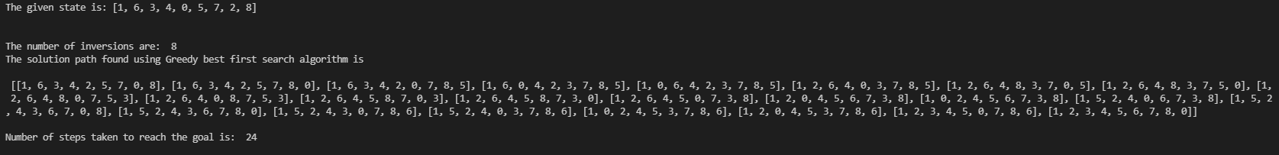



**The average number of steps for Greedy Best First search algorithm is :** 31.6

**The average number of steps for A* search algorithm is :** 12

From the observations, based on the average number of steps we can say that A* search algorithm performs better than the Best First search algorithm for the above-mentioned heuristics. In terms of dominance, H2>H3>H1. However, even though A* search algorithm performs better than Greedy Best First search algorithm, the latter is computationally more efficient than the former.