Date:



Cal:

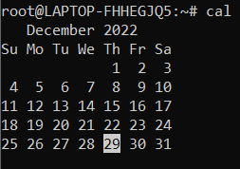

Echo:



Ls:

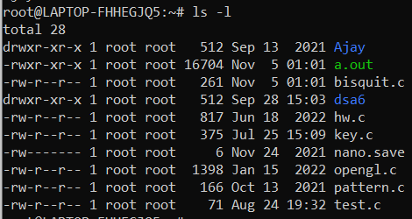

Lp: line printer

Man :

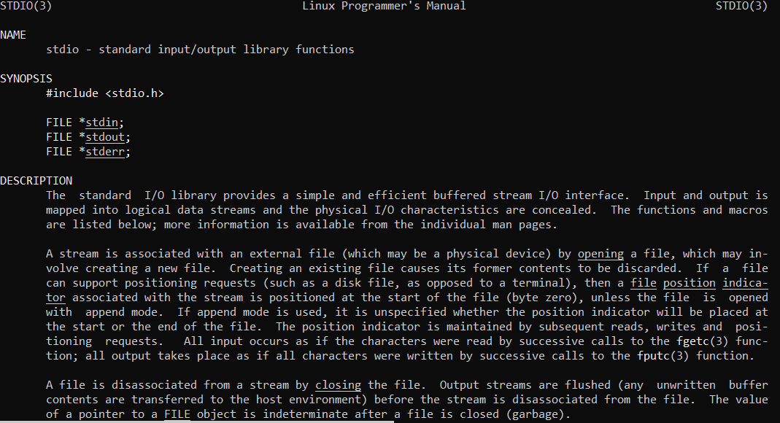

Who/whoami:

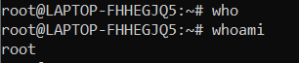

Uptime:



Uname:



Hostname :



Bc:(basic calculator)

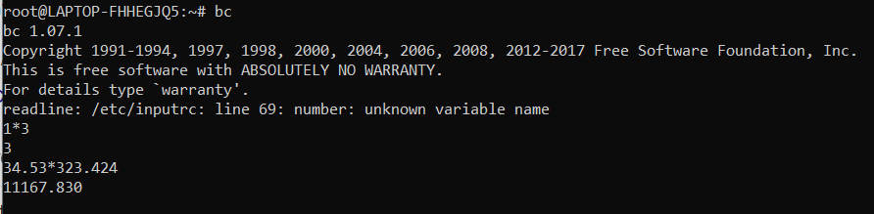

File Handling Commands:

Cat:

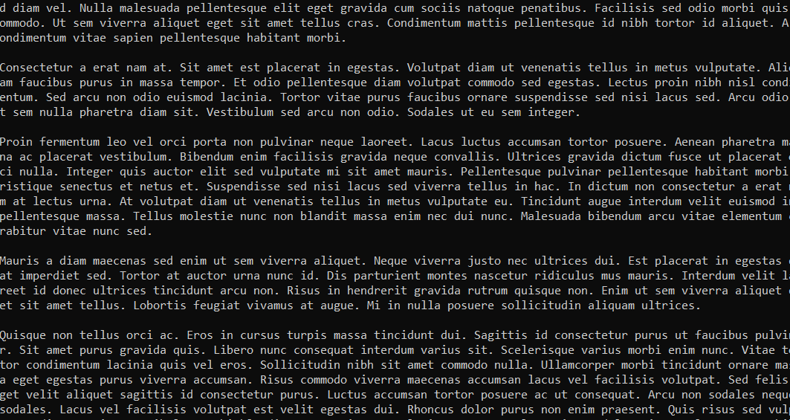

2.grep:

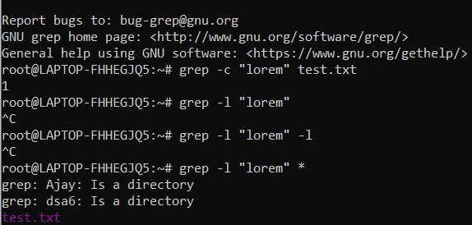

3. rm:



4.touch



5.cp



6.mv



7.cut

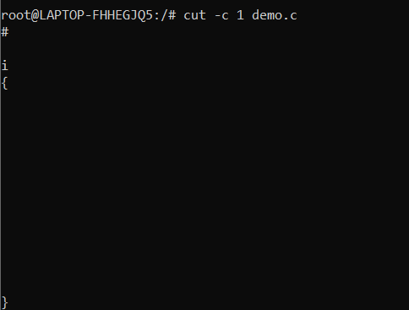

8.head



9.tail



10.chmod



11.wc(word count s);

