Software Requirements Specification (SRS)

Hospital Management System (HMS)
Quality Goal Q07: Improve Data Accuracy
BBAT104: Fundamentals of TQM | Course Project | Session 2026-27
Student: Ajay Bora | Branch: CSE | Section: B

1. Introduction

1.1 Purpose
This document specifies the functional and non-functional requirements for the Hospital Management System (HMS), the baseline software system assigned for this course project. It also defines the requirements needed to implement the assigned Quality Goal Q07 - Improve Data Accuracy, per BBAT104 project guidelines.

1.2 Scope
The system manages three core entities - Patients, Doctors and Appointments - through full CRUD operations. On top of this baseline, five Q07 features are implemented to reduce data-entry errors: Input Masking, Dropdown Lists, Auto-Complete, Confirmation Modals, and Audit Logs.

1.3 Definitions
- CTQ - Critical to Quality parameter
- CRUD - Create, Read, Update, Delete
- RPN - Risk Priority Number (Severity x Occurrence x Detection)
- SQC - Statistical Quality Control

2. Overall Description
HMS is a desktop application built with Python, Tkinter (GUI) and SQLite (storage). It follows a layered architecture separating presentation, business logic and data access, shown in Figure 1.
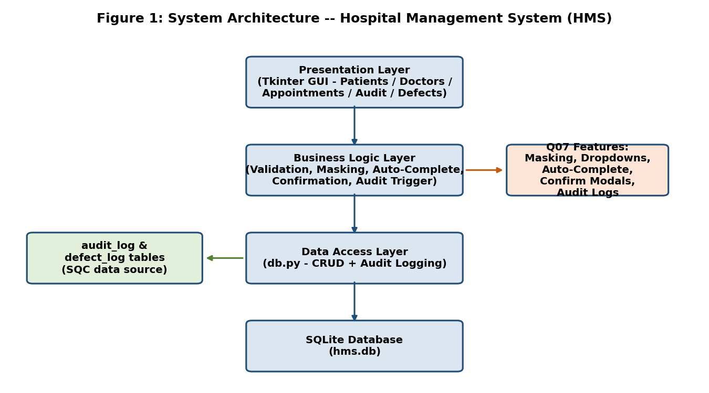

3. Critical to Quality (CTQ) Parameters
The following CTQs translate the Q07 goal (Improve Data Accuracy) into measurable targets:
CTQ Requirement | Measurable Target
Phone numbers 100% 10-digit valid | 0 malformed phone entries after masking
Gender / Blood Group always from fixed set | 0 free-text typos in these fields
No duplicate patient records | Duplicate rate reduced via auto-complete search-before-add
Every critical action confirmed | 0 accidental deletes without confirmation prompt
Every data change traceable | 100% of INSERT/UPDATE/DELETE actions present in audit_log

4. Functional Requirements
ID | Requirement
FR-1 | System shall allow Add/View/Update/Delete of Patient records.
FR-2 | System shall allow Add/View/Update/Delete of Doctor records.
FR-3 | System shall allow booking, updating and cancelling Appointments linking a Patient and a Doctor.
FR-4 | System shall mask phone number input to +91-XXXXX-XXXXX and reject non-digit characters (Q07).
FR-5 | System shall restrict Gender, Blood Group, Department and Status fields to fixed dropdown lists (Q07).
FR-6 | System shall auto-suggest existing patient names as the user types, to prevent duplicate entries (Q07).
FR-7 | System shall display a Yes/No confirmation dialog before any Delete or Update action (Q07).
FR-8 | System shall write every INSERT/UPDATE/DELETE to an audit_log table with timestamp and action details (Q07).
FR-9 | System shall allow logging of defects into a Defect Checksheet for SQC analysis.

5. Non-Functional Requirements
Attribute | Requirement
Usability | Front-desk staff should be able to register a new patient in under 60 seconds.
Reliability | No unhandled exceptions should crash the application during normal CRUD use.
Data Accuracy | All entry fields must be validated before database commit (see FR-4 to FR-6).
Maintainability | Application split into db.py (data layer) and main.py (UI layer) for modularity.
Portability | Runs on any system with Python 3.x and Tkinter (bundled with standard CPython).

6. Assumptions & Constraints
- Single-user desktop deployment; no concurrent multi-user locking is implemented.
- Phone numbers are assumed to be 10-digit Indian mobile numbers (+91 prefix).
- SQLite is used for simplicity; not intended for high-concurrency production use.

7. Traceability to TQM Principles
- Poka-Yoke (Error Prevention): Input Masking + Dropdown Lists prevent invalid data at entry.
- Customer Focus: Reduces front-desk rework and patient-record errors.
- Fact-Based Decision Making: Audit Log and Defect Checksheet feed the Pareto/FMEA analysis in Reviews 3-4.

