**OUTPUTS**

In this section we will see output of various modules stated earlier.

Application was installed in the two android mobiles with two separate versions of android, namely: Android KitKat ( 4.4.4 ) and Android Lollipop ( 5.1 ). Every module was then executed and screenshots were taken. Those screenshots are shown here along with module name and description.

1. Splash Screen

This is splash screen, it is shown every time application is

used from home screen or recent app tray.

1. Login Screen

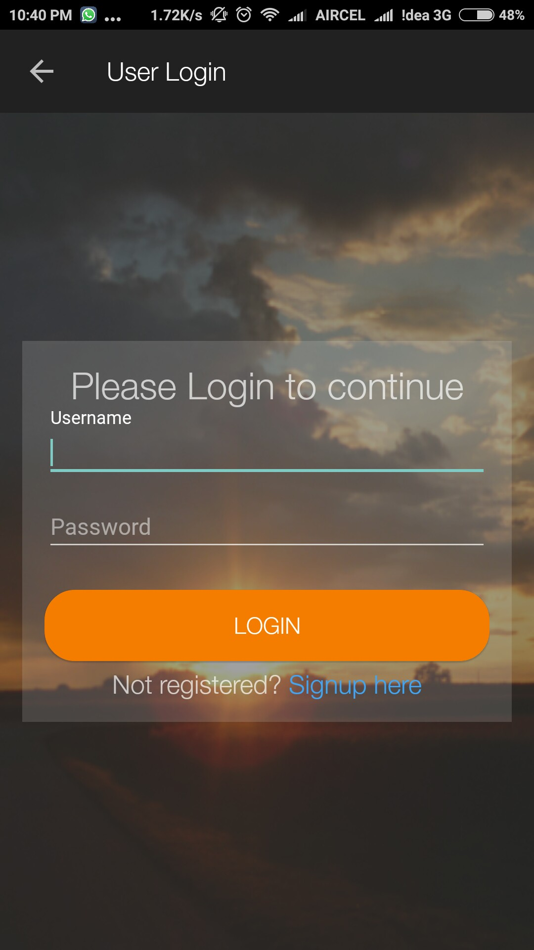

Receptionist is asked for user credential, provided by SmarterClinics, to login in order to use the application further. It is done only once till he/she logs out or his/her session expires.

Successful login leads to Dashboard.

1. Dashboard

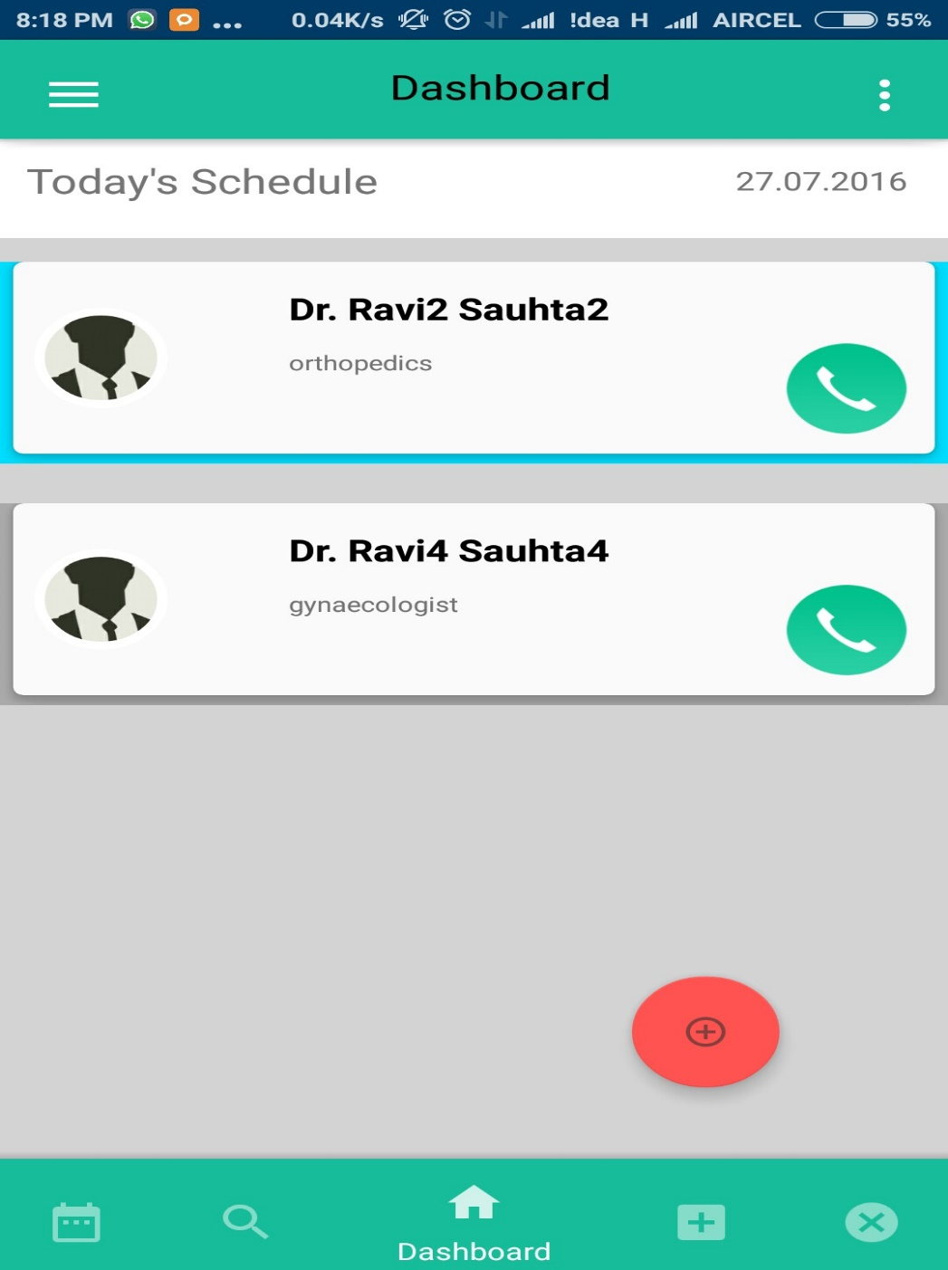

Dashboard enlist all the doctors practicing with the clinic along with their display picture and field of practice.

Direct call can be made to the doctor using the call icon in the card.

By clicking the doctor’s name or speciality, receptionist moves to a new screen where doctor’s current day appointment is shown in sorted order of appointment time.

3.1 Making call

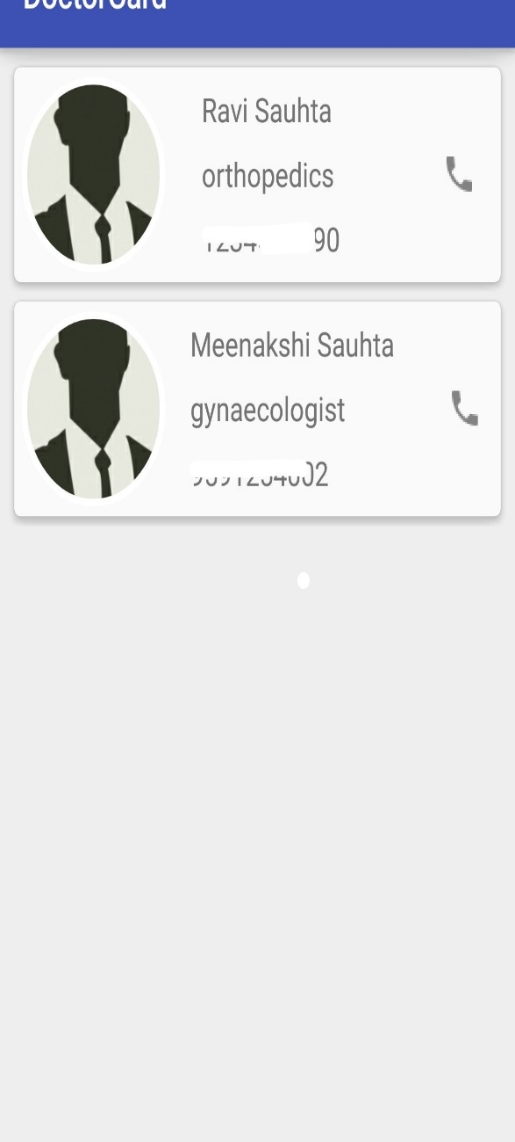 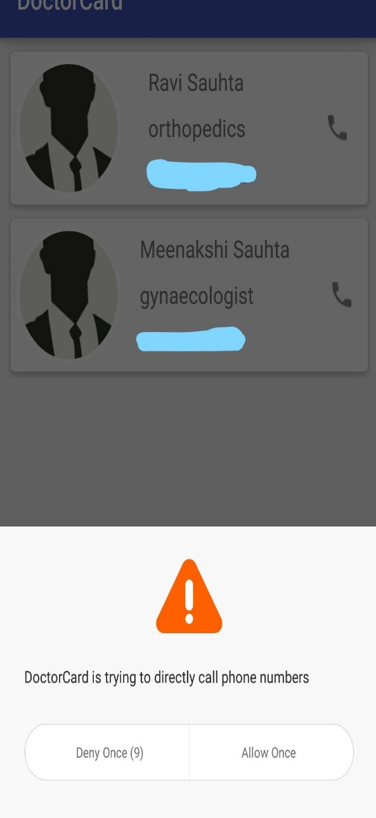

Ca

Caller icon in the doctor card is programmed to make call to the respective doctor. This is done by clicking icon and then granting access to make call.

1. Queue Managing

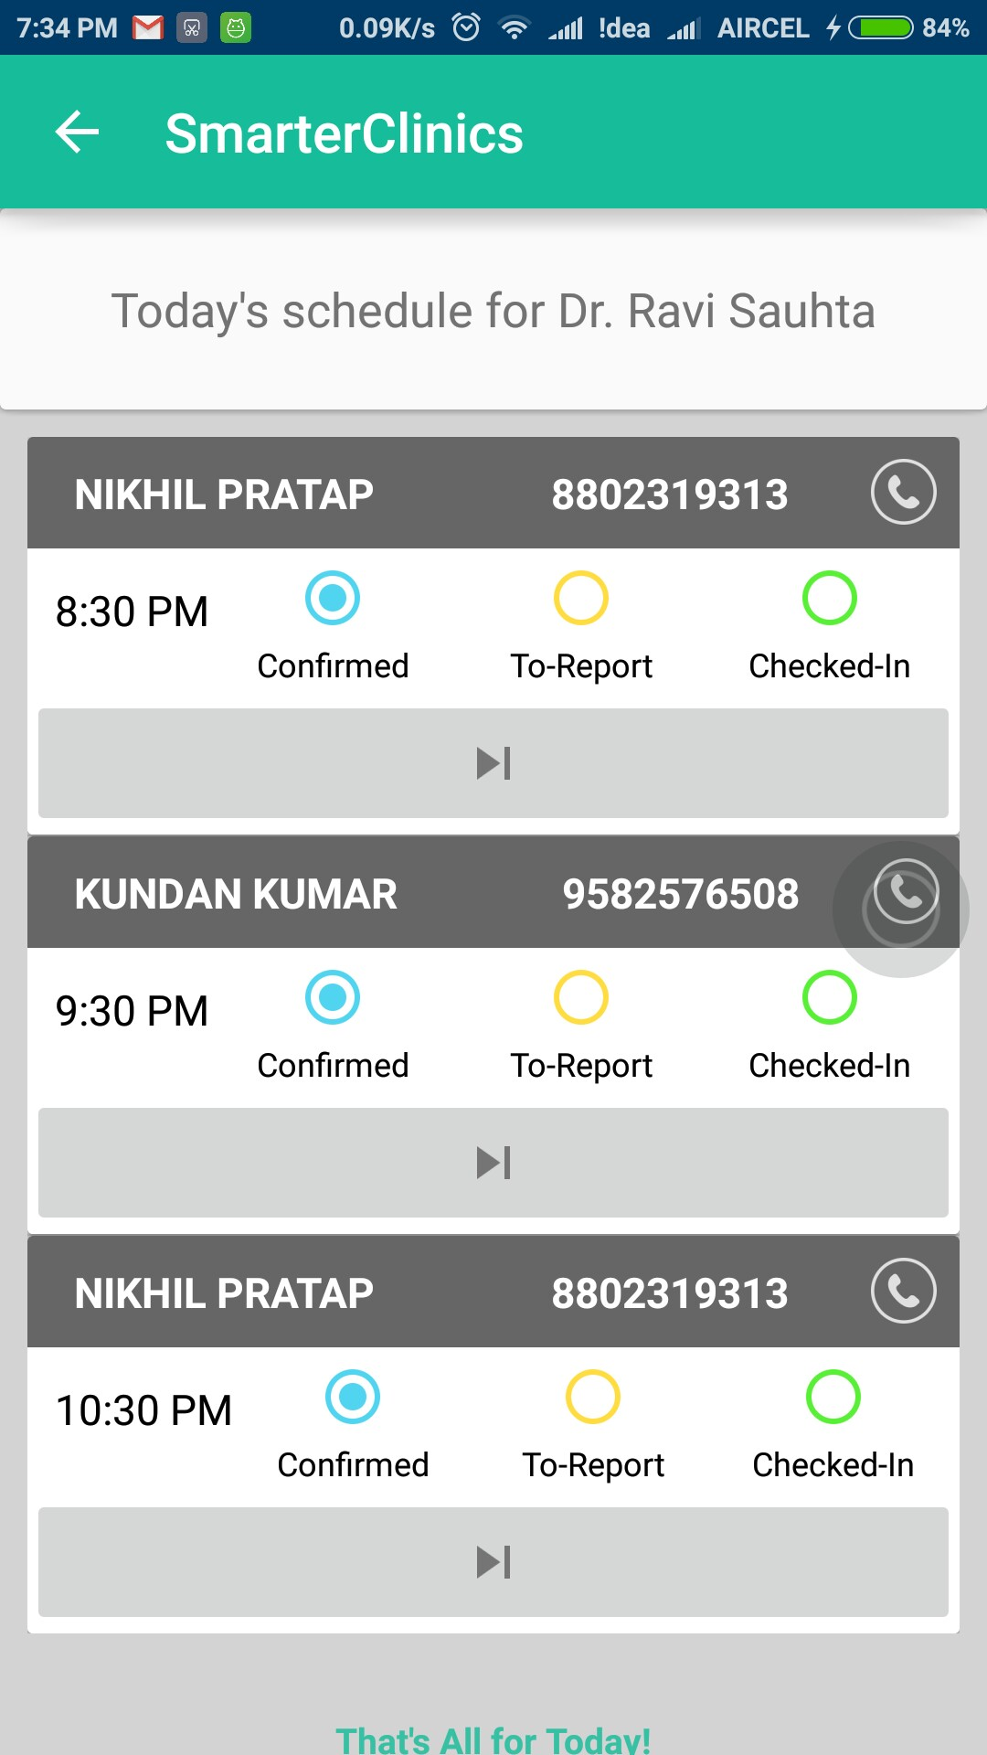

When receptionist clicks on any doctor card, then this activity opens up, which contains all the appointment of the doctor for that day.

Appointments are shown in card which contains patient’s name, mobile number, time of appointment and current status of the patient.

Here status are shown in radio buttons which goes on and off according to the current status of the patient, where the status has following meaning:

*Confirmed* - Patient appointment has been booked and he/she has not cancelled the same.

*To-Report -* Patient has entered the clinic and is waiting in the queue.

*Checked-In* - Patient is in doctor’s cabin now.

Only one patient can be checked in at a time.

Receptionist can process the patient through there 3 states using the button given below the radio buttons.

Once a patient checks-in, doctor processes with the further steps.

Based on medical record and health of patient doctor prescribes him medicine and mark the patient checked-out. Then receptionist can process the next patient in queue.

* 1. Confirmed

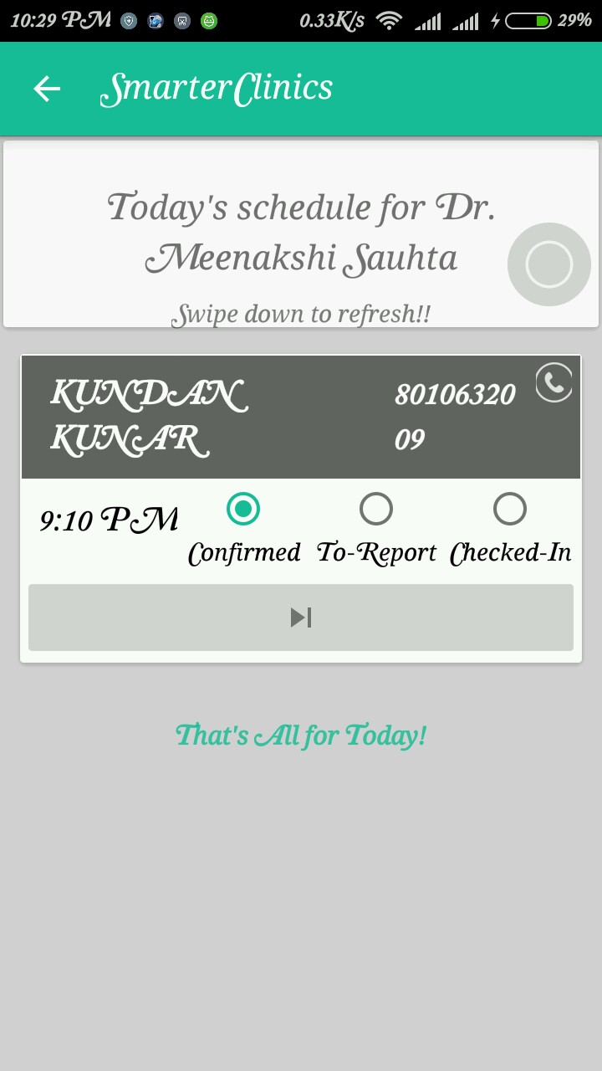

* 1. To-Report :

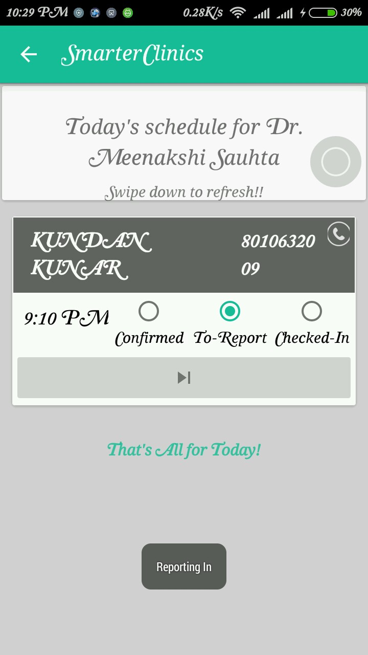

* 1. Checked-In

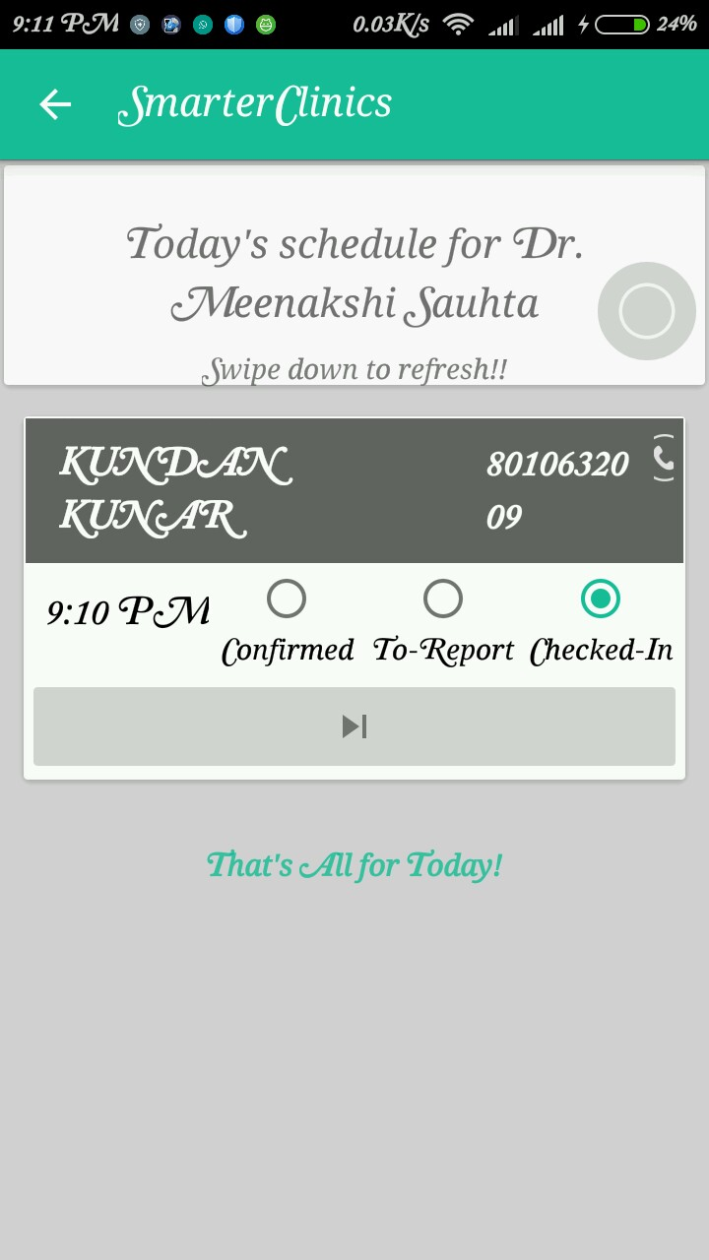

1. Patient Registration

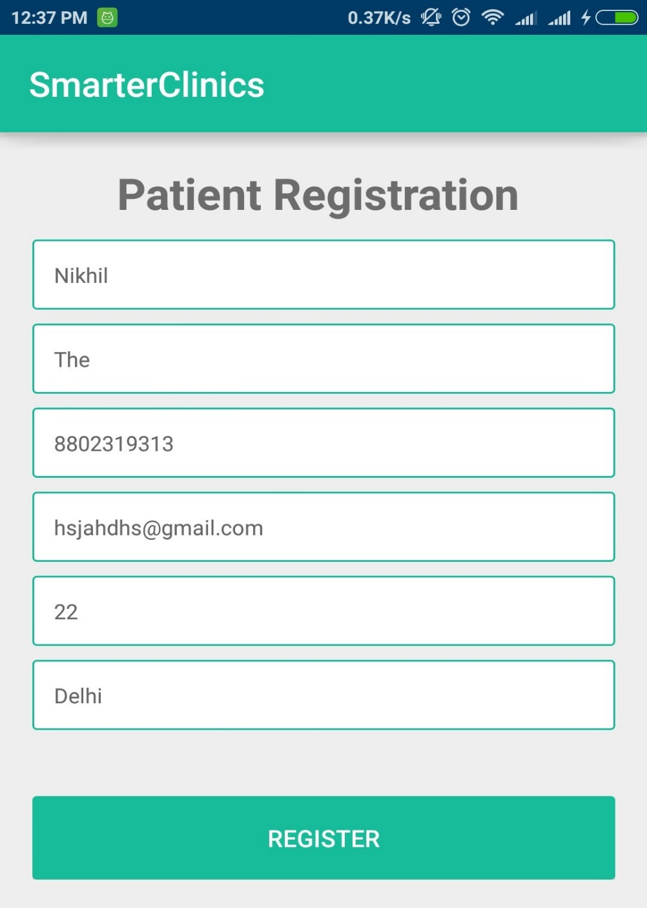

Receptionist will enter details of new patient with required details as first name, last name,

Mobile number, email address, age and location.

Out of which email and location can be skipped but all other details are necessary.

If the name and number combination is found unique then patient is registered.

Patient Search

1. Patient Search

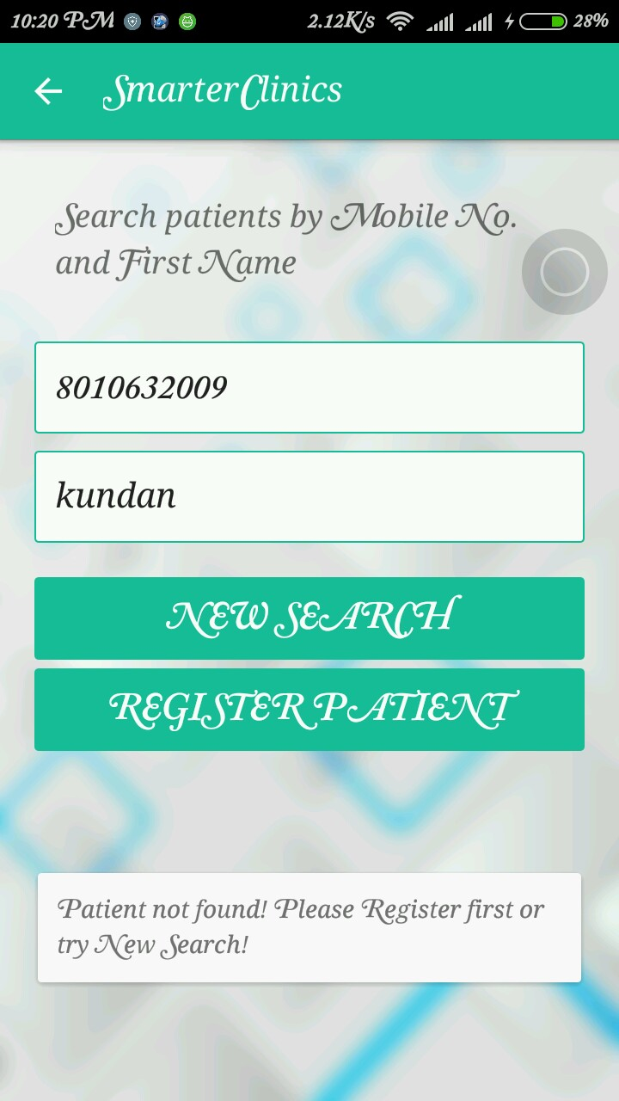

Searches for patient based on their name and mobile number provided at the time of registration.

If found list of appointment of that person is shown, if not then this message shows up and registration jump button is visible.

Cancel Appointment

* 1. Cancel Appointment : initial list

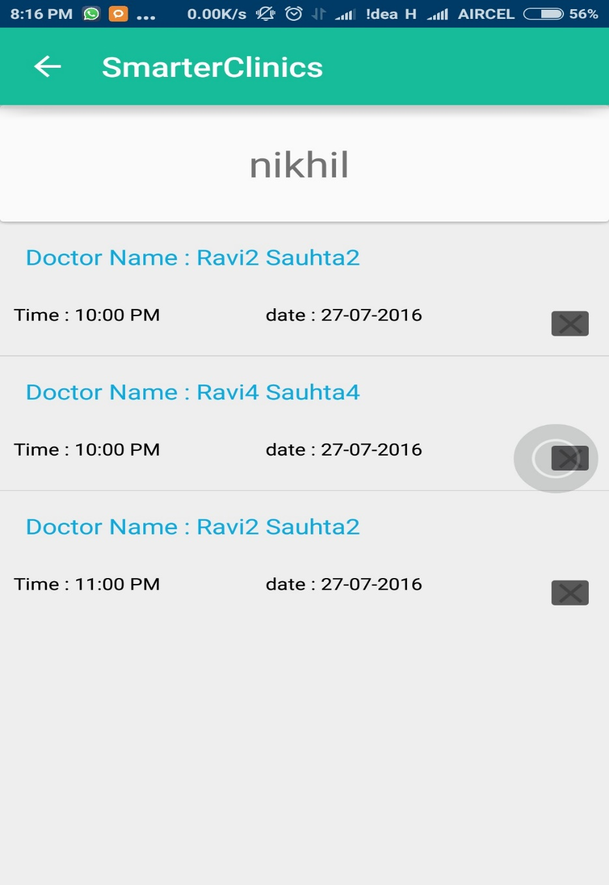

“X” image button is used to cancel particular appointment.

On pressing it, a dialog box shows up, then actions are made according to the choice selected by the receptionist.

* 1. Cancel Appointment : Dialog Box

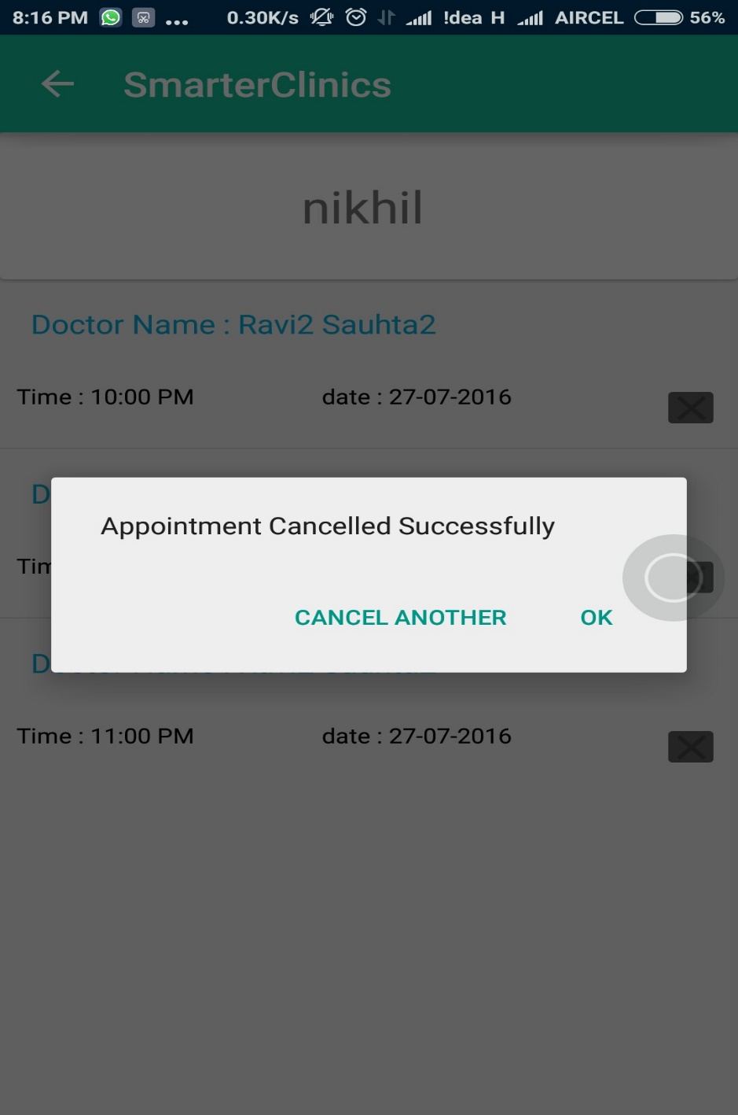

Dialog box is used to here to show success of operation performed. It contains two message:

1. CANCEL ANOTHER : it will refresh this activity and loads remaining appointments.
2. OK: It will redirect the application to dashboard.

* 1. Cancel Appointment : final list

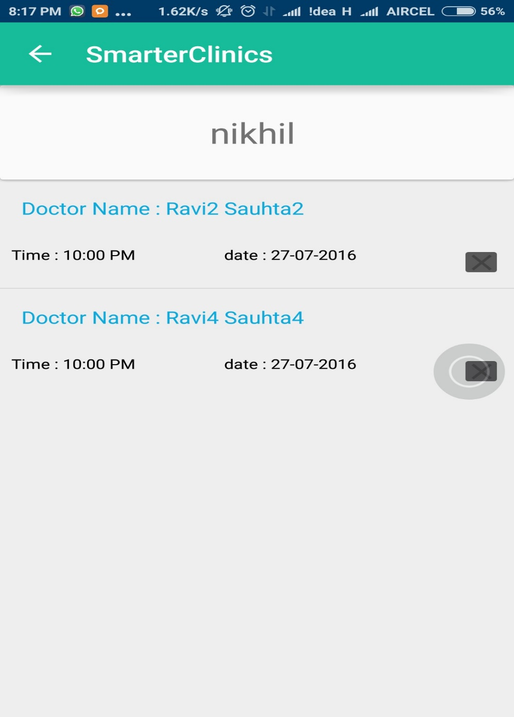

On clicking CANCEL ANOTHER, same activity is

reloaded with trimmed list of appointment.

We tried to cancel Appointment scheduled for

11 PM, which have been cancelled successfully.

Appointment Booking

* 1. Appointment Booking : Choose Doctor

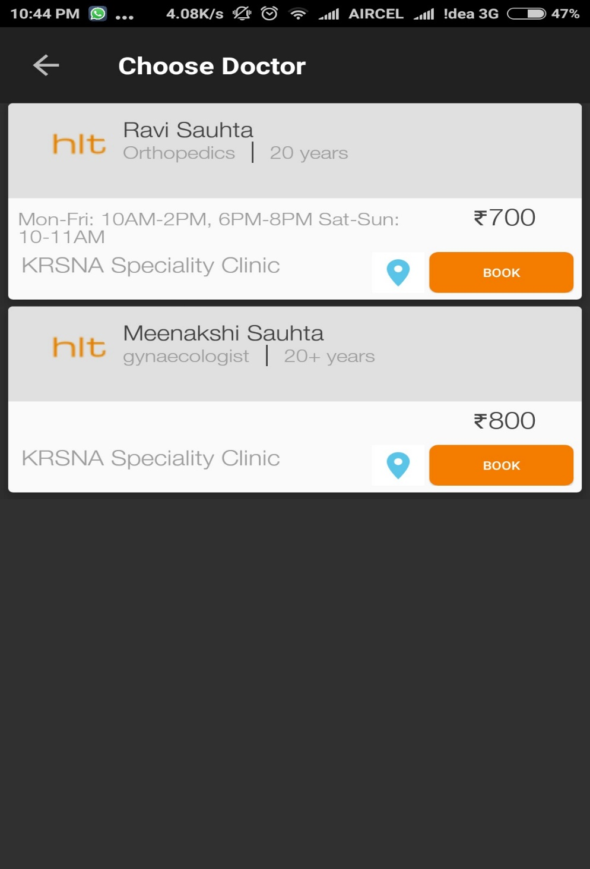

Based on patient request receptionist select a doctor.

For reference, Doctor’s card is prepared with all the information that either patient or receptionist might

want to know as name, speciality, exp., OPD schedule

and fee.

* 1. Appointment Booking : Select Date Slot

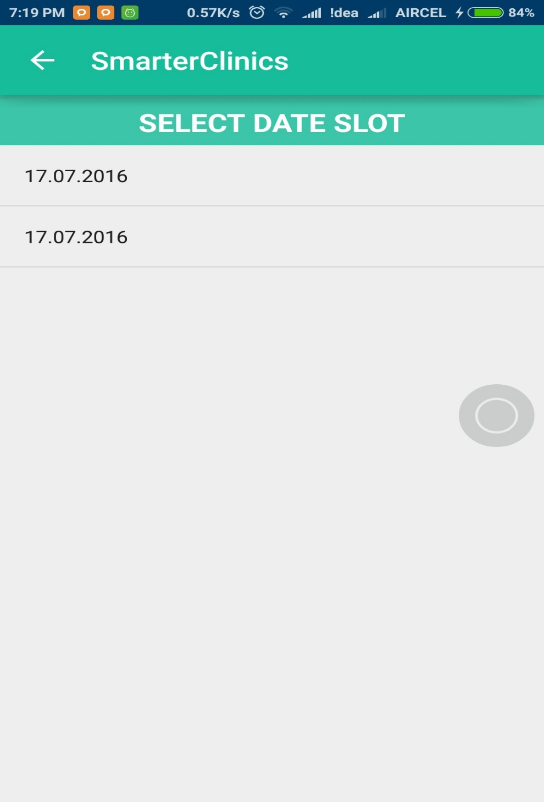

After choosing a doctor, next activity opens with a list of available date of that doctor. Receptionist will choose a date which is eventually picked by patient or as suggested by doctor for round up.

* 1. Appointment Booking : Select Time Slot

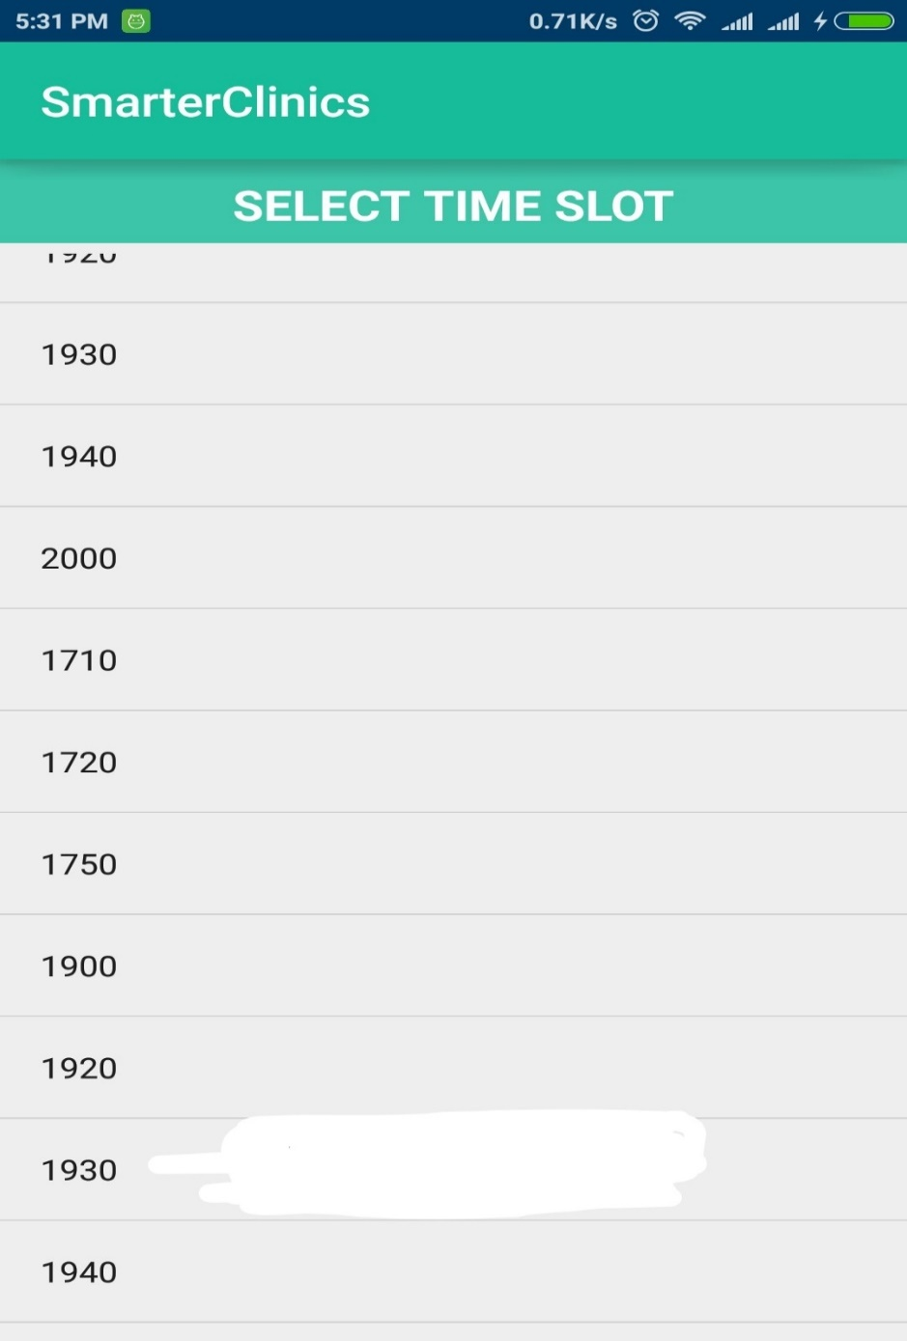

Time slot is chosen from the list of slots available.

By clicking on any time slot an appointment of the patient with the chosen doctor is scheduled on selected date and clicked slot.

Then application is redirected to dashboard and a message is sent to the patient conforming the appoint booking.

* 1. Appointment Booking : Success

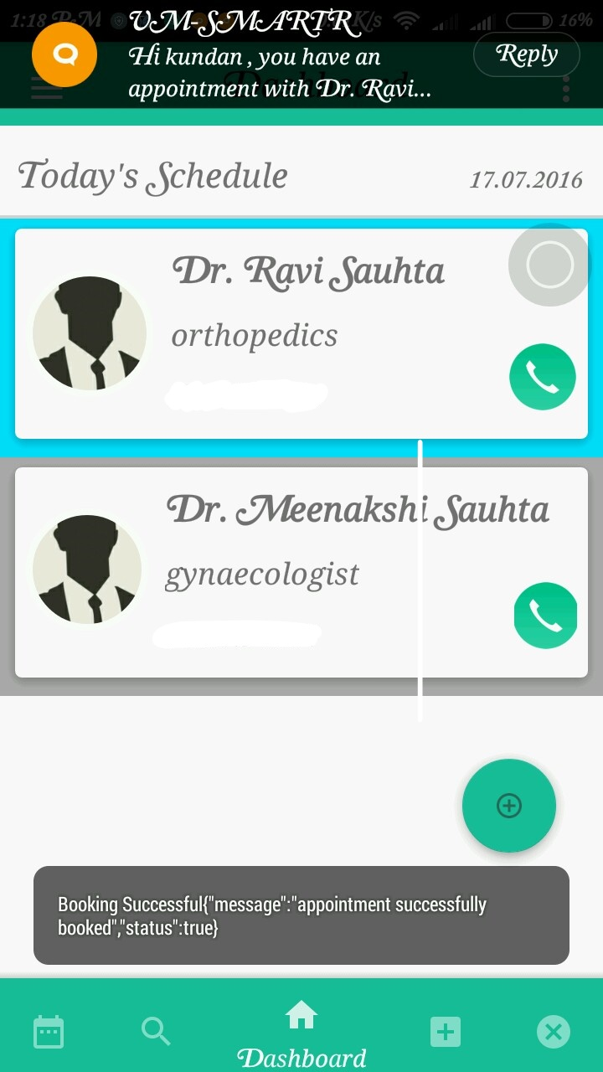

On successful appointment booking application is redirected to the dashboard. A success message is shown to receptionist and a message is sent to the patient as confirmation of the appointment.