**Schematic:**

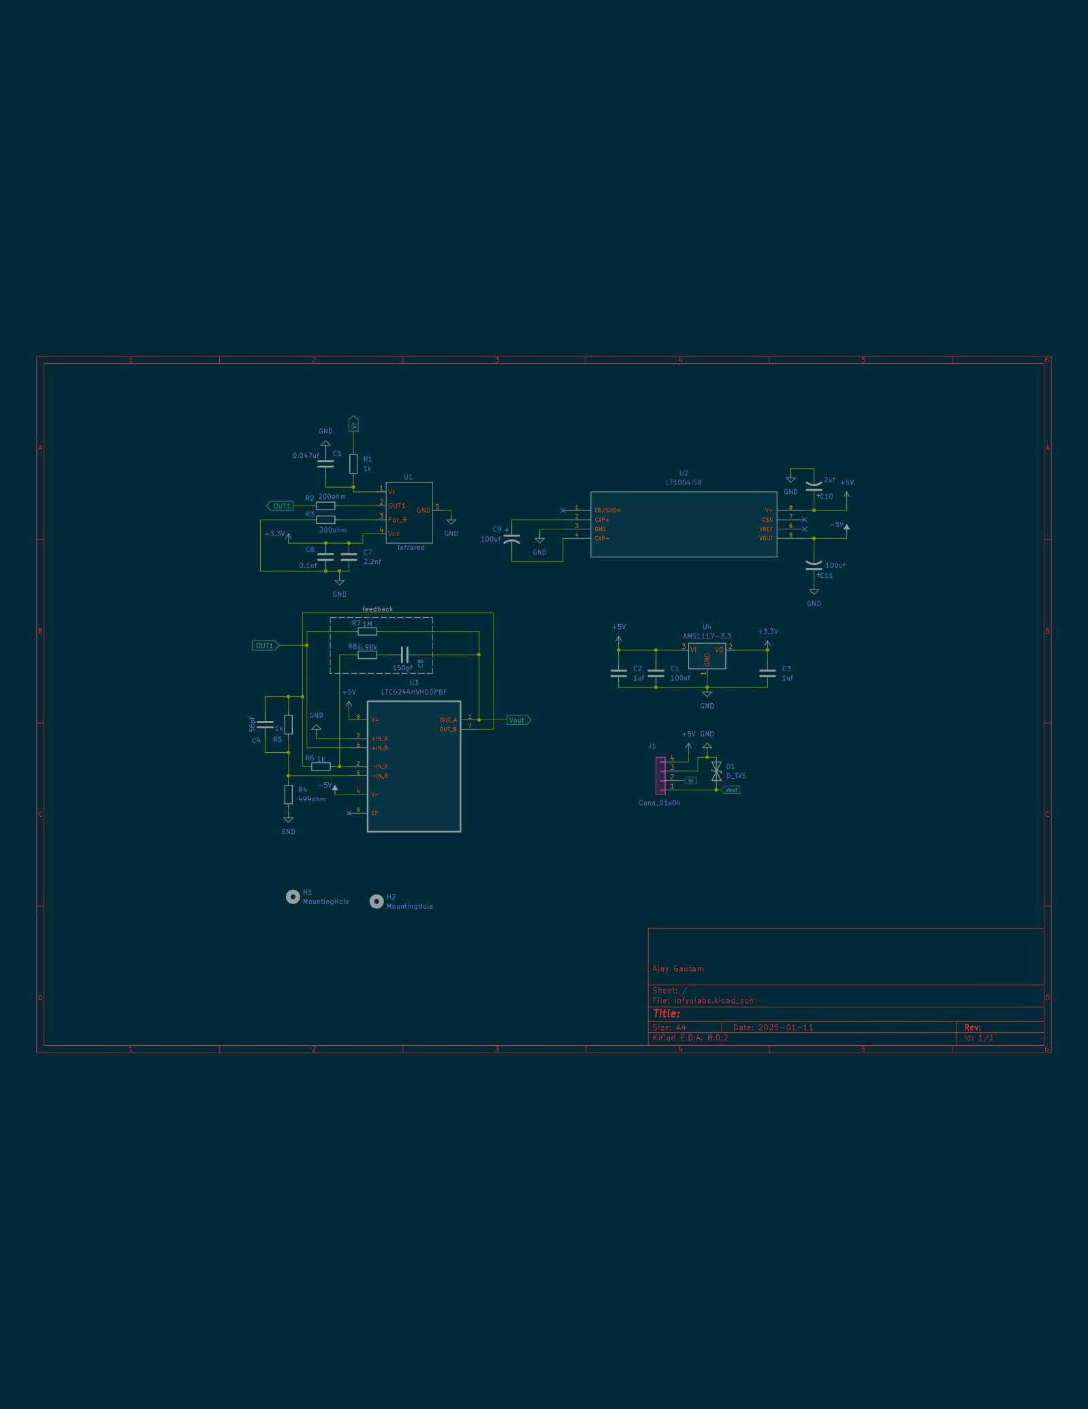**Figure 1: Schematic**

**PCB layout:**

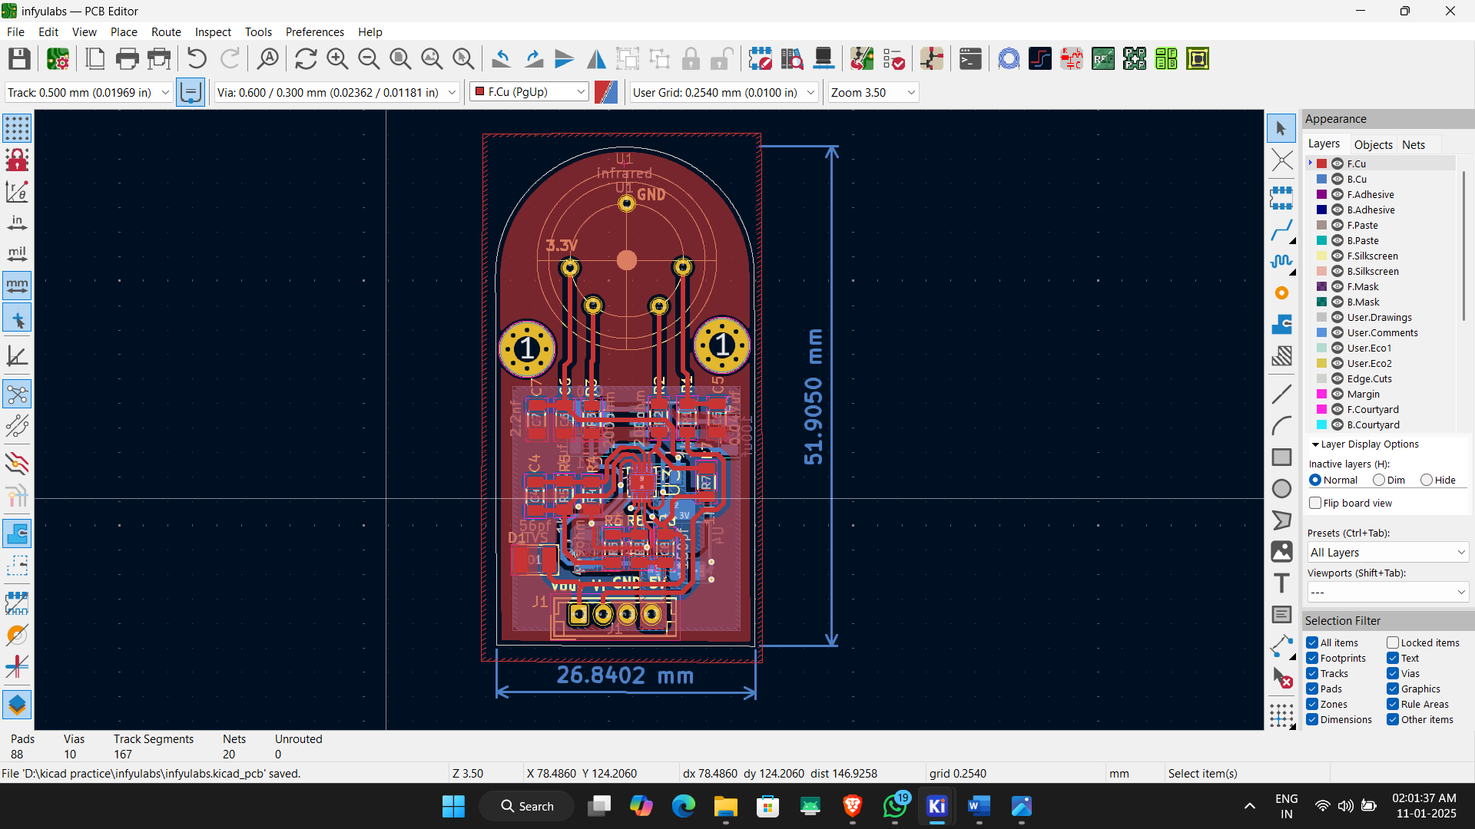

**Figure 2: PCB Layout**

**3D Render View:**

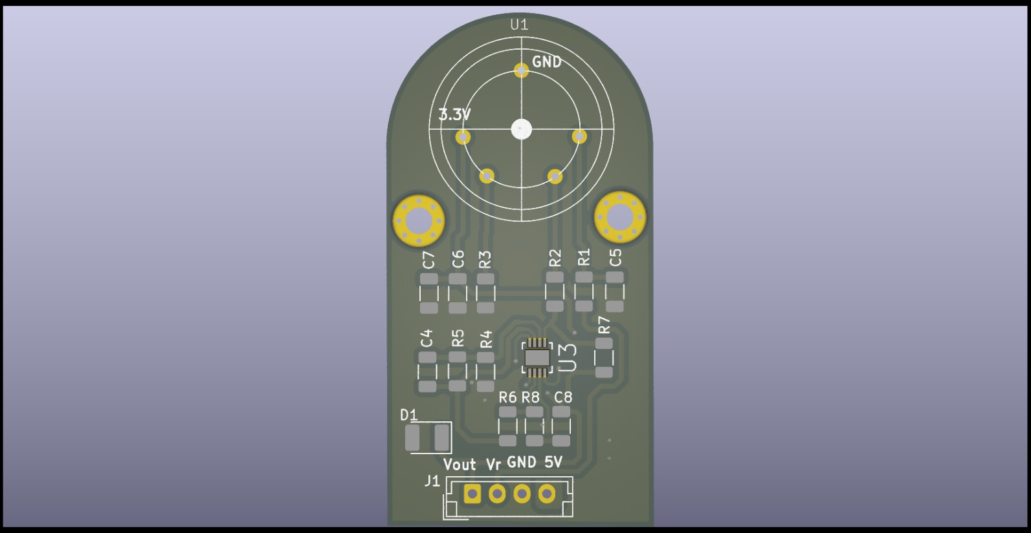

**Figure 3: Front view without SMD and THT**

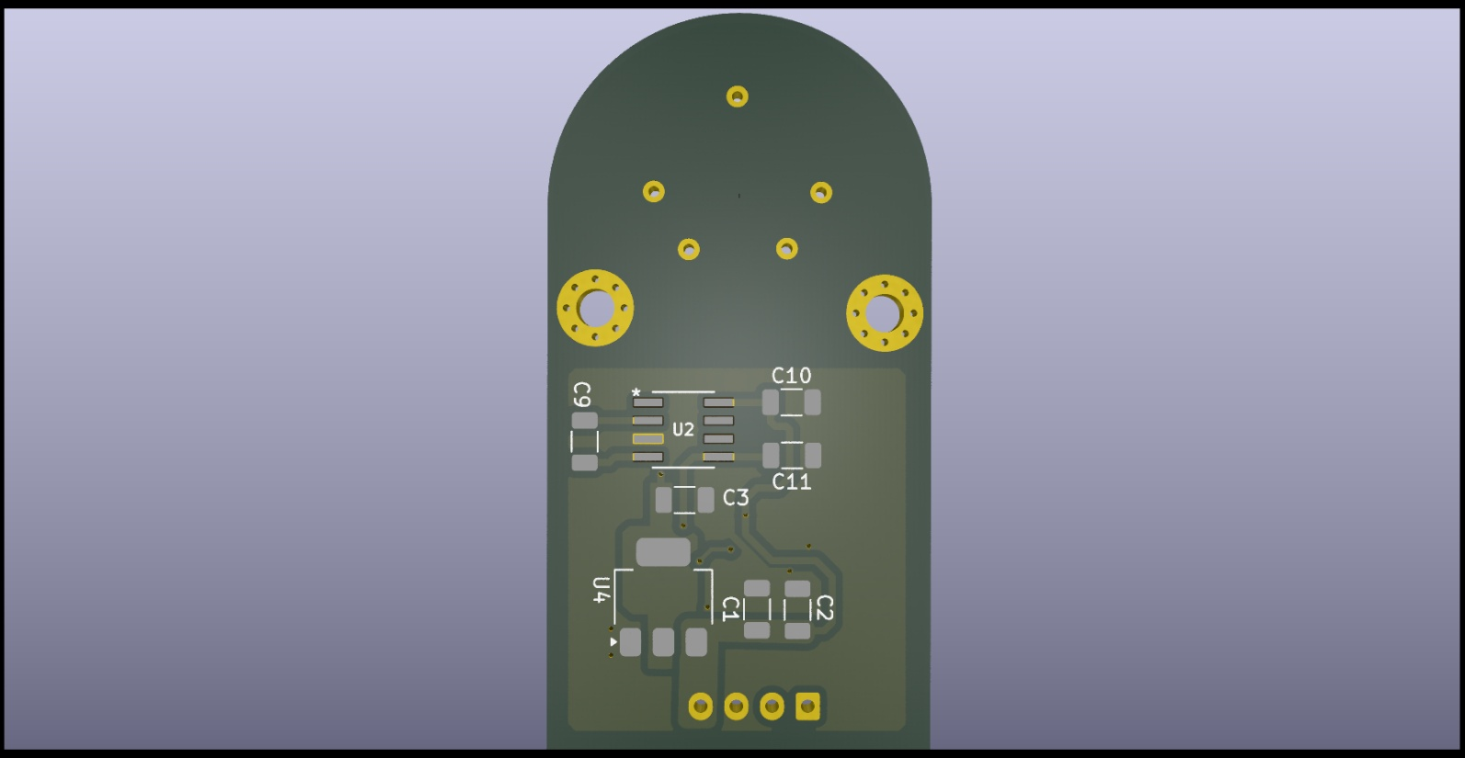

**Figure 4: Back view without SMD and THT**

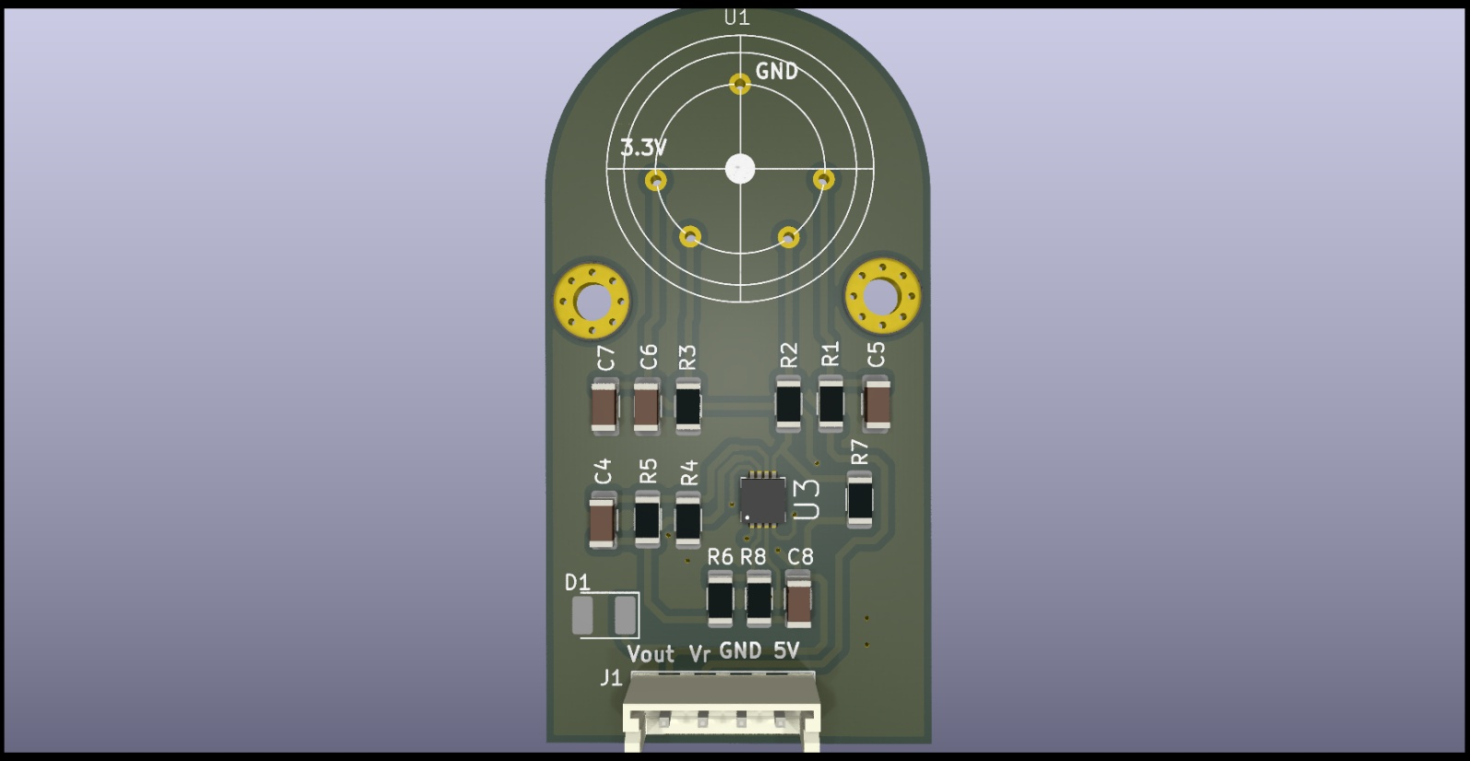

**Figure 5: Front view with SMD and THT (Sensor Footprint is Custom made and JST Connector)**

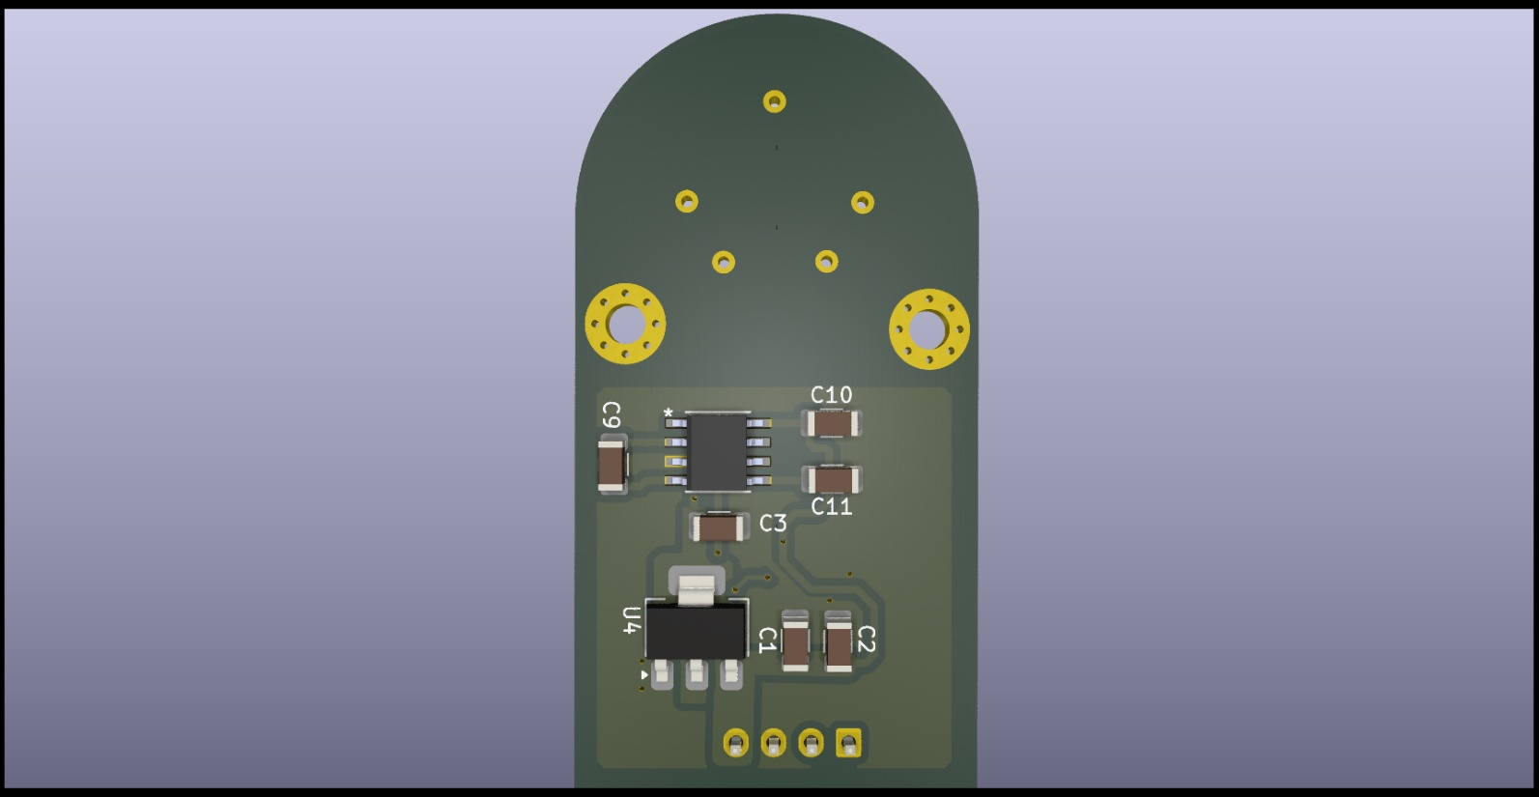

**Figure 6: Back view with SMD and THT**

**Overview:**

1. **For ESD protection TVS Diode used.**
2. **Basic Voltage Inverter is used for -5V output (LT1054).**
3. **Used LTC6244HV low-noise transimpedance amplifier (TIA).**
4. **Used LDO AMS1117 with coupling capacitors, generally we call them step down capacitor. Used for filtering the voltage.**
5. **low-pass filter, RC circuit is implemented for blocking high signal.**
6. **Remark: it could be even smaller. Current Size: 5.19CM x 2.68CM.**
7. **In this design, Via hole D:0.3mm, Pad D: 0.6mm and Track width: 0.3mm and 0.5mm also use Polygon (Zone). (As Per Manufacturer Standards)**