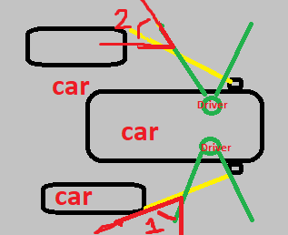Fig: -

car and obstacle detection using for adas

* **Green colour area is an area of vision of driver from inside the car.**
* **Yellow colour area is an area of vision of side mirror.**
* 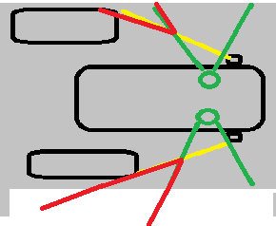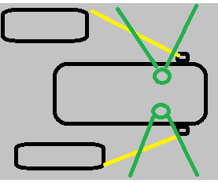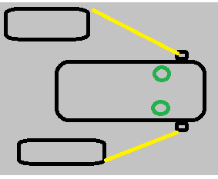**Red colour area is an area of blind spot where mirror and driver not reach.**

Fig: 1

Here, I have used to ultrasonic sensor for detection because it has a range of 200cm. so it is quite easy to implement in small scale level. For large level we could use more powerful and high price ultrasonic sensor.

fig:2

fig:3

It can detect both side cars i.e. left and right side cars. It and be indicated by using lads , here for right side indication, I am using red led with 220 ohm resistor. you can use according to your need. Left side indication, I am using blue led. if both side have car so, I am glowing green led. But here I am glowing all three led. please note this.

**Components: -**

1. **Led *3 {red, green and blue}**
2. **220 ohm resistor.**
3. **Arduino uno.**
4. **Arduino cable.**
5. **Connecting wire.**
6. **Ultrasonic sensor.*2**
7. **Breadboard.**
8. **And laptop with Arduino ide.**

**Circuit diagram: -**

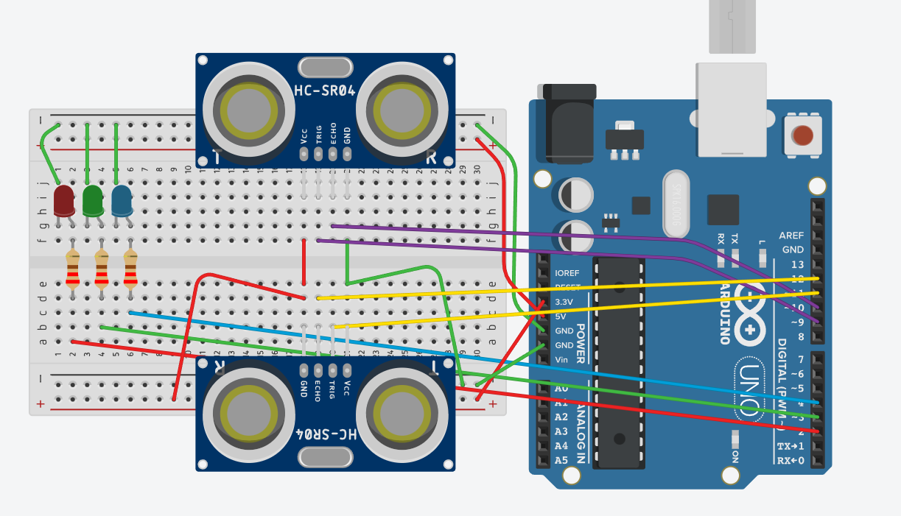

Code: -

// modified by Ajay Gautam

const int trigPin = 9;

const int echoPin = 10;

const int trigPin1 = 11;

const int echoPin1 = 12;

const int led1 = 2;

const int led2 = 3;

const int led3 = 4;

int distance;

int distance1;

// modified by Ajay Gautam

void setup() {

Serial.begin(9600);

pinMode(trigPin, OUTPUT);

pinMode(echoPin, INPUT);

pinMode(trigPin1, OUTPUT);

pinMode(echoPin1, INPUT);

pinMode(led1, OUTPUT);

pinMode(led2, OUTPUT);

pinMode(led3, OUTPUT);

}

void loop() {

digitalWrite(trigPin, LOW);

delayMicroseconds(2);

digitalWrite(trigPin, HIGH);

delayMicroseconds(10);

digitalWrite(trigPin, LOW);

distance= (pulseIn(echoPin, HIGH))*0.034/2;

Serial.print("Distance: ");

Serial.println(distance);

digitalWrite(trigPin1, LOW);

delayMicroseconds(2);

digitalWrite(trigPin1, HIGH);

delayMicroseconds(10);

digitalWrite(trigPin1, LOW);

distance1 = (pulseIn(echoPin1,HIGH))*0.034/2;

if(distance<=50){

Serial.println("led1 on");

digitalWrite(led1, HIGH);

delay(100);

}

else{

Serial.println("led3 off");

digitalWrite(led1, LOW);

}

if(distance<=50){

Serial.println("led3 on");

digitalWrite(led3, HIGH);

delay(100);

}

else{

Serial.println("led3 off");

digitalWrite(led3, LOW);

}

if(distance1 <=50){

Serial.println("led3 on");

digitalWrite(led3, HIGH);

delay(100);

}

else{

Serial.println("led3 off");

digitalWrite(led3, LOW);

}

// modified by Ajay Gautam

if((distance&&distance1)<=150){

Serial.println("led on");

digitalWrite(led1, HIGH);

digitalWrite(led2, HIGH);

digitalWrite(led3, HIGH);

delay(100);

}

else{

Serial.println("led off");

digitalWrite(led1, LOW);

digitalWrite(led2, LOW);

digitalWrite(led3, LOW);

delay(100);

}

}

Procedure: -

1. Load above code in ide.
2. Set desire limiting range for detection on object i.e. car. In my care I have used 50 as range.
3. Compile code and upload in uno board.
4. Set up the circuit in your model according to need to detect objects.

**Future scope: -**

**It has varies future scope in different domain. Like it can be use in cars, truck and bus breaking system where instead of led we can connect piston or motor for breaking purpose.**

**Conclusion: -**

1. **In this project , we were seen and study the working and application of ultrasonic sensor in vehicle industry.**
2. **It can be use to detect car and indication purpose.**