Social worker module
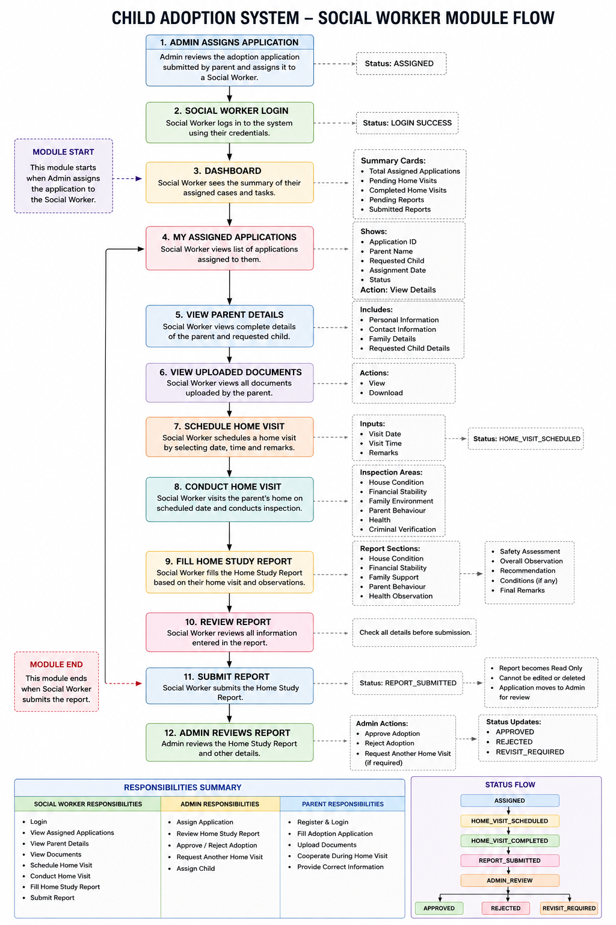

1. Login
- Login
- Logout
- Change Password

2. Dashboard
Show:
- Assigned Applications
- Pending Home Visits
- Completed Home Visits
- Submitted Reports

3. View Assigned Applications
Display:
- Application ID
- Parent Name
- Child Name
- Application Date
- Status
Action:
- View Details

4. View Parent Details
Display:

Personal Information
- Name
- Age
- Gender
- Occupation
- Annual Income

Contact
- Phone
- Email
- Address

Family Details
- Marital Status
- Family Members

5. View Uploaded Documents
Display:
- Aadhaar
- PAN
- Income Certificate
- Address Proof
- Marriage Certificate (if applicable)
Actions:
- View
- Download

6. Schedule Home Visit
Fields:
- Visit Date
- Visit Time
- Remarks
Button:
- Schedule

7. Conduct Home Visit
During the visit, inspect:
- House Condition
- Financial Stability
- Family Environment
- Parent Behaviour
- Child Safety
(No need to record GPS, upload photos, or digital signatures.)

8. Fill Home Study Report
This is the main functionality.
Sections:

House Condition
- Excellent
- Good
- Average
- Poor

Financial Stability
- Stable
- Moderate
- Weak

Family Support
- Excellent
- Good
- Average
- Poor

Parent Behaviour
Rating (1–5)

Overall Observation
Textarea

Recommendation
- Recommended
- Recommended with Conditions
- Not Recommended

Final Remarks
Textarea

Submit Report
After submission:
- Report becomes read-only.
- Admin can review it.

9. View Submitted Reports
Display:
- Application ID
- Parent Name
- Visit Date
- Recommendation
Action:
- View Report

