What is a Database?
A database is an organized collection of data that is stored and managed so it can be easily accessed, updated, and retrieved.
👉 In simple words:
A database is like a digital storage system where you keep information in a structured way.
Example:
- A student management system stores student names, IDs, marks → this is a database.
- A banking system stores account details and transactions → also a database.
In SQL, we use databases to store data in tables and manage it efficiently.

✅ Types of Databases
Databases can be classified in different ways, but here are the most common types you should know in SQL:

1. Relational Database (RDBMS) ✅ (Most important in SQL)
- Data is stored in tables (rows and columns).
- Tables can be related to each other using keys (primary key, foreign key).
- Uses SQL (Structured Query Language).
Examples:
- MySQL
- PostgreSQL
- Oracle
- SQL Server
👉 Example:
Table: Students
+----+--------+-------+
| ID | Name | Marks |
+----+--------+-------+
| 1 | Ajay | 85 |
| 2 | Ravi | 90 |

2. Non-Relational Database (NoSQL)
- Does NOT use tables like traditional databases.
- Stores data in formats like:
  - Key-value
  - Document
  - Graph
  - Column-based
Examples:
- MongoDB
- Cassandra
- Redis
👉 Used when:
- Data is unstructured or large (Big Data, real-time apps)

3. Hierarchical Database
- Data is organized in a tree structure (parent → child relationship).
- Each child has only one parent.
👉 Example:
Company
├── HR
└── IT
├── Developer
└── Tester

4. Network Database
- Similar to hierarchical, but a child can have multiple parents.
- Forms a graph-like structure.

What is Normalization?
Normalization is a process in databases used to organize data efficiently by reducing redundancy (duplicate data) and improving data integrity (accuracy and consistency).
Normalization helps to:
- ✅ Remove duplicate data
- ✅ Avoid data inconsistency
- ✅ Improve database performance
- ✅ Make data easy to maintain
1. First Normal Form (1NF)
🔹 Definition
A table is in 1NF if:
- All columns contain atomic (single) values
- No repeating groups or multiple values in a column
2. Second Normal Form (2NF)
🔹 Definition
A table is in 2NF if:
- It is already in 1NF
- No partial dependency
👉 Partial dependency means: A column depends only on part of a composite key, not the whole key.
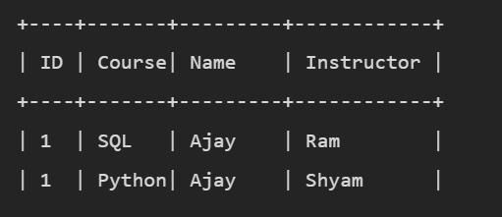it is 1NF
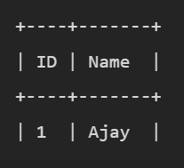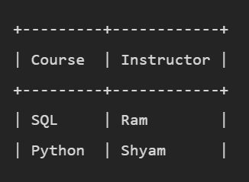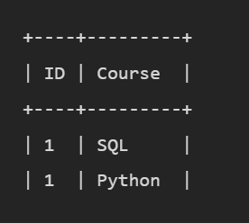
Now:
- No partial dependency
- Each table has proper relation
3. Third Normal Form (3NF)
🔹 Definition
A table is in 3NF if:
- It is in 2NF
- No transitive dependency
👉 Transitive dependency means: A non-key column depends on another non-key column
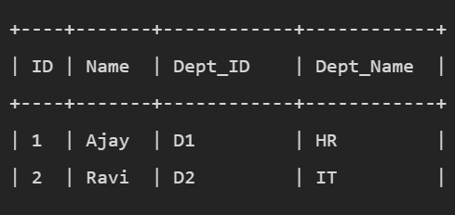
- Dept_Name depends on Dept_ID (not directly on ID)
👉 So: ID → Dept_ID → Dept_Name
👉 This is transitive dependency
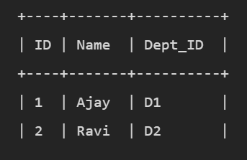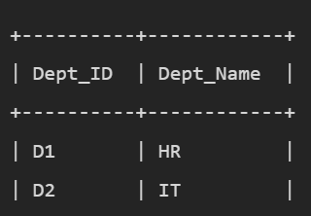
. Boyce-Codd Normal Form (BCNF)
🔹 Definition
A table is in BCNF if:
- It is in 3NF
- Every determinant is a candidate key
👉 Determinant = column that determines other columns
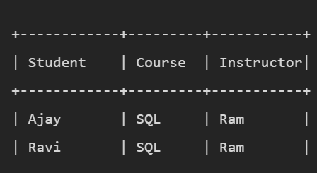Course determines Instructor, but Course is not a candidate key
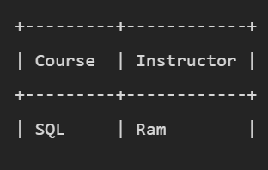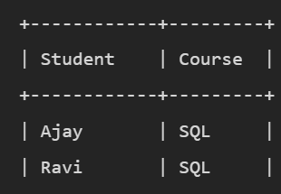

What is JOIN in SQL?
A JOIN is used to combine rows from two or more tables based on a related column between them.
In real databases:
- Data is stored in multiple tables (because of normalization)
- To get complete information, we need to combine tables

1. INNER JOIN
- Returns only matching records from both tables.
1.Inner Join
SELECT Students.ID, Name, Marks
FROM Students
INNER JOIN Marks
ON Students.ID = Marks.ID;

2. LEFT JOIN (LEFT OUTER JOIN)
🔹 Definition
Returns:
- All records from left table
- Matching records from right table
- If no match → NULL
SELECT Students.ID, Name, Marks
FROM Students
LEFT JOIN Marks
ON Students.ID = Marks.ID;

3. RIGHT JOIN (RIGHT OUTER JOIN)
🔹 Definition
Returns:
- All records from right table
- Matching from left table
SELECT Students.ID, Name, Marks
FROM Students
RIGHT JOIN Marks
ON Students.ID = Marks.ID;

4. FULL JOIN (FULL OUTER JOIN)
🔹 Definition
Returns:
- All records from both tables
- Non-matching → NULL

SELECT Students.ID, Name, Marks
FROM Students
FULL OUTER JOIN Marks
ON Students.ID = Marks.ID;

5. CROSS JOIN
🔹 Definition
Returns all possible combinations of rows
👉 Cartesian product
SELECT Name, Marks
FROM Students
CROSS JOIN Marks;

6. SELF JOIN
🔹 Definition
Joining a table with itself
SELECT A.Name, B.Name
FROM Students A
JOIN Students B
ON A.ID <> B.ID; //pair of students

Type | Full Form | Purpose | Commands
DDL | Data Definition | Structure | CREATE, ALTER, DROP
DML | Data Manipulation | Data handling | INSERT, UPDATE, DELETE
DQL | Data Query | Fetch data | SELECT
DCL | Data Control | Permissions | GRANT, REVOKE
TCL | Transaction Control | Transactions | COMMIT, ROLLBACK
What are Constraints in SQL?
Constraints in SQL are rules applied on table columns to restrict the type of data that can be stored.
1. NOT NULL
🔹 Purpose
Ensures that a column cannot have NULL (empty) values
2. UNIQUE
🔹 Purpose
Ensures all values in a column are distinct (no duplicates)
3. PRIMARY KEY ✅ (Very Important)
🔹 Purpose
- Uniquely identifies each record
- Cannot be NULL
- Combination of NOT NULL + UNIQUE

4. FOREIGN KEY ✅

🔹 Purpose
- Creates a link between two tables (maintains referential integrity)

5. CHECK

🔹 Purpose
- Ensures that values satisfy a specific condition

6. DEFAULT

🔹 Purpose
- Assigns a default value if none is provided

7. AUTO_INCREMENT (MySQL-specific)

🔹 Purpose
- Automatically generates unique numbers
Feature | PRIMARY KEY | UNIQUE KEY
Uniqueness | Yes | Yes
NULL values | ❌ Not allowed | ✅ Allowed
Number per table | Only 1 | Multiple
Purpose | Identifies record | Prevent duplicate values
Index type | Clustered | Non-clustered

SQL runs in this order:
FROM
WHERE
GROUP BY
HAVING
SELECT
ORDER BY
Every column in SELECT must be either:
- In GROUP BY, OR
- Used with an aggregate function

