Twitter Troll Classification

Abstract –
Internet trolls are gaining more influence in society due to the rapid growth of social media. Some tweeter user’s trolls that get paid to spread certain opinions or information online. Identifying a troll can be difficult. This study examines if it is possible to identify troll on Twitter by artificial intelligence on user tweets and modelling it as a classification problem. The experiment was done with twitter troll data and normal tweets. The users were modelled into data points based on the text of the tweets.
Introduction
There has been a good amount of discussion recently about how certain people receive a lot of bullying, trolling messages on Twitter. Twitter has pretty basic tools for blocking trolls, but what if there was a tool that was more like a spam email classifier? It would take each tweet as it is sent, and classify it as either trolling or not. Ideally, users would be able to mark specific tweets as trolling as well, the way you can with spam emails. Eventually, such a tool would become very good at classifying trolling tweets, and you would never have to read the hateful, crazy messages again! How nice that would be. In this project we have python file which will predict the class of each tweet.
About the dataset –
We have data from twitter which contains user id, tweet id actual tweet and the class of that tweet.
Data is in a tabular format. Which is created by using API which bridged between Python and Twitter? To do this or to access the data we need to have twitter credential’s which are necessary to run that API. Here we have shared the data in excel format so no need to call that API.
Here is the snap of the data; we can see here the format of actual data
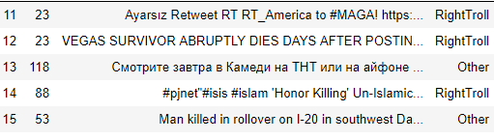
Very first thing about the data we need to check is the distribution of the data along with the response variable or class. So here is the chart of those classes. Its important to know if we want to check the data is balanced or imbalanced.
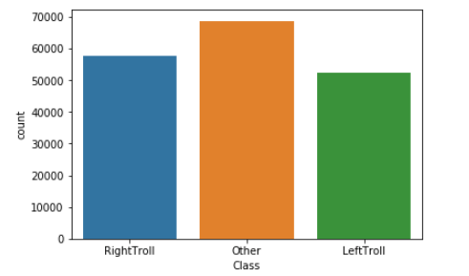
Here the count if Other is bit high compare to other classes but that is negligible. So lets move towards further analysis.
Methodology-
NLP(Natural language processing) techniques are based on machine learning and especially statistical learning which uses a general learning algorithm combined with a large sample, a corpus, of data to learn the rules. Text classification has been handled as a Natural Language Processing denoted NLP, at many levels of granularity. Starting from being a document level classification task, it has been handled at the sentence level and more recently at the phrase level. NLP is a field in computer science which involves making computers derive meaning from human language and input as a way of interacting with the real world.
The main or high level stages of text classification are as follows,
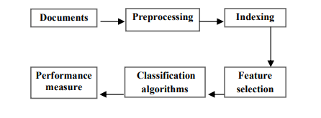
Pre-processing-
In natural language processing or text mining the biggest challenge is to convert the text data into numeric format so that model can learn the pattern from it. But we cannot feed whole corpus to model. For that we need to pre-process it as in we need to clean it first so for that there are several methods to do that. According to anterior research, the feature extraction methods have to take the following specificity into account
- Presence is better than Frequency- Two possible methods for extracting features from a text are either to generate a bag of words which contains each words present in the text, or to count the frequency at which each word appears in the text. Previous researches have shown that analyses are more accurate when focusing on the word presence
- Removal of alphanumeric data- Digits are not relevant for analysing the data, so they can be removed from the sentences. Furthermore, in some cases digits will be mixed with words, removing them may allow to associate two features which may have been considered different by the algorithm otherwise. For example, some data may contain “iPhone”, when other will contain “iphone7”. The tokenization process, which will be introduced later, will not separate “iPhone” from “7”, so these two features will be considered as different. Removing the “7” will allow the features representing these two words to be the same.
- Lemmatizing / steaming word- Both lemmatization and steaming allow to ignore the possible variation of a word. These methods are often applied for extracting features from a text. They allow to reduce the amount of features generated, and regroup similar features
- Convert all data in same case- The important step in the pre-processing is to go through all the data and change every uppercase letter to their corresponding lowercase letter. When processing a word, the analysis will be case sensitive and the program will consider “data” and “Data” as two totally different words. It is important that, these two words are considered as the same features. Otherwise, the algorithms will affect sentiments which may differ to these two words. For example, on these three sentences: “data are good”, “Awesome data”, and “Bad Data”. The first and second sentences both contain “data” and are positive; the third sentence contains “Data” and is negative. The algorithm will guess that sentences containing “data” are more likely to be positive and those containing “Data” negative. If the uppercases had been removed the algorithm would have been able to guess that the fact that the sentence contains “data” is not very relevant to detect whether or the sentence is positive. This pre-processing step is even more important since the data are retrieved from Twitter. Social media users are often writing in uppercase even if it is not required, thus this pre-processing step will have a better impact on social media data than other “classical” data

Indexing–
The documents representation is one of the pre-processing technique that is used to reduce the complexity of the documents and make them easier to handle, the document have to be transformed from the full text version to a document vector now only step remain is to tokenize means to split the data into words and form the term frequency and Inverse document frequency of the data. This is one of the popular methods to convert words into numeric matrix. It has one hyper parameter which is number of features or the number of column of that matrix. In dataset repository three matrix are available small (50 features), medium (100 features) and large (200 features). We can directly use them also
These score are calculated by multiplying TF and IDF for specific words. So, the score of any word in any document can be represented as per the following equation
𝑇𝐹𝐼𝐷𝐹(𝑤𝑜𝑟𝑑, 𝑑𝑜𝑐) = 𝑇𝐹(𝑤𝑜𝑟𝑑, 𝑑𝑜𝑐) ∗ 𝐼𝐷𝐹(𝑤𝑜𝑟𝑑)
Therefore in this method, two matrices have to be calculated, one containing the inverse document frequency of a word in the whole corpus of documents and another containing the term frequency of each word in each document. The formulae to calculate both of them are as follows:
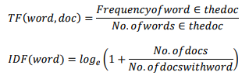
The simple TF-IDF model works well and gives importance to the uncommon words rather than treating all the words as equal in case of binary bag of words model. This model however fails to perform accurately when it encounters any sentence containing negations. This negation is a very common linguistic construction that affects word/sentence polarity. Therefore, the model should be framed in such a way that if presence of negations is considered then better result can be obtained

Machine Learning model –

After getting numeric matrix of feature only part remains is build a machine learning model and validate the results. As we have seen there are three classes so we can say this problem as multi-classification or supervised machine learning model. There are more than dozen algorithms available for this but we will go with tree based model which is Random Forest. This is an extension of decision tree model.
After building model we should validate model on test data.
We are getting 70% accuracy of model. We have used accuracy and confusion matrix metrics to validate the results.

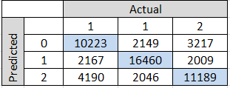

Conclusion/Further use cases –

Now we have number of how many percentages our model is correct. So we can say that based on tweet we can give 70% correct class whether it is a troll or not. Even by doing some further analysis we can increase that number also. Even we handled three classes; if we drop the other class then also we can improvise our model.

In terms of future work, there are a number of additional avenues worth exploring. There are several ways of improving the accuracy further, ranging from improving the training data to using more complex classification techniques.

References

Martin Kay. 1986. Parsing in Functional Unification Grammar. In "Readings in Natural Language Processing", B. J. Grosz, K. Sparck Jones & B. L. Webber, ed., pages 125-138, Morgan Kaufmann Publishers, Los Altos, California.
Frederick Mosteller and David Wallace. 1964. Inference and Disputed Authorship: The Federalist. Addison-Wesley, Reading, Massachusetts.
Karen Sparck Jones. 1972. A statistical interpretation of term specificity and its application in retrieval. Journal of Documentation, 28(1):11-21.
Wikipedia contributors. n.d. Wikipedia:Lists of common misspellings. In Wikipedia, The Free Encyclopedia. https://en.wikipedia.org/w/index.php?title=Wikipedia:Lists_of_common_misspellings&oldid=813410985

