Basic Input and Output Statements

Program:

Output:

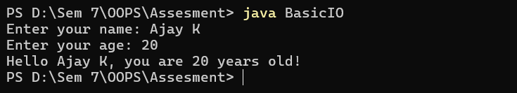

Data Types

Program:

Output:

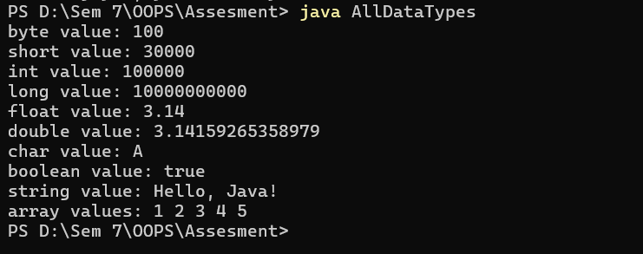

Data Operations

Program:

Output:

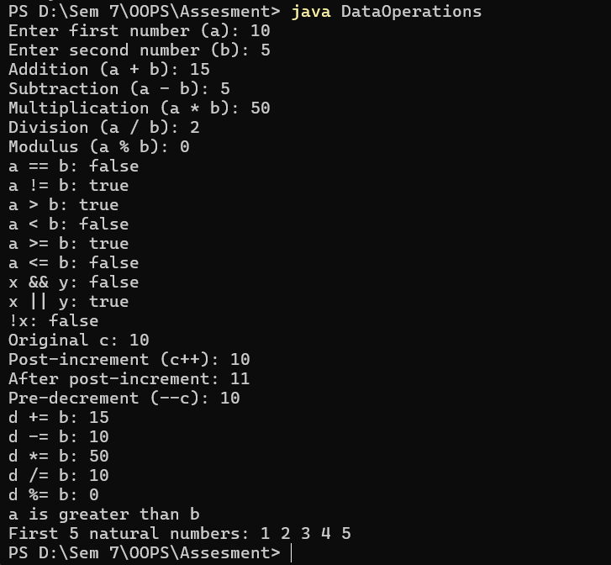

Control Statements

Program:

Output:

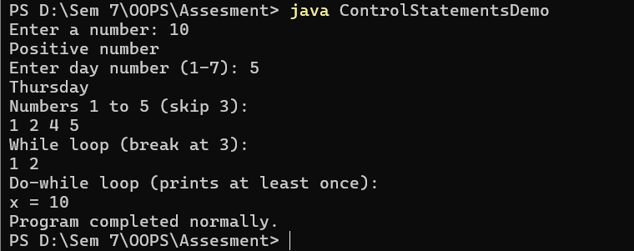

Access Modifiers

Program:

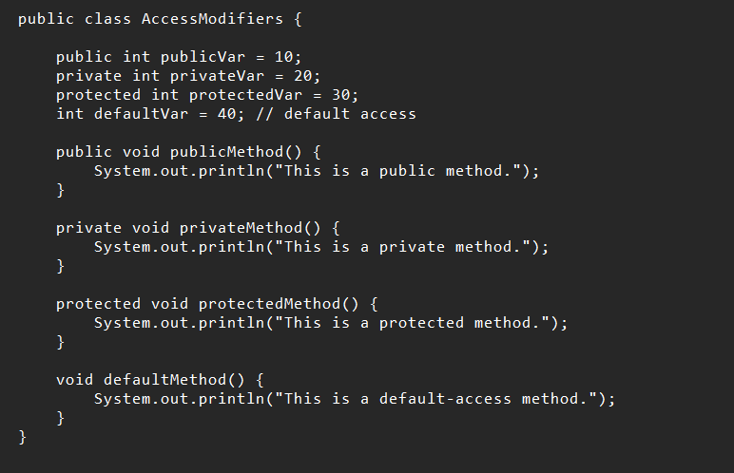

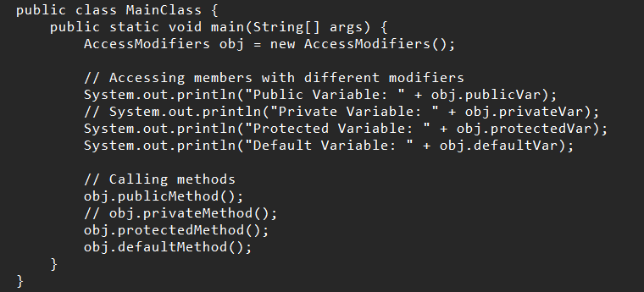

Output:

